When we think about the travel agencies ,we associate them with tour guide that might lead you to the perfect vacation.

Of course this statement might be true but we can't just ignore the facts that we put our trust(money) into their hands and while doing that we are exposed to different types of risks.

Application:

There are different types of consequences which can be associated with the purchase and consumption of products or services . This is why perceived risk can take multiple facets such as: financial, social, psychological, physical, performance risks or time risk . When considering the specific case of online shopping, a tri-dimensional view can be appropriate: risks associated with the product itself, risks associated with the Internet as the purchase mode, and risks associated with the site on which the transaction is made .

Investigating the online context, perceived risks are specifically or stronger associated with online shopping: economic risk, social risk, performance risk, security risk, and privacy risk.

Security risk is more or less connected to the financial one which basically refers to the probability of losing the money paid for a product because of product faults or low performance. Security risk can actually be considered as a financial risk with a larger stake. When paying by credit card over the Internet the consumer risks losing all the money in his bank account as his personal information can be stolen by hackers. A secure transaction is what most consumers are concerned of, safety issues in purchasing online travel services are reported as major reasons for not performing any electronic commerce transactions.

Regarding privacy risk (also called intimacy risk) comes from the fact that e-shops usually register all personal data of their customers, not only the data they are willing to give when completing the purchase forms, but also data regarding their activity on the website, creating a profile for each customer. This wouldn’t be such a big issue if the e-shops used the data only for their own interest. Yet, customer databases are sold to third parties more frequently, exposing consumers to unwanted advertising messages. Even though noted as an important barrier to e-commerce usage, perceived risk does not seem to stop people from buying online travel services .

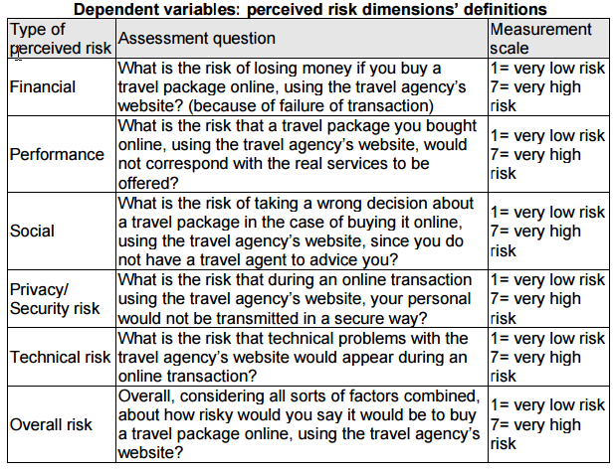

Agency (optional):

Also the travel agency can experiment difficulties .

We have grouped the categories of risks that might concern the travel agencies as it follows:

- organisational risk

- environment risk

- competitiveness risk

- economic risk

- political factors

- infrastructure

- circumstantial risk

- business insufficiencies and specific (local) risk

Factor 1 - Organizational risk (Internal business risk)

-Lack of funding for product development

-Theft in business by tourists and/or staff members

-Lack of proper financial systems

-Insufficient funding for training

-Unable to fulfill needs of tourists

Factor 2 - Environmental (Nature)

-Water pollution

-Air pollution

-Fire

-Natural disasters

-Climate change

Factor 3 - Competitiveness

-The range of products belonging to competitors

-Distance from main competitor

-Prices of competitors

-Technological changes e.g reservation systems, new programs

-Too high prices in tourism industry

-Increase in fuel cost

Factor 4 e Economic risk

-Increase in fuel cost

-Decrease in disposable income

-Inflation

-Cost of transportation

-Interest rates

-Currency fluctuations

Factor 5 - Political factors

-Political instability in neighboring countries

-Legislation

-Terrorist activities

-Political instability in Romania

-Wars/conflicts

Factor 6 - Infrastructure

-Air line safety

-Airport safety and security

-Lack of qualified staff

-Lack of experienced staff

-Road safety

Factor 7 - Circumstantial risk

-Increased competition, (inter) nationally

-Stress

-Decreasing leisure time of tourists

Factor 8 - Business insufficiencies

-Urbanization

-Crime in general

-Repeat business vs new business

-Amount of overtime worked by employees

-Image of the country/destination

-Range of products too limited

-Aging tourist markets

Factor 9 - Specific (local) risk

-Insufficient marketing by local authorities

-Customer complaints

-Carrying capacity (i.e. too many tourists/visitors)

-Diseases

-Seasonality