Planning for provably reliable navigation using an unreliable, nearly sensorless robot

Lewis and O’Kane, IJRR 2013

Quiz by Daniel Bao, Prepared for Dr. Becker’s Robotic Swarm Control Lab

Instructions: Fill in the blanks! Guidelines for grading will be specific enough for differentiation between BS and actual answers

Good luck!

1. (1 Point) What kind of robot is being tested (Sensors and Capabilities)?
   1. (Fill in here)
2. (1 Point) Why is this type of robot good for research (1 Relevant reason required)?
   1. (Fill in here)
3. (2 Points) What is the difference between a point node and a segment node (List as many as you can, only 2 differences are required for maximum points)?
4. (3 Points) Please complete the 3 other angles in the triangle below.
   1. 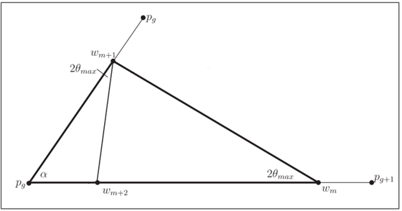
5. (1 Point) How does the robot plan for long, rectangular paths?
   1. (Fill in here)
6. (1 Point) What is a safe action?
   1. (Fill in here)
7. (1 Point) How did the robot get close to the goal in the worst case scenario?
   1. (Fill in here)