School of Engineering and Physical Sciences  Electrical Electronic and Computer Engineering | 

B31XM – Advanced Image Analysis
Programming Assignment 1: Non-linear averaging for image processing
(5% of the final mark, submit your report via Vision by Friday 26 September 2013)

Given an grey-scale image I(x,y), consider the following non-linear iterative process:
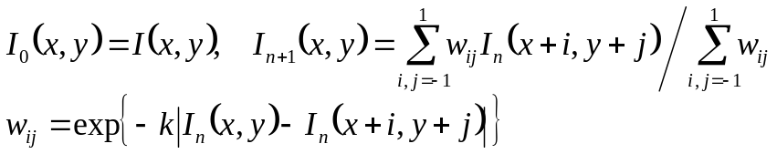
where k is a positive constant. Note that the weights {w_{ij}} depend on the pixel positions (x,y) and the iteration number n. After a certain number of iterations you should get results similar to those shown in the picture below: small-scale image details are removed while salient image edges are sharpened. So it leads to an edge-aware base-detail decomposition of a given image. Here k and the total number of iterations are user-specified parameters.

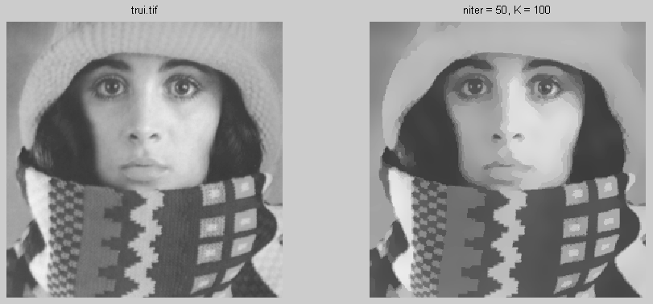

The above non-linear image filtering scheme can be considered as a simplified version of the nonlinear diffusion approach proposed by Pietro Perona and Jitendra Malik [1].

[1] P. Perona and J. Malik, “Scale-space and edge detection using anisotropic diffusion”, IEEE Transactions of Pattern Analysis and Machine Intelligence, Vol. 12, No. 7, July 1990.

Implement the above non-linear iterative image filtering procedure and investigate how it can be used for a better edge detection and image segmentation.

