School of Engineering and Physical Sciences  Electrical Electronic and Computer Engineering | 

B31XM – Advanced Image Analysis
Linear diffusion for signal and image processing

During this lab session, we deal with a simple diffusion equation and its applications for signal/image smoothing.

One can show that the diffusion equation 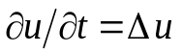can be considered as a gradient descent minimization procedure for the so-called membrane energy
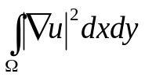
Let us start from applying the diffusion equation to one-dimensional signals. Such 1-D signals can be easily generated from images:
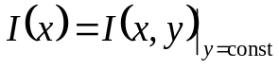

Given a signal I(x), consider its evolution governed by the following equation which is called the heat or diffusion equation
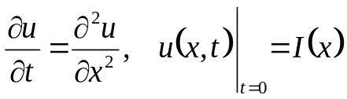
Let us approximate the partial derivatives in the above equation by finite differences:
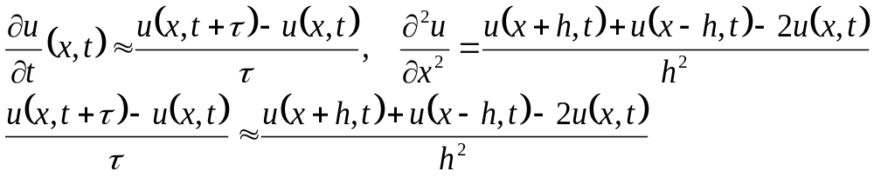
where h and τ are small enough. Let us divide the x-axis by equally spaced nodes a distance h apart and t-axis by equally spaced nodes a distance τ apart. Let
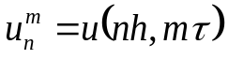
We arrive at a finite difference equation
It turns out that this discrete evolution process is stable when α<1/2 and unstable otherwise.

Task 1. Implement this process for sufficiently small τ (assume that h=1) . Compare the evolution of 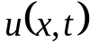 with that obtained by convolving I(x) with a Gaussian.

Task 2. Consider now a similar process applied to a 2-D image I(x,y)
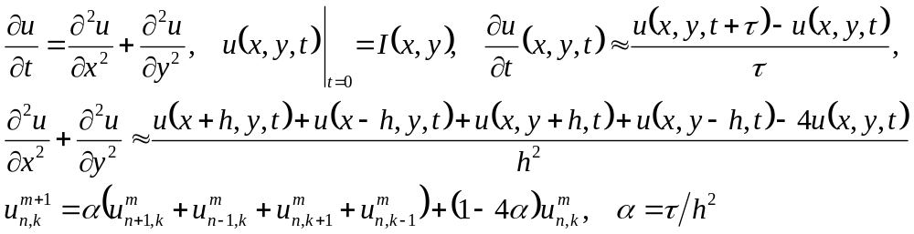
Compare the evolution of 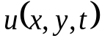 with that obtained by convolving I(x,y) with a Gaussian. You may find that for two-dimensional signals (images), the above discrete evolution process is stable when α<1/4 and unstable otherwise.

Task 3. Consider now the so-called implicit discretization of the heat equaition
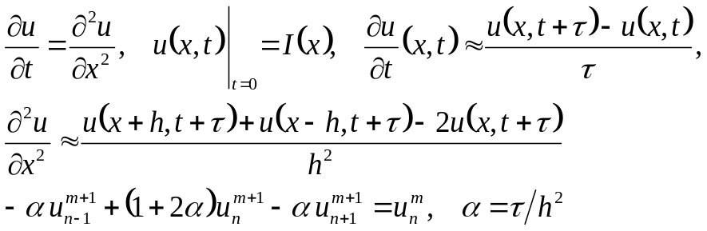
Verify that it approximates convolution with a Gaussian. Check whether it defines to a stable process.

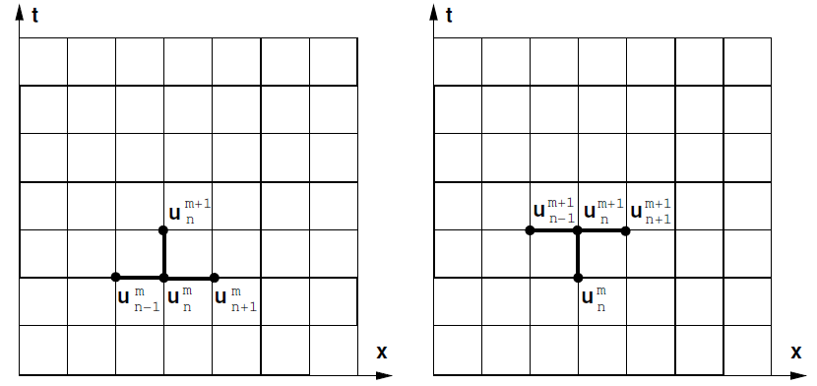
Task 4. Extend the above implicit scheme to images.

