School of Engineering and Physical Sciences  Electrical Electronic and Computer Engineering  B31XM – Advanced Image Analysis: week 10 lab | 

- Adapative image smoothing
Consider a simple gradient descent TV energy minimization procedure tv-diffusion.m. Check whether it gives better results than your implementation of adaptive nonlinear averaging. Try to use various values for the time step-size.

2. Signal and image deblurring
Image deblurring is the problem of recovering a sharp image from its blurry observation.
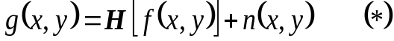The most commonly used mathematical model for blurring image degradation is given by
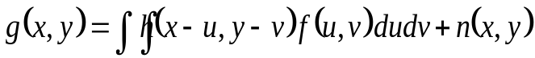Here f (x,y) is the latent (unblurred) image, g(x,y) is the degraded image, H is a linear operator representing the blur, and n stands for an additive noise. Usually H is a convolution and we can write
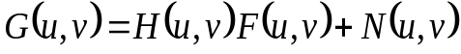Applying the Fourier transform to both sides of this equation yields
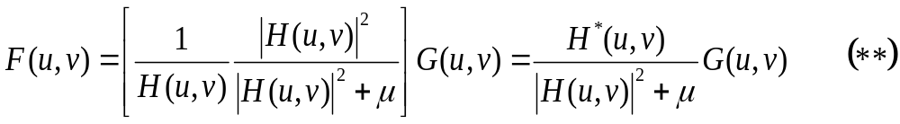A popular deconvolution approach consists of approximating the solution to the above equation by
where μ is a positive constant chosen properly.

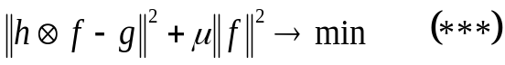It is not difficult to show that the above deconvolution procedure is equivalent to the following energy minimization problem
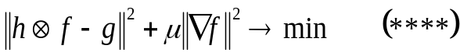where || · || is the standard L² norm: if f=(f₁,f₂,…f_{n}) then || f ||²=| f₁|²+|f₂|²+…+|f_{n} |². In addition to (***) one can consider energy minimization problems
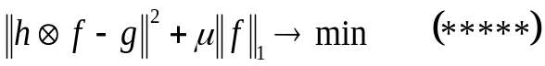and
where || · ||₁ is the so-called L¹ norm: if f=(f₁,f₂,…f_{n}) then || f ||₁=| f₁|+|f₂|+…+|f_{n} |. Energy minimization problem (*****), which can be solved using iterative methods, leads to an efficient restoration of sparse signals.

Play with test_sparse_deblur.m (see also uci_sparse_deblur.pdf) to see how the above energy minimization problems can be used for signal deblurring. Scheck what happens if a sinusoidal signal is considered. Start to work on the 3rd programming assignment.

