School of Engineering and Physical Sciences  Electrical Electronic and Computer Engineering | 

B31XM – Advanced Image Analysis
Programming Assignment 3: Signal and Image Deblurring
(5% of the final mark, submit your report via Vision by Friday 24 October 2014)

Image deblurring is the problem of recovering a sharp image from its blurry observation.
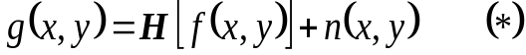The most commonly used mathematical model for blurring image degradation is given by
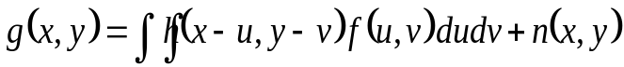Here f (x,y) is the latent (unblurred) image, g(x,y) is the degraded image, H is a linear operator representing the blur, and n stands for an additive noise. Usually H is a convolution and we can write
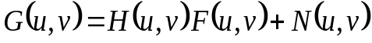Applying the Fourier transform to both sides of this equation yields
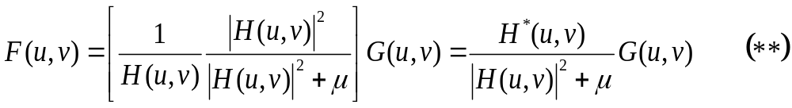A popular deconvolution approach consists of approximating the solution to the above equation by
where μ is a positive constant chosen properly.

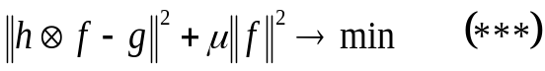It is not difficult to show that the above deconvolution procedure is equivalent to the following energy minimization problem
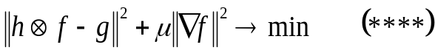where || · || is the standard L² norm. Let us consider a similar variational problem
Energy minimization problem (****) performs image deblurring and can be easily solved in the frequency domain similar to how (***) is solved by (**).

Your tasks.
Implement the image deblurring schemes corresponding to (***) and (****). Use various types of blur (Gaussian blur, motion blur) and noise (weak noise, strong noise). Evaluate your results in terms of reconstruction quality and sensitivity to noise. Compare your results with those obtained using the Richardson-Lucy method (available from Matlab).

Files test_sparse_deblur.m and uci_sparse_deblur.pdf which contain implementations and descriptions of (***) and (****) for 1-D signals should help you with this assignment.

