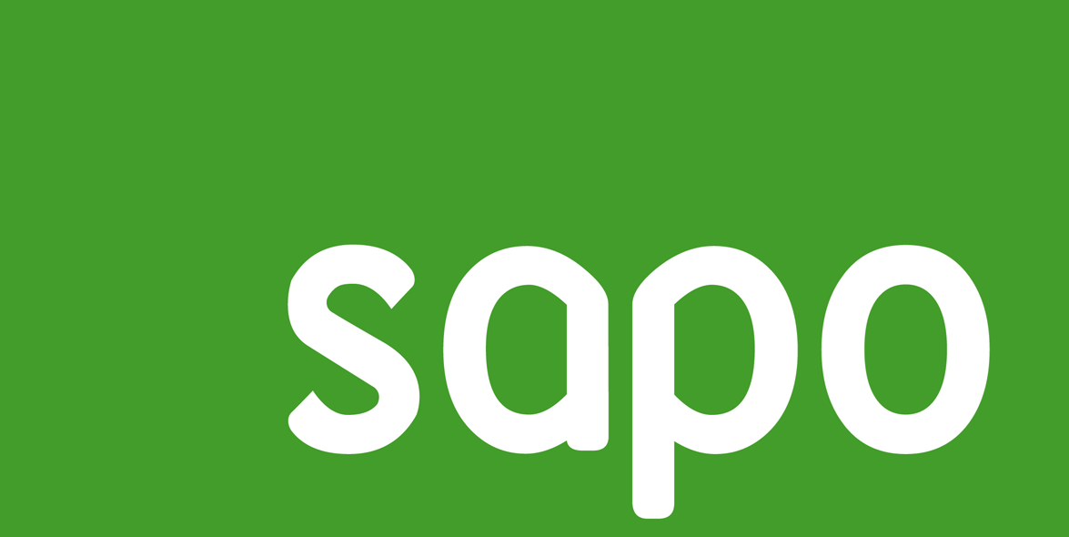

**How to consume SAPO SOAP Services from a Windows 8 App**

**v0.1**

# Introduction

The present document

<http://social.msdn.microsoft.com/Forums/en-US/winappswithcsharp/thread/676f2908-48a7-413e-9340-caa22956363e>