TDDE07_20210603

## Exam TDDE07 20210603 Daniel Bissessar 9811203893 danbi675

#a)  
n <- 100  
sa <- 38  
alpha <- 16  
beta <- 24  
prob <- pbeta(0.4,alpha+sa, beta+n-sa)  
print(c("Posterior probability is ", prob))

## [1] "Posterior probability is " "0.639961700759514"

xgrid <- seq(0,1,0.01)  
toplot <- 1-dbeta(xgrid,alpha+sa, beta+n-sa)  
plot(xgrid,toplot, type = 'l')

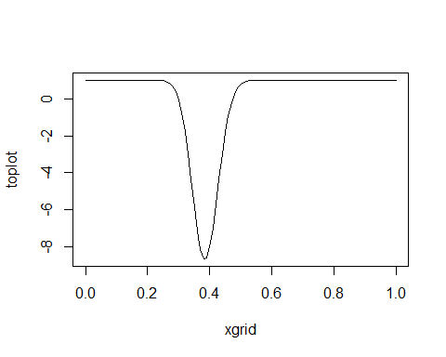

#b)  
draws <- rbeta(10000, alpha+sa, beta+n-sa)  
draws <- (1-draws)/draws  
interval <- quantile(draws, probs = c(0.025,0.975))  
print(interval)

## 2.5% 97.5%   
## 1.139428 2.260659

#The odds of a customer buying product a from the selection are in the interval 1.14:1 to 2,25:1

#c) From exercise session 4  
mlikelihood <- beta(alpha+sa, beta+n-sa)/beta(alpha,beta)  
print(c("Marginal likelihood: ",mlikelihood))

## [1] "Marginal likelihood: " "7.55677069331938e-30"

#d)  
dirichletpar <- c(20+38,20+27,20+35)  
library(DirichletReg)

## Warning: package 'DirichletReg' was built under R version 4.0.5

## Loading required package: Formula

draws <- rdirichlet(10000, dirichletpar)  
prob <- sum(draws[,1]>draws[,3])/10000  
print(c("The posterior probability is :", prob))

## [1] "The posterior probability is :" "0.6056"

#d)  
logpostdist <- function(x,samp) {  
 sampsumsqr <- sum(samp**2)  
 return(dgamma(x,2,rate = sampsumsqr))  
}  
xgrid <- seq(0,1,0.001)  
toplot <- rep(0, length(xgrid))  
count <- 1  
for (i in xgrid) {  
 toplot[count] <- logpostdist(i,sqrt(2.8))  
 count <- count + 1  
}  
plot(xgrid,toplot, type = 'l')  
#e)  
fxtheta <- function(theta, x) {  
 2*theta*x*exp(-theta*x^2)  
}  
approx <- optim(0.5, fxtheta, x = sqrt(2.8), lower = 0.1, method = 'L-BFGS-B', hessian = TRUE, control = list(fnscale=-1))  
count <- 1  
approxplot <- rep(0, length(xgrid))  
for (i in xgrid) {  
 approxplot[count] <- dnorm(i,approx$par,sqrt(-(solve(approx$hessian))))  
 count <- count + 1  
}  
lines(xgrid, approxplot)

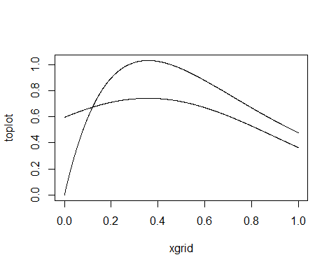

# Reading the data from file  
load(file = 'C:/Users/Daniel Bissessar/Downloads/UniversityEntrance.RData')  
library(geoR)

## Warning: package 'geoR' was built under R version 4.0.5

## --------------------------------------------------------------  
## Analysis of Geostatistical Data  
## For an Introduction to geoR go to http://www.leg.ufpr.br/geoR  
## geoR version 1.8-1 (built on 2020-02-08) is now loaded  
## --------------------------------------------------------------

library(mvtnorm)  
BayesLinReg <- function(y, X, mu_0, Omega_0, v_0, sigma2_0, nIter){  
 # Direct sampling from a Gaussian linear regression with conjugate prior:  
 #  
 # beta | sigma2 ~ N(mu_0, sigma2*inv(Omega_0))  
 # sigma2 ~ Inv-Chi2(v_0,sigma2_0)  
 #  
 # INPUTS:  
 # y - n-by-1 vector with response data observations  
 # X - n-by-nCovs matrix with covariates, first column should be ones if you want an intercept.  
 # mu_0 - prior mean for beta  
 # Omega_0 - prior precision matrix for beta  
 # v_0 - degrees of freedom in the prior for sigma2  
 # sigma2_0 - location ("best guess") in the prior for sigma2  
 # nIter - Number of samples from the posterior (iterations)  
 #  
 # OUTPUTS:  
 # results$betaSample - Posterior sample of beta. nIter-by-nCovs matrix  
 # results$sigma2Sample - Posterior sample of sigma2. nIter-by-1 vector  
   
 # Compute posterior hyperparameters  
 n = length(y) # Number of observations  
 nCovs = dim(X)[2] # Number of covariates  
 XX = t(X)%*%X  
 betaHat <- solve(XX,t(X)%*%y)  
 Omega_n = XX + Omega_0  
 mu_n = solve(Omega_n,XX%*%betaHat+Omega_0%*%mu_0)  
 v_n = v_0 + n  
 sigma2_n = as.numeric((v_0*sigma2_0 + ( t(y)%*%y + t(mu_0)%*%Omega_0%*%mu_0 - t(mu_n)%*%Omega_n%*%mu_n))/v_n)  
 invOmega_n = solve(Omega_n)  
   
 # The actual sampling  
 sigma2Sample = rep(NA, nIter)  
 betaSample = matrix(NA, nIter, nCovs)  
 for (i in 1:nIter){  
   
 # Simulate from p(sigma2 | y, X)  
 sigma2 = rinvchisq(n=1, df=v_n, scale = sigma2_n)  
 sigma2Sample[i] = sigma2  
   
 # Simulate from p(beta | sigma2, y, X)  
 beta_ = rmvnorm(n=1, mean = mu_n, sigma = sigma2*invOmega_n)  
 betaSample[i,] = beta_  
   
 }  
 return(results = list(sigma2Sample = sigma2Sample, betaSample=betaSample))  
}  
#a)  
n <- 10000  
mu0 <- c(0,0,0,0,0,0,0)  
v0 <- 1  
sigma20 <- 4  
omega0 <- 25*diag(7)  
  
  
samps <- BayesLinReg(y,X,mu0,omega0,v0,sigma20,n)  
betas <- samps$betaSample  
b0 <- c(mean(betas[,1]), quantile(betas[,1], probs = c(0.025,0.975)))  
b1 <- c(mean(betas[,2]), quantile(betas[,2], probs = c(0.025,0.975)))  
b2 <- c(mean(betas[,3]), quantile(betas[,3], probs = c(0.025,0.975)))  
b3 <- c(mean(betas[,4]), quantile(betas[,4], probs = c(0.025,0.975)))  
b4 <- c(mean(betas[,5]), quantile(betas[,5], probs = c(0.025,0.975)))  
b5 <- c(mean(betas[,6]), quantile(betas[,6], probs = c(0.025,0.975)))  
b6 <- c(mean(betas[,7]), quantile(betas[,7], probs = c(0.025,0.975)))  
print(c("Beta 0: ", b0))

## 2.5% 97.5%   
## "Beta 0: " "1.04694044181316" "0.897426691756313" "1.19516675512569"

print(c("Beta 1: ", b1))

## 2.5% 97.5%   
## "Beta 1: " "0.510123713633544" "0.354244222698317" "0.664884955912163"

print(c("Beta 2: ", b2))

## 2.5%   
## "Beta 2: " "0.207783071897359" "0.0843370759000889"   
## 97.5%   
## "0.331257597432662"

print(c("Beta 3: ", b3))

## 2.5%   
## "Beta 3: " "0.22692250763477" "-0.036403996116405"   
## 97.5%   
## "0.492287321008506"

print(c("Beta 4: ", b4))

## 2.5%   
## "Beta 4: " "0.0865530366427908" "-0.100619103282906"   
## 97.5%   
## "0.27803039420171"

print(c("Beta 5: ", b5))

## 2.5%   
## "Beta 5: " "0.101021803416884" "-0.160555648015241"   
## 97.5%   
## "0.359951612938553"

print(c("Beta 6: ", b6))

## 2.5%   
## "Beta 6: " "-0.0508552213614252" "-0.239726977339611"   
## 97.5%   
## "0.140132684097251"

#The strictly positive values for the interval of beta1 can be interpreted as verbal IQ being a factor that increases the score on a university exam

#b)  
postmed <- median(samps$sigma2Sample)  
print(postmed)

## [1] 0.6673574

#c) to compare these we can compare the distributions for beta5 and beta6 with a Z-test to see if they have the same distribution  
beta5mean <- mean(betas[,6])  
beta6mean <- mean(betas[,7])  
sdbeta5 <- sd(betas[,6])  
sdbeta6 <- sd(betas[,7])  
z <- (beta5mean-beta6mean)/sqrt(sdbeta5**2+sdbeta6**2)  
print(z)

## [1] 0.924068

#since z < 2 we cannot say that beta5 and beta6 are different

#d)  
gridstep <- 0.01  
start <- min(X[,2])  
stop <- max(X[,2])  
grid <- seq(start,stop,gridstep)   
known <- c(0.5,0,0)  
probFunc1 <- function(grid, x){  
 y = betas[,1] + betas[,2]*grid + betas[,3]*x[1] + betas[,4]*x[2] + betas[,5]*x[3] + betas[,6]*grid*x[2] + betas[,7]*grid*x[3]  
 quants <- quantile(y, probs = c(0.05,0.95))  
 return(c(mean(y),quants[1],quants[2]))  
}  
q <- matrix(0, length(grid), 3)  
count <- 1  
for (i in grid) {  
 q[count,] <- probFunc1(i,known)  
 count <- count + 1  
}  
plot(grid,q[,1], type = 'l')  
lines(grid,q[,2], col = 2)  
lines(grid,q[,3], col = 2)

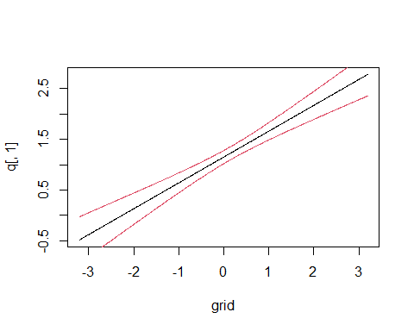

#e)  
student <- c(0.4,1,1,0)  
  
probFunc2 <- function(x, n){  
 be <- rmvnorm(n, c(mean(betas[,1]),mean(betas[2]),mean(betas[,3]),mean(betas[,4]),mean(betas[,5]),mean(betas[,6]),mean(betas[,7]), postmed))  
 y = be[,1] + be[,2]*x[1] + be[,3]*x[2] + be[,4]*x[3] + be[,5]*x[4] + be[,6]*x[1]*x[3] + be[,7]*x[1]*x[4]  
   
 return(y)  
}  
probsstudent <- probFunc2(student, n)  
hist(probsstudent, freq = F)

