Name: Daniel Boktor
Date: April 22, 2023
08.07 Picture Lab Worksheet
Directions: Make note of your responses to the following questions as you work through the activities and exercise in the lesson.
Activity 5 Questions
Question | Yes | No
- Is the method getPixels2D in the Picture.java class? |  | No
- Is the method getPixels2D in the SimplePicture.java class? | Yes
- Will the following code compile?  DigitalPicture p = new DigitalPicture(); |  | No
- Assuming a no-argument constructor exists for SimplePicture, will the following code compile?  DigitalPicture p = new SimplePicture(); | Yes
- Assuming a no-argument constructor exists for Picture, will the following code compile?  DigitalPicture p = new Picture(); | Yes
- Assuming a no-argument constructor exists for Picture, will the following code compile?  SimplePicture p = new Picture(); | Yes
- Assuming a no-argument constructor exists for SimplePicture, will the following code compile?  Picture p = new SimplePicture(); |  | No

Activity 5 Exercise Results

- Describe your method for keepOnly red, blue, or green.
My keepOnly method sets all colors bar the one in the header equal to 0.

- For the negate method, paste your code related to calculating and setting the
values for red, blue, and green.
public void grayscale(){
- Pixel[][] pixels = this.getPixels2D();
- for (Pixel[] rowArray : pixels)
- {
- for (Pixel pixelObj : rowArray)
- {
- int mean = (((int)(pixelObj.getBlue()+pixelObj.getRed()+pixelObj.getGreen()))/3);
- pixelObj.setGreen(mean);
- pixelObj.setBlue(mean);
- pixelObj.setRed(mean);
- }
- }
- }

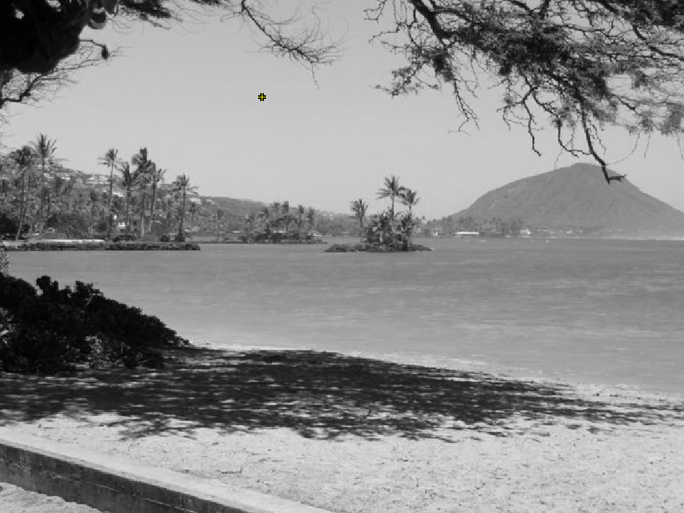
- Paste a copy of the image that is the result of calling the grayscale.

- For the method fixUnderwater, describe the algorithm you'd propose to accomplish the task.
I would first manually find the rows and columns that the fish belong to, and then brighten those pixels. I would most likely do this by finding the mean of the pixels, and then adding it to each pixel.
Activity 6 Exercise Results
- Paste the image that is the result of calling the method mirrorVerticalRightToLeft.
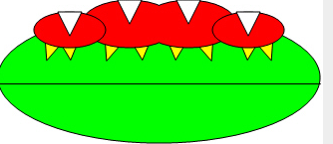
- Describe the algorithm for the method mirrorHorizontal works.
MirrorHorizontal works by first defining a base pixel or the top, then finding the corresponding bottom pixel, and then setting the bottom pixel’s color to that of the top pixel. The bottom of the image is made into a copy of the top, and thus, the original bottom is erased from the image.

- Paste the image that is the result of calling the method mirrorHorizontalBotToTop.
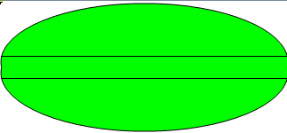
Activity 7 Questions
  - How many times would the body of this nested for loop execute? _90__
for(int row = 7; row < 17; row++)
for(int col = 6; col < 15; col++)
  - How many times would the body of this nested for loop execute? 112___
for(int row = 5; row <= 11; row++)
for(int col = 3; col <= 18; col++)

Activity 7 Exercise Results

- What value is displayed for count after the nested loop ends in the mirrorTemple method?
18410
- Paste the image that is the result of calling the method mirrorArms.

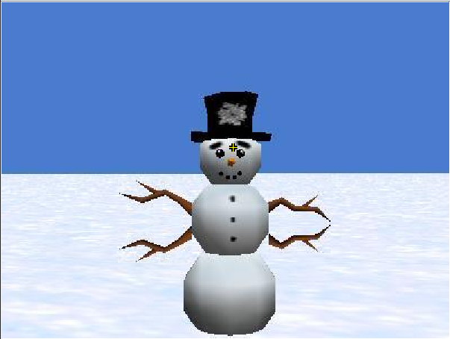

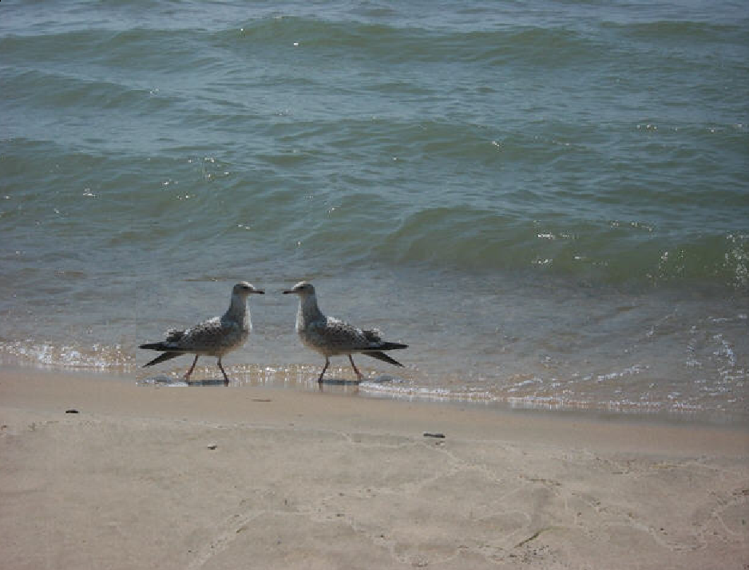
Paste the image that is the result of calling the method mirrorGull.

