Container Build Platform
A Step-by-Step, Low-Level Tutorial
Enterprise Container Factory — DevSecOps Build Pipeline
Docker · GitHub Actions · Trivy · AWS ECR · Cosign · Terraform

Domain 1 (DevOps) — Project 3
Author: Olalekan Gabriel Ogundare
Repository: github.com/danielblakeman10/Container-Build-Platform

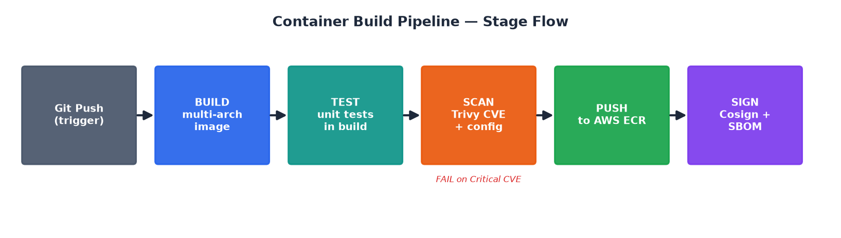
Figure 0 — The end-to-end pipeline you will build in this tutorial.

What This Tutorial Covers
This document walks you through the Container Build Platform from absolute zero to a working, secure, automated container build-and-publish pipeline. Every section explains not just WHAT to type, but WHY it works that way at a low level — what each tool does under the hood, what the security trade-offs are, and how the pieces fit together. The code shown is the actual code in your repository.
- Part 1 — Concepts & Mental Model (what a 'build platform' really is)
- Part 2 — Prerequisites & Local Environment Setup
- Part 3 — The Multi-Stage Dockerfile (line by line)
- Part 4 — Building & Testing Locally
- Part 5 — Image Tagging Strategy & the helper scripts
- Part 6 — Vulnerability Scanning with Trivy
- Part 7 — The GitHub Actions CI Pipeline (job by job)
- Part 8 — AWS Setup: IAM, ECR, S3 & Secrets
- Part 9 — Pushing to ECR & the CodeBuild alternative
- Part 10 — Image Signing & SBOMs with Cosign
- Part 11 — Image Lifecycle Management & Cleanup
- Part 12 — Infrastructure as Code (Terraform)
- Part 13 — End-to-End Run-Through & Verification
- Appendix A — Troubleshooting
- Appendix B — Glossary

Part 1 — Concepts & Mental Model

1.1 What problem does this platform solve?
Imagine ten different teams each writing their own way to build a Docker image, tag it, scan it for security holes, and push it to a registry. You get ten inconsistent, often insecure pipelines. A Container Build Platform (sometimes called an “Enterprise Container Factory”) centralizes that into one reusable, audited, secure path that every team plugs into.
Your platform takes source code and produces a signed, scanned, versioned container image sitting safely in a private registry — automatically, on every push. Nothing reaches production without passing through the same gates.

1.2 The core vocabulary
Term | Plain-English meaning
Image | A frozen, read-only template containing your app + everything it needs to run.
Container | A running instance of an image (like a process started from a program).
Registry | A storage server for images. AWS ECR is Amazon's private registry.
Layer | A cached filesystem diff. Each Dockerfile instruction creates one.
Multi-stage | Using throwaway build stages so the final image stays tiny & clean.
CI/CD | Continuous Integration / Delivery — automation that builds & ships on every push.
CVE | A publicly catalogued security vulnerability (Common Vulnerabilities & Exposures).
SBOM | Software Bill of Materials — a manifest of everything inside your image.
Signing | Cryptographically proving an image is authentic and untampered.

1.3 The six pipeline stages
Everything in this project maps to six conceptual stages. Keep this picture in your head for the rest of the tutorial:

Figure 1 — Build → Test → Scan → Push → Sign, triggered by a git push.
# | Stage | Tool | Gate
1 | Build | Multi-stage Dockerfile + Buildx | Required
2 | Test | Unit/integration tests in build | Required
3 | Scan | Trivy (CVE + misconfig) | WARN on High, FAIL on Critical
4 | Push | AWS ECR | Required
5 | Sign | Cosign / Notary + SBOM | Recommended
6 | Cleanup | ECR lifecycle policy | Scheduled

Part 2 — Prerequisites & Local Environment Setup

2.1 Tools you need installed
Tool | Version | Why
Docker | 24.0+ | Builds and runs containers. Needs BuildKit (default in 24+).
AWS CLI | v2 | Talks to ECR, S3, IAM from your terminal.
Git | any recent | Version control + the SHA tags your scripts generate.
Trivy | latest | Local vulnerability scanning (optional but recommended).
Cosign | v2.2+ | Image signing (optional, for the signing stage).
[i] NOTE On your Windows machine, run these in Git-Bash so the shell scripts (.sh files) work. Docker Desktop must be running before any docker command.

2.2 Verify your setup
Run each of these. Every command should print a version, not an error:
docker --version # Docker version 24.x or higher
docker buildx version # buildx is what enables multi-arch builds
aws --version # aws-cli/2.x
git --version
trivy --version # optional
cosign version # optional

2.3 Clone the repository
git clone https://github.com/danielblakeman10/Container-Build-Platform.git
cd Container-Build-Platform
Take a moment to look at the folder structure — each folder has a single, clear responsibility:
Folder | Contains | Covered in
dockerfiles/ | The multi-stage Dockerfile template + compose | Part 3
.github/workflows/ | ci.yml, ecr.yml, signing.yml pipelines | Parts 7,10,11
.github/scripts/ | parse-version, image-tagging, cleanup-ecr | Parts 5,11
.github/codebuild-spec.yml | AWS-native build alternative | Part 9
terraform/ | ECR + lifecycle infrastructure as code | Part 12
registry/ | ECR lifecycle policy JSON | Part 11
examples/ | Sample apps to actually build | Part 4

Part 3 — The Multi-Stage Dockerfile (Line by Line)
This is the heart of the platform. Open dockerfiles/Dockerfile. We'll dissect every instruction and explain what Docker does internally for each.

3.1 Why multi-stage at all?
A naive Dockerfile ships the compiler, source code, and build tools to production. That bloats the image (hundreds of MB) and hands attackers a toolbox. Multi-stage builds use temporary stages to compile, then copy ONLY the finished binary into a tiny final image. Everything else is thrown away.
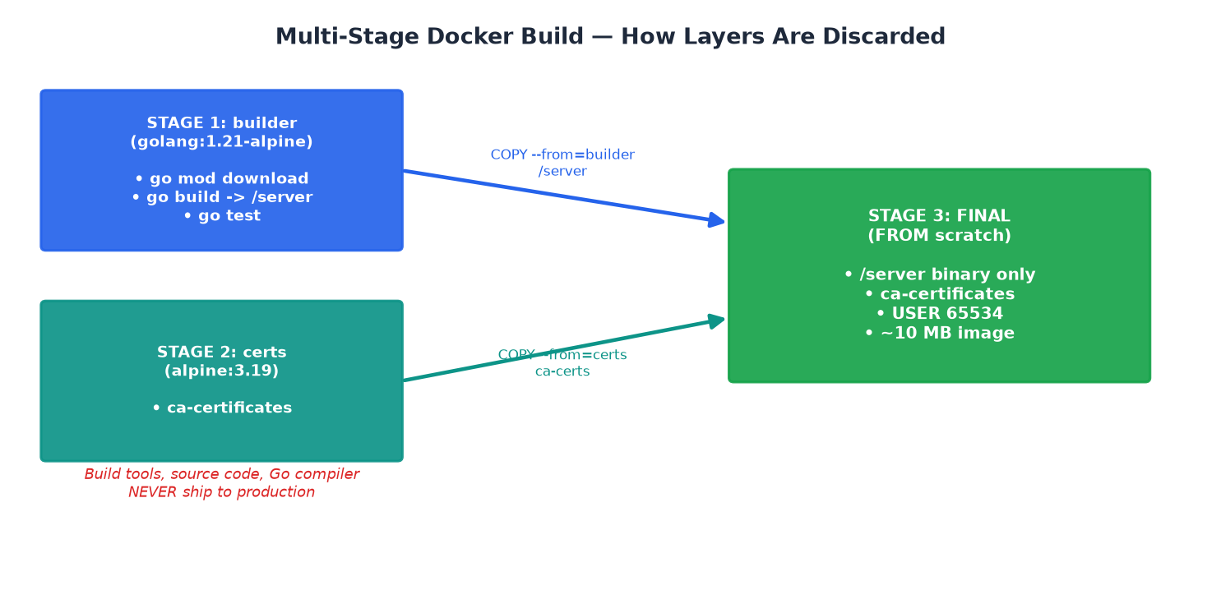
Figure 2 — Build artifacts are copied forward; build tooling is discarded.

3.2 Stage 1 — the builder
FROM --platform=$BUILDPLATFORM golang:1.21-alpine AS builder
RUN apk add --no-cache git ca-certificates
WORKDIR /app
COPY go.mod go.sum ./
RUN go mod download && go mod verify
COPY . .
RUN CGO_ENABLED=0 GOOS=linux \
go build -ldflags="-w -s -trimpath" -o /server .
RUN CGO_ENABLED=0 GOOS=linux go test -v -cover ./...
- FROM ... AS builder — names this stage so later stages can copy from it. $BUILDPLATFORM lets Buildx build natively for the host arch then cross-compile.
- apk add --no-cache — Alpine's package manager; --no-cache avoids leaving an index behind (smaller layer, nothing to clean up).
- COPY go.mod go.sum first, THEN run download — this is deliberate layer caching. Dependencies change rarely; source changes often. By copying just the module files first, Docker reuses the cached dependency layer until go.mod itself changes — builds become dramatically faster.
- CGO_ENABLED=0 — disables C bindings so Go produces a fully static binary with no shared-library dependencies. This is what lets us later run on 'scratch' (an empty image with no libc at all).
- -ldflags="-w -s -trimpath" — -w/-s strip debug symbols (smaller binary, less info for an attacker); -trimpath removes local filesystem paths from the binary.
- Tests run inside the build — if a test fails, the image never gets built. The build itself is your first quality gate.

3.3 Stage 2 — certificates
FROM alpine:3.19 AS certs
RUN apk --update add ca-certificates
A separate tiny stage whose only job is to provide the TLS root certificates your app needs to make HTTPS calls. Isolating it keeps the final image minimal and the intent clear.

3.4 Stage 3 — the production image
FROM scratch
COPY --from=certs /etc/ssl/certs/ca-certificates.crt /etc/ssl/certs/
COPY --from=builder /server /server
USER 65534:65534
HEALTHCHECK --interval=30s --timeout=3s --start-period=5s --retries=3 \
CMD ["/server", "/health"]
EXPOSE 8080
ENTRYPOINT ["/server"]
- FROM scratch — the empty base image. Zero OS, zero shell, zero package manager. Smallest possible attack surface. Only your static binary + certs exist.
- COPY --from=... — pulls exactly two artifacts forward from the earlier stages. Nothing else from those stages survives.
- USER 65534:65534 — the 'nobody' user. The container runs unprivileged, so even if compromised, the process has no root rights.
- HEALTHCHECK — Docker/orchestrators periodically run this; a failing health check marks the container unhealthy and can trigger a restart.
- ENTRYPOINT (exec form) — the JSON-array form runs the binary directly as PID 1 without a shell wrapper, so signals (SIGTERM on shutdown) reach your app cleanly.
[!] PITFALL Because 'scratch' has no shell, you cannot 'docker exec' a bash session into this container to debug it. For debugging, build the 'builder' target instead (see the dev compose file in Part 4).

Part 4 — Building & Testing Locally

4.1 A simple build
# from the repo root
docker build -t myapp:latest -f dockerfiles/Dockerfile .
- -t myapp:latest — tags (names) the resulting image.
- -f dockerfiles/Dockerfile — path to the Dockerfile.
- . (the final dot) — the build context: the directory Docker sends to the builder. .dockerignore controls what gets excluded.

4.2 Multi-architecture builds with Buildx
Real platforms serve both Intel/AMD (amd64) and ARM (arm64, e.g. Apple Silicon, AWS Graviton). Buildx + QEMU emulation builds both from one machine:
docker buildx create --use --name multiarch
docker buildx build \
--platform linux/amd64,linux/arm64 \
-t myapp:latest \
-f dockerfiles/Dockerfile \
--load .
[i] NOTE --load only works for a single platform locally; to keep BOTH architectures you --push to a registry, which stores them under one tag as a 'manifest list'. The CI pipeline does exactly this.

4.3 The development compose file
dockerfiles/docker-compose.dev.yml targets the 'builder' stage (which has a shell and tools) and mounts your source as a volume for fast local iteration:
services:
app:
build:
context: ..
dockerfile: dockerfiles/Dockerfile
target: builder # <- the debuggable stage
ports: ["8080:8080"]
environment:
- ENVIRONMENT=development
- LOG_LEVEL=debug
volumes:
- ../:/app
docker compose -f dockerfiles/docker-compose.dev.yml up --build

Part 5 — Image Tagging Strategy
A tag is a human-friendly pointer to an image digest (a sha256 hash). The same image gets MULTIPLE tags so different consumers can refer to it the way that suits them.
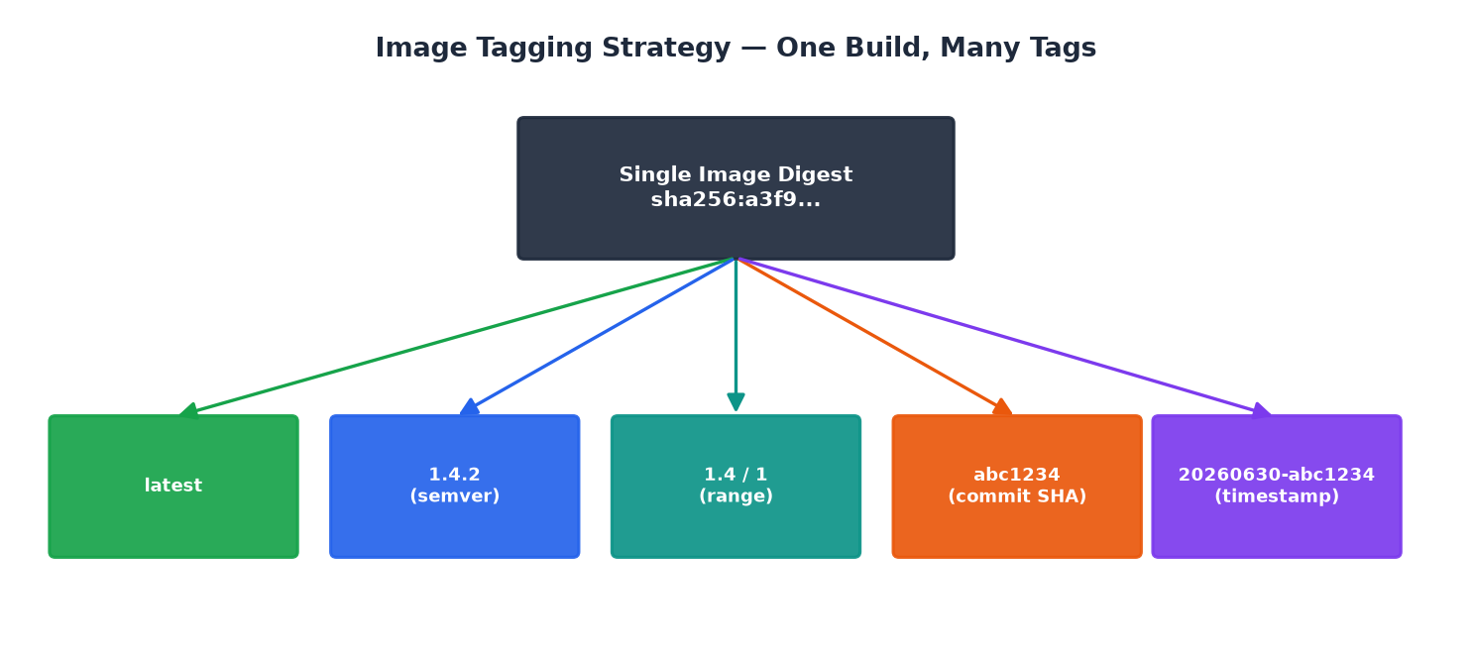
Figure 3 — One immutable digest, many tags pointing at it.
Tag type | Example | Use case
latest | myapp:latest | Dev — always newest on main
semver | myapp:1.4.2 | Production releases (immutable)
range | myapp:1.4 / myapp:1 | Staging — newest patch in a line
commit SHA | myapp:abc1234 | Reproducible / traceable builds
timestamp | myapp:20260630-abc1234 | Audit trail

5.1 parse-version.sh — extracting a semantic version
REF="${1:-$(git describe --tags --always --abbrev=7 ...)}"
REF="${REF#v}" # strip leading 'v'
if [[ "$REF" =~ ^([0-9]+)\.([0-9]+)\.([0-9]+)$ ]]; then
echo "$REF"; exit 0 # it's a clean semver tag
fi
echo "0.0.0-dev-$(git rev-parse --short HEAD)" # fallback
This reads the latest git tag. If it looks like 1.4.2 it returns it; otherwise it produces a safe dev version stamped with the commit SHA. The regex with BASH_REMATCH is how bash captures the major/minor/patch groups.

5.2 image-tagging.sh — generating all the tags
SHA=$(git rev-parse --short HEAD)
DATE=$(date +%Y%m%d)
VERSION=$(git describe --tags --abbrev=0 | sed 's/^v//' || echo 0.0.0)
case "$TAG_TYPE" in
semver) tags+=("$IMAGE:$VERSION")
tags+=("$IMAGE:${VERSION%.*}") # 1.4 (strip .patch)
tags+=("$IMAGE:${VERSION%%.*}") # 1 (strip .minor.patch)
esac
- ${VERSION%.*} — bash parameter expansion: remove the shortest trailing '.*', turning 1.4.2 into 1.4.
- ${VERSION%%.*} — remove the longest trailing '.*', turning 1.4.2 into 1.
[!] BUG SPOTTED In your image-tagging.sh the 'case' has 'all|latest' first AND 'semver|all' second. Because bash 'case' stops at the first match, the 'all' option only ever hits the latest branch — semver/sha/timestamp tags are skipped when TAG_TYPE=all. Fix: give 'all' its own branch that appends every tag type, or remove 'all' from the latest line. (See Appendix A.)

Part 6 — Vulnerability Scanning with Trivy
Trivy inspects your image's OS packages and language dependencies against CVE databases, and also checks for misconfigurations. It is the security gate of the pipeline.

6.1 Local scan
trivy image myapp:latest
# only fail on the serious stuff:
trivy image --severity HIGH,CRITICAL --ignore-unfixed myapp:latest
- --ignore-unfixed — skip CVEs that have no patch available yet (you can't fix them, so don't fail the build on them).
- --severity — which levels to report.

6.2 The gating philosophy
Your README defines the policy: WARN on High, FAIL on Critical. This is the pragmatic middle ground — criticals block the release; highs are surfaced but don't halt everything. In ci.yml this maps to two Trivy steps: one uploads a full SARIF report (exit-code 0, never blocks) for the GitHub Security tab, and a second config scan with exit-code 1 that actually fails the job.
- name: Run Trivy vulnerability scanner
uses: aquasecurity/trivy-action@master
with:
image-ref: '${{ env.REGISTRY }}/${{ env.IMAGE_NAME }}:${{ github.sha }}'
format: 'sarif'
output: 'trivy-results.sarif'
severity: 'CRITICAL,HIGH,MEDIUM'
exit-code: '0' # report only, never blocks

Part 7 — The GitHub Actions CI Pipeline
Open .github/workflows/ci.yml. This is the automation that ties everything together. We'll go job by job.
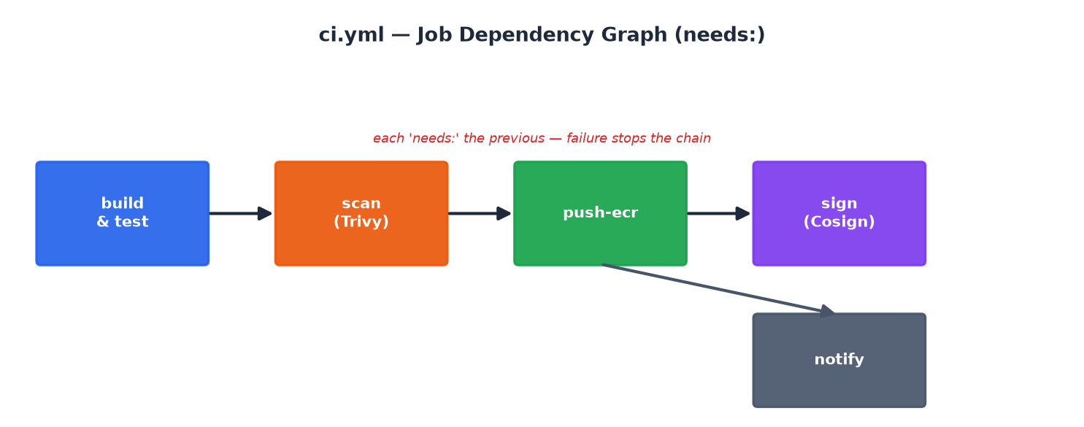
Figure 4 — Jobs chained with 'needs:'. A failure stops everything downstream.

7.1 Triggers, env, and permissions
on:
push:
branches: [main, master]
tags: ['v*']
pull_request:
branches: [main, master]
env:
REGISTRY: ghcr.io
IMAGE_NAME: ${{ github.repository }}
BUILD_PLATFORMS: linux/amd64,linux/arm64
permissions:
contents: read
packages: write
security-events: write
- on.push.tags ['v*'] — pushing a tag like v1.4.2 triggers a release build.
- permissions — least privilege for the workflow token: read code, write packages, upload security results. Nothing more.

7.2 Job 1 — build (and test)
Sets up QEMU + Buildx (multi-arch), computes all tags with docker/metadata-action, logs in, then builds and pushes:
- uses: docker/metadata-action@v5
with:
tags: |
type=sha,prefix=,format=long
type=semver,pattern={{version}}
type=semver,pattern={{major}}.{{minor}}
type=raw,value=latest,enable={{is_default_branch}}
- uses: docker/build-push-action@v5
with:
platforms: ${{ env.BUILD_PLATFORMS }}
push: ${{ github.event_name != 'pull_request' }}
cache-from: type=gha
cache-to: type=gha,mode=max
provenance: mode=max
sbom: true
- push only when NOT a pull_request — PRs build to validate but never publish. This prevents untrusted PR code from pushing images.
- cache-from/to: type=gha — uses GitHub's cache so layers persist between runs.
- provenance + sbom — generates supply-chain attestations automatically.

7.3 Job 2 — scan
needs: [build]. Runs the two Trivy steps from Part 6 and uploads SARIF to the Security tab.

7.4 Job 3 — push-ecr
needs: [build, scan] and only runs on non-PR events. Configures AWS credentials, logs in to ECR, retags the image for ECR, pushes, generates an SBOM, and uploads it to S3. Uses the 'production' GitHub Environment so you can require approvals.

7.5 Job 4 — sign
needs: [push-ecr]. Installs Cosign and signs the pushed image (Part 10).

7.6 Job 5 — notify
if: always(). Writes a markdown summary table of every job's result to the run summary so you get a one-glance status report.
[!] BUG SPOTTED In the push-ecr 'docker tag' lines, the latest tag uses $ECR_REPO/$ECR_REPO:latest instead of $ECR_REGISTRY/$ECR_REPO:latest. The push target is correct but the tag source is malformed — the latest push will fail. Fix in Appendix A.

Part 8 — AWS Setup: IAM, ECR, S3 & Secrets
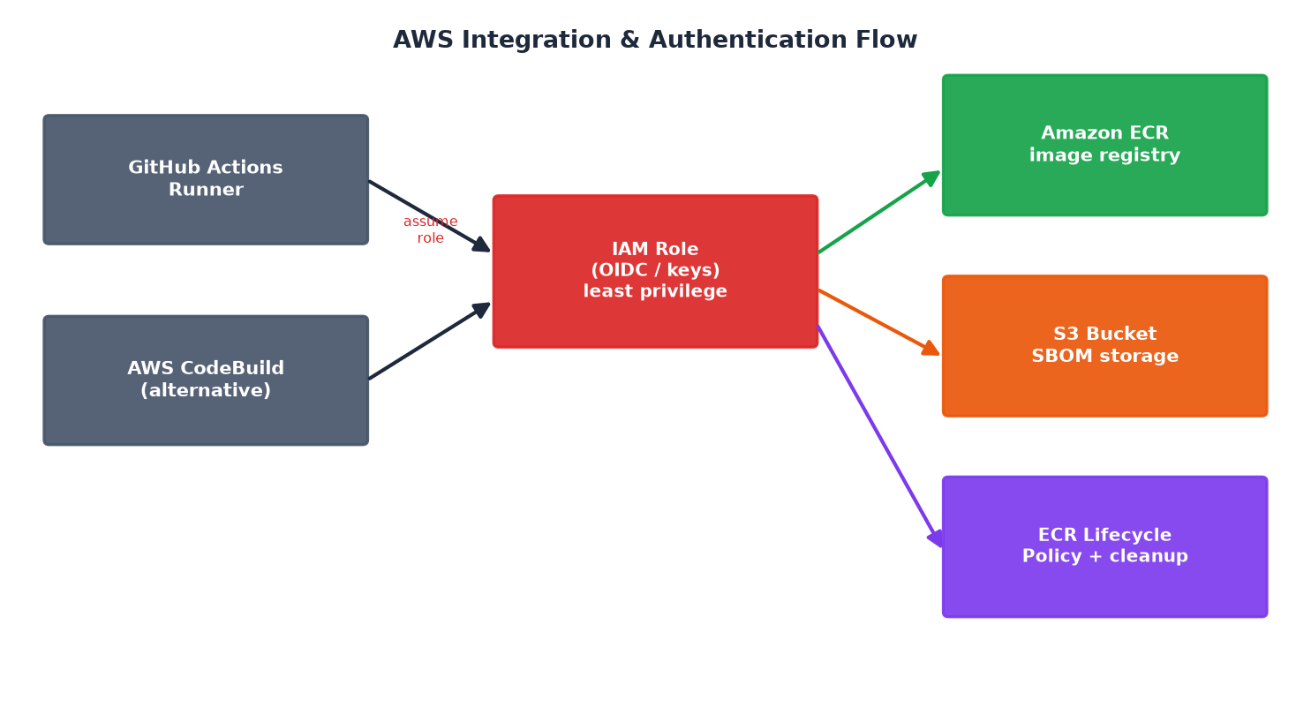
Figure 5 — How the pipeline authenticates to and uses AWS services.

8.1 Create the ECR repository
aws ecr create-repository \
--repository-name myapp \
--image-scanning-configuration scanOnPush=true \
--region us-east-1
- scanOnPush=true — ECR runs its own basic scan on every push (defense in depth alongside Trivy).

8.2 The IAM permissions the pipeline needs
Create an IAM role/user with a least-privilege policy. The pipeline must be able to authenticate to ECR, push images, write SBOMs to S3, and manage lifecycle:
{
"Version": "2012-10-17",
"Statement": [
{"Effect":"Allow",
"Action":["ecr:GetAuthorizationToken"],
"Resource":"*"},
{"Effect":"Allow",
"Action":["ecr:BatchCheckLayerAvailability",
"ecr:PutImage","ecr:InitiateLayerUpload",
"ecr:UploadLayerPart","ecr:CompleteLayerUpload",
"ecr:BatchDeleteImage","ecr:PutLifecyclePolicy"],
"Resource":"arn:aws:ecr:us-east-1:<ACCOUNT_ID>:repository/myapp"},
{"Effect":"Allow",
"Action":["s3:PutObject"],
"Resource":"arn:aws:s3:::<SBOM_BUCKET>/*"}
]
}
[+] BEST PRACTICE Prefer GitHub OIDC over long-lived AWS keys: GitHub mints a short-lived token per run and assumes the role, so there are no static secrets to leak. Your sister 3-tier project already uses OIDC — reuse that pattern here.

8.3 The GitHub Secrets you must set
Repository → Settings → Secrets and variables → Actions. ci.yml references all of these:
Secret | Purpose
AWS_ACCESS_KEY_ID | AWS auth (or use OIDC role instead)
AWS_SECRET_ACCESS_KEY | AWS auth secret
AWS_REGION | e.g. us-east-1
ECR_REGISTRY | <account>.dkr.ecr.<region>.amazonaws.com
ECR_REPO | Repository name, e.g. myapp
SBOM_BUCKET | S3 bucket name for SBOM storage
COSIGN_YAML | Cosign signing config/key material
SECURITY Never hardcode these in the YAML. They are injected as masked environment values at run time — this is the 'security tool / secrets in an env var' requirement from your project brief.

Part 9 — Pushing to ECR & the CodeBuild Alternative

9.1 Manual push (understand what CI automates)
aws ecr get-login-password --region us-east-1 | \
docker login --username AWS --password-stdin \
<account>.dkr.ecr.us-east-1.amazonaws.com
docker tag myapp:latest \
<account>.dkr.ecr.us-east-1.amazonaws.com/myapp:1.4.2
docker push <account>.dkr.ecr.us-east-1.amazonaws.com/myapp:1.4.2
get-login-password returns a temporary token; piping it into docker login authenticates without storing credentials on disk.

9.2 The CodeBuild alternative (.github/codebuild-spec.yml)
Your project brief asks to 'build using EC2 and put it in the container'. AWS CodeBuild runs your build on AWS-managed EC2 compute. The buildspec mirrors the CI pipeline in three phases:
version: 0.2
phases:
pre_build:
commands:
- aws ecr get-login-password --region $AWS_REGION | \
docker login --username AWS --password-stdin $ECR_REGISTRY
- COMMIT_HASH=$(echo $CODEBUILD_RESOLVED_SOURCE_VERSION | cut -c 1-7)
- IMAGE_TAG=${COMMIT_HASH}
build:
commands:
- docker build --platform linux/amd64,linux/arm64 \
--cache-from $ECR_REGISTRY/$ECR_REPO:latest \
-t $ECR_REGISTRY/$ECR_REPO:$IMAGE_TAG -f dockerfiles/Dockerfile .
post_build:
commands:
- trivy image --severity HIGH,CRITICAL $ECR_REGISTRY/$ECR_REPO:$IMAGE_TAG
- docker push $ECR_REGISTRY/$ECR_REPO:$IMAGE_TAG
- pre_build — authenticate + compute the tag from the commit hash CodeBuild exposes in $CODEBUILD_RESOLVED_SOURCE_VERSION.
- build — the docker build, reusing :latest as a cache source for speed.
- post_build — scan, then push. Artifacts (image-listing.json) are exported.
[i] NOTE GitHub Actions and CodeBuild are two front-ends to the SAME Dockerfile and scanning logic. Pick one as primary; the other demonstrates portability.

Part 10 — Image Signing & SBOMs with Cosign

10.1 Why sign?
A signature cryptographically proves an image came from your pipeline and hasn't been tampered with since. Combined with an SBOM (the ingredient list), you get supply-chain integrity — a core DevSecOps requirement.

10.2 signing.yml — triggered after a successful build
on:
workflow_run:
workflows: ["Container Build Pipeline"]
types: [completed]
jobs:
sign-image:
if: ${{ github.event.workflow_run.conclusion == 'success' }}
It looks up the freshly pushed image's digest (signing by digest, not tag, is the secure way — tags can move, digests cannot), then:
IMAGE="$ECR_REGISTRY/$ECR_REPO@$DIGEST"
cosign sign --yes "$IMAGE"
trivy image --format spdx-json --output sbom.spdx.json "$IMAGE"
cosign attach sbom --sbom sbom.spdx.json --type spdx "$IMAGE"

10.3 Verifying a signature
cosign verify --key cosign.pub \
<account>.dkr.ecr.us-east-1.amazonaws.com/myapp@sha256:...
[!] PITFALL Signing by tag is unsafe — always sign and verify by @sha256 digest, which is exactly what signing.yml does.

Part 11 — Image Lifecycle Management & Cleanup
Registries fill up fast and storage costs money. Two mechanisms keep ECR tidy: a declarative lifecycle policy (ECR enforces it) and an imperative cleanup script (for finer control).

11.1 The lifecycle policy (registry/lifecycle-policy.json)
Priority | Rule
1 | Keep only the most recent 30 images; expire the rest
2 | Expire 'latest'-prefixed images older than 90 days
3 | Delete untagged images older than 7 days
ecr.yml applies it on a daily schedule (cron '0 2 * * *') with aws ecr put-lifecycle-policy.

11.2 cleanup-ecr.sh — the imperative cleaner
images=$(aws ecr list-images --repository-name "$ECR_REPO" \
--query 'images[*] | sort_by(@, &imagePushTime)' --output json)
# Strategy 1: remove untagged images older than 7 days
# Strategy 2: if total > MAX_IMAGES, remove the oldest overflow
aws ecr batch-delete-image --repository-name "$ECR_REPO" \
--image-ids imageDigest="$digest"
- sort_by(@, &imagePushTime) — a JMESPath query that sorts images oldest-first so the script can target the oldest for deletion.
- DRY_RUN flag — the 4th argument; when 'true' the script reports what it WOULD delete without deleting. ecr.yml defaults dry_run to 'true' — a safety net.
[+] BEST PRACTICE Always run cleanup with DRY_RUN=true first and read the output before doing a real deletion. Deletions are irreversible.

Part 12 — Infrastructure as Code (Terraform)
Rather than clicking in the AWS console, define the ECR repo and its lifecycle policy as code in terraform/modules/ecs-builder/. This satisfies the 'IaC' requirement and makes the infra reproducible and reviewable.

12.1 A minimal ECR module
# main.tf
resource "aws_ecr_repository" "this" {
name = var.repo_name
image_tag_mutability = "IMMUTABLE"
image_scanning_configuration { scan_on_push = true }
}
resource "aws_ecr_lifecycle_policy" "this" {
repository = aws_ecr_repository.this.name
policy = file("${path.module}/../../../registry/lifecycle-policy.json")
}
# variables.tf
variable "repo_name" { type = string }
# outputs.tf
output "repository_url" { value = aws_ecr_repository.this.repository_url }
- image_tag_mutability = IMMUTABLE — once a tag points at a digest it can never be reassigned. This prevents 'tag hijacking' where 1.4.2 silently changes.
- Reusing lifecycle-policy.json — the same policy file feeds both the runtime ecr.yml workflow and Terraform, so there is one source of truth.

12.2 Applying it
cd terraform
terraform init # download providers, configure backend
terraform plan # preview changes (read-only)
terraform apply # create the ECR repo + policy

Part 13 — End-to-End Run-Through & Verification
Put it all together. This is the full loop from code change to signed image:
- Make a code change and commit it on a feature branch.
- Open a pull request → ci.yml builds + scans but does NOT push (PR safety).
- Merge to main → ci.yml builds multi-arch, scans, pushes to ECR, writes SBOM to S3, then signing.yml signs the image by digest.
- Tag a release: git tag v1.4.2 && git push --tags → semver tags are published.
- Nightly → ecr.yml applies the lifecycle policy and runs cleanup (dry-run).

13.1 Verification checklist
# image is in ECR with expected tags
aws ecr describe-images --repository-name myapp --region us-east-1
# SBOM landed in S3
aws s3 ls s3://<SBOM_BUCKET>/
# signature verifies
cosign verify --key cosign.pub <account>.dkr.ecr.us-east-1.amazonaws.com/myapp@sha256:...
# pull and run
docker run --rm -p 8080:8080 <account>.dkr.ecr.us-east-1.amazonaws.com/myapp:1.4.2

Appendix A — Troubleshooting & Known Issues in This Repo

A.1 Two real bugs found in your current code
image-tagging.sh — the 'all' case never emits semver/sha/timestamp tags. Fix the case block:
case "$TAG_TYPE" in
all)
tags+=("$IMAGE_NAME:latest")
tags+=("$IMAGE_NAME:$VERSION")
tags+=("$IMAGE_NAME:${VERSION%.*}")
tags+=("$IMAGE_NAME:${VERSION%%.*}")
tags+=("$IMAGE_NAME:$SHA")
tags+=("$IMAGE_NAME:${DATE}-${SHA}")
;;
latest) tags+=("$IMAGE_NAME:latest") ;;
semver) tags+=("$IMAGE_NAME:$VERSION" "$IMAGE_NAME:${VERSION%.*}" "$IMAGE_NAME:${VERSION%%.*}") ;;
sha) tags+=("$IMAGE_NAME:$SHA") ;;
timestamp) tags+=("$IMAGE_NAME:${DATE}-${SHA}") ;;
esac
ci.yml push-ecr — the 'latest' docker tag source is wrong:
# WRONG (current):
docker tag ...:$IMAGE_TAG $ECR_REPO/$ECR_REPO:latest
# CORRECT:
docker tag $ECR_REGISTRY/$ECR_REPO:$IMAGE_TAG $ECR_REGISTRY/$ECR_REPO:latest

A.2 Common errors
Symptom | Likely cause & fix
denied: not authorized (ECR) | Token expired or wrong region. Re-run get-login-password.
exec /server: no such file | Binary built for wrong arch, or not static. Check CGO_ENABLED=0.
Trivy job fails the build | A CRITICAL CVE exists. Patch the base image or add --ignore-unfixed.
multi-arch build fails locally | QEMU not set up. Run docker/setup-qemu-action or install qemu.
cosign verify fails | Verifying by tag not digest, or wrong public key.
.sh scripts 'not found' on Windows | Run in Git-Bash, and chmod +x the scripts.

Appendix B — Glossary
Term | Definition
BuildKit | Docker's modern build engine; enables caching, secrets, multi-arch.
Buildx | CLI plugin front-end to BuildKit for multi-platform builds.
Manifest list | An index pointing at per-architecture images under one tag.
Digest | Immutable sha256 content hash uniquely identifying an image.
OIDC | OpenID Connect; lets GitHub assume an AWS role without static keys.
SARIF | Standard format for static-analysis results (the GitHub Security tab).
JMESPath | Query language for JSON used in AWS CLI --query expressions.
Distroless | Minimal base images with no shell/package manager (alt. to scratch).
PID 1 | The first process in a container; must handle signals for clean shutdown.

— End of Tutorial —
Container Build Platform · Enterprise Container Factory

