**BIG DATA ANALYSIS WITH IBM CLOUD DATABASES**

**Abstract:**

Big data is a collection of massive and complex data sets and data volume that include the huge quantities of data, data management capabilities, social media analytics and real-time data. Big data analytics is the process of examining large amounts of data.

**Objectives:**

The objective is to extract valuable insights from extensive datasets, ranging from climate trends to social patterns. The project includes designing the analysis process, setting up IBM Cloud Databases, performing data analysis, and visualizing the results for business intelligence.

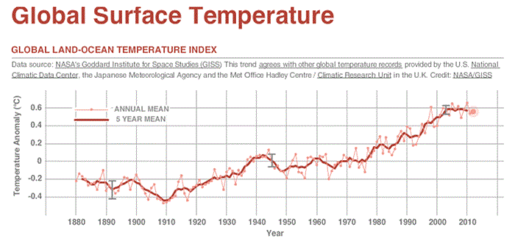

**Goals:**

**1. Effective Data Selection:** Identify and select datasets that are highly relevant to the project's objectives, ensuring that they are of high quality, up-to-date, and representative of the phenomena being investigated.

**2. Efficient Database Setup**: Establish IBM Cloud Databases with optimal security measures, scalability, and performance, tailored to the specific requirements of the project.

**3. Thorough Data Exploration:** Develop comprehensive data exploration processes to gain a deep understanding of the datasets, including data profiling and metadata collection.

**4. Accurate Analysis:** Implement appropriate analysis techniques that are aligned with project goals, resulting in accurate and meaningful insights.

**5. Compelling Visualization:** Create visually engaging and informative data visualizations that cater to the needs of both technical and non-technical stakeholders.

**Detailed plan:**

**Week 1-2: Project Initiation**

* Define clear project objectives and scope.
* Formulate a project team and assign roles.
* Identify key stakeholders and their expectations.
* Create a preliminary project timeline and budget.

**Week 3-4: Data Selection**

* Identify and gather relevant datasets for analysis.
* Assess data sources and quality.
* Ensure data compliance and legality.
* Begin documenting dataset characteristics and metadata.

**Week 5-6: Database Setup**

* Set up IBM Cloud Databases securely and efficiently.
* Define the database schema and storage strategy.
* Implement access controls and security measures.
* Ensure scalability and performance considerations are addressed.

**Week 7-8: Data Exploration and Analysis Techniques**

* Develop queries and scripts for data exploration.
* Perform basic data profiling to understand data distribution and types.
* Identify relevant variables or attributes for analysis.
* Start implementing appropriate analysis techniques based on project goals.

**Week 9: Visualization**

* + Begin designing visualizations for conveying analysis results.
  + Explore visualization tools and libraries.
  + Draft initial visual representations of findings.

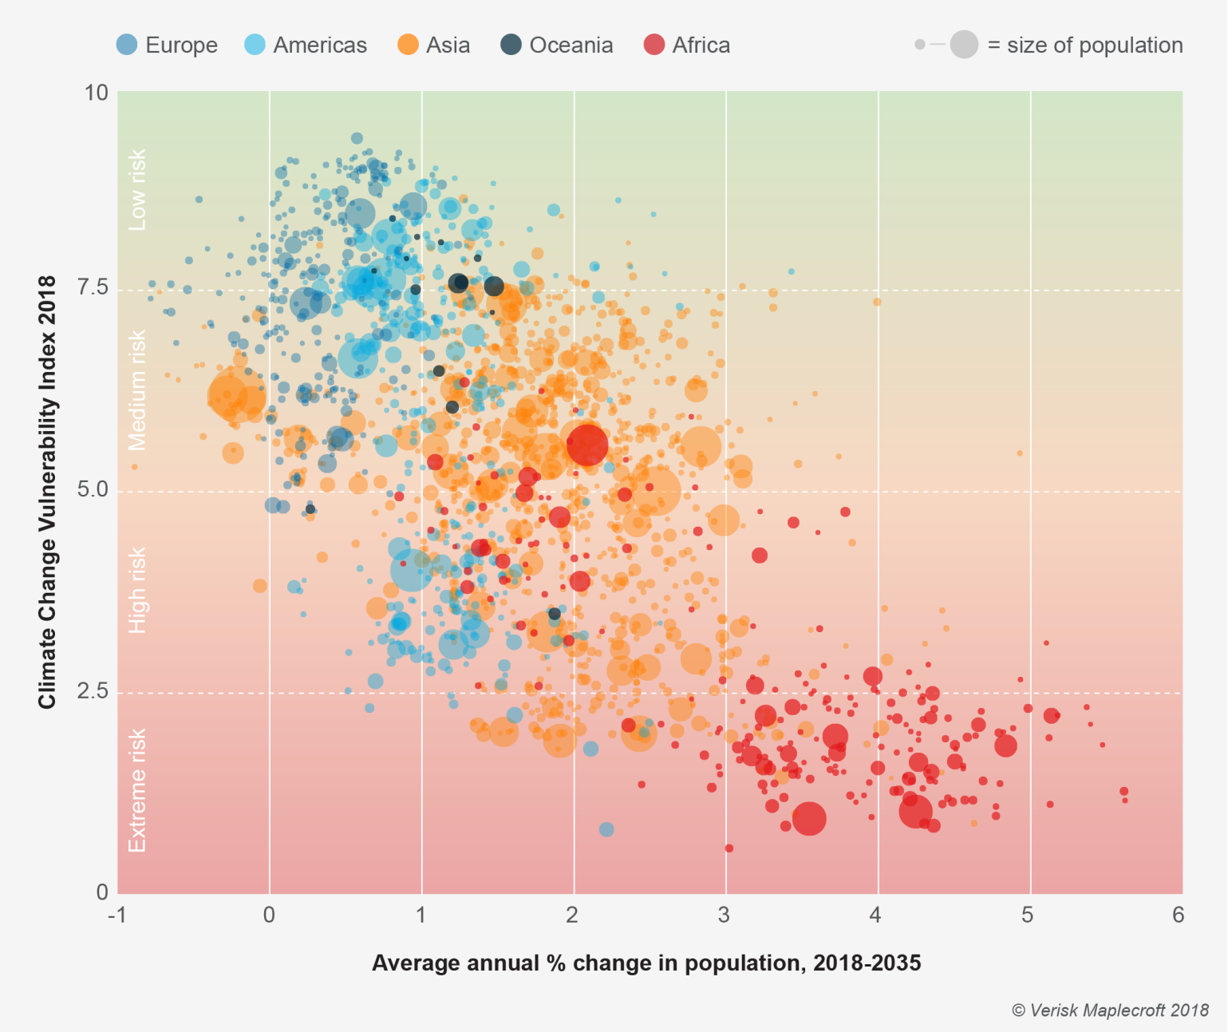

**Week 10: Business Insights and Conclusion**

* Interpret analysis findings in the context of project objectives.
* Derive valuable business intelligence and recommendations.
* Prepare a summary report of insights and project outcomes.
* Conduct a project review and evaluation.

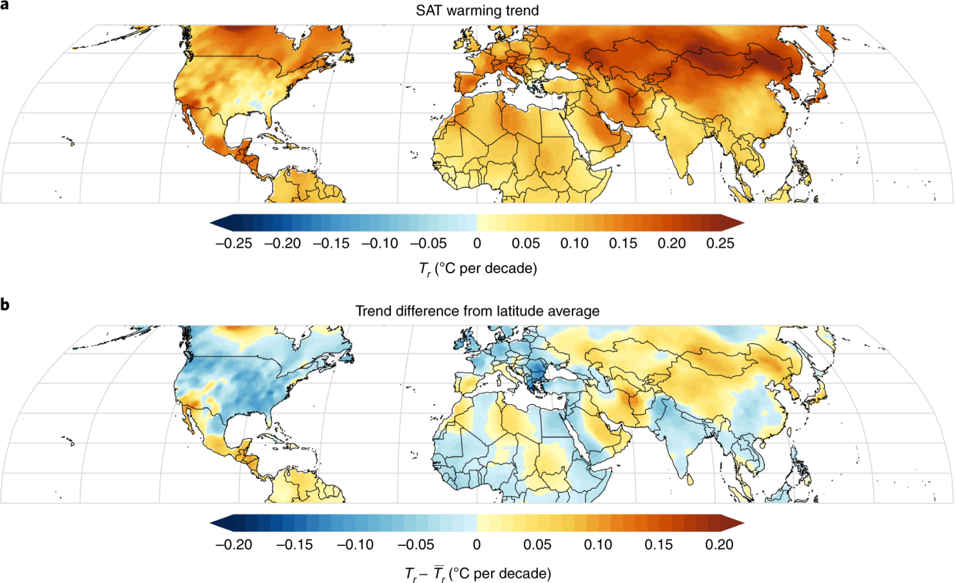

**Benefits:**

**Informed Decision-Making:** By extracting valuable insights from extensive datasets, organizations can make data-driven decisions, leading to more effective strategies, optimized operations, and improved outcomes.

**Efficiency Improvement:** Efficient data management and analysis processes, supported by IBM Cloud Databases, can result in cost savings and operational efficiencies.

**Competitive Advantage:** Organizations that harness the power of big data analytics gain a competitive edge by responding faster to market trends, customer preferences, and emerging opportunities.

**Potential Impact:**

**Improved Environmental Policy:** Climate trend analysis can contribute to informed environmental policies, helping governments and organizations address climate change and its impacts more effectively.

**Business Growth:** Data-driven insights can lead to revenue growth and expansion opportunities for businesses across various industries.

**Societal Benefits:** The project can lead to societal benefits by providing insights into social patterns that can inform public policy, healthcare strategies, and social interventions.

**Potential challenges and risks:**

**1. Data Quality and Availability:**

**Challenge:** Ensuring that the selected datasets are of high quality and up-to-date can be challenging. Data may contain errors, missing values, or inconsistencies.

**Risk:** Poor data quality can lead to inaccurate analysis results and unreliable insights.

**2. Data Security and Privacy:**

**Challenge:** Managing data security and privacy, especially when dealing with sensitive or personally identifiable information (PII), is complex and requires careful handling.

**Risk:** Data breaches or privacy violations can result in legal and reputational consequences.

**3. Visualization Complexity:**

**Challenge:** Designing effective and meaningful visualizations can be challenging, particularly when dealing with complex datasets.

**Risk:** Poorly designed visualizations may fail to convey insights effectively.

**Conclusion:**

The project on "Big Data Analysis with IBM Cloud Databases" aims to extract valuable insights from extensive datasets, fostering informed decision-making and business intelligence. The detailed plan outlines a systematic approach over ten weeks, from project initiation to insights generation. Benefits include improved efficiency, competitive advantage, and societal impacts. However, challenges like data quality and security must be managed. By executing this plan effectively, organizations can harness the power of data analytics to drive growth, innovation, and informed environmental policies, while addressing potential risks to ensure reliable outcomes.