Actifisys Documentation

Codename: dnyActifisys
Author: Daniel Brendel <dbrendel1988@gmail.com>
Version: 1.0

Welcome to the documentation of Actifisys – the free and open-source activity finder system. This documentation will introduce you to the system and help you to manage it.

Table of contents
Installation 2
Maintainer area 3
Cookie consent 3
About 3
Imprint 3
ToS – Terms of service 3
Registration info 3
FAQ 4
Environment 5
Users 6
Newsletter 8
Themes 9
Logo 10
Background 10
Reports 11
Formatted project name 12
Account verification 12
Categories 13
Head code 15
Ad code 16
Locations 17
User views 18
Index page 18
View activity 19
Submitting an activity 19
Messages 21
Notifications 21
Personal user settings 22
User profile 24
Favorites 26

Installation

The installation is very quick. Create a file called ‚do_install‘ in the root directory of the project files. Then browse to /install. You will then see an installation wizard form.

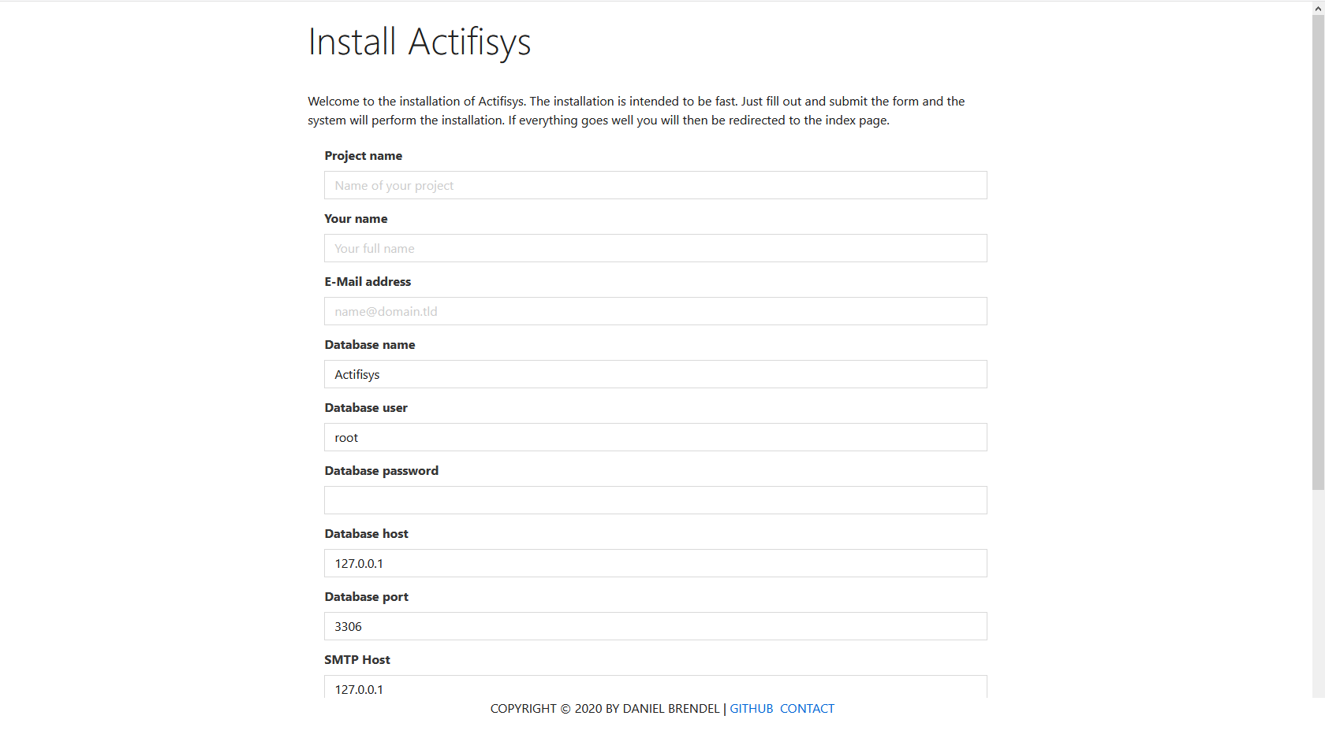

Fill out the form in order to install the system. The following options are to be set:
- Project name: The name of your project
- E-Mail address: Your e-mail address. It will be used to create an admin and maintainer account for you
- Database name: Name of the database to be used. If it does not exist the system will try to create it
- Database user: User name to login to the database
- Database password: Password to login to the database
- Database host: Hostname or IP address of the database
- Datapase port: Port of the database service
- SMTP Host: Host of the SMTP service. Will be used for e-mailing
- SMTP User: User of the SMTP service
- SMTP Password: The password
- SMTP From address: The address to be used in the e-mail header
- SMTP From name: The from-name to be used in the e-mail header

After filling out the form, submit it and then if everything goes well you will be logged in with the name ‚admin‘. A password will be generated for you, which will be shown to you. You can change it afterwards.

Now you should be redirected to the maintainer page. This page allows you to fully customize your project.

Maintainer area

Cookie consent

Here you can specify the text of the cookie context frame. This is useful to hint stuff like cookie information, terms of service, privacy, etc. HTML is supported.

About

Here you can specify the content of the top headline, the sub headline and HTML content of the about content.

Imprint

Here you can specify your imprint. HTML is supported.

ToS – Terms of service

Here you can specify your terms of service. HTML is supported.

Registration info

This text will be shown at the bottom of the registration form. HTML is supported.

FAQ

Here you can manage your frequently asked questions
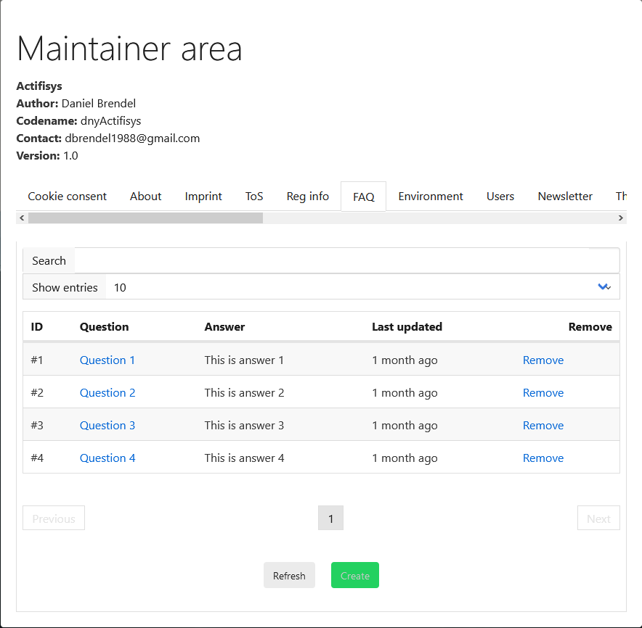

Environment

Here you can specify your environment settings.

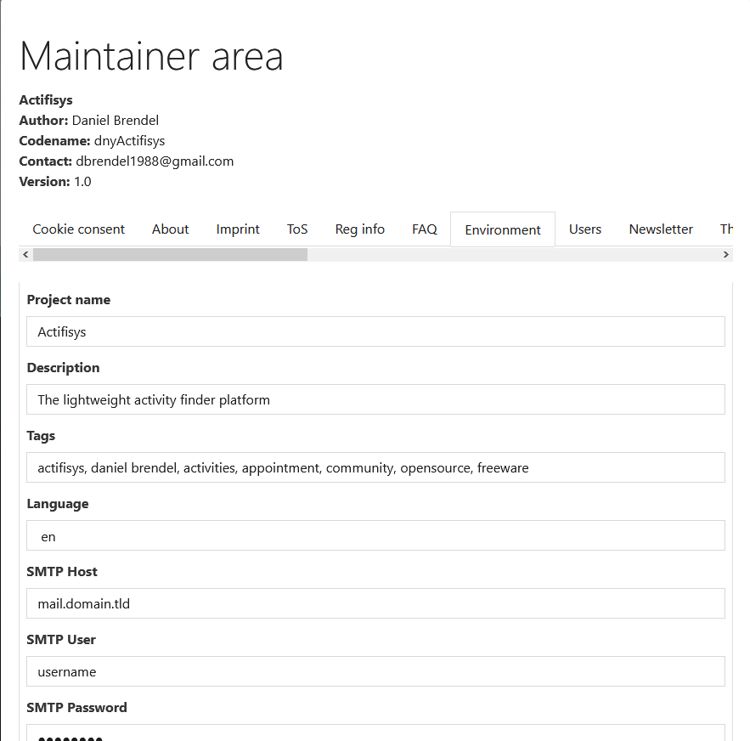

The following options are available:
- Project name: The name of your project
- Description: Description of your project used for the meta description element
- Tags: Tags used for the meta tags element
- Language: Overall language of the service
- SMTP Host: Host of the SMTP service used for e-mailing
- SMTP User: SMTP User
- SMTP Password: Password for authentication
- SMTP From name: From-name e-mail header field value
- SMTP From address: From-address e-mail header field value
- Google Analytics token: If you want to include Google Analytics in your service
- Twitter news feed: A Twitter handle which is used to display at the news page
- HelpRealm Workspace: If you want to use HelpRealm as support ticket backend then you can pass here your workspace hash identifier
- HelpRealm API Token: Your HelpRealm API token used for creating tickets
- HelpRealm ticket type ID: The ticket type ID to be used for creating tickets
- Account verification: Enable (1) or disable (0) the account verification feature

Users
Here you can query a specific user by either ID, name or e-mail. You can then edit some of the user settings.
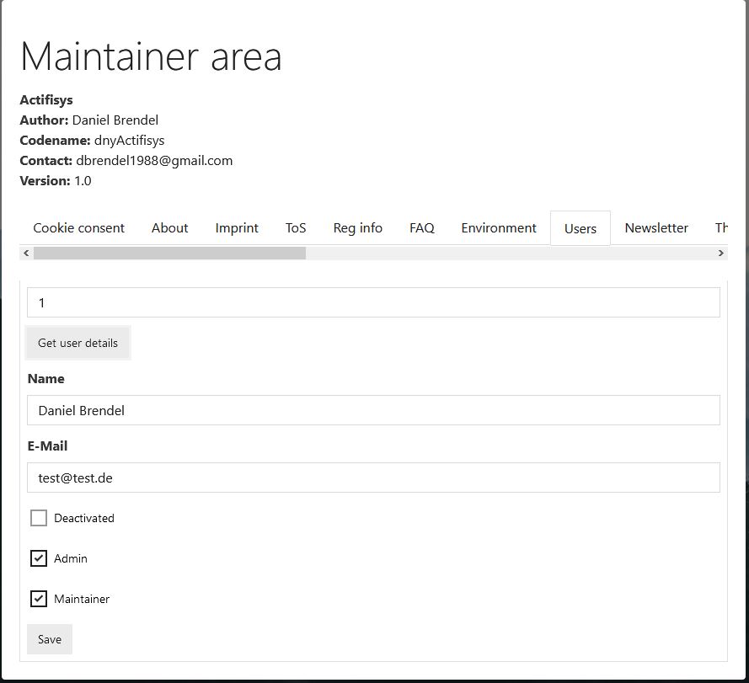

Newsletter

Here you can send a newsletter to all users that have enabled this in their preferences.
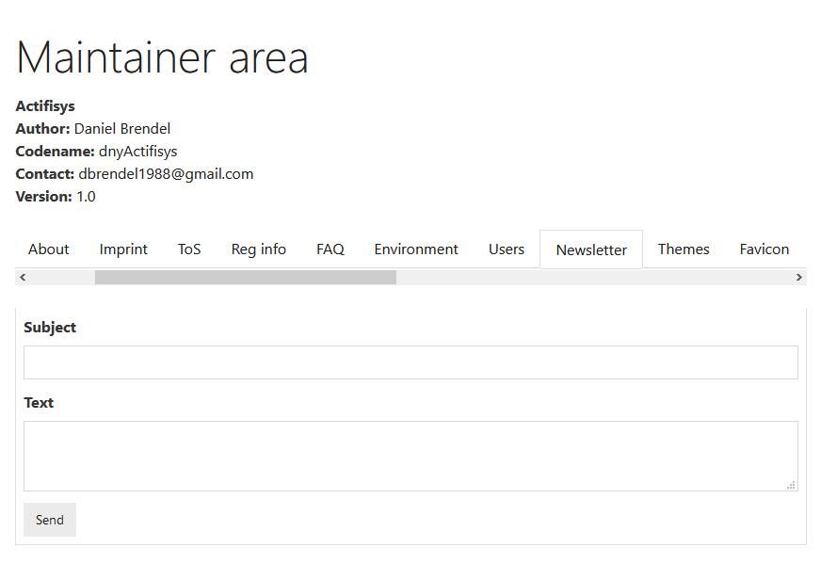
In order to enable this feature you must set a cronjob to run /newsletter_cronjob/your_password where „your_password“ is the password defined in your .env file named „APP_CRONPW“. This ensures that the backend job is not misused by non-permissive people.

Themes

Here you can manage CSS themes which can be used by the members.
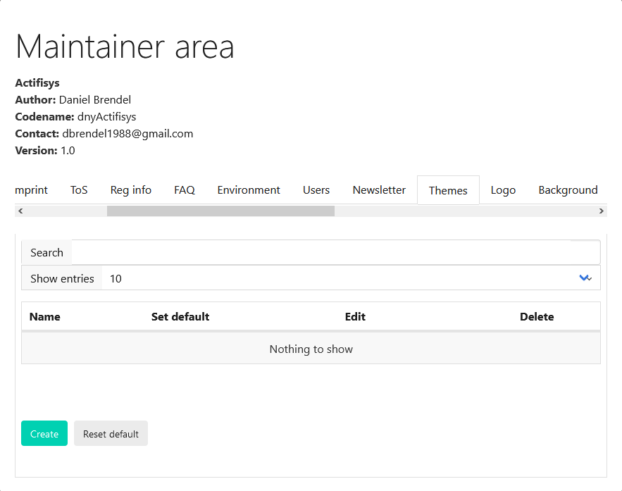

Logo

Here you can replace the current logo:
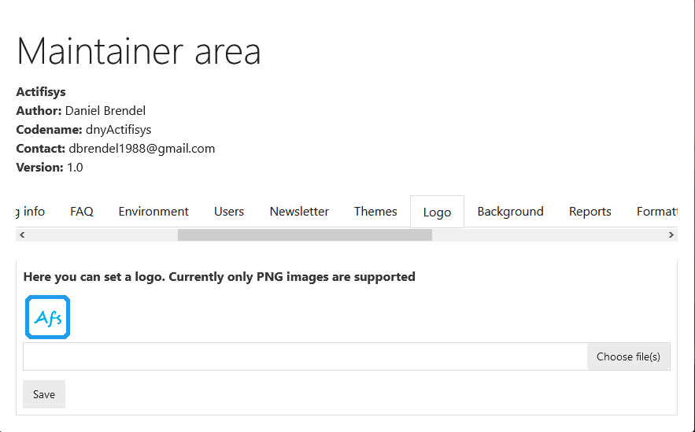

Background

Here you can set the background and header information.

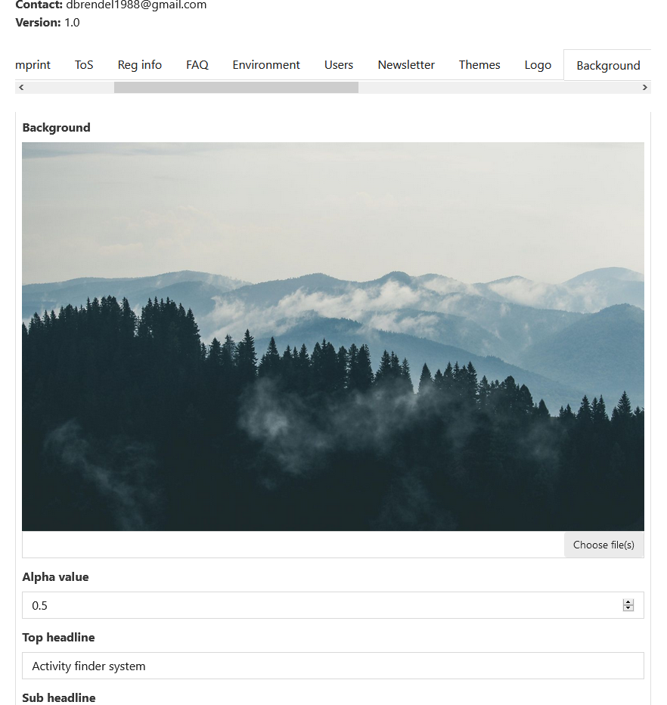

Reports

Here you can view all top reported activities, users and comments. You can lock those entities, delete them or set them safe if the content is approbriate. For each entity type the items with the highest report count are listed.

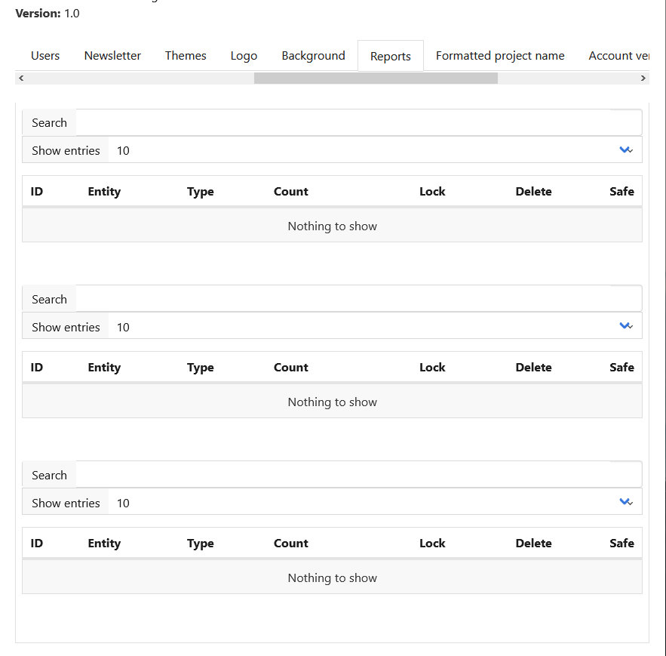

Formatted project name

Here you can specify HTML formatted project name. If not specified then a default format will be used.

Account verification

Here you can approve account verifications or deline them.

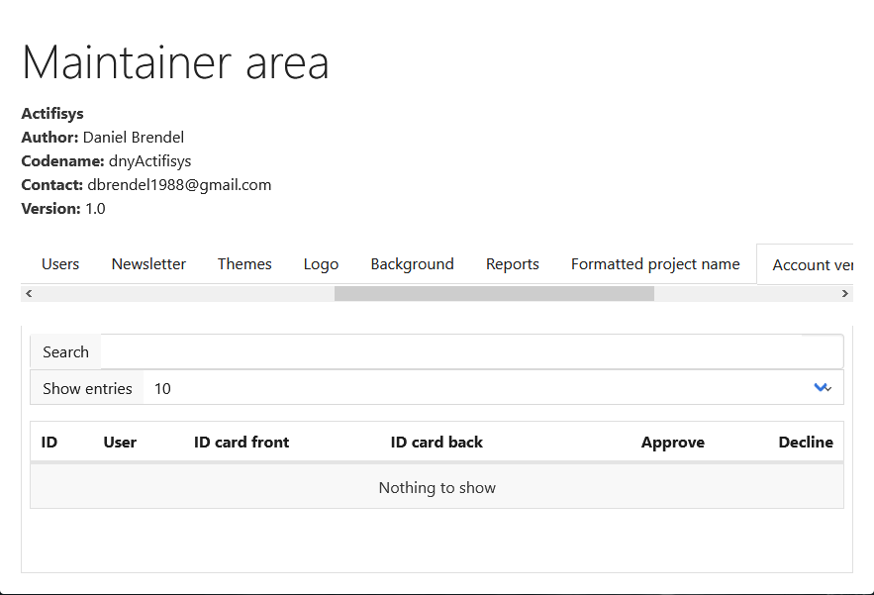

Categories

Here you can specify categories which will be used for users to create activities. You can specify the name, description and a preview image of a category. Preview images will be shown in the header of an activity in the feed or user profile. This enables that users will recognize activity categories faster with time when they see an activity.
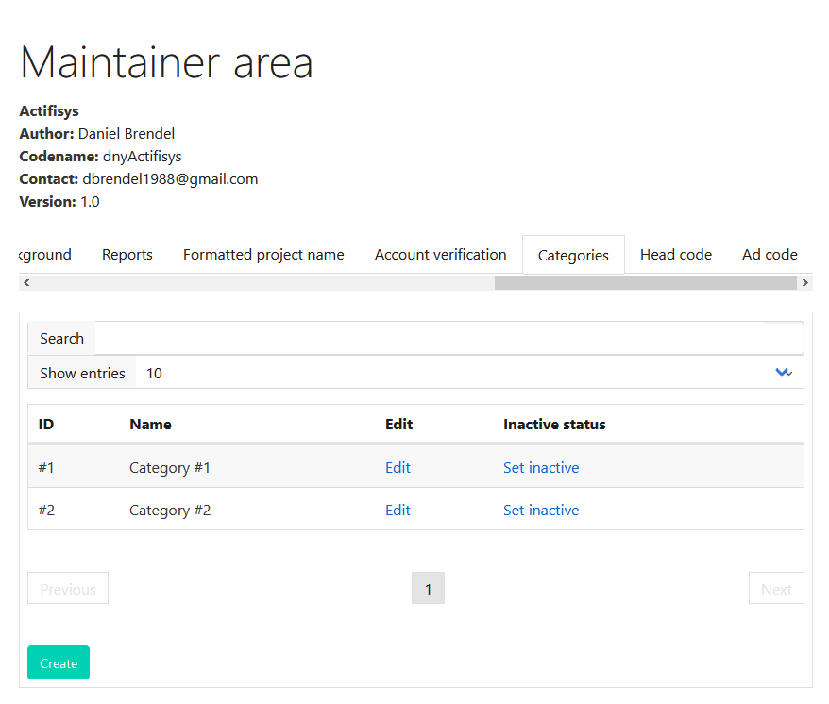

Head code

Here you can specify custom code which will then be inserted in the head section of the outputted document code.
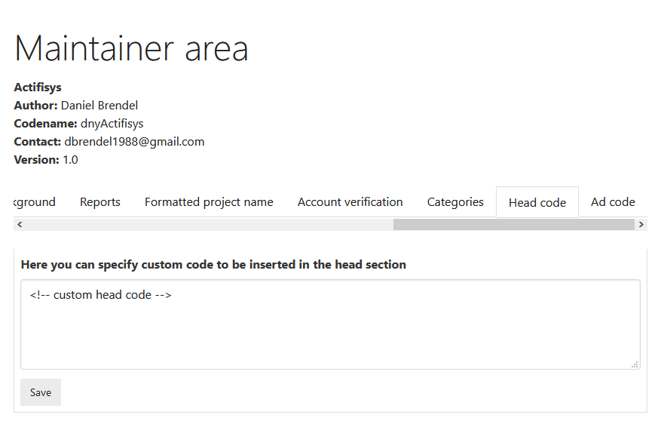

Ad code

Here you can specify code for ads. If specified ads will be shown in the activity feed. For each fetch of an activity pack there will one ad be inserted. In total you will then have N activities + 1 ad.
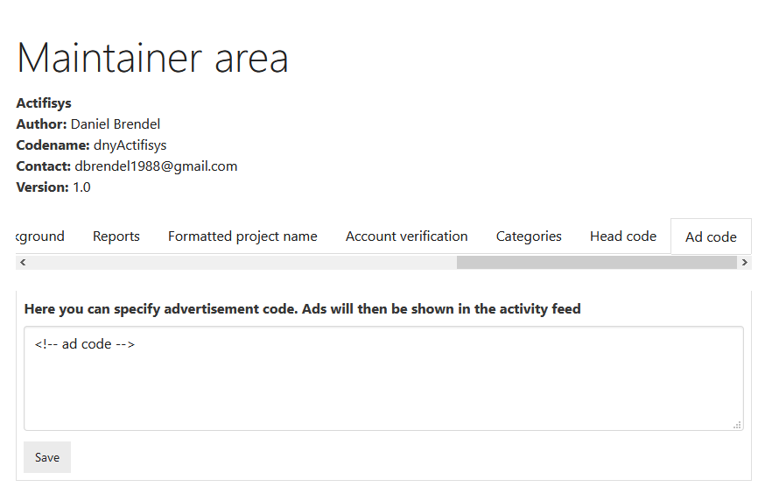

Locations

Here you can manage the locations which are used for creating and editing and filtering activities.
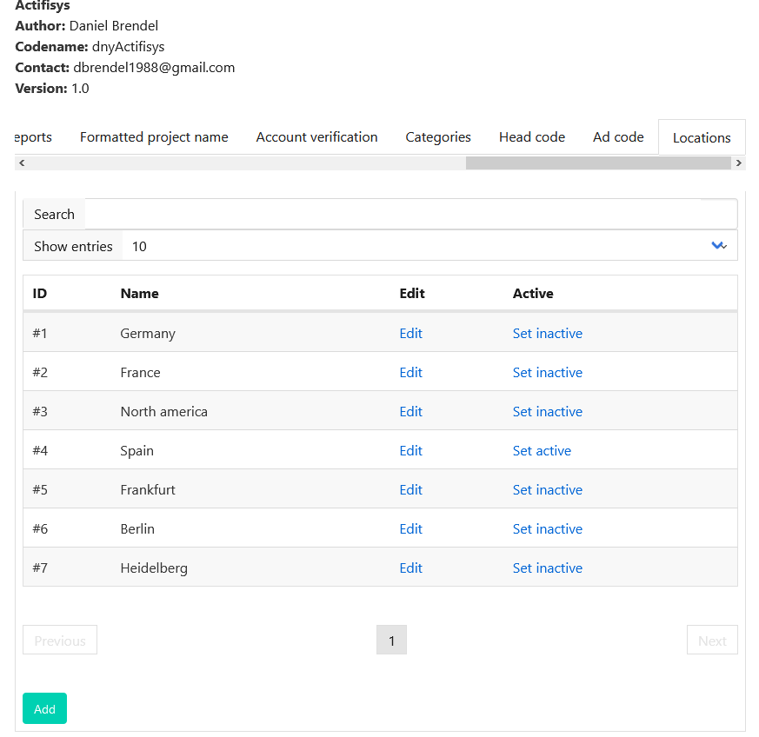

User views

Index page

This is the index page of the system. Here users can view the current available activities. Also they can login or register. There is also an about content available under the activity feed.
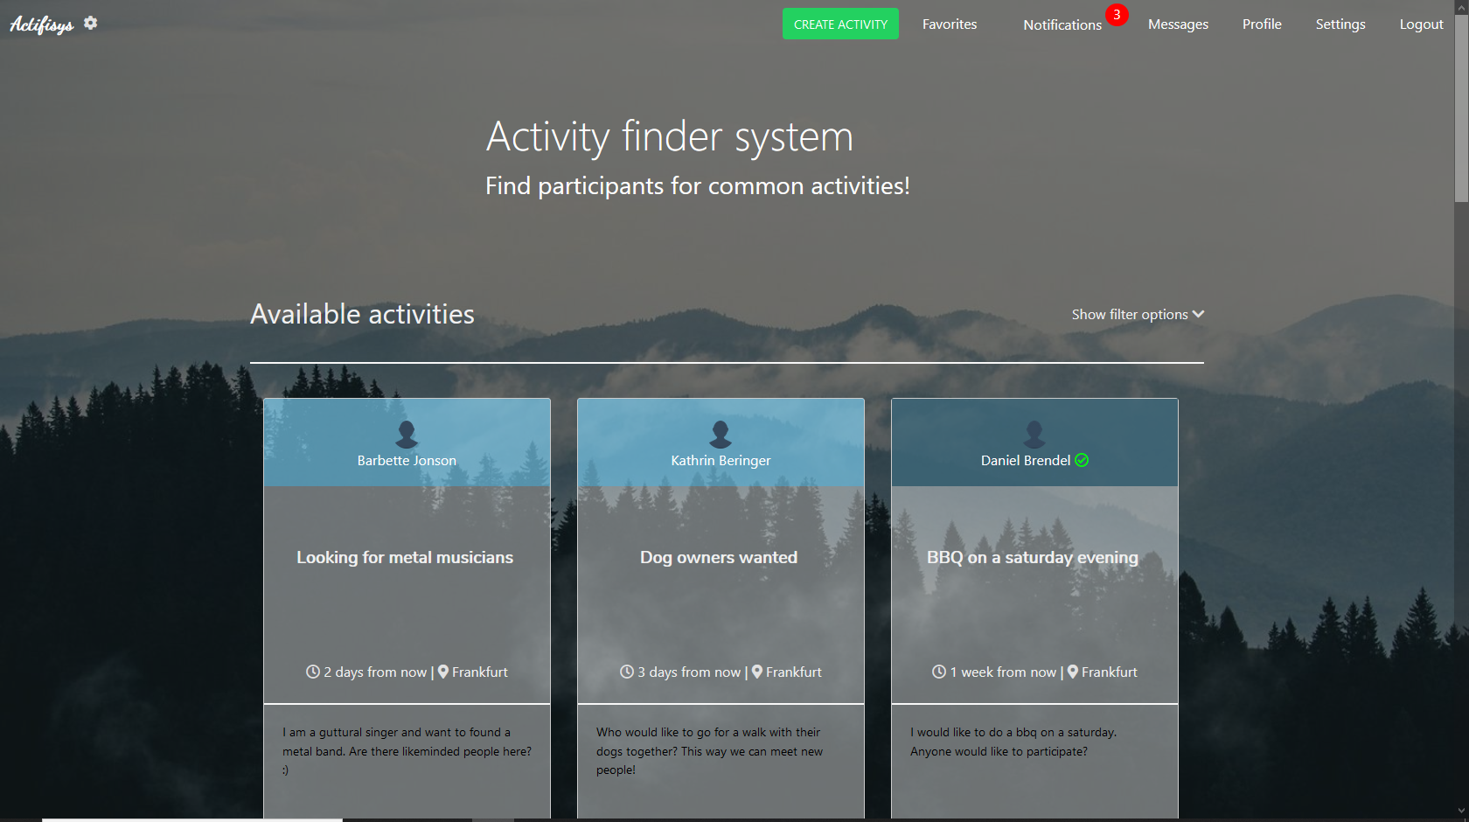
There is also always a bottom bar where users can go to the news (if enabled), imprint, FAQ, ToS and contact (if enabled) page if desired.

Also users can show filter options where they can filter by location, date range, tag or category.

When logged in they can create an activity, view favorites and notifications, go to messages, settings, profile and perform a logout.

View activity

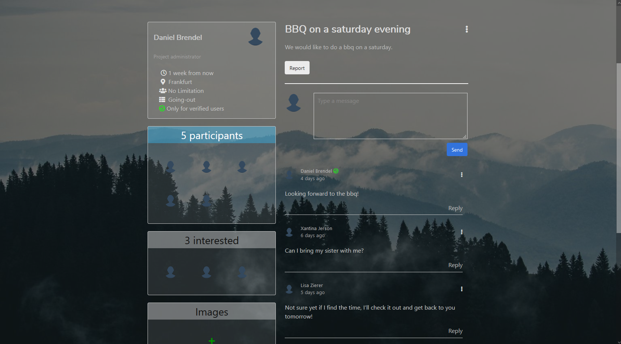
Here you can view the activity details. You can participate (potentially or actually), perform activity options and post comments. Admins and owners can also do specific management operations.
Participants can also upload images.
Activities can be limited by amount of users and also restricted to a specific gender.

Submitting an activity

In order to create a new activity, you can use the activity form for that.

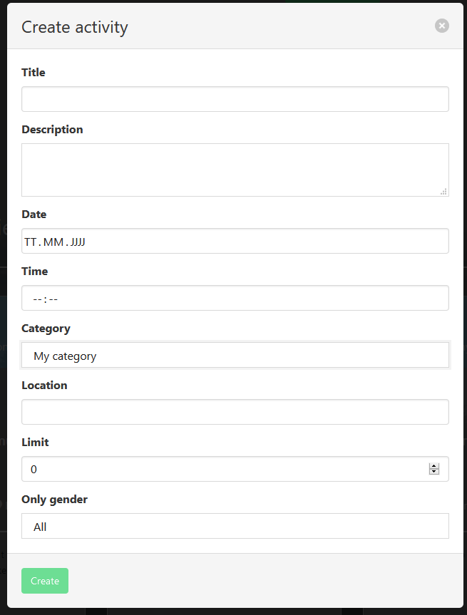
Here you specify the title, description, date and time of the event, the location and also a limit of participants and gender. Verified users can set activities only available to verified users. After creating your activity you will be redirected to the activity page where you can manage it.

Messages

You can also send messages to users.

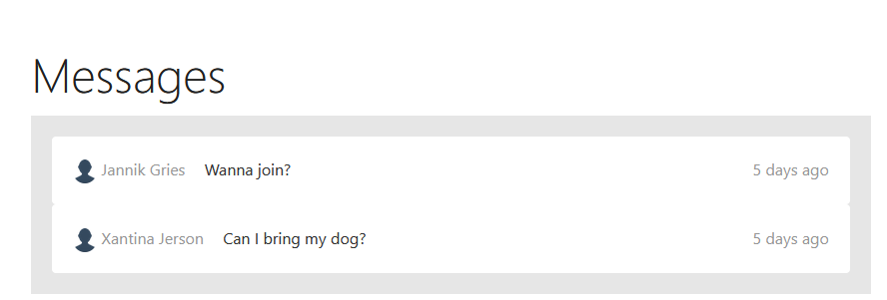

The message list shows the messages sorted by creation date. Unread messages will be highlighted. Click on a message to view the conversation.

The conversation thread shows a form where to submit a new message and also the last messages from sender and recipient sorted as a conversation thread.

Notifications

You will get notifications on certain events, such as if someone joined your activity, posted a comment, a favorite created a new activity, an activity is canceled you participated to, if someone added you to their favorites and if someone sent you a message.
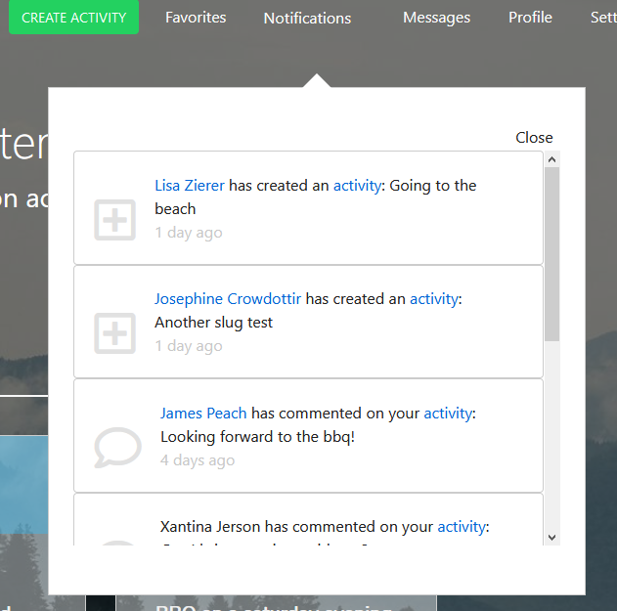

Personal user settings

In the settings menu you can manage your personal data, change password or e-mail address, manage your notification subscriptions and manage your membership.
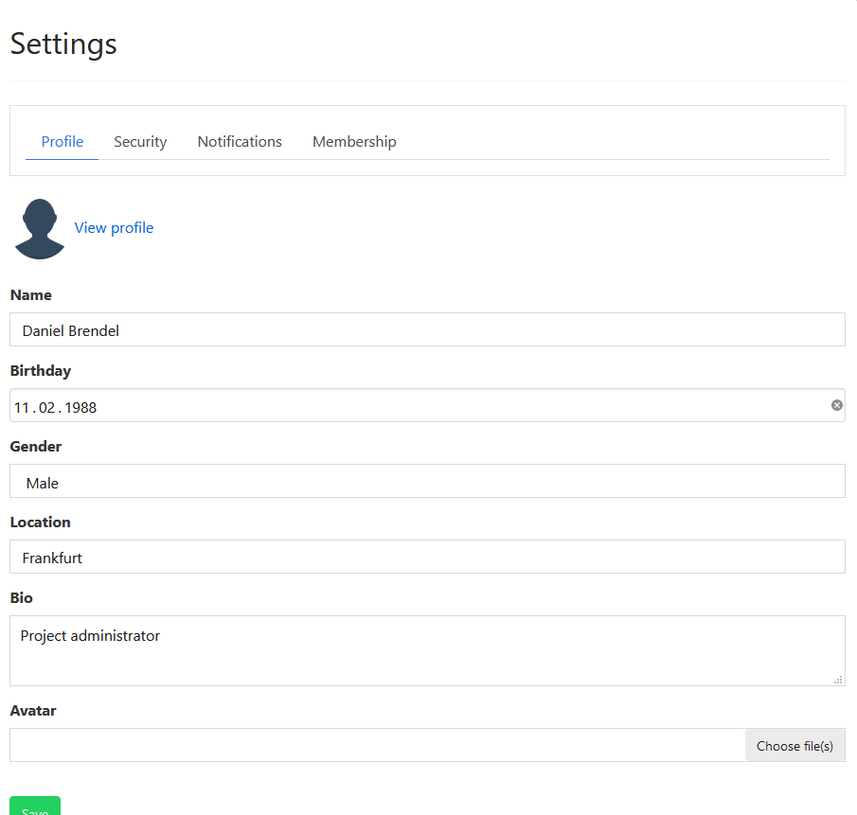
- Profile section enables users to manage their profile data
- Security section enables users to change password, e-mail address and set whether guests may see their profile or not
- Notifications section enables users to manage their notification subscriptions
- Membership section enables users to purchase pro mode, request account verification or delete their account

User profile

There is also a profile view for user related information.
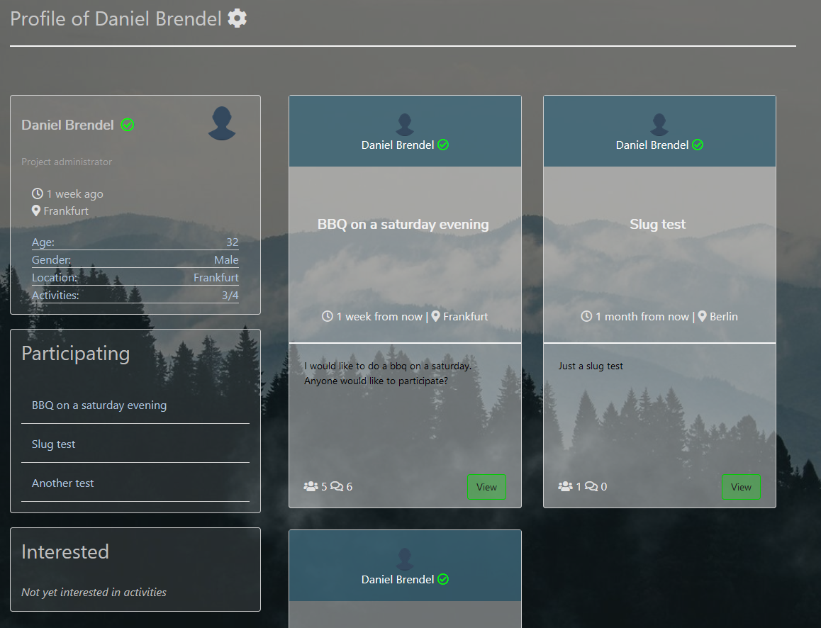
On a user profile you see some bio information and current activities of the user.
If a user views their own profile then a list of participating and potential interested activities is shown.
If a user views a profile of another user then they can perform some actions.
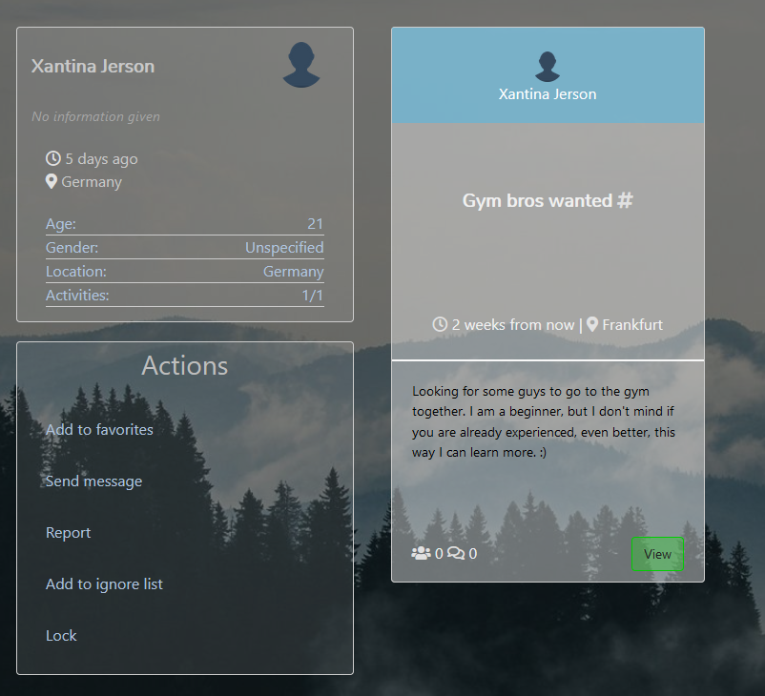
(Admins/Maintainers have more options as shown in the screenshot)

Favorites

There is also a popup overlay where you can view and manage your favorites. An indicator will be shown if a favorited user has open activities.

