Danigram Documentation

Codename: dnyDanigram
Author: Daniel Brendel <dbrendel1988@gmail.com>
Version: 1.0

Welcome to the documentation of Danigram – the free and lightweight image sharing community platform system. This documentation will introduce you to the system and help you to manage it.

Table of contents
Installation 2
Maintainer area 3
Index content 3
Cookie consent 3
About 3
Imprint 3
ToS – Terms of service 3
Registration info 3
FAQ 4
Environment 4
Users 5
Newsletter 6
Themes 7
Favicon 7
Reports 8
Welcome overlay 8
Formatted project name 9
User views 10
Index page 10
Feed area 10
Submitting a post 13
Messages 15
Notifications 16
Profile editing 16

Installation

The installation is very quick. Create a file called ‚do_install‘ in the root directory of the project files. Then browse to /install. You will then see an installation wizard form.

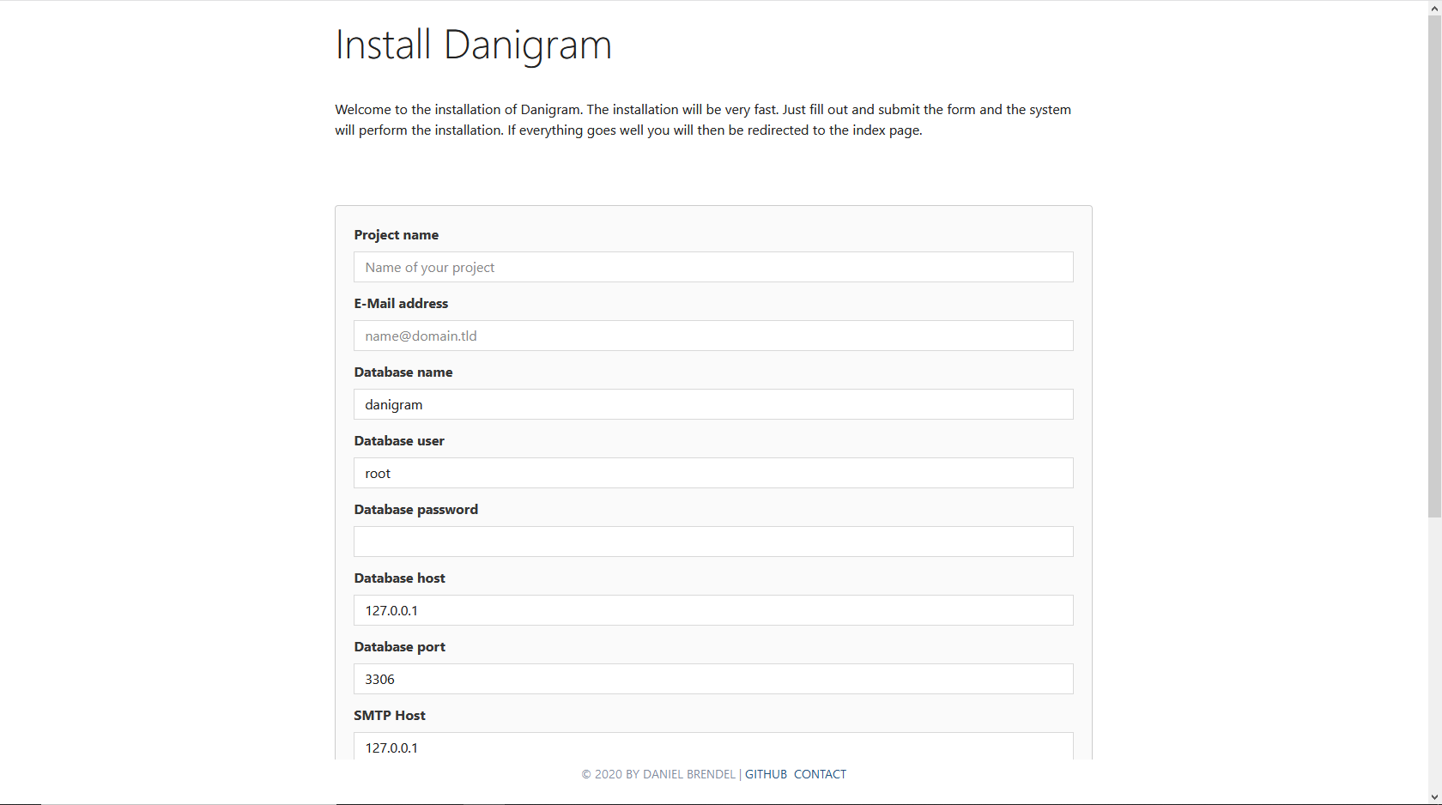
Fill out the form in order to install the system. The following options are to be set:
- Project name: The name of your project
- E-Mail address: Your e-mail address. It will be used to create an admin and maintainer account for you
- Database name: Name of the database to be used. If it does not exist the system will try to create it
- Database user: User name to login to the database
- Database password: Password to login to the database
- Database host: Hostname or IP address of the database
- Datapase port: Port of the database service
- SMTP Host: Host of the SMTP service. Will be used for e-mailing
- SMTP User: User of the SMTP service
- SMTP Password: The password
- SMTP From address: The address to be used in the e-mail header
- SMTP From name: The from-name to be used in the e-mail header

After filling out the form, submit it and then if everything goes well you will be logged in with the name ‚admin‘. A password will be generated for you, which will be shown to you. You can change it afterwards.

Now you should be redirected to the maintainer page. This page allows you to fully customize your project.

Maintainer area

Index content

In this tab you can specify the content that will be shown at the index page for guest users. HTML is supported.

Cookie consent

Here you can specify the text of the cookie context frame. This is useful to hint stuff like cookie information, terms of service, privacy, etc. HTML is supported.

About

Here you can specify the content of the about page. HTML is supported.

Imprint

Here you can specify your imprint. HTML is supported.

ToS – Terms of service

Here you can specify your terms of service. HTML is supported.

Registration info

This text will be shown at the bottom of the registration form. HTML is supported.

FAQ

Here you can manage your frequently asked questions

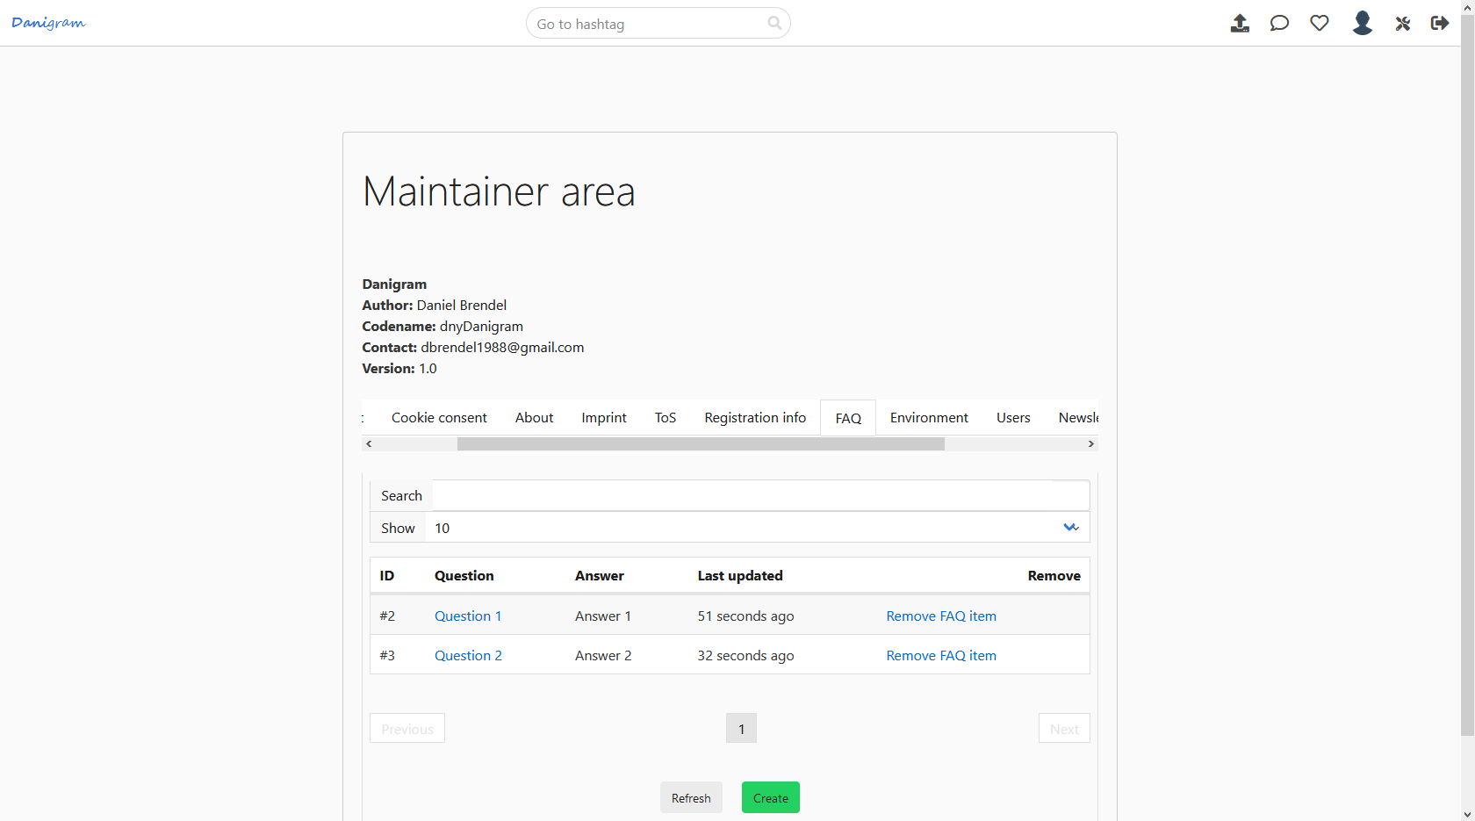

Environment

Here you can specify your environment settings.
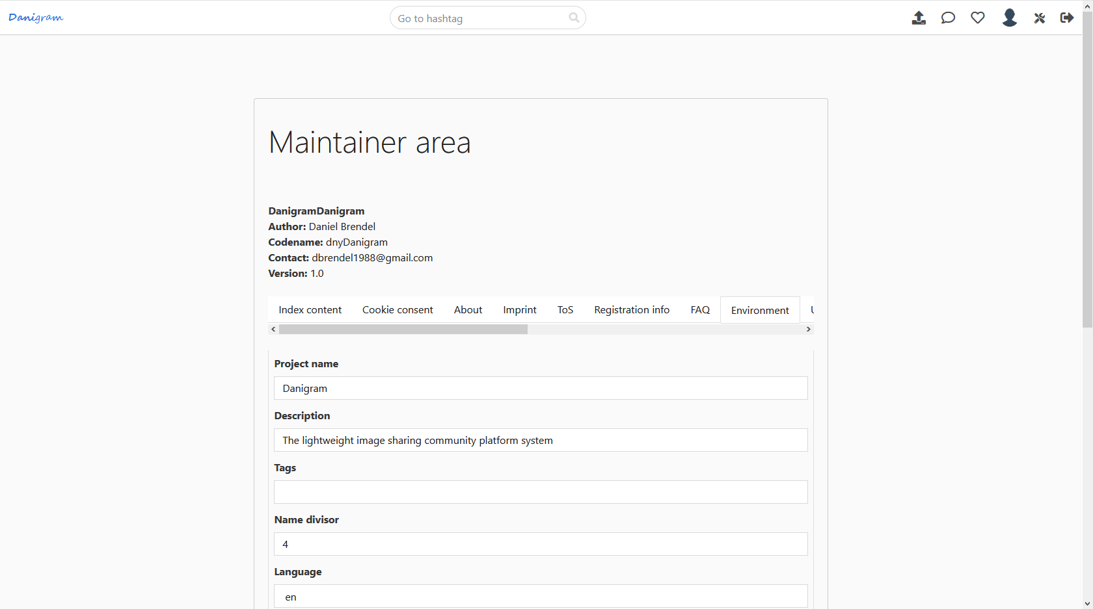

The following options are available:
- Project name: The name of your project
- Description: Description of your project used for the meta description element
- Tags: Tags used for the meta tags element
- Language: Overall language of the service
- SMTP Host: Host of the SMTP service used for e-mailing
- SMTP User: SMTP User
- SMTP Password: Password for authentication
- SMTP From name: From-name e-mail header field value
- SMTP From address: From-address e-mail header field value
- Public feed: If activated then the feed area will be publicly viewable, otherwise users have to sign in to view the feed
- Google Analytics token: If you want to include Google Analytics in your service
- Twitter news feed: A Twitter handle which is used to display at the news page
- HelpRealm Workspace: If you want to use HelpRealm as support ticket backend then you can pass here your workspace hash identifier
- HelpRealm API Token: Your HelpRealm API token used for creating tickets

Users

Here you can query a specific user by either ID, name or e-mail. You can then edit some of the user settings.
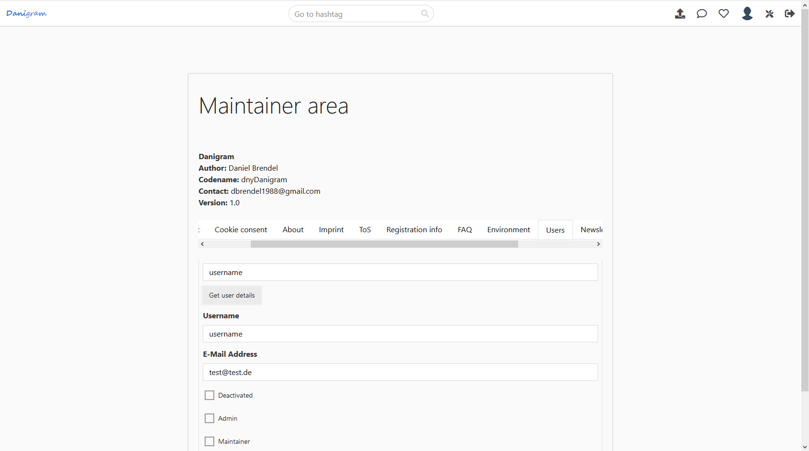

Newsletter

Here you can send a newsletter to all users that have enabled this in their preferences.
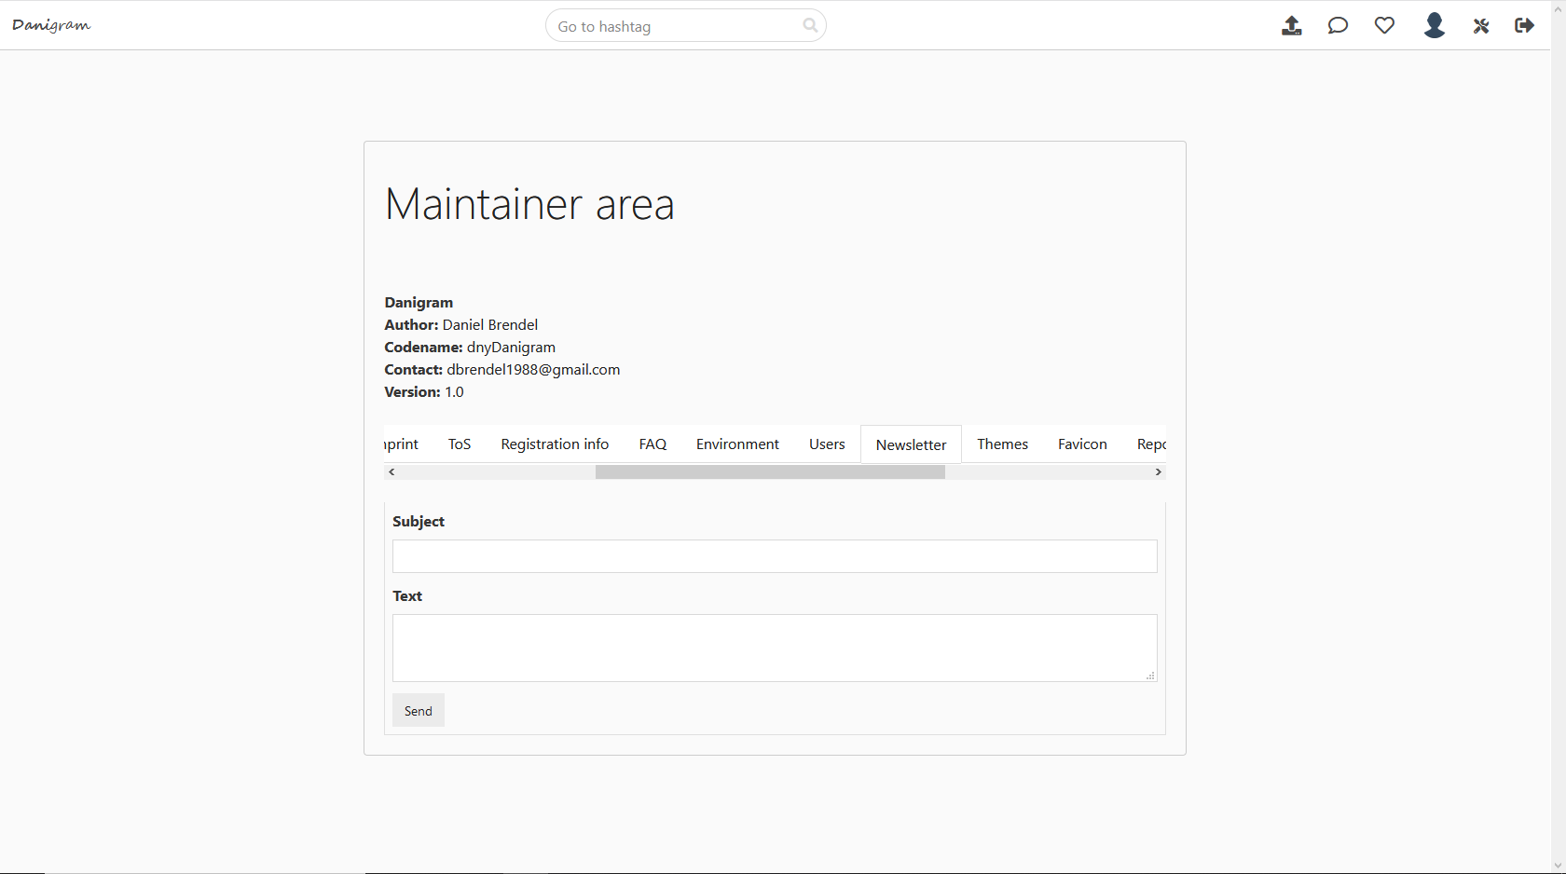

Themes

Here you can manage CSS themes which can be used by the members.
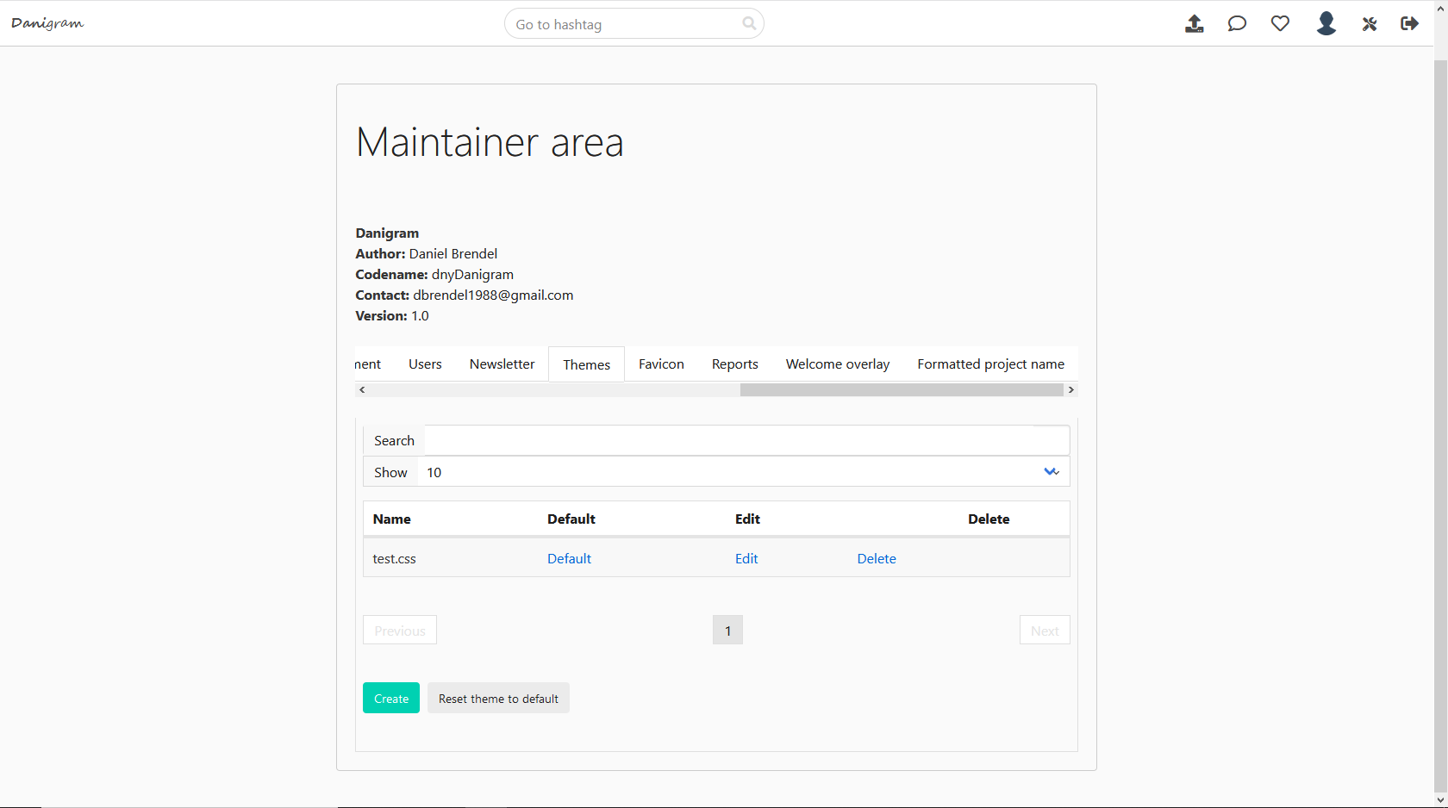

Favicon

Here you can replace the current Favicon:
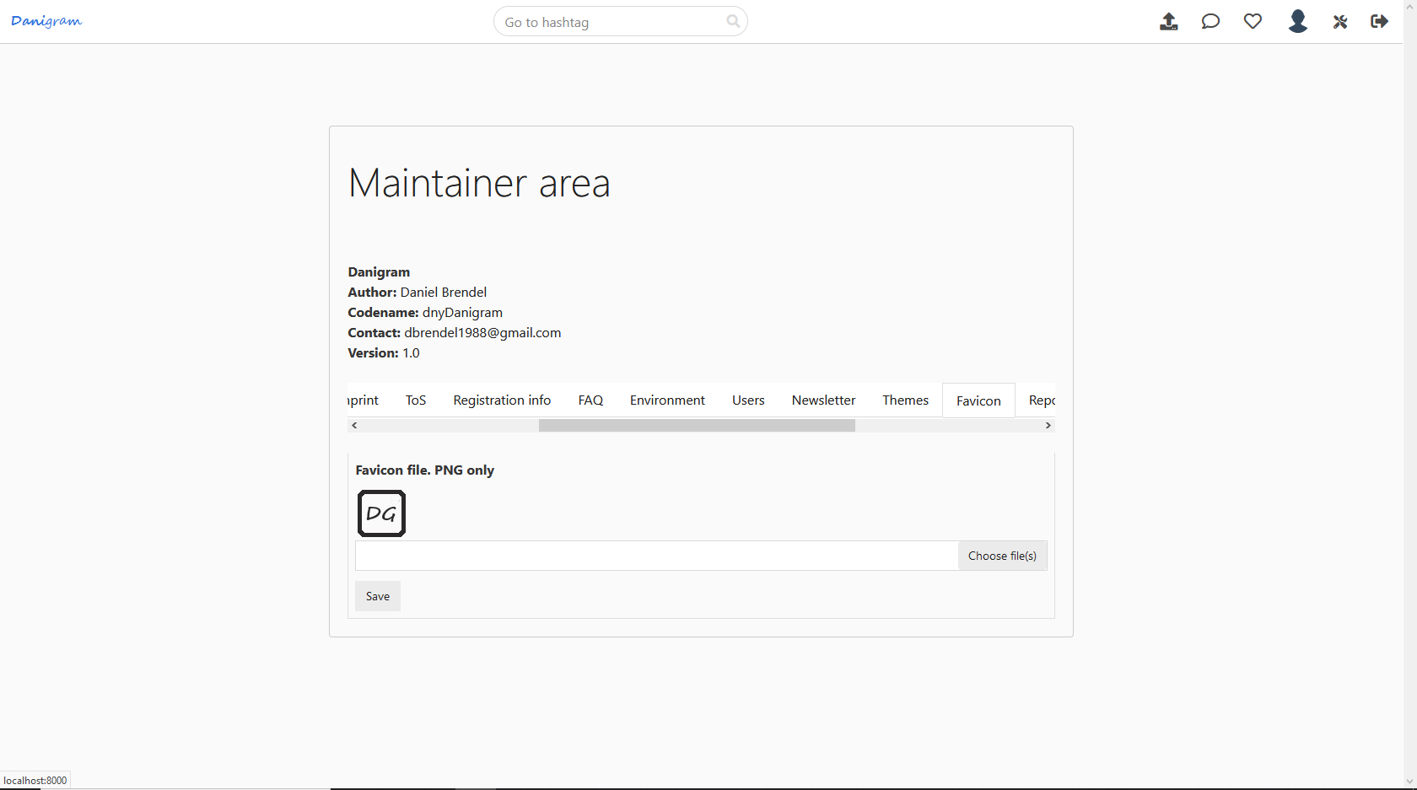

Reports

Here you can view all top reported posts, users, hashtags and comments. You can lock those entities, delete them or set them safe if the content is approbriate. For each entity type the items with the highest report count are listed.
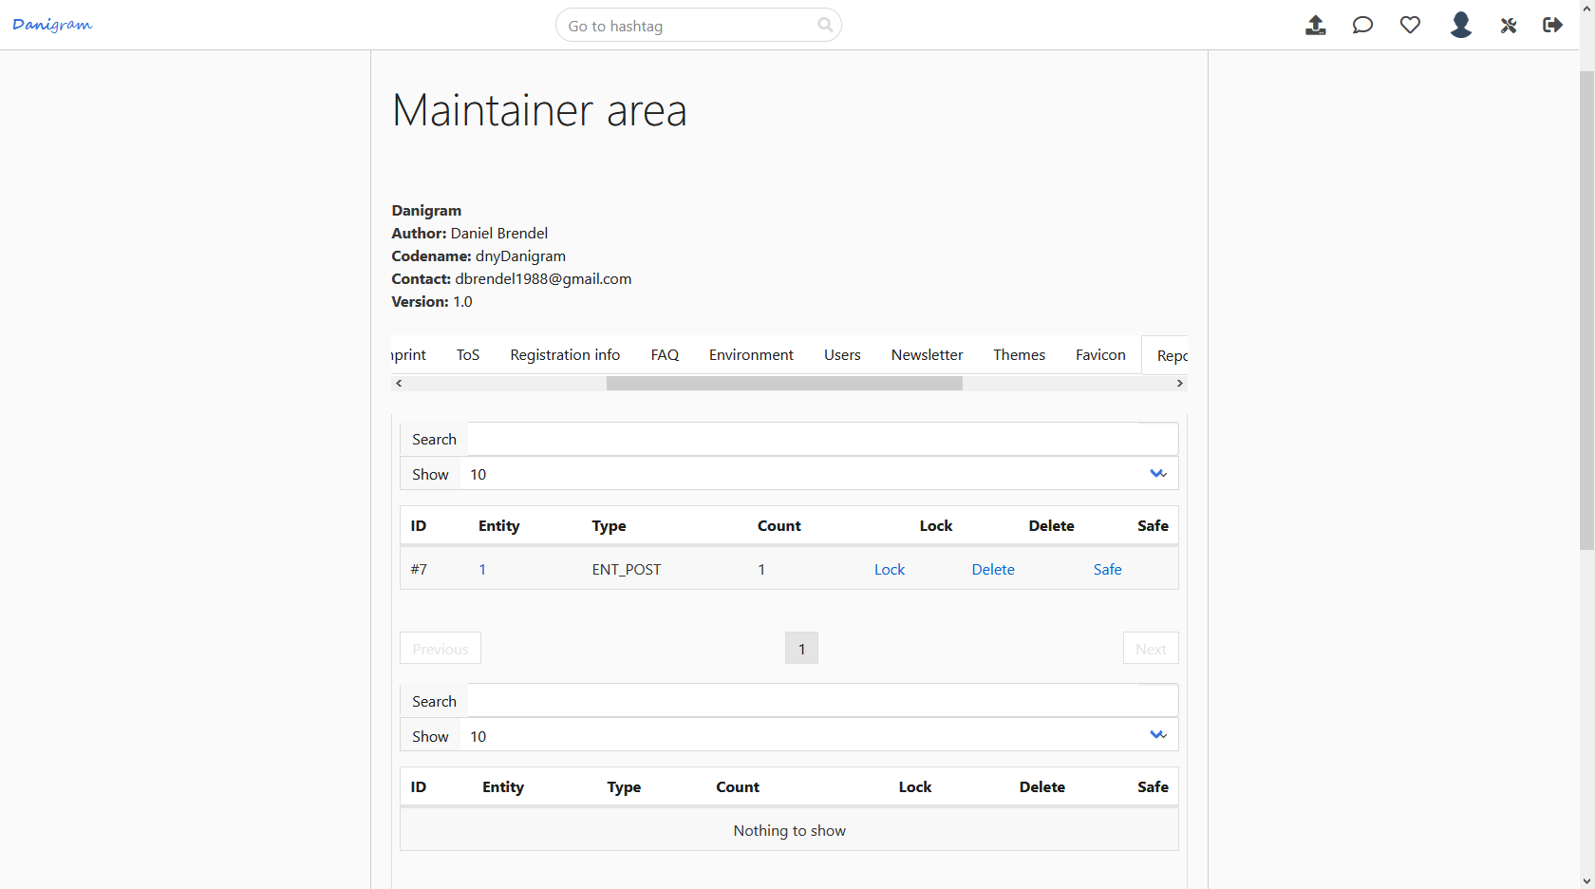

Welcome overlay

Here you can define the content of a welcome overlay that is shown in the feed area for users that have not yet seen it and clicked on continue. This overlay is useful if you need an agreement from the user. If you don‘t specify any content then the overlay won‘t be shown.
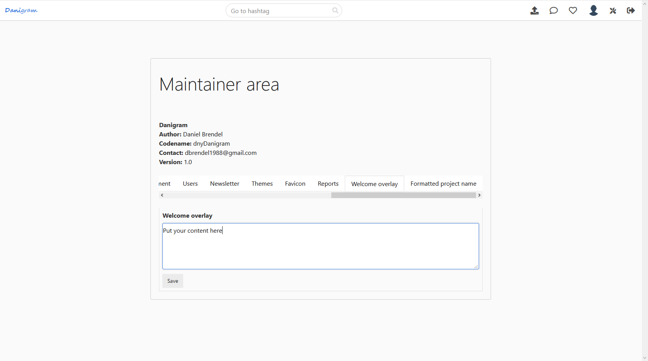
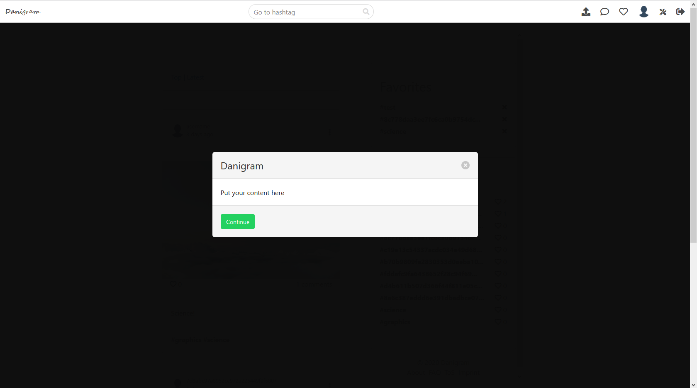

Formatted project name

Here you can specify HTML formatted project name. If not specified then a default format will be used.

User views

Index page

This is the page for guests. There they can login, register and view project related pages, such as news, FAQ, about, imprint, contact and ToS. Also they can recover their password. This page will only be shown for guests and if public feed is disabled.
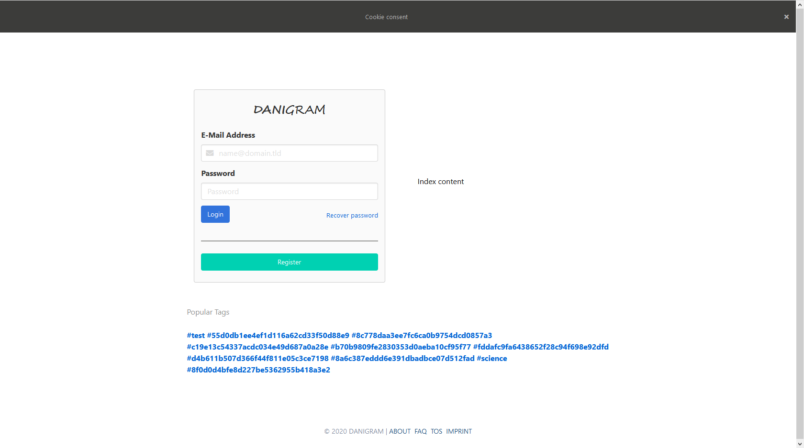

Feed area

After logging in or if public feed is enabled the user will be redirected to the feed page.
The top navbar will provide options depending on the user authentication. Guests can login and signup as well as recover password. Members have the possibilities which will be described later below.
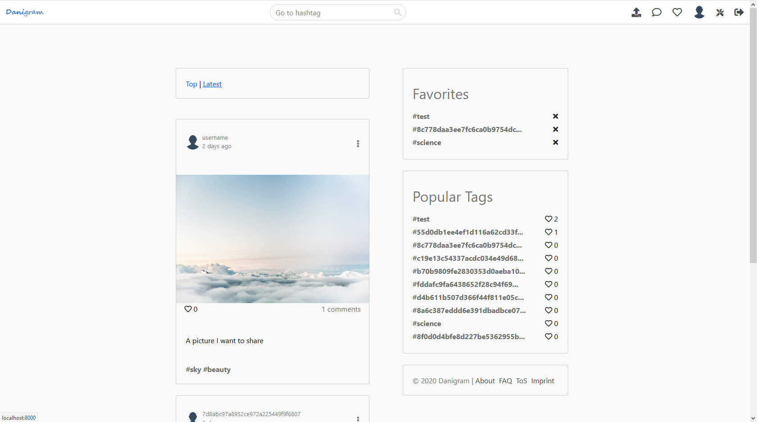
Here the user will see posts, favorites, popular tags and company info. At the top there is a navigation menu where the user can quickly jump to a hashtag and also do operations such as uploading, view messages, view notifications, go to own profile and logout – granted that the user is authenticated. Maintainers will also have the option to go to the maintainer section. Guest users will have the possibility to sign up and login / recover password
Also they can set whether they want to see the latest posts or the top posts.
By scrolling to the bottom the system will fetch a pack of new posts dynamically. This goes on for each scroll operation as long as there is content.
There is also a feed available for showing a post, which then loads also a comment section where users can comment on the post.
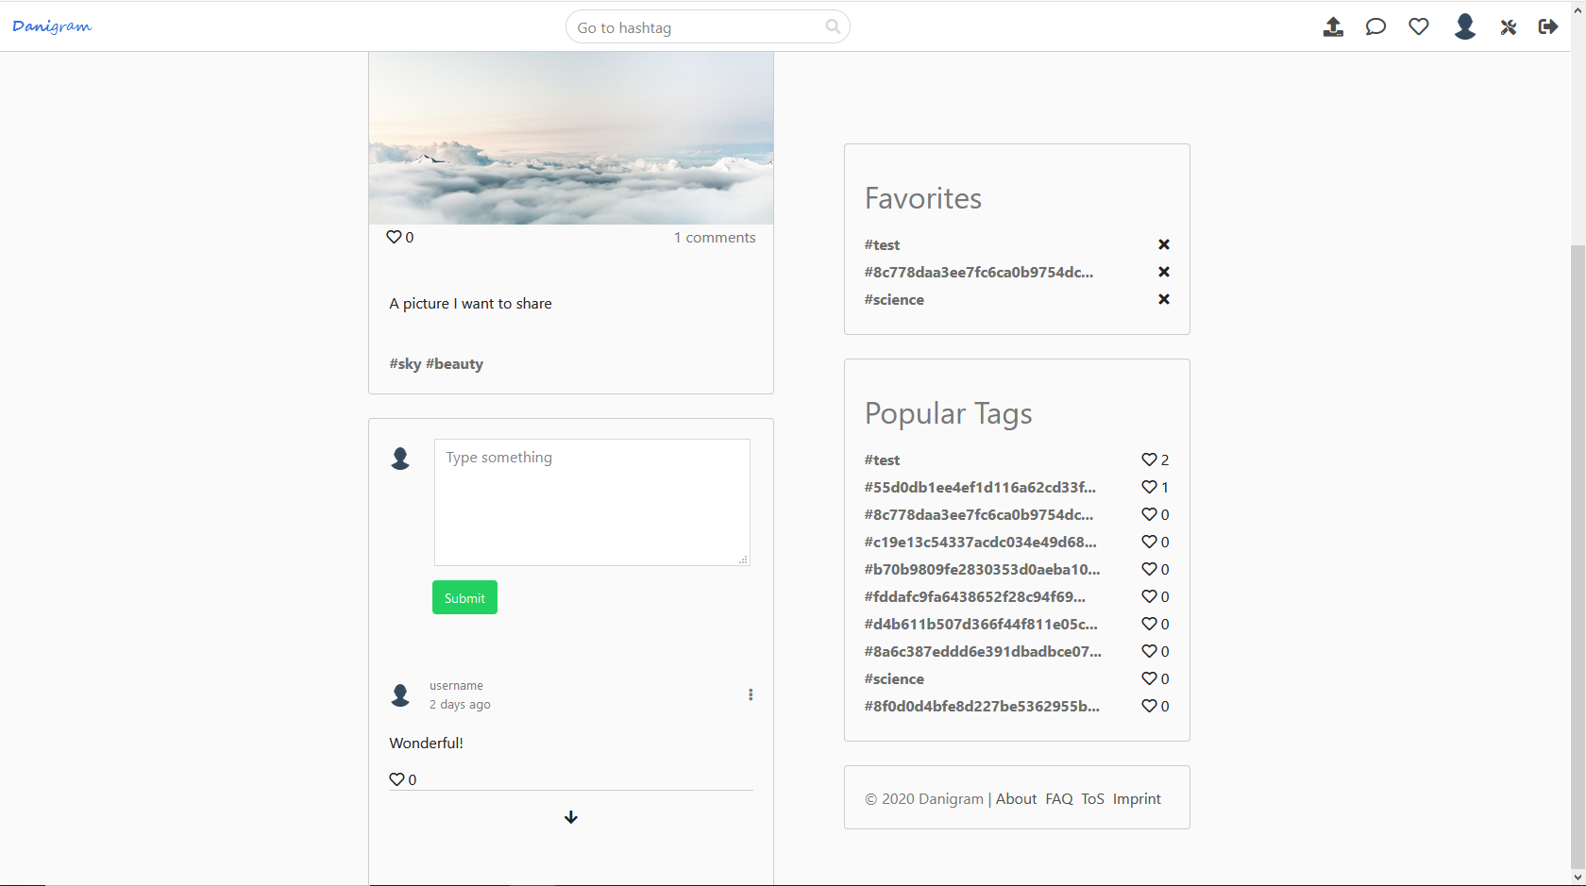

Also there is a feed for showing the posts of a specific user.

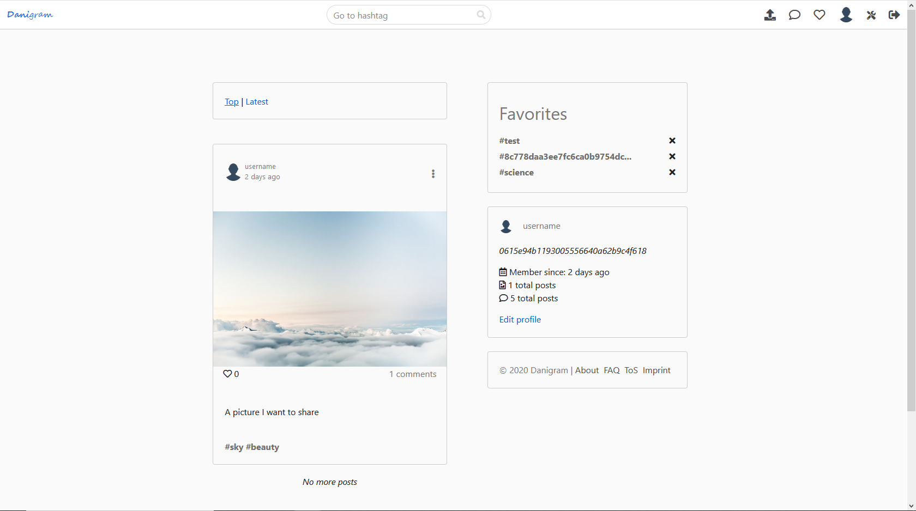

Here member options are available. If it is your profile you can toggle a form where to edit your settings. If it is the profile of someone else you can add the user to favorites or report the user.
Also there is a feed for browsing a specific hashtag. There will be options for the hashtag available, such as supporting the hashtag and adding to favorites or reporting (if the user is logged in).

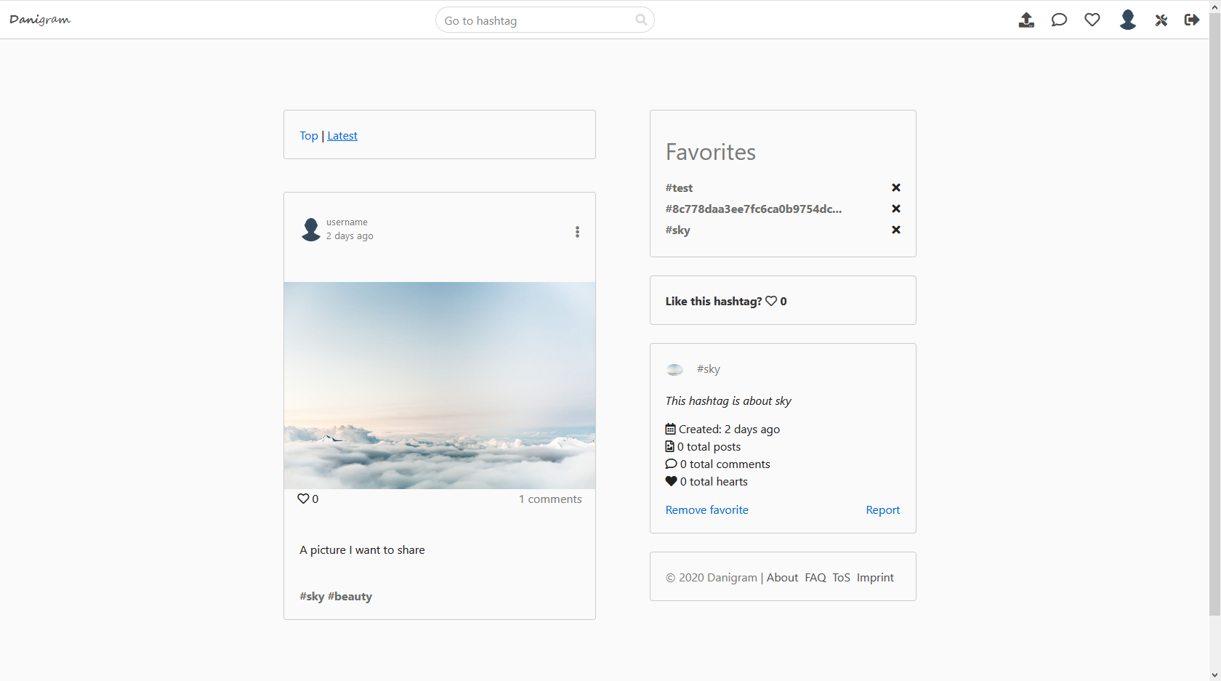

Submitting a post

In order to submit a post there is a form available for that. Posting is only allowed for authenticated users.
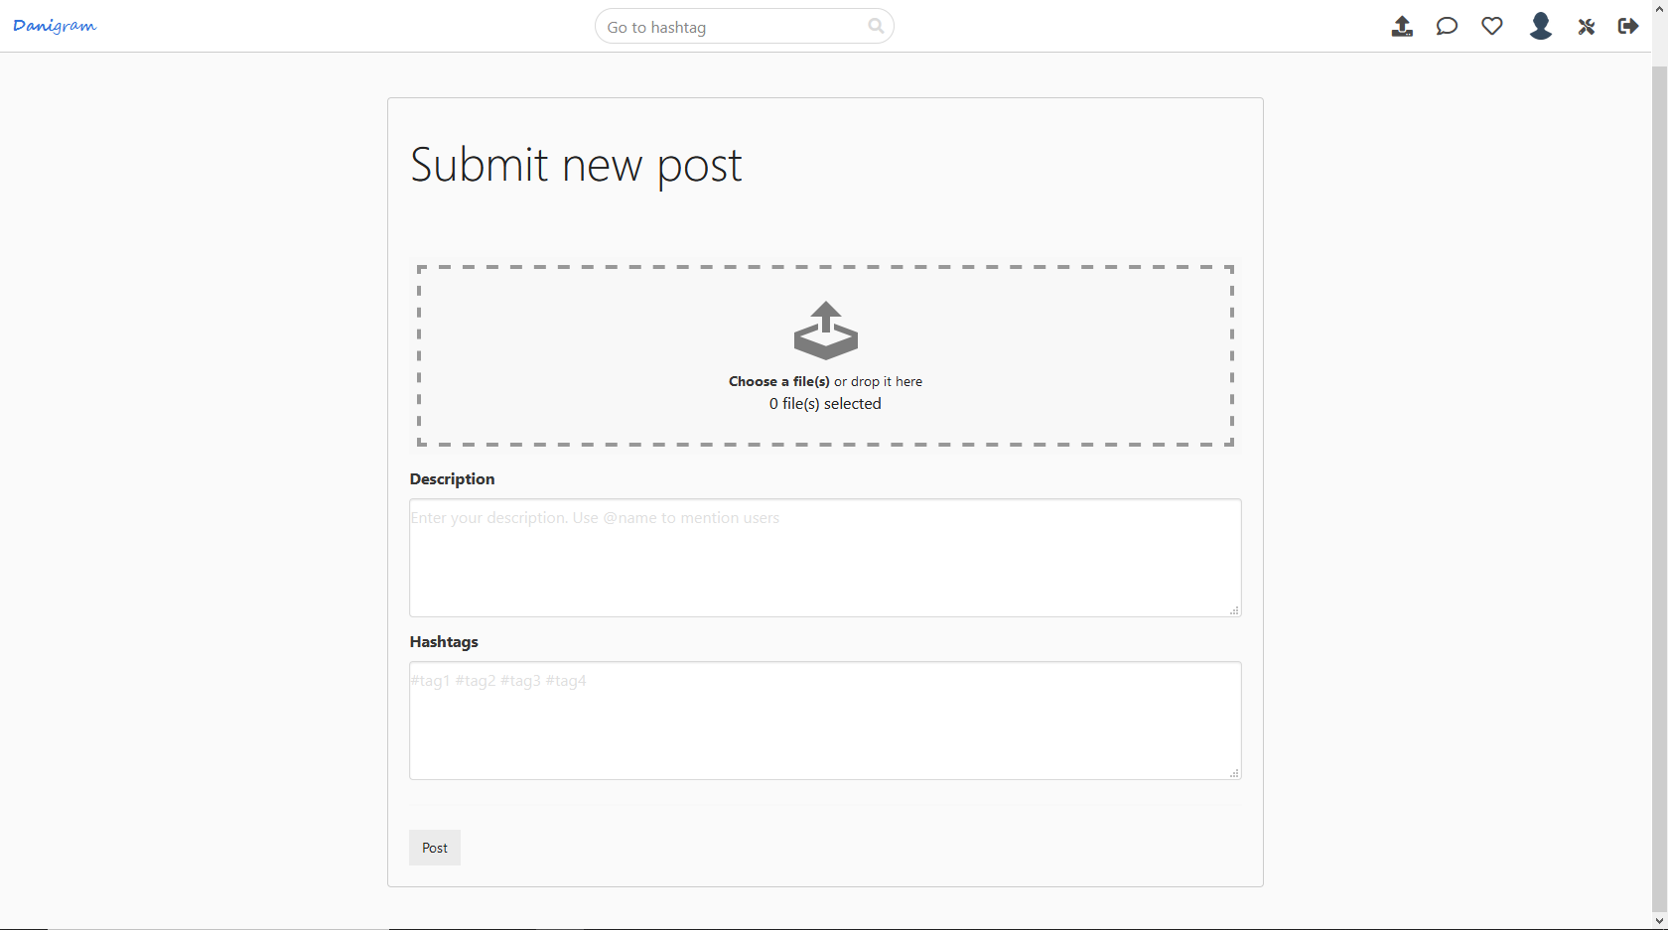
It is designed for doing a very quick upload. Just specify the image, a description and the hashtags. That‘s it! Hashtags are separated by a space character. In the description you can also mention users by prefixing their name with the @ character. They will get a notification that they have been mentioned in your post. The same works also for comments.
You can also view post specific settings. Click the menu icon.
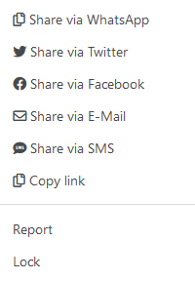

There you can share the post, report it or lock it if it is yours or you are an admin

Admins can lock posts, comments, hashtags and users.

Messages

You can also send messages to users.
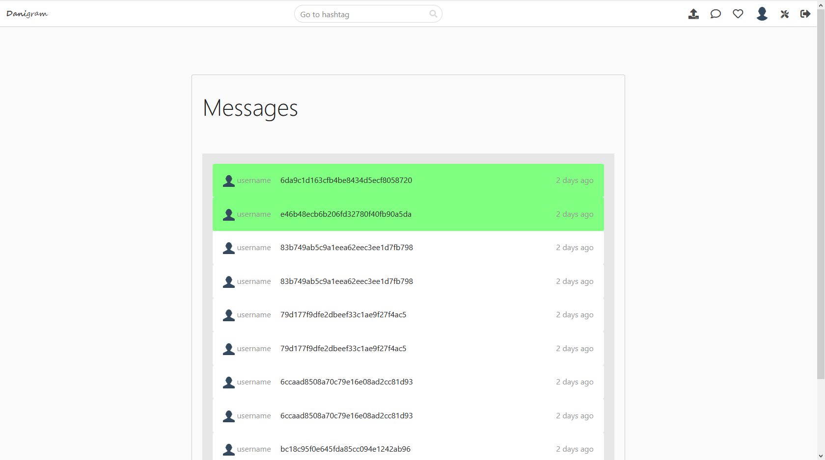
The message list shows the messages sorted by creation date. Unread messages will be highlighted. Click on a message to view the conversation.
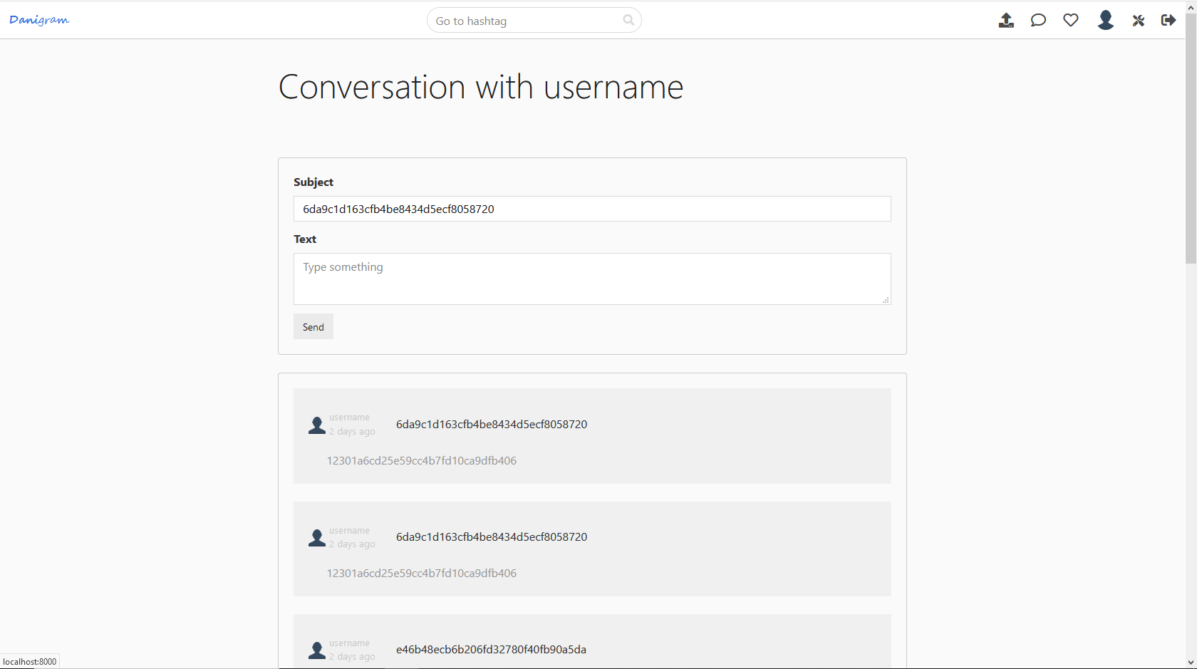
The conversation thread shows a form where to submit a new message and also the last messages from sender and recipient sorted as a conversation thread.

Notifications

You will get notifications if someone has hearted your post/comment, sent you a message, mentioned you in a post/comment or added you to their favorites.
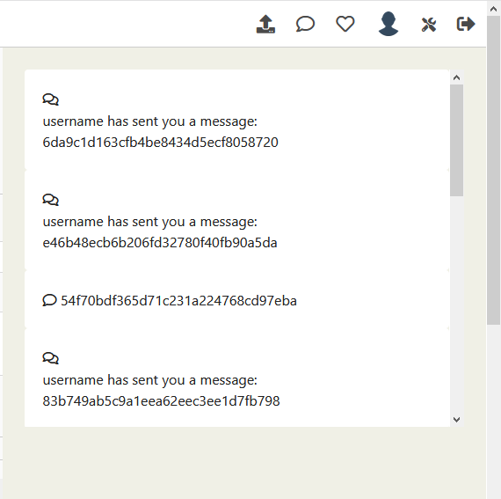
If a user has granted permission then there will also be push messages created for notifications.

Profile editing

Users can edit their profile by browsing to their profile page and then click the edit link. There they can change their username, bio, password, e-mail, upload an avatar, manage subscriptions, set themes and deactivate or delete their profile.
