HelpRealm Documentation

Codename: dnyHelpRealm
Author: Daniel Brendel <dbrendel1988@gmail.com>
Version: 0.1

Welcome to the documentation of HelpRealm – the free SaaS support ticket system. This guide shows you how to use the app. If you have any questions or need help please don‘t hesitate to contact me.

Table of contents
Registration 2
Customer view 3
Dashboard 6
Tickets 7
Groups 10
Agents 13
FAQ 15
System settings 17
Profile Settings 19

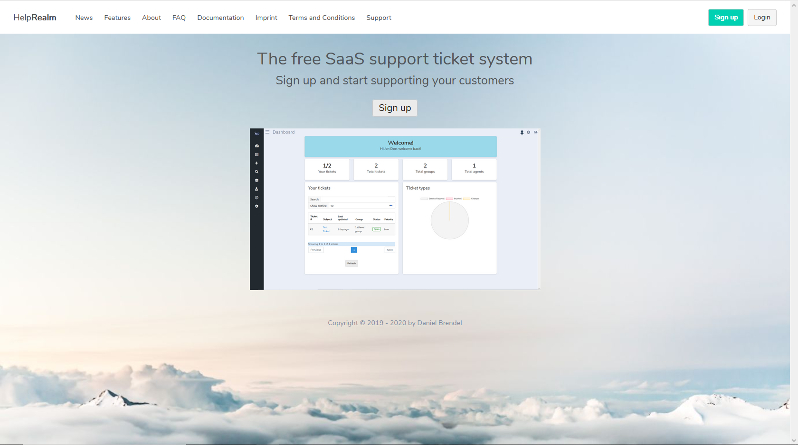

Registration

Just go to the official homepage of HelpRealm and read the terms and conditions carefully. If you agree with them then click on the signup button. A window should appear:

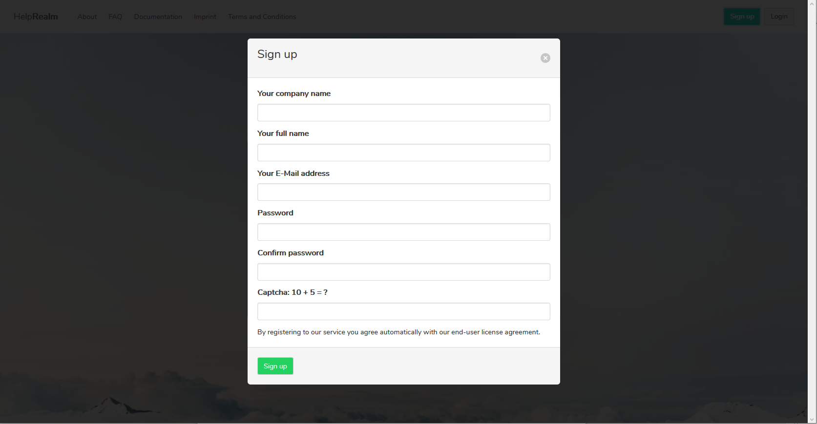
Enter your company name, your full name, your e-mail address, your password with confirmation and the captcha. Your account will then be created. After account creation you need to confirm your account with the specified e-mail address. After successfully confirming your account you will then be able to login into your workspace.

Go to system settings. You will find your workspace link there. This is the link you have to provide to your customers in order for them to create support requests.

Customer view

The customer view is what your clients see. They can either see a form where to create or open tickets with and also a personal page showing ticket information and conversation. Also they can view the FAQ.

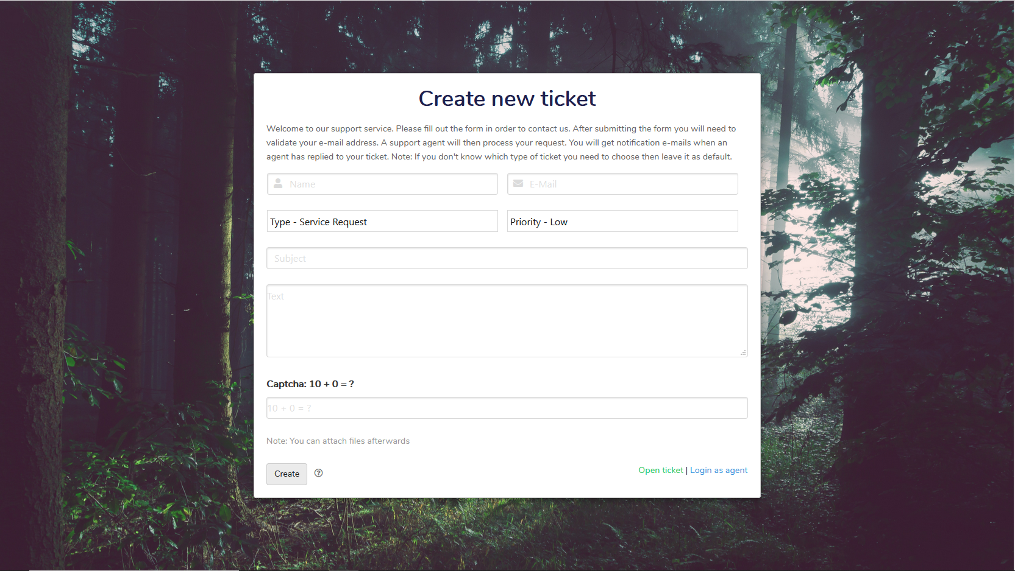

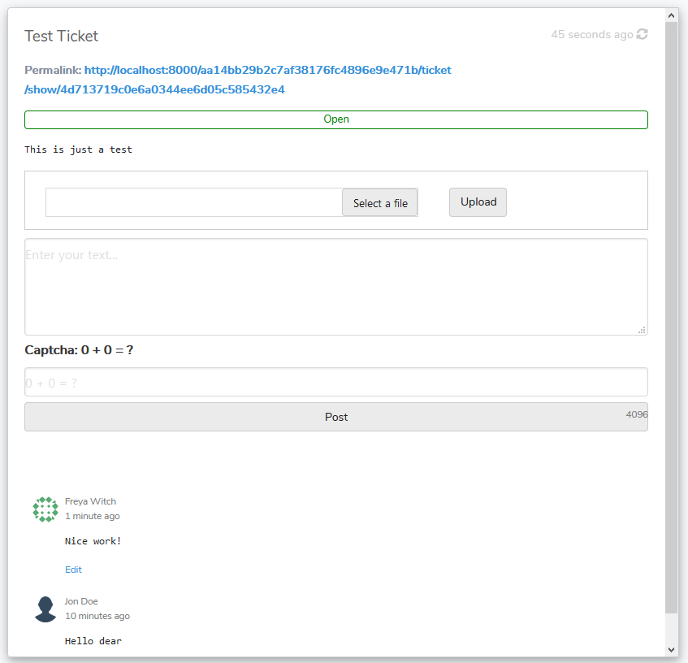
Before being able to manage a ticket by the owner customer, the customer needs to confirm their e-mail address after the ticket has been created. On successfull confirmation the customer can then post comments and upload files. The ticket will initially be set to „Awaiting confirmation“ and after successfull confirmation it will be set to „Open“.

The customer needs to held the link to the support conversation private. There they can communicate with the support staff and also exchange files. Whenever a customer replies to a ticket it will be set to status „open“. When a support agent replies it will set to „waiting“ which indicates that the staff is waiting for the customer to reply. When a ticket is closed by staff the customer can no longer reply or upload files to the ticket.

Customers will recieve e-mails for the associated events.

A customer can click „Open ticket“ and enter a ticket hash in order to view the ticket detail form. The ticket hash is the same as in the private ticket link.

The FAQ overlay looks as follows:
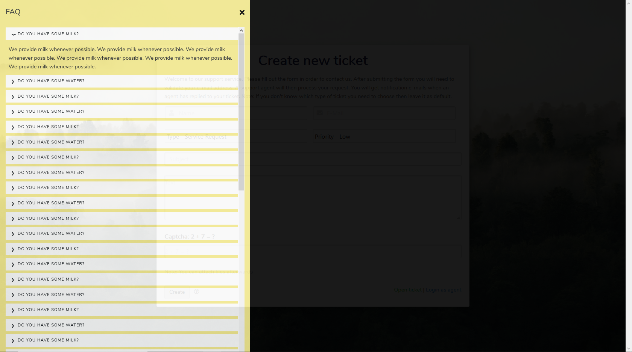

Dashboard

The dashboard shows you some general data. There you can view an overview of your tickets and general information about tickets.

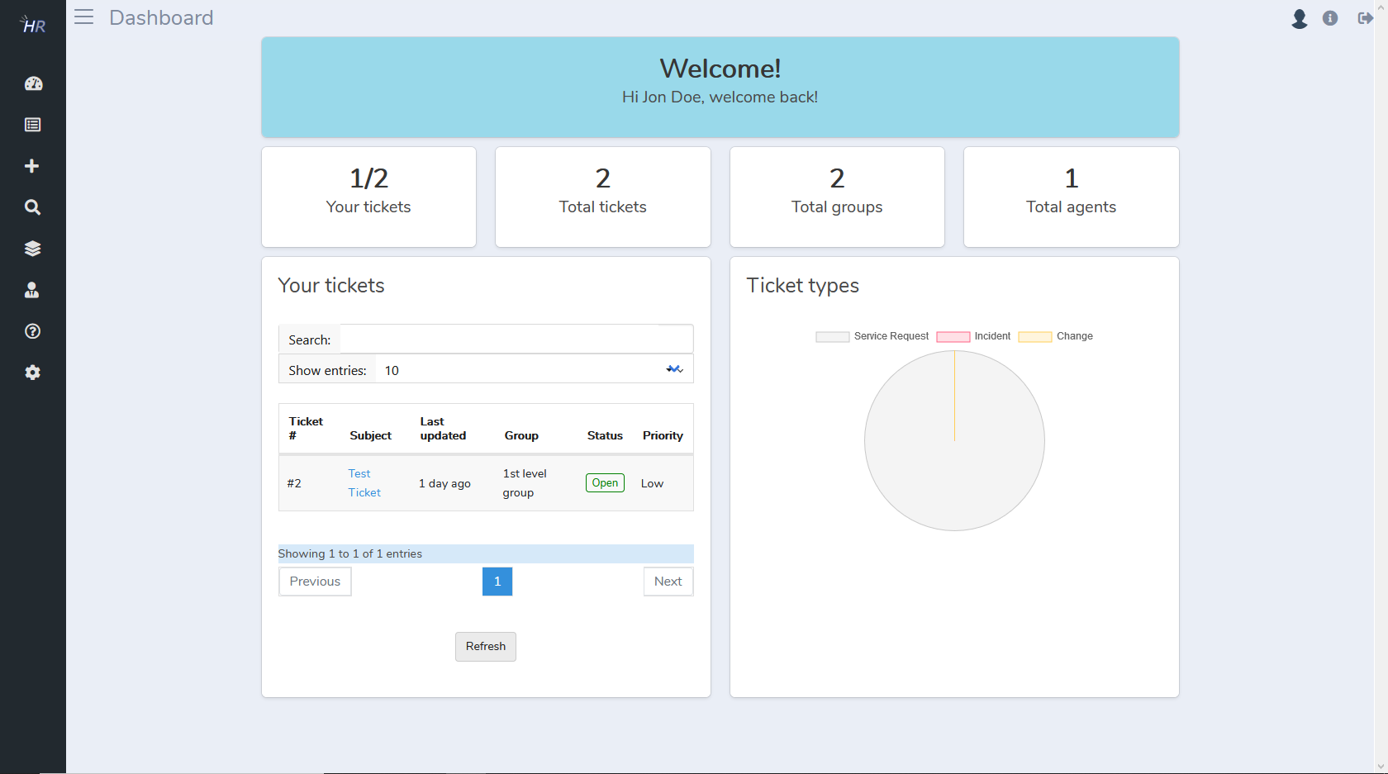

On left side there a menu. It covers the following items:
- Dashboard: Opens the dashboard as seen above
- Ticket list: Opens a ticket list where you can see tickets of your groups and tickets that are assigned to you
- Ticket creation: Here you can create tickets for customers
- Ticket search: Shows a form where you can search for tickets
- Groups: Manage ticket groups here. Only available for superadmins
- Agents: Manage your agents here. Only available for superadmins
- System: Manage system settings here. Only available for superadmins

Tickets

As an agent you can view your tickets and the tickets in the group you are in. Here you can see basic details of the tickets. Click a ticket in order to open it.

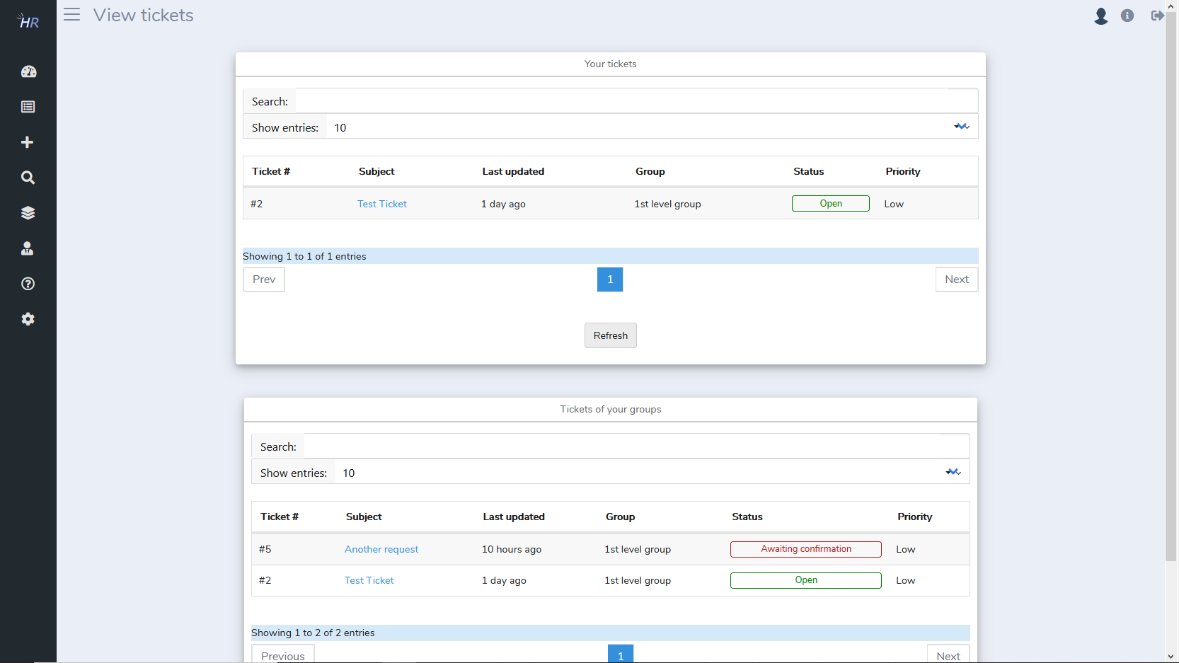

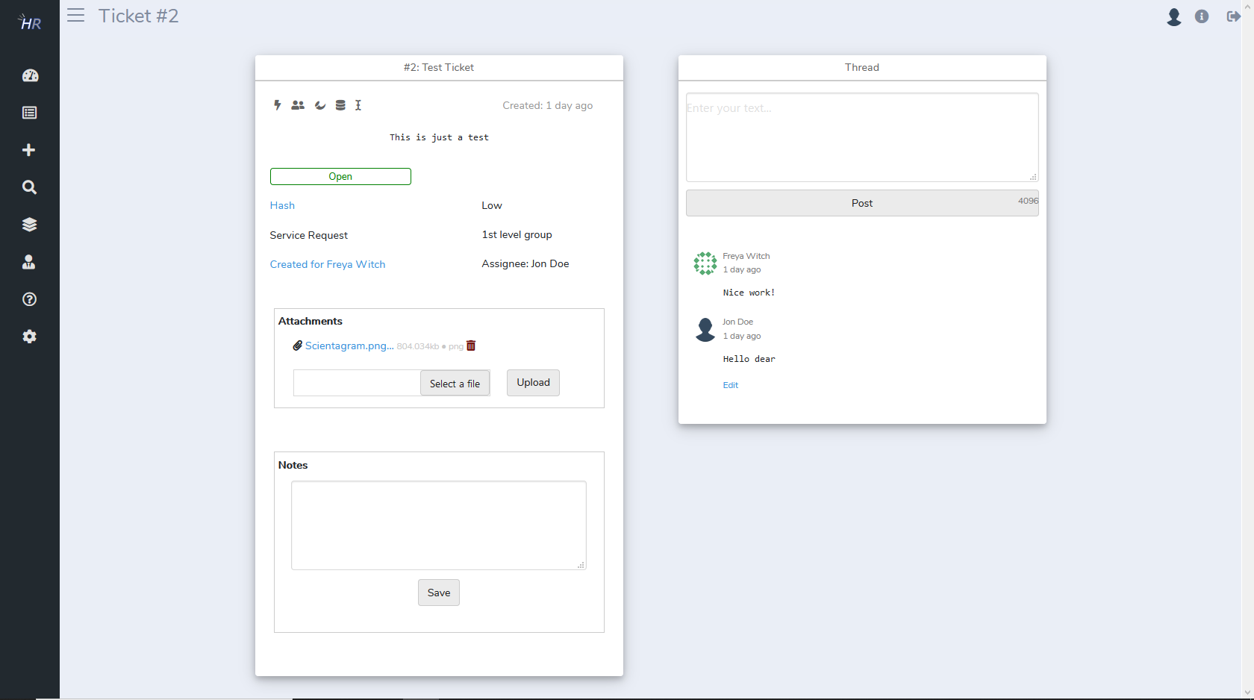

Now you can add comments, manage the ticket data and add attachments.
The following ticket options exist (left to right):



- Assign ticket to agent. A window will open where you can select an agent
- Assign ticket to group. A window will open where you can select a group
- Set ticket status. Here you can set the status open, waiting and closed
- Set ticket priority. Here you can set it to low, medium or high
- Set ticket type. Here you can change it to one of the ticket types you have defined

Click the „Hash“ link in order to view the ticket hash. You can share it with the customer.

You can create tickets for customers. Therefore click on the „+“ icon:

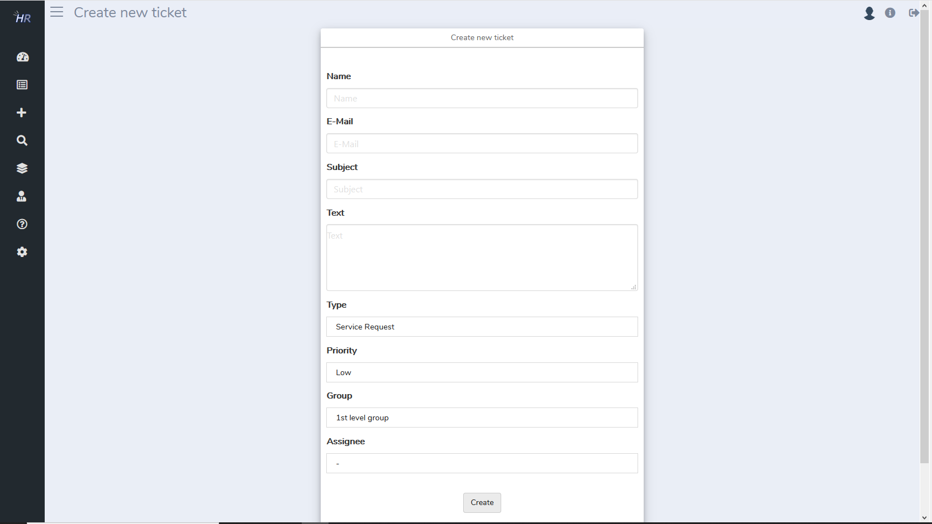

All fields are mandatory. You don‘t need to specify an agent if you want to just have it in a group and let the agents decide who takes it.

Note: It is also possible to reply to ticket notification emails in order to post to the ticket thread. A customer replying to a notification email will also lead to confirming their email address.
You also can search for tickets by clicking the lense button. Tickets can be found by ID, hash, subject and description.

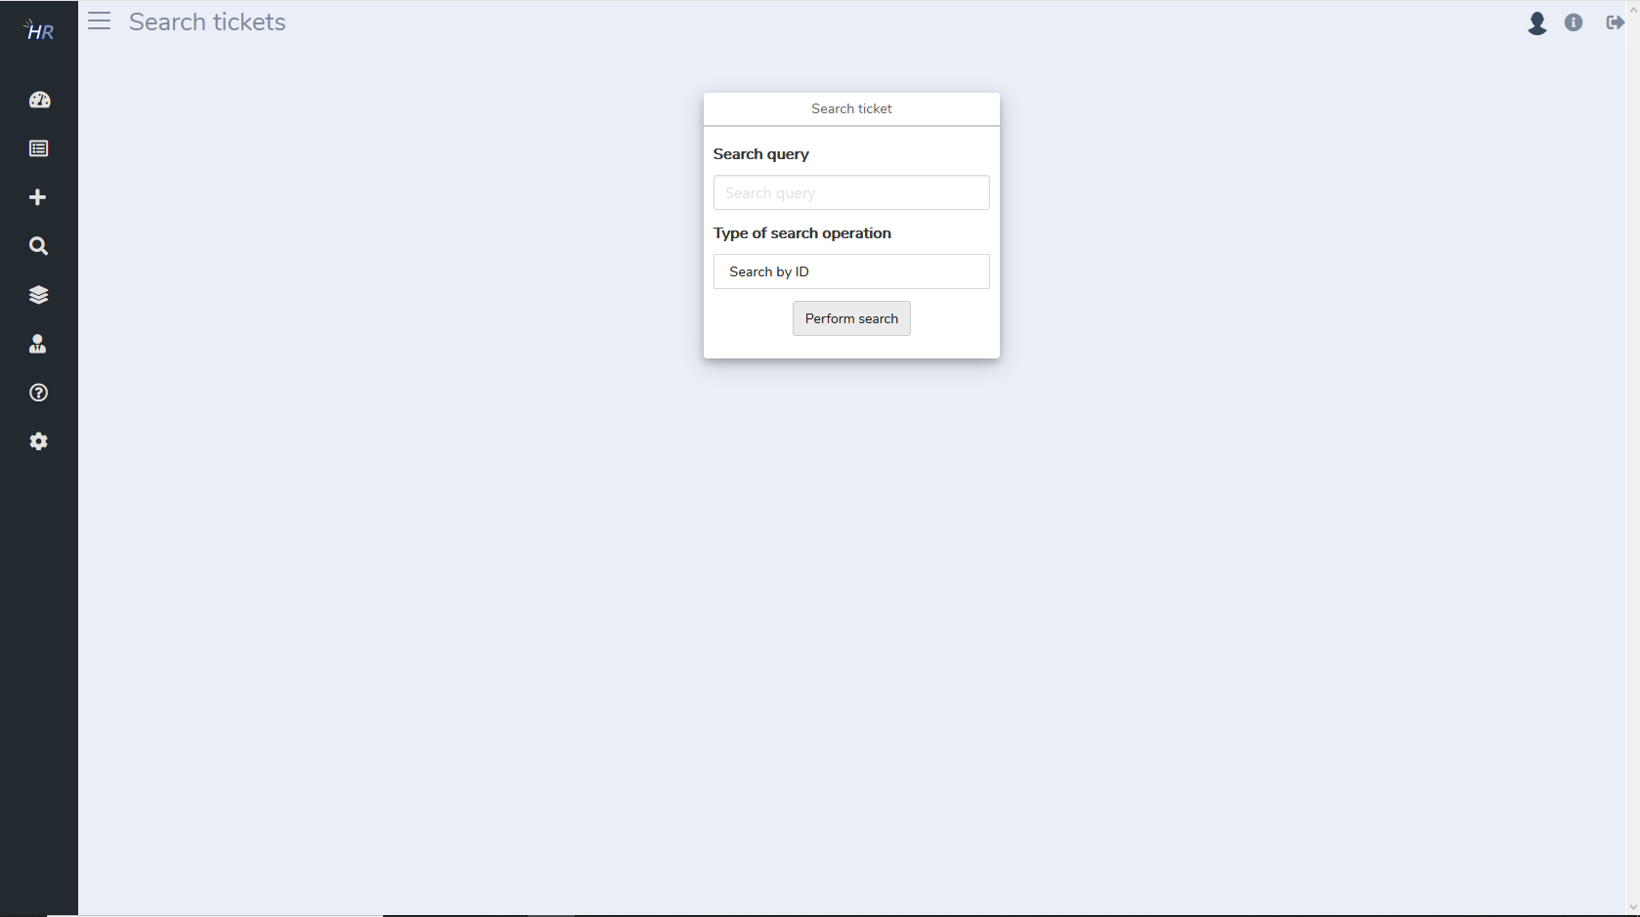

Groups

Here you can view a list of all created groups. Click a group in order to edit the group details. Click „Create“ in order to create a new group.

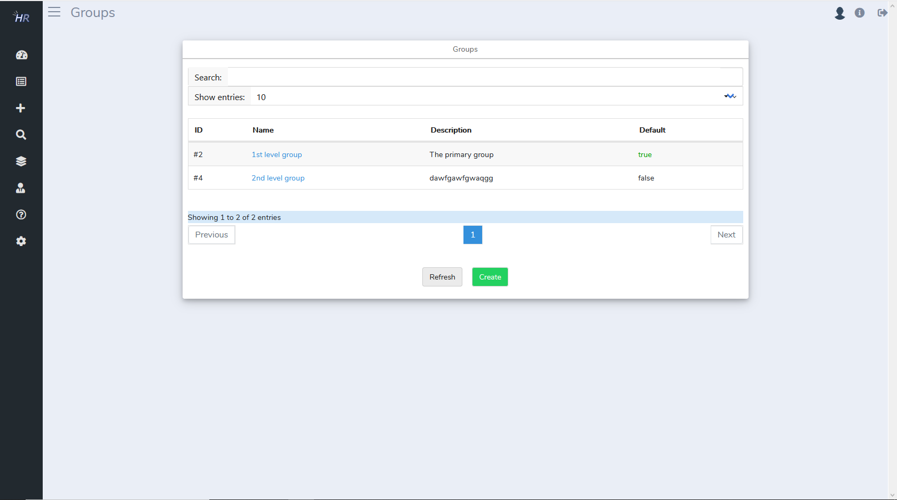

On group details view you can edit the group and also assign and remove agents

- Click on the „Add to group“ button to add an agent. A window with a list of agents will open
- Click the „Remove“ link in order to remove an agent from the group

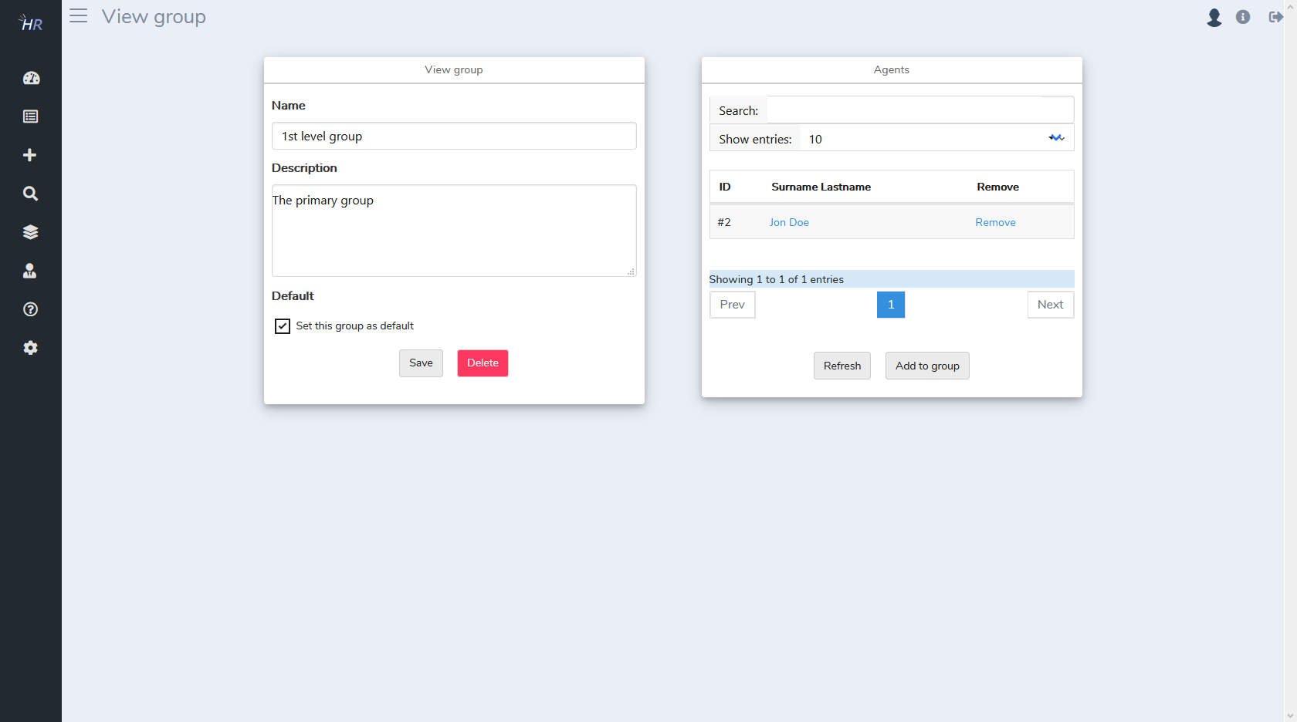
Back to the group list view, you can click „Create“ button to open a form where you can create a new group.

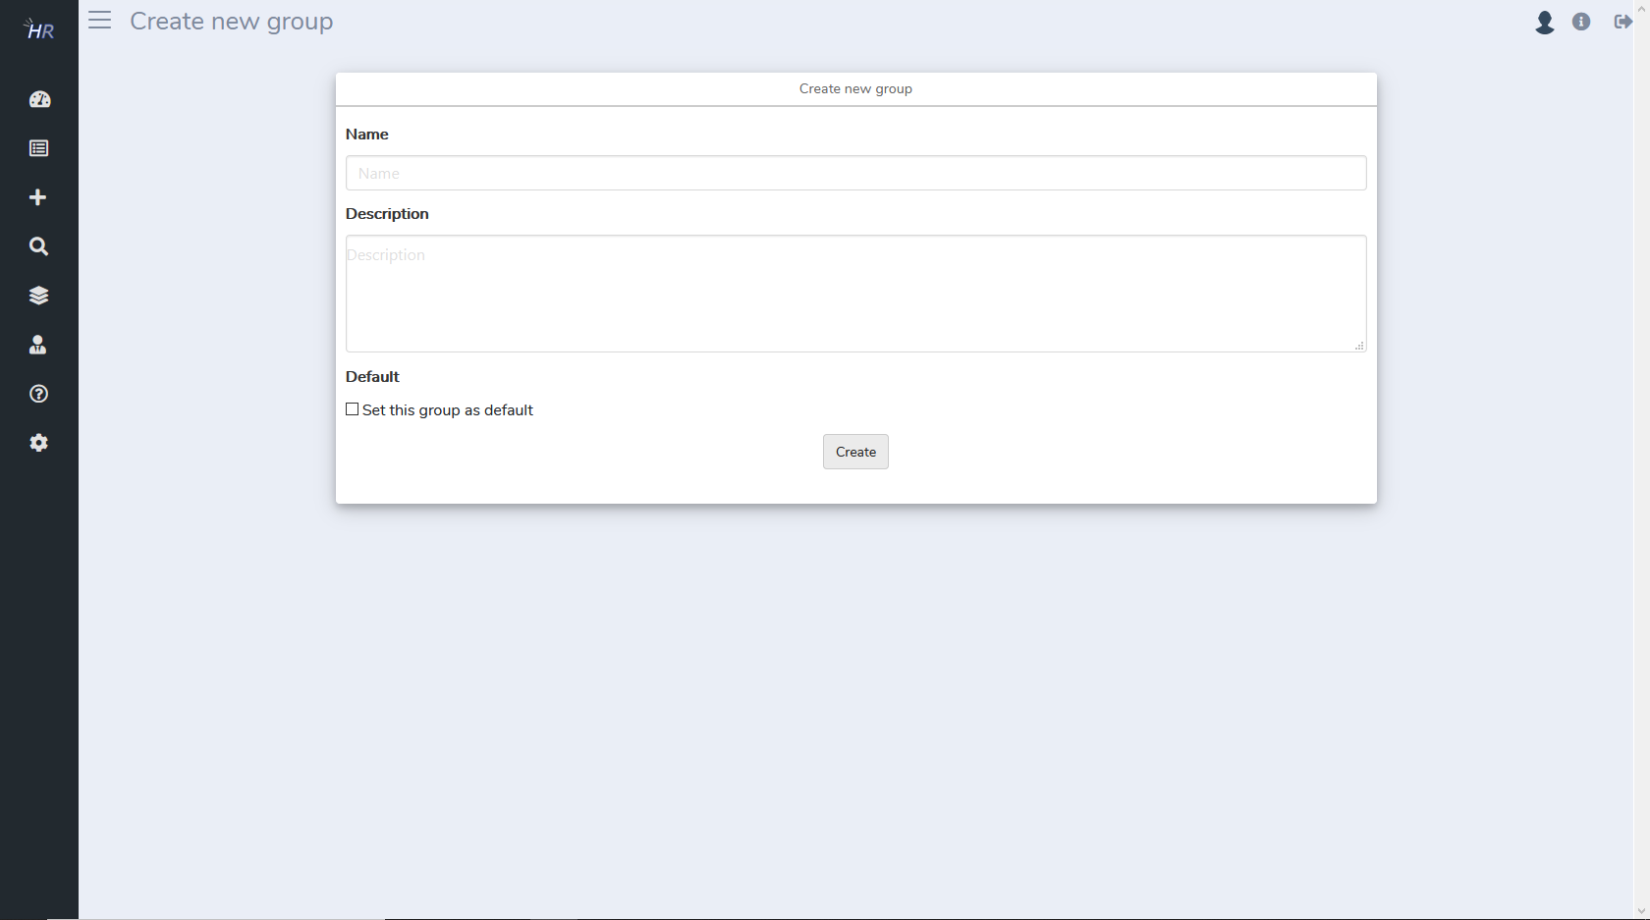
Note: Default group means that newly created tickets will be automatically inserted into the group. Only one group can be set as default. Setting multiple groups to default will be ignored.

Agents

Here you can view all your agents. You can click an agent in order to edit their details and assign groups. Also you can add new agents and delete existing ones. Be careful when granting superadmin rights. You should only give that permission to team members you are in that position of your company.

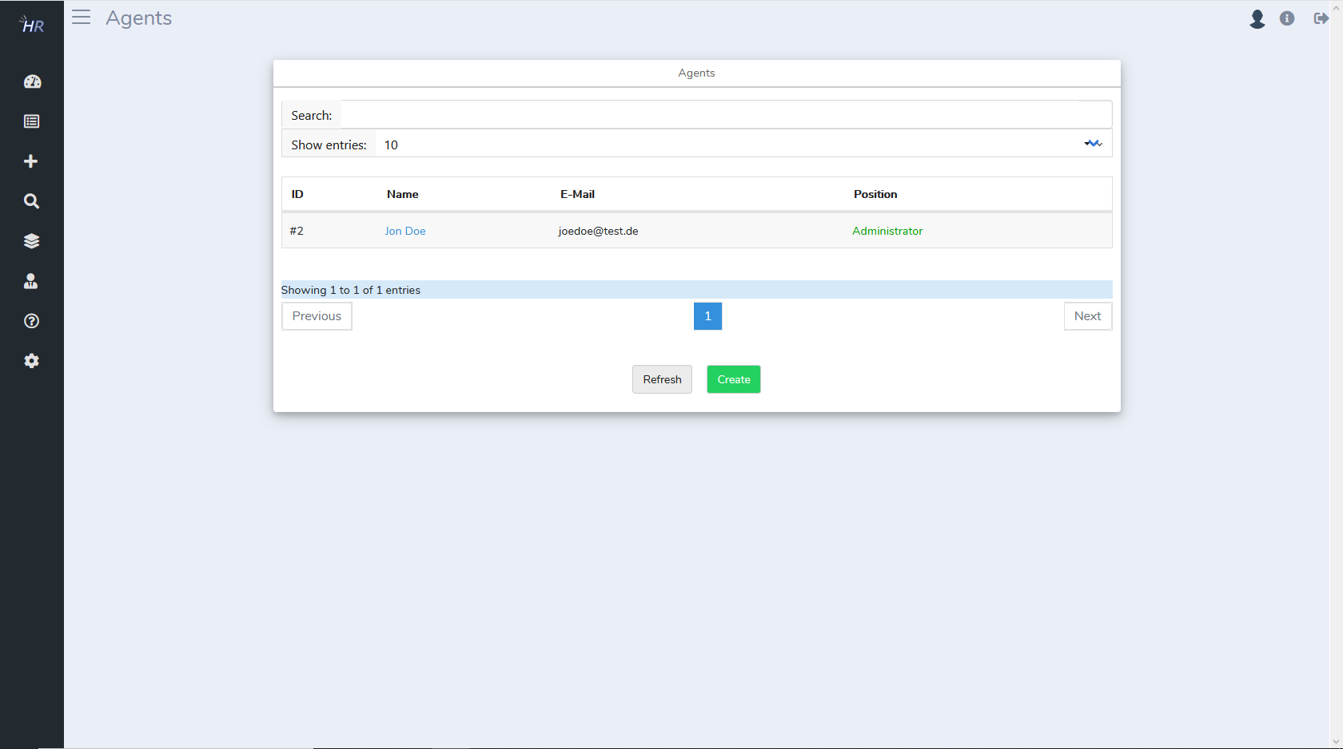

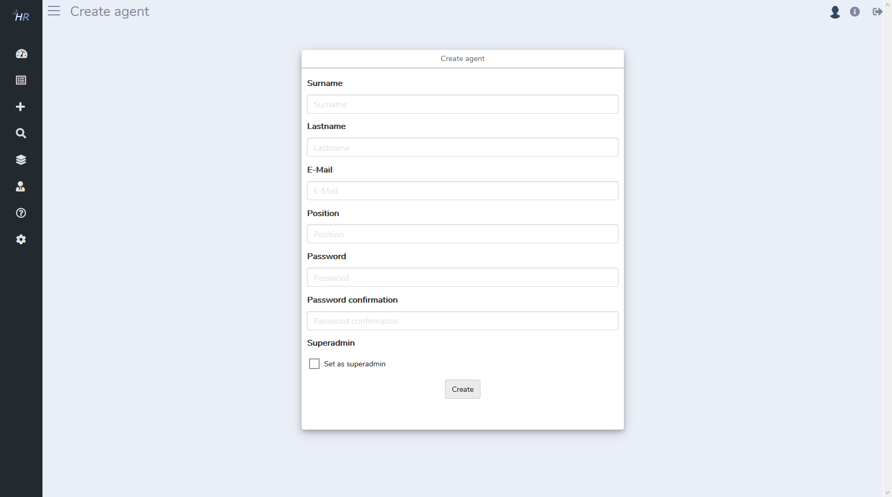

If an agent is currently not active you can disable the active flag. Non-active agents will not be able to login and can‘t be assigned to tickets. If an agent returns to work then you can set the agent to active again.

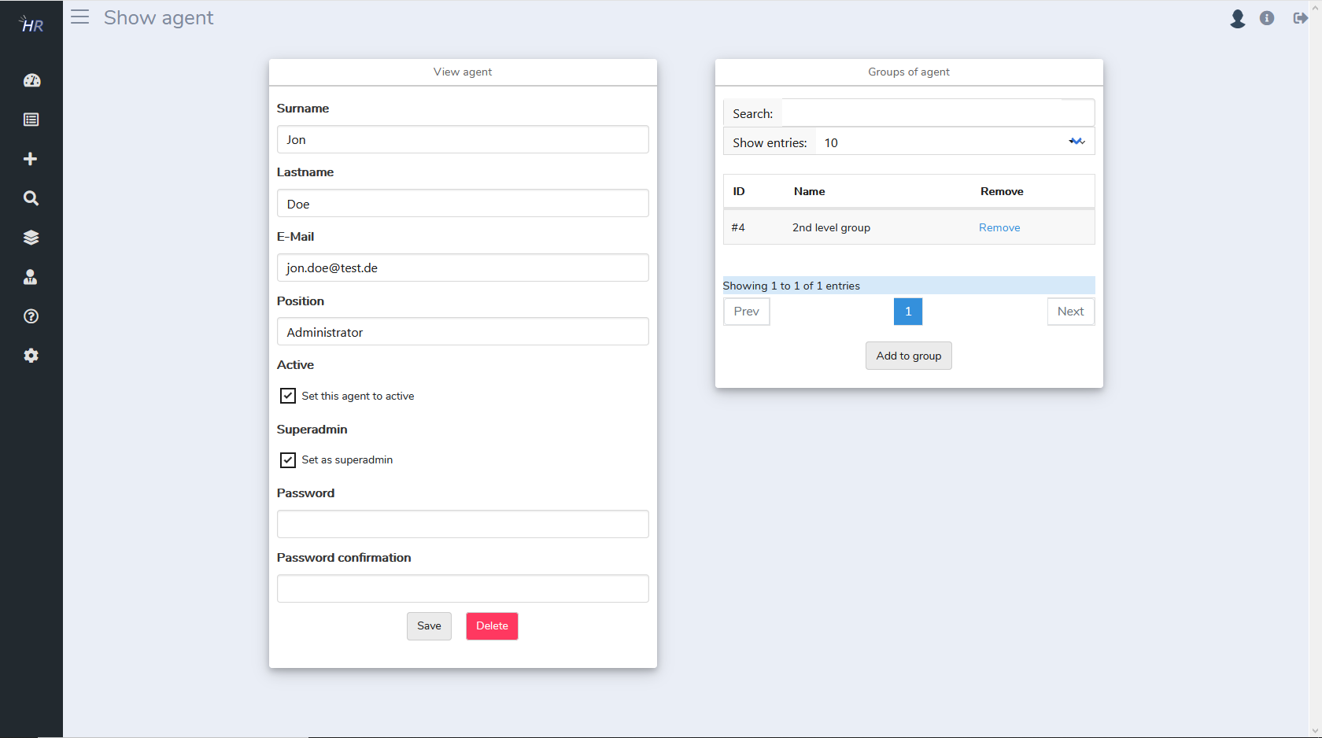

FAQ

You can manage frequently asked questions here. FAQs can be used to provide answers to common questions so a customer doesn‘t need to create a ticket for any simple problem. Click the question mark item to view the list of FAQs.

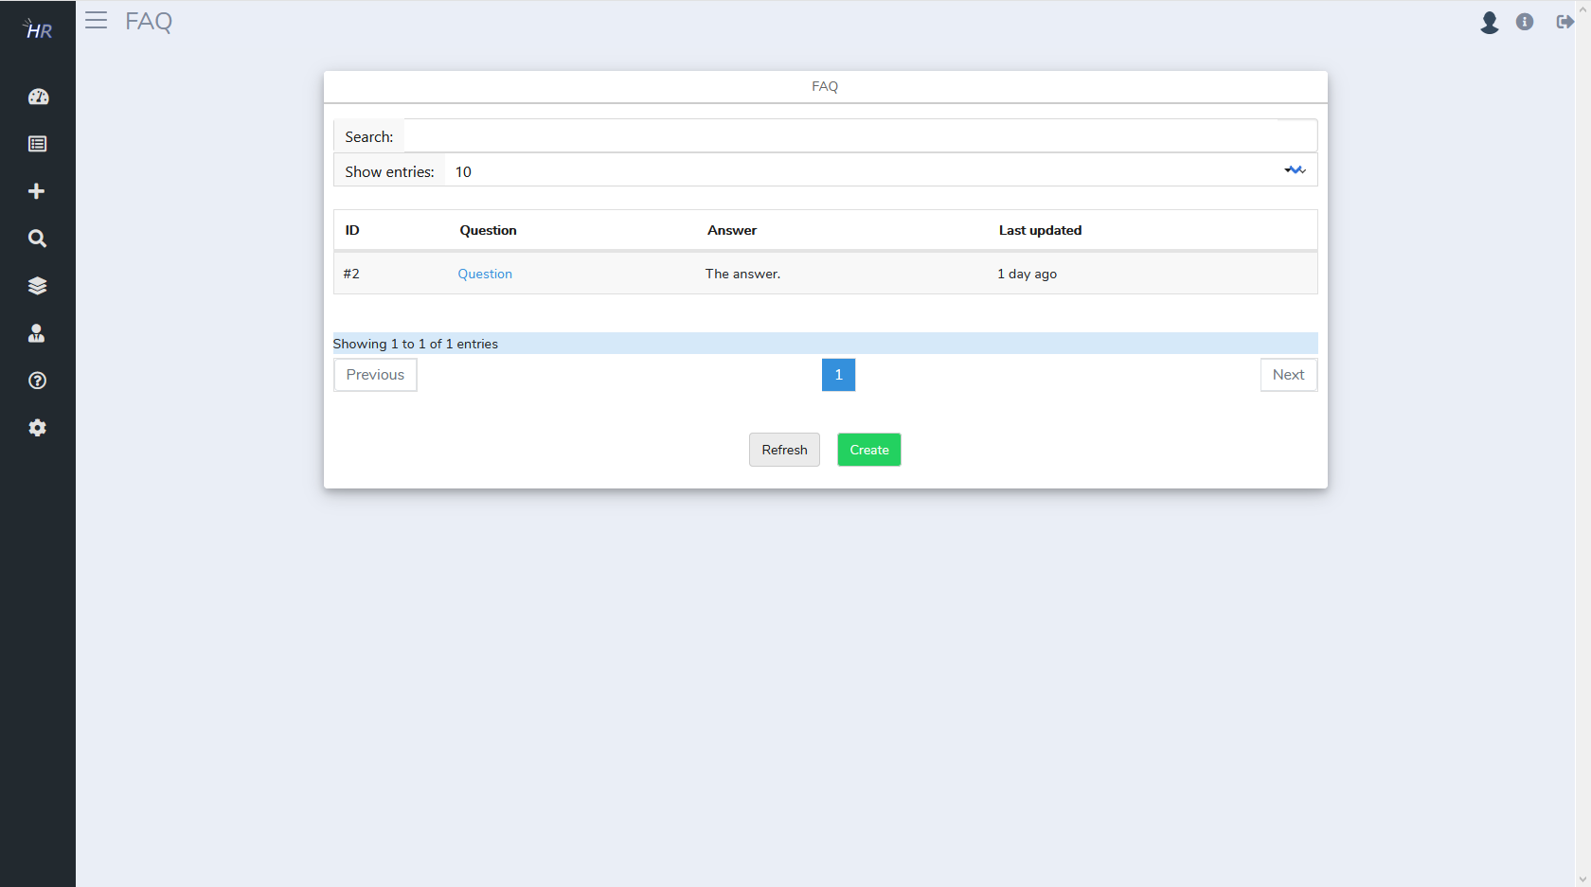
Click the create button to create a new FAQ.

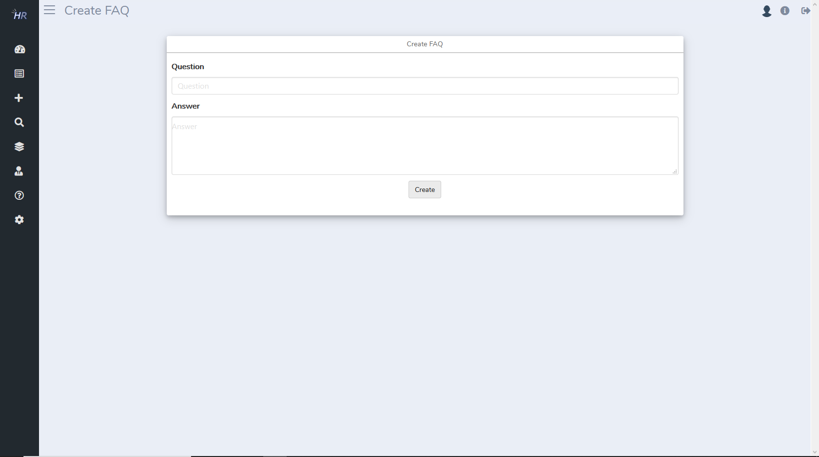
In the FAQ list you can click on an item in order to edit it.

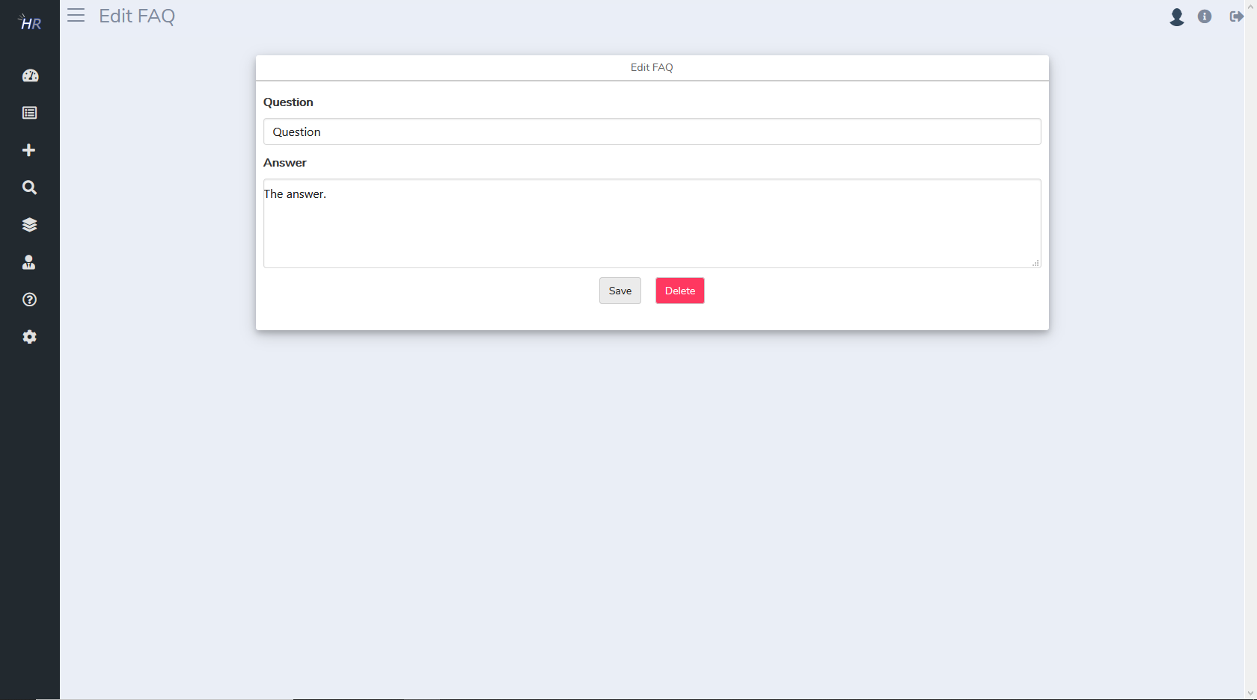

System settings

Here you can manage system settings. You can set the company name, the global language (used for your customer views), the ticket form welcome message, ticket types and background mode. Global language is overritten by personal language that can be set by agents of their own profile (see settings section).

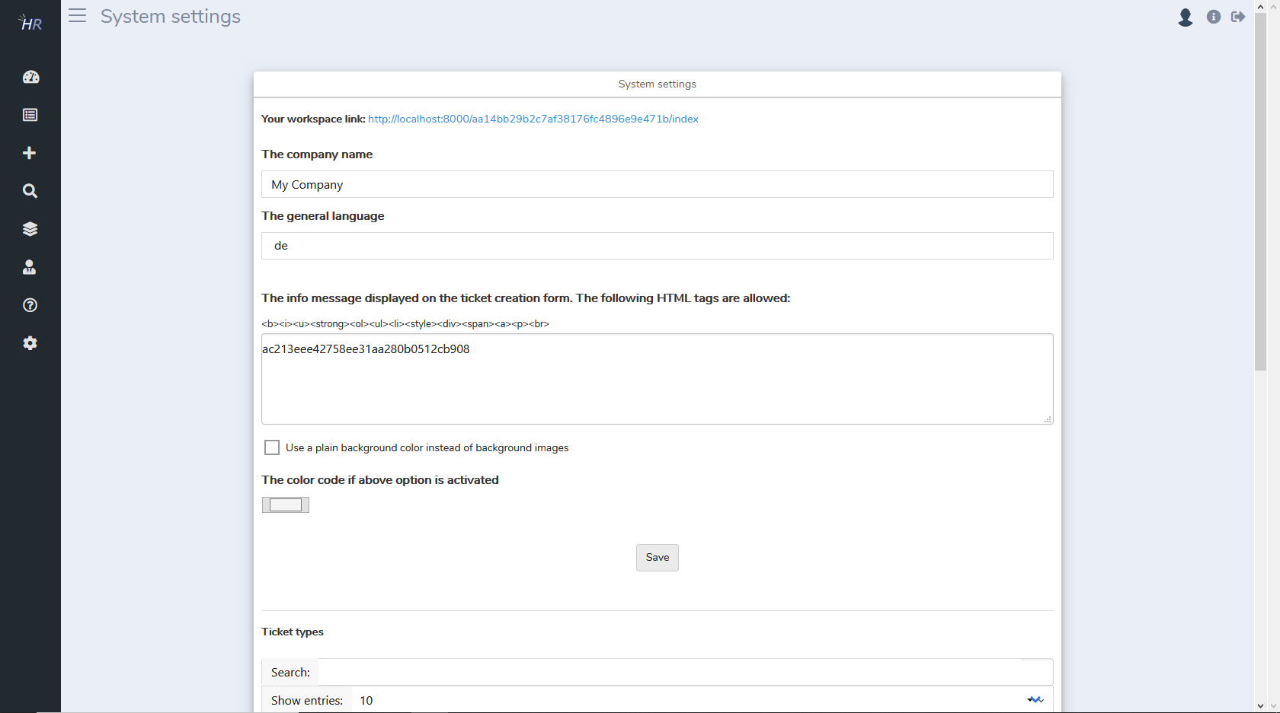
The ticket types should define the types of ticket that are suitable for your business. Commonly there are types such as Service Request, Incident and Change.

Regarding the background mode you can specify whether background images or a plain background color shall be used in the customer views. And also you can upload new background images or delete existing ones.

There is also a danger zone where you can cancel your workspace. This will result in erasing all your workspace data and cannot be undone.

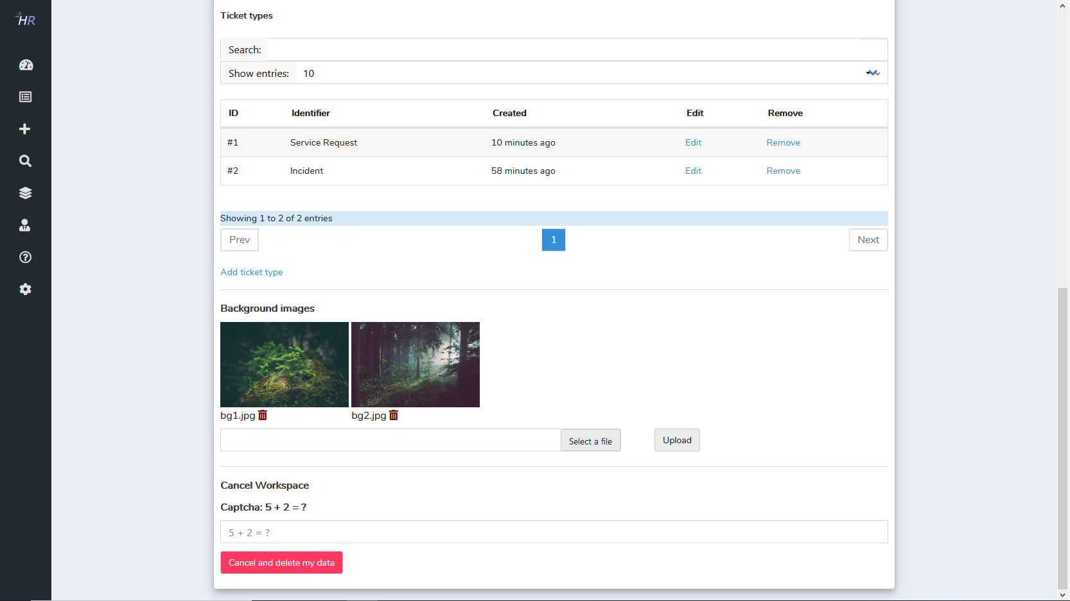

Profile Settings

You can edit your own settings in the settings menu. There you can edit your personal settings, change your password, upload an avatar and change your language.

