4HC3 Assignment #2 Parking Meter – Design Decisions

| Daniel Agostinho  001414323  Hamilton, Canada  agostd@mcmaster.ca | Jin Lee  001417622  Hamilton, Canada  leejs9@mcmaster.ca | Tara Madani  001431692  Hamilton, Canada  madanit@mcmaster.ca |
| --- | --- | --- |

# ABSTRACT

## The purpose of this paper is to outline some of the design decisions that were considered during the development of the user interface.

## Author Keywords

UI: User Interface; XPP: XpressPark Pass;

# INTRODUCTION

# Parking meters are some of the friendliest, unfriendly user interfaces known to man. As stated in the guidelines, mechanical parking devices are very simple to use whilst electronic parking meters are bogged down by digital functions to accommodate a variety of payment options. While the use of parking devices that utilize license plates or parking space numbers are a lot easier to use, for the purpose of this assignment, the design demonstrated in the interface is more practical and has more features than the typical “display your permit on dashboard” parking meter.

# DESIGN DECISIONs

# The interface begins with a very clear set of options. The user can either print a new ticket, add more time to an existing ticket, using your XpressPark Pass (XPP for short), or refund an existing ticket. The time is static and will be displayed in the top with the rates in the top right corner so that users will have visual access to the two most important variables at all times. Before continuing, it is important to note that the time added can be edited at anytime through all the screens, the buttons highlighted in pink are physical functions being digitally simulated and would otherwise not be shown on the screen.

All of the controls that are necessary to the user are displayed as bright buttons (some with images to help further infer the meaning of these buttons). The images assist in conveying the purpose of the button and add to the conceptual model the user has about the system. For example, the “Tap” feature of the XPP is labeled with a familiar icon for contactless payment.

# ADDITIONAL FEATURES

There are two additional main features that were not suggested in the original instructions for this user interface: the option to take an existing parking ticket and add additional time to the ticket, and secondly the option to have a premium paid parking feature.

The ability to add more time to the user’s in a facilitated manner is a much needed feature. The hassle of having to buy a new ticket because of an unanticipated need to stay in the parking spot longer, is an absolute annoyance. The user interface now allows the user to submit their previous ticket to the meter and add additional time. The remaining time is displayed and the user can then gauge how much additional time is needed. The printing and payment of the ticket after that point is the exact same as buying a new ticket.

The XpressPark Pass is a fictitious parking pass that was created for the “brand” of machines meaning that the user can refill the card online and use it as an express method of paying for parking spots. This system mimics the PRESTO card system. The user would select the XPP option on the main menu, tap their card to “sign in” and selects that they are parking. Once the user leaves, they do the same process except they select that they are leaving and the amount is automatically deducted from their account balance. This saves the hassle of the user having to estimate how long they anticipate they will be parked for. The ticket that the user prints is slightly different than the regular parking ticket because there is no time limit on the parking ticket. This system would allow the user to be more flexible with how long they want to park and it provides a faster way of getting the parking ticket.

**EARLY DESIGN IDEAS**

Below are some early iterations of the design and the flow of the UI.

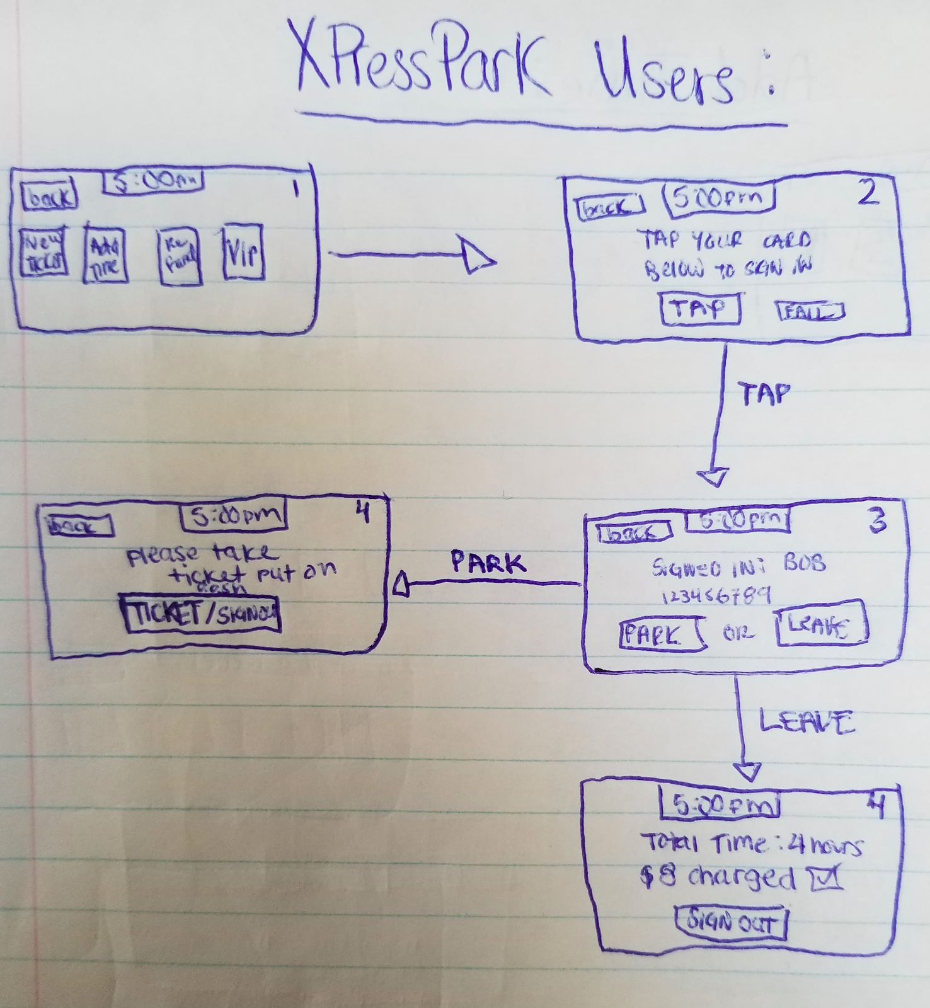

**Figure 1. Premium parking screen idea**

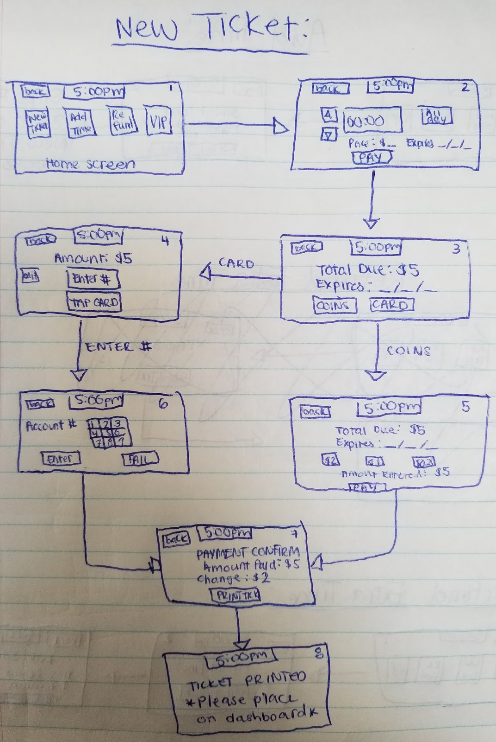

**Figure 2. Purchasing New Ticket**

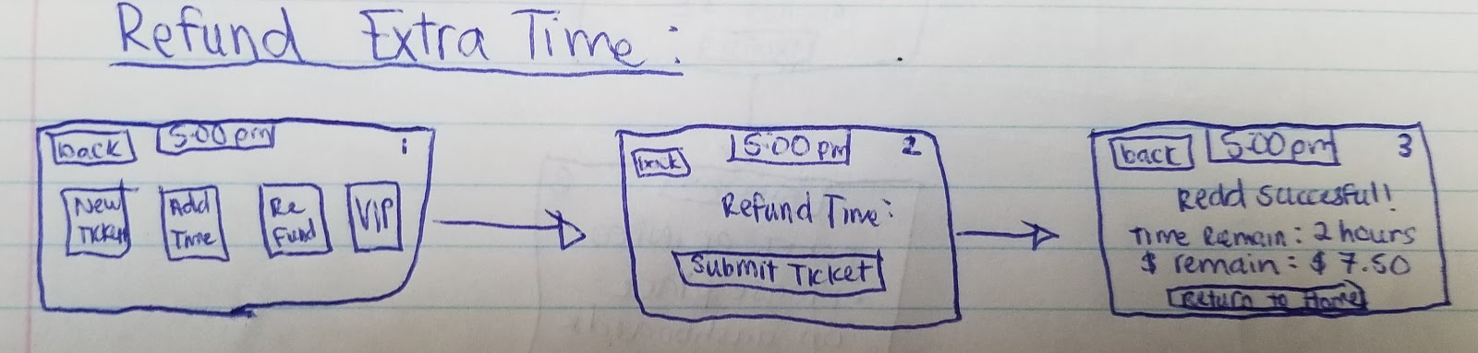

**Figure 3. Refunding Time Left Over on Ticket**

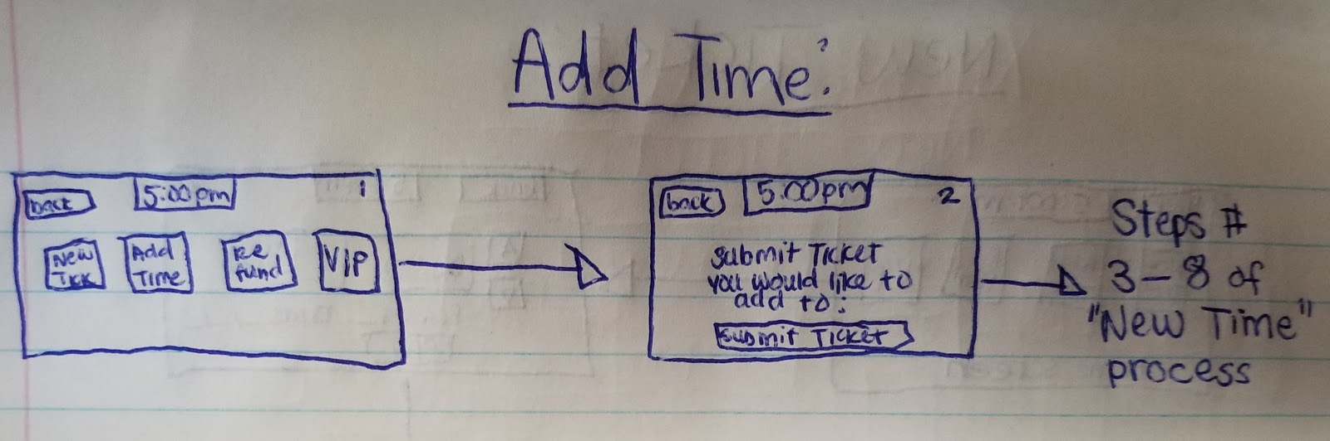

**Figure 4. Adding Additional Time to Current Ticket**