Public support for welfare and redistributive policies in Ireland
Daniel Capistrano
Bertrand Maître
Helen Russell

January 2026

RESEARCH SERIES
NUMBER XX

Available to download from www.esri.ie (Style: RS Title page – Add info)
https://doi.org/10.26504/rs...

ISBN 978-0-7070-XXXX-X (only include an isbn if the report is being printed)

© 202X The Economic and Social Research Institute
Whitaker Square, Sir John Rogerson’s Quay, Dublin 2.
This Open Access work is licensed under a Creative Commons Attribution 4.0 International License (https://creativecommons.org/licenses/by/4.0/), which permits unrestricted use, distribution, and reproduction in any medium, provided the original work is properly credited.

ABOUT THE ESRI
The Economic and Social Research Institute (ESRI) advances evidence-based policymaking that supports economic sustainability and social progress in Ireland. ESRI researchers apply the highest standards of academic excellence to challenges facing policymakers, focusing on ten areas of critical importance to 21st century Ireland.

The Institute was founded in 1960 by a group of senior civil servants led by
Dr T.K. Whitaker, who identified the need for independent and in-depth research analysis. Since then, the Institute has remained committed to independent research and its work is free of any expressed ideology or political position. The Institute publishes all research reaching the appropriate academic standard, irrespective of its findings or who funds the research.

The ESRI is a company limited by guarantee, answerable to its members and governed by a Council, comprising up to 14 representatives drawn from a cross-section of ESRI members from academia, civil services, state agencies, businesses and civil society. Funding for the ESRI comes from research programmes supported by government departments and agencies, public bodies, competitive research programmes, membership fees, and an annual grant-in-aid from the Department of Public Expenditure, Infrastructure, Public Service Reform and Digitalisation.

Further information is available at www.esri.ie.

THE AUTHORS
Xxxxx Xxxxx is an Associate Research Professor at the Economic and Social Research Institutute (ESRI) and an Adjunct Professor at Trinity College Dublin (TCD). Xxxxx Xxxxx is a Senior Research Office at the ESRI and an Adjunct Associate Professor at TCD.

or

Xxxxx Xxxxxxx and Xxxxx Xxxx are Associate Research Professors and Xxxxx Xxxxx is Research Officer at the Economic and Social Research Institute (ESRI) and all also hold adjunct positions at Trinity College Dublin (TCD). Xxxxx Xxxxx is a research assistant at the ESRI.
(Style: RS Body Text)

ACKNOWLEDGEMENTS
Style: RS Body Text

This report has been accepted for publication by the Institute, which does not itself take institutional policy positions. All ESRI Research Series reports are peer reviewed prior to publication. The author(s) are solely responsible for the content and the views expressed.
(Style: RS Disclaimer)

TABLE OF CONTENTS
Executive summary 5
CHAPTER 1 6
Introduction 6
1.1 Previous research 6
1.1.1 Societal level influences 7
1.1.2 Socio-demographic predictors of welfare attitudes 7
1.1.3 Political attitudes and welfare attitudes 7
1.1.4 Welfare for whom? 8
1.1.5 Experimental studies of welfare attitudes 8
1.2 Methods and data 8
CHAPTER 2 10
Who supports redistribution? 10
2.1 Higher support in Ireland compared to other northern European countries 10
2.2 A third of the Irish population would agree with higher taxes if it means more or better public services 11
2.3 Female and lower SES respondents are more supportive of redistribution 13
2.4 Left-wing voters are more supportive of redistribution 16
2.5 Age, gender and social class are relevant even controlling for economic activity, education and financial situation 17
CHAPTER 3 20
WHAT DO PEOPLE THINK ABOUT WELFARE POLICIES? 20
3.1 Meritocratic differences are acceptable for younger and right-wing respondents 20
3.2 The government should have more responsibility towards old citizens and working parents compared to the unemployed 21
3.3 Most respondents indicate that immigrants could receive social benefits after having worked and paid taxes for at least one year 23
3.4 The view that ‘Social benefits make people lazy’ is more prevalent in Ireland compared to the European average 24
3.5 Younger respondents in Ireland are more likely to agree that social benefits make people lazy 26
3.6 Unfairly low wages are more relevant than unfairly high wages for support for redistribution in Ireland 28
CHAPTER 4 30
Has support for redistribution changed over time? 30
4.1 Age and Gender 32
4.2 Relevant events 34
4.2.1 Attitudes are impacted by government campaigns 35
4.2.2 Budget announcement 37
4.2.3 Pandemic 39
CHAPTER 5 42
Conclusions and policy implications 42
References 44

Executive summary
Drawing on data from the European Social Survey (ESS), the current report presents findings of a research project that explored attitudes towards welfare and redistributive policies among Irish residents. The main findings of the report are:
- 3 in 4 Irish residents indicate that they agree that the government should reduce differences in income. This proportion is slightly higher than the European average and the ones from other northern European countries (Figure 2.1).
- Females and those from lower social classes are more supportive of income redistribution (Table 2.1).
- Ireland has one of the highest proportions in Europe of respondents who believe that ‘social benefits make people lazy’ (Figure 3.5).
- Younger, right-wing, and those with lower educational attainment are more likely to agree that social benefits make people lazy (Table 3.1).
- From 2009 to 2016 there was an increase in the proportion of respondents who agree that ‘social benefits lead to a more equal society’ (Figure 3.4).
- In Ireland, perceptions about unfairness of the income of the rich is associated with support for redistribution as much as perceptions of how unfairly low the income of the poor is. In countries such as Norway and France, unfairly high incomes are more strongly associated with support for redistribution (Figure 3.6).
- Support for income redistribution among the working class in Ireland is now at the highest level since 2002 (Figure 4.2).
- Events such as government campaigns and budget announcements have significant but short-lived impact on welfare attitudes (Figure 4.7) and support for redistribution (Figure 4.9).
- Those who experienced job loss during the COVID19 pandemic are more supportive of redistribution, regardless of their financial situation (Figure 4.10).

CHAPTER 1
Introduction
Many vulnerable individuals and families in Ireland, each with different profiles, circumstances, and needs, are struggling to make ends meet and are falling into poverty. According to 2024 figures from the Central Statistics Office (CSO), 12 per cent are at risk of poverty and 16 per cent experience material deprivation. A significant part of the Irish population relies on welfare benefits (social transfers), but the current level of support is often insufficient to protect them from poverty. Given the limits to government finances and the competing demands for funding social welfare in Ireland, it is crucial to have a better understanding of the public support to State actions designed to address these challenges.
With this objective, the current report presents findings of a research project that explored attitudes towards welfare and redistributive policies among Irish residents. Ireland offers a particularly relevant context for this research. Over the past few decades, the Irish society experienced different levels of economic growth, income inequality, and poverty (Roantree et al. 2025). In this sense, the changing socio-economic environment provides valuable information to examine the factors associated with public support for welfare policies and income redistribution. To explore this, we analyse multiple rounds of the European Social Survey (ESS) conducted between 2002 and 2024.
The research project was guide by the following general questions:
- Who in Ireland supports income redistribution?
- What do Irish residents think about welfare policies?
- Has the overall support for welfare policies and income redistribution changed over time?
Chapter 2 in this report addresses the first question of a diffuse and generalised support for income and wealth redistribution in the Irish society. Chapter 3, addressing the second question, examines more specific support for welfare policies, beliefs about social benefits and their beneficiaries. Finally, Chapter 4 looks at change over time in relation to these topics and explores the possible impact of the 2008 economic recession and the 2020 pandemic.

1.1 Previous research
There is a substantial body of research on attitudes to welfare policies and the factors that influence their development. The analyses presented in this report stem from the following theoretical advancements on this topic.

1.1.1 Societal level influences
First, while the literature highlights several macro-level correlates (e.g. political culture, trust in government), economic inequality stands out as the most discussed factor. Comparative research in Europe found higher support for income redistribution in countries with higher inequality (Velev and Schmidt-Catran 2024; Finseraas 2009). However, despite rising levels of inequality in the past decades, support for redistribution remained apparently stable over time (Lupu and Pontusson 2023), which could be an explanation for a lack of major political reaction to income inequality following the median-voter rationale (Meltzer and Richard 1981). Nevertheless, covering a longer period of time, Hillen and Steiner (2025) find evidence that demand for redistribution grows when levels of inequality rise and lack of policy responsiveness might be due to other factors rather than a lack of public demand.

1.1.2 Socio-demographic predictors of welfare attitudes
Several socio-demographic characteristics have been found to be associated with welfare attitudes and support for income redistribution. In terms of gender, women are found to be systematically more progressive in relation to policy preferences and support for redistribution (Shorrocks and Grasso 2020; Inglehart 2018; Grasso and Shorrocks 2025). The drivers of this gap are less understood, however, with some explanations pointing out to the role of societal normative and policy frameworks (Goossen 2020), and others highlighting men’s overconfidence in their abilities and consequential disfavour of social protection policies (Buser et al. 2020).
Another important factor underlined in the literature is the difference across age groups and generations. Steele, Cohen, and Van Der Naald (2022) find statistically significant differences across a sample of 30 countries with older respondents being more favourable of income redistribution. Using age-period-cohort analysis, Grasso and Shorrocks (2025) highlights the association between gender and generation, with the cohorts of women born after 1946 being more supportive of redistribution compared to men in their cohorts.

1.1.3 Political attitudes and welfare attitudes
There is robust evidence on the significant association between welfare/redistributive attitudes and a range of ideological dispositions. Overall, almost all studies indicate higher support for welfare policies and redistribution among those who positioned themselves as more left-leaning in the left-right ideological scale (Jaeger 2008). Although country-level characteristics might play a moderation role, Lindqvist (2025) finds that this relationship is generalised across most European countries.

1.1.4 Welfare for whom?
A central concern in the literature on the support for the welfare state is the extent to which the public have a hierarchy of groups that are seen as more or less deserving of support. In an overview of this research, Oorschot and Roosma (2017) note that support for welfare policies, social transfers and redistribution is conditional on the social legitimacy of these policies’ target groups.
Support for redistribution policies and anti-poverty strategies is also related to individuals understanding of the causes of poverty or wealth. Those that attribute poverty or wealth to individual behaviour or disposition are less likely to support redistribution policies, while those that attribute them to external, structural forces are more likely to support redistribution (Bullock, Williams, and Limbert 2003).

1.1.5 Experimental studies of welfare attitudes
Numerous experimental studies have examined how conceptions of fairness or the willingness to regard the interests of others informs decisions, and behavior is not just driven solely by self-interest as suggested by earlier models (Meltzer and Richard 1981). These experiments routinely find that individuals care about fairness. In a meta-analysis of such experiments administered in the past two decades, Nunnari and Pozzi (2022) identify an overall aversion to inequality, despite high levels of heterogeneity across studies an participants.
Based also on another meta-analysis, Ciani, Freget, and Manfredi (2021) show that providing information about the level of inequality in surveys affects concerns about inequality but has a ‘small effect’ on demand for redistribution. Finally, Chow and Galak (2012) indicate that the way in which inequality is framed (the rich making more than the poor or the poor making less than the rich) influences the negative relationship between conservatism and support for redistribution.

1.2 Methods and data
Social researchers make use of a varied set of methods to assess welfare attitudes. However, the main quantitative method in this field is social survey (Steele and Breznau 2019; Svallfors 2012). Despite their limited capacity to capture nuance and ambivalence in welfare attitudes (Goerres and Prinzen 2012), surveys help researchers to identify trends and patterns within and across different societies.
In this sense, the main data source selected for this project is the European Social Survey (ESS). More than 20 European countries participate in this cross-sectional survey that is conducted roughly every two years. Ireland is one of the few countries that participated in all 11 rounds since 2002. On average, 2,200 people in private households who were 18 or older and resident in Ireland were interviewed in each of these rounds.
This research analysed several questions from a special module on welfare attitudes that was fielded in 2009 and 2016. However, most of the analysis is based on a core question, included in all rounds, on the role of the government in reducing income inequalities. This question is used as an indicator of generalised support for the welfare state. Beyond that, the ESS questionnaire contains several other questions relevant to this research related to socio-demographic characteristics. In addition, based on the class scheme developed by Oesch (2006), a “social class” variable was constructed using questions about the respondent’s occupation (following Tawfik and Oesch (2020) script).
Finally, this research also relied on public opinion data from Voter Surveys (VS) conducted immediately after the European elections (2014, 2019, 2024). These surveys are part of the European Elections Studies (EES), which also features political elite surveys, media studies, and the Euromanifestos project that codes Party Manifestos. Despite being part of the Eurobarometer project before 1994, three EES surveys have been conducted independently since 1999. The survey offers additional information particularly on electoral behaviours and political attitudes.

CHAPTER 2
Who supports redistribution?
The ESS question used to assess support for redistribution asked participants to indicate if the government should take measures to reduce differences in income levels. The interviewer manual does not contain any additional instruction in relation to this question, so respondents provided their answers according to their understanding of the following wording: “Using this card, please say to what extent you agree or disagree with each of the following statements. The government should take measures to reduce differences in income levels”. The answer alternatives presented were “Agree strongly”, “Agree”, “Neither agree nor disagree”, “Disagree”, and “Disagree strongly”.
This question has been widely used across comparative studies on welfare attitudes and redistributive preferences (Finseraas 2009; Jaeger 2008; Lindqvist 2025). However, recent studies have raised concerns in relation to the reliability of this question as a measurement of support for redistribution. Margalit and Raviv (2024) argue that reduction in income differences is too abstract and respondents in general do not link it to concrete redistributive measures. Similarly, it has been suggested that this question only captures a diffuse inclination to equality and that is why responses might be inconsistent with voting preferences across countries (Dallinger 2022). Nevertheless, Breznau et al. (2025) argue that the absence of a relationship between this measurement and other expected correlates (voting preferences, support for concrete policies) is due to the omission of views on government (trust and perceptions of corruption) as a moderating variable. In addition, this report also describes support for more concrete welfare policies in Chapter 3.
Similar to the main ESS question, the VS questionnaires also ask whether voters are in favour of wealth redistribution from the rich to the poor using a scale from 0 (‘fully oppose’) to 10 (‘fully favour’). The original scale of this variable was inverted for this analysis. So, in the results presented here, higher values indicate more in favour of redistribution.

2.1 Higher support in Ireland compared to other northern European countries
The overall levels of support for income redistribution in 2023 shown in Figure 2.1 is in line with the south/north geographical divide identified before (Meuleman et al. 2018), with Finseraas (2009) suggesting that countries with higher income inequality tend to be more supportive of income redistribution. About 76% of respondents in Ireland indicated that they either ‘agree’ (45%) or ‘agree strongly’ (31%) that the government should reduce income differences. This percentage is higher than the European average (71%), and the one observed in other northern European countries such as the UK (70%), Iceland (68%), Norway (68%), Sweden (66%), and Finland (62%).
Figure 2.1: Proportion who agree that the ‘Government should reduce income differences’, Europe, 2023
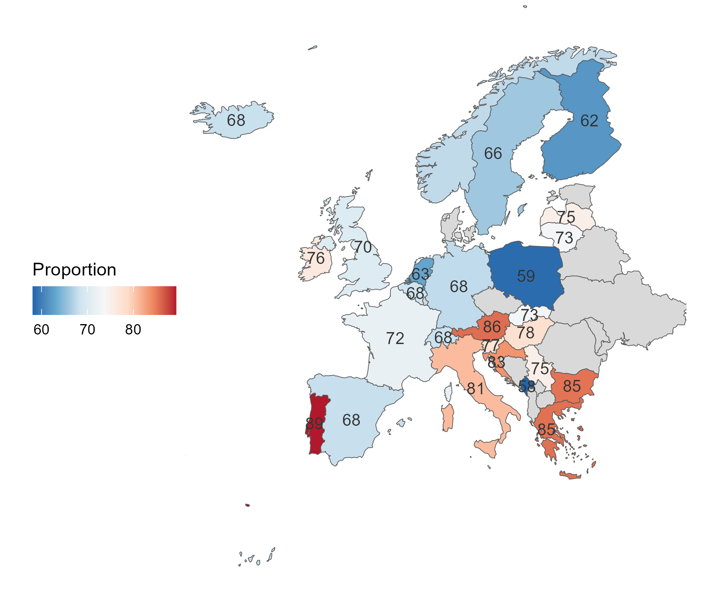
Source: Authors’ own analysis of the European Social Survey Round 11

2.2 A third of the Irish population would agree with higher taxes if it means more or better public services
In terms of policy relevance and social change, it is important to assess how much support for redistribution coincides with willingness to act on that through paying more taxes, for instance. Using data from survey experiments in Germany, Italy, Spain, and the United Kingdom, Bremer and Bürgisser (2025) note that support for tax cuts is not widespread and unconditional. The study indicates that ideology and self-interest play a role in preferences for progressive reforms as well.
As part of the National Election and Democracy Study, An Coimisiún Toghcháin (2024) conducted a post-election survey between 2024 and 2015 including questions on attitudes and policy preferences. Respondents were asked to what extend they agree that “The government should increase taxes a lot and spend much more on health and social services”. About 32% of respondents agreed with this statement (8% ‘strongly agree’ and 24% ‘somewhat agree’).
To explore relative differences across groups, we ran a logistic regression model using agreement with tax increase as a response variable. The explanatory variables included gender, age group, educational attainment, and social class. In addition, the model also includes a question on acceptance of inequality (agreement that “There is nothing wrong with some people being a lot richer than others”). As expected, those who ‘strongly disagree’ or ‘somewhat disagree’ have, respectively, 26% and 22% lower odds of supporting tax increase compared to those who strongly agree with the inequality statement.
The results also indicate that women have 6% higher odds of agreeing with tax increase compared to men. In relation to age, those older than 65 (16%) and aged between 55 and 64 (11%) also have increased odds of supporting tax increase in comparison with those younger than 24. No significant differences were found across other age groups, social class, or educational attainment.
In 2025, the Eurobarometer conducted a survey on citizen’s attitudes towards taxation. Participants were asked which among the following statements they agreed the most:
- Taxes are too high, and I would decrease them even if it means fewer or lower quality public services
- I agree with higher taxes if it means more or better public services
- Both taxes and public services should stay at the same level
In Ireland, 34% of respondents indicated that they would agree with higher taxes if it means more or better public services. This is the 6th highest percentage across the 27 participant countries. This proportion varies from 16% in Luxembourg and Belgium to 42% in Sweden and Spain. Comparing countries at the national level in Figure 2.2, there is no clear relationship between this proportion and the overall support for redistribution measured by the ESS in 2023.
Figure 2.2: Relationship between support for redistribution and agreement that there could be ‘higher taxes if it means more or better public services’, Europe, 2023/2025
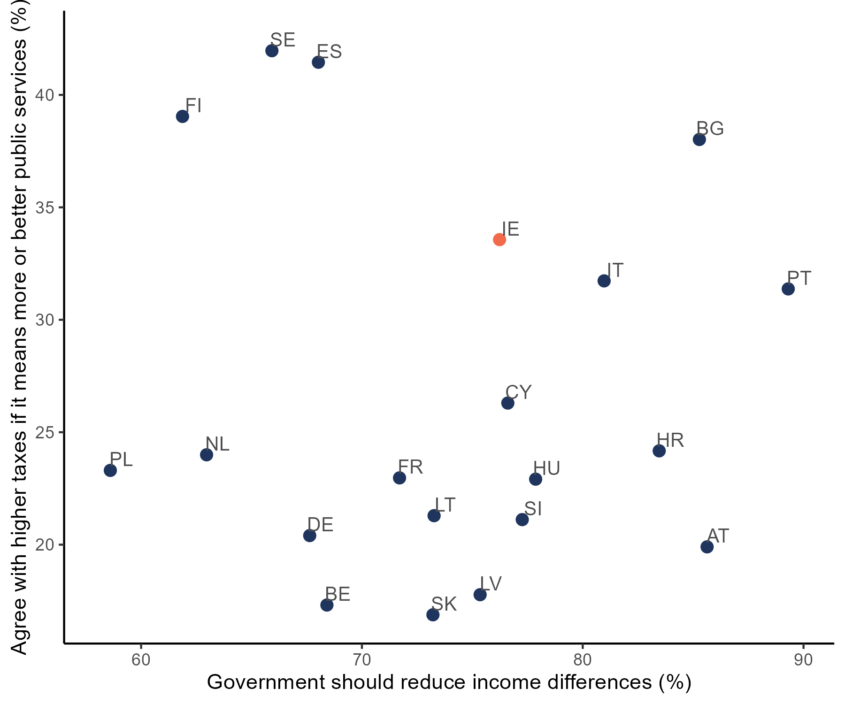
Source: Authors’ own analysis of the European Social Survey Round 11 and Eurobarometer Flash Survey 2025
Comparing ESS data on support for specific welfare policies (discussed in Chapter 3) and government policies, Rosset, Poltier, and Pontusson (2025) found mixed evidence for policy responsiveness. Although tax policies in several countries have moved in the same direction of the increasingly progressive attitudes to welfare, unemployment policy has not had the same trajectory.

2.3 Female and lower SES respondents are more supportive of redistribution
Despite the profusion of studies on the relationship between gender and welfare policies, there is a gap in understanding the gender dimension of beliefs and perceptions in relation to these policies (Garritzmann and Schwander 2021). Considering the marked gender differences in access to the labour market and levels of pay in Ireland (Hingre et al. 2024), it is plausible to also expect differences in demands for income redistribution.
On average, there is no statistically significant differences for male and female individuals in the latest rounds of both surveys. The ESS question on the government role has the same proportion of agreement for male and female respondents (76%). Similarly, the voter study identified similar mean values for wealth redistribution across male (5.4) and female (5.2) participants.
However, as shown in Figure 2.3, there is some variation across time in relation to this gap. Considering all 11 rounds of the ESS together, there is a significantly higher support for redistribution among female respondents compared to male respondents. However, both genders tend to follow a similar trend in their support for redistribution over time.
Figure 2.3: Support for redistribution in Ireland by sex, 2002-2023
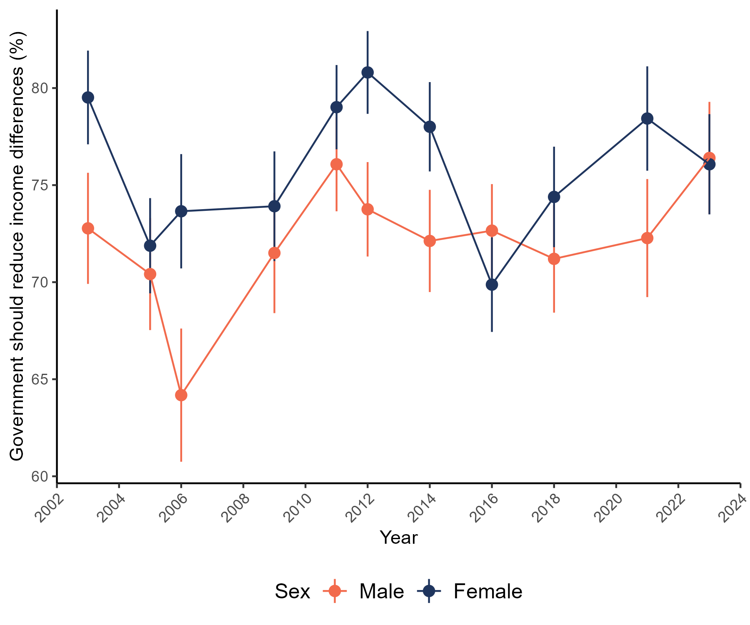
Source: Authors’ own analysis of the European Social Survey
In addition, data suggest an age pattern where younger respondents tend to be more supportive of income redistribution in Ireland. As shown in Figure 2.4, the opposite pattern is observed in Finland and Iceland, which are two of the countries with the highest positive correlations. Although the UK also has a similar negative relationship between age and support, the agreement among young respondents (18-35) is higher in Ireland.
Figure 2.4: Scatter plot of support for redistribution by age and country, 2023
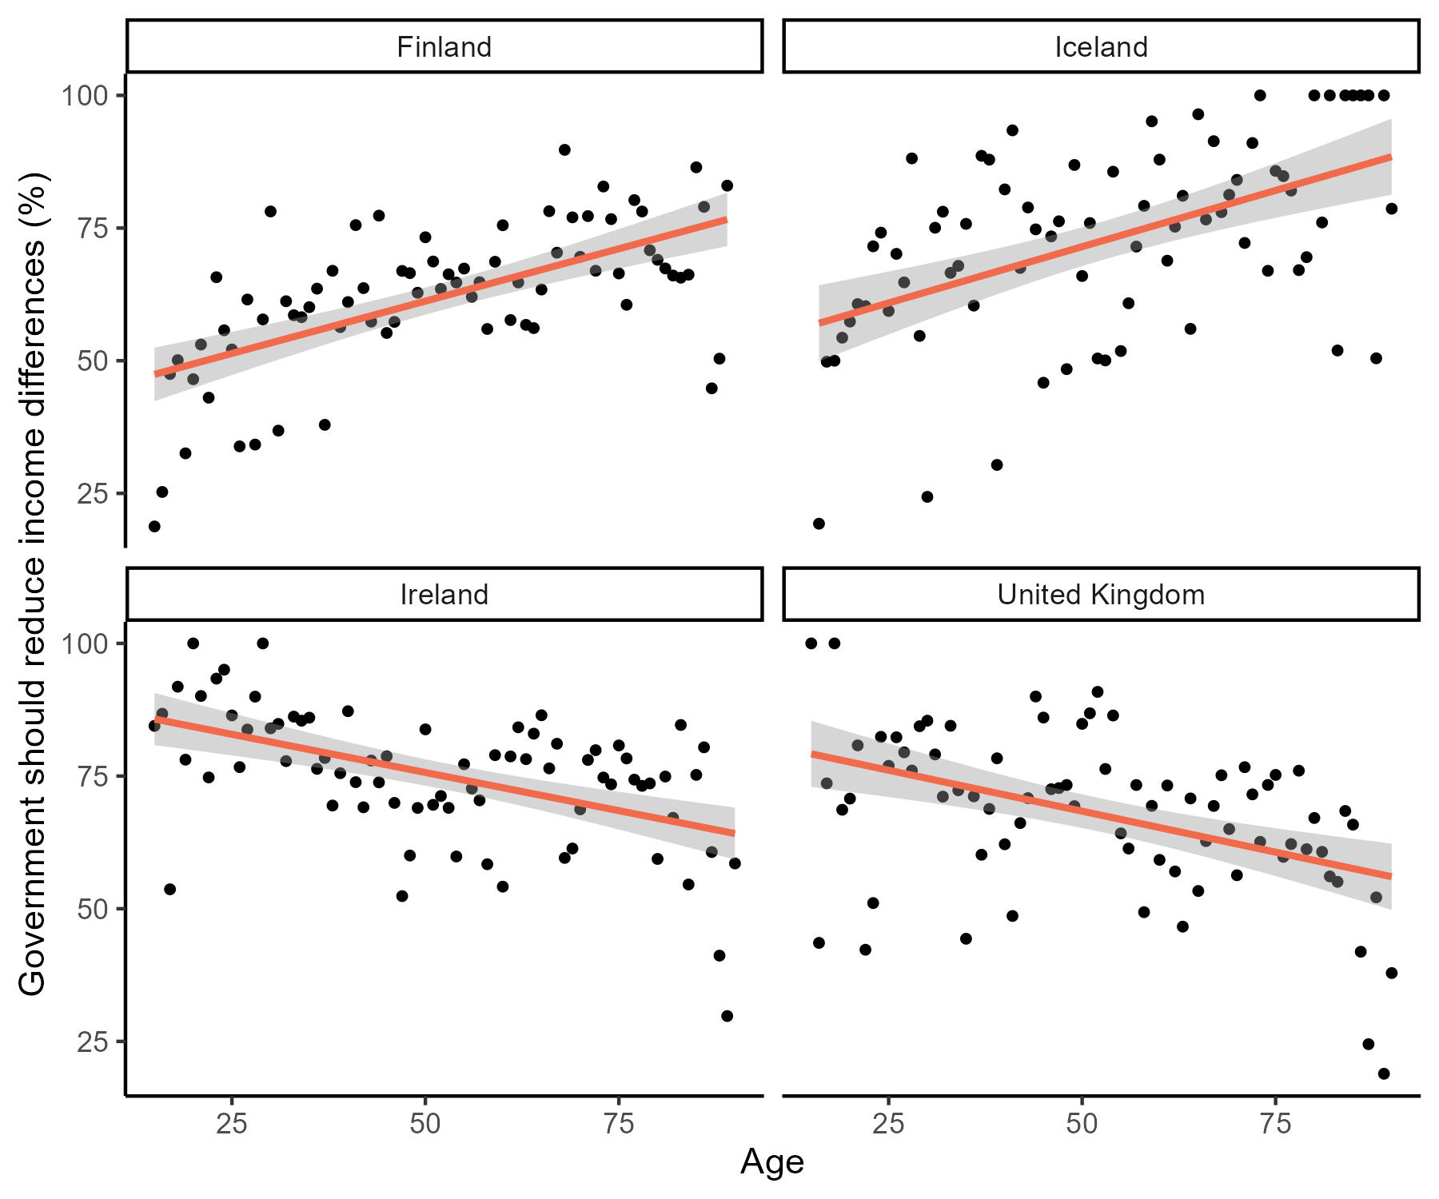
Source: Authors’ own analysis of the European Social Survey Round 11
Using a longer time period, however, we observe different relationships depending on the time of the data collection. These different associations over time might suggest a context-dependent association or different levels of support across generations instead of age groups. This topic is further explored in Chapter 4.
Finally, there is robust evidence for the association between socio-economic status (SES) and overall welfare attitudes in Europe (Svallfors 2012; Kulin and Svallfors 2013; Langsæther and Evans 2020; Steele, Cohen, and Van Der Naald 2022). In Ireland, the analysis using social class, household income, and ‘feeling about financial situation of the household’ suggests a negative relationship between SES and support for redistribution. The mean values shown in Figure 2.5 indicate that both ‘skilled’ manual and ‘unskilled’ workers show higher levels of agreement with the government reducing income differences whereas ‘small business owners’ and the ‘service class’, which includes managers and professionals, show lower levels of agreement. Higher support is also found among those in lower income quintiles and whose financial situation is ‘very difficult’.
Figure 2.5: Mean value of support for redistribution by social class, income quintile, and financial situation, Ireland, 2002-2023
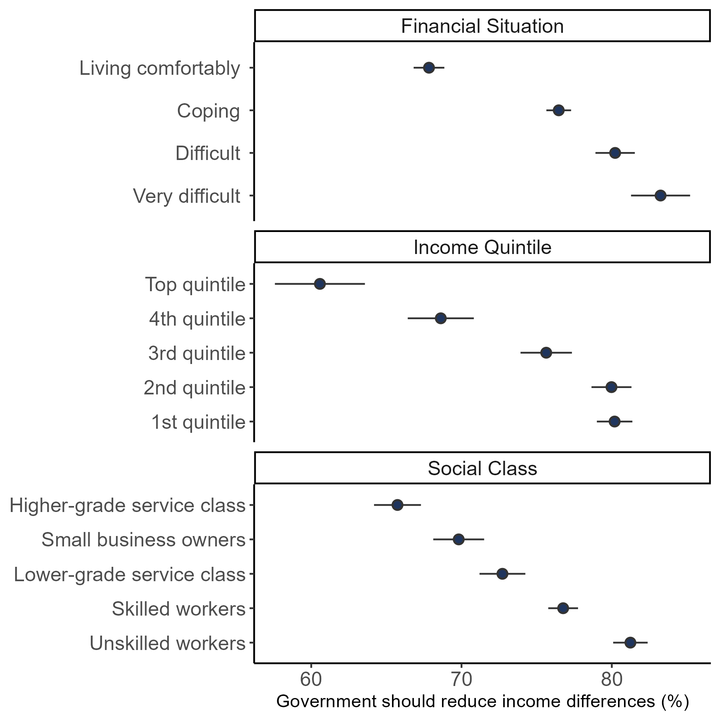
Source: Authors’ own analysis of the European Social Survey

2.4 Left-wing voters are more supportive of redistribution
There is a consistent pattern of association between the respondents’ ideological positioning and support for redistribution. The survey includes a traditional question implemented in international surveys designed to assess ideological position of individuals (Aybar, Pérez, and Pavía 2024). In this question, respondents are asked to point out where they would position themselves in a scale where 0 means the left and 10 means the right. Results consistently indicate that individuals who place themselves more to the left of the scale tend to be more supportive of redistribution, even though this correlation is weaker in Ireland compared to other European countries.
With the data from the 2024 Voter Survey it is also possible to examine differences in redistribution preferences across voting choice in the European Parliament elections. On a scale varying from 1 to 10, People Before Profit (7.5) and Sinn Féin (6.4) voters indicate the highest support, whereas Green Party (4.7) and Fine Gael (4.7) voters reported the lowest support among the main parties. Even when controlling for positioning in the left-right scale, differences between the former two and latter two parties are statistically significant. These estimates should be interpreted with caution due to the small sample size of respondents who voted in the last European elections. However, Attewell (2021) indicate that this pattern is consistent across most Western European countries, and welfare attitudes are relevant predictors of voting even for parties with focus on non-economic issues such as ‘immigration’ and EU integration.

2.5 Age, gender and social class are relevant even controlling for economic activity, education and financial situation
We created a statistical model to assess the extent to which these individual factors are associated with support for redistribution in Ireland. In addition to these main variables, the model includes a measurement of the household financial situation. A subjective measurement was chosen (‘Satisfaction with the household income’) instead of household income due to the high proportion of missing values in the former. However, the same model using household income instead of this subjective measurement indicates similar results for the main variables (see Annex 1). The following control variables were also added to the model: economic activity (‘Main activity in the last seven days’), educational attainment, and political ideology (‘Placement in the left-right scale’).
Table 2.1 below details the estimates of the model detecting significant differences across groups. The results in this table, as well as in subsequent tables and figures throughout the report, are presented as odds ratios. An odds ratio lower than 1 indicates that the group is less likely to experience the outcome compared to the reference group (highlighted in the table). An odds ratio greater than 1 suggests that the group is more likely to experience the outcome than the reference group. Older age groups show higher support compared to the youngest group (18 to 24 years old), which is the opposite relationship found for the latest round in 2023, but also found in other participant countries such as the UK. Both SES variables (social class and financial situation) suggest that respondents in more precarious socio-economic situation are more likely to be favourable of the government reducing income differences.
Table 2.1: Logistic regression estimates (odds-ratio) for ‘support for redistribution’, Ireland, 2002-2023
Characteristic | OR | 95% CI | p-value
Age group
18-24 (Ref.) | — | —
25-35 | 1.19 | 1.02, 1.38 | 0.025
36-45 | 1.15 | 0.99, 1.35 | 0.067
46-55 | 1.15 | 0.98, 1.34 | 0.080
56-65 | 1.66 | 1.40, 1.97 | <0.001
>66 | 1.43 | 1.16, 1.75 | <0.001
Gender
Male (Ref.) | — | —
Female | 1.12 | 1.03, 1.20 | 0.004
Born in country
Yes | — | —
No | 0.83 | 0.76, 0.92 | <0.001
Oesch class position
Higher-grade service class (Ref.) | — | —
Lower-grade service class | 1.33 | 1.19, 1.49 | <0.001
Small business owners | 1.11 | 0.98, 1.25 | 0.093
Skilled workers | 1.51 | 1.37, 1.68 | <0.001
Unskilled workers | 1.95 | 1.73, 2.20 | <0.001
Placement on left right scale | 0.90 | 0.88, 0.92 | <0.001

Source: Authors’ own analysis of the European Social Survey Note: Higher scores on left-right scale indicate placement on the right of centre. ‘Main activity’, ‘Educational attainment’ and ‘ESS round’ omitted (see Annex 1 for full table)
Those who were not born in Ireland are significantly less likely to support redistribution compared to those born in Ireland. This is a pattern found in other European countries by Gonnot and Polito (2023), who suggests that this could be explained by experiences with discrimination and lower access to social benefits. As discussed earlier in this chapter, both female respondents and those who place themselves on the left of the left-right scale are more likely to support income redistribution, even when controlling for other factors such as age and social class.
Overall, the examination of individual factors associated with support for income redistribution in Ireland goes in the same direction of the literature pointing out the role of material interests (financial situation) and perspectives of upward mobility (social class) Bonnet et al. (2024).

CHAPTER 3
WHAT DO PEOPLE THINK ABOUT WELFARE POLICIES?
This chapter moves from general support for redistribution to consider individuals perceptions of fairness and their support for specific policies. Is the general public more or less favourable of policies directed at specific groups? Is there evidence of a hierarchy of recipients? It also considers beliefs about the causes of inequality and how such beliefs relate to attitudes towards redistribution.
The data analysed in this chapter draws on a special module from the European Social Survey on welfare attitudes that was fielded in 2009 (Round 4) and repeated in 2016 (Round 8) (see Meuleman et al. (2018) for more on this module). These rounds of data collection contain additional questions on beliefs about welfare, social benefits and their beneficiaries.

3.1 Meritocratic differences are acceptable for younger and right-wing respondents
As discussed in the previous chapter, a few socio-demographic characteristics such as age and social class may influence people’s views on redistribution. The connection between these two factors, social position and redistributive preferences, tend to be explained by self-interest, meaning that people may support redistribution if they believe that it would improve their own material conditions and lives. However, a large body of research shows that other factors related to peoples’ views on fairness are also relevant to understand overall support to welfare policies (Cavaillé 2025).
In the 2016 ESS, respondents were asked to what extent they agree with the statement that ‘Large differences in people’s incomes are acceptable to properly reward differences in talents and efforts’. The majority of participants in Ireland (58%) either “agree” or “agree strongly” with the statement.
A multivariate analysis with the same explanatory variables from the model of the Table 2.1 suggests that gender and class are not statistically significant predictors of agreement that large differences in incomes are acceptable. However, older respondents and those who identify more with the political right tend to agree more with this statement.

3.2 The government should have more responsibility towards old citizens and working parents compared to the unemployed
A crucial aspect of the sustainability of modern welfare states is the public support given to its policies. A vast literature in social sciences has addressed the social legitimacy of welfare policies that are targeted at specific groups (Oorschot and Roosma 2017), as they create contentious views on which social groups are more or less deserving of the State attention. In the ESS, respondents were asked to indicate how much responsibility governments should have for the following:
“… ensure sufficient childcare services for working parents”
“… ensure a reasonable standard of living for the old”
“…ensure a reasonable standard of living for the unemployed”
In the Figure 3.1, higher values denote higher government responsibility. On average, respondents from all countries (except The Netherlands) believe that the government should be least responsible for the unemployed compared to working parents and older citizens. It is also worth noting the magnitude of the differences between groups across countries. The gap between unemployed and other groups is much larger Poland and Germany, compared to other countries such as Spain, for example. In Ireland, similar to Switzerland, the gaps between these three groups are significantly smaller.
Figure 3.1: Mean values for deservingness of government support by group and country, 2016
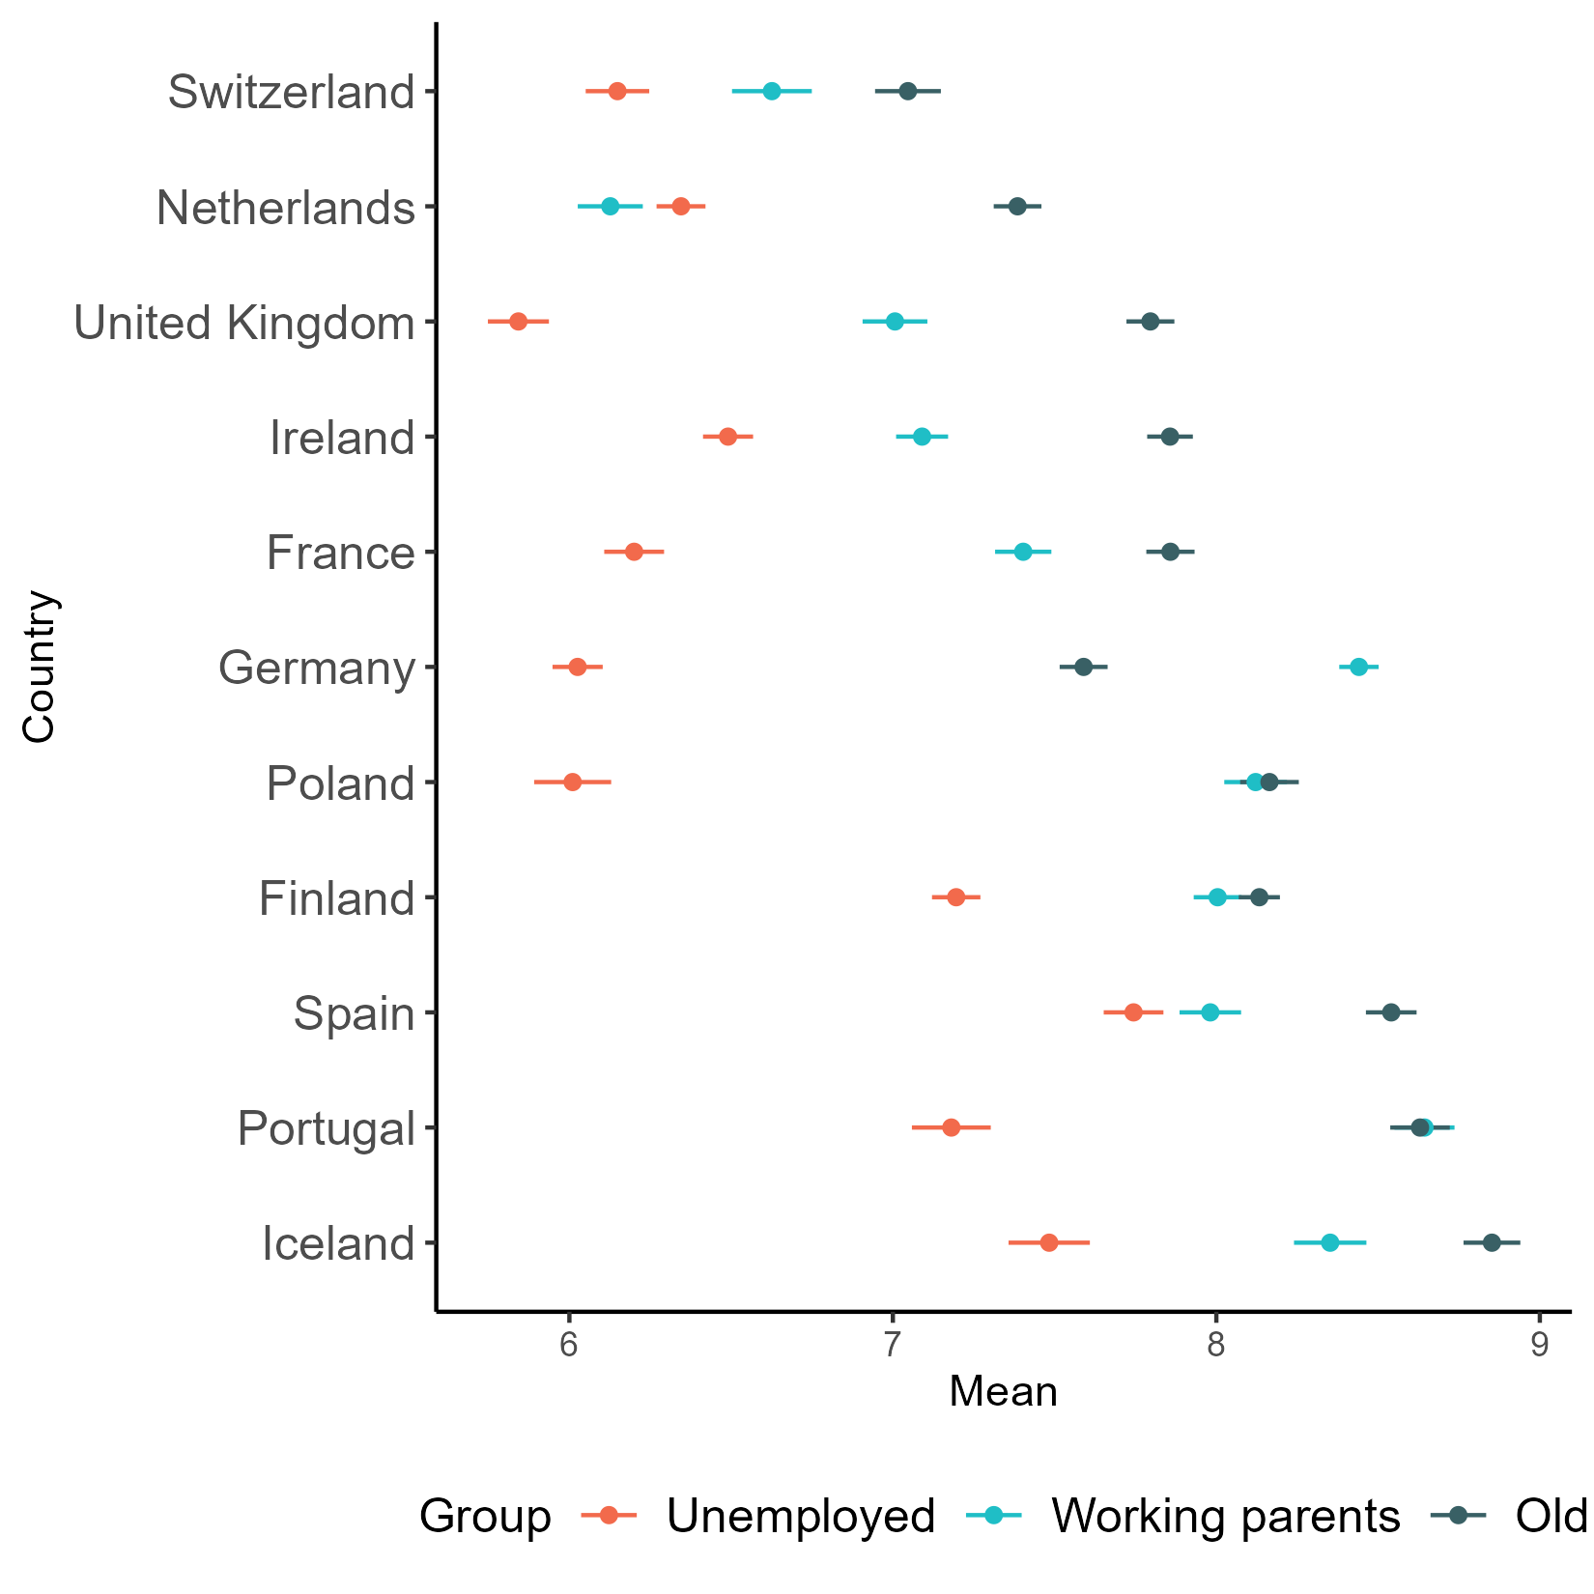
Source: Authors’ own analysis of the European Social Survey Round 8
In Ireland, the ranking of prioritisation is similar across different characteristics of respondents. However, comparing age groups, the older the respondent, there is an increasing prioritisation of the “old” and decreasing prioritisation of “working parents” (Figure 3.2). In addition, among those in a ‘very difficult’ financial situation, there are no significant differences in the prioritisation of working parents over the unemployed over.
Figure 3.2: Mean values for deservingness of government support by group, Ireland, 2016
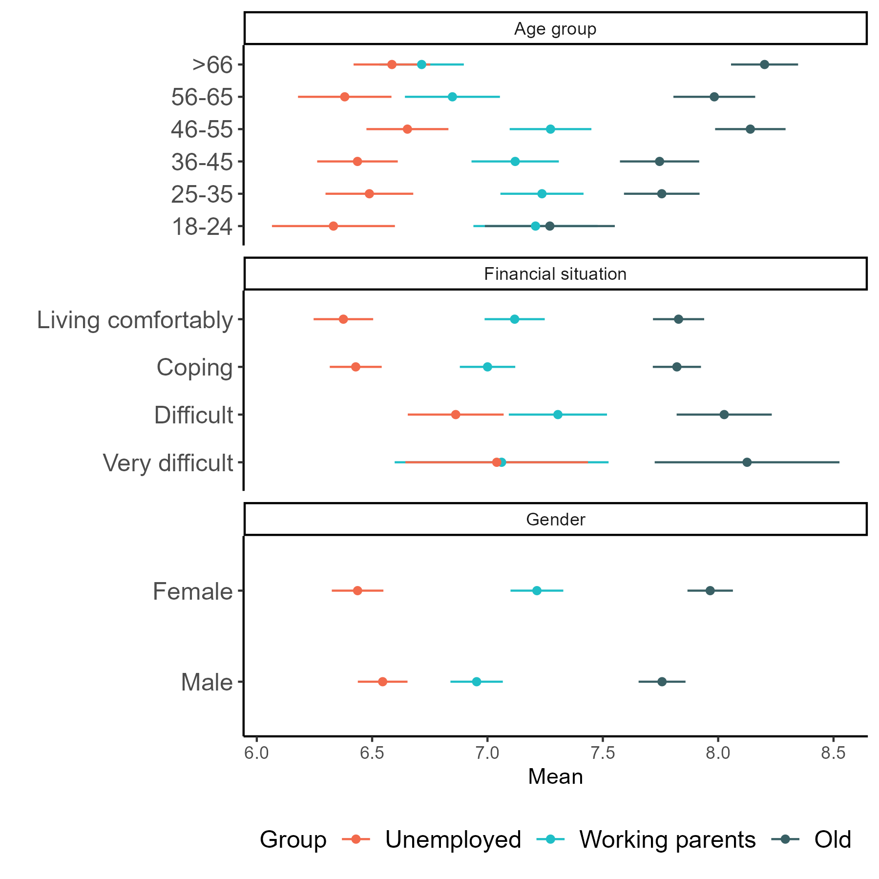
Source: Authors’ own analysis of the European Social Survey Round 8

3.3 Most respondents indicate that immigrants could receive social benefits after having worked and paid taxes for at least one year
Overall, data from 2016 indicates that about half of respondents in Ireland believe that immigrants should obtain rights to social benefits/services “After worked and paid taxes at least a year”. The other options that received most answers were “Once they have become a citizen” (19%) and “After a year, whether or not have worked” (16%).
As shown in Figure 3.3, only 5% in 2016 indicated that “They should never get the same rights”. This proportion is significantly higher in countries such as Hungary (30%) and Czechia (24%). In Ireland, this proportion is also higher for those in worse financial situation (19%) and among those who are unemployed and not looking for job (18%).
Figure 3.3: Distribution for ‘When should immigrants obtain rights to social benefits/services’, Ireland, 2016
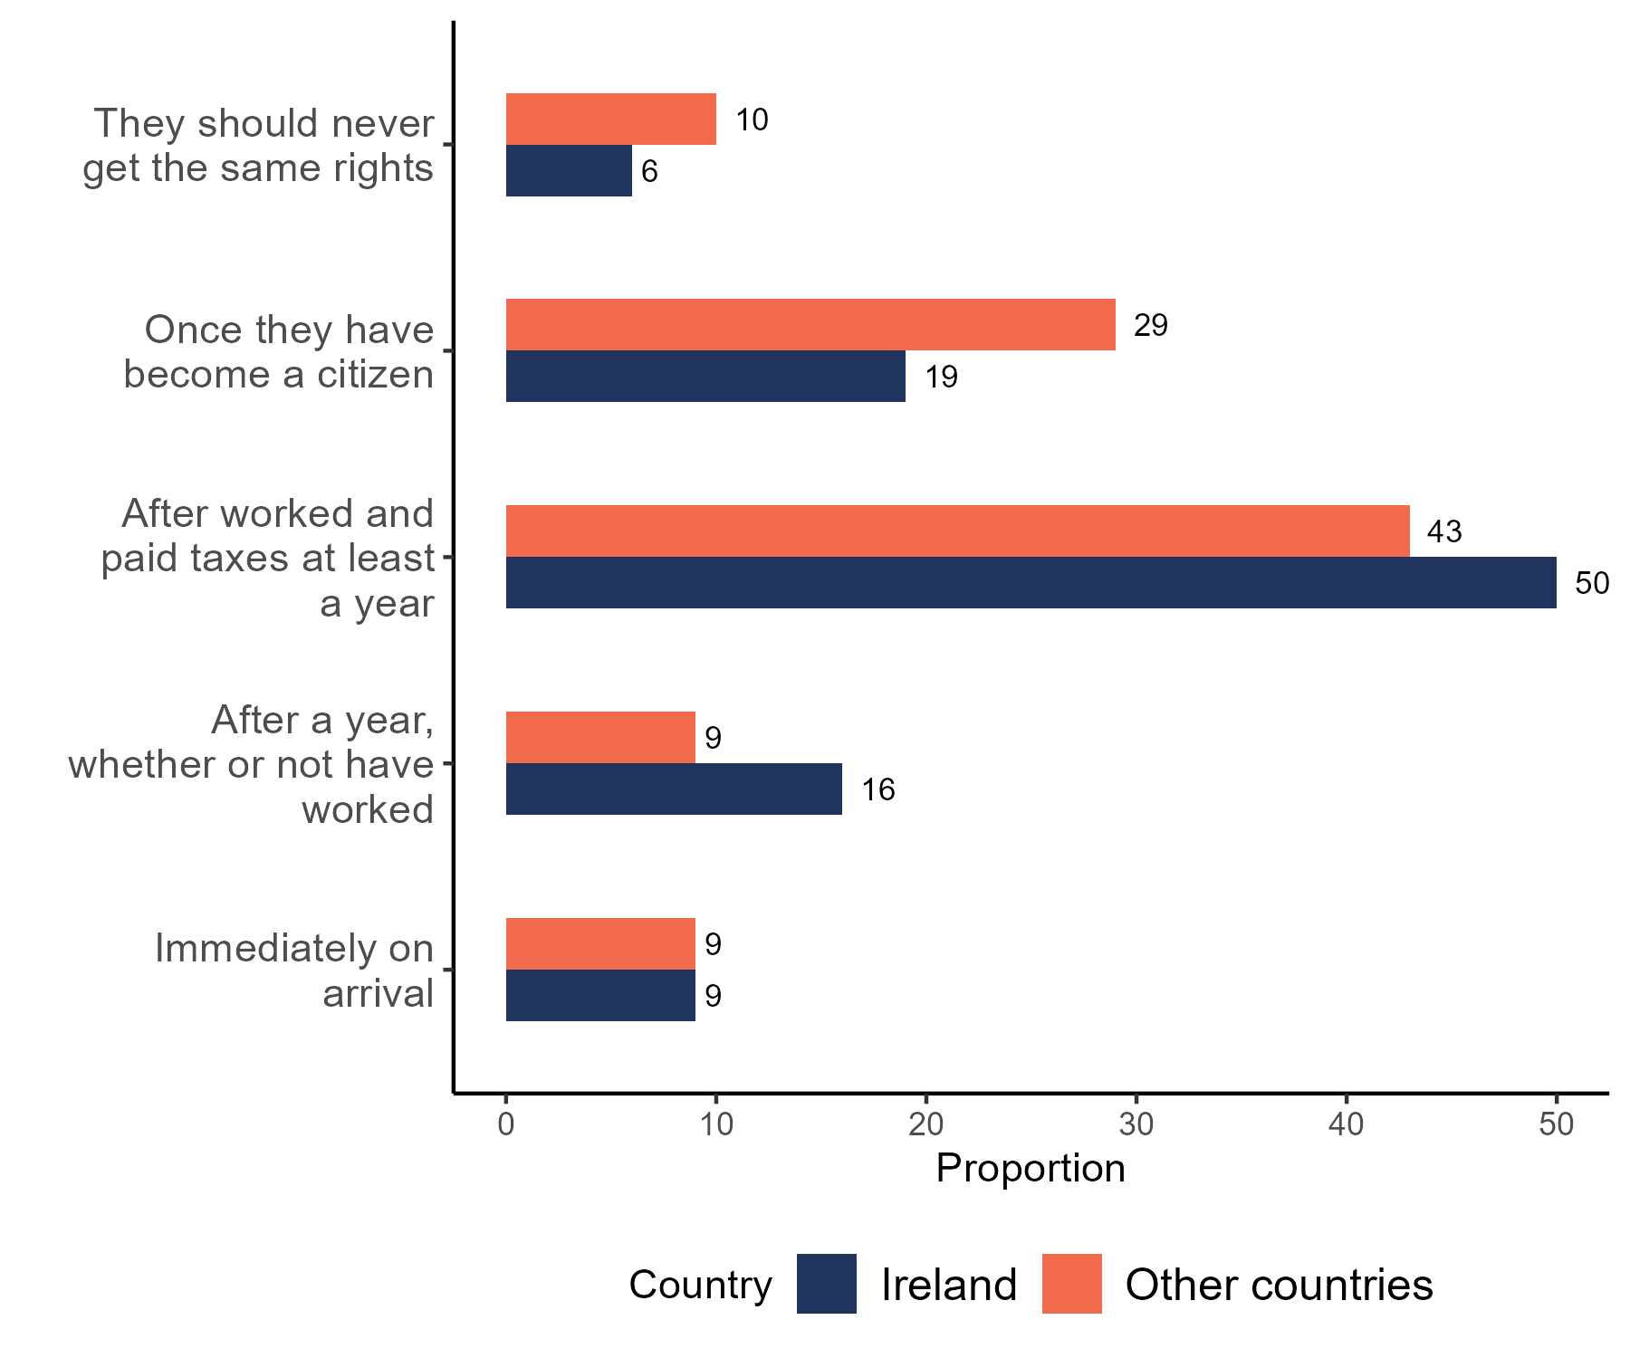
Source: Authors’ own analysis of the European Social Survey Round 8

3.4 The view that ‘Social benefits make people lazy’ is more prevalent in Ireland compared to the European average
The module also included questions in relation to beliefs about the consequences of social benefits and services. Participants were asked to indicate to what extent they agree that social benefits and services in [country]…
“…cost businesses too much in taxes/charges?”
“…lead to a more equal society?”
“… make people lazy?”
“…make people less willing care for one another?”
“…prevent widespread poverty”
“…place too great strain on economy”
The average level of agreement with these statements reduced slightly between 2008/2009 at the onset of the recession and 2016 during the recovery period. Nevertheless, the ranking of agreement among statements remains the same, as shown in Figure 3.4. The exception is the average agreement with “social benefits lead to a more equal society”, which observed a minor increase and surpassed the average agreement with “put strain in the economy” and “cost business too much in taxes”. It is also worth noting the strong decline in the percentage who agree that it hurts economy and business. This might be due to the rising unemployment and collapse of businesses during the financial crash.
Figure 3.4: Proportion of respondents who agree with statements about social benefits, Ireland, 2009/2016
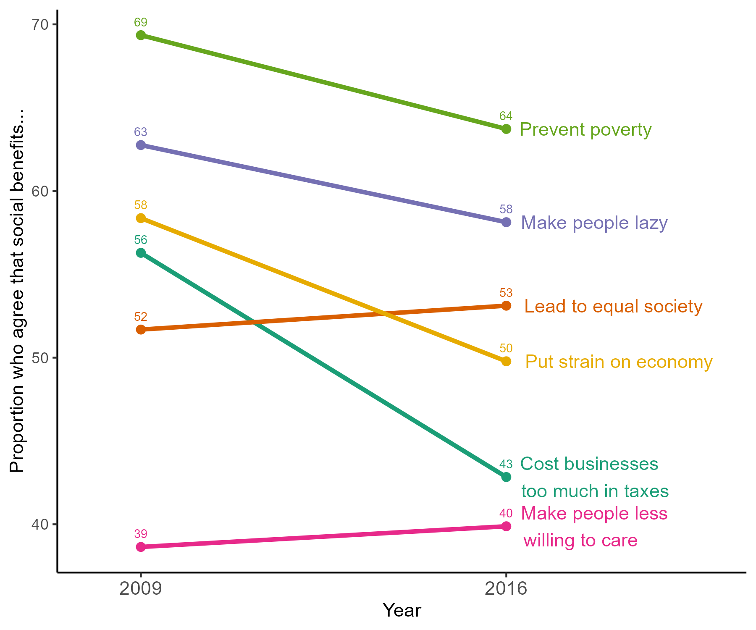
Source: Authors’ own analysis of the European Social Survey
Despite the reduction from 2009 to 2016, as shown in Figure 3.5, Ireland (58%) had the third highest proportion of respondents agreeing that “social benefits make people lazy”, behind Portugal (63%) and Poland (60%). This proportion is significantly lower in countries such as Iceland (24%), Sweden (35%), and Germany (43%). Finally, as expected, those who strongly agree that “social benefits make people lazy” are also less likely to support income redistribution (68%), whereas those who strongly disagree are more supportive of redistribution (84%).
Figure 3.5: Proportion of agreement that social benefits make people lazy, Europe, 2009/2016
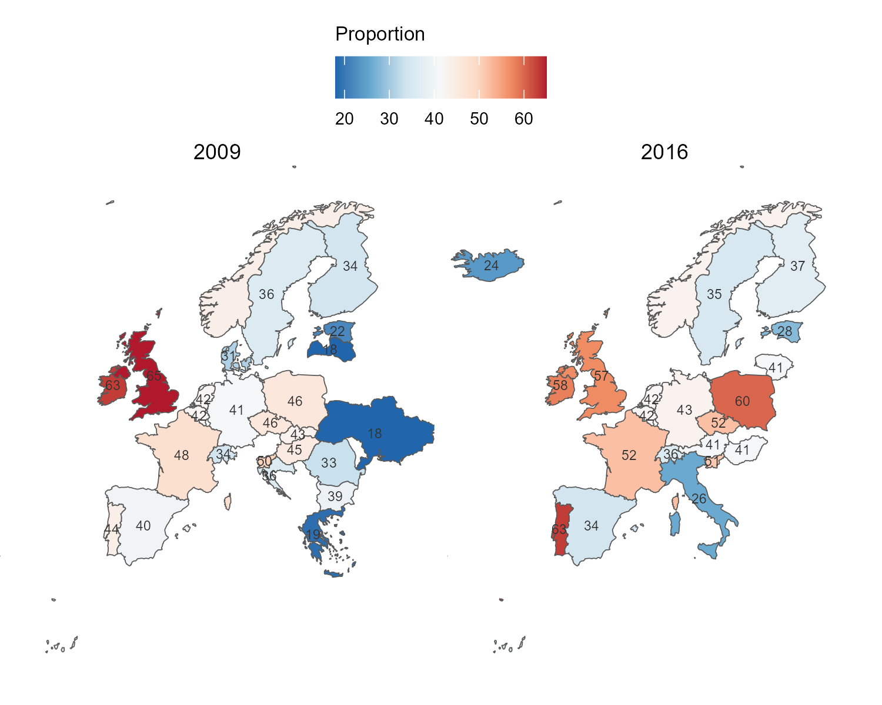
Source: Authors’ own analysis of the European Social Survey

3.5 Younger respondents in Ireland are more likely to agree that social benefits make people lazy
Table 3.1 below presents coefficients of the regression models for the countries with the highest proportion of agreement with the statement on lazyness: Ireland, Portugal, Poland, and the United Kingdom. The significant explanatory variables are different across these four countries. In Ireland, respondents in the 18-24 age group are more inclined to agree with this statement compared to all older age groups. Conversely, the difference between age groups is not statistically significant in any of the other three groups.
In Portugal, female respondents have 75% increased odds of agreeing that social benefits make people lazy compared to men. Differences across social class groups are not significant in Ireland or Poland. But both in Portugal and the UK, the working class have higher odds of agreeing with the statement on lazyness compared to the higher-grade service class.
Finally, in Ireland, the UK and Portugal, the agreement is higher among those respondents who position themselves more to the righe of the left-right ideological scale. The exception is Poland, where the opposite effect is statistically significant.
Table 3.1: Logistic regression estimates for agreement on statements about ‘social benefits’, Ireland, 2016
Characteristic | Ireland |  | United Kingdom |  | Portugal |  | Poland
Characteristic | OR | p-value | OR | p-value | OR | p-value | OR | p-value
Age group
18-24 (Ref.) | — |  | — |  | — |  | —
25-35 | 0.44 | 0.002 | 1.05 | 0.9 | 0.64 | 0.2 | 0.84 | 0.6
36-45 | 0.43 | 0.002 | 1.23 | 0.4 | 1.15 | 0.7 | 0.69 | 0.2
46-55 | 0.29 | <0.001 | 0.94 | 0.8 | 1.14 | 0.7 | 0.93 | 0.8
56-65 | 0.42 | 0.002 | 0.81 | 0.5 | 1.19 | 0.6 | 0.66 | 0.2
>66 | 0.27 | <0.001 | 1.06 | 0.9 | 1.55 | 0.3 | 0.72 | 0.4
Gender
Male (Ref.) | — |  | — |  | — |  | —
Female | 1.09 | 0.4 | 1.07 | 0.5 | 1.75 | <0.001 | 1.06 | 0.6
Oesch class position
Higher-grade service class (Ref.) | — |  | — |  | — |  | —
Lower-grade service class | 1.35 | 0.069 | 1.64 | 0.003 | 1.70 | 0.054 | 0.86 | 0.5
Small business owners | 0.81 | 0.2 | 1.88 | 0.001 | 3.08 | <0.001 | 1.14 | 0.5
Skilled workers | 1.17 | 0.3 | 1.83 | <0.001 | 2.08 | 0.002 | 0.69 | 0.080
Unskilled workers | 1.10 | 0.6 | 2.42 | <0.001 | 2.89 | <0.001 | 1.18 | 0.5
Placement on left right scale | 1.10 | <0.001 | 1.36 | <0.001 | 1.07 | 0.016 | 0.93 | 0.003

Source: Authors’ own analysis of the European Social Survey. Note: Higher scores on left-right scale indicate placement on the right of centre. ‘Main activity’, ‘Born in country’, ‘Educational attainment’ and ‘ESS round’ omitted (see Annex 1 for full table)

3.6 Unfairly low wages are more relevant than unfairly high wages for support for redistribution in Ireland
As argued by Cavaillé (2025), support for redistribution is also dependent on people’s perceptions of fairness. One might be more supportive of redistribution if they perceive that the richest in society earn too much (proportionality principle). At the same time, redistribution might be preferred if the poorest are receiving too little (reciprocity principle). In a special module conducted in 2018, the ESS asked respondents to assess how fair are the incomes received by the top and bottom deciles of the country’s income distribution as well as their own gross income. The scale goes from -4 (Low, extremely unfair), through 0 (Fair), to 4 (High, extremely unfair).
Figure 3.6 below shows the odds-ratio of these variables added to the model described in Table 2.1. For most countries, the more unfair the income of top the top decile is perceived, the higher the odds of supporting redistribution. This relationship is particularly strong in Norway and France, for instance. On the other hand, if a respondent perceives the bottom decile as unfairly high, the odds of supporting redistribution is lower. This association is particularly strong in Finland and France. In Ireland, both variables have weaker nonetheless significant effects. Across all countries respondents’ perceptions of fairness of their own incomes is not a significant predictor of support for redistribution.
Figure 3.6: Effect (odds-ratio) of perception of ‘unfairness of income’ on ‘support for redistribution’, 2018
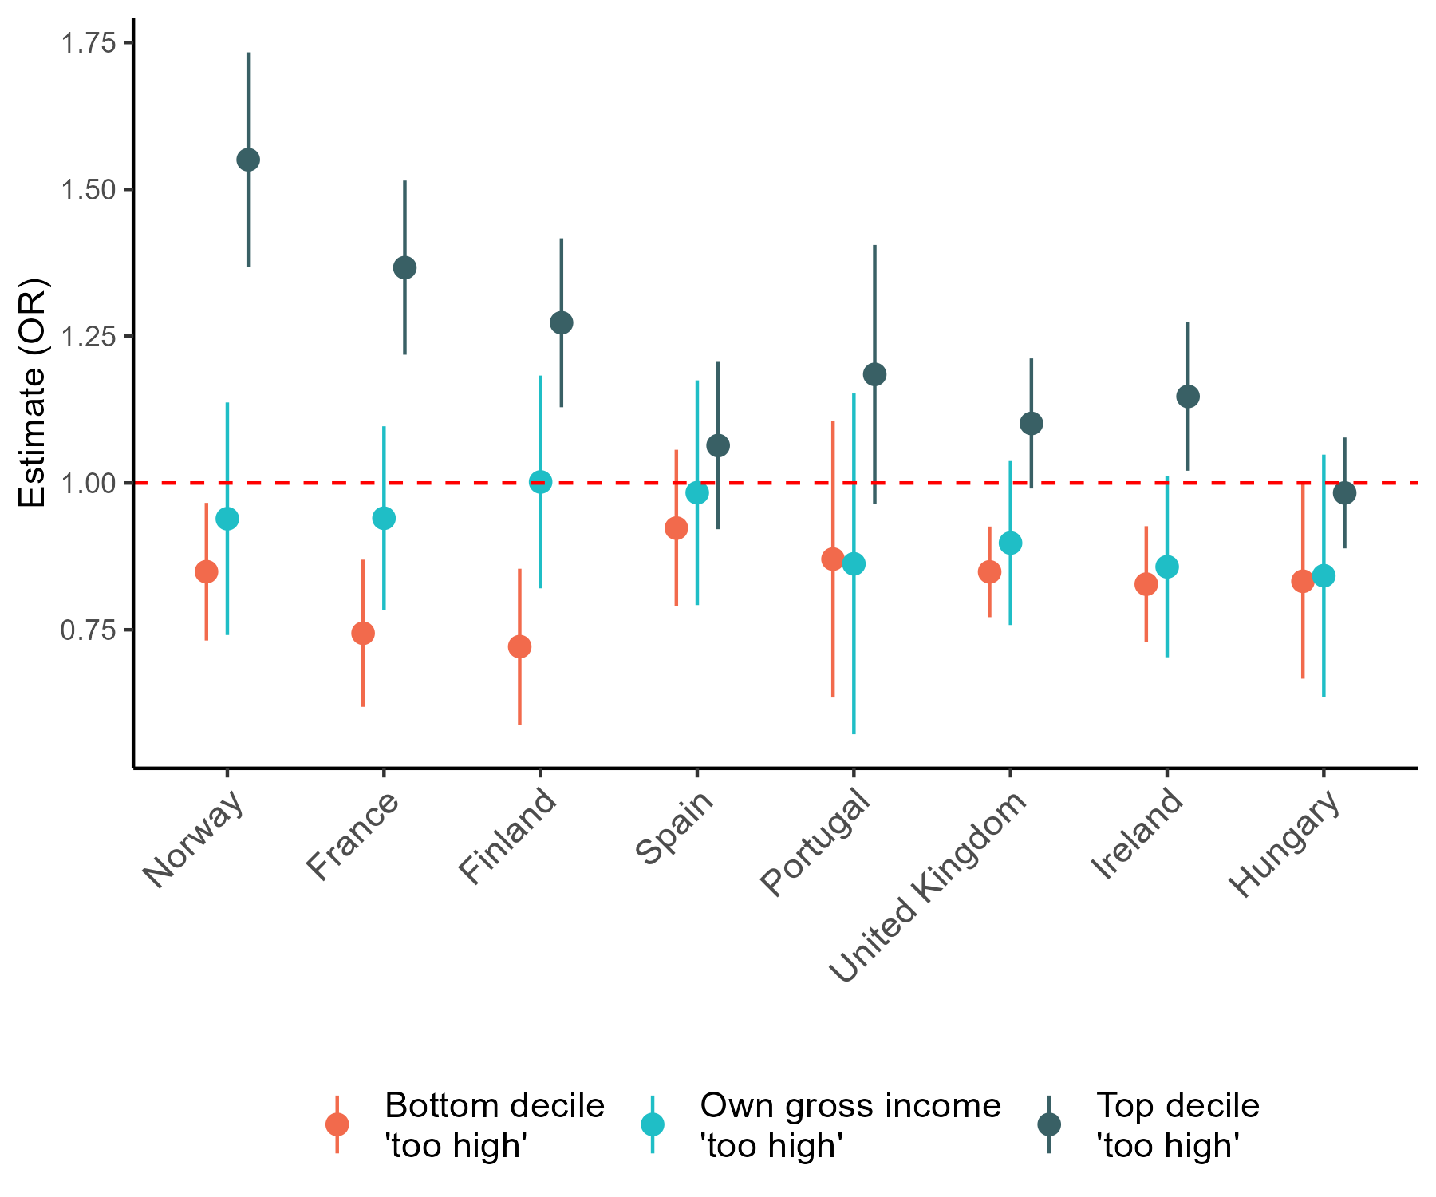
Source: Authors’ own analysis of the European Social Survey

CHAPTER 4
Has support for redistribution changed over time?
The period covered by the research from 2002 to 2024 encapsulates two significant societal shocks, the financial crisis and recession starting in 2008 and the Pandemic starting in 2020. Both shocks resulted in significant changes in the labour market, in the reliance on social transfers and especially in the pandemic changes in the role of the state in people’s everyday lives. Here we consider how support has changed over the past twenty years and whether these major shocks influence public opinion on redistribution. There are also more routine events that occur over the period that might be expected to influence attitudes, such as the regular cycle of budgets. The chapter also assesses whether there is evidence that such events are associated with any change in attitudes.
The Figure 4.1 displays the proportion of respondents in Ireland and other countries who agree that ‘Government should reduce income differences’ by year of the start of the survey. Overall, there is a stable agreement (70 %). Rounds 5 to 7 (2009-2012) as well as 10-11(2022-2024) show a slightly higher agreement compared to other rounds and the European average. This overall trajectory in Ireland is similar to Portugal and differs substantially from the British and Dutch trajectories. The increase during the years of economic recession (when both Ireland and Portugal were severely affected) suggests a relationship between macro-economic indicators and support for redistribution.
Figure 4.1: Proportion agreeing that the ‘Government should reduce income differences’ by year, 2002-2024
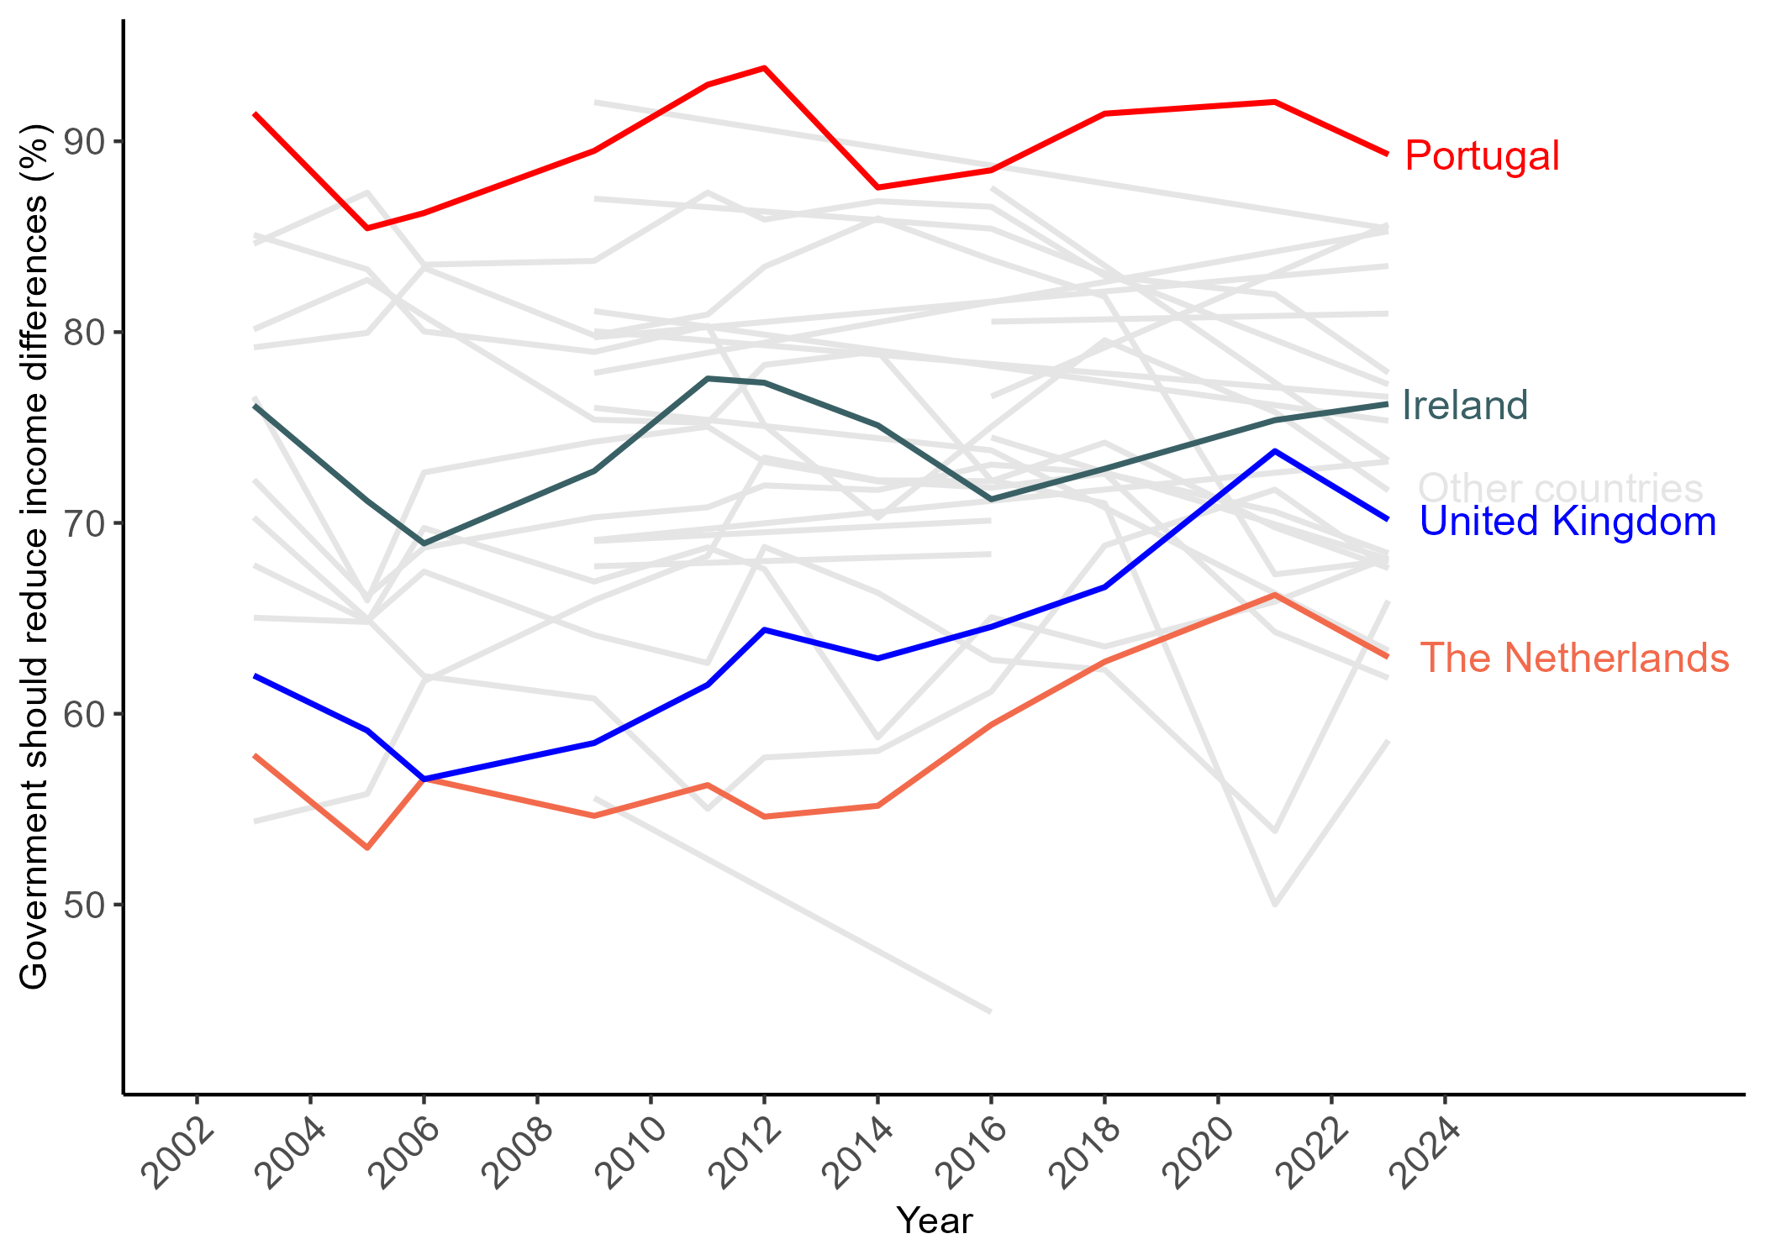
Source: Authors’ own analysis of the European Social Survey
However, the recovery from the economic recession initiated a different trajectory for different social classes despite the overall increase during the recession. As shown in Figure 4.2, respondents in the service class had an overall reduction in the level of support for redistribution since the peak of the economic recession. On the other hand, respondents grouped into the working classes (skilled and unskilled) have a trajectory of stable or increasing support since then. In fact, 85% of unskilled workers indicated in latest round that the government should reduce differences in income, which is the highest proportion in the time series since 2002.
Figure 4.2: Proportion agreeing that the ‘Government should reduce income differences’ by social class and year, Ireland, 2002-2024
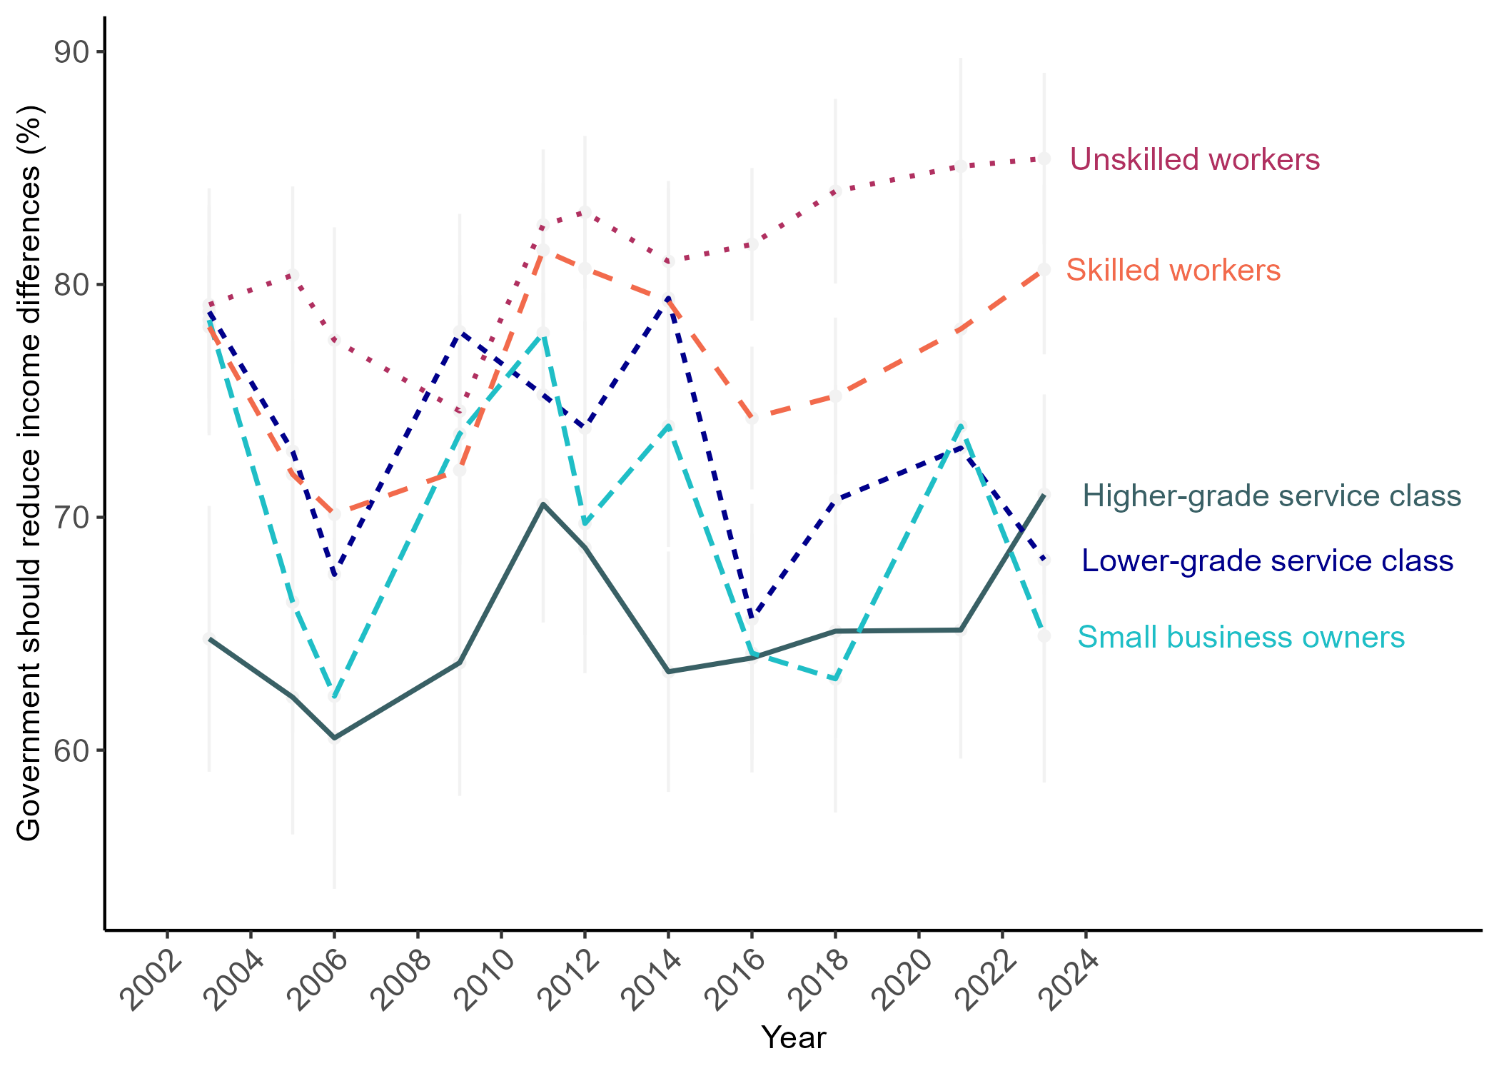
Source: Authors’ own analysis of the European Social Survey
The solid line in Figure 4.3 represents the seasonally adjusted monthly unemployment rate from Central Statistics Office (CS0) and the points represent the monthly proportion of respondents supporting income redistribution in Ireland, with size proportional to the number of respondents. The dotted line shows the 3-month moving average of the support for redistribution. The figure suggests an increase in support in anticipation of the unemployment rise (although based on limited number of observations). On the other hand, the sharp reduction in unemployment was not accompanied by a significant decrease in support, which has been stable since mid-2010’s.
Figure 4.3: Monthly unemployment rate and moving average (3 months) of support for redistribution, Ireland, 2002-2023
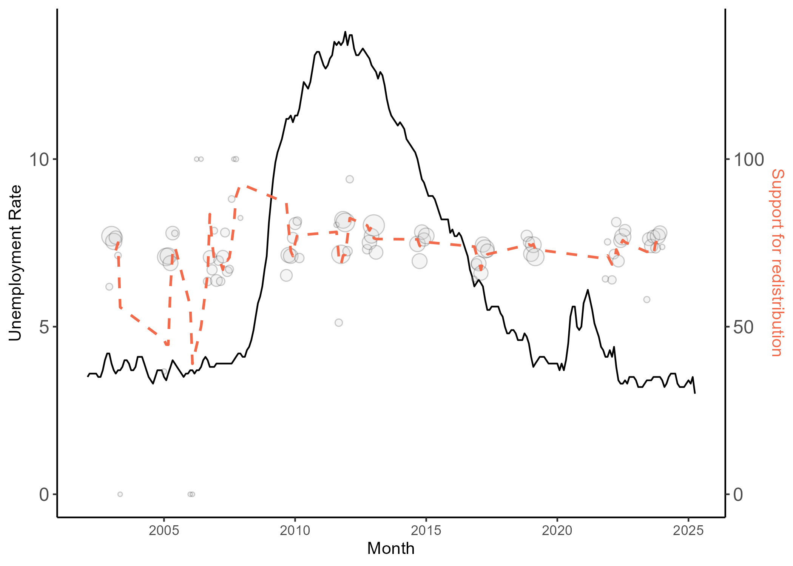
Source: Authors’ own analysis of the European Social Survey and Central Statistics Office

4.1 Age and Gender
The relationship between age and the response variable seems to change across rounds. As discussed in Chapter 2, the multivariate regression model indicates that, considering all rounds, older respondents are more supportive of the government reducing income differences. However, the average support by age observed in the latest round (11) seem to indicate the opposite (see Figure 4.4 in Chapter 2). During the third and fourth rounds (2006-2009), there is a positive association between age and support for redistribution.
Figure 4.4: Scatter plot for ‘reduce income differences’ by age and ESS starting year, Ireland
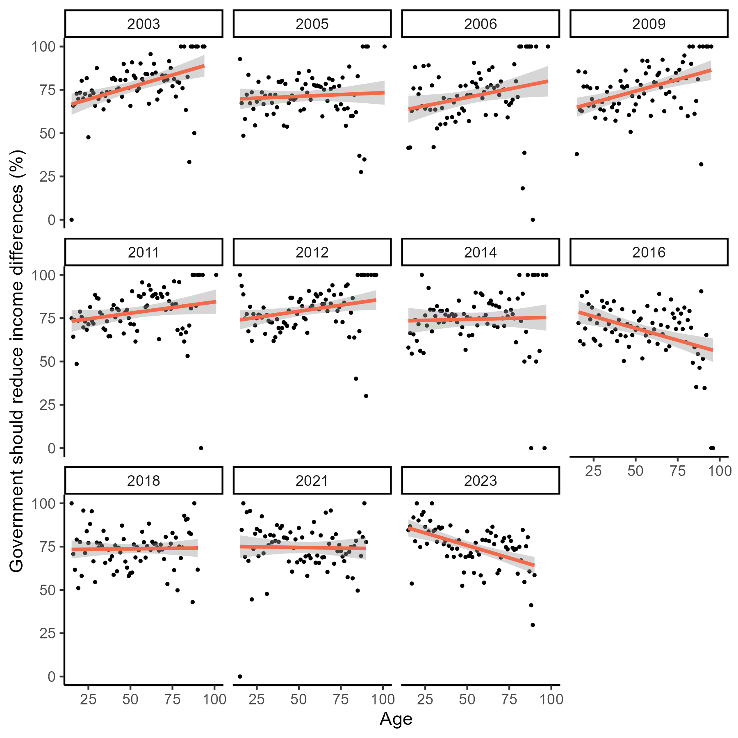
Source: Authors’ own analysis of the European Social Survey
To try to disentangle age and period effects, Figure 4.5 below presents the support for redistribution across respondents grouped according to their birth year (pseudo-cohort) and gender. The younger cohort born in the 1980s- early 2000s, who are aged 18-21 years old in the beginning of the series (2002) show increasing support as they enter and establish themselves in the labour market. The two older cohorts show a substantial variation with average higher support during the recession and early years of the economic recovery (2008-2014).
Figure 4.5: Support for redistribution over time by pseudo-cohort and gender, Ireland
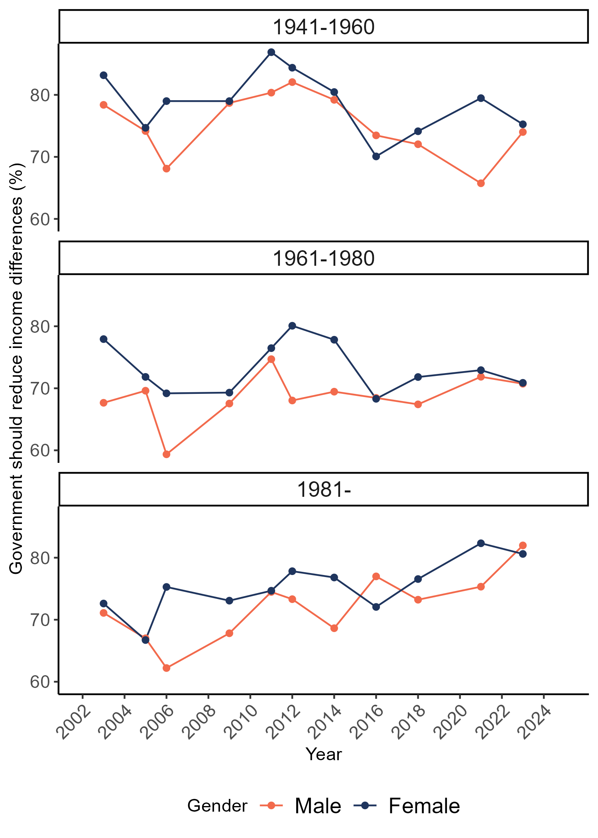
Source: Authors’ own analysis of the European Social Survey

The visual examination of Figure 4.5 suggests a common aspect between the youngest and the oldest cohort, which is the divergent gender trajectories from the 2nd to the 3rd round. In addition, the oldest cohort also experienced a similar gender divergence between the 9th and 10th rounds. These two periods are marked by the initial signs of the 2008 economic recession and the pre-post periods of the pandemic.

4.2 Relevant events
There is a growing number of studies showing that socio-economic events shape attitudes, preferences and beliefs related to welfare and redistribution (Giuliano and Spilimbergo 2025). Due to the cross-sectional nature of the European Social Survey, testing the impact of these changes, such as the recession or the pandemic, is challenging. The survey interviews different individuals across substantially different time periods, so the differences found across rounds might be due to a diverse range of measured and unmeasured factors.
However, several Event Study methods provide tools to examine the impact of more specific events contained in shorter time frames. Dunaiski and Tukiainen (2025), for instance, detected a difference in the perception of fairness of income in Finland in the period immediately after the country’s ‘Tax Day’, when authorities publish a list of individuals with the highest taxable income in the country. The authors utilised the ‘Unexpected Event During Survey’ (UEDS) design (Muñoz, Falcó-Gimeno, and Hernández 2020) to assess the impact of the event taking the respondents interviewed before the event as the control group in a quasi-experiment approach.

4.2.1 Attitudes are impacted by government campaigns
During the 2016-2017 data collection, the Irish government launched a campaign against welfare fraud. With the slogan ‘Welfare Cheats, Cheat Us All’, the Department of Social Protection funded a widely publicised media campaign with the intent of increasing fraud reporting and changing public perceptions of welfare fraud (Devereux and Power 2019). The campaign ran from April to July 2017. The majority (73%) of the respondents had been interviewed by then and the remaining interviews were conducted during the period of the campaign. After analysing the content of the campaign and reporting statistics, Power, Devereux, and Ryan (2022) show that it had not affect the overall number of fraud reports, but may have impacted the public legitimacy of welfare recipients in general.
Using data from the ESS, we assessed the impact of this campaign on welfare attitudes in Ireland. Figure 4.6 depicts the 7-day exponential moving average of three variables in the 30-day time window around the launch of the campaign on the 17th of April. For two of three selected statements related to welfare attitudes, the visual examination suggests a change of trajectory after the beginning of the campaign. The variables were used in their original format (5-point agreement scale) to avoid reduction in statistical power, considering the already reduced number of observations with a narrow time bandwidth.
Figure 4.6: 7-day exponential moving average (EMA) for three questions on welfare attitudes, Ireland, 2016-2017
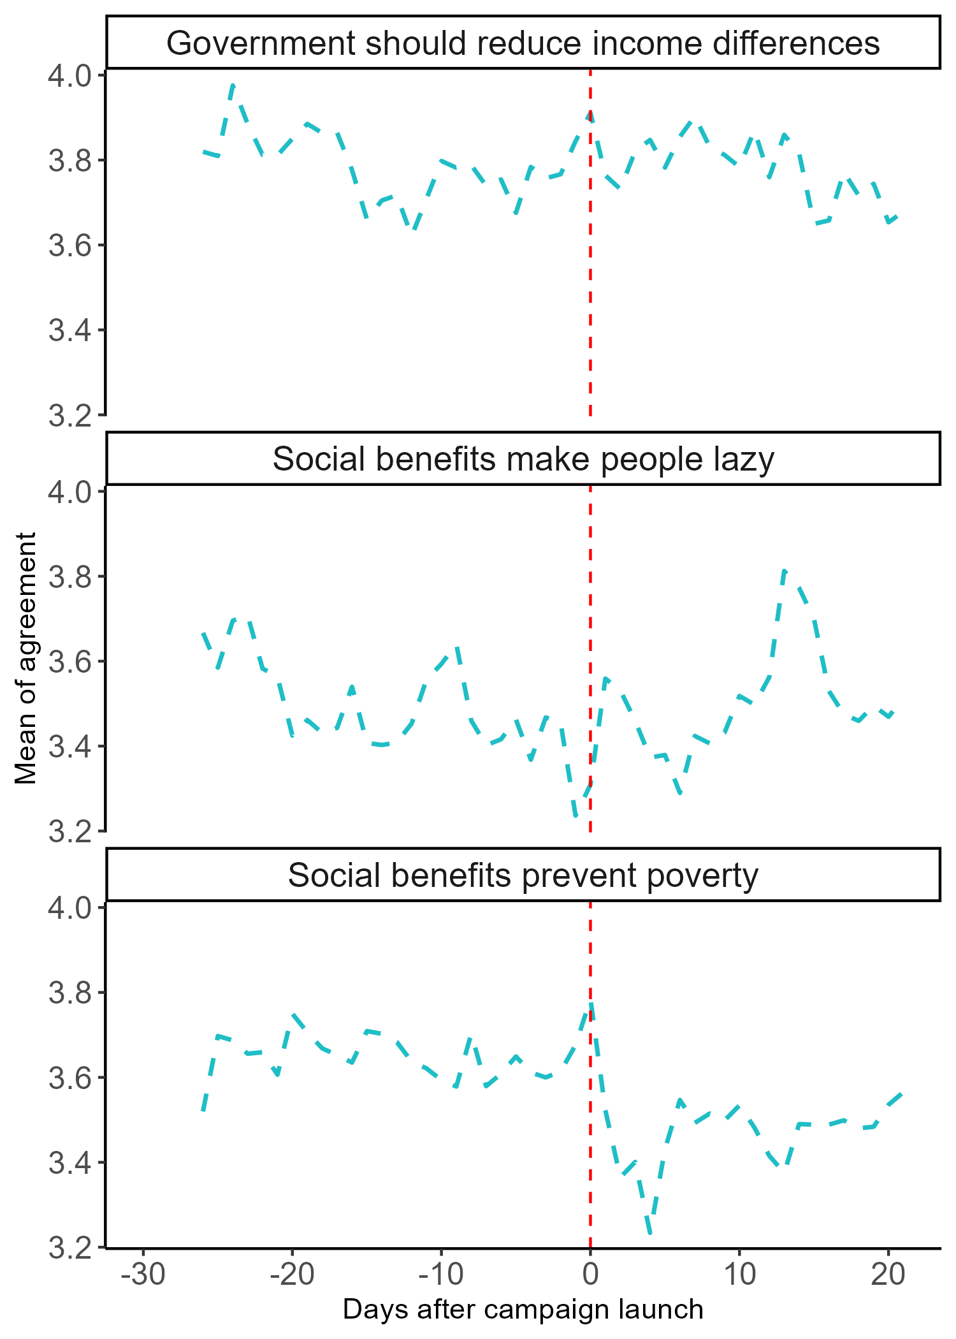
Source: Authors’ own analysis of the European Social Survey Round 8

The difference between the percentages of agreement and mean values of these variables before and after the launch is only statistically significant to agreement with ‘prevent poverty’. However, considering the potential violation of the ignorability assumption (Muñoz, Falcó-Gimeno, and Hernández 2020), we built a logistic regression model using controls for potential socio-demographic differences in the composition of the group of respondents before and after the campaign launch. Considering that this period coincides with the final quarter of the data collection, it is reasonable to expect that it may contain a higher proportion of hard-to-reach respondents (e.g. employed, higher social class, younger respondents). So, variables such as main activity, social class, age and gender were included in the model. The observations selected for the analysis are from interviews conducted two weeks prior or after the campaign launch. We also removed from the analysis respondents who indicate that they do not watch, listen or read news about politics or current affairs (9%), as they were unlikely exposed to the campaign.
Figure 4.7 presents the estimates of the effect of being interviewed after the launch of the DSP campaign. No significant effects were found for the variables related to support for redistribution and the view that social benefits prevent poverty. However, the model detects a statistically significant increase on the level of agreement that social benefits make people lazy among interviews conducted after the launch of the campaign compared to those interviewed up to 30 days prior to the launch.
Figure 4.7: Linear regression estimates for period of interview, Ireland, 2016-2017
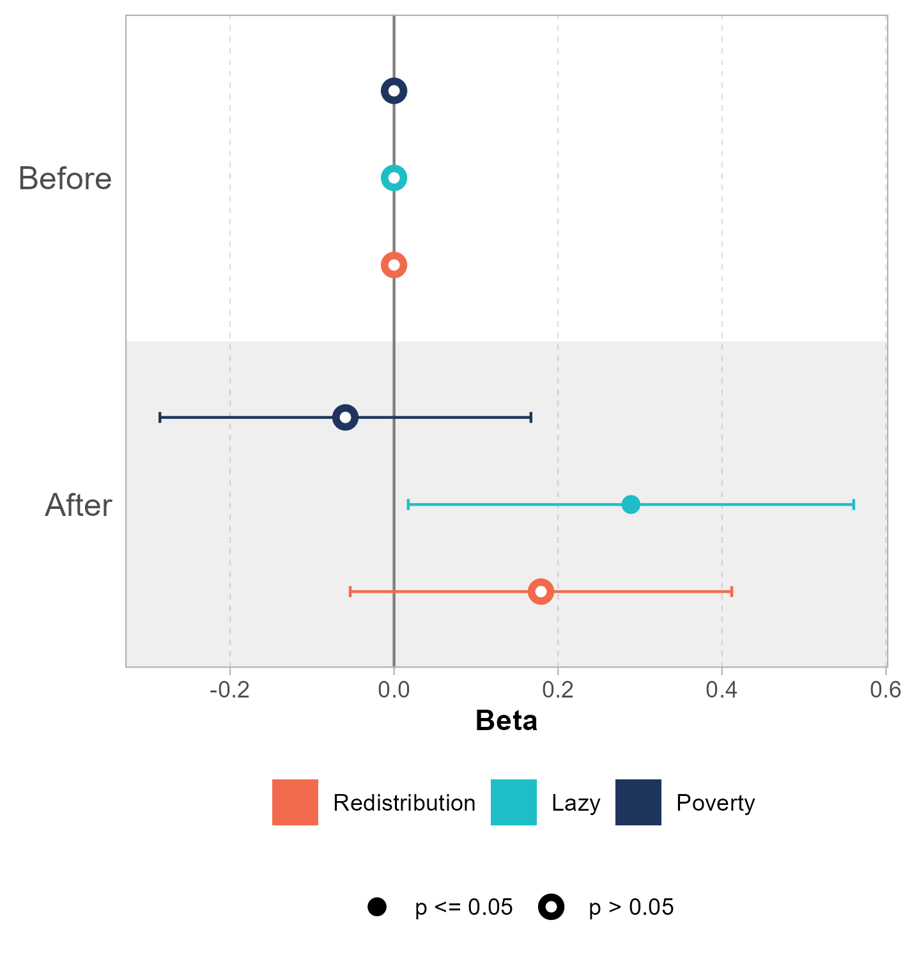
Source: Authors’ own analysis of the European Social Survey Round 8

4.2.2 Budget announcement
Another relevant event for welfare attitudes and support for redistribution is the annual budget announcement for the following year. This cannot be considered an unexpected event as the government provides prior indication of when it will be announced. Therefore, some participants might be expecting such event and cannot be considered an analogous to a control group in a quasi-experiment. Nevertheless, we hypothesise that the media coverage after the announcement may increase the salience of welfare policies and positively impact respondents’ support for redistribution. It is noteworthy that those who reported that they did not consume any media in a typical day were excluded from the analysis (between 3% and 10% depending on the round).
The announcement dates in Ireland coincided with the European Social Survey fieldwork in six different years: 2006, 2009, 2011, 2012, 2014, and 2023. The Figure 4.8 shows the 7-day exponential moving average for the agreement with the statement that the government should reduce differences in income. The analyses use the same 60-day time window around the announcement of the budget.
Figure 4.8: 7-day moving average for support for redistribution within the 30-day period of the public budget announcement, Ireland
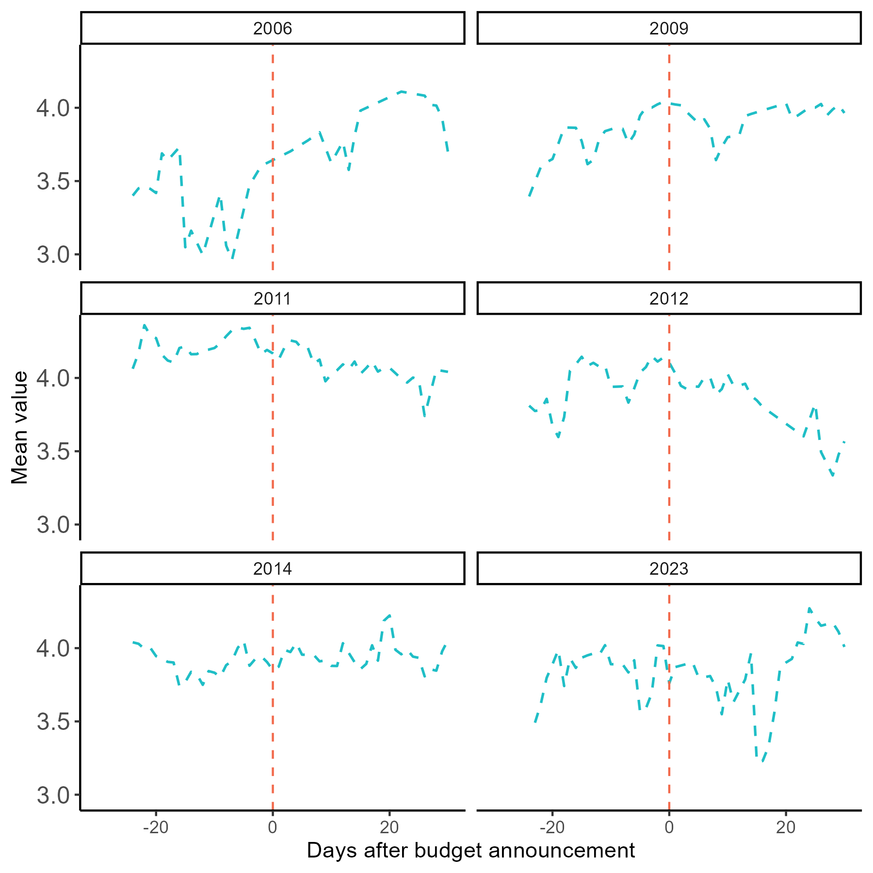
Source: Authors’ own analysis of the European Social Survey
To test the impact of the budget announcement, we adopted a similar approach to the one discussed in the previous section. The model includes the same variables to control for systematic differences in the sample composition of those interviewed before and after the announcement. Using the same time window of 60 days (a month before and a month after), we do not find any statistically significant differences in the support for redistribution. However, the difference is statistically significant when we select a shorter time window for the analyses.
As shown in Figure 4.9, when we look at subsets of the sample in varied time windows from 5 to 40 days, the differences are only statistically significant up to 28 days. The continuous line shows the predicted change in support for each time window analysed. The dotted lines represent the 95% confidence interval of this estimate. The direction of the effect is the opposite of what expected, with lower support for redistribution after the publication of the budget.
One potential explanation of this result is a higher salience of redistributive issues prior to the publication as a result of media speculation and campaigns from different organisation attempting to influence the public debate. In this interpretation, the higher support for redistribution only occurs in the month prior to the announcement. Figure 4.9 also includes the estimates from the same model using “satisfaction with government” as dependent variable. In this case, no significant differences are found regardless of the time bandwidth.
This relatively weak and short-lived effect found in Ireland goes in the same direction of Dunaiski and Tukiainen (2025) conclusion that political events such as the ‘Tax Day’ in Finland have limited impact on attitudes.
Figure 4.9: Linear regression estimates for being interviewed after the budget announcement by time window, Ireland
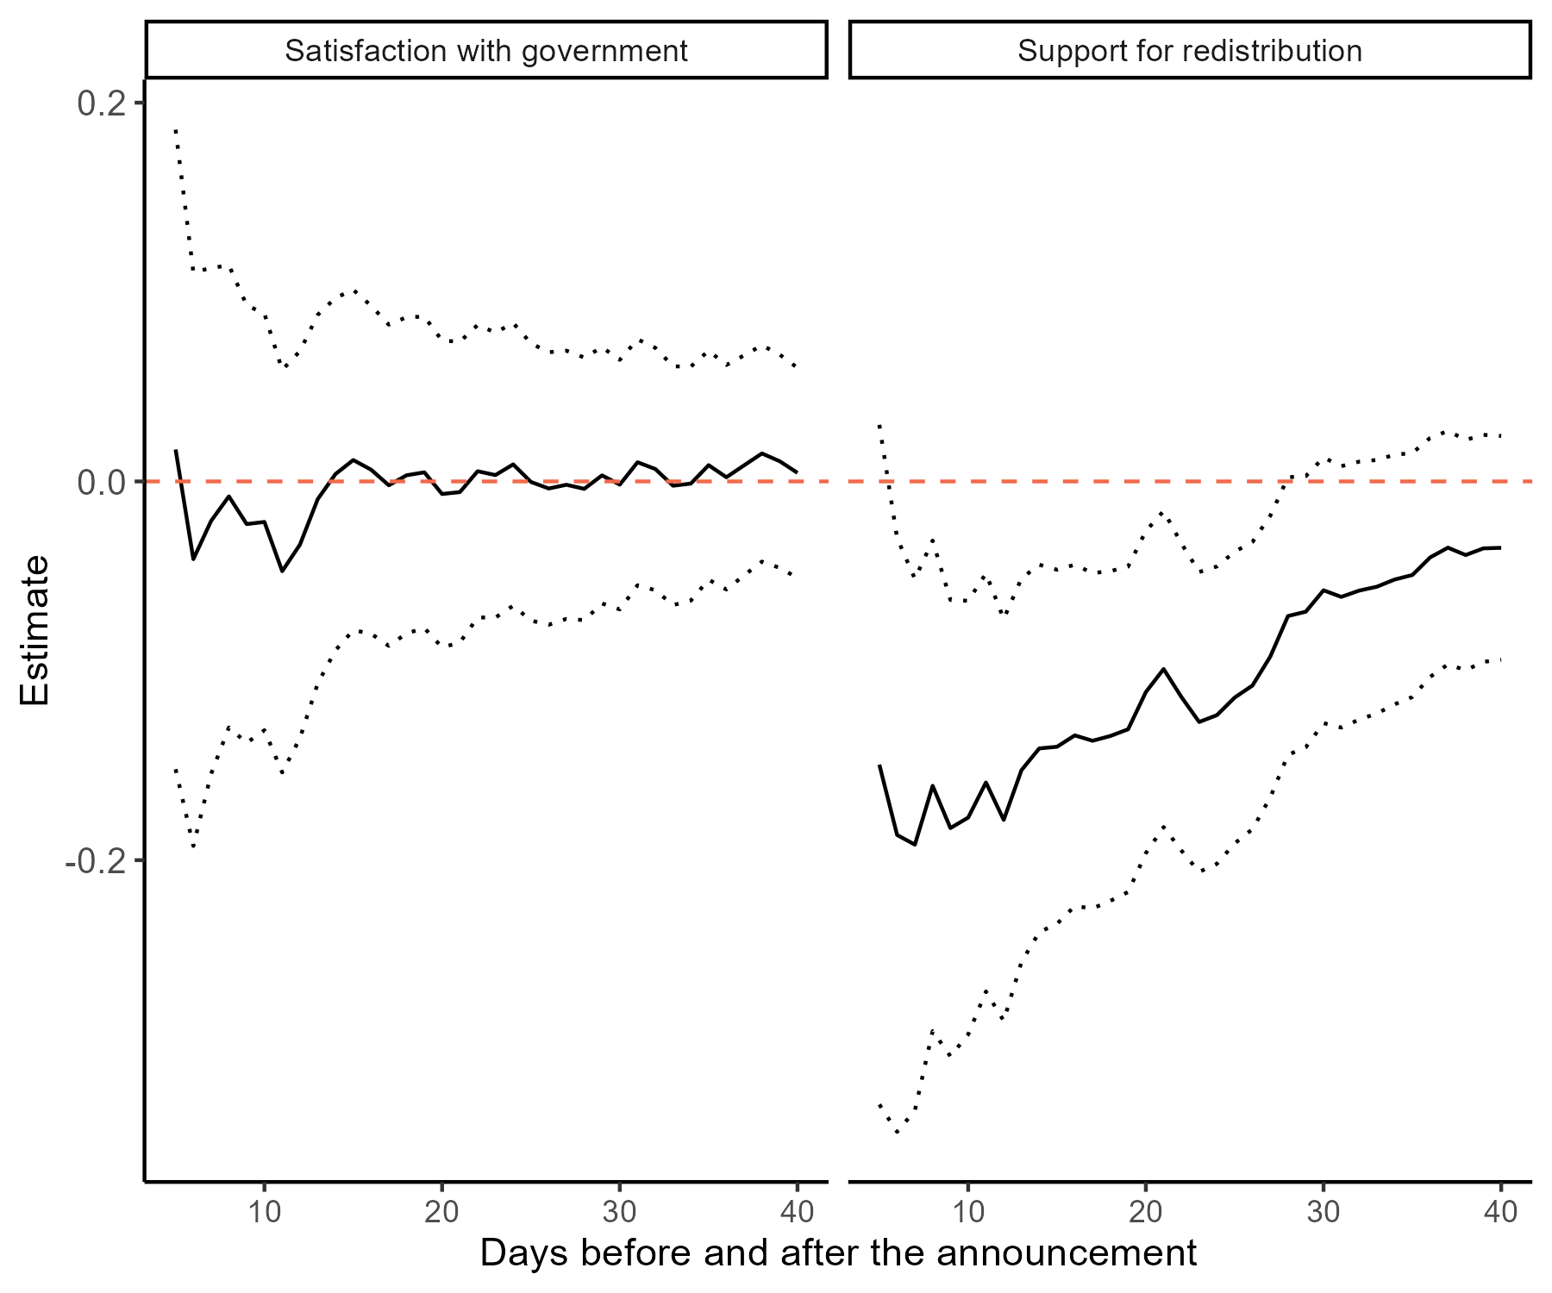
Source: Authors’ own analysis of the European Social Survey Round 8

4.2.3 Pandemic
A major event experienced during the ESS time series was the COVID19 pandemic. Evidence from a survey experiment in the United States show that participants were more willing to prioritize society’s problems when exposed to issues related to the pandemic (Cappelen et al. 2021). Van Hootegem and Laenen (2023) observed that support for a universal basic income in Belgium increased with the pandemic but it was short lived.
In response to the pandemic the Irish government introduced a major package of income supports. This included the Pandemic Unemployment Payment, the Temporary Wage Subsidy Scheme/Employer Wage Subsidy Scheme (see Alamir, McGinnity, and Russell (2024) for further discussion of government supports). At their height, these schemes were supporting one million workers and 37,000 enterprises, at a cost of €16.7 billion up to October 2021 (Department of Public Expenditure and Reform 2021).
The first ESS data collection after the pandemic in Ireland occurred between November 2021 and August 2022. By this time, as shown in Figure 4.3, the unemployment rate was already returning to levels similar to the period before the start of the pandemic. The survey included a specific module on items related to respondents’ experiences during the pandemic. A sub-group of questions asked participants to indicate if any of the following happened to them as a result of the coronavirus pandemic:
I was made redundant/lost my job
I have not been in work at any time since the start of the pandemic
The income from my job was reduced
My working hours were reduced
I was furloughed
I was forced to take unpaid leave/holiday
None of these
Figure 4.10 below shows the proportion of respondents who agree that the government should reduce differences in income by social class and personal impact of the pandemic. Overall, the working class seem to be supportive of redistribution regardless of the pandemic experiences. On the other hand, the higher-grade service class seems to be more supportive among those who lost their jobs (82% support) compared to those who indicated that nothing happened (60% support).
Figure 4.10: Proportion of support for redistribution by social class and personal impact of the pandemic, Ireland, 2021
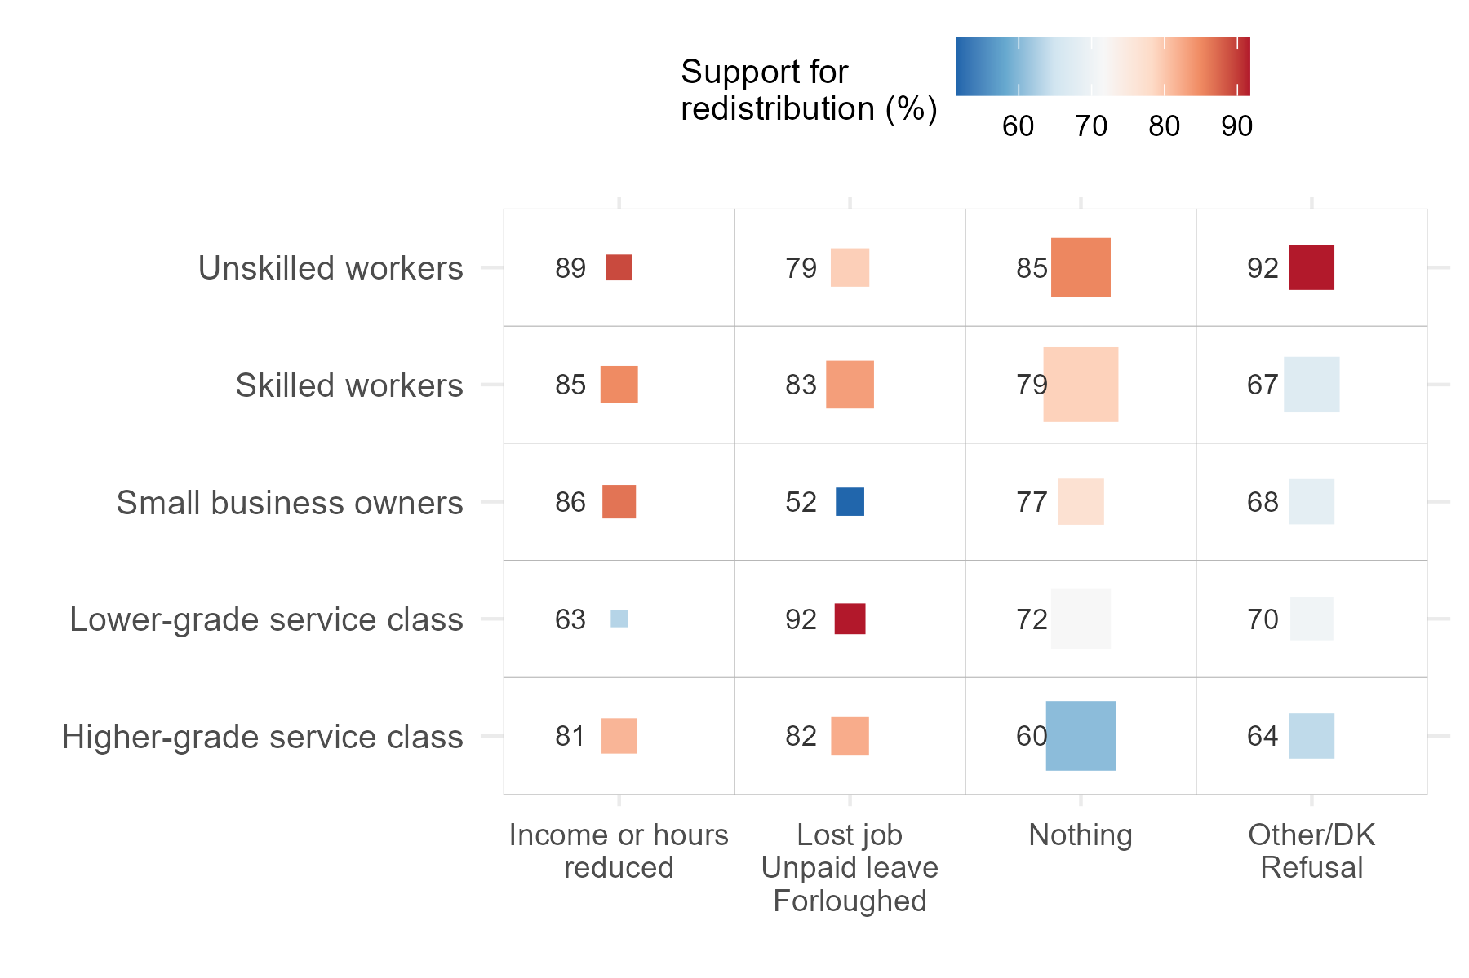
Source: Authors’ own analysis of the European Social Survey
Note: Square sizes represent the number of participants in each cell. Numbers represent and colours represent the proportion of participants in the cell that agree with the statement on redistribution.

CHAPTER 5
Conclusions and policy implications
Public support for the welfare state is an important foundation for democratic governments to pursue the policies needed to alleviate poverty in society. The attitudes examined in this study are key indicators of this support. On some issues, public attitudes can be instigator of policy change. For example, public support for abortion in Ireland was widespread prior to the referendum in 2018 (Elkink et al. 2020). On other issues, a policy action may prompt changes in attitudes and behaviour.
In Ireland, about three-quarters of the adult population support redistribution, either agreeing or strongly agreeing that the government should reduce differences in income. This is among the highest proportions in Europe. The level of support is particularly high among low-income households, female and the younger cohort. While the overall proportion fluctuated over the period analysed (2002-2024) it never fell below 65%, giving Irish governments a sustained backing for redistributive policies.
At the same time, compared to other European countries, Ireland has a higher proportion of respondents who are willing to pay more taxes if that leads to improved public services. However, there is no clear relationship between the aggregate country-level support for redistribution and willingness to pay more taxes.
Despite the high levels of support for welfare policies and redistribution, Ireland also has one of the highest proportions of people in Europe who believe that “social benefits make people lazy”. This points to the importance of addressing public misconceptions and challenging negative stereotypes about welfare recipients.
Findings from experimental research suggests that the framing of policies is important, and the provision of information on the extent of inequality. This is reinforced by this report’s findings on the ‘welfare cheats’ campaign. Framing the receipt of social transfers as potentially fraudulent increased the perception that social benefits make people lazy, which is associated with lower support for welfare policies and redistribution. In this sense, campaigns that emphasise entitlements and rights are likely to reinforce a more collective public good’ view of the welfare state and counteract negative perceptions of individuals in receipt of benefit as underserving. Efforts should be made to highlight the positive role of social protection in promoting equality and social cohesion.
The analysis of survey data over time also shows that support for redistribution tends to increase during periods of economic crisis, such as the 2008 recession and the COVID-19 pandemic. Ireland experienced a substantial level of government intervention in the economy during the pandemic, which resulted in social transfers to those that may not previously have drawn on such benefits. This translated into higher support for government redistribution. However, the nature of pandemic as an external shock meant that public less likely to attribute blame to those who found themselves in need of government support, therefore the support for redistribution in these circumstances may not sustain over time.
Nevertheless, despite the short-lived effects of these external events, policymakers may take the opportunity of these moments of support to implement more permanent reforms that go beyond the period of crisis.

References

Alamir, Anousheh, Frances McGinnity, and Helen Russell. 2024. “The Equality Impact of the Covid-19 Pandemic on the Irish Labour Market,” April. https://doi.org/10.26504/jr6.
An Coimisiún Toghcháin. 2024. “Ireland’s National Election and Democracy Study (NEDS) General Election Survey.”
Attewell, David. 2021. “Deservingness Perceptions, Welfare State Support and Vote Choice in Western Europe.” West European Politics 44 (3): 611–34. https://doi.org/10.1080/01402382.2020.1715704.
Aybar, Cristina, Virgilio Pérez, and Jose M. Pavía. 2024. “Scale Matters: Unravelling the Impact of Likert Scales on Political Self-Placement.” Quality & Quantity 58 (4): 3725–46. https://doi.org/10.1007/s11135-023-01825-2.
Bonnet, Julien, Emanuele Ciani, Gianluca Grimalda, Fabrice Murtin, and David Pipke. 2024. “What Explains Preferences for Redistribution?: Evidence from an International Survey.” {OECD} {Papers} on {Well}-being and {Inequalities}. https://doi.org/10.1787/c0120dea-en.
Bremer, Björn, and Reto Bürgisser. 2025. “Lower Taxes at All Costs? Evidence from a Survey Experiment in Four European Countries.” Journal of European Public Policy 32 (5): 1225–52. https://doi.org/10.1080/13501763.2024.2333856.
Breznau, Nate, Lisa Heukamp, Hung HV Nguyen, and Tom Knuf. 2025. “The Moderating Role of Government Heuristics in Public Preferences for Redistribution.” Journal of European Social Policy 35 (1): 21–39. https://doi.org/10.1177/09589287241290742.
Bullock, Heather E., Wendy R. Williams, and Wendy M. Limbert. 2003. “Predicting Support for Welfare Policies: The Impact of Attributions and Beliefs About Inequality.” Journal of Poverty 7 (3): 35–56. https://doi.org/10.1300/j134v07n03_03.
Buser, Thomas, Gianluca Grimalda, Louis Putterman, and Joël Van Der Weele. 2020. “Overconfidence and Gender Gaps in Redistributive Preferences: Cross-Country Experimental Evidence.” Journal of Economic Behavior & Organization 178 (October): 267–86. https://doi.org/10.1016/j.jebo.2020.07.005.
Cappelen, Alexander W., Ranveig Falch, Erik Ø. Sørensen, and Bertil Tungodden. 2021. “Solidarity and Fairness in Times of Crisis.” Journal of Economic Behavior & Organization 186 (June): 1–11. https://doi.org/10.1016/j.jebo.2021.03.017.
Cavaillé, Charlotte. 2025. Fair Enough?: Support for Redistribution in the Age of Inequality. 1st ed. Cambridge University Press. https://doi.org/10.1017/9781009366038.
Chow, Rosalind M., and Jeff Galak. 2012. “The Effect of Inequality Frames on Support for Redistributive Tax Policies.” Psychological Science 23 (12): 1467–69. https://doi.org/10.1177/0956797612450035.
Ciani, Emanuele, Louis Freget, and Thomas Manfredi. 2021. “Learning about Inequality and Demand for Redistribution: A Meta-Analysis of in-Survey Informational Experiments.” Organisation for Economic Co-Operation; Development (OECD). https://doi.org/10.1787/8876ec48-en.
Dallinger, Ursula. 2022. “On the Ambivalence of Preferences for Income Redistribution: A Research Note.” Journal of European Social Policy 32 (2): 225–36. https://doi.org/10.1177/09589287211066469.
Department of Public Expenditure and Reform. 2021. “Spending Review 2021 The Pandemic Unemployment Payment and the Employment Wage Subsidy Scheme: Trends and Interactions.” https://assets.gov.ie/205494/d9521623-4d24-4937-b09d-a5a2535d4158.pdf.
Devereux, Eoin, and Martin J. Power. 2019. “Fake News? A Critical Analysis of the ‘Welfare Cheats, Cheat Us All ’ Campaign in Ireland.” Critical Discourse Studies 16 (3): 347–62. https://doi.org/10.1080/17405904.2019.1568898.
Dunaiski, Maurice, and Janne Tukiainen. 2025. “Does Income Transparency Affect Support for Redistribution? Evidence from Finland’s Tax Day.” The Journal of Politics 87 (3): 823–37. https://doi.org/10.1086/732955.
Elkink, Johan A., David M. Farrell, Sofie Marien, Theresa Reidy, and Jane Suiter. 2020. “The Death of Conservative Ireland? The 2018 Abortion Referendum.” Electoral Studies 65 (June): 102142. https://doi.org/10.1016/j.electstud.2020.102142.
Finseraas, Henning. 2009. “Income Inequality and Demand for Redistribution: A Multilevel Analysis of European Public Opinion.” Scandinavian Political Studies 32 (1): 94–119. https://doi.org/10.1111/j.1467-9477.2008.00211.x.
Garritzmann, Julian L., and Hanna Schwander. 2021. “Gender and Attitudes Toward Welfare State Reform: Are Women Really Social Investment Promoters?” Journal of European Social Policy 31 (3): 253–66. https://doi.org/10.1177/0958928720978012.
Giuliano, Paola, and Antonio Spilimbergo. 2025. “Aggregate Shocks and the Formation of Preferences and Beliefs.” Journal of Economic Literature 63 (2): 542–97. https://doi.org/10.1257/jel.20241674.
Goerres, Achim, and Katrin Prinzen. 2012. “Can We Improve the Measurement of Attitudes Towards the Welfare State? A Constructive Critique of Survey Instruments with Evidence from Focus Groups.” Social Indicators Research 109 (3): 515–34. https://doi.org/10.1007/s11205-011-9915-5.
Gonnot, Jérome, and Federica lo Polito. 2023. “Cultural Transmission and Political Attitudes: Explaining Differences Between Natives and Immigrants in Western Europe.” Working {Papers} 2023-12. CEPII research center. https://doi.org/None.
Goossen, Mikael. 2020. “The Gender Gap in Welfare State Attitudes in Europe: The Role of Unpaid Labour and Family Policy.” Journal of European Social Policy 30 (4): 452–66. https://doi.org/10.1177/0958928719899337.
Grasso, Maria, and Rosalind Shorrocks. 2025. “Are New Generations of Women More Left-Wing Than Men? Generations and Gender Gaps in Attitudes to Inequality and Social Services.” Journal of European Public Policy, April, 1–28. https://doi.org/10.1080/13501763.2025.2490811.
Hillen, Sven, and Nils D. Steiner. 2025. “Rising Inequality and Public Support for Redistribution.” European Journal of Political Research 64 (1): 442–55. https://doi.org/10.1111/1475-6765.12696.
Hingre, Garance, Helen Russell, Frances McGinnity, and Emer Smyth. 2024. “Gender and Labour Market Inclusion on the Island of Ireland.” Economic; Social Research Institute. https://doi.org/10.26504/rs176.
Inglehart, Ronald F. 2018. Cultural Evolution: People’s Motivations Are Changing, and Reshaping the World. 1st ed. Cambridge University Press. https://doi.org/10.1017/9781108613880.
Jaeger, M. M. 2008. “Does Left-Right Orientation Have a Causal Effect on Support for Redistribution? Causal Analysis with Cross-Sectional Data Using Instrumental Variables.” International Journal of Public Opinion Research 20 (3): 363–74. https://doi.org/10.1093/ijpor/edn030.
Kulin, J., and S. Svallfors. 2013. “Class, Values, and Attitudes Towards Redistribution: A European Comparison.” European Sociological Review 29 (2): 155–67. https://doi.org/10.1093/esr/jcr046.
Langsæther, Peter Egge, and Geoffrey Evans. 2020. “More Than Self-Interest: Why Different Classes Have Different Attitudes to Income Inequality.” The British Journal of Sociology 71 (4): 594–607. https://doi.org/10.1111/1468-4446.12747.
Lindqvist, Jesper. 2025. “Eastern Europe Is No Exception: Acceptance of Inequality and Left–Right Politics.” Acta Politica 60 (3): 483–501. https://doi.org/10.1057/s41269-024-00332-y.
Lupu, Noam, and Jonas Pontusson, eds. 2023. Unequal Democracies: Public Policy, Responsiveness, and Redistribution in an Era of Rising Economic Inequality. 1st ed. Cambridge University Press. https://doi.org/10.1017/9781009428682.
Margalit, Yotam, and Shir Raviv. 2024. “Does Support for Redistribution Mean What We Think It Means?” Political Science Research and Methods 12 (4): 870–78. https://doi.org/10.1017/psrm.2023.57.
Meltzer, Allan H., and Scott F. Richard. 1981. “A Rational Theory of the Size of Government.” Journal of Political Economy 89 (5): 914–27. https://doi.org/10.1086/261013.
Meuleman, Bart, Wim Van Oorschot, Dimitri Gugushvili, Sharon Baute, Sam Delespaul, Tijs Laenen, Femke Roosma, and Federica Rossetti. 2018. “The Past, Present and Future of European Welfare Attitudes: Topline Results from Round 8 of the European Social Survey.” ESS Topline Series.
Muñoz, Jordi, Albert Falcó-Gimeno, and Enrique Hernández. 2020. “Unexpected Event During Survey Design: Promise and Pitfalls for Causal Inference.” Political Analysis 28 (2): 186–206. https://doi.org/10.1017/pan.2019.27.
Nunnari, Salvatore, and Massimiliano Pozzi. 2022. “Meta-Analysis of Inequality Aversion Estimates.” {SSRN} {Scholarly} {Paper}. Rochester, NY: Social Science Research Network. https://doi.org/10.2139/ssrn.4169385.
Oesch, Daniel. 2006. “Coming to Grips with a Changing Class Structure: An Analysis of Employment Stratification in Britain, Germany, Sweden and Switzerland.” International Sociology 21 (2): 263–88. https://doi.org/10.1177/0268580906061379.
Oorschot, Wim van, and Femke Roosma. 2017. “The Social Legitimacy of Differently Targeted Benefits.”
Power, Martin J., Eoin Devereux, and Majka Ryan. 2022. “Framing and Shaming: The 2017 Welfare Cheats, Cheat Us All Campaign.” Social Policy and Society 21 (4): 646–56. https://doi.org/10.1017/S1474746422000082.
Roantree, Barra, Helen Russell, Anousheh Alamir, Míde Griffin, Bertrand Maître, and Tara Mitchell. 2025. “Poverty, Income Inequality and Living Standards in Ireland: Fifth Annual Report.” ESRI. https://doi.org/10.26504/jr14.
Rosset, Jan, Jérémie Poltier, and Jonas Pontusson. 2025. “Unevenly Unequal Responsiveness: Public Opinion and Redistributive Policy Shifts in Western Europe Since 2008.” Politics & Society 53 (2): 243–73. https://doi.org/10.1177/00323292241283293.
Shorrocks, Rosalind, and Maria T. Grasso. 2020. “The Attitudinal Gender Gap Across Generations: Support for Redistribution and Government Spending in Contexts of High and Low Welfare Provision.” European Political Science Review 12 (3): 289–306. https://doi.org/10.1017/S1755773920000120.
Steele, Liza G., and Nate Breznau. 2019. “Attitudes Toward Redistributive Policy: An Introduction.” Societies 9 (3): 50. https://doi.org/10.3390/soc9030050.
Steele, Liza G., Joseph Nathan Cohen, and Joseph R. Van Der Naald. 2022. “Wealth, Income, and Preferences for Redistribution: Evidence from 30 Countries.” Social Science Research 108 (November): 102746. https://doi.org/10.1016/j.ssresearch.2022.102746.
Svallfors, Stefan, ed. 2012. Contested Welfare States: Welfare Attitudes in Europe and Beyond. Stanford University Press. https://doi.org/10.11126/stanford/9780804782524.001.0001.
Tawfik, Amal, and Daniel Oesch. 2020. “Script to Construct an Indicator of Social Class in the ESS.” Https://Www. Europeansocialsurvey. Org/Docs/Shared_user_resources/Oesch/Oesch_social_class_schema. Zip (Zugegriffen Am 11.11. 2021). https://scholar.google.com/scholar?cluster=14780777134980176311&hl=en&oi=scholarr.
Van Hootegem, Arno, and Tijs Laenen. 2023. “A Wave of Support? A Natural Experiment on How the COVID-19 Pandemic Affected the Popularity of a Basic Income.” Acta Politica 58 (3): 695–713. https://doi.org/10.1057/s41269-022-00260-9.
Velev, Valentin, and Alexander W Schmidt-Catran. 2024. “Economic Inequality and Public Support for Redistribution in Europe: A Cross-Sectional and Longitudinal Multilevel Analysis.” International Journal of Public Opinion Research 36 (4): edae055. https://doi.org/10.1093/ijpor/edae055.

For more info, visit https://www.europeansocialsurvey.org
We use a logistic regression model which is a statistical method commonly employed to estimate the probability of an outcome occurring (in this case, supporting redistirbution) based on one or more independent variables (e.g. gender, age, social class). Similar results are found using a linear model and the original 5-point scale as response variable (please see Annex 1). As observations from multiple rounds were pooled together for this analysis, we added to the model the variable denoting the round to account for the shared variance and dependence of observations within each round.
Coefficients for the control variables were omitted to faciliate reading, but the full table can be found in Annex 1.
The ESS data collection period for each round in Ireland varied from 5 months up to 20 months.
Exponential moving averages attributes greater weight to more recent observations, making it more responsive to potential trajectory changes.

