Public support for welfare and redistributive policies in Ireland
Bertrand Maître, Daniel Capistrano, Helen Russell
Table of contents

1. Introduction
Many vulnerable individuals and families in Ireland, each with different profiles, circumstances, and needs, are struggling to make ends meet and are falling into poverty. A significant number of these people rely heavily on welfare benefits, but the current level of support is often insufficient to protect them from poverty. In a context of increasing challenges to social welfare in Ireland, it is crucial to have a better understanding of the public support to State actions designed to address these challenges.
With this objective, the current report presents findings of a research project that explored attitudes towards welfare and redistributive policies among Irish residents. Ireland offers a particularly relevant context for this research. Over the past few decades, the Irish society experienced different levels of economic growth, market inequality, and poverty (Roantree et al. 2025). In this sense, the changing conditions provide valuable information to examine the factors associated with public support for welfare policies and income redistribution.
The research project was guide by the following general questions:
- Who in Ireland supports income redistribution?
- What Irish residents think about welfare policies?
- Has the overall support for welfare policies and income redistribution changed over time?
Chapter 2 in this report addresses the first question of a diffuse and generalised support for income and wealth redistribution in the Irish society. Chapter 3, addressing the second question, examines more specific support to welfare policies, beliefs about social benefits and their beneficiaries. Finally, Chapter 4 looks at change over time in relation to these topics and explores the possible impact of the 2008 economic recession and the 2020 pandemic.

1.1 Key points
- 3 in 4 Irish residents indicate that they agree that the government should reduce differences in income. This proportion is slightly higher than the European average and the ones from other northern European countries (Figure 1).
- Female ESS respondents and those from lower social classes are more supportive of income redistribution (Table 1).
- Ireland has one of the highest proportions in Europe of respondents who believe that ‘social benefits make people lazy’ (Figure 8).
- Younger, right-wing, and those with lower educational attainment are more likely to agree that social benefits make people lazy (Table 2).
- From 2009 to 2016 there was an increase in the proportion of respondents who agree that ‘social benefits lead to a more equal society’ (Figure 7).

1.2 Methods and data
Social researchers make use of a varied set of methods to assess welfare attitudes. However, the main quantitative method in this field is social survey (Steele and Breznau 2019; Svallfors 2012). Despite their limited capacity to capture nuance and ambivalence in welfare attitudes (Goerres and Prinzen 2012), surveys help researchers to identify trends and patterns within and across different societies.
In this sense, the main data source selected for this project is the European Social Survey (ESS). More than 20 European countries participate in this survey that is conducted roughly every two years. Ireland is one of the few countries that participated in all 11 rounds since 2002. On average, 2,200 people who were 18 or older and resident in Ireland were interviewed in each of these rounds.
This research analysed several questions from a special module on welfare attitudes that was fielded in 2009 and 2016. However, most of the analysis is based on a core question, included in all rounds, on the role of the government in reducing income inequalities. Beyond that, the ESS questionnaire contains several other questions relevant to this research related to socio-demographic characteristics. In addition, based on the class scheme developed by Oesch (2006), a “social class” variable was constructed using questions about the respondent’s occupation (following Tawfik and Oesch (2020) script).
Finally, this research also relied on public opinion data from Voter Surveys (VS) conducted immediately after the European elections (2014, 2019, 2024). These surveys are part of the European Elections Studies (EES), which also features political elite surveys, media studies, and the Euromanifestos project that codes Party Manifestos. Despite being part of the Eurobarometer project before 1994, thee EES surveys have been conducted independently since 1999. The survey offers additional information particularly on electoral behaviours and political attitudes.

2. Who supports redistribution?
The ESS question used to assess support for redistribution asked participants to indicate if the government should take measures to reduce differences in income levels. The interviewer manual does not contain any additional instruction in relation to this question, so respondents provided their answers according to their understanding of the following wording:
 Question wording
Using this card, please say to what extent you agree or disagree with each of the following statements. The government should take measures to reduce differences in income levels.
1 - Agree strongly
2 - Agree
3 - Neither agree nor disagree
4 - Disagree
5 - Disagree strongly
Recent studies have raised concerns in relation to the reliability of this question as a measurement of support for redistribution. Margalit and Raviv (2024) argue that reduction in income differences is too abstract and respondents in general do not link it to concrete redistributive measures. Similarly, it has been suggested that this question only captures a diffuse inclination to equality and that is why responses might be inconsistent with voting preferences across countries (Dallinger 2022). However, Breznau et al. (2025) argue that the absence of a relationship between this measurement and other expected correlates (voting preferences, support for concrete policies) is due to the omission of views on government (trust and perceptions of corruption) as a moderating variable. In addition, this report also describes support for more concrete welfare policies in Chapter 3.
Similar to the main ESS question, the VS questionnaires also ask whether voters are in favour of wealth redistribution from the rich to the poor using a scale from 0 (‘fully oppose’) to 10 (‘fully favour’). The original scale of this variable was inverted for this analysis. So, in the results presented here, higher values indicate more in favour of redistribution.

2.1 Higher support in Ireland compared to other northern European countries
The overall levels of support for income redistribution in 2023 shown in Figure 1 is in line with the south/north geographical divide identified before (Meuleman et al. 2018), with Finseraas (2009) suggesting that countries with higher income inequality tend to be more supportive of income redistribution. About 76% of respondents in Ireland indicated that they either ‘agree’ (45%) or ‘agree strongly’ (31%) that the government should reduce income differences. This percentage is higher than the European average (71%), and the one observed in France (72%), UK (70%), the Netherlands (63%) and Poland (59%).
Figure 1: Proportion who agree that the ‘Government should reduce income differences’, Europe, 2023
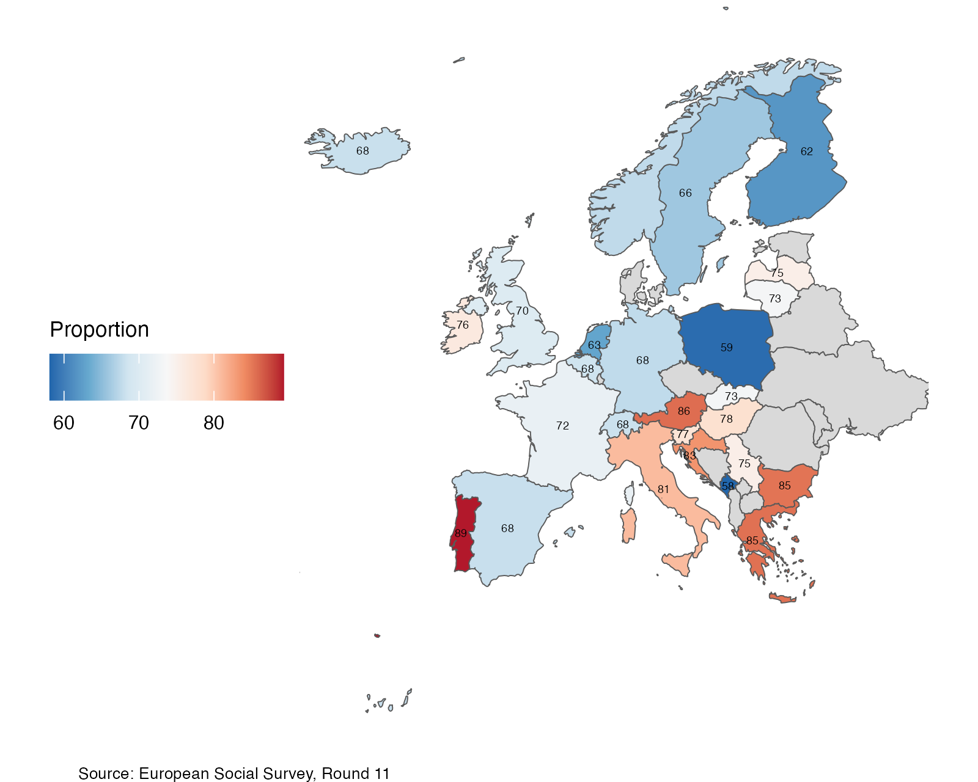

2.2 There is no clear relationship between support for redistribution and willingness to pay more taxes
In August 2025, the Eurobarometer conducted a survey on citizen’s attitudes towards taxation. Participants were asked which among the following statements they agreed the most:
- Taxes are too high, and I would decrease them even if it means fewer or lower quality public services
- I agree with higher taxes if it means more or better public services
- Both taxes and public services should stay at the same level
In Ireland, 34% of respondents indicated that they would agree with higher taxes if it means more or better public services. This is the 6th highest percentage across the 27 participant countries. This proportion varies from 16% in Luxembourg and Belgium to 42% in Sweden and Spain. Comparing countries at the national level in Figure 2, there is no clear relationship between this proportion and the overall support for redistribution measured by the ESS in 2023.
Figure 2: Relationship between support for redistribution and agreeement that there could be ‘higher taxes if it means more or better public services’, Europe, 2023/2025
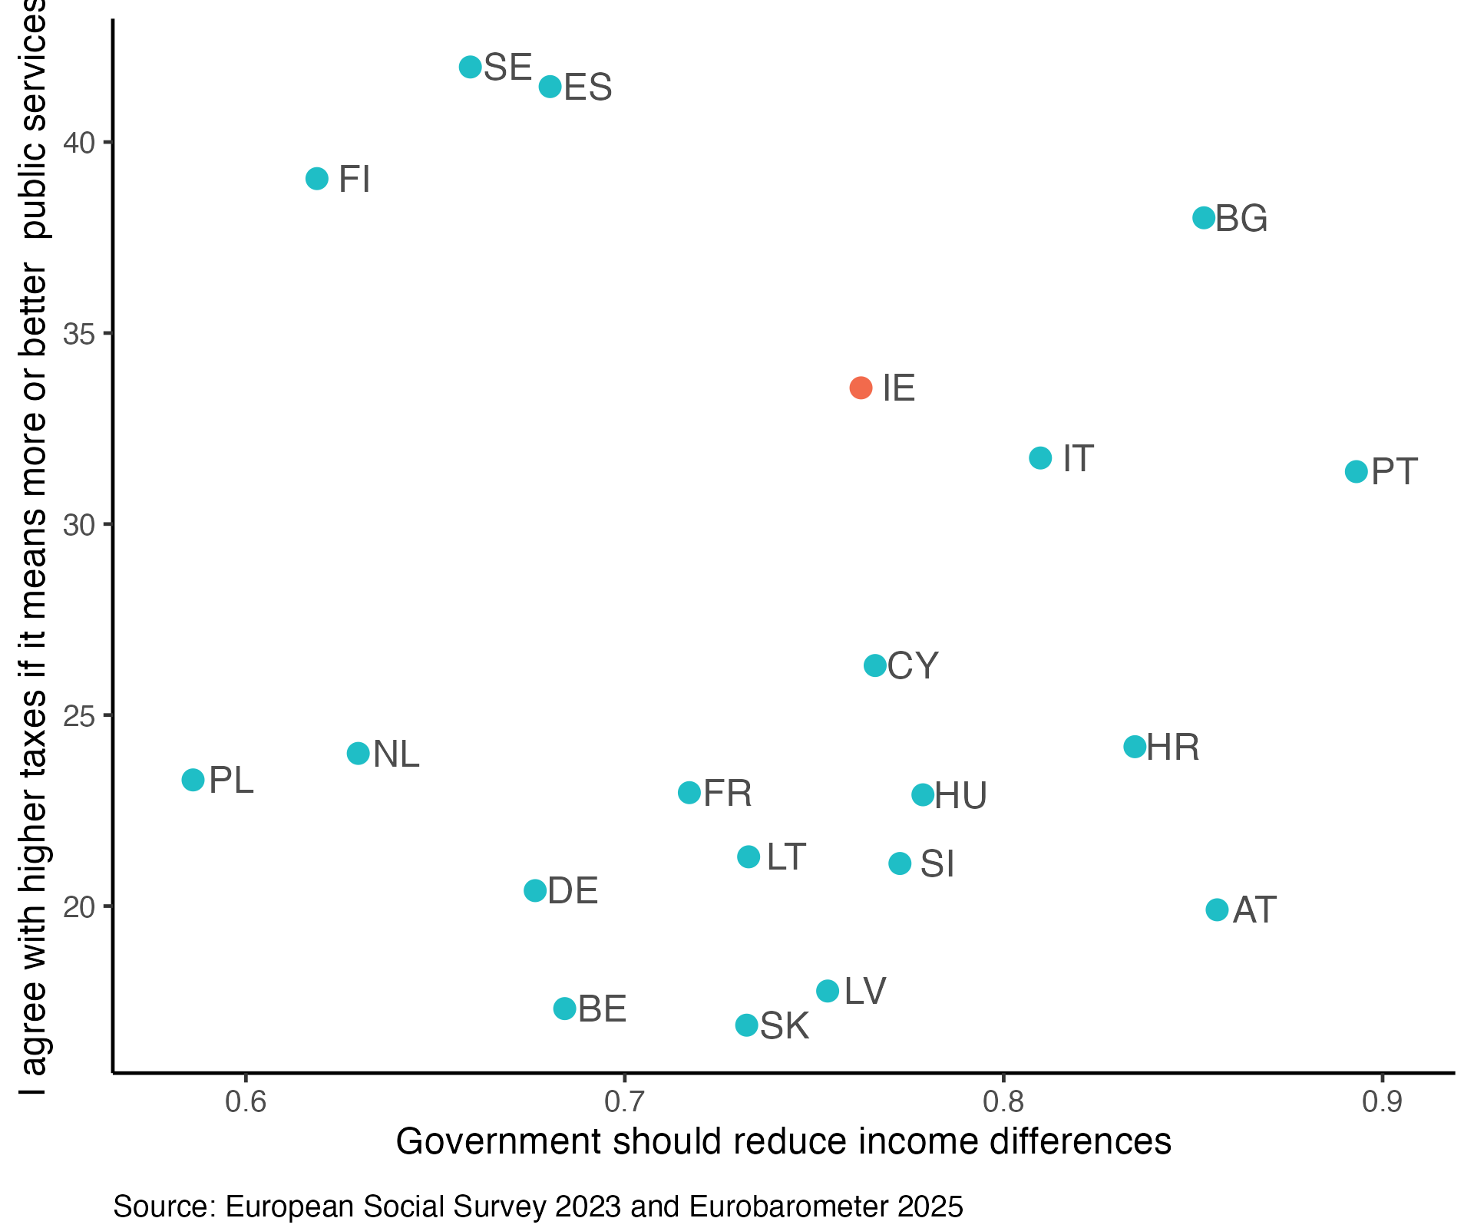
Comparing ESS data on support for specific welfare policies (discussed in Chapter 3) and government policies, Rosset, Poltier, and Pontusson (2025) found mixed evidence for policy responsiveness. Although tax policies in several countries have moved in the same direction of the increasingly progressive attitudes to welfare, unemployment policy has not had the same trajectory.

2.3 Female and lower SES respondents are more supportive of redistribution
Despite the profusion of studies on the relationship between gender and welfare policies, there is a gap in understanding the gender dimension of beliefs and perceptions in relation to these policies (Garritzmann and Schwander 2021). Considering the marked gender differences in access to the labour market and levels of pay in Ireland (Hingre et al. 2024), it is plausible to also expect differences in demands for income redistirbution.
On average, it is not possible to identify statistically significant differences for male and female individuals in the latest rounds of both surveys. The ESS question on the government role has the same proportion of agreement for male and female respondents (76%). Similarly, the voter study identified similar mean values for wealth redistribution across male (5.4) and female (5.2) participants.
However, as shown in Figure 3, there is some variation across time in relation to this gap. Considering all 11 rounds of the ESS together, there is a significantly higher support for redistribution among female respondents compared to male respondents.
Figure 3: Support for redistribution in Ireland by sex, 2002-2023
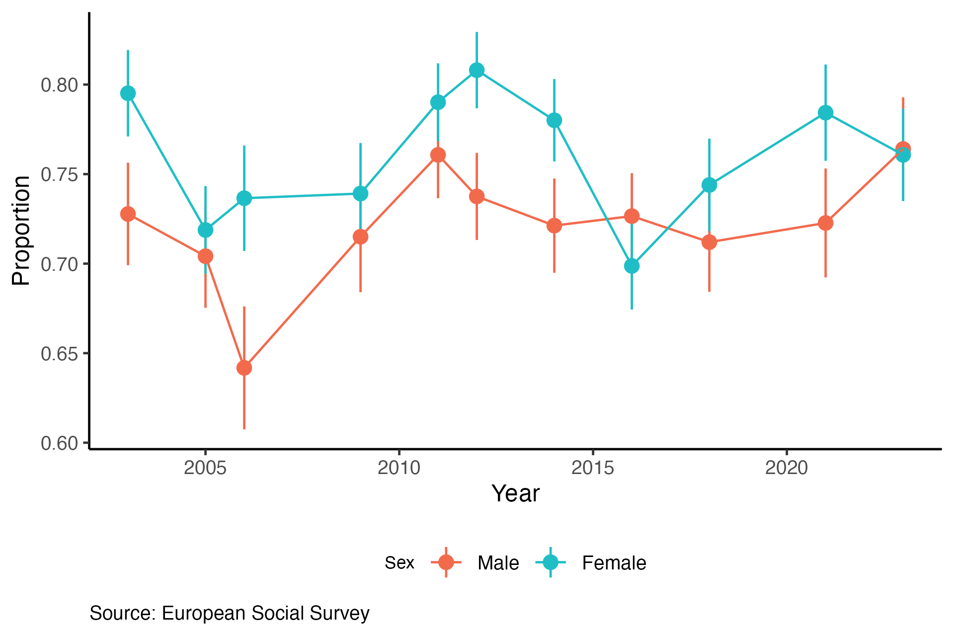
In addition, data suggest an age pattern where younger respondents tend to be more supportive of income redistribution in Ireland. As shown in Figure 4, the opposite pattern is observed in Finland and Iceland. Although the UK also has a similar negative relationship between age and support, the agreement among young respondents (18-35) is higher in Ireland.
Figure 4: Scatter plot of support for redistribution by age and country, 2023
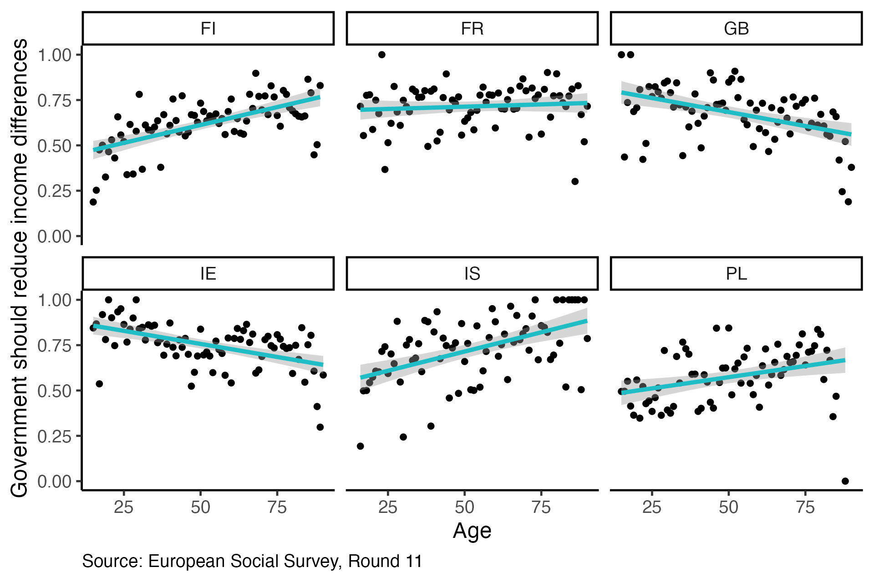
Using a longer time period, however, we observe different relationships depending on the time of the data collection. These different associations over time might suggest a context-dependent association or different level of support across generations instead of age groups. This topic is further explored in Chapter 4.
Finally, there is robust evidence for the association between socio-economic status (SES) and overall welfare attitudes in Europe (Svallfors 2012; Kulin and Svallfors 2013; Langsæther and Evans 2020). The analysis using social class, household income, and ‘feeling about financial situation of the household’ suggests a negative relationship between SES and support for redistribution. The mean values shown in Figure 5 indicate that both ‘skilled’ and ‘unskilled’ workers show higher levels of agreement with the government reducing income differences whereas ‘small business owners’ and the ‘service class’, which includes managers and professionals, show lower levels of agreement. A higher support is also found among those in lower income quintiles and whose financial situation is ‘very difficult’.
Figure 5: Mean value of support for redistribution by social class, income quintile, and financial situation, Ireland, 2002-2023
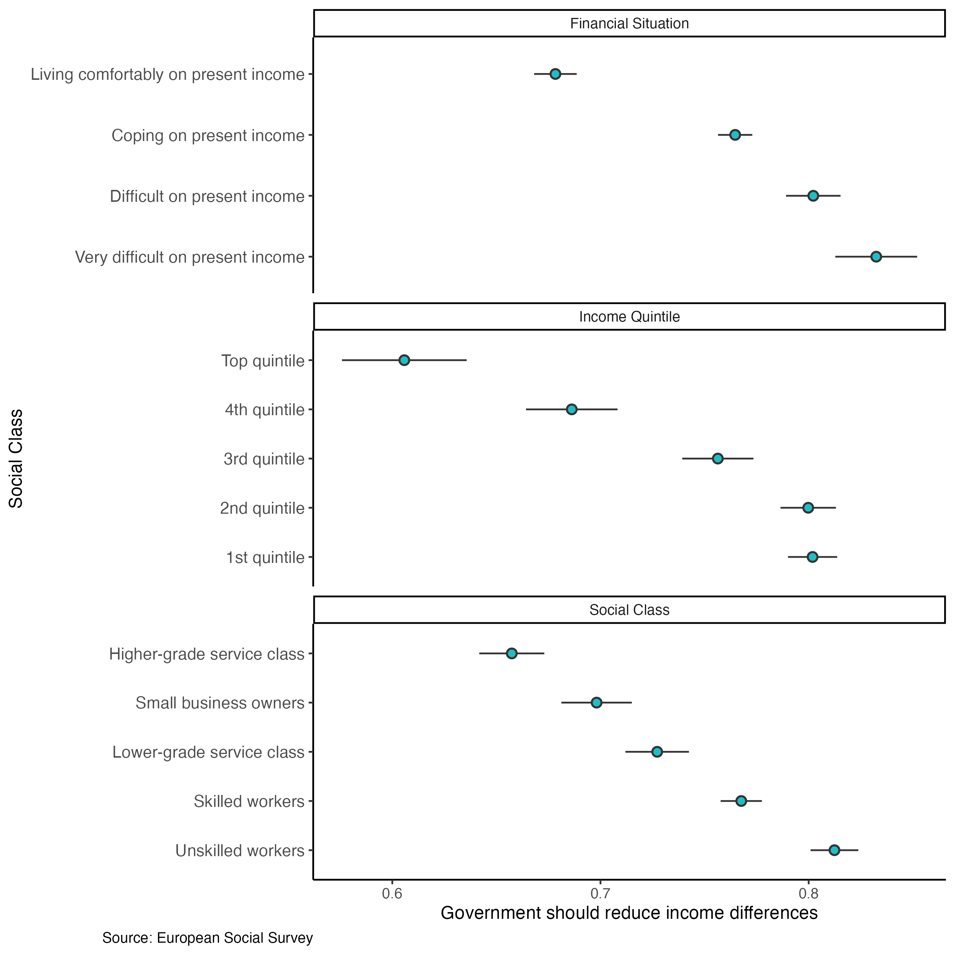

2.4 Left-wing voters are more supportive of redistribution
The ESS survey also finds a consistent pattern of association between the respondents’ ideological positioning and support for redistribution. Those participants who position themselves more to the left of the left-right political scale tend to be more supportive of redistribution since 2002, even though this correlation is weaker in Ireland compared to other European countries.
With the data from the Voter Survey it is also possible to examine differences in redistribution preferences across voting choice in the European Parliament elections. People Before Profit (7.5) and Sinn Féin (6.4) voters indicate the highest support, whereas Green Party (4.7) and Fine Gael (4.7) voters reported the lowest support among the main parties. Even when controlling for positioning in the left-right scale, differences between the former two and latter two parties are statistically significant. These estimates should be interpreted with caution due to the small sample size of respondents who voted in the last European elections. However, Attewell (2021) indicate that this pattern is consistent across most Western European countries, and welfare attitudes are relevant predictors of voting even for parties with focus on non-economic issues such as ‘immigration’ and EU integration.

2.5 Age, gender and social class are relevant even controlling for economic activity, education and financial situation
We created a fixed-effects multivariate regression model to assess the extent to which these individual factors are associated with support for redistribution, considering all ESS rounds in Ireland. In addition to these main variables, the model also includes a measurement of the household financial situation. A subjective measurement was chosen (‘Satisfaction with the household income’) instead of household income due to the high proportion of missing values in the former. However, the same model using household income instead of this subjective measurement indicates similar results for the main variables (see Annex 1). Finally, the following control variables were also added to the model: economic activity (‘Main activity in the last seven days’), educational attainment, and political ideology (‘Placement in the left-right scale’).
Table 1 below shows the coefficients of the logistic regression model detecting significant differences across groups. Older age groups are all expected to show higher support compared to the youngest group (18 to 24 years old), which is the opposite relationship found for the latest round in 2023, but also found in other participant countries such as the UK. Both SES variables (social class and financial situation) suggest that respondents in more precarious socio-economic situation are more likely to be favourable of the government reducing income differences.
Those who were not born in Ireland are significantly less likely to support redistribution compared to natives. This is a pattern found in other European countries by Gonnot and Polito (2023), who suggests that this could be explained by experiences with discrimination and lower access to social benefits. As discussed earlier in this chapter, both female respondents and those who place themselves on the left of the left-right scale are more likely to support income redistribution, even when controlling for other factors such as age and social class.
Table 1: Logistic regression coefficients (odds-ratio) for ‘support for redistribution’, Ireland, 2002-2023
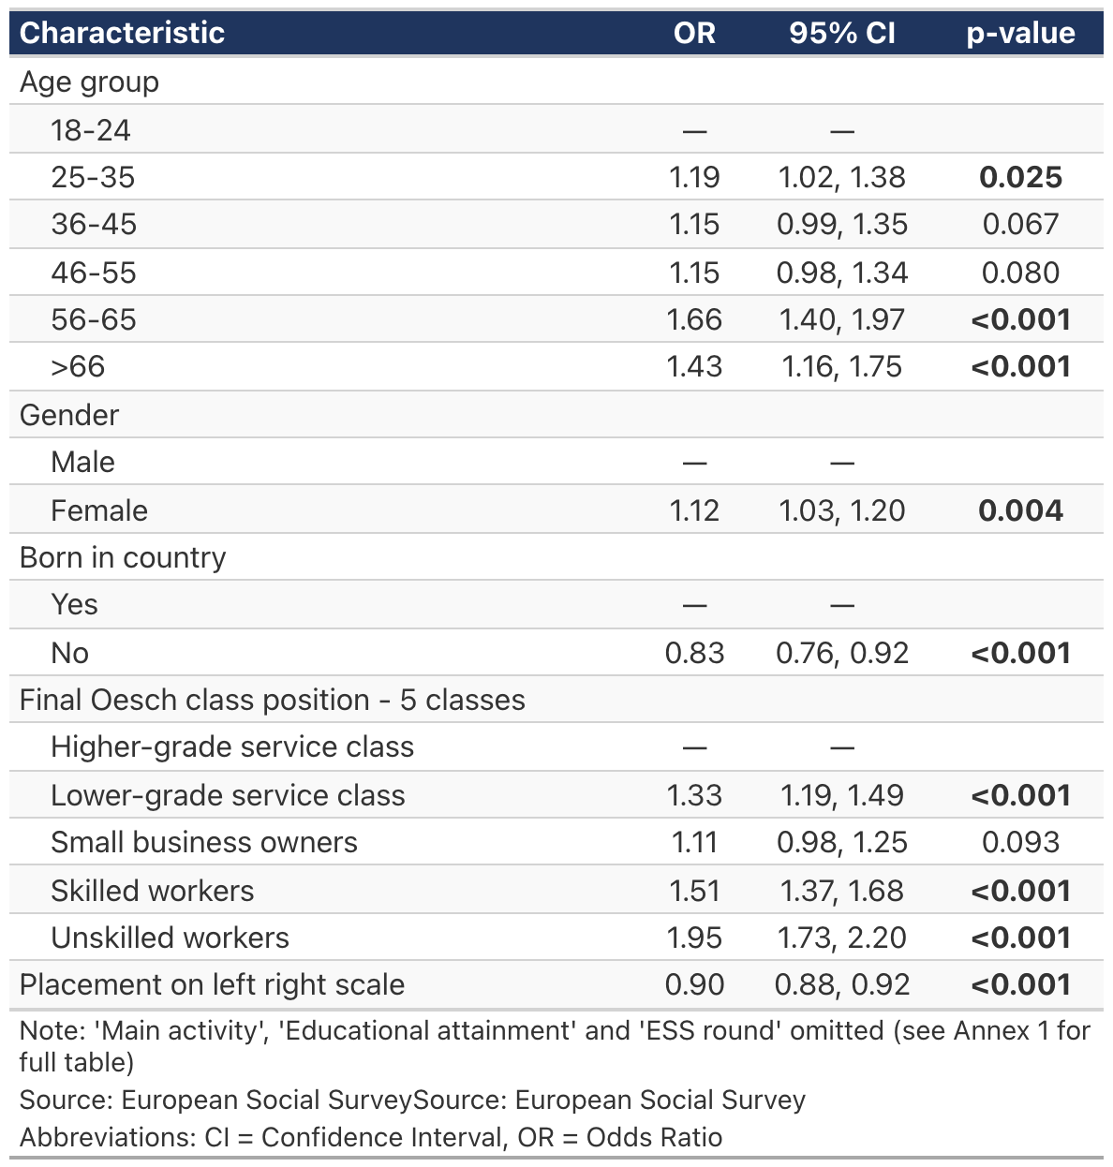
Overall, the examination of individual factors associated with support for income redistribution in Ireland goes in the same direction of the literature pointing out the role of material interests (financial situation) and perspectives of upward mobility (social class) Bonnet et al. (2024).

3. What people think about welfare policies?
The data analysed in this chapter refers to a special module from the European Social Survey on welfare attitudes that was fielded in 2009 (Round 4) and repeated in 2016 (Round 8) (see Meuleman et al. (2018) for more on this module). These rounds of data collection contain additional questions on beliefs about welfare, social benefits and their beneficiaries.

3.1 Meritocratic differences are acceptable for younger and right-wing respondents
As discussed in the previous chapter, a few socio-demographic characteristics such as age and social class may influence people’s views on redistribution. The connection between these two factors, social position and redistributive preferences, tend to be explained by self-interest, meaning that people may support redistribution if they believe that it would improve their own material conditions and lives. However, a large body of research shows that other factors related to peoples’ views on fairness and meritocracy are also relevant to understand overall support to welfare policies (Cavaillé 2025).
In the 2016 ESS, respondents were asked to what extent they agree with the statement that ‘Large differences in people’s incomes are acceptable to properly reward differences in talents and efforts’. The majority of participants (58%) either “agree” or “agree strongly” with the statement.
A multivariate analysis with the same explanatory variables from the model of the Table 1 suggests that gender and class are not statistically significant predictors of agreement. However, older respondents and those who identify more with the political right tend to agree more with this statement.

3.2 The government should have more responsibility towards old citizens and working parents compared to the unemployed
A crucial aspect of the sustainability of modern welfare states is the public support given to its policies. A vast literature in social sciences has addressed the social legitimacy of welfare policies that are targeted at specific groups (Oorschot and Roosma 2017), as they create contentious views on which social groups are more or less deserving of the State attention. In the ESS, respondents were asked to indicate how much responsibility governments should have to the following:
“… ensure sufficient childcare services for working parents”
“… ensure a reasonable standard of living for the old”
“…ensure a reasonable standard of living for the unemployed”
In the Figure 6, higher values denote higher government responsibility. On average, respondents from all countries (except The Netherlands) believe that the government should be least responsible for the unemployed compared to working parents and older citizens.
Figure 6: Mean values for deservingness of government support by group and country, 2016
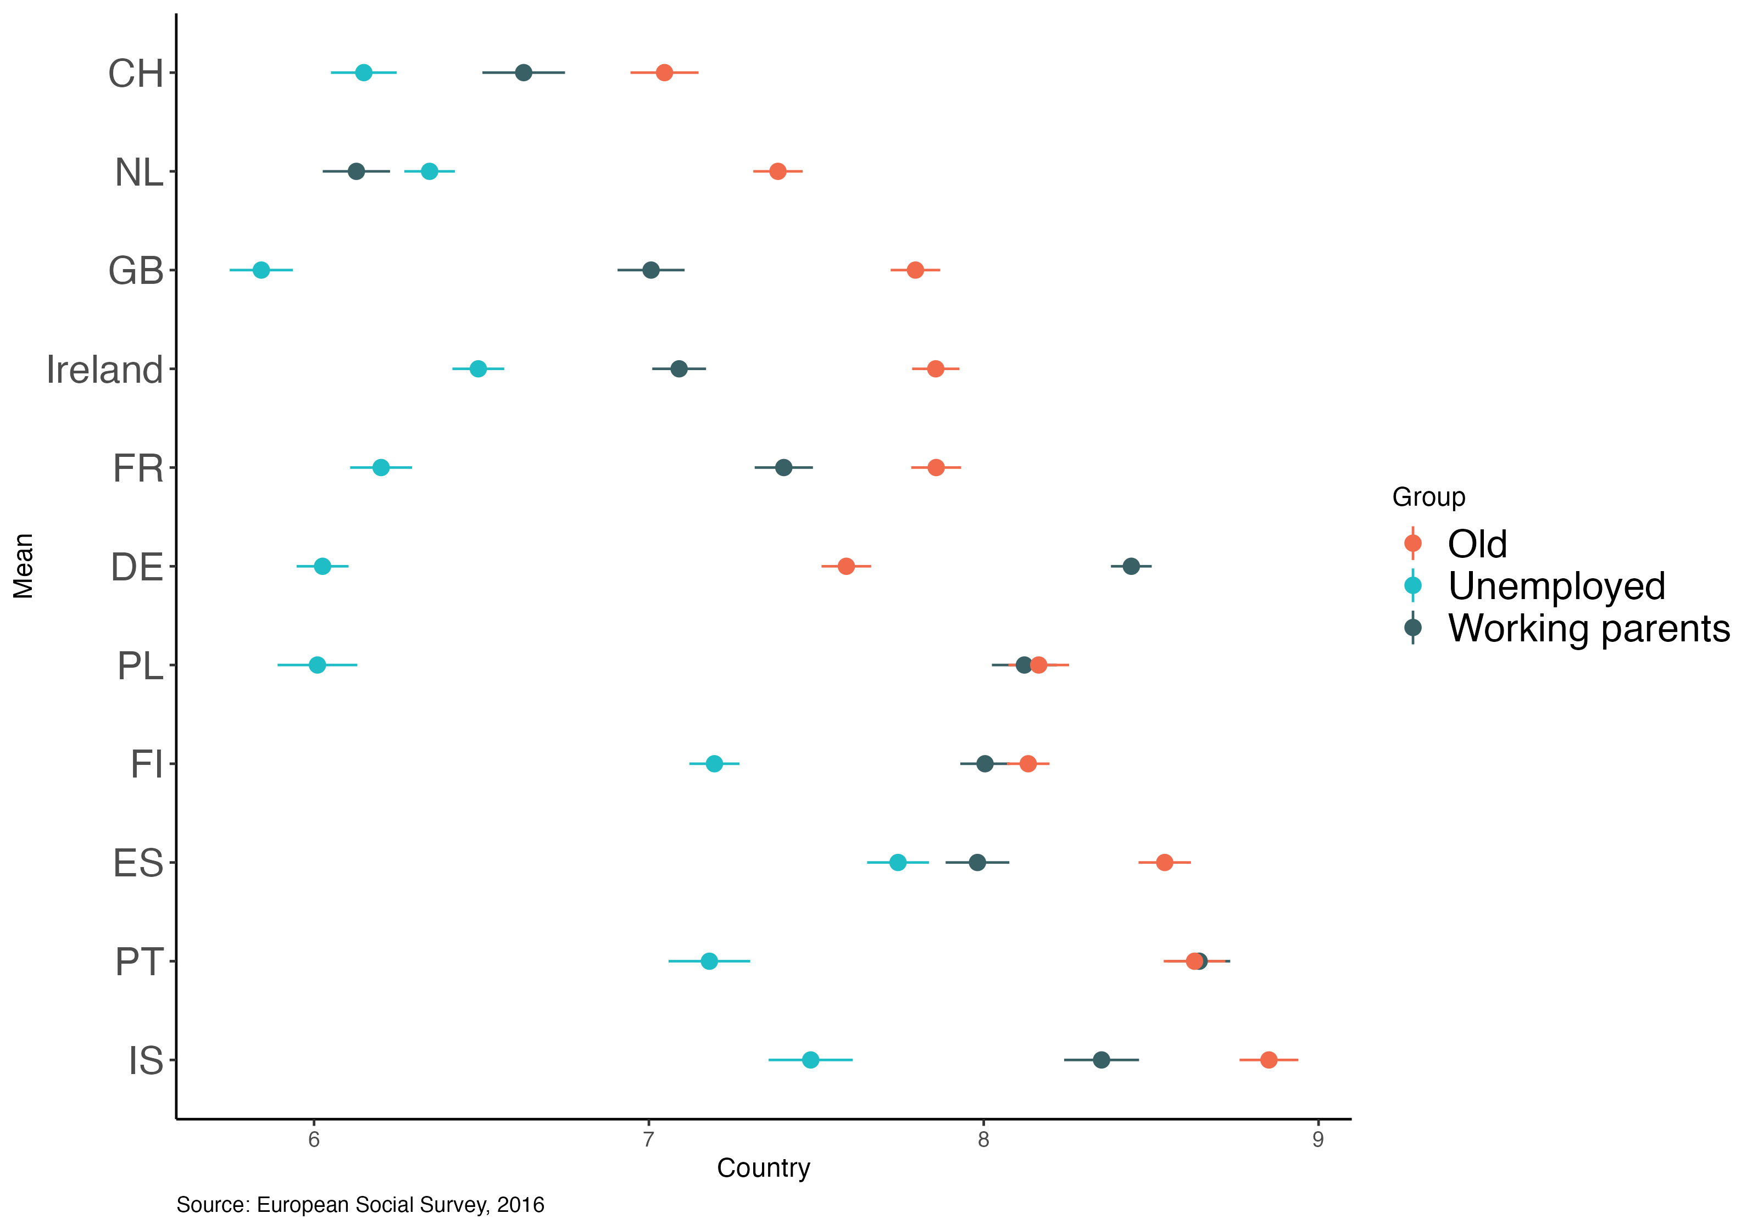
In Ireland, a greater prioritisation of the older over the unemployed is found mainly among respondents who are female, in paid work, and with lower level of educational attainment.

3.3 The view that ‘Social benefits make people lazy’ is more prevalent in Ireland compared to the European average
The module also included questions in relation to beliefs about the consequences of social benefits and services:
Question wording
Using this card please tell me to what extent you agree or disagree that social benefits and services in [country]…
“…cost businesses too much in taxes/charges?”
“…lead to a more equal society?”
“… make people lazy?”
“…make people less willing care for one another?”
“…prevent widespread poverty”
“…place too great strain on economy”
The average level of agreement with these statements reduced slightly comparing 2008 and 2016, but the ranking of agreement among the remains the same, as shown in Figure 7. The exception is the average agreement with “social benefits lead to a more equal society”, which observed a minor increase and surpassed the average agreement with “put strain in the economy” and “cost business too much in taxes”.
Figure 7: Proportion of respondents who agree with statements about social benefits, Ireland, 2009/2016
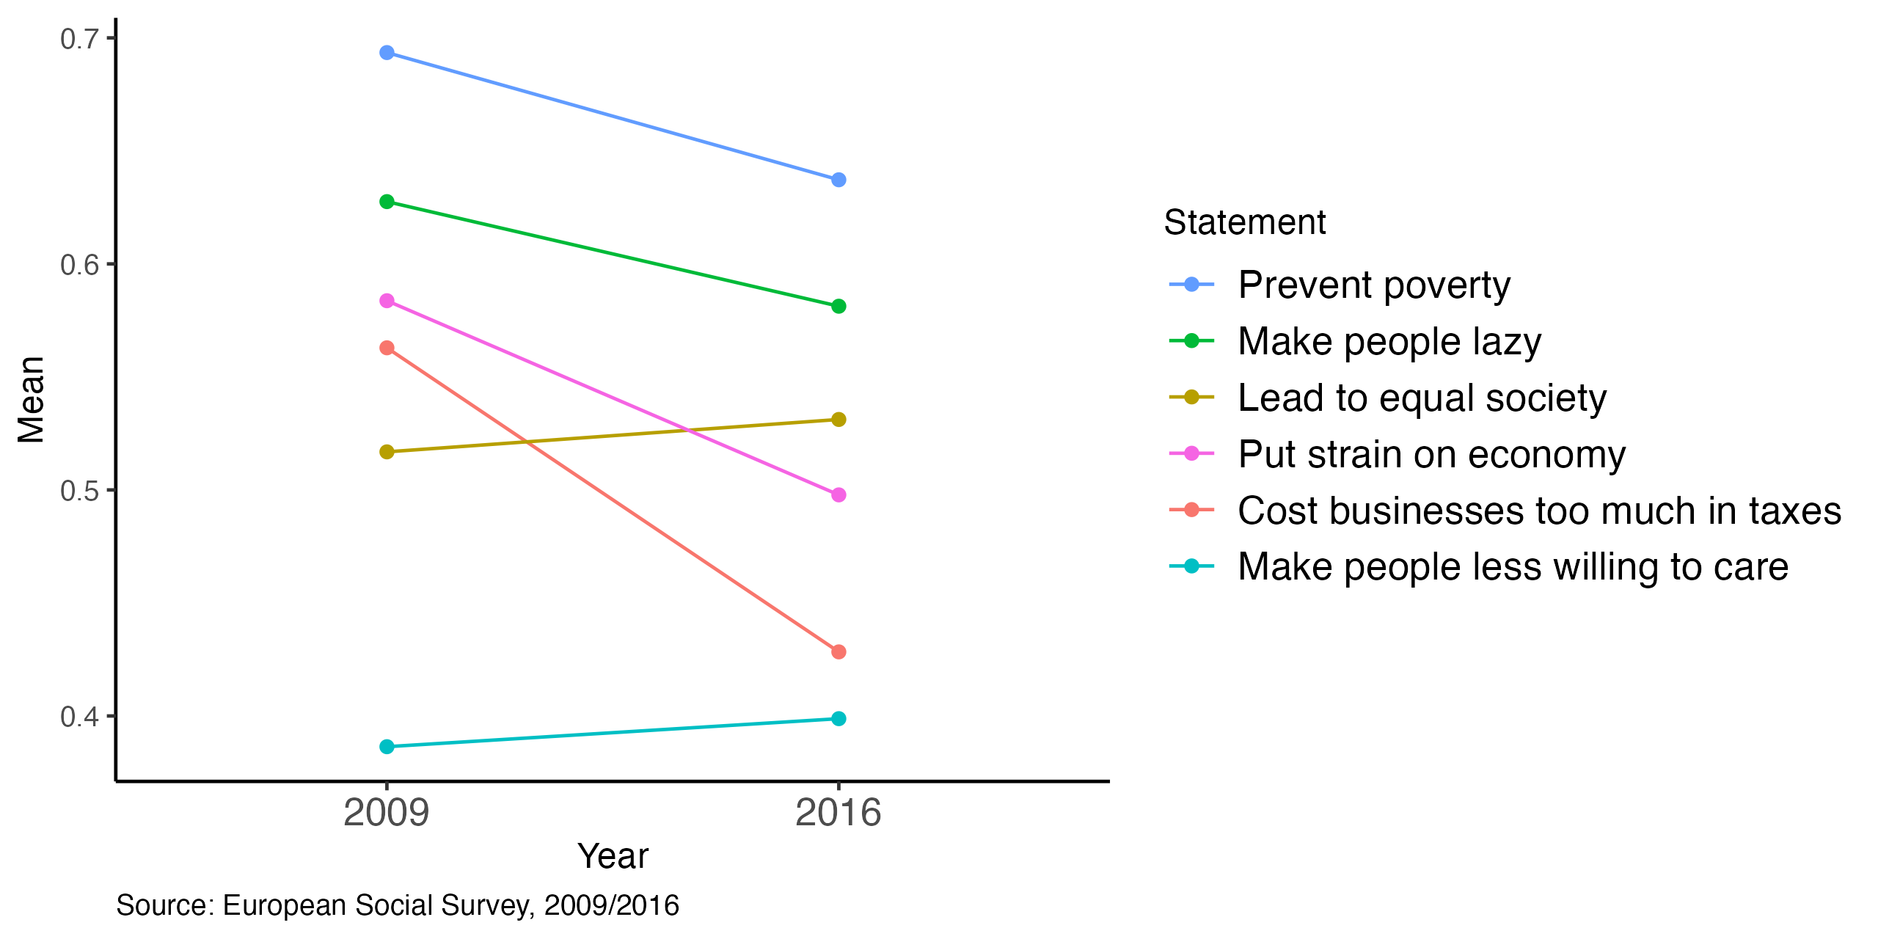
Despite the reduction from 2009 to 2016, as shown in Figure 8, Ireland (58%) had the third highest proportion of respondents agreeing that “social benefits make people lazy”, behind Portugal (63%) and Poland (60%). This proportion is significantly lower in countries such as Iceland (24%), Sweden (35%), and Germany (43%). Finally, as expected those who believe that “social benefits make people lazy” are also less likely to support income redistribution.
Figure 8: Proportion of agreement that social benefits make people lazy, Europe, 2009/2016
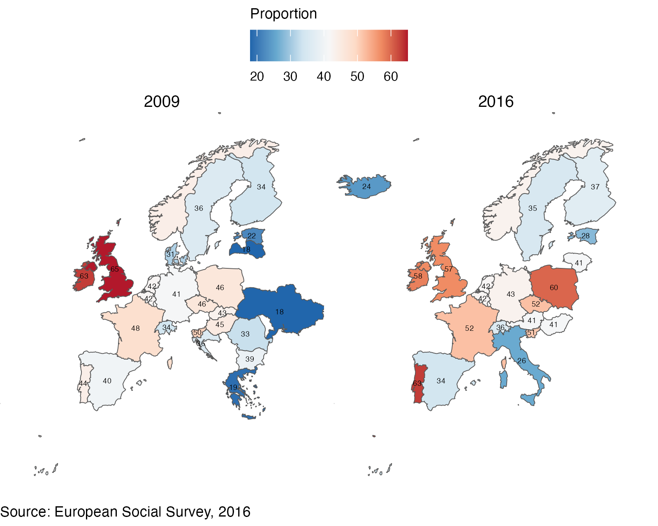

3.4 Compared to male respondents, female respondents are less likely to agree that social benefits lead to equality
Table 2 below shows logistic regression models for two selected dimensions of beliefs about social benefits. The first model, on social benefits as promoters of equality, no significant differences were found across groups in main variables such as age and social class. However, the model indicates that female respondents are more likely to disagree with the equality outcome compared to male respondents. Another significant difference was found in the ‘financial situation’ variable, with those who are coping on present income being less likely to agree with the equality statement compared to those living comfortably. Those in worse subjective financial situation (‘very difficult on present income’) have higher likelihood of agreeing although this difference is not statistically significant.
Table 2: Logistic regression estimates for agreement on statements about ‘social benefits’, Ireland, 2016
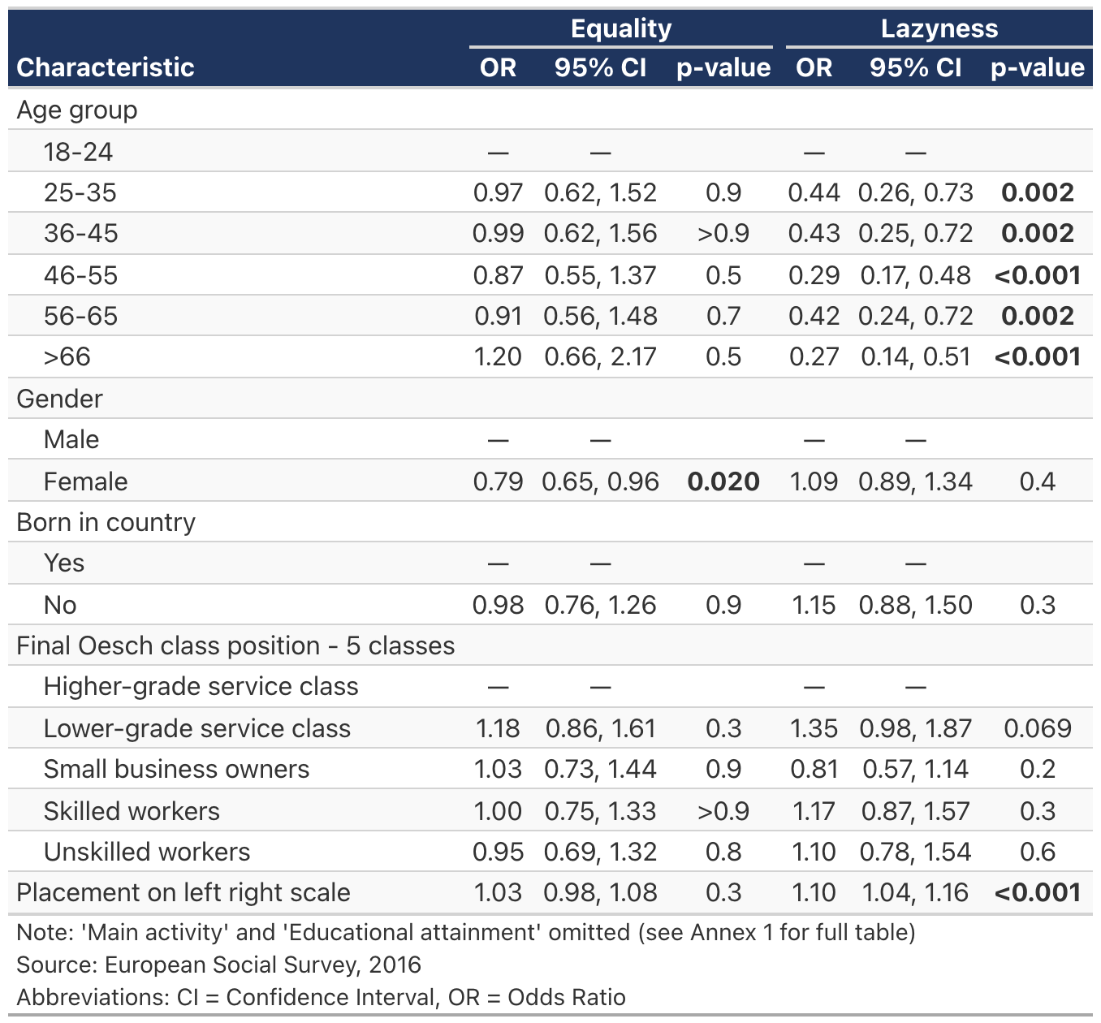

3.5 Older, right-wing, and those with lower educational attainment are more likely to agree that social benefits make people lazy
The second model on Table 2 provides a different picture in relation to beliefs on social benefits resulting in lazyness. Respondents in the 18-24 age group are more inclined to agree with this statement compared to all older age groups. In addition, those who place themselves more to the right of the left-right ideological scale and those with lower educational attainment tend to agree with this statement that social benefits make people lazy.

3.6 Most respondents indicate that immigrants could receive social benefits after having worked and paid taxes for at least one year
Overall, data from 2016 indicates that about half of respondents in Ireland believe that immigrants should obtain rights to social benefits/services “After worked and paid taxes at least a year”. The other options that received most answers were “Once they have become a citizen” (19%) and “After a year, whether or not have worked” (16%).
As shown in Figure 9, only 5% in 2016 indicated that “They should never get the same rights”. This proportion is significantly higher in countries such as Hungary (30%) and Czechia (24%). In Ireland, this proportion is also higher for those in worse financial situation (19%) and among those who are unemployed and not looking for job (18%).
Figure 9: Distribution for ‘When should immigrants obtain rights to social benefits/services’, Ireland, 2016
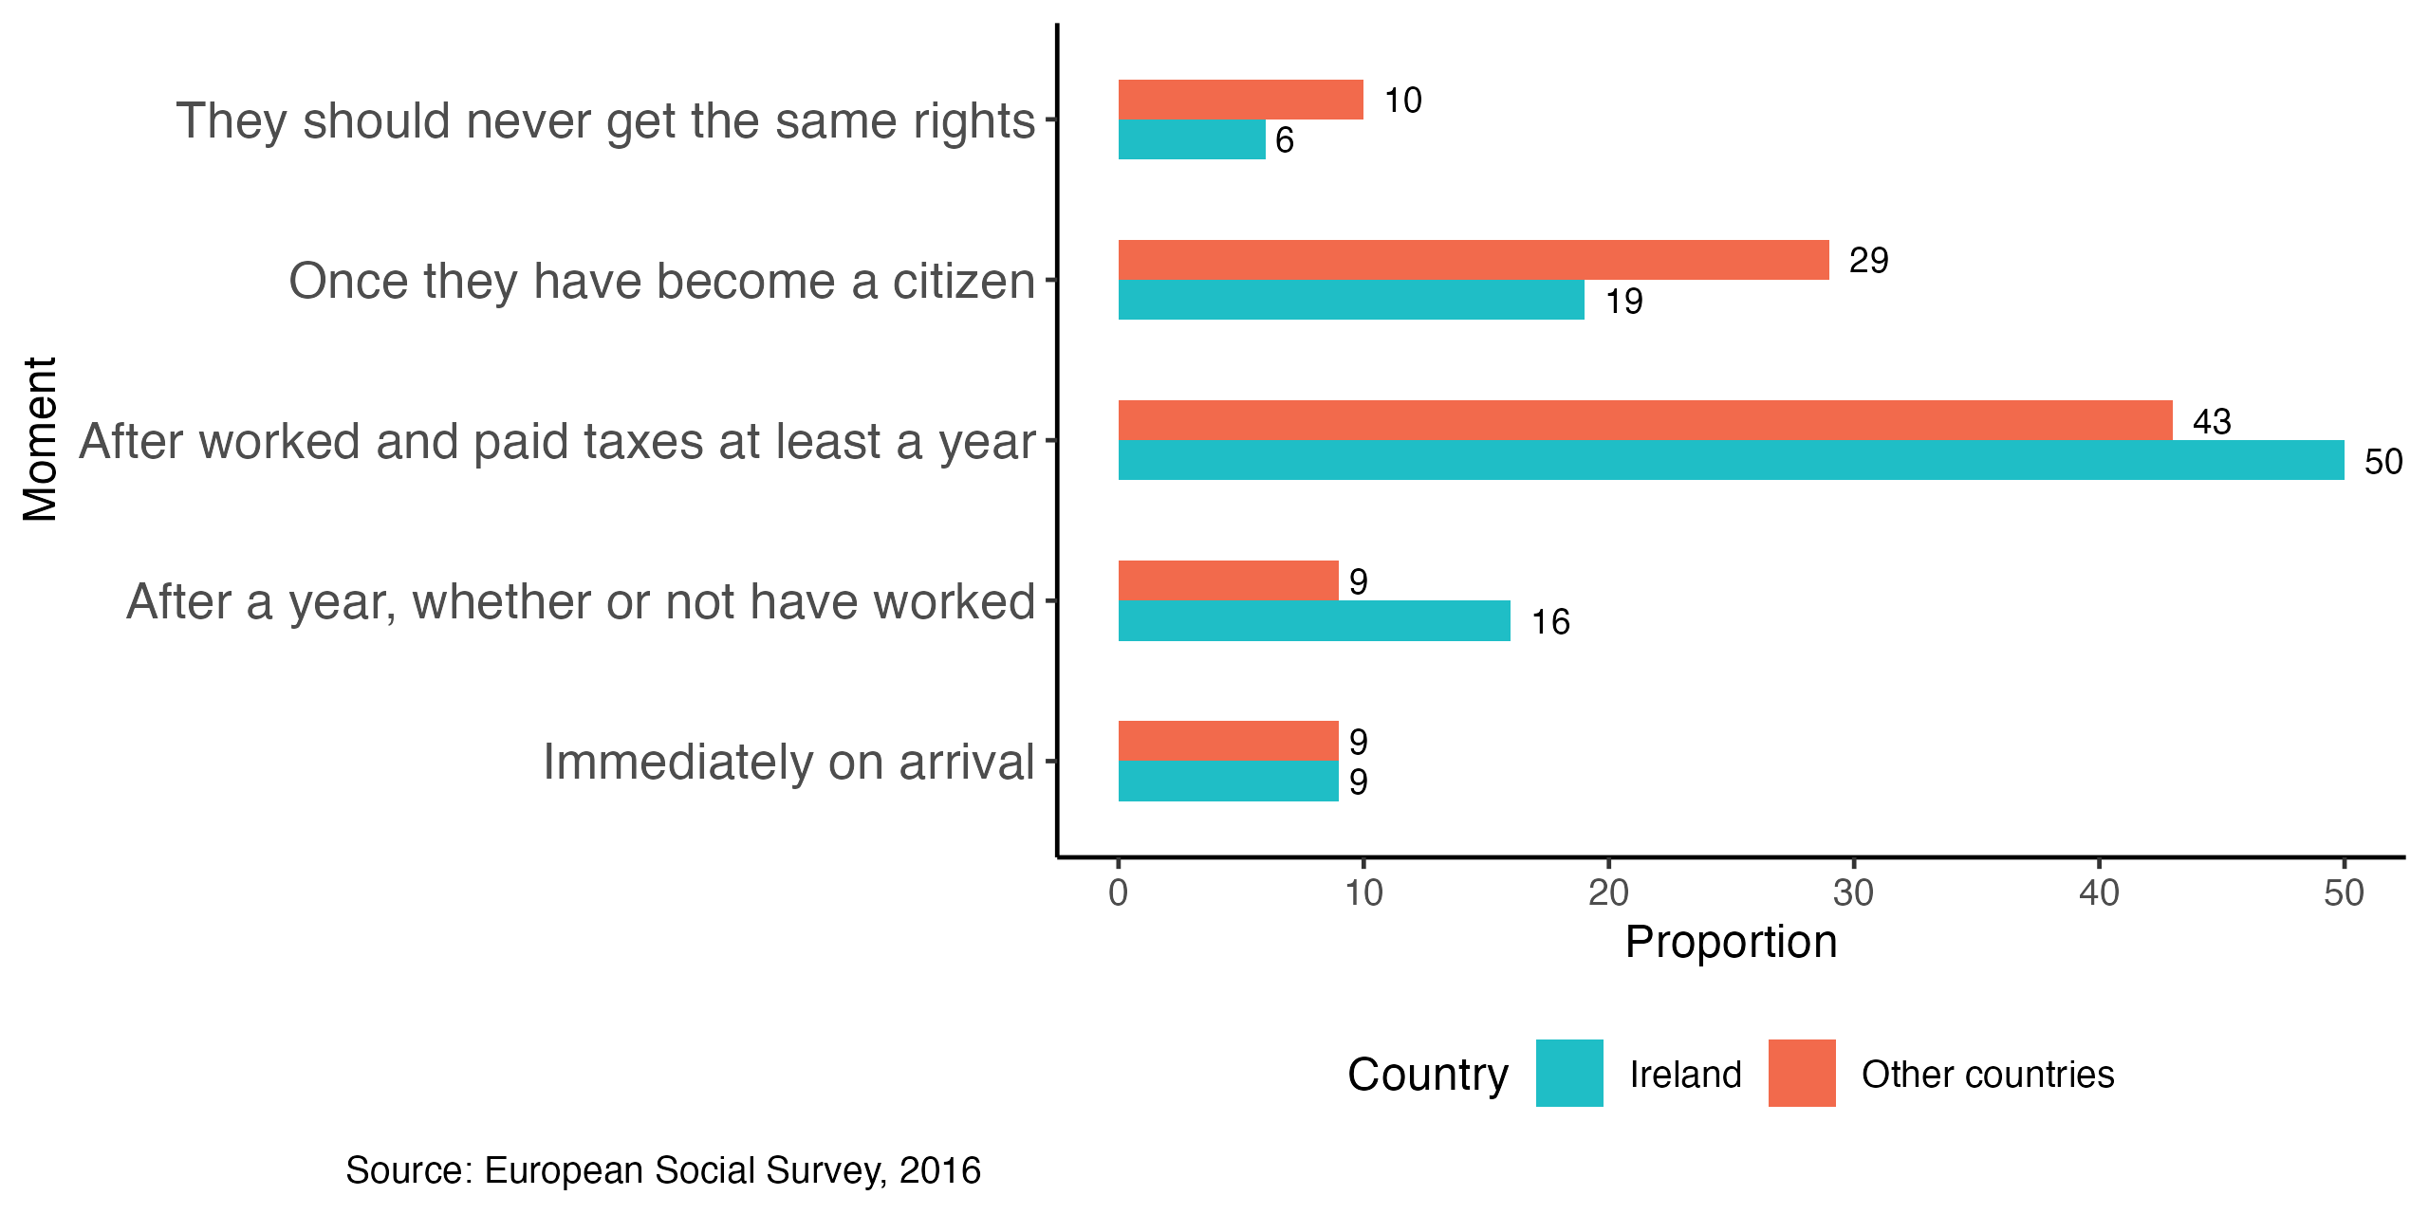

3.7 Unfairly low wages are more relevant than unfairly high wage for support for redistribution
As argued by Cavaillé (2025), support for redistribution is also dependent on people’s perceptions of fairness. One might be more supportive of redistribution if they perceive that the richest in society earn too much (proportionality principle). At the same time, redistribution might be preferred if the poorest are receiving too little (reciprocity principle). In a special module conducted in 2018, the ESS asked respondents to assess how fair are the incomes received by the top and bottom deciles of the country’s income distribution as well as their own gross income. The scale goes from -4 (Low, extremely unfair), through 0 (Fair), to 4 (High, extremely unfair).
Figure 10 below shows the odds-ratio of these variables added to the model described in Table 1. For most countries, the more unfairly high top earners are perceived the higher the odds of supporting redistribution. This relationship is particularly strong in Norway and France, for instance. On the other hand, the more unfairly low bottom earnings are perceived, the lower the odds of supporting redistribution. This association is particularly string in Finland and France. In Ireland, both variables have weaker nonetheless signidficant effects. Across all countries respondents’ perceptions of fairness of their own incomes is not a significant predictor of support for redistribution.
Figure 10: Effect (odds-ratio) of perception of ‘fairness of income’ on ‘support for redistribution’, 2018
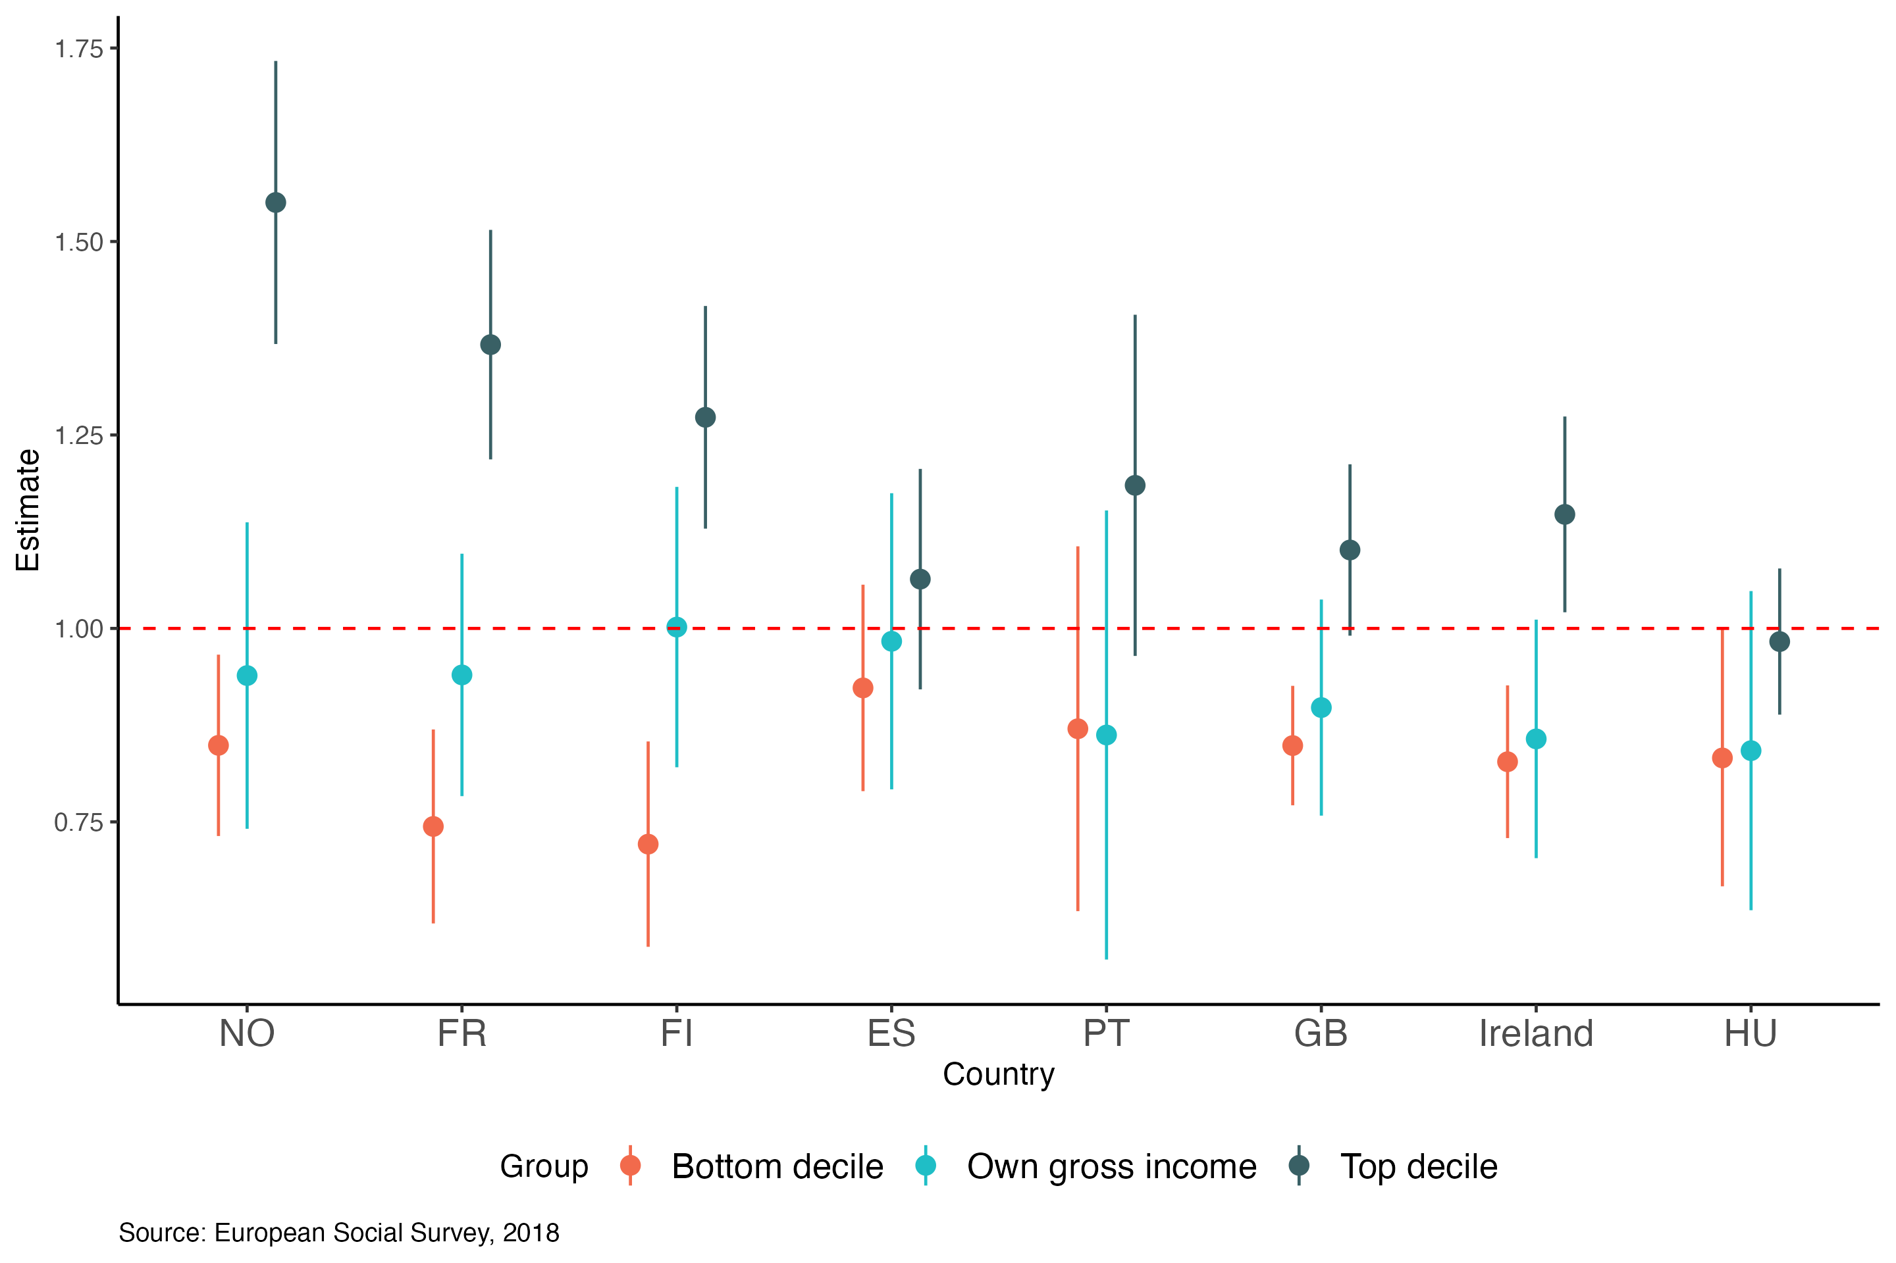

4. Has the support changed over time?
The Figure 11 below shows the proportion of respondents in Ireland and other countries who agree that ‘Government should reduce income differences’ by year of the start of the survey. Overall there is a stable agreement (70)%. Rounds 5 to 7 (2009-2012) as well as 10-11(2022-2024) show a slightly higher agreement compared to other rounds and the European average. This overall trajectory in Ireland is similar to Portugal and differs substantially from the British and Dutch trajectories. The increase during the years of economic recession (when both Ireland and Portugal were severely affected) suggests a relationship between macro-economic indicators and support for redistribution.
Figure 11: Proportion agreeing that the ‘Government should reduce income differences’ by round
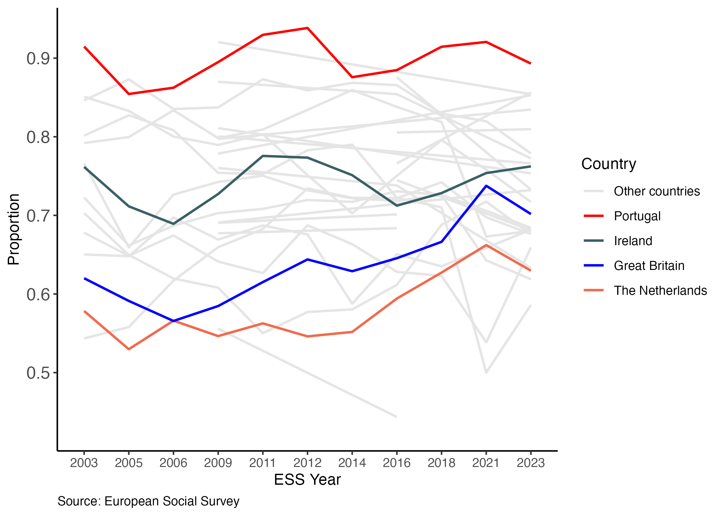
The solid line in Figure 12 shows the seasonally adjusted monthly unemployment rate from Central Statistics Office (CS0) and the points represent the monthly proportion of respondents supporting income redistribution in Ireland, with size proportional to the number of respondents. The dotted line shows the 3-month moving average of the support for redistribution. The figure suggest an increase in support in anticipation of the unemployment rise (although based on limited number of observations). On the other hand, the sharp reduction in unemployment was not accompanied by a significant decrease in support, which has been stable since mid-2010’s.
Figure 12: Monthly unemployment rate and moving average (3 months) of support for redistribution, Ireland, 2002-2023
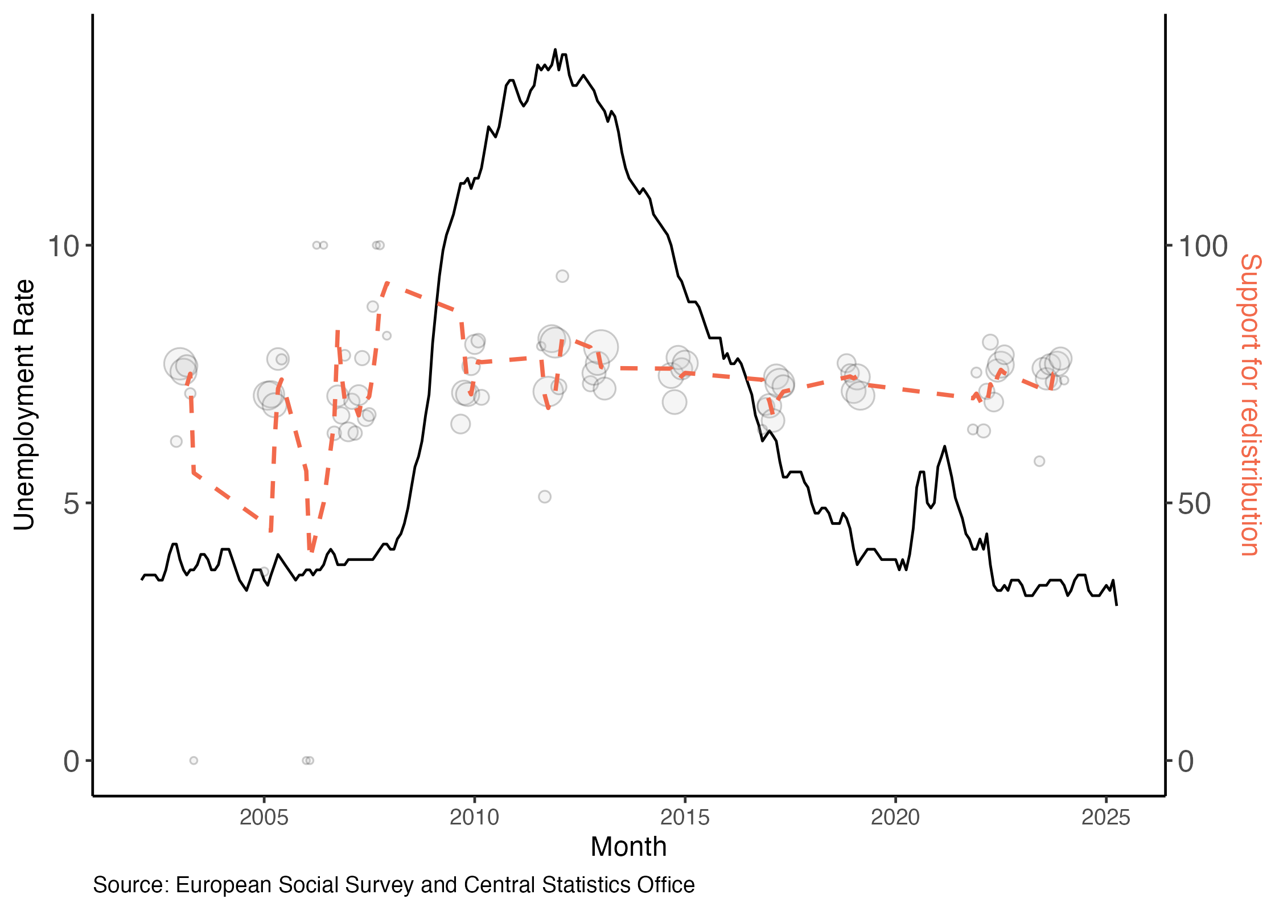

4.1 Age and Gender
The relationship between age and the response variable seems to change across rounds. As discussed in Chapter 2, the multivariate regression model indicates that, considering all rounds, older respondents support more the government reducing income differences. However, the average support by age observed in the latest round (11) seem to indicate the opposite (see Figure 13 in Chapter 2). During the third and fourth rounds, there is a positive association between age and support for redistribution.
Figure 13: Scatter plot for ‘reduce income differences’ by age and ESS round, Ireland
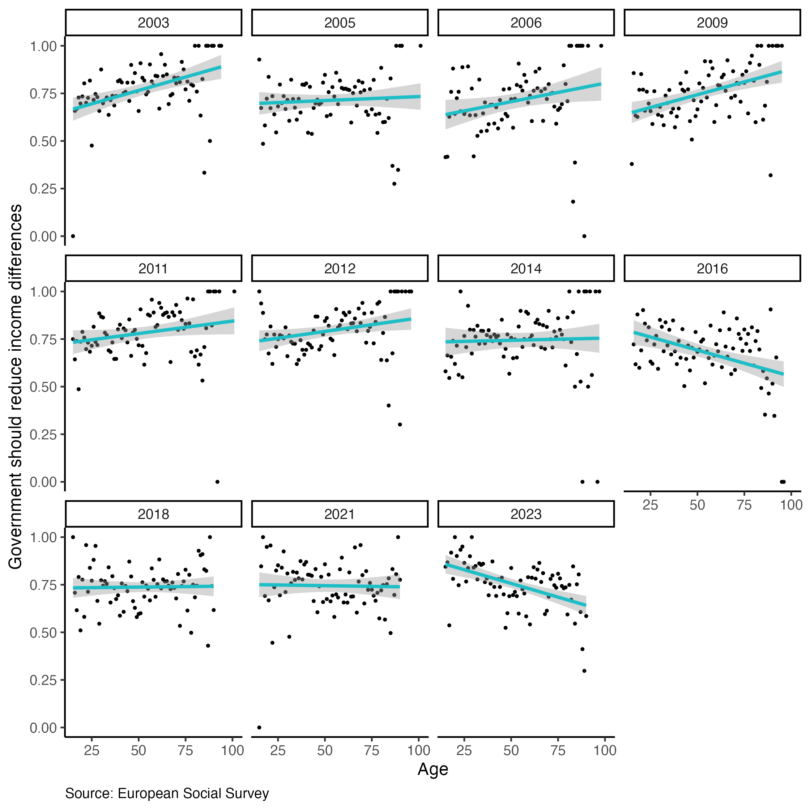
The Figure 14 below shows the support for redistribution across respondents grouped according to their birth year (pseudo-cohort) and gender. The younger cohort (18-21 years old in the beginning of the series) show increasing support as they enter and establish themselves in the labour market. The two older cohorts show a substantial variation with average higher support during the recession and recovery years (2008-2014).
Figure 14: Support for redistribution over time by pseudo-cohort and gender, Ireland
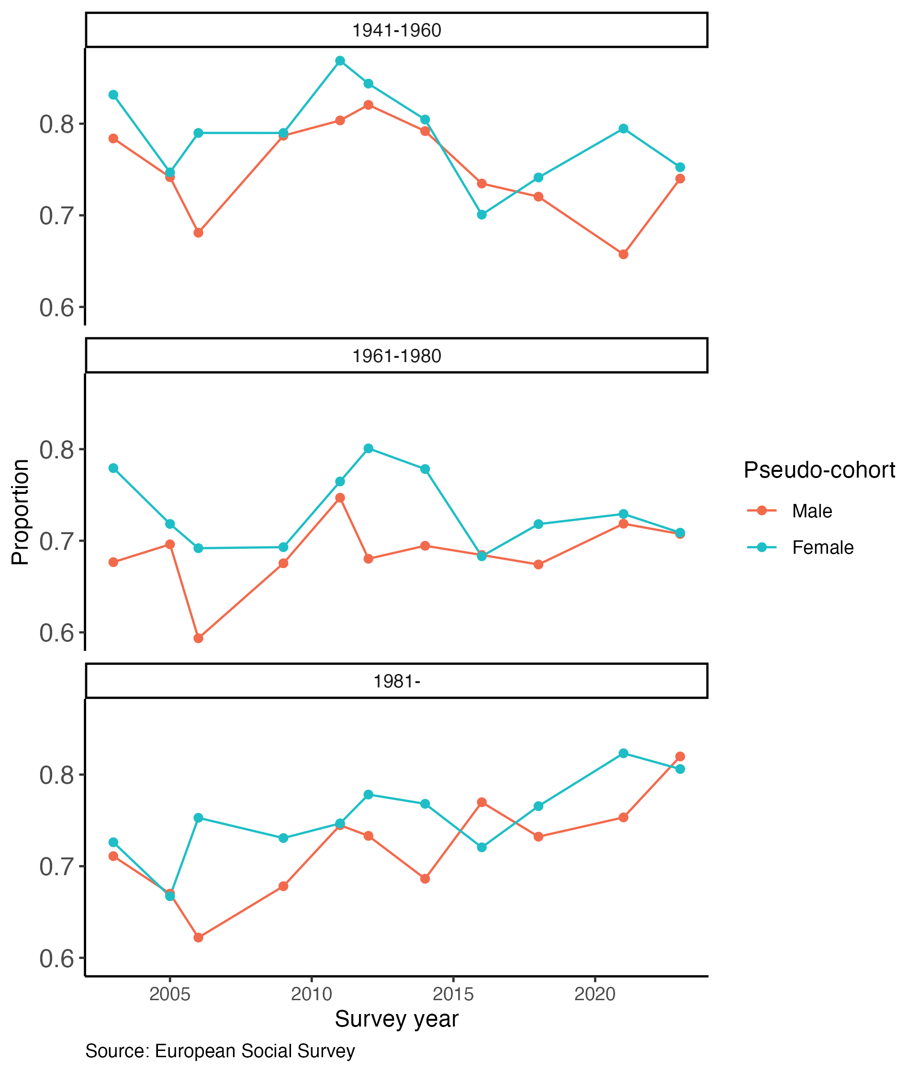
The visual examination of Figure 14 shows a common aspect between the youngest and the oldest cohort, which is the divergent gender trajectories from the 2nd to the 3rd round. In addition, the oldest cohort also experienced a similar gender divergence between the 9th and 10th rounds. These two periods are marked by the initial signs of the 2008 economic recession and the pre-post periods of the pandemic.

4.2 Relevant events
Due to the cross-sectional nature of the European Social Survey, testing the impact of major socio-economic changes, such as the recession or the pandemic, is challenging. The survey interviews different individuals across substantially different time periods, so the differences found across rounds might be due to a diverse range of measured and unmeasured factors.
However, several Event Study methods provide tools to examine the impact of more specific events contained in shorter time frames. Dunaiski and Tukiainen (2025), for instance, detected a difference in the perception of fairness of income in Finland in the period immediately after the country’s ‘Tax Day’, when authorities publish a list of individuals with the highest taxable income in the country. The authors utilised the ‘Unexpected Event During Survey’ (UEDS) design (Muñoz, Falcó-Gimeno, and Hernández 2020) to assess the impact of the event taking the respondents interviewed before the event as the control group in a quasi-experiment approach.

4.2.1 Attitudes are impacted by government campaigns
During the ESS Round 8 data collection, the government launched a campaign against welfare fraud. With the slogan ‘Welfare Cheats, Cheat Us All’, the Department of Social Protection funded a widely publicised media campaign with the intent of increasing fraud reporting and changing public perceptions of welfare fraud (Devereux and Power 2019). The campaign ran from April to July 2017. 73% of the respondents had been interviewed by then and the remaining interviews were conducted during this period. After analysing the content of the campaign and reporting statistics, Power, Devereux, and Ryan (2022) show that it had not affect the overall number of fraud reports, but may impacted the public legitimacy of welfare recipients in general.
Using data from the ESS, we assessed the impact of this campaign on welfare attitudes in Ireland. Figure 15 shows the 7-day moving average of three variables in the 30-day time window around the launch of the campaing on the 17th of April. For two of the three statements related to welfare attitudes, the visual examination suggests a change of trajectory after the beginning of the campaign.
Figure 15: 7-day moving average for three questions on welfare attitudes, Ireland, 2016-2017
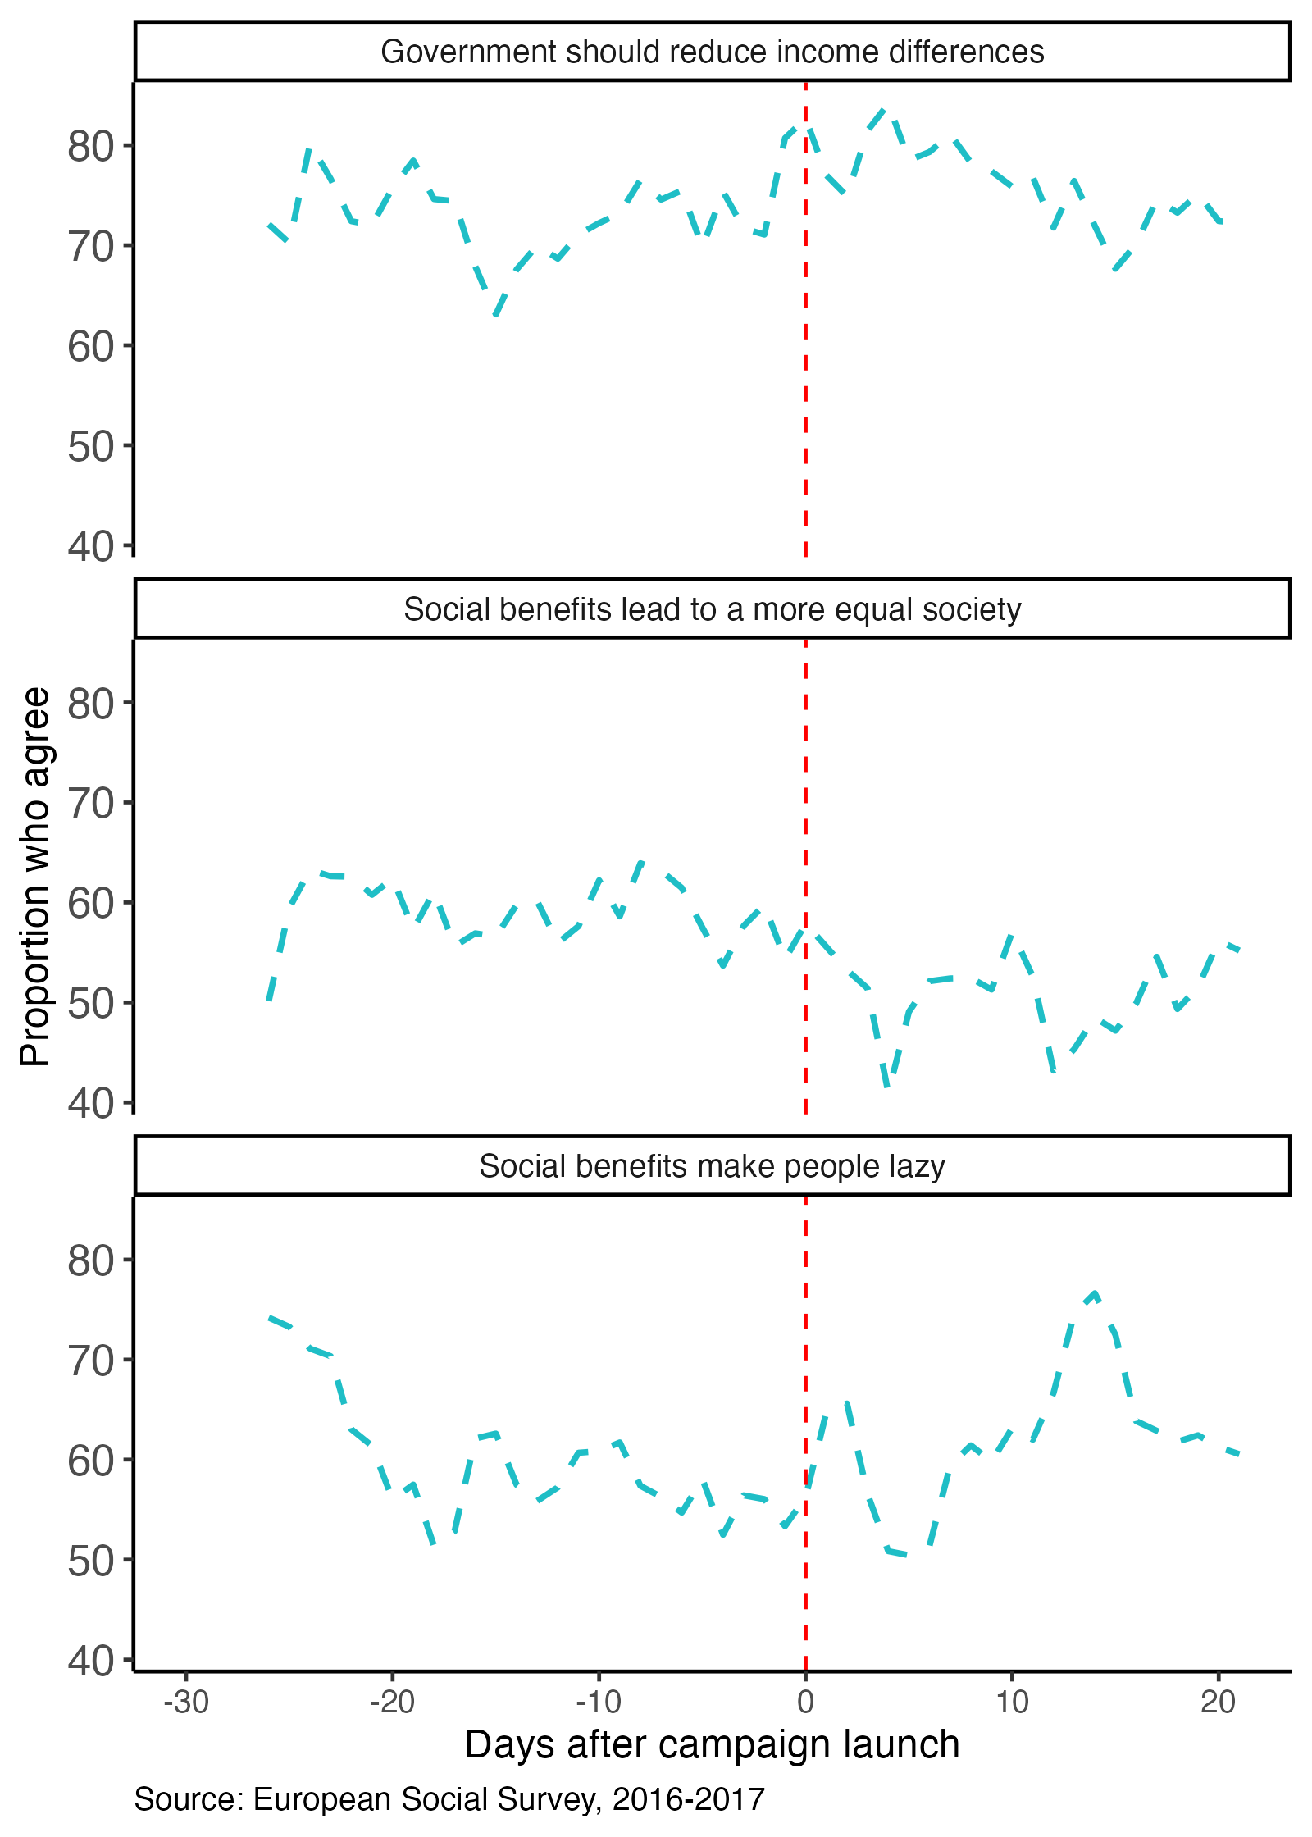
To test if the difference is statistically significant, we built a logistic regression model with time-fixed effects and controls for potential socio-demographic differences in the period before and after the campaign launch. Considering that this period coincides with the final quarter of the data collection, it is reasonable to expect that it may contain a higher proportion of hard-to-reach respondents (e.g. employed, higher social class, younger respondents). So, variables such as main activity, social class, age and gender were included in the model. The observations selected for the analysis are from interviews conducted two weeks prior or after the campaign launch. We also removed from the analysis respondents who indicate that they do not watch, listen or read news about politics or current affairs (9%).
Figure 16 shows the estimates of the effect of being interviewed after the launch of the DSP campaign. No significant effects were for the variables related to support for redistribution and the view that social benefits lead to a more equal society. However, the model suggests that respondents have about 80% higher odds of agreeing that social benefits make people lazy if interviewed up to 15 days after the launch of the campaign compared to those interviewed up to 15 days prior to the launch.
Figure 16: Estimates (odds-ratio) for period of interview on welfare attitudes, Ireland, 2016-2017
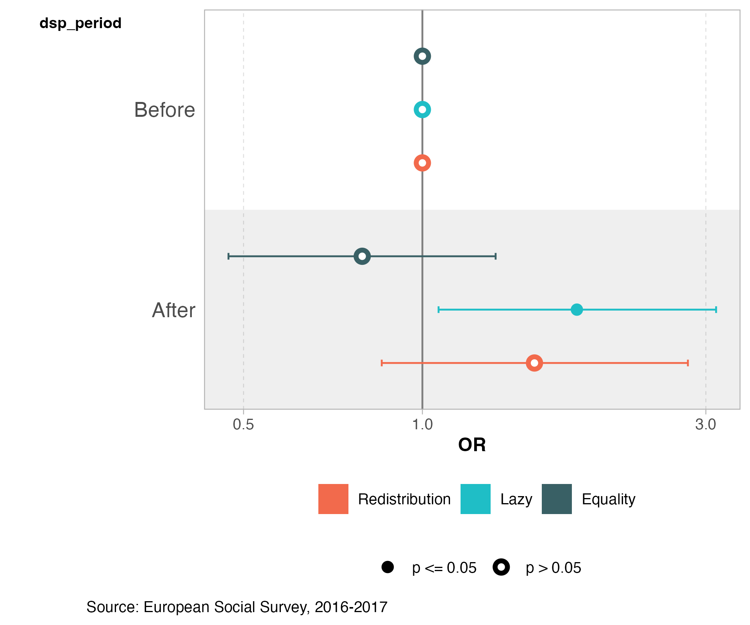

4.2.2 Budget announcement
Another relevant event for welfare attitudes and support for redistribution is the annual announcement of the public budget for the following year. Although this cannot be considered an unexpected event, we hypothesise that the media coverage after the announcement may increase the salience of welfare policies and positively impact respondents’ support for redistribution.
The announcement dates in Ireland coincided with the European Social Survey fieldwork in six different years: 2006, 2009, 2011, 2012, 2014, and 2023. The Figure 17 shows the 7-day moving average for the proportion of respondents who agree that the government should reduce differences in income within the 30-day time window around the announcement of the budget.
Figure 17: 7-day moving average for support for redistribution within the 30-day period of the public budget announcement, Ireland
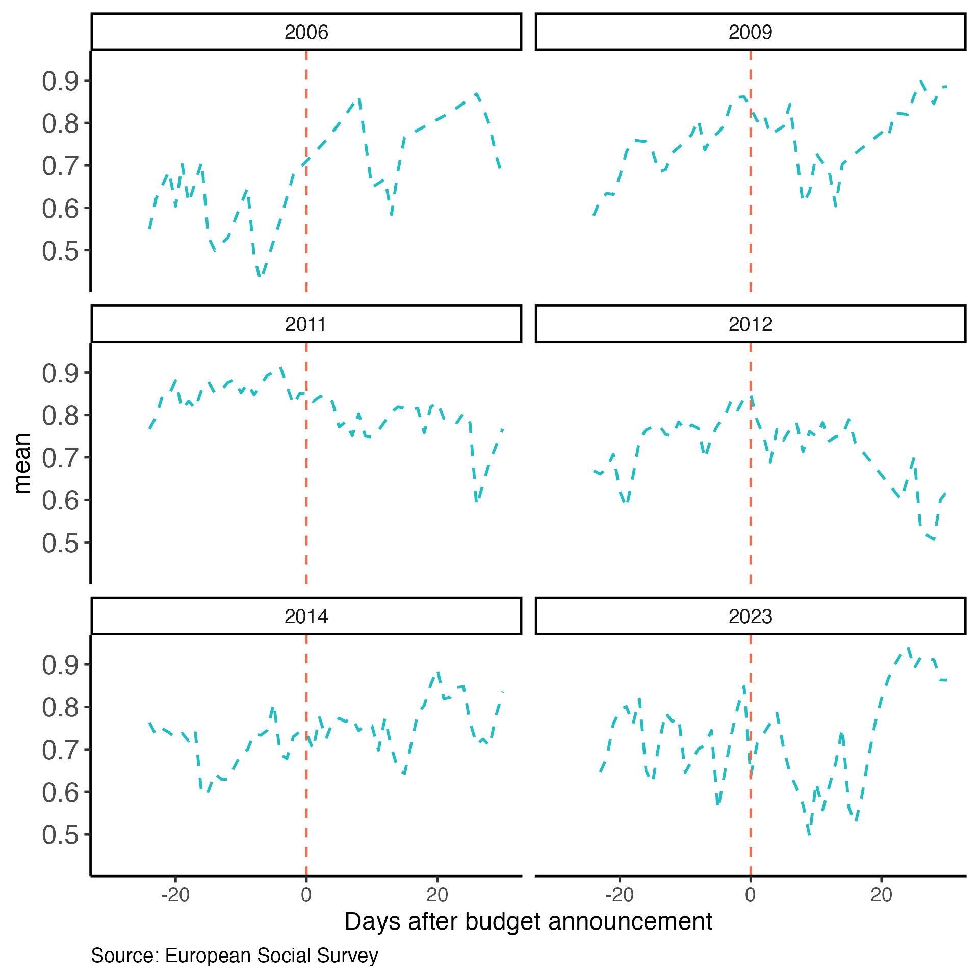
To test the impact of the budget announcement, we adopted a similar approach to the one discussed in the previous section. The model includes the same variables to control for sistematic differences in the sample composition of those interviewed before and after the announcement. Using the same time window of 30 days, we do not find any statistically significant differences in the support for redistribution. However, the difference is statistically significant when we select a shorter time window for the analyses.
As shown in Figure 18, when we consider only interviews conducted within a week or two-week period of the announcement, the differences are statistically significant. The direction of the effect is the opposite of what expected, with lower support for redistribution after the publication of the budget. One potential explanation is a higher salience of redistributive issues prior to the publication as a result of media speculation and campaigns from different organisation attempting to influence the public debate.
This relatively weak and short-lived effect found in Ireland goes in the same direction of Dunaiski and Tukiainen (2025) conclusion that political events such as the ‘Tax Day’ in Finland have limited impact on attitudes.
Figure 18: Estimates (odds-ratio) for period of interview on support for redistribution by time window, Ireland
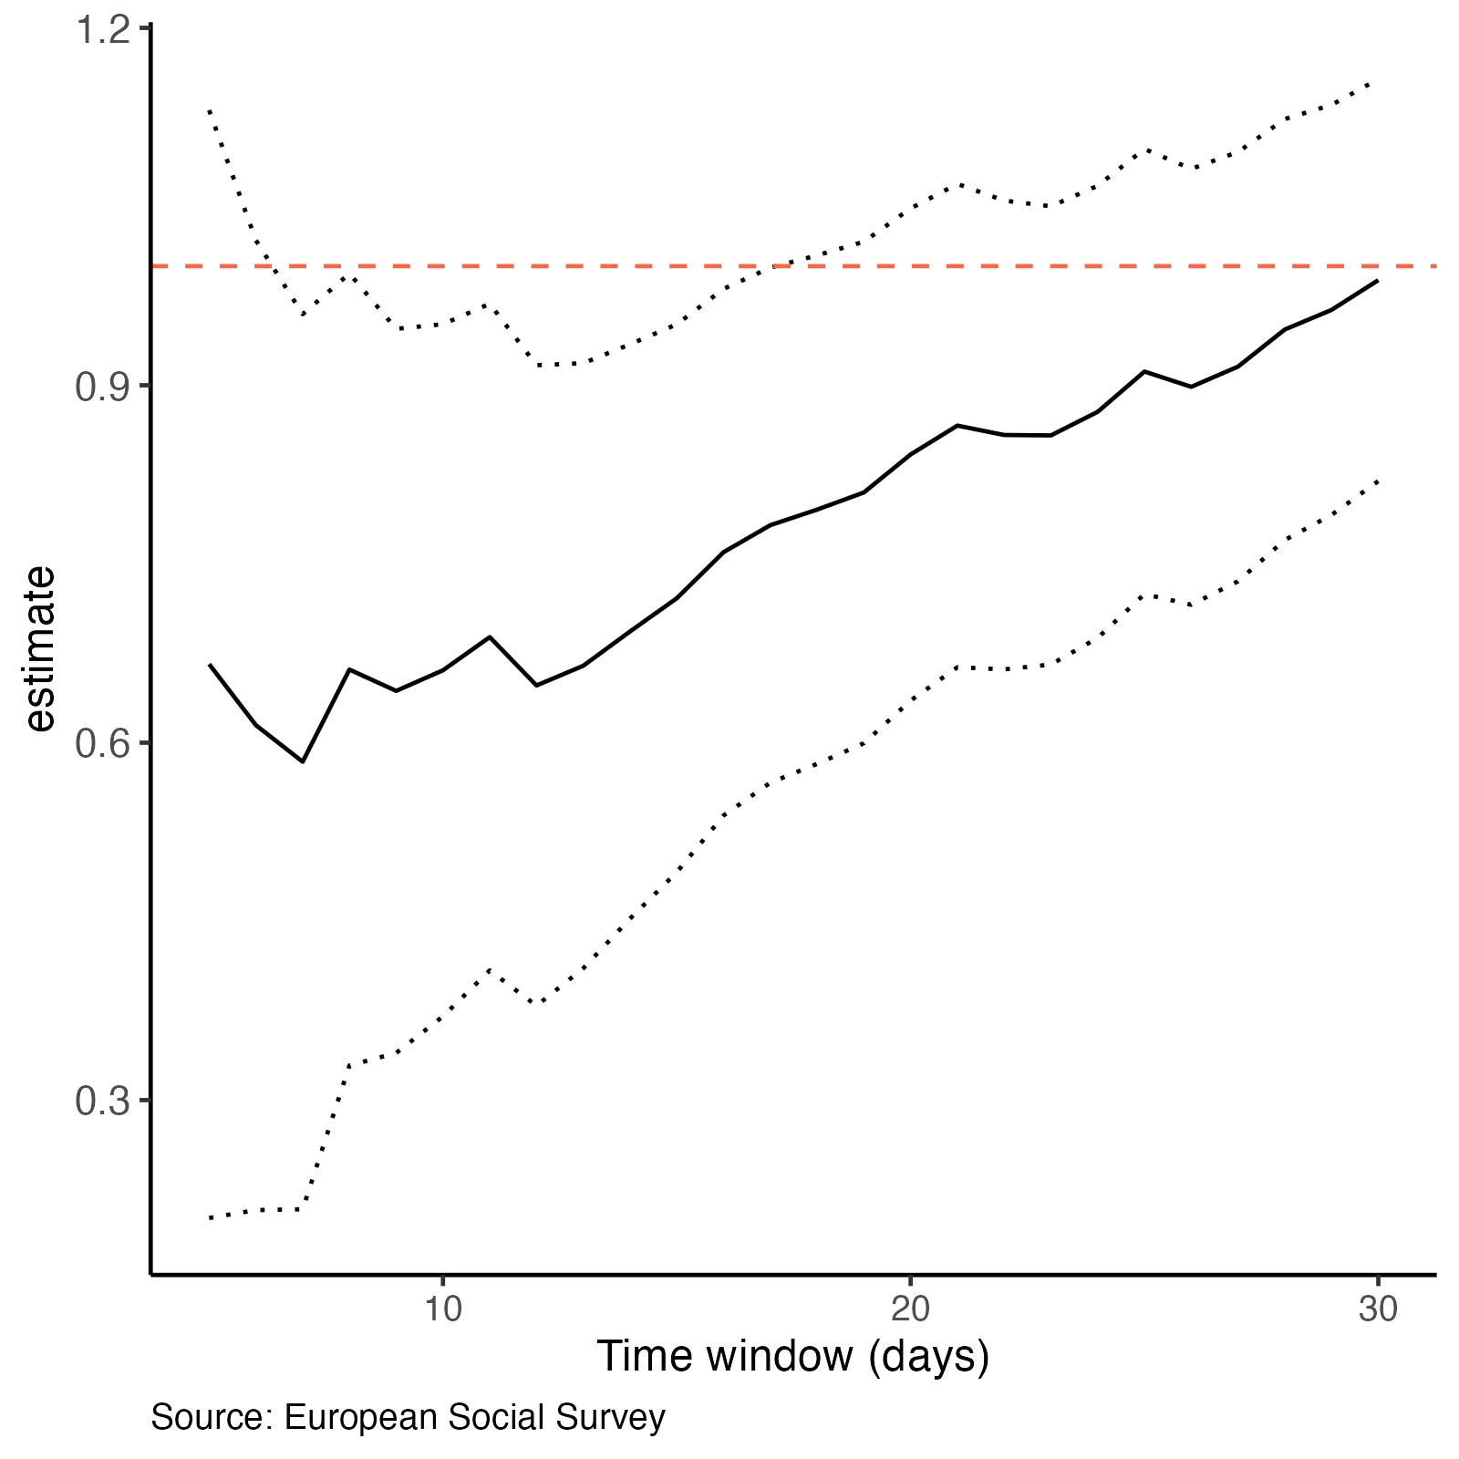

4.2.3 Pandemic
A major event experienced during the ESS time series was the COVID19 pandemic. Evidence from a survey experiment in the United States show that participants were more willing to prioritize society’s problems when exposed to issues related to the pandemic (Cappelen et al. 2021). Van Hootegem and Laenen (2023) show that the increase in support for a universal basic income increased with the pandemic but it was short lived.
The first ESS data collection after the pandemic in Ireland occurred between November 2021 and August 2022. By this time, as shown in Figure 12, the unemployment rate was already returning to levels similar to the period before the start of the pandemic. The survey included a specific module on items related to respondents’ experiences during the pandemic. A sub-group of questions asked participants to indicate if any of the following happened to them as a result of the coronavirus pandemic:
I was made redundant/lost my job
I have not been in work at any time since the start of the pandemic
The income from my job was reduced
My working hours were reduced
I was furloughed
I was forced to take unpaid leave/holiday
None of these
Figure 19 below shows the proportion of respondents who agree that the government should reduce differences in income by social class and personal impact of the pandemic. Overall the working class seem to be supportive of redistribution regardless of the pandemic experiences. On the other hand, the higher-grade service class seems to be more supportive among those who lost their jobs (82% support) compared to those who indicated that nothing happened (60% support).
Figure 19: Proportion of support for redistribution by social class and personal impact of the pandemic, Ireland, 2021
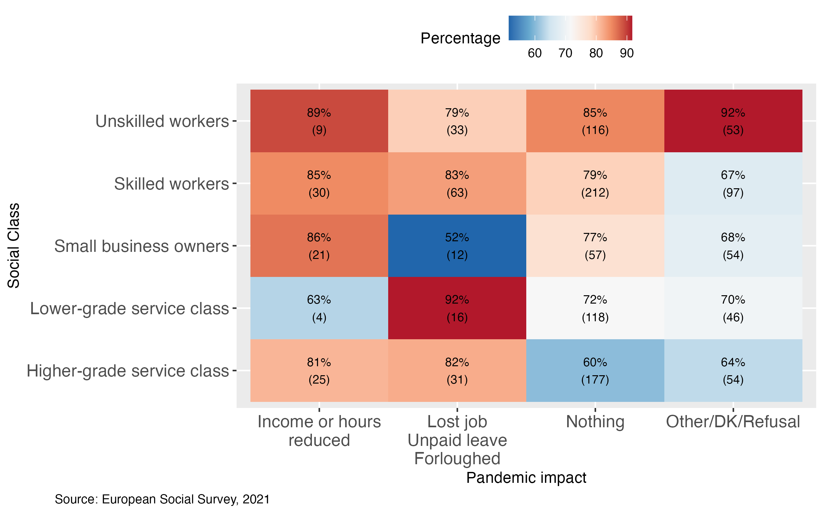

References
Attewell, David. 2021. “Deservingness Perceptions, Welfare State Support and Vote Choice in Western Europe.” West European Politics 44 (3): 611–34. https://doi.org/10.1080/01402382.2020.1715704.
Bonnet, Julien, Emanuele Ciani, Gianluca Grimalda, Fabrice Murtin, and David Pipke. 2024. “What Explains Preferences for Redistribution?: Evidence from an International Survey.” {OECD} {Papers} on {Well}-being and {Inequalities}. https://doi.org/10.1787/c0120dea-en.
Breznau, Nate, Lisa Heukamp, Hung HV Nguyen, and Tom Knuf. 2025. “The Moderating Role of Government Heuristics in Public Preferences for Redistribution.” Journal of European Social Policy 35 (1): 21–39. https://doi.org/10.1177/09589287241290742.
Cappelen, Alexander W., Ranveig Falch, Erik Ø. Sørensen, and Bertil Tungodden. 2021. “Solidarity and Fairness in Times of Crisis.” Journal of Economic Behavior & Organization 186 (June): 1–11. https://doi.org/10.1016/j.jebo.2021.03.017.
Cavaillé, Charlotte. 2025. Fair Enough?: Support for Redistribution in the Age of Inequality. 1st ed. Cambridge University Press. https://doi.org/10.1017/9781009366038.
Dallinger, Ursula. 2022. “On the Ambivalence of Preferences for Income Redistribution: A Research Note.” Journal of European Social Policy 32 (2): 225–36. https://doi.org/10.1177/09589287211066469.
Devereux, Eoin, and Martin J. Power. 2019. “Fake News? A Critical Analysis of the ‘Welfare Cheats, Cheat Us All ’ Campaign in Ireland.” Critical Discourse Studies 16 (3): 347–62. https://doi.org/10.1080/17405904.2019.1568898.
Dunaiski, Maurice, and Janne Tukiainen. 2025. “Does Income Transparency Affect Support for Redistribution? Evidence from Finland’s Tax Day.” The Journal of Politics 87 (3): 823–37. https://doi.org/10.1086/732955.
Finseraas, Henning. 2009. “Income Inequality and Demand for Redistribution: A Multilevel Analysis of European Public Opinion.” Scandinavian Political Studies 32 (1): 94–119. https://doi.org/10.1111/j.1467-9477.2008.00211.x.
Garritzmann, Julian L., and Hanna Schwander. 2021. “Gender and Attitudes Toward Welfare State Reform: Are Women Really Social Investment Promoters?” Journal of European Social Policy 31 (3): 253–66. https://doi.org/10.1177/0958928720978012.
Goerres, Achim, and Katrin Prinzen. 2012. “Can We Improve the Measurement of Attitudes Towards the Welfare State? A Constructive Critique of Survey Instruments with Evidence from Focus Groups.” Social Indicators Research 109 (3): 515–34. https://doi.org/10.1007/s11205-011-9915-5.
Gonnot, Jérome, and Federica lo Polito. 2023. “Cultural Transmission and Political Attitudes: Explaining Differences Between Natives and Immigrants in Western Europe.” Working {Papers} 2023-12. CEPII research center. https://doi.org/None.
Hingre, Garance, Helen Russell, Frances McGinnity, and Emer Smyth. 2024. “Gender and Labour Market Inclusion on the Island of Ireland.” Economic; Social Research Institute. https://doi.org/10.26504/rs176.
Kulin, J., and S. Svallfors. 2013. “Class, Values, and Attitudes Towards Redistribution: A European Comparison.” European Sociological Review 29 (2): 155–67. https://doi.org/10.1093/esr/jcr046.
Langsæther, Peter Egge, and Geoffrey Evans. 2020. “More Than Self-Interest: Why Different Classes Have Different Attitudes to Income Inequality.” The British Journal of Sociology 71 (4): 594–607. https://doi.org/10.1111/1468-4446.12747.
Margalit, Yotam, and Shir Raviv. 2024. “Does Support for Redistribution Mean What We Think It Means?” Political Science Research and Methods 12 (4): 870–78. https://doi.org/10.1017/psrm.2023.57.
Meuleman, Bart, Wim Van Oorschot, Dimitri Gugushvili, Sharon Baute, Sam Delespaul, Tijs Laenen, Femke Roosma, and Federica Rossetti. 2018. “The Past, Present and Future of European Welfare Attitudes: Topline Results from Round 8 of the European Social Survey.” ESS Topline Series.
Muñoz, Jordi, Albert Falcó-Gimeno, and Enrique Hernández. 2020. “Unexpected Event During Survey Design: Promise and Pitfalls for Causal Inference.” Political Analysis 28 (2): 186–206. https://doi.org/10.1017/pan.2019.27.
Oesch, Daniel. 2006. “Coming to Grips with a Changing Class Structure: An Analysis of Employment Stratification in Britain, Germany, Sweden and Switzerland.” International Sociology 21 (2): 263–88. https://doi.org/10.1177/0268580906061379.
Oorschot, Wim van, and Femke Roosma. 2017. “The Social Legitimacy of Differently Targeted Benefits.”
Power, Martin J., Eoin Devereux, and Majka Ryan. 2022. “Framing and Shaming: The 2017 Welfare Cheats, Cheat Us All Campaign.” Social Policy and Society 21 (4): 646–56. https://doi.org/10.1017/S1474746422000082.
Roantree, Barra, Helen Russell, Anousheh Alamir, Míde Griffin, Bertrand Maître, and Tara Mitchell. 2025. “Poverty, Income Inequality and Living Standards in Ireland: Fifth Annual Report.” ESRI. https://doi.org/10.26504/jr14.
Rosset, Jan, Jérémie Poltier, and Jonas Pontusson. 2025. “Unevenly Unequal Responsiveness: Public Opinion and Redistributive Policy Shifts in Western Europe Since 2008.” Politics & Society 53 (2): 243–73. https://doi.org/10.1177/00323292241283293.
Steele, Liza G., and Nate Breznau. 2019. “Attitudes Toward Redistributive Policy: An Introduction.” Societies 9 (3): 50. https://doi.org/10.3390/soc9030050.
Svallfors, Stefan, ed. 2012. Contested Welfare States: Welfare Attitudes in Europe and Beyond. Stanford University Press. https://doi.org/10.11126/stanford/9780804782524.001.0001.
Tawfik, Amal, and Daniel Oesch. 2020. “Script to Construct an Indicator of Social Class in the ESS.” Https://Www. Europeansocialsurvey. Org/Docs/Shared_user_resources/Oesch/Oesch_social_class_schema. Zip (Zugegriffen Am 11.11. 2021). https://scholar.google.com/scholar?cluster=14780777134980176311&hl=en&oi=scholarr.
Van Hootegem, Arno, and Tijs Laenen. 2023. “A Wave of Support? A Natural Experiment on How the COVID-19 Pandemic Affected the Popularity of a Basic Income.” Acta Politica 58 (3): 695–713. https://doi.org/10.1057/s41269-022-00260-9.

For more info, visit https://www.europeansocialsurvey.org

