# Resultados do Modelo DID

## Tabela de Resultados

| Group (Year of Treatment) | Time (Year) | ATT Estimate | Std..Error | Conf..Low | Conf..High |
| --- | --- | --- | --- | --- | --- |
| 2,008 | 2,002 | -43,821.5334 | 13,593.746 | -70,465.2753 | -17,177.7915 |
| 2,008 | 2,003 | 30,768.8783 | 3,588.448 | 23,735.5210 | 37,802.2355 |
| 2,008 | 2,004 | 139,448.2571 | 4,971.110 | 129,704.8820 | 149,191.6322 |
| 2,008 | 2,005 | 15,793.8288 | 11,233.347 | -6,223.5318 | 37,811.1894 |
| 2,008 | 2,006 | -67,404.5164 | 12,223.461 | -91,362.5001 | -43,446.5326 |
| 2,008 | 2,007 |  |  |  |  |
| 2,008 | 2,008 | -205,540.5059 | 79,781.540 | -361,912.3252 | -49,168.6867 |
| 2,008 | 2,009 | -15,958.0519 | 133,726.764 | -278,062.5092 | 246,146.4053 |
| 2,008 | 2,010 | 125,104.6286 | 139,439.829 | -148,197.4362 | 398,406.6934 |
| 2,008 | 2,011 | -224,423.5891 | 128,854.657 | -476,978.7177 | 28,131.5395 |
| 2,008 | 2,012 | -248,939.9224 | 117,163.528 | -478,580.4375 | -19,299.4074 |
| 2,008 | 2,013 | -274,591.2164 | 99,511.162 | -469,633.0934 | -79,549.3394 |
| 2,008 | 2,014 | -179,843.9091 | 85,586.584 | -347,593.6143 | -12,094.2039 |
| 2,008 | 2,015 | 131,207.0450 | 64,291.738 | 5,195.2383 | 257,218.8517 |
| 2,008 | 2,016 | 111,316.6318 | 57,901.547 | -2,170.3999 | 224,803.6635 |
| 2,008 | 2,017 | -50,928.8317 | 53,165.729 | -155,133.6615 | 53,275.9981 |
| 2,008 | 2,018 | -35,839.3940 | 94,663.479 | -221,379.8131 | 149,701.0251 |
| 2,008 | 2,019 | -4,663.2523 | 90,672.624 | -182,381.5950 | 173,055.0904 |
| 2,008 | 2,020 | -133,051.9680 | 100,896.850 | -330,809.7943 | 64,705.8583 |
| 2,008 | 2,021 | -145,763.8920 | 82,226.798 | -306,928.4154 | 15,400.6315 |
| 2,008 | 2,022 | -193,403.3066 | 92,255.630 | -374,224.3418 | -12,582.2714 |
| 2,016 | 2,002 |  |  |  |  |
| 2,016 | 2,003 | -10,031.8032 | 3,523.594 | -16,938.0470 | -3,125.5594 |
| 2,016 | 2,004 | 19,797.5462 | 5,236.447 | 9,534.1097 | 30,060.9827 |
| 2,016 | 2,005 | 552.3852 | 9,695.457 | -18,450.7108 | 19,555.4811 |
| 2,016 | 2,006 | -58,090.1683 | 9,250.182 | -76,220.5258 | -39,959.8109 |
| 2,016 | 2,007 | 2,176.9969 | 13,558.323 | -24,397.3153 | 28,751.3091 |
| 2,016 | 2,008 | -27,540.2773 | 13,247.200 | -53,504.7892 | -1,575.7654 |
| 2,016 | 2,009 | -33,101.0818 | 39,346.625 | -110,220.4659 | 44,018.3023 |
| 2,016 | 2,010 | 75,576.0677 | 7,112.682 | 61,635.2119 | 89,516.9235 |
| 2,016 | 2,011 | -59,002.6089 | 1,999.515 | -62,921.6581 | -55,083.5596 |
| 2,016 | 2,012 | 24,336.3437 | 9,633.467 | 5,454.7481 | 43,217.9392 |
| 2,016 | 2,013 | 104,665.8688 | 18,737.472 | 67,940.4232 | 141,391.3144 |
| 2,016 | 2,014 | -94,470.1581 | 3,168.400 | -100,680.2226 | -88,260.0935 |
| 2,016 | 2,015 | 140,464.7699 | 16,013.206 | 109,078.8857 | 171,850.6542 |
| 2,016 | 2,016 | 99,567.2392 | 3,494.455 | 92,718.1067 | 106,416.3717 |
| 2,016 | 2,017 | -77,156.4732 | 11,153.240 | -99,016.8229 | -55,296.1235 |
| 2,016 | 2,018 | -101,829.5287 | 13,884.253 | -129,042.6653 | -74,616.3921 |
| 2,016 | 2,019 | -51,195.2699 | 11,760.548 | -74,245.9433 | -28,144.5965 |
| 2,016 | 2,020 | -166,802.6883 | 16,544.511 | -199,229.9294 | -134,375.4472 |
| 2,016 | 2,021 | -86,470.9048 | 9,783.688 | -105,646.9341 | -67,294.8754 |
| 2,016 | 2,022 | -78,362.2905 | 10,166.442 | -98,288.5165 | -58,436.0645 |
| 2,017 | 2,002 |  |  |  |  |
| 2,017 | 2,003 | -11,494.7125 | 9,990.586 | -31,076.2610 | 8,086.8360 |
| 2,017 | 2,004 | 15,142.6800 | 15,571.047 | -15,376.5720 | 45,661.9320 |
| 2,017 | 2,005 | 2,958.5218 | 8,002.928 | -12,727.2169 | 18,644.2605 |
| 2,017 | 2,006 | -77,696.1966 | 35,872.080 | -148,005.4737 | -7,386.9194 |
| 2,017 | 2,007 | 5,540.5824 | 13,484.302 | -20,888.6493 | 31,969.8142 |
| 2,017 | 2,008 | -4,580.9836 | 8,340.082 | -20,927.5436 | 11,765.5764 |
| 2,017 | 2,009 | 7,412.3073 | 13,644.878 | -19,331.6534 | 34,156.2679 |
| 2,017 | 2,010 | 4,382.9961 | 8,101.566 | -11,496.0725 | 20,262.0648 |
| 2,017 | 2,011 | -9,576.2158 | 9,179.443 | -27,567.9243 | 8,415.4927 |
| 2,017 | 2,012 | -7,458.0185 | 31,692.104 | -69,574.5430 | 54,658.5059 |
| 2,017 | 2,013 | 6,533.2152 | 7,100.464 | -7,383.6933 | 20,450.1237 |
| 2,017 | 2,014 | -55,328.7487 | 56,375.657 | -165,825.0364 | 55,167.5391 |
| 2,017 | 2,015 | 23,735.2284 | 5,526.407 | 12,903.4714 | 34,566.9853 |
| 2,017 | 2,016 | -15,313.9171 | 10,725.113 | -36,335.1393 | 5,707.3052 |
| 2,017 | 2,017 | -14,103.6296 | 28,512.365 | -69,987.8654 | 41,780.6063 |
| 2,017 | 2,018 | -752.5723 | 35,895.826 | -71,108.3903 | 69,603.2457 |
| 2,017 | 2,019 | -49,065.4310 | 61,459.364 | -169,525.7853 | 71,394.9233 |
| 2,017 | 2,020 | -86,958.2957 | 78,371.377 | -240,566.1951 | 66,649.6037 |
| 2,017 | 2,021 | -39,853.0611 | 54,778.819 | -147,219.5469 | 67,513.4247 |
| 2,017 | 2,022 | -48,085.8609 | 71,350.272 | -187,932.3943 | 91,760.6725 |
| 2,018 | 2,002 | -25,299.8001 | 13,130.214 | -51,035.0195 | 435.4193 |
| 2,018 | 2,003 | -885.6254 | 3,494.214 | -7,734.2850 | 5,963.0341 |
| 2,018 | 2,004 | 21,493.7107 | 38,542.505 | -54,049.5986 | 97,037.0200 |
| 2,018 | 2,005 | 14,566.0022 | 8,917.018 | -2,911.3536 | 32,043.3581 |
| 2,018 | 2,006 | -26,627.3277 | 9,915.501 | -46,061.7100 | -7,192.9453 |
| 2,018 | 2,007 | 124,059.1860 | 118,516.250 | -108,232.6641 | 356,351.0362 |
| 2,018 | 2,008 | -7,598.5520 | 40,072.890 | -86,141.4155 | 70,944.3116 |
| 2,018 | 2,009 | 74,249.1396 | 48,106.319 | -20,039.2462 | 168,537.5254 |
| 2,018 | 2,010 | -31,316.4242 | 23,045.099 | -76,484.8184 | 13,851.9699 |
| 2,018 | 2,011 | -48,089.7401 | 43,857.660 | -134,050.7537 | 37,871.2736 |
| 2,018 | 2,012 | -44,613.8668 | 43,546.409 | -129,964.8293 | 40,737.0956 |
| 2,018 | 2,013 | 37,996.7170 | 19,480.614 | -185.2874 | 76,178.7213 |
| 2,018 | 2,014 | 71,194.3967 | 30,443.387 | 11,525.3575 | 130,863.4359 |
| 2,018 | 2,015 | 21,276.1321 | 29,815.073 | -37,161.4118 | 79,713.6761 |
| 2,018 | 2,016 | -38,244.9954 | 30,735.240 | -98,486.0650 | 21,996.0742 |
| 2,018 | 2,017 | 6,748.3639 | 29,100.691 | -50,288.9910 | 63,785.7187 |
| 2,018 | 2,018 | -21,651.0683 | 19,887.506 | -60,630.5809 | 17,328.4443 |
| 2,018 | 2,019 | -19,037.1446 | 36,170.394 | -89,931.1163 | 51,856.8271 |
| 2,018 | 2,020 | -18,423.1545 | 32,179.873 | -81,495.7064 | 44,649.3974 |
| 2,018 | 2,021 | -15,422.6237 | 22,954.938 | -60,414.3026 | 29,569.0552 |
| 2,018 | 2,022 | -31,557.0351 | 45,887.096 | -121,495.7441 | 58,381.6739 |

## Visualização dos Coeficientes

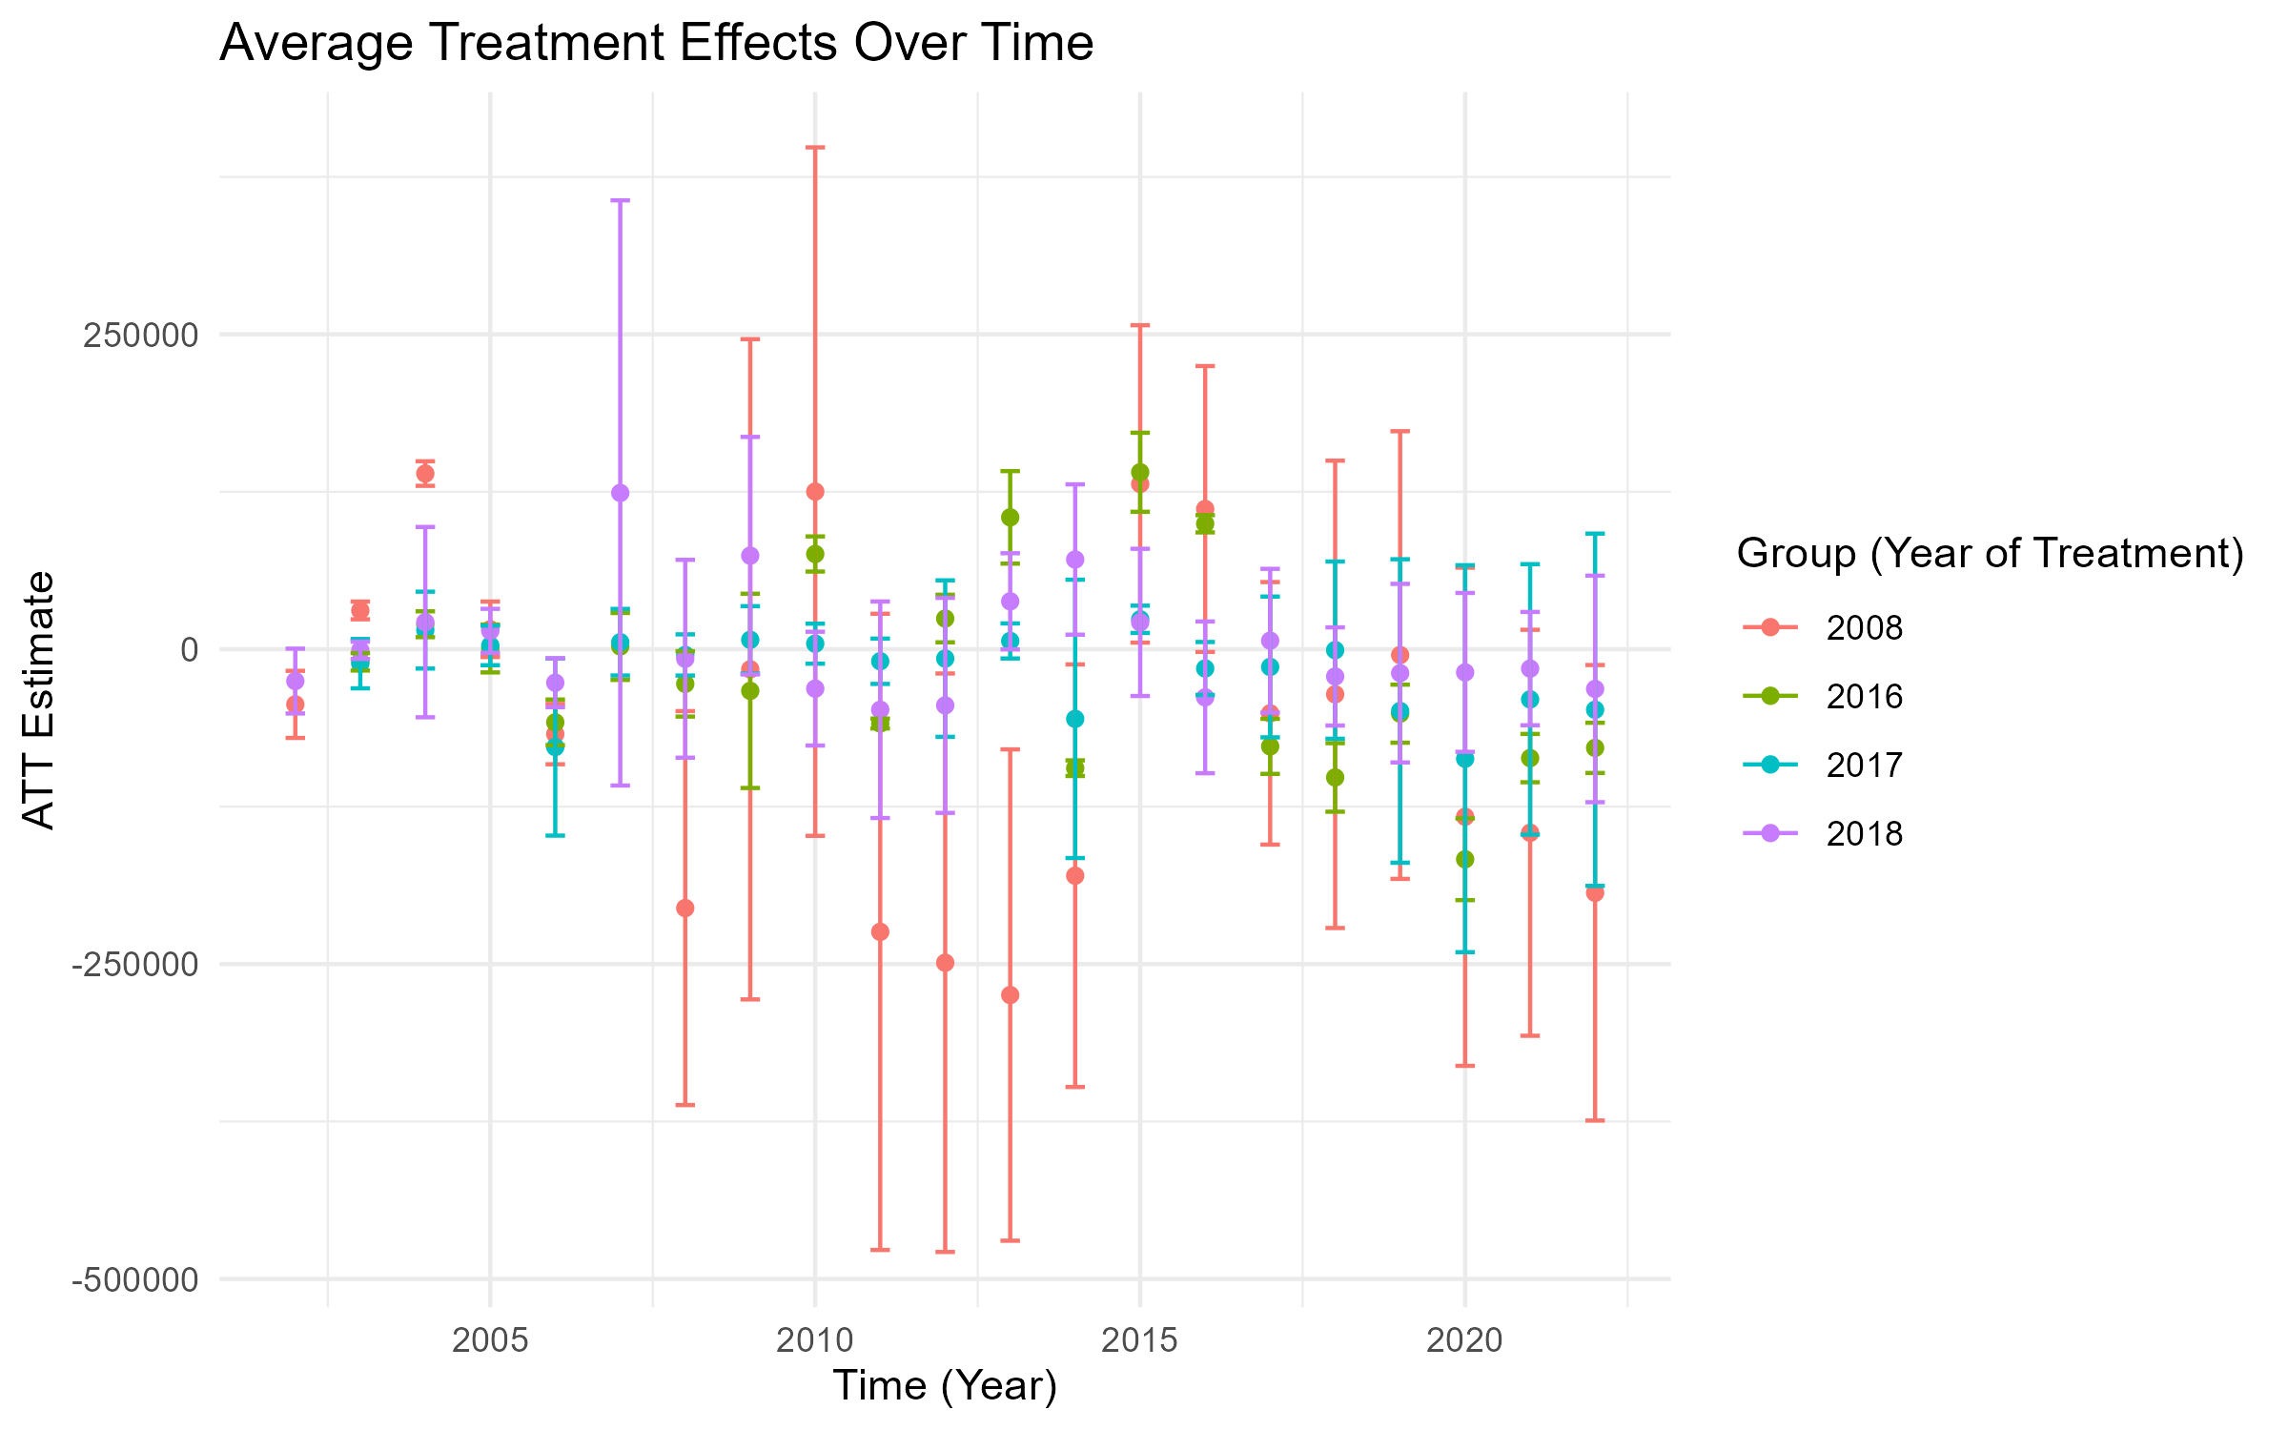

Observação: Os intervalos de confiança ao nível de 95% são apresentados para cada coeficiente estimado.