**Embedded Systems Security’18**

**Laboratory assignment 1**

**Name:** Daniel Cazar

1. **The hello world program**



1. **The hello world program modified**



1. **A full adder**

|  |  |  |
| --- | --- | --- |
| **Files** | | |
|  |  |  |

* **What is adder and how it works?**

Adder is a digital system that computes the sum of 3 bits (inputs: i0, i1, ci) and gives back a result expressed with 2 bits (outputs: s, co).

* **What do entity, architecture, port, component, process mean?**

- Entity is the logic representation of a digital system. If the entity is used as ***testbench*** then normally no ports are defined.

- Architecture is a piece of code that defines how the digital system works internally.

- Port is used to define how many inputs and outputs the digital system has.

- Component is used to create instances of the digital system. In this example the component is an instance of the entity ***adder.***

- Process is the main part of the digital system because it represents step by step how the digital system is going to do its job (processing).

* **How is the full adder tested?**

It’s tested using the ***testbench*** which in this example is called ***adder_tb***. It checks the outputs between the matrix of patterns and the outputs that were generated using the architecture of the ***adder*** entity.

**Signals visualization**

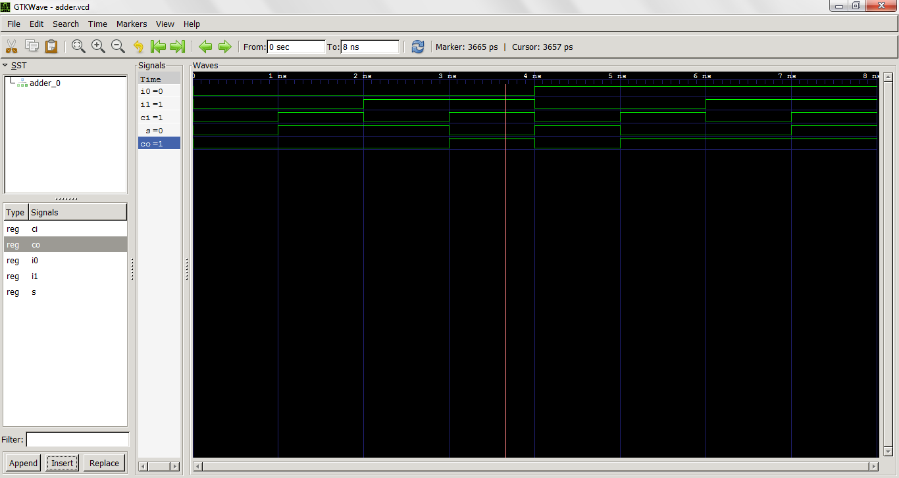

1. **Logical circuit**

|  |  |
| --- | --- |
| **Logical Circuit** | **Files** |
|  |  |
|  |
|  |

**Signals visualization**

