Embedded Systems Security’18

Solution of List #2

Daniel Cazar
Faculty of Fundamental Problems of Technology
Politechnika Wrocławska
2018-03-13

Summary

This report shows two models of VHDL with the functionality of LFSR and especially with a modified version of A5/1. The results after completion of this list of assignments demonstrate firstly that is relatively easy to design and build such models of LFSR, and secondly that the main feature of the A5/1 in the process of generating random bit sequence can be evaluated with NIST Statistical Test Suite for random and pseudo-random number generators. Results of four Statistical tests show that the bit-sequence (RND) generated by A5/1 is not random at least in two tests (runs of zeros and ones, and longest run of ones in a block of 128 bits).
Table of Contents

Summary i
Introduction 1
Assignment 1 1
Results 1
Assignment 2 2
Results 2
Assignment 3 3
Results 3
Assignment 4 4
Results 4
Assignment 5 5
Results 5
Conclusions 6
Appendix 1 7
VHDL code of modified version of stream cipher A5/1 7
Appendix 2 11
Python code of NIST statistical tests 11
References 13

Introduction

Through this report you will find a construction of a VHDL model for a bit-sequence generator using 2 LFSRs, and a modified version of the stream cipher A5/1. Furthermore, you will find a set of randomness tests using NIST Suite for Random and Pseudorandom Number Generators. In the end you will find some conclusions derived from the analysis of results of assignments.

Assignment 1

Download code available for this class. Read it carefully before running any ghdl instance!. Go through both architectures of lfsr entity, sketch them out on paper. Mark other signals from the lfsr_tb.vhd: load, q1, q2, LFSR1, LFSR2.

Results

File lfsr.vhd shows an exemplary implementation of two LFSR (linear feedback shift register) and file lfsr_tb.vhd shows a testbench, that instantiates two such registers, loads one of them with an IV (initialization vector), and runs them both, producing two sequences of bits. Drawing what is written on those two files we have next diagram. It shows that LFSRs are asynchronous and produce two sequences of bits.

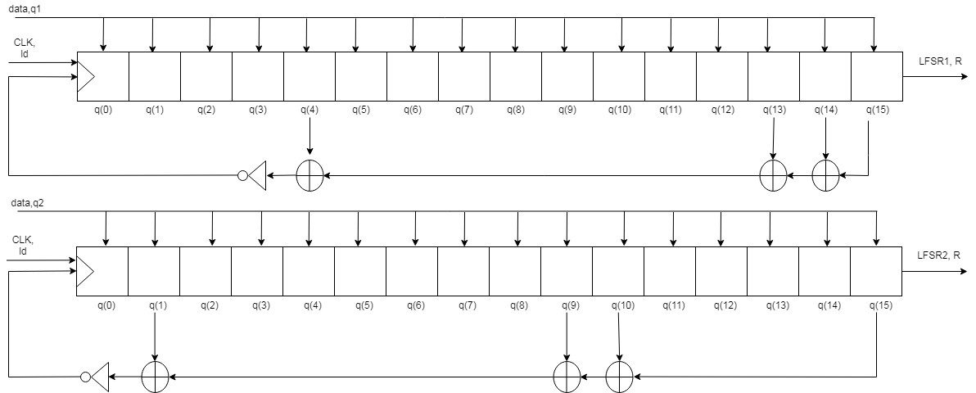
Figure 1 Asynchronous LFSR1 and LFSR2

Description of entity LFSR:

- Clk: Input that is used as clock of the LFSR.
- Ld: Input that allows to store data into LFSR.
- Data: Input that is used to store a bit-sequence of 16 bits. It initialize with all zeros.
- R: Output that is used to save the last bit that is shifted by the LFSR.

Description of signals:

- Load: Signal that allows inserting data into LFSRs. When is equal to ‘1’ it’s used to initialize the LFSRs only one time. When is equal to ‘0’ it lets LFSRs to run freely.
- q1, q2: They are signals of 16 bits long used as IV (Initialization Vector). Into the code of testbench they have next values:
q1 = 0000 0000 0000 0000 (2) = 0000 in hexadecimal
q2 = 1111 1010 1111 1010 (2) = FAFA in hexadecimal
- Clock: Signal that is used to clock all LFSRs. This signal doesn’t halt, should be killed or use a parameter (--stop-time=XXX) to its duration
- LFSR1, LFSR2: Signals used as output. They generate the bit-sequence.

Assignment 2

Run code for the testbench a number of times, changing the IV of both UUT’s. Observe how (if) the changes you introduce change the output.

Results

- q1=0x0000, q2=0xFAFA

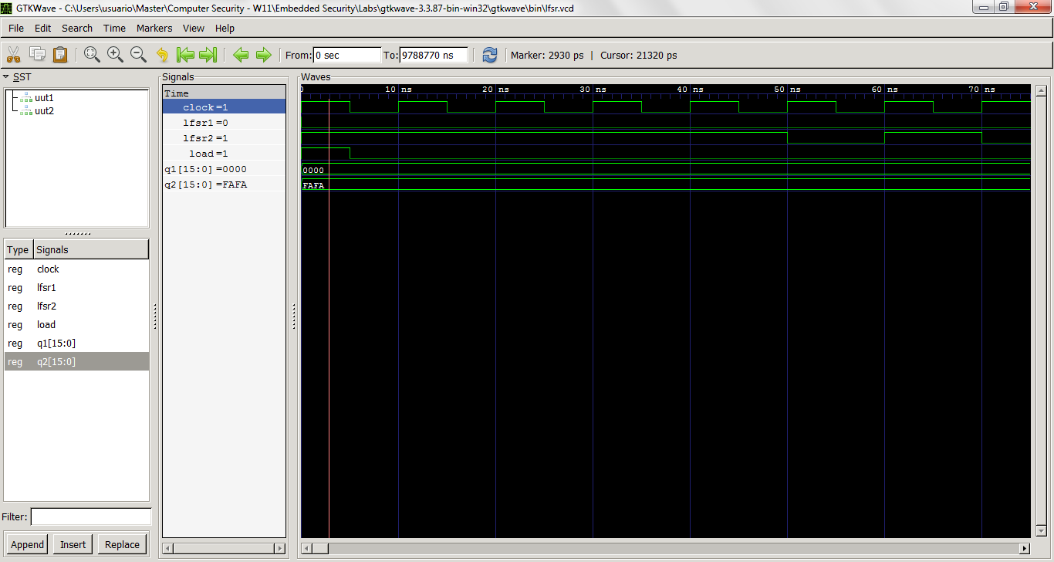
Figure 2 Initialization Vector change #1
- q1=0xFFFF, q2=0x0001

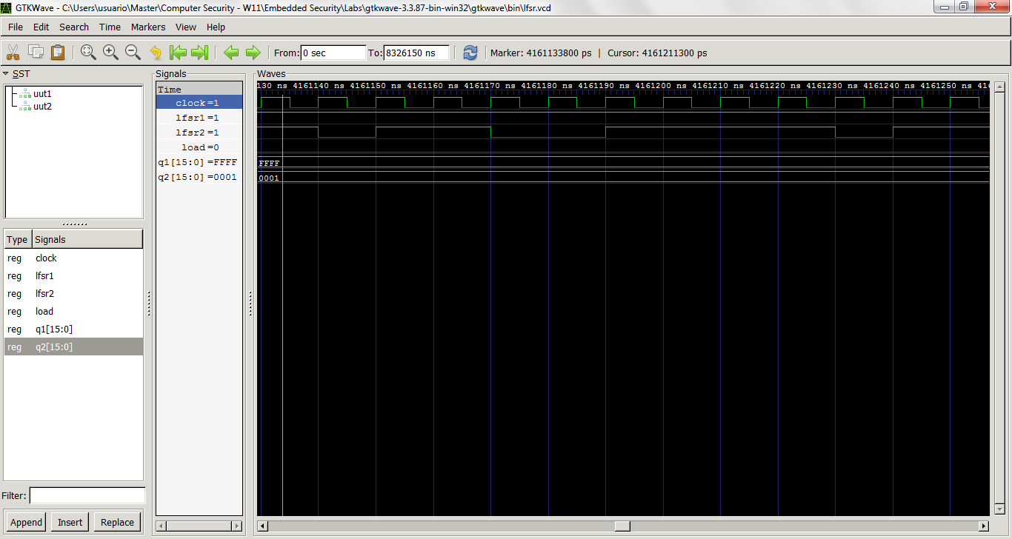
Figure 3 Initialization Vector change #1
The output of each LFSR changed because they are asynchronous. They not communicate each other.

Assignment 3

Modify the code so that the LFRS’s reflect those found in A5/1 (A5/1 stream cipher) (change the lengths and tap positions). Connect outputs of these LFSR’s to a three-input XOR to produce another signal, say RND. Using std.textio library from previous class print out to console the value of RND after each clock cycle. Alternately, you can write this directly to a file, see https://www.nandland.com/vhdl/examples/example-file-io.html for an example.

Results

Signal RND was printed out to console after each clock cycle. Then, the bit-sequence was manually saved into a file (output_results.txt) to be able to work in next assignment. The maximum sequence length that was possible to print it out was 297 bits. Code for this assignment can be found in Annex 1.
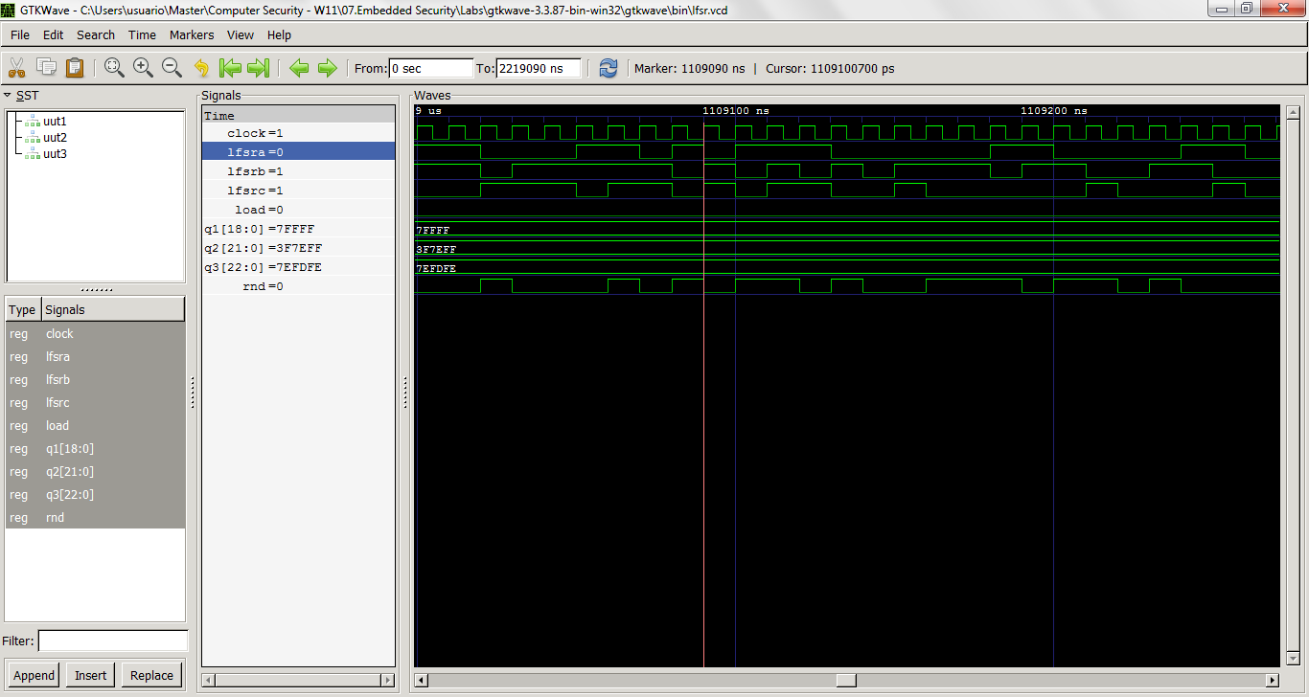
Figure 4 RND signal

Assignment 4

Using any programming language write a tool to determine the randomness properties of the sequence of RND bits you produced. Choose 3-4 tests from A Statistical Test Suite for Random and Pseudorandom Number Generators for Cryptographic Applications by NIST (800-22r1a, 2010).

Results

At first glance, the bit-sequence looks random, although after implementing four statistical tests it appears that is not anymore. First test relies on a simple calculation of the proportion (Frequency) of zeros and ones for the entire bit-sequence. Second test calculates the proportion (Frequency) of ones within a block of 128 bits. Third test calculates the runs of zeros and ones. A run is defined as a sequence where a single value is repeated one or more times. Finally, the test number four calculates the longest run of ones in a block of 128 bits. As far we can see, the minimum bit-sequence length must be 128 bits to be able to execute all four tests. Code for this assignment can be found in Annex 2.
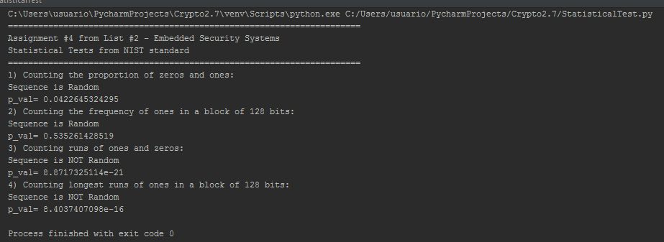
Figure 5 Statistical test results

Assignment 5

Using the tool, try to find such IV’s that result in poorest randomness for the analyzed LFSR configuration.

Results

For all four tests it has been defined a threshold (epsilon=0,01). If P_Value is less than 0.01, then the bit-sequence is consider as non-random (cells marked with red color), otherwise is consider as random (cells marked with green color). Next table shows the Initialization Vectors chosen and P_Value of each test.

Table 1 Randomness of a binary sequence.
IV | Test 1 | Test 2 | Test 3 | Test 4
q2=1111110111111011111111(2)  q3=11111101111110111111110(2) | 0.0422645324295 | 0.535261428519 | 8.8717325114e-21 | 8.4037407098e-16
q1=1111111111111111111(2)  q2=1111111111111111111111(2)  q3=11111111111111111111111(2) | 0.270247912323 | 0.209611387151 | 1.99579591814e-17 | 2.9029920133e-12
q1=1010101010101010101(2)  q2=1010101010101010101010(2)  q3=10101010101010101010101(2) | 0.323917219844 | 0.984496437005 | 1.35850366837e-16 | 0.0221849845048
q1=1111111110000000000(2)  q2=1111111111100000000000(2)  q3=11111111111000000000000(2) | 0.384088249474 | 0.28650479686 | 4.81211860874e-17 | 0.339601296069
q1=0000000000111111111(2)  q2=0000000000011111111111(2)  q3=00000000000011111111111(2) | 0.523288344712 | 0.778800783071 | 4.40293062297e-17 | 0.231359882757
q1=0000000000000000001(2)  q2=0000000000000000000001(2)  q3=000000000000000000000001(2) | 0.684609468567 | 0.606530659713 | 1.06891285594e-21 | 5.54101863583e-12

Conclusions

From results of assignment 5 we see that the most problematic statistical test is number 3, which determine whether the number of runs of ones and zeros is as expected for a random sequence. From the point of view of an attacker we can expect to easily guess the next bits of the keyStream and we can even generate by ourselves CipherText because is just a simple operation XOR between KeyStream and Plaintext. From the point of view of an auditor we see that this bit-sequence already generated doesn’t compliance with the NIST standard and for instance we could recommend that our modified version of A5/1 should consider the integration of majority voting entity in order to generate a random bit-sequence that passes test number 3.

It turns out not quite difficult to design and build VHDL models. We started designing VHDL models from scratch and now we can say that we have a good understanding how for instance A5/1 is built. This experience that we just got it might be really useful in the case of designing crypto algorithms like AES for instance.
Appendix 1

VHDL code of modified version of stream cipher A5/1

LFSR.vhd

-- lfsr.vhd
library IEEE;
use IEEE.STD_LOGIC_1164.ALL;
use IEEE.STD_LOGIC_UNSIGNED.ALL;

-- this is an asynchronous parallel-in serial-out LFSR with 19 bits long
entity lfsr1 is
Port ( clk : in STD_LOGIC;
ld : in STD_LOGIC;
data: in STD_LOGIC_VECTOR(18 downto 0) := (OTHERS => '0');
R : out STD_LOGIC
);
end lfsr1;

library IEEE;
use IEEE.STD_LOGIC_1164.ALL;
use IEEE.STD_LOGIC_UNSIGNED.ALL;

-- this is an asynchronous parallel-in serial-out LFSR with 22 bits long
entity lfsr2 is
Port ( clk : in STD_LOGIC;
ld : in STD_LOGIC;
data: in STD_LOGIC_VECTOR(21 downto 0) := (OTHERS => '0');
R : out STD_LOGIC
);
end lfsr2;

library IEEE;
use IEEE.STD_LOGIC_1164.ALL;
use IEEE.STD_LOGIC_UNSIGNED.ALL;

-- this is an asynchronous parallel-in serial-out LFSR with 23 bits long
entity lfsr3 is
Port ( clk : in STD_LOGIC;
ld : in STD_LOGIC;
data: in STD_LOGIC_VECTOR(22 downto 0) := (OTHERS => '0');
R : out STD_LOGIC
);
end lfsr3;

-- there can be many architectures (aka "ways things work")
-- defined for a given entity. here we define three, that differ
-- in places where taps are located
ARCHITECTURE first OF lfsr1 IS
-- this will store internal state of LFSR
-- initialise it to all-zeroes
signal q : STD_LOGIC_VECTOR(18 downto 0) := (OTHERS => '0');
BEGIN

-- this process will be executed each time
-- a change in either of the signals: clk, ld, data
-- is detected. this is the "sensitivity list"
PROCESS(clk, ld, data)
BEGIN
-- note that if 'ld = 1' then, regardless of clk the LFSR
-- will read external data; that's why it's __asynchronous__
if(ld = '1')
then
q <= data;
-- however, if 'ld' is not operational, then 'clk' will
-- cause the state change
elsif(clk'event and clk = '1')
then
-- cyclic shift - as simple as that
q(18 downto 1) <= q(17 downto 0);
-- taps at bits 13, 16, 17 and 18
q(0) <= q(13) XOR q(16) XOR q(17) XOR q(18);
end if;
END PROCESS;

-- this is not a part of the process - this assignment is
-- permanent, i.e. "it's always there" - just like a wire
-- connecting MSB to the output
R <= q(18);

END first;

-- another architecture of the same entity 'lfsr'
ARCHITECTURE second OF lfsr2 IS
-- this will store internal state of LFSR
-- initialise it to all-zeroes
signal q : STD_LOGIC_VECTOR(21 downto 0) := (OTHERS => '0');
BEGIN

PROCESS(clk, ld, data)
BEGIN
if(ld = '1')
then
q <= data;
elsif(clk'event and clk = '1')
then
q(21 downto 1) <= q(20 downto 0);
-- taps at bits 20, and 21
q(0) <= q(20) XOR q(21);
end if;
END PROCESS;

R <= q(21);

END second;

-- another architecture of the same entity 'lfsr'
ARCHITECTURE third OF lfsr3 IS
-- this will store internal state of LFSR
-- initialise it to all-zeroes
signal q : STD_LOGIC_VECTOR(22 downto 0) := (OTHERS => '0');
BEGIN

-- this process will be executed each time
-- a change in either of the signals: clk, ld, data
-- is detected. this is the "sensitivity list"
PROCESS(clk, ld, data)
BEGIN
-- note that if 'ld = 1' then, regardless of clk the LFSR
-- will read external data; that's why it's __asynchronous__
if(ld = '1')
then
q <= data;
-- however, if 'ld' is not operational, then 'clk' will
-- cause the state change
elsif(clk'event and clk = '1')
then
-- cyclic shift - as simple as that
q(22 downto 1) <= q(21 downto 0);
-- taps at bits 7, 20, 21 and 22
q(0) <= q(7) XOR q(20) XOR q(21) XOR q(22);
end if;
END PROCESS;

-- this is not a part of the process - this assignment is
-- permanent, i.e. "it's always there" - just like a wire
-- connecting MSB to the output
R <= q(22);

END third;

LFSR_TB.vhd

-- lfsr_tb.vhd
library IEEE;
use IEEE.STD_LOGIC_1164.ALL;
use IEEE.STD_LOGIC_UNSIGNED.ALL;
use IEEE.STD_LOGIC_TEXTIO.all;
use std.textio.all;

-- this is a testbench, but can be any other entity
entity lfsr_tb is
end lfsr_tb;

architecture complex of lfsr_tb is
-- this clock runs at HOW MANY MHz?
constant clock_period : time := 10 ns;
--a 1 nS period corresponds to 1 GHz
--1000 nS => 1 microsecond => 1 MHz
--10ns=10GHz

-- clock signal
signal clock : std_logic := '0';
-- lines for loading-up LFSRs
signal q1 : std_logic_vector(18 downto 0) := (others => '1');
signal q2 : std_logic_vector(21 downto 0) := (others => '1');
signal q3 : std_logic_vector(22 downto 0) := (others => '1');
-- signal to start loading LFSRs
signal load : std_logic := '0';
-- outputs from LFSRs
signal LFSRA,LFSRB,LFSRC : std_logic;
-- signal used to calculate XOR of outputs of three LFSRs
signal RND : std_logic;

-- just a reminder what will be tested
component lfsr1
port(
clk : in STD_LOGIC;
ld : in STD_LOGIC;
data : in STD_LOGIC_VECTOR(18 downto 0);
R : out STD_LOGIC );
end component;

component lfsr2
port(
clk : in STD_LOGIC;
ld : in STD_LOGIC;
data: in STD_LOGIC_VECTOR(21 downto 0);
R : out STD_LOGIC );
end component;

component lfsr3
port(
clk : in STD_LOGIC;
ld : in STD_LOGIC;
data: in STD_LOGIC_VECTOR(22 downto 0);
R : out STD_LOGIC );
end component;

-- remember? we defined three architectures for 'lfsr'
for UUT1 : lfsr1 use entity work.lfsr1(first);
for UUT2 : lfsr2 use entity work.lfsr2(second);
for UUT3 : lfsr3 use entity work.lfsr3(third);

begin
-- let's create instances of our LFSRs
UUT1 : lfsr1 port map ( clk => clock, ld => load, data => q1, R => LFSRA );
UUT2 : lfsr2 port map ( clk => clock, ld => load, data => q2, R => LFSRB );
UUT3 : lfsr3 port map ( clk => clock, ld => load, data => q3, R => LFSRC );

-- this will run infinitely, stopping every few ns
clocker : process
variable v_OLINE : line;
begin
clock <= not clock;
wait for clock_period/2;

write(v_OLINE, RND);
writeline(output, v_OLINE);

end process;

-- this will run once and then wait for ever
init : process

begin

-- time to tell LFSRs to load up some data
load <= '1';
-- and give it to them (to one of them, at least)
q2 <= "1111110111111011111111";
q3 <= "11111101111110111111110";
-- even though LFSRs are async, let's wait for a bit...
wait until clock'event and clock = '0';
-- ... and let them run freely
load <= '0';

-- this process is finished, make it wait ad infinitum
wait;
end process;

--calculate XOR of three outputs of LFSRs
RND <= LFSRA xor LFSRB xor LFSRC;
-- okay, what's going on here? well, the 'clocker' process
-- keeps running, changing clk -> NOT clk -> clk -> NOT clk ...
-- and clk is fed to LFSRs, so they are busy working
-- the simulation will continue until you kill it, or specify
-- the stop time using '--stop-time=XXX' switch to ghdl
end complex;

Appendix 2

Python code of NIST statistical tests

# statisticalTest.py
from __future__ import division
import scipy.special as spc
import math
import numpy

def checker(p_val):
epsilon = 0.01
if p_val > epsilon:
print("Sequence is Random")
else:
print("Sequence is NOT Random")

def count_zeros_and_ones(bin_data):
ones, zeros = 0, 0
# If the char is 0 minus 1, else add 1
for char in bin_data:
if char == '0':
zeros += 1
else:
ones += 1
print"Count 1 =", ones, "Count 0 =", zeros

def monobit(bin_data):
count = 0
# If the char is 0 minus 1, else add 1
for char in bin_data:
if char == '0':
count -= 1
else:
count += 1
# Calculate the p value
sobs = abs(count) / math.sqrt(len(bin_data))
p_val = spc.erfc(math.fabs(sobs) / math.sqrt(2))
return p_val

def block_frequency(bin_data, block_size=128):
# Work out the number of blocks, discard the remainder
num_blocks = math.floor(len(bin_data) / block_size)
block_start, block_end = 0, block_size
# Keep track of the proportion of ones per block
proportion_sum = 0.0
for i in range(int(num_blocks)):
# Slice the binary string into a block
block_data = bin_data[block_start:block_end]
# Keep track of the number of ones
ones_count = 0
for char in block_data:
if char == '1':
ones_count += 1
pi = ones_count / block_size
proportion_sum += pow(pi - 0.5, 2.0)
# Update the slice locations
block_start += block_size
block_end += block_size
# Calculate the p-value
chi_squared = 4.0 * block_size * proportion_sum
p_val = spc.gammaincc(num_blocks / 2, chi_squared / 2)
return p_val

def runs(bin_data):
ones_count, n = 0, len(bin_data)
for char in bin_data:
if char == '1':
ones_count += 1
p, vobs = float(ones_count / n), 1
tau = 2 / math.sqrt(len(bin_data))
if abs(p - 0.5) >= tau:
return 0.0
else:
for i in range(1, n):
if bin_data[i] != bin_data[i - 1]:
vobs += 1

num = abs(vobs - 2.0 * n * p * (1.0 - p))
den = 2.0 * math.sqrt(2.0 * n) * p * (1.0 - p)
p_val = spc.erfc(float(num / den))
return p_val

def longest_runs(bin_data):
if len(bin_data) < 128:
print("\t", "Not enough data to run test!")
return -1.0
elif len(bin_data) < 6272:
k, m = 3, 8
v_values = [1, 2, 3, 4]
pik_values = [0.21484375, 0.3671875, 0.23046875, 0.1875]

# Work out the number of blocks, discard the remainder
num_blocks = math.floor(len(bin_data) / m)
frequencies = numpy.zeros(k + 1)
block_start, block_end = 0, m
for i in range(int(num_blocks)):
# Slice the binary string into a block
block_data = bin_data[block_start:block_end]
# Keep track of the number of ones
max_run_count, run_count = 0, 0
for j in range(0, m):
if block_data[j] == '1':
run_count += 1
max_run_count = max(max_run_count, run_count)
else:
max_run_count = max(max_run_count, run_count)
run_count = 0
max_run_count = max(max_run_count, run_count)
if max_run_count < v_values[0]:
frequencies[0] += 1
for j in range(k):
if max_run_count == v_values[j]:
frequencies[j] += 1
if max_run_count > v_values[k - 1]:
frequencies[k] += 1
block_start += m
block_end += m
chi_squared = 0
for i in range(len(frequencies)):
chi_squared += (pow(frequencies[i] - (num_blocks * pik_values[i]), 2.0)) / (num_blocks * pik_values[i])
p_val = spc.gammaincc(float(k / 2), float(chi_squared / 2))
return p_val

def readKeystream(fname):

with open(fname) as f:
content = f.readlines()
# Remove whitespace characters like `\n` at the end of each line
content = [x.strip('\n') for x in content]
a= ''.join(content)
return a

if __name__ == '__main__':
fname = 'C:\Users\usuario\Master\output_results.txt'
# RND is generated by implementatiion of A5/1 using ghdl model.
RND = readKeystream(fname)
print("======================================================================")
print("Assignment #4 from List #2 - Embedded Security Systems")
print("Statistical Tests from NIST standard")
print("======================================================================")
print("1) Counting the proportion of zeros and ones:")
checker(monobit(RND))
print('p_val='), monobit(RND)
print("2) Counting the frequency of ones in a block of 128 bits:")
checker(block_frequency(RND))
print('p_val='), block_frequency(RND)
print("3) Counting runs of ones and zeros:")
checker(runs(RND))
print('p_val='), runs(RND)
print("4) Counting longest runs of ones in a block of 128 bits:")
checker(longest_runs(RND))
print('p_val='), longest_runs(RND)

References

800-22r1a. (2010, April). A Statistical Test Suite for Random and Pseudorandom Number Generators for Cryptographic Applications. Retrieved from NIST: https://nvlpubs.nist.gov/nistpubs/legacy/sp/nistspecialpublication800-22r1a.pdf

A5/1 stream cipher. (n.d.). Retrieved February 26, 2018, from https://es.wikipedia.org/wiki/A5/1

