Embedded Systems Security’18

Solution of List #3

Daniel Cazar
Faculty of Fundamental Problems of Technology
Politechnika Wrocławska
2018-04-17

Summary

This report shows two traces of IrDA communication that are encoded with NEC protocol. The results after completion of this list #3 shows that the protocol used for that communication is not so complex. At the end you will find the binary sequence obtained from traces of IrDA.

Table of Contents

Summary i
Introduction 1
Assignment 1 1
Brief explanation about NEC protocol (Altium) 1
Conclusions 3
References 3

Introduction

Through this report you will find an explanation of the protocol NEC used in IrDA communication and in the end you will see two binary sequences successfully decoded. The communication was implemented using infrared receiver TSOP2238, a TV Remote Control and Arduino. The traces of these communications were sent personally and we take it for granted.

Assignment 1

Using the traces sent by email, try to decode the final binary sequence using Salae logic analyzer software.

Brief explanation about NEC protocol (Altium)

The NEC IR transmission protocol uses pulse distance encoding of the message bits. Logical bits are transmitted as follows:

- Logical '0' – a 562.5µs pulse burst followed by a 562.5µs space, with a total transmit time of 1.125ms
- Logical '1' – a 562.5µs pulse burst followed by a 1.6875ms space, with a total transmit time of 2.25ms

When a key is pressed on the remote controller, the message transmitted consists of the following, in order:

- a 9ms leading pulse burst (16 times the pulse burst length used for a logical data bit)
- a 4.5ms space
- the 8-bit address for the receiving device
- the 8-bit logical inverse of the address
- the 8-bit command
- the 8-bit logical inverse of the command
- a final 562.5µs pulse burst to signify the end of message transmission.

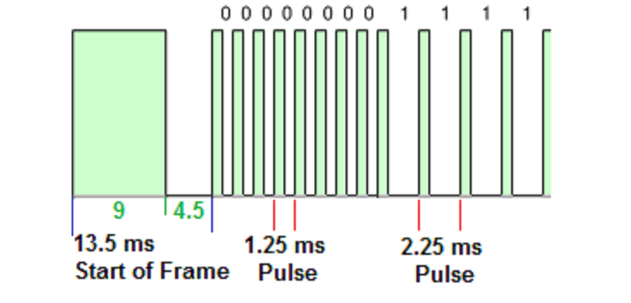
Figure 1 NEC IR Transmission protocol
Repeat Codes

If the key on the remote controller is kept depressed, a repeat code will be issued, typically around 40ms after the pulse burst that signified the end of the message. A repeat code will continue to be sent out at 108ms intervals, until the key is finally released. The repeat code consists of the following, in order:

- a 9ms leading pulse burst
- a 2.25ms space
- a 562.5µs pulse burst to mark the end of the space (and hence end of the transmitted repeat code).

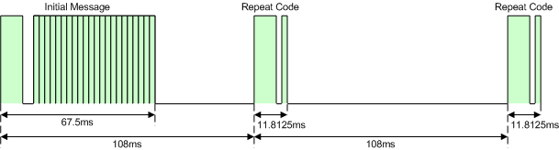
Figure 2 Repeat codes

Results

After analyzing the traces I end up with the next explanation and results. Figure 3 shows that long periods are represented as ‘1’s and short periods as ‘0’s. Furthermore, Table1 shows the sequence decoded and doesn’t consider the “repeat codes” that were found in the traces.

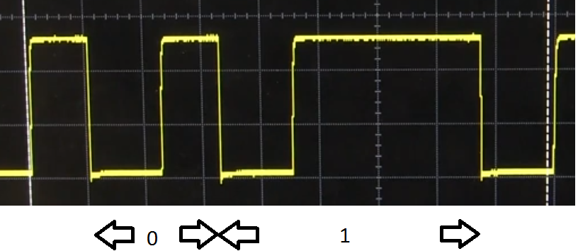
Figure 3 NEC protocol receiver

Tabla 1 Encode/decode IrDA communication
Encode | Decode
 | 
 | 

Conclusions

The protocol NEC used for IrDA communication when the sequence is receive is encoded in such a way that the length of the period of ‘0’s and ‘1’s changes (they are not the same). They are encoded without having a fixed length for bit '0' and bit '1'. The long period is assigned to encode “1”s and the short period to encode “0”s.

From the point of view of an attacker it results easy to decode the sequence after collecting the traffic of IrDA communication because it doesn’t rely on the advantages of cryptography to secure it and to provide confidentiality, integrity, non-repudiation,

References

Altium. (n.d.). NEC Infrared Transmission Protocol. Retrieved 04 01, 2018, from http://techdocs.altium.com/display/FPGA/NEC+Infrared+Transmission+Protocol

