Embedded Systems Security’18

Solution of List #4

Daniel Cazar
Faculty of Fundamental Problems of Technology
Politechnika Wrocławska
2018-04-29

Summary

This report shows two implementations over Arduino boards and IrDA hardware using A5/1 (modified version) as a keystream. First implementation uses two PCs communicating each other. Separately produce keystreams from A5/1 and pass it to Arduino boards using UART. The encrypted message is sent between the Arduinos over IrDA link. Second implementation uses two Arduino boards connected via UART link to PCs for message transmission. The keystream is received in the Sending PC via UART link and forwarded in parallel with the cryptogram via IrDA link.

Table of Contents

Summary i
Introduction 1
Assignment 1 1
Design 1
Results 2
Problems encountered 2
Assignment 2 3
Design 3
Results 3
Sketch encryption One Time Pad – IrDA link + Software Serial 3
Conclusions 4
Annex 1 5
A5/1 Keystream over UART 5
Annex 2 8
Sketch encryption One Time Pad – IrDA link 8

Introduction

Through this report you will find designs and implementations of securing communication between two Arduino boards using One Time Pad. To accomplish these assignments it was used the next requirements:

- A modified version of the stream cipher A5/1 (Anexo 1) implemented in python as a pseudogenerator.
- Arduino UNO
- Infrared receiver TSOP2238
- Infrared transmitter
- Resistance

Assignment 1

The two communicating PCs separately produce the keystream using A5/1 and then pass it to Arduino boards using UART. The encrypted message is sent between the Arduinos over IrDA link.

Design

The next picture shows the circuit implemented in order to communicate via IrDA link.

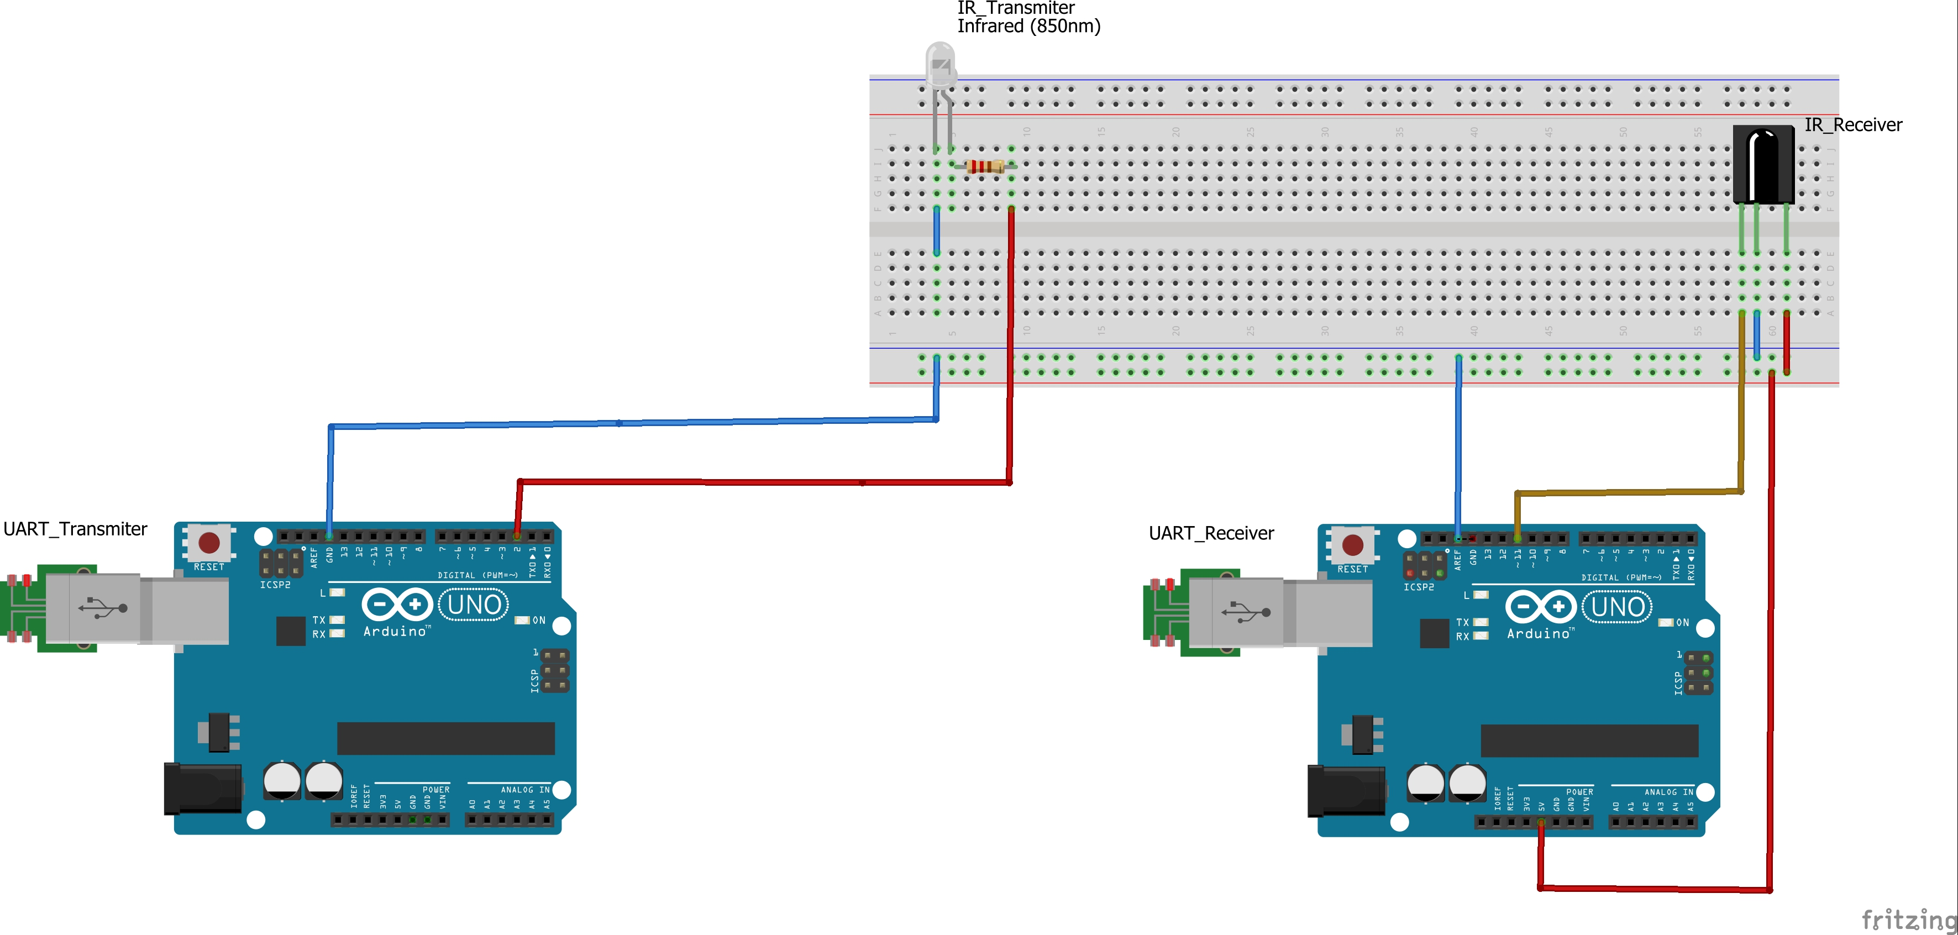
Figure 1 Infrared communication

Results

Implementation of the diagram depicted before has been tested in only one Arduino board as the transmitter. The test consider the encryption of a message “hello” encoded in binary and then send it back to PC. The side of the receiver was not possible to be tested because of hardware limitations. Even though, the code to send the ciphertext over IrDA link it is written and can be found in Anexo#1.

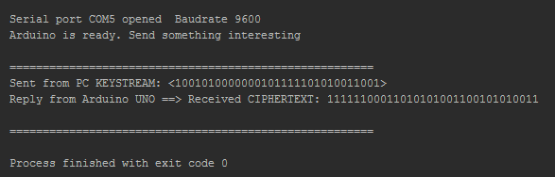
Figure 2 Encryption One Time Pad

Problems encountered

The main problems encountered were those related with parsing the binary sequence and be able to XOR (plaintext ^ keystream). I started thinking on parsing the binary string to a real binary and then compute the xor. This had a limitation on the length of the datatype bin (32 max). To avoid this I just xored strings. Next, I show the code that avoided.

for(int i=0; i<32; i++){
value += messageFromPC[i];
}

// Convertion string-binary to binary
for (unsigned int i = 0; i < value.length(); ++i)
{
switch(value[i]) {
case '1':
result = result | 1;
result = result << 1;
break;
case '0':
result = result << 1;
break;
}
}

xored = result ^ plaintext; //One time pad – CipherText

Assignment 2

The two communicating Arduino boards are connected via UART link for message transmission. The keystream is received from the sending PC via UART link and forwarded in parallel with the cryptogram via IrDA link.

Design

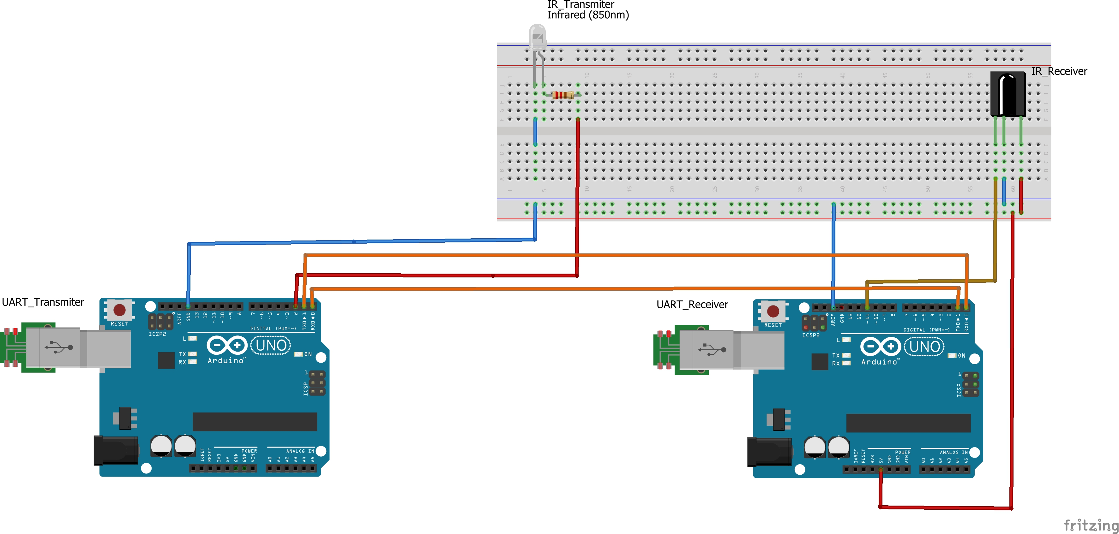
Figure 3 Infrared and serial communication

Results

Implementation of the diagram depicted before has been tested in only one Arduino board as the transmitter. The test consider the encryption of a message “hello” encoded in binary and then send it back to PC. The side of the receiver was not possible to be tested because of hardware limitations. Even though, the code to send the ciphertext over Software Serial and keyStream over IrDA is written and can be found in the following lines. As you noticed, this assignment is pretty similar to the previous one. I show only the extra code that should be added in the previous Sketch.

Sketch encryption One Time Pad – IrDA link + Software Serial

#include <SoftwareSerial.h>
SoftwareSerial mySerial(5, 6); // RX, TX

void setup() {
// starting the software serial
mySerial.begin(4800);
}

void loop() {
getDataFromPC();
updateFlashInterval();
flashLEDs();
replyToPC();
//transmitterIrDA();
//receiverIrDA(); //uncomment this line and comment previous line in order to be the receiver
sendOverSoftSerial();
}

void sendOverSoftSerial() {
delay(10);
int i;
for(i=0; i< buffSize; i++){
mySerial.print(messageFromPC[i] ^ plaintext[i]);
}
}

//IdRA communication
void transmitterIrDA() {

for (int i = 0; i < 32; i++) {
irsend.sendSony(messageFromPC[i], 12);
delay(40);
}
delay(5000); //5 second delay between each signal burst
}

Conclusions

Both communications from assignment 1 and 2 respectively rely on the definition on the One Time Pad encryption scheme. Although the implementation in both assignments are absolutely bad performed by the misuse of the key management process. This process must be as secure as the encryption scheme used. Due the encryption scheme is categorize as a symmetric key encryption, then, both parties must implement a process to exchange key securely. For instance, it could be considered to use Deffie Hellman for this specific case.

The first assignment is the one that is closer to an implementation of a real One Time Pad scheme because it assumes that the key is not send through an insecure channel. As a suggestion I can say that it could be a good practice if the key is generated randomly with a mix of pseudo and physic generator and then store securely in a SD-card and then send to each party to make use the encryption and decryption.

Annex 1

A5/1 Keystream over UART

#Start of A5/1 generator Keystream
#========================================

# Operation XOR
def xor(a,b):
global bit
if a==b:
bit=0
else:
bit=1
return

def cycle(shift, code):
#LFSR1
if code == 1:
xor(shift[18], shift[17])
xor(bit, shift[16])
xor(bit, shift[13])
shift.insert(0, bit)
del shift[19]
#LFSR2
if code == 2:
xor(shift[20], shift[21])
shift.insert(0, bit)
del shift[22]
#LFSR3
if code == 3:
xor(shift[20], shift[21])
xor(bit, shift[22])
xor(bit, shift[7])
shift.insert(0, bit)
del shift[23]

if __name__ == '__main__':
#Setting the initial values
sessionKey = [0, 1, 1, 0, 1, 0, 1, 0, 0, 1, 0, 0, 0, 1, 0, 0, 0, 1, 0, 1, 0, 1, 0, 1, 0, 1, 0, 0, 1, 0, 0, 0, 0, 1, 1, 1, 1, 1, 0, 0, 0, 1, 1, 1, 1, 0, 1, 1, 0, 0, 1, 1, 1, 0, 0, 0, 0, 1, 0, 0, 0, 0, 1, 1]
LSFR1 = sessionKey[0:19]
LSFR2 = sessionKey[19:41]
LSFR3 = sessionKey[41:64]
keyStream = []
bit = 0

#Generating keyStream. Its lenght is equal to m
n = 0
m = 32 # length of the binary-sequence
while n < m:
#the ouptut is a XOR of the first, the second and the third LFSR
xor(LSFR1[18], LSFR2[21])
xor(bit, LSFR3[22])
keyStream.insert(0, bit)

#In each round all LFSRs are moving
cycle(LSFR1, 1)
cycle(LSFR2, 2)
cycle(LSFR3, 3)
n += 1

temp_keystream = "".join(str(i) for i in keyStream)

# End of A5/1 generatorKeystream
#========================================

# Start of UART communication
#========================================
def sendToArduino(sendStr):
ser.write(sendStr)

def recvFromArduino():
global startMarker, endMarker

ck = ""
x = "z" # any value that is not an end- or startMarker
byteCount = -1 # to allow for the fact that the last increment will be one too many

# wait for the start character
while ord(x) != startMarker:
x = ser.read()

# save data until the end marker is found
while ord(x) != endMarker:
if ord(x) != startMarker:
ck = ck + x
byteCount += 1
x = ser.read()

return (ck)

def waitForArduino():
# wait until the Arduino sends 'Arduino Ready' - allows time for Arduino reset
# it also ensures that any bytes left over from a previous message are discarded

global startMarker, endMarker

msg = ""
while msg.find("Arduino is ready") == -1:

while ser.inWaiting() == 0:
pass

msg = recvFromArduino()

print msg
print
print "======================================================="

def sendKeystream(td):
numLoops = len(td)
waitingForReply = False

n = 0
while n < numLoops:

teststr = td[n]

if waitingForReply == False:
sendToArduino(teststr)
print "Sent from PC KEYSTREAM: " + teststr
waitingForReply = True

if waitingForReply == True:

while ser.inWaiting() == 0:
pass

dataRecvd = recvFromArduino()
print "Reply from Arduino UNO ==> Received " + dataRecvd
n += 1
waitingForReply = False

print "======================================================="

time.sleep(5)
# ======================================

# Connection with Arduino
# ======================================

import serial
import time

print
print

# Start connection with Arduino
serPort = "COM5"
baudRate = 9600
ser = serial.Serial(serPort, baudRate)
print "Serial port " + serPort + " opened Baudrate " + str(baudRate)

startMarker = 60
endMarker = 62

waitForArduino()

testData = []
testData.append("<" + temp_keystream + ">")

sendKeystream(testData)

ser.close

Annex 2

Sketch encryption One Time Pad – IrDA link

#include <IRremote.h>

IRsend irsend;
int RECV_PIN = 11;
IRrecv irrecv(RECV_PIN);
decode_results results;

const byte numLEDs = 2;
byte ledPin[numLEDs] = {12, 13};
unsigned long LEDinterval[numLEDs] = {200, 400};
unsigned long prevLEDmillis[numLEDs] = {0, 0};

const byte buffSize = 33;
char inputBuffer[buffSize];
const char startMarker = '<';
const char endMarker = '>';
byte bytesRecvd = 0;
boolean readInProgress = false;
boolean newDataFromPC = false;
unsigned long curMillis;

char messageFromPC[buffSize] = {0};
int newFlashInterval = 0;

char plaintext[buffSize] = "01101000011011110110110001100001"; //hola in binary

void setup() {
Serial.begin(9600);

// flash LEDs so we know we are alive
for (byte n = 0; n < numLEDs; n++) {
pinMode(ledPin[n], OUTPUT);
digitalWrite(ledPin[n], HIGH);
}
delay(500); // delay() is OK in setup as it only happens once

for (byte n = 0; n < numLEDs; n++) {
digitalWrite(ledPin[n], LOW);
}

// tell the PC we are ready
Serial.println("<Arduino is ready. Send something interesting>");

//uncomment next lines in order to be the receiver
//Serial.println("Enabling IRin");
//irrecv.enableIRIn(); // Start the receiver
//Serial.println("Enabled IRin");

}

void loop() {
getDataFromPC();
updateFlashInterval();
flashLEDs();
replyToPC();
//transmitterIrDA();
//receiverIrDA(); //uncomment this line and comment previous line in order to be the receiver

}

void getDataFromPC() {

// receive data from PC and save it into inputBuffer
if(Serial.available() > 0) {

char x = Serial.read();

if (x == endMarker) {
readInProgress = false;
newDataFromPC = true;
inputBuffer[bytesRecvd] = 0;
parseData();
}

if(readInProgress) {
inputBuffer[bytesRecvd] = x;
bytesRecvd ++;
if (bytesRecvd == buffSize) {
bytesRecvd = buffSize - 1;
}
}

if (x == startMarker) {
bytesRecvd = 0;
readInProgress = true;
}
}
}

void parseData() {

strcpy(messageFromPC, inputBuffer); // copy it to messageFromPC

}

void replyToPC() {

if (newDataFromPC) {
newDataFromPC = false;

Serial.print("<CIPHERTEXT: ");
int i;
for(i=0; i< buffSize; i++){
Serial.print(messageFromPC[i] ^ plaintext[i]);
}
Serial.println(">");
}
}

void updateFlashInterval() {

// this illustrates using different inputs to call different functions
if (strcmp(messageFromPC, "LED1") == 0) {
updateLED1();
}

if (strcmp(messageFromPC, "LED2") == 0) {
updateLED2();
}
}

void updateLED1() {

if (newFlashInterval > 100) {
LEDinterval[0] = newFlashInterval;
}
}

void updateLED2() {

if (newFlashInterval > 100) {
LEDinterval[1] = newFlashInterval;
}
}

void flashLEDs() {

for (byte n = 0; n < numLEDs; n++) {
if (curMillis - prevLEDmillis[n] >= LEDinterval[n]) {
prevLEDmillis[n] += LEDinterval[n];
digitalWrite( ledPin[n], ! digitalRead( ledPin[n]) );
}
}
}

//IdRA communication
void transmitterIrDA() {

for (int i = 0; i < buffSize; i++) {
irsend.sendSony(messageFromPC[i] ^ plaintext[i], 12);
delay(40);
}
delay(5000); //5 second delay between each signal burst
}

void receiverIrDA() {
if (irrecv.decode(&results)) {
Serial.println(results.value, BIN);
irrecv.resume(); // Receive the next value
}
delay(100);
}

