Embedded Systems Security’18

Solution of List #6

Daniel Cazar
Faculty of Fundamental Problems of Technology
Politechnika Wrocławska
2018-05-21

Summary

This report shows two implementations of Java Card applet that work with cryptographic algorithms in order to get familiar with cryptography within Java Card programming. For instance, the first applet uses hashing algorithms MD5 and SHA. It checks if CREF simulator has support for those hashing algorithms.

The second applet uses RSA algorithm. The idea with this applet is get familiar with asymmetric cryptography. It uses generation of Private and Public Key. Furthermore, it implements a verification function that as input receives the plaintext then is encrypted and as a result the original plaintext is give it back. This allows us to verify that the generation of the keys and encryption-decryption is working correctly.

Table of Contents

Summary i
Introduction 1
Assignment 2 1
Assignment 4 1
Results 1
Conclusions 2
Annex 1 3
Hello World – Java Card 3

Introduction

Through this report you will find two Java Card applets that implement hashing algorithms and RSA algorithm. First applet shows which hashing algorithms are supported by the simulator. Second applet shows a simple generation of Public/Private keys and verification of encryption with RSA.

Assignment 1

Write a JavaCard applet which will detect all hash functions available in the CREF emulator. Use javacard.security.MessageDigest class.

Results

The code for this assignment could be found in Annex #1. There, you can see that applet makes use of javacard.security.CryptoException. When simulator encounter an error, then it catches and send an exception with value 3, specifically SW1=0x00, SW2=0x03, meaning that the algorithm is not supported by the simulator. In case that simulator responds satisfactorily with SW1=0x90, SW2=00, it means that the hashing algorithm was found and is supported by the simulator. The hashing algorithms that were found having support by the simulator are the following: SHA_1 and SHA_256.

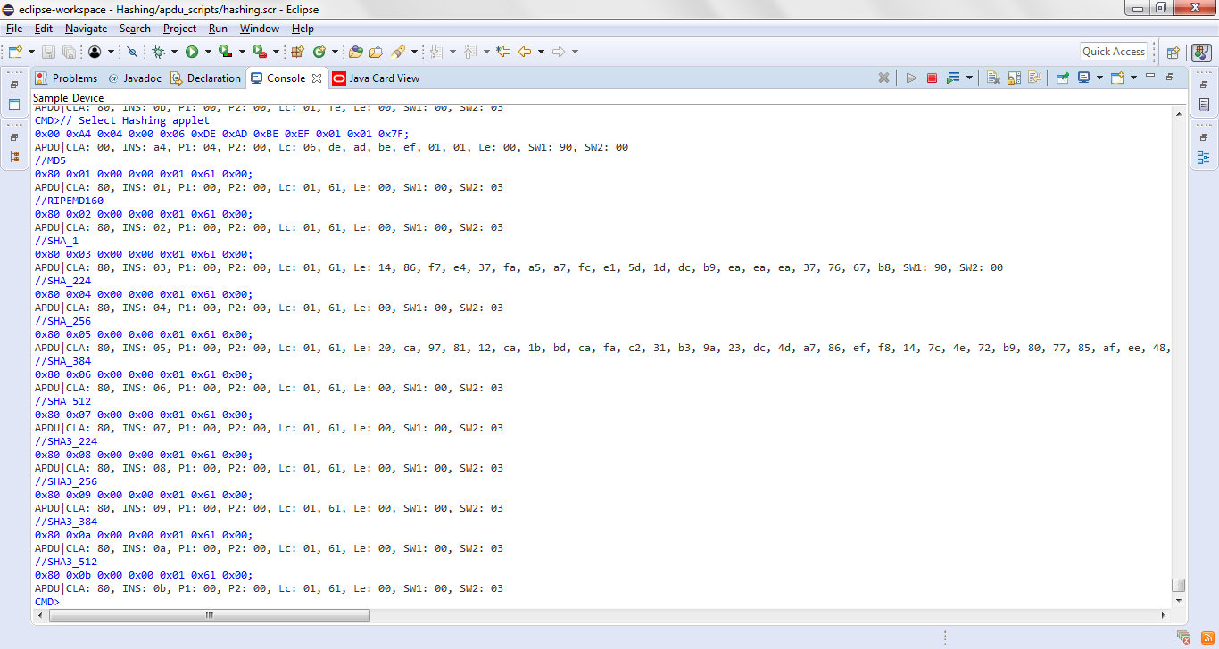
Figure 1 Supported Hashing Algorithms

Assignment 2

Using javacard.security.KeyPair class generate RSA key pair. The applet should return the public key on INS 0x11 and the private one on INS 0x22. Verify if the keys returned by the applet are in fact RSA keys. Choose some random m < N and encrypt it with the public key e: = me modN. Then calculate for the private key d : m0 = d modN) and verify if m0 ?=m.

Results

The code for this assignment could be found in Annex #2. There, you can see that applet makes use of next parameters (length of key, algorithm) for key generation:

- short keyLen = (short)512
- byte alg = KeyPair.ALG_RSA

Those parameters where used because we check that the longest length Keys (2048, 1024) were not supported by the simulator.

We retrieved the public and private key using the standard notation with modulus and exponent. Even though we notice that is possible to use CRT notation that could be useful when we don’t have those values. Whatsmore, the exponent encountered in the public key is the default value (01 00 01) HEX = (65537) Decimal.

In Figure 4 you can see as a result that we get plaintext which is the value of field Data (0x01 0x02 0x03 0x04 0x05) sent by APDU command. This certifies that we managed to verify that generation of the RSA keys and encryption-decryption is working correctly.

For both object instances of encryption and decryption we use ALG_RSA_PKCS1. This cipher pads input data according to the PKCS#1 specification. In contrast we found that there is ALG_RSA_NOPAD that does not pad input data. We couldn’t try the last one because we checked that is not supported by the simulator.

INS=0x00
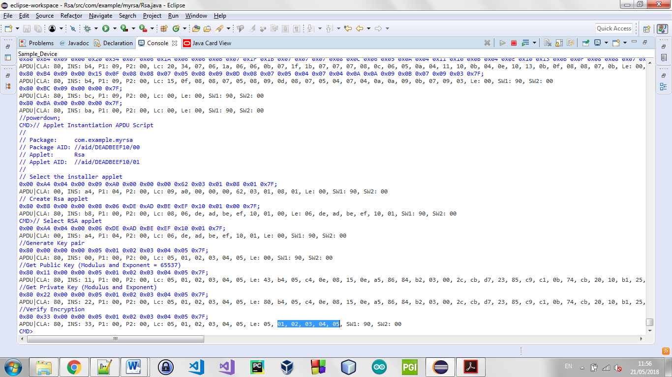
Figure 2 RSA Key Generation
INS=0x11 → Get Public Key
INS=0x22 → Get Private Key
Figure 3 RSA Public and Private Key

INS=0x33
Figure 4 Verification RSA encryption-decryption

Conclusions

The creation of RSA keys is not trivial and even more so in embedded systems that are exposed to many attacks. Nevertheless in this laboratory the creation of RSA keys were done in such a way to get familiar with cryptographic algorithms. The main aspects within the creation of RSA keys that have to be treated more carefully are:

- First of all, the exponent should not be the same and especially not the default value (65537).
- The length of the Key must be at minimum 2048 due that currently is feasible to crack weak RSA Keys (for instance, there is software that factorizes prime numbers called msieve that could be useful for this sort of approach).
- The RSA keys shouldn’t leave the terminal and must remain within the device.

Java Card 3.0.5 has a wide variety of algorithms. Although, we encountered so many cases that we wanted to use an algorithm as it was not supported by the simulator. As a suggestion, use try and catch to analyze the error. The crypto errors found were the following:

Error | Value | Description | How was used?
ILLEGAL_USE | 5 | This reason code is used to indicate that the signature or cipher algorithm does not pad the incoming message and the input message is not block aligned. | Used with problems with padding.
NO_SUCH_ALGORITHM | 3 | This reason code is used to indicate that the requested algorithm or key type is not supported. | Used to recognize if the algorithm is supported by the simulator.

Annex 1

Hashing – Java Card

package com.example.mypackage;

import javacard.framework.APDU;
import javacard.framework.Applet;
import javacard.framework.ISO7816;
import javacard.framework.ISOException;
import javacard.framework.Util;
import javacard.security.MessageDigest;

import javacard.security.CryptoException;

public class Hashing extends Applet {

private static final byte HW_CLA = (byte) 0x80;
private static final byte HW_INS_MD5 = (byte) 0x01;
private static final byte HW_INS_RIPEMD160 = (byte) 0x02;
private static final byte HW_INS_SHA = (byte) 0x03;
private static final byte HW_INS_SHA_224 = (byte) 0x04;
private static final byte HW_INS_SHA_256 = (byte) 0x05;
private static final byte HW_INS_SHA_384 = (byte) 0x06;
private static final byte HW_INS_SHA_512 = (byte) 0x07;
private static final byte HW_INS_SHA3_224 = (byte) 0x08;
private static final byte HW_INS_SHA3_256 = (byte) 0x09;
private static final byte HW_INS_SHA3_384 = (byte) 0xa;
private static final byte HW_INS_SHA3_512 = (byte) 0xb;

private byte [] receivedData;
private byte [] hashedData;
private MessageDigest mesDig;

private Hashing(byte[] bArray, short bOffset, byte bLength) {
register();
} // end of the constructor

public static void install(byte[] bArray, short bOffset, byte bLength) {
// create a Wallet applet instance
new Hashing(bArray, bOffset, bLength);
} // end of install method

@Override
public boolean select() {
return true;
}// end of select method

@Override
public void process(APDU apdu) {
if (selectingApplet()) {
return;
}

byte[] buffer = apdu.getBuffer();

byte CLA = (byte) (buffer[ISO7816.OFFSET_CLA] & 0xFF);

byte INS = (byte) (buffer[ISO7816.OFFSET_INS] & 0xFF);

if (CLA != HW_CLA) {

ISOException.throwIt(ISO7816.SW_CLA_NOT_SUPPORTED);

}

switch (INS) {

case HW_INS_MD5:
try {
mesDig = MessageDigest.getInstance(MessageDigest.ALG_MD5, false);

}catch(CryptoException e){
ISOException.throwIt(e.getReason());
//NO_SUCH_ALGORITHM = SW2:0x03
}
resendHash(apdu, MessageDigest.LENGTH_MD5);
mesDig.reset();
break;
case HW_INS_RIPEMD160:
try {
mesDig = MessageDigest.getInstance(MessageDigest.ALG_RIPEMD160, false);

}catch(CryptoException e){
ISOException.throwIt(e.getReason());
//NO_SUCH_ALGORITHM = SW2:0x03
}
resendHash(apdu, MessageDigest.LENGTH_RIPEMD160);
mesDig.reset();
break;
case HW_INS_SHA:
try {
mesDig = MessageDigest.getInstance(MessageDigest.ALG_SHA, false);

}catch(CryptoException e){
ISOException.throwIt(e.getReason());
//NO_SUCH_ALGORITHM = SW2:0x03
}
resendHash(apdu, MessageDigest.LENGTH_SHA);
mesDig.reset();
break;
case HW_INS_SHA_224:
try {
mesDig = MessageDigest.getInstance(MessageDigest.ALG_SHA_224, false);

}catch(CryptoException e){
ISOException.throwIt(e.getReason());
//NO_SUCH_ALGORITHM = SW2:0x03
}
resendHash(apdu, MessageDigest.LENGTH_SHA_224);
mesDig.reset();
break;
case HW_INS_SHA_256:
try {
mesDig = MessageDigest.getInstance(MessageDigest.ALG_SHA_256, false);
}catch(CryptoException e){
ISOException.throwIt(e.getReason());
//NO_SUCH_ALGORITHM = SW2:0x03
}
resendHash(apdu, MessageDigest.LENGTH_SHA_256);
mesDig.reset();
break;
case HW_INS_SHA_384:
try {
mesDig = MessageDigest.getInstance(MessageDigest.ALG_SHA_384, false);
}catch(CryptoException e){
ISOException.throwIt(e.getReason());
//NO_SUCH_ALGORITHM = SW2:0x03
}
resendHash(apdu, MessageDigest.LENGTH_SHA_384);
mesDig.reset();
break;
case HW_INS_SHA_512:
try {
mesDig = MessageDigest.getInstance(MessageDigest.ALG_SHA_512, false);
}catch(CryptoException e){
ISOException.throwIt(e.getReason());
//NO_SUCH_ALGORITHM = SW2:0x03
}
resendHash(apdu, MessageDigest.LENGTH_SHA_512);
mesDig.reset();
break;
case HW_INS_SHA3_224:
try {
mesDig = MessageDigest.getInstance(MessageDigest.ALG_SHA3_224, false);
}catch(CryptoException e){
ISOException.throwIt(e.getReason());
//NO_SUCH_ALGORITHM = SW2:0x03
}
resendHash(apdu, MessageDigest.LENGTH_SHA3_224);
mesDig.reset();
break;
case HW_INS_SHA3_256:
try {
mesDig = MessageDigest.getInstance(MessageDigest.ALG_SHA3_256, false);
}catch(CryptoException e){
ISOException.throwIt(e.getReason());
//NO_SUCH_ALGORITHM = SW2:0x03
}
resendHash(apdu, MessageDigest.LENGTH_SHA3_256);
mesDig.reset();
break;
case HW_INS_SHA3_384:
try {
mesDig = MessageDigest.getInstance(MessageDigest.ALG_SHA3_384, false);
}catch(CryptoException e){
ISOException.throwIt(e.getReason());
//NO_SUCH_ALGORITHM = SW2:0x03
}
resendHash(apdu, MessageDigest.LENGTH_SHA3_384);
mesDig.reset();
break;
case HW_INS_SHA3_512:
try {
mesDig = MessageDigest.getInstance(MessageDigest.ALG_SHA3_512, false);
}catch(CryptoException e){
ISOException.throwIt(e.getReason());
//NO_SUCH_ALGORITHM = SW2:0x03
}
resendHash(apdu, MessageDigest.LENGTH_SHA3_512);
mesDig.reset();
break;

default:
ISOException.throwIt(ISO7816.SW_INS_NOT_SUPPORTED);
}

}

void resendHash(APDU apdu, byte hashLength){
byte[] buffer = apdu.getBuffer();
receiveData(apdu);
short recivedDataLength = (short) receivedData.length;
hashedData = new byte[(short)hashLength];

try {
mesDig.doFinal(receivedData, (short)0, recivedDataLength, hashedData,
(short)0);
}catch(CryptoException e){
ISOException.throwIt(e.getReason());
}

try {
Util.arrayCopyNonAtomic(hashedData, (short) 0, buffer, (short) 0,
hashLength);
}catch(ArrayIndexOutOfBoundsException e){
ISOException.throwIt((short)0xAEAE);
}
apdu.setOutgoingAndSend((short) 0, hashLength);

}

void receiveData(APDU apdu) {

byte[] buffer = apdu.getBuffer();
short recvLen = apdu.setIncomingAndReceive();
receivedData = new byte [recvLen];
short receivedIdx = 0;
short dataOffset = apdu.getOffsetCdata();

while (recvLen > 0) {
receivedData[receivedIdx]=buffer[dataOffset];
recvLen = apdu.receiveBytes(dataOffset);
receivedIdx++;
dataOffset++;

}
}
}

Annex 2

RSA – Java Card

package com.example.myrsa;

import javacard.security.*;
import javacard.framework.*;
import javacardx.crypto.*;

public class Rsa extends Applet {

private static final byte HW_CLA = (byte) 0x80;
private static final byte HW_INS_GenKeys = (byte) 0x00;
private static final byte HW_INS_PubKey = (byte) 0x11;
private static final byte HW_INS_PrivKey = (byte) 0x22;
private static final byte HW_INS_Verify = (byte) 0x33;

private static final short SW_REFERENCE_DATA_NOT_FOUND = (short)0x6A88;

private byte[] rsaPubKey;
private short rsaPubKeyLen;
private byte[] rsaPriKey;
private short rsaPriKeyLen;
private Cipher rsaCipher;
private Cipher rsaDeCipher;

private Rsa(byte[] bArray, short bOffset, byte bLength) {
rsaPubKey = new byte[(short) 256];
rsaPriKey = new byte[(short) 256];
rsaPubKeyLen = 0;
rsaPriKeyLen = 0;

register();
} // end of the constructor

public static void install(byte[] bArray, short bOffset, byte bLength) {
// create a Wallet applet instance
new Rsa(bArray, bOffset, bLength);
} // end of install method

@Override
public boolean select() {
return true;
}// end of select method

@Override
public void process(APDU apdu) {
if (selectingApplet()) {
return;
}

byte[] buffer = apdu.getBuffer();
byte CLA = (byte) (buffer[ISO7816.OFFSET_CLA] & 0xFF);
byte INS = (byte) (buffer[ISO7816.OFFSET_INS] & 0xFF);

if (CLA != HW_CLA) {

ISOException.throwIt(ISO7816.SW_CLA_NOT_SUPPORTED);

}

switch (INS) {

case HW_INS_GenKeys:
//GEN_RSA_KEYPAIR
genRsaKeyPair();
break;

case HW_INS_PubKey:
//GET_RSA_PUBKEY
getRsaPubKey(apdu);
break;

case HW_INS_PrivKey:
//GET_RSA_PRIKEY
getRsaPriKey(apdu);
break;

case HW_INS_Verify:
//VERIFY
rsaVerify(apdu);
break;

default:
ISOException.throwIt(ISO7816.SW_INS_NOT_SUPPORTED);
}

}
//Generate Key Pair
private void genRsaKeyPair()
{

short keyLen = (short)512;
byte alg = KeyPair.ALG_RSA;
KeyPair keyPair = new KeyPair(alg, keyLen);

//(Re)Initializes the key objects encapsulated in this KeyPair instance with new key values.
keyPair.genKeyPair();

rsaPubKeyLen = 0;
rsaPriKeyLen = 0;

//Get a reference to the public key component of this 'keyPair' object.
RSAPublicKey pubKey = (RSAPublicKey)keyPair.getPublic();
short pubKeyLen = 0;
//Store the RSA public key value in the global variable 'rsaPubKey', the public key contains modulo N and Exponent E
pubKeyLen += pubKey.getModulus(rsaPubKey, pubKeyLen);
pubKeyLen += pubKey.getExponent(rsaPubKey, pubKeyLen);

short priKeyLen = 0;

//Returns a reference to the private key component of this KeyPair object.
RSAPrivateKey priKey = (RSAPrivateKey)keyPair.getPrivate();
//RSA Algorithm, the Private Key contains N and D, and store these parameters value in global variable 'rsaPriKey'.
priKeyLen += priKey.getModulus(rsaPriKey, priKeyLen);
priKeyLen += priKey.getExponent(rsaPriKey, priKeyLen);

rsaPubKeyLen = pubKeyLen;
rsaPriKeyLen = priKeyLen;

}

//Get the value of RSA Public Key from the global variable 'rsaPubKey'
private void getRsaPubKey(APDU apdu)
{
byte[] buffer = apdu.getBuffer();
if (rsaPubKeyLen == 0)
{
ISOException.throwIt(SW_REFERENCE_DATA_NOT_FOUND);
}

if (buffer[ISO7816.OFFSET_P1]==0)
{

Util.arrayCopyNonAtomic(rsaPubKey,(short)0,buffer,(short)0,rsaPubKeyLen);
//Util.arrayCopyNonAtomic(rsaPubKey,(short)0,buffer,ISO7816.OFFSET_EXT_CDATA,rsaPubKeyLen);
apdu.setOutgoingAndSend((short)0,rsaPubKeyLen);

}
else
{
ISOException.throwIt(ISO7816.SW_INCORRECT_P1P2);
//SW1=6A SW2=86 Incorrect P1 or P2 parameter

}

}

//Get the value of RSA Private Key
private void getRsaPriKey(APDU apdu)
{
byte[] buffer = apdu.getBuffer();
if (rsaPriKeyLen == 0)
{
ISOException.throwIt(SW_REFERENCE_DATA_NOT_FOUND);
}

if (buffer[ISO7816.OFFSET_P1]==0)
{

Util.arrayCopyNonAtomic(rsaPriKey,(short)0,buffer,(short)0,rsaPriKeyLen);
apdu.setOutgoingAndSend((short)0,rsaPriKeyLen);

}
else
{
ISOException.throwIt(ISO7816.SW_INCORRECT_P1P2);
//SW1=6A SW2=86 Incorrect P1 or P2 parameter

}
}

//RSA algorithm encrypt and decrypt
private void rsaVerify(APDU apdu)
{
//byte[] hello = { (byte) 'H', (byte) 'e', (byte) 'l', (byte) 'l', (byte) 'o', (byte) '1', (byte) '2', (byte) '3', (byte) '4'};
//byte []encryptedData = new byte[64];
byte[] buffer = apdu.getBuffer();
short Lc = apdu.getIncomingLength();

//Create a RSA_PKCS1 object instance
rsaCipher = Cipher.getInstance(Cipher.ALG_RSA_PKCS1, false);
rsaDeCipher = Cipher.getInstance(Cipher.ALG_RSA_PKCS1, false);

short keyLen = (short) 512;
byte alg = KeyPair.ALG_RSA;
KeyPair keyPair = new KeyPair(alg, keyLen);

//(Re)Initializes the key objects encapsulated in this KeyPair instance with new key values.
keyPair.genKeyPair();

//Get a reference to the public key component.
RSAPublicKey pubKey = (RSAPublicKey)keyPair.getPublic();

//Get a reference to the private key component.
RSAPrivateKey priKey = (RSAPrivateKey)keyPair.getPrivate();

try {

//In multiple-part encryption/decryption operations, only the first APDU command will be used.
rsaCipher.init(pubKey, Cipher.MODE_ENCRYPT);

//Generates encrypted output from all input data.
//rsaCipher.doFinal(buffer, (short)0, len, buffer, (short)0);
rsaCipher.doFinal(buffer, (short) ((short) 1 + ISO7816.OFFSET_LC), Lc, buffer, (short) 0);
//ISO7816.OFFSET_CDATA

//In multiple-part encryption/decryption operations, only the first APDU command will be used.
rsaDeCipher.init(priKey, Cipher.MODE_DECRYPT);

//Generates encrypted output from all input data.
rsaDeCipher.doFinal(buffer, (short)0, (short) 64, buffer, (short)0);
apdu.setOutgoingAndSend((short)0, Lc);

}catch(CryptoException e){
ISOException.throwIt(e.getReason());

}

}
}

