An autoinhibitory gene can generate persistent oscillations. A specific instance of this behavior is provided the *circadian rhythm generator in the fruit fly Drosophila melanogaster.*

We are familiar with the circadian rhythms of our own bodies; they regulate our sleep-wake

cycles and are disrupted by jet-lag when we travel across time zones. Because they allow prediction of periodic changes in temperature and light, these internal rhythms are an important aspect of many organisms’ biology.

Behavioral studies of these internal clocks have shown them to have a free-running period of

roughly 24 hours (i.e.in the absence of external cues). Moreover, these rhythms are readily entrained to light and temperature cues and are remarkably robust to changes in ambient temperature.

In mammals, the primary circadian pacemaker has been identified as a group of about 8000

neurons in the suprachiasmatic nucleus (located in the hypothalamus), which have a direct connection to the retina (in the eye). A model of the gene network responsible for generation of circadian rhythms in mammals is provided in:

*Leloup, J.-C. & Goldbeter, A .(2003).Toward a detailed computational model for the mammalian   
circadian clock. Proceedings of the National Academy of Sciences USA, 100, 7051–7056.*

Here, we consider the first dynamical mathematical model that was proposed for a circadian

oscillator: Albert Goldbeter''s model of circadian rhythms in Drosophila, reviewed in:

*Goldbeter, A. (1996). Biochemical Oscillations and Cellular Rhythms: The Molecular Bases of*

*Periodic and Chaotic Behaviour, Cambridge, UK: Cambridge University Press.*

Studies of Drosophila have yielded many advances in genetics. In 1971, Ronald Konopka and

Seymour Benzer published a study in which they identified flies with mutations that caused changes in the period of the free-running circadian rhythm

*Konopka, R. J. & Benzer, S. (1971). Clock mutants of Drosophila melanogaster. Proceedings of*

*the National Academy of Sciences USA, 68, 2112–2116.*

These mutations occurred in a gene named per (for period); the protein product is called PER. In contrast to wild-type (i.e. non-mutant) flies, whose rest/activity patterns demonstrated a roughly 24 hour free-running period, they reported on three mutations:

• an arrhythmic mutant that exhibits no discernible rhythm in its activity;

• a short-period mutant with a period of about 19 hours;

• a long-period mutant with a period of about 28 hours.

Additional molecular analysis provided clues to the dynamic behaviour of per gene expression.

Observations of wild-type flies revealed that total PER protein levels, per mRNA levels, and levels of phosphorylated PER protein all oscillate with the same 24-hour period, with the peak in mRNA preceding the peak in total protein by about 4 hours. Moreover, it was shown that when the import of PER protein into the nucleus was blocked, the oscillations did not occur. Based on these observations, Goldbeter constructed a model of an autoinhibitory per circuit.

Goldbeter's model, sketched below, has the following basic structure: a gene codes for a product that, after a delay, represses its own expression. The delay is caused by transport across the nuclear membrane and a two-step activation process (by phosphorylation).

The feedback loop begins with the production of per mRNA (M), which is exported from the

nucleus to the cytosol. In the cytosol, the mRNA is translated into protein, and is subject to degradation.

Newly-translated PER protein (P0) is inactive. It undergoes two rounds of phosphorylation to become active PER (P2), which is reversibly transported across the nuclear membrane. Once in

the nucleus (PN), PER represses transcription of the per gene. Degradation of PER is assumed to occur only in the cytosol, and degradation of inactive PER is assumed negligible.

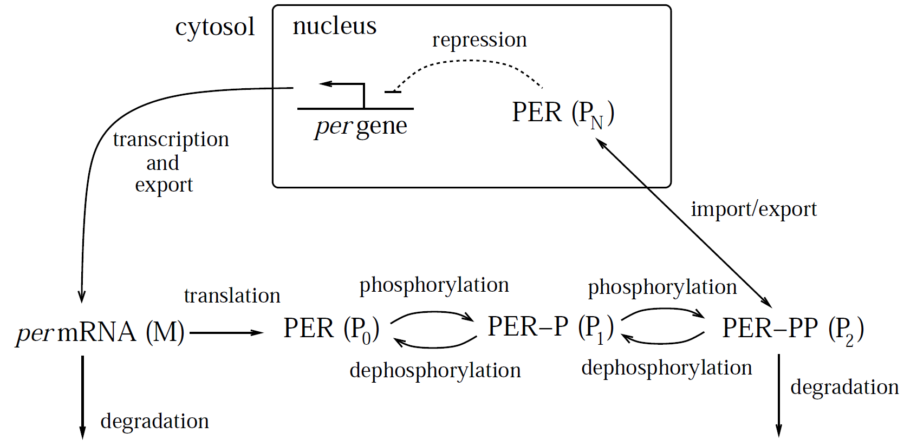

*Goldbeter''s circadian oscillator model. (The dashed blunted arrow indicates repression.) The*

*per gene is transcribed in the nucleus; per mRNA (M) is exported to the cytosol, where is it translated and is subject to degradation. PER protein (P0) is activated by two reversible rounds of phosphorylation. Active PER (P2) is subject to degradation, and can cross the nuclear membrane. Once in the nucleus, PER (PN) represses transcription of the per gene. Delay oscillations arise from the combination of autoinhibitory feedback, nonlinear repression kinetics, and delay.*

Using lowercase letters to denote concentrations, and a quasi-steady state (Michaelis-Menten) approximation for the enzymatic reactions, Goldbeter's model takes the form:

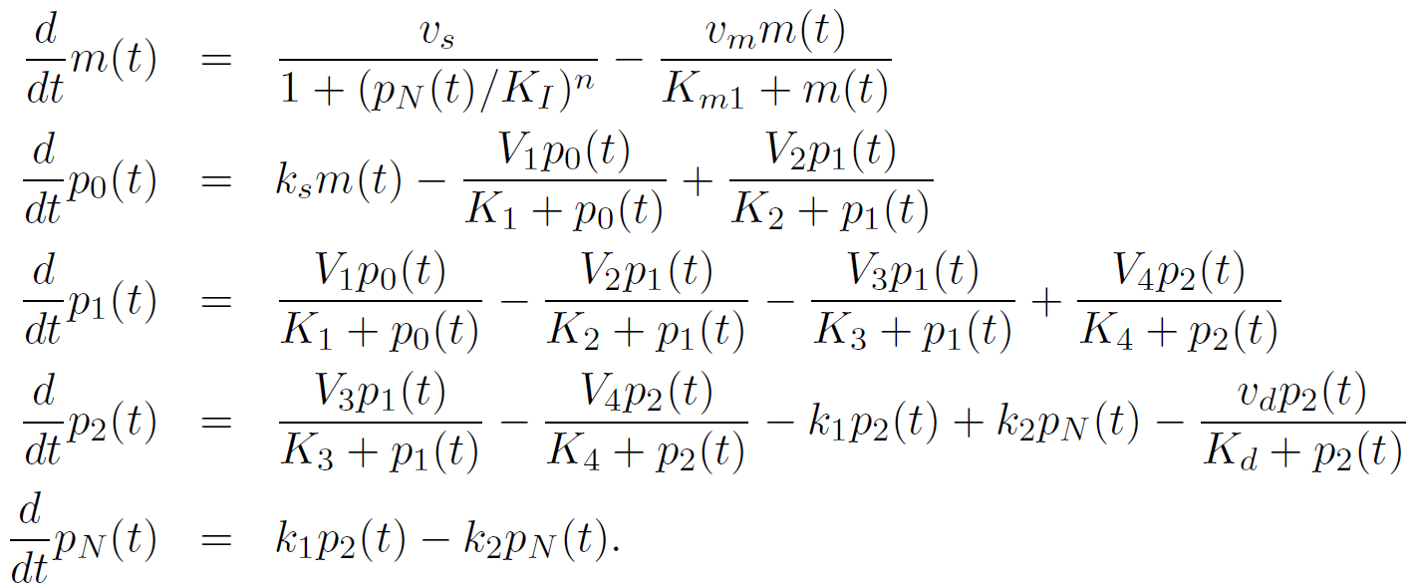

The model is based on first-order kinetics for transport across the nuclear membrane, and Michaelis-Menten kinetics for the degradation and phosphorylation/dephosphorylation processes. Transcription and export of mRNA are lumped into a single process, which is cooperatively repressed by PN with Hill coefficient n. This model only exhibits oscillatory behaviour if the repression kinetics is sufficiently nonlinear. Goldbeter carried out his analysis with n =4; he

found that the model can exhibit oscillations with n = 2 or even n = 1, but only under restrictive

conditions on the other parameter values.

The oscillatory behaviour of the model is illustrated in the Figure below. Panel A shows the periodic behaviour of per mRNA, total PER protein, and nuclear PER protein. The period is very roughly 24 hours, and the mRNA peak precedes the total PER peak by about 4 hours. This behaviour is consistent with experimental observation, but does not provide direct validation of the model, because Goldbeter chose parameter values to arrive at this behaviour. Nevertheless, the model represented a valuable hypothesis as to how circadian rhythms could be generated by the activity of the per gene.

Goldbeter used the model to explore possible mechanisms for the effects of the short-and

long-period per mutations. To explore the hypothesis that these mutations affect the rate of PER

degradation, he determined the effect of changes in the maximal PER degradation rate (v_d) on the oscillation period. His findings, reproduced in Panel B, show that as v_d varies (between 0.45 and 2.6 μM/hr), the period ranges between 20 and 62 hours (beyond this range. the oscillations are lost). The mutant periods fall roughly into this range, indicating that alterations in the protein degradation rate could be the cause of the observed changes.

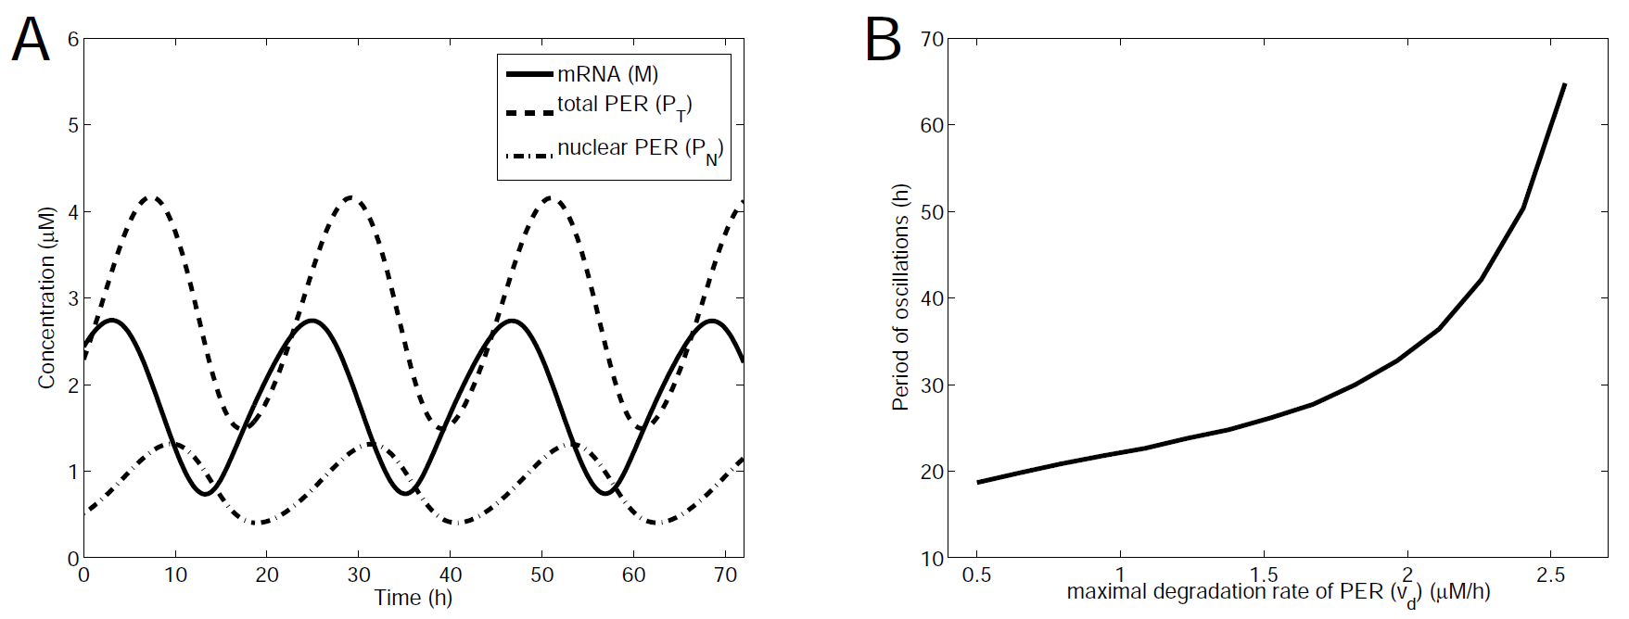

*Behavior of the Goldbeter circadian oscillator model.*

*A. The simulated concentrations of mRNA(m), total PER protein (pT = p0 +p1 +p2 +pN), and nuclear PER protein(pN). The period of the oscillation is about 24 hours, with a lag of about 4 hours between the peak in mRNA and protein levels.*

*B. This continuation diagram shows the effect of changes in the maximal PER degradation rate (vd) on the oscillation period. Within the range over which oscillations occur, the period ranges from about 20 to more than 60 hours. Parameter values are v_s = 0.76 μM/h, v_m = 0.65 μM/h, v_d = 0.95 μM/h, k_s = 0.38 h^-1, k1 = 1.9h^-1, k_2 = 1.3 h^-1, V_1 = 3.2 μM/h, V_2 = 1.58 μM/h, V_3 =5 μM/h, V_4 = 2.5 μM/h, K_1 = K2 = K3 = K4 =1 μM, K_I = 1 μM, K_m1 =0.5 μM, K_d =0.2 μM, n = 4.*

PROBLEMS (use the script *circadian_drosophila_goldbeter.m* )

1. Using the parameter values in the Figure, run a simulation of the model. Print your plot.

(Note: the solution is computed from time -50 to time Tend=200, but only displayed for 3 days. The reason that the simulation is starter at t=-50 is to give it time to reach the periodic orbit by time t=0.)

Answer this question: the period is not quite 24hr, but a bit less. Approximately how long is the period? (I found that changing the “axis” command to

axis([0 24 0 6])

helps to see it better.) Give your answer the closest hour (24hr, 21hr, etc).

ANS: about 22hr

2. The oscillatory behaviour of this model is crucially dependent on the level of cooperativity.

Change n to 2, and simulate with Tend=400 (to analyze longer-term behavior). Plot with

axis([0 400 0 6])   
  
and print your plot. Oscillations are now damped.

ANS:

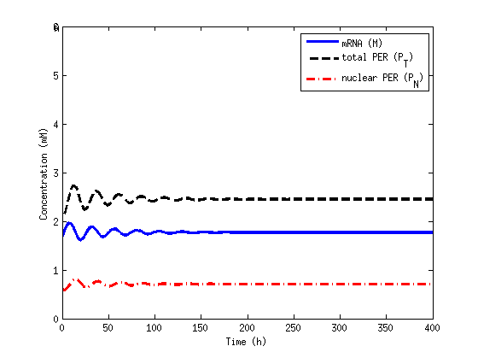

END ANS

3. Now change n to 3 and again plot from t=0 to t=400. Print. What can you say about the period, compared to the case n=4? What about the amplitude of total PER?

ANS:

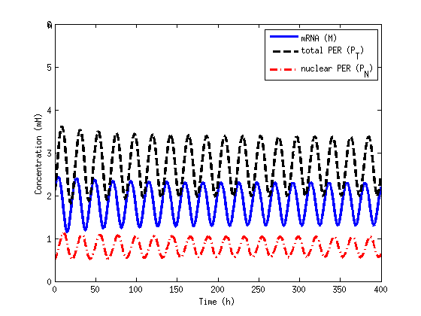

period seems about the same, about 22hr, but amplitude is a bit smaller.

Additional problems, not assigned:

(Delays.) Modify the model so that the two phosphorylation steps are replaced by an explicit delay.What size delay is required to recover circadian (24-hour) oscillations?

(Period changes) Returning to the original model formulation, verify Goldbeter’s finding that the period can be shortened or lengthened by mutations to the per gene that affect the protein’s degradation rate. Suggest an alternative effect of the mutation in the per gene that could also lead to changes in the period of the oscillation. Verify your conjecture by running simulations.

(TIM.) In the years since Goldbeter's model was published, additional experiments have led to a better understanding of the circadian clock in Drosophila. In addition to the PER protein, the circadian network in Drosophila also involves a protein called TIM (for ‘timeless’), expressed from the gene tim. John Tyson and colleagues published a simple model that incorporates the interaction between PER and TIM in:

*Tyson, J. J., Hong, C. I., Thron, C. D., & Novak, B. (1999). A simple model of circadian rhythms  
based on dimerization and proteolysis of PER and TIM. Biophysical Journal, 77 (1999), 2411–  
2417*

In their model, PER proteins form homodimers. These dimers then associate with two molecules of TIM into a PER2-TIM2 complex. These complexes migrate to the nucleus, where they inhibit expression of both PER and TIM. Degradation of both TIM and PER is constitutive, but PER is protected from degradation when in dimer form.

a) Draw an interaction diagram describing the mechanism.

b) Verify that this mechanism can explain the following experimental observations:

i) Cells that lack the tim gene do not exhibit oscillatory behaviour.

ii) Circadian oscillations can be entrained to follow 24 hour light-dark cycles. Exposure to light

enhances degradation of TIM.

c) Develop a differential equation model of this system. Describe the features of your model

that could enable oscillatory behaviour. You may want to make use of the following reasonable

assumptions: (i) mRNA dynamics occur quickly; (ii) dimerization events occur quickly; (iii) PER

and TIM concentrations follow similar time-courses and so the two species can be lumped into a

single protein pool. As verified by Tyson and colleagues, a satisfactory model can involve as few as three state variables.