**The Goodwin oscillator**

In 1965, Brian Goodwin proposed a generic model of an oscillatory genetic circuit in:

*Goodwin,B.C.(1965). Oscillatory behavior in enzymatic control processes. Advances in Enzyme   
Regulation, 3, 425–428.*The model, sketched below, involves a single gene.

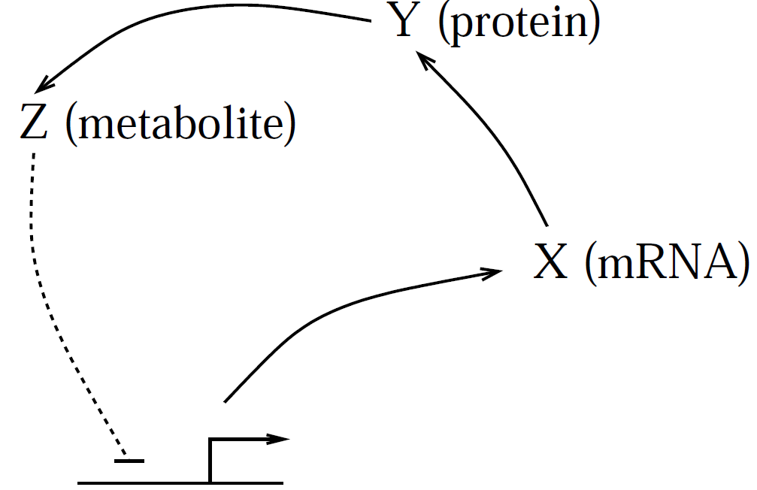

*The Goodwin oscillator. (The dashed blunted arrow indicates repression.)*

*The mRNA(X) is translated into an enzyme(Y), which catalyses production of a metabolite (Z), which (indirectly) represses gene expression. This negative feedback, coupled with the delay inherent in the three-step loop, can result in oscillatory behavior.*

The mRNA, X, is translated into enzyme Y , which catalyses production of metabolite Z, which causes inhibition of expression (by activating an unmodeled repressor). Neglecting the specifics of catalysis and inhibition, Goodwin formulated the model in terms of concentrations x, y and z as:

The model was not meant to describe a particular system; it was constructed to demonstrate how persistent oscillations could be generated by an autoinhibitory gene circuit. Goodwin included three states in the model to impose sufficient delay in the negative feedback loop.

Oscillations can arise from negative feedback if the effect of the feedback is delayed and if there is sufficient nonlinearity in the loop. Indeed, a two-state model that arises from applying the quasi-steady state assumption to the Goodwin model cannot exhibit sustained oscillations, as verified by J. S. Griffith in:

Griffith, J.S.(1968). Mathematics of cellular control processes I. Negative feedback to one gene.   
Journal of Theoretical Biology, 20, 202–208.

Even with three steps providing a lag in the feedback, a high degree of nonlinearity is required

to generate limit-cycle oscillations in this model. In his paper, Griffith showed that the system

cannot exhibit sustained oscillations unless the Hill coefficient *n* is higher than eight, and even

then, oscillations only occur for certain values of the other parameters.

The system's oscillatory behaviour is shown in the Figure below.

The mechanism of oscillations is apparent in Panel A. In each cycle, the mRNA concentration rises, followed by a rise in enzyme concentration, and then a rise in metabolite concentration. The rise in z causes a crash in x, which causes y and z to drop, allowing x to rise again. Panel B shows a three-dimensional phase portrait, confirming that the system trajectories all settle to a periodic (limit cycle) behaviour.

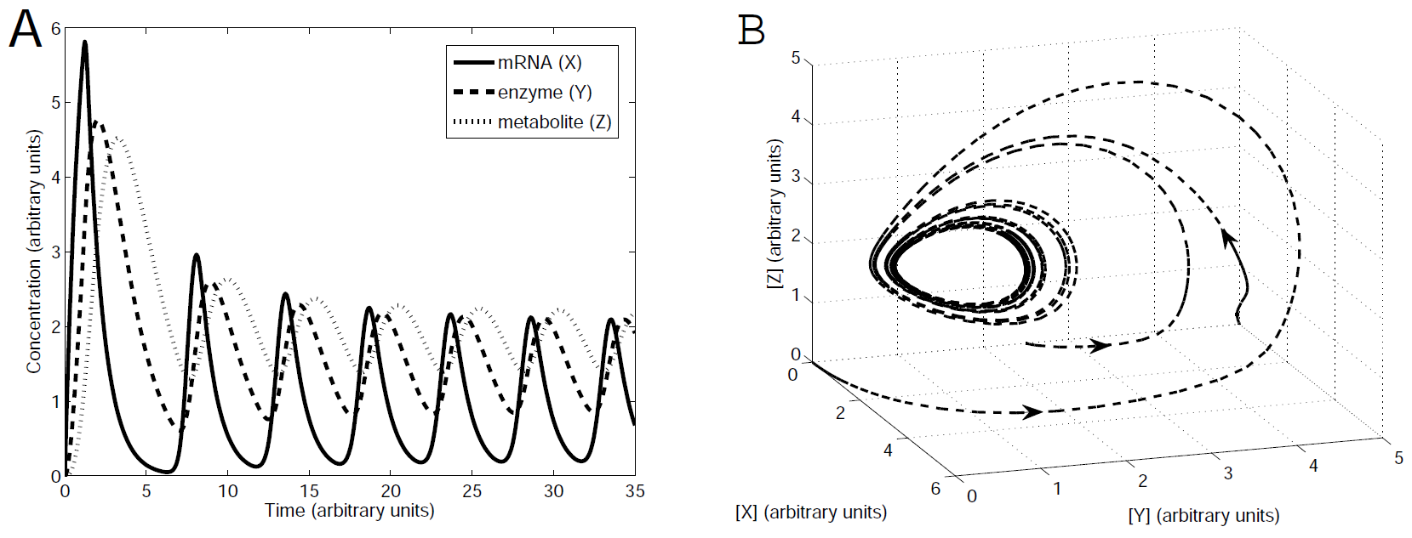

*The Goodwin oscillator.*

*A. This simulation shows relaxation to sustained (limit cycle) oscillations.*

*B. A phase portrait showing convergence to a limit cycle in the three-dimensional phase space. Parameter values are a = 360 (concentration . time^-1), k = 1.368 (concentration), b = 1 (time^-1),* α *= 1 (time^-1),* β *= 0.6 (time^-1),* 𝜸 *= 1 (time^-1),* δ *= 0.8 (time^-1), n = 12. Units are arbitrary.*

Goodwin offered multiple interpretations of his model. In addition to the description given here (X is mRNA, Y is enzyme, Z is metabolite), he also suggested that the model could

be used to describe the following feedback loops:

a) X is nuclear mRNA, Y is cytoplasmic mRNA, Z is protein product;

b) X is mRNA, Y is inactive protein product, Z is active protein product;

PROBLEM: (Use the script *goodwin_oscillator.m* )

This system exhibits limit-cycle oscillations provided the Hill coefficient n is sufficiently large.

Unfortunately, for reasonable choices of the other parameter values, n has to be chosen very high to ensure oscillatory behaviour. Modifications that generate oscillations with smaller Hill

coefficients are shown below. (In exploring these models, make sure simulations run for sufficiently long that the asymptotic behaviour is clear.)

a) Taking parameter values as in the Figure, verify that there are no oscillations if we modify n to n = 7. Print the plot.

b) Replace the term for degradation of Z by a Michaelis-Menten term:

Verify that this modified system oscillates even with no cooperativity (i.e. with n = 1).

Take a = 150, k = 1, b = α = β = 𝜸 = 0.2, δ = 15, and K_M = 1. (You need to plot to Tend=500 to clearly see the oscillations.)

Notice: because the variables in the program are written a little differently (“kappa1” is what we call k, and ‘k1’ is 1), you should use:

a1=150;

kappa1=1;

k1=1;

b1=0.2;

alpha1=0.2;

beta1=0.2;

gamma1=0.2;

delta1=15;

besides changing n and Tend.

Optional problem (not to be handed-in):

Taking parameter values as in the original Figure, modify the model by adding a fourth step to the

activation cascade. (Use dynamics identical to the third step.) Verify that the additional lag

introduced by this fourth component allows the system to exhibit sustained oscillations with n = 6.

The conclusion from these problems is that either high cooperativity in the feedback, additional steps that cannot be ignored, or some other phenomenon such as degradation by an enzyme that is not too abundant, is required for oscillations. Thus, if oscillations are observed, one has a hint that some such mechanism may be acting.