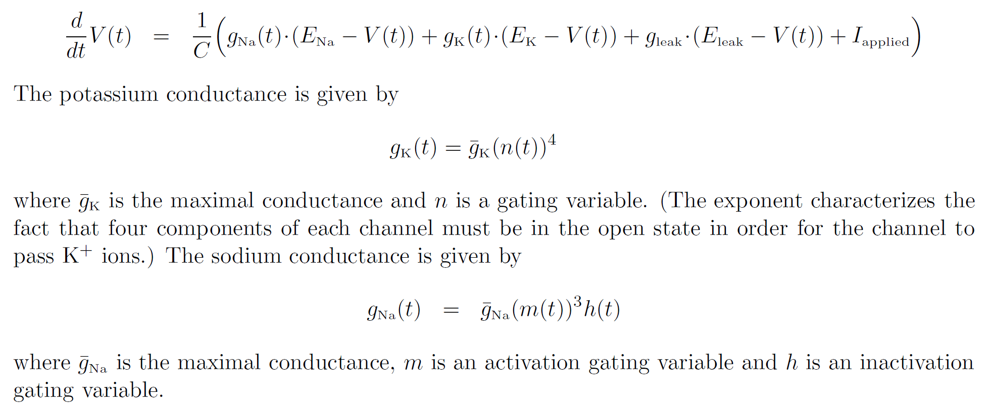

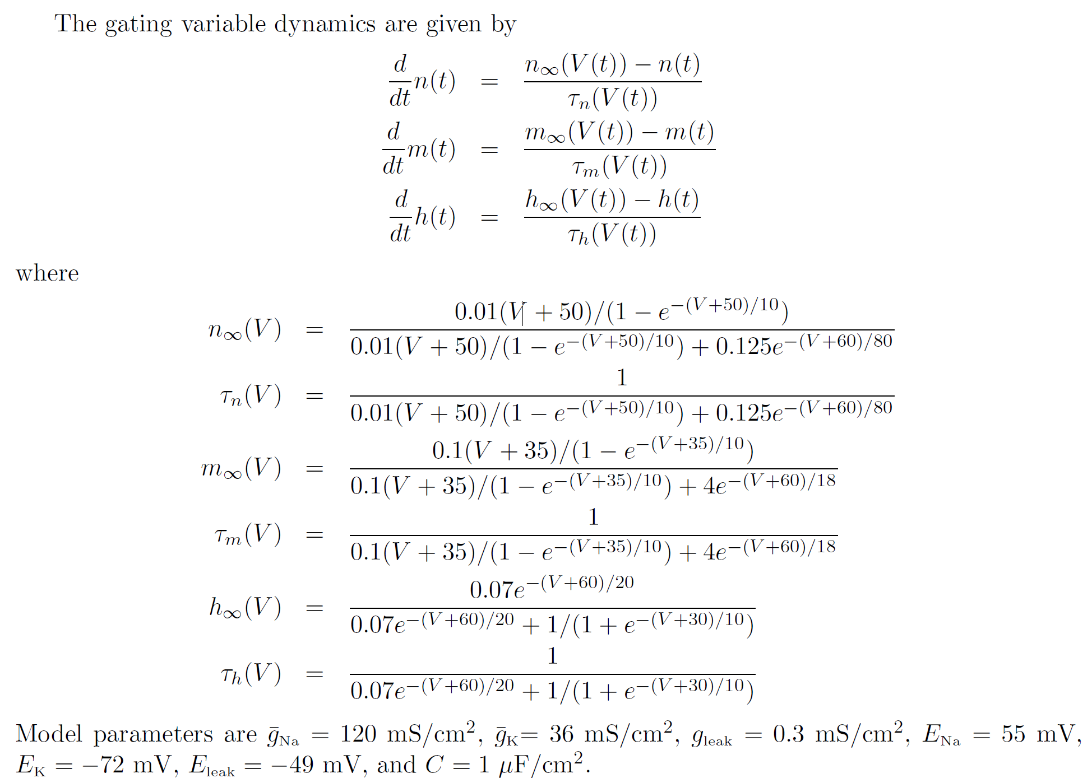

PROBLEMS:

a) Simulate the system with the given parameter values, using the MATLAB script

*hodgkin_huxley.m*

Print the plot.

b) Answer these questions, looking at the code for the MATLAB script, and at the plot:

i) For how long an interval, and at which two times, is the current I_applied being applied?

ii) What is the difference between the two pulses (besides their being applied at different times, obviously)?

ii) How did the system react to each of the two pulses?

c) Generate plots of m and h (on the same plot), using these commands in the MATLAB file, after the current figure:

figure(2)

set(gca,'fontsize',14)

plot(t,s(:,2), t,s(:,3), 'Linewidth', 2)

legend('m','h')

and print your answer.

This verifies that m(t) and h(t) tend to “cancel each other out” through most of the process (except during a spike!).

d) Now add this code, which generates plots for the sodium and potassium currents (I used the range 3800:4200 to focus on the part of the plot where the action potential happened):

figure(3)

I_Na = g_N_bar*(s(:,1)-E_N).*s(:,2).^3.*s(:,3);

I_K = g_K_bar*(s(:,1)-E_K).*s(:,4).^4;

figure(3)

set(gca,'fontsize',14)

plot(t(3800:4200),I_Na(3800:4200),t(3800:4200),I_K(3800:4200),'Linewidth',2)

legend('Na current, K current')

Plot and print.

Observe that the action potential begins with a sodium influx, followed by the flow of potassium out of the cell. (This is seen in the delay in changes between the blue and green lines.)