**Pymaceuticals Analysis**

**Background:** A study was conducted to see how certain drugs would help with fighting squamous cell carcinoma, a common skin cancer. Two hundred and fifty mice were given a specific drug regime over the course of 45 days. The drugs include Capomulin, Infubinol, Ketapril, and Placebo.

**Graphical Data Analysis and Observable Trends:**

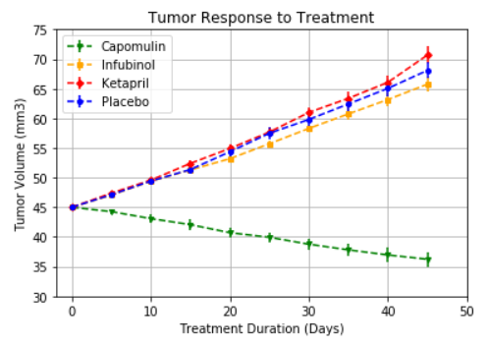

Over the course of 45 days, only the Capomulin drug regime had a decrease in tumor volume on the mice. The Infubinol, Ketapril, and Placebo drug regime all resulted in an increase in tumor volume or at least had no positive effect on tumor volume.

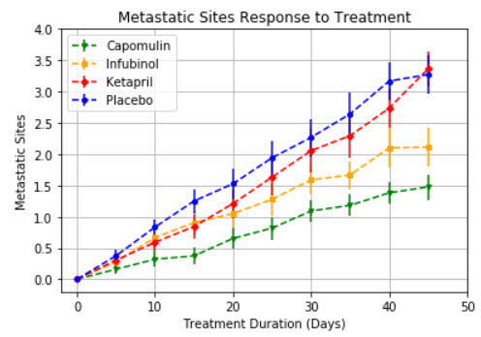

All drug regimes had a slightly positive effect on slowing down the increase of metastatic sites; however, it is good to note that the Capomulin drug regime resulted in the least amount of metastatic site growth since the regime was also the only one that resulted in a decrease in tumor volume.

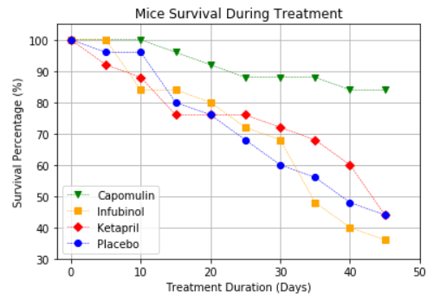

None of the drugs cured squamous cell carcinoma; however, the Capomulin drug regime did result in the least amount of mice death over the 45 day experiment with a survival percentage of 85%. All the other drugs resulted in over half the mice dying.