# Manufacturing Steps

The product consists of two main parts; the touchscreen and the button box. As the touchscreen is purchased, little manufacturing is required but some assembly still is needed.

Hardware

* Official Raspberry Pi Touchscreen Display with Stand
* Raspberry Pi 2.0 with microSD card
* 5V 2A micro-USB power connector
* Keyboard and mouse
* PCB with 4 10kΩ resistors and multi-strand wire.
* 3mm Adhesive mounting pillars
* 4 Arcade Buttons
* GPIO Shroud header
* 40 pin ribbon cable with headers
* 125x125x45 ABS case
* Micro-USB to USB cable

Start by assembling the Official touchscreen using the instructions supplied with the product. Mount the Raspberry Pi using the supplied screws, ensuring it is securely attached.

Button Box

1. Create the PCB for the GPIO connections and buttons.
2. Drill the holes for the components (0.5mm) and the mounting holes (3mm)
3. Get the purchased 125x125x45 case and mark out the holes to be drilled. 4 holes are required of 33mm diameter each. They should be positioned with equal spacing to each other.
4. Drill small pilot holes in the case and slowly enlarge them using larger drill bits or other suitable object until all 4 holes are 33mm in diameter.
5. File a 1mm gap for the ribbon cable to exit the case so that the lid can close flush.
6. Solder in the GPIO shroud header and the resistors.
7. Solder wire to the legs of the switches.
8. Insert the buttons into the case
9. Solder the wire from the buttons to the PCB.
10. Insert the mounting pillars and attach the PCB to the case.
11. Run the ribbon cable out of the case and shut the lid and screw it in.

Then attach the ribbon cable to the Raspberry Pi on the back of the touchscreen and the product is complete. Plug in the power and follow the instructions to get the game set up.

# Product images

|  |  |
| --- | --- |
| PCB design mask | C:\Users\Daniel\OneDrive\Pictures\Camera Roll\IMG_20170111_171053744.jpg  PCB with header pins and resistors added |

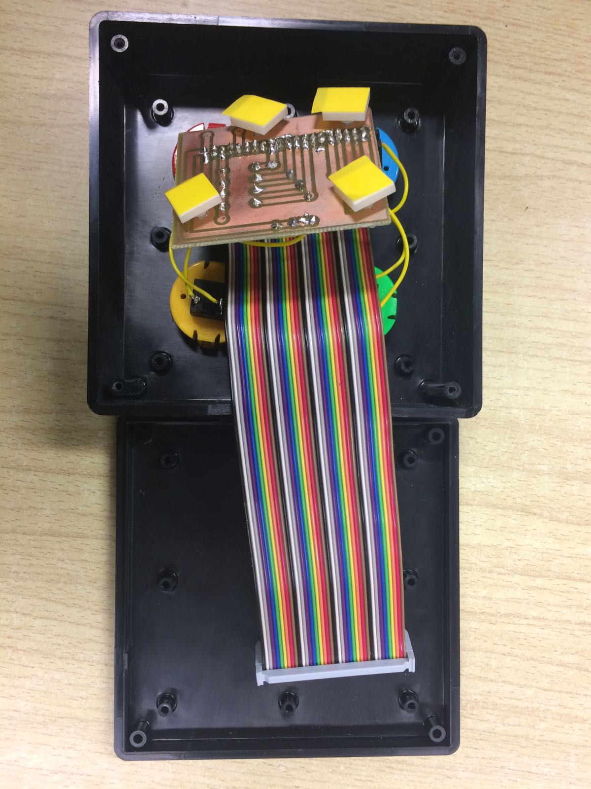

PCB and connections inside case