**PiRight**

# Basic Usage Instructions

1. Attach the ribbon cable from the button box to the Raspberry Pi. The cable should come flat out of the button box and bend over to attach to the Pi, as shown above. Make sure the connector is pushed flush to the board.

2. Plug in the micro-USB power cable to the input located on the lower board. Please note a 2A power cable is required for the system to operate properly. Turn on the power supply and the Pi will boot up into the program.

# Teacher Mode Instructions

1. Plug a keyboard into one of the available USB ports located on the Raspberry Pi.
2. Within the program, touch the ‘Teacher Mode’ symbol. You will be prompted for a password. The password has been set to ‘raspberry’.
3. You will be presented with several options:

A

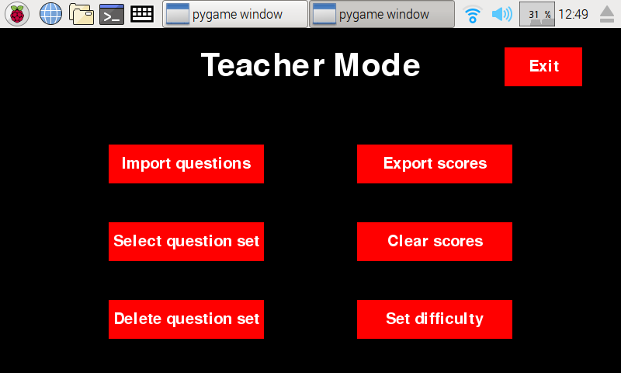

G

F

E

D

C.

B

* 1. ‘Import Questions’ – Will open a file browser that will allow you to find and locate custom made .csv files of questions and import them to the Pi.
  2. ‘Export Scores’ – Will open a file browser that will allow you to choose a location, such as a USB, to save the scores to for external use.
  3. ‘Select question set’ – Opens a file browser that will allows you to choose the questions that will be asked when the student presses play on the main screen.
  4. ‘Clear scores’ – Deletes all previous saved scores and names from the Raspberry Pi. Confirmation will be required before scores are erased to prevent accidental wipes.
  5. ‘Delete question set’ – Opens a file browser that allows you to choose a set of questions to delete. Confirmation will be required before they are erased.
  6. ‘Set difficulty’ – allows you to set the speed of the game, on a scale from 1 (slow) to 5 (fast).
  7. ‘Exit’ – Exits teacher mode and returns to the main screen.

Adding Custom Questions

Open ‘template.csv’ which can be found on the GitHub page. Instructions for how to use the spreadsheet are located at the top of the columns. Once you have entered your desired questions, save the spreadsheet and change the name so that your question set can be identified (make sure it is still saved as a .csv file). Move the file to a USB drive which can then be removed and plugged into the Pi. Then enter Teacher Mode, and select import questions. Locate the questions on your USB drive and import them.

# First Time Setup

For the first time using and assembling the kit, please see below.

1. Set up your Raspberry Pi using the latest version of Raspbian, or use a pre-flashed SD card. More information is available at [www.raspberrypi.org/learning/software-guide/](http://www.raspberrypi.org/learning/software-guide/).
2. Update the Pi using ‘*sudo apt-get update’* and ‘*sudo apt-get dist-upgrade’*
3. Download the latest PiRight software from the Github repository by entering the following in the terminal.
   1. ‘git clone <https://github.com/danielchriscarter/PiRight>’
   2. ‘cd PiRight’
   3. ‘sudo ./installDependancies.sh’

These commands (especially the last) may take a while – please be patient.

1. 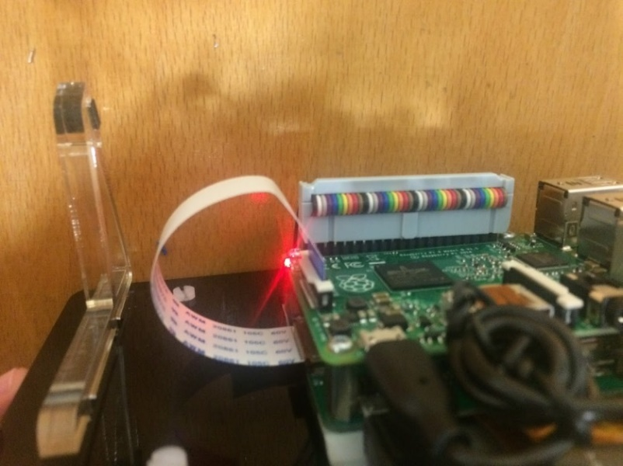Shut down the Pi before continuing.
2. Assemble the touchscreen monitor using the supplied instructions.
3. Using the supplied DSI cable (see picture on right), connect the raspberry Pi to the monitor board.
4. Mount the raspberry pi to the touchscreen using the supplied screws.
5. Use the USB to micro-USB cable provided to bridge power between the two boards. The micro-USB is plugged into the power input of the Pi, and the USB is plugged into the power output of the monitor board.
6. Connect the ribbon cable and power supply, and boot up the Pi.