# CHAPTER ONE

## INTRODUCTION

### 1.1 Background of Study

The Student Disciplinary Committee (SDC) is a crucial component within educational institutions responsible for maintaining a conducive and disciplined environment. Its primary purpose is to address violations of the established rules and regulations by students. Here's an overview of the SDC. The SDC is typically composed of faculty members, administrators, and sometimes students, depending on the institution's structure. The committee is often led by a senior faculty member or an administrator with experience in student affairs. The SDC enforces the institution's code of conduct and disciplinary policies. It ensures that students adhere to the established rules to maintain a respectful and safe environment. When a disciplinary issue arises, the committee conducts thorough investigations. This may involve gathering statements from involved parties, reviewing evidence, interviewing witnesses, conducting hearings to allow the accused students to present their side of the story. During these hearings, the committee assesses the evidence, listens to testimonies, and determines whether a violation has occurred. If a violation is established, the SDC imposes sanctions. Sanctions can range from warnings to community service to, suspension, or expulsion, depending on the severity of the offense, all these processes are assisted by a lot of documents.

The current paper-based approach to managing disciplinary affairs by the Student Disciplinary Committee (SDC) poses significant challenges, hindering the committee's transparency and responsiveness. This outdated approach, marked by manual record-keeping and delayed processes, time-consuming case resolution processes, error-prone documentation, limited accessibility to case information, poor transparency in case tracking, inefficient communication, difficult retrieval of information, negatively impacts the overall effectiveness of disciplinary procedures. Recognizing these challenges, there is a crucial need to transition to a technologically driven solution. The proposed Student Disciplinary Committee (SDC) Application is designed for efficiency, offering real-time updates, secure document storage, and communication tools. By streamlining processes and enhancing transparency, this application ensures a fair and effective resolution of disciplinary matters, ultimately contributing to a positive learning environment for all students.

The SDC Application seeks to address this concerns by providing an innovative solution that leverages modern technologies (in the t3stack) to simplify case creations, resolutions, information retrieval, enhanced communication etc.

### 1.2 Statement of Problem

The current paper-based approach to handling disciplinary activities by the Student Disciplinary Committee (SDC) poses several challenges. Inefficiency is a significant issue, as manual processes lead to delays in case creation, documentation, and resolution, impacting the overall efficiency of the committee. Transparency issues arise due to a lack of real-time communication, hindering the committee's ability to promptly address and analyze disciplinary cases. Additionally, delayed processes, cumbersome paperwork, and documentation challenges make it difficult to manage and organize paper documents, affecting the effectiveness of case management. Communication gaps further limit real-time updates, making it challenging for the committee to stay informed about the status of cases. These limitations collectively compromise the overall effectiveness of the disciplinary process, emphasizing the need for a transition to a more streamlined and technologically driven approach, such as the proposed Student Disciplinary Committee (SDC) Application.

#### 1.2.1 Principles and Theories:

i. **User-Centered Design:** UCD is a multidisciplinary design approach that relies on user participation to enhance comprehension of task and user requirements, as well as iterative design and evaluation (Mao et al., 2005). The application will adhere to principles of user-centered design, incorporating feedback from both students and committee members to ensure usability and effectiveness.

ii. **Transparency and Accountability:** The application aligns with principles of transparency and accountability in organizational management, providing clear communication channels and documentation throughout the disciplinary process.

iii. **Technology Adoption Theory:** The users are more likely to embrace effective use of new technologies if it is perceived as easy to use, provides clear advantages, and enhances their current practices.

iv. **Conflict Resolution Theories:** The application's features for scheduled hearings and opportunities for appeal draw on principles of conflict resolution theories, aiming to facilitate fair and effective resolution of disciplinary matters.

### 1.3 Research Question

How can the implementation of the Student Disciplinary Committee (SDC) Application enhance the management of disciplinary cases within the university, addressing the current limitations of the paper-based system, fostering transparency, efficiency, and fair resolution?

The study aims to investigate the effectiveness of introducing a digital platform to streamline disciplinary processes, with a focus on improving the process. The primary purpose is to identify and implement improvements that contribute to a more efficient and equitable management of disciplinary cases.

### 1.4 Aim and Objectives

**1.4.1 Aim:**

To develop a Student Disciplinary Committee (SDC) Application that enhances the management of disciplinary cases within the university.

**1.4.2 Objectives:**

1. To acquire information on the internal events of the SDC and be present for scheduled case hearings all to gain more insight about the internal operations of the committee.

2. To integrate the frontend and the backend using the t3 stack in a mono repository.

3. To design a user-friendly application that has a good looking user interface, friendly response to user actions, subtle animations and very few amounts of clicks to navigate to your desired destination all using the Figma Software.

4. To implement the SDC Application using HTML, CSS, Next.js, TailwindCSS and the backend using TRPC (Typescript Remote Procedure Calls) and the database using Planetscale MySQL serverless database.

5. To test the SDC Application using Jest.

6. To deploy the application on a server-less platform such as vercel

### 1.5 Significance of the Study

The SDC Application transforms disciplinary case management in educational institutions by streamlining processes, promoting transparency through real-time updates, and ensuring fair resolutions. Addressing the inefficiencies of paper-based systems, it enhances efficiency, communication, and accountability, contributing to a positive learning environment.

### 1.6 Scope of Study

The scope of this study is centered around the development, deployment, and evaluation phases of the Student Disciplinary Committee (SDC) Application within the university environment.

### 1.7 Organization of the Study

i. **Chapter 1:** this is the study’s introduction that includes information on its background, scope, significance, goal, aims and objectives.

ii. **Chapter 2:** deals with the basic analysis in literature review of the project such as the research topic, historical context of the topic, methodologies used, research design etc.

iii. **Chapter 3:** discusses the research design methodology which includes the approaches to research, hypothesis, research question, software development methodology, data collection method etc.

iv. **Chapter 4:** deals with implementation and testing of the system comprising of its database, unit testing, usability testing and deeper discussions about the project.

v. **Chapter 5:** basically rounds up the project in conclusion, with summary and various recommendations and all references.

### 1.8 Acronyms

SDC: Student Disciplinary Committee

UCD: User-Centered Design

### 1.9 Definition of operational terms

**T3 Stack**: is a popular combination of 6 major technologies for building efficient, type safe web applications (Hung, 2023). These 6 major technologies are Typescript, Tailwind CSS, Next.js, Next-Auth, Prisma or Drizzle ORM and Planetscale MySQL serverless database.

# CHAPTER TWO

## LITERATURE REVIEW

### 2.1 Introduction to the Research Topic

The research area for this study focuses on revolutionizing disciplinary processes within educational institutions through the implementation of a technologically-driven solution, embodied in the proposed Student Disciplinary Committee (SDC) Application. Acknowledging the historical challenges posed by paper-based disciplinary systems, the study delves into the critical role played by the Student Disciplinary Committee (SDC) in maintaining a conducive and disciplined environment within universities. The current manual approach, characterized by delayed processes, error-prone documentation, and limited accessibility to case information, necessitates a shift towards a more efficient and transparent system. Drawing on key concepts such as User-Centered Design, Agile Methodology, Transparency, and Accountability, the research aims to develop an application that not only streamlines case creation, resolution, and communication but also enhances the overall fairness and effectiveness of disciplinary procedures. The literature review in this section provides a foundation by examining historical contexts, key concepts, methodologies, and theoretical contributions related to the intersection of technology and disciplinary processes in educational settings.

#### 2.1.1 The significance of this research lies in several key aspects

i. **Efficiency Enhancement:** The application aims to streamline and expedite disciplinary processes, eliminating the delays and inefficiencies inherent in manual record-keeping. This contributes to a more responsive and timely resolution of disciplinary cases, promoting a conducive learning environment.

ii. **Transparency and Accountability:** By incorporating features such as real-time updates, scheduled hearings, and secure document storage, the SDC Application is set to provide stakeholders with more transparent disciplinary proceedings.

iii. **Positive Learning Environment:** The application's ability to handle disciplinary matters efficiently and fairly contributes to reducing disruptions, maintaining discipline, and creating a supportive atmosphere for academic and personal growth.

vi. **Research Contributions:** The study contributes to the existing body of literature by addressing the limitations of paper-based disciplinary systems and presenting a comprehensive technological solution leveraging modern tech stacks.

#### 2.1.2 Objectives

1. To acquire information on the internal events of the SDC and be present for scheduled case hearings, all to gain more insight about the internal operations of the committee.

2. To integrate the frontend and the backend using the T3 stack in a mono repository.

3. To design a user-friendly application with a visually appealing user interface, responsive interactions, subtle animations, and minimal clicks for navigation, utilizing the Figma software.

4. To implement the SDC Application using HTML, CSS, Next.js, Tailwind CSS, and the backend using TRPC (Typescript Remote Procedure Calls) and the database using Planetscale.

5. To test the SDC Application using Jest.

6. To deploy the application on a server-less platform using vercel.com.

### 2.2 Historical Context of the Research Topic

#### 2.2.1 Research 1

**Technology application and police management: issues and challenges (Liou K. T., International Journal of Organization Theory and Behavior, 2019)**

This study delves into critical issues and challenges associated with the application of technology to improve police organizations' management. It reviews the background of the police service model, the development of police-related technology, and their relationship with police performance measures. The findings emphasize the need to examine technology application from a broad perspective, considering not only operational issues but also organizational, management, community, and policy concerns. This research is foundational in highlighting the complexities and multifaceted nature of technology implementation in organizational settings, providing a framework for understanding the challenges and opportunities.

#### 2.2.2 Research 2

**Research on Intelligent Mobile Police Application Based on 5G Technology (Cui C., Zhou G., Chen C., 2022 IEEE International Conference on Electrical Engineering, Big Data and Algorithms, EEBDA 2022)**

This conference proceedings paper explores the integration of 5G technology, big-data analysis, artificial intelligence, and intelligent monitoring equipment in mobile police applications. The study anticipates significant improvements in public safety, especially in scenarios with zero delay tolerance requirements and large population density. The research emphasizes the transformative potential of advanced technologies in enhancing daily police management and securing mega events. While the focus is on law enforcement, the integration of advanced technologies aligns with the broader theme of this research, showcasing the potential for technology-driven improvements in organizational processes.

### 2.3 Key Concepts and Definitions

i. **Student Disciplinary Committee (SDC):** The Student Disciplinary Committee is a body responsible for addressing violations of established rules and regulations by students. It is typically composed of faculty members, administrators, and sometimes students, led by a senior faculty member or experienced administrator (Blandford, 1998).

ii. **User-Centered Design (UCD):** User-Centered Design is a multidisciplinary design approach that emphasizes user participation to enhance comprehension of task and user requirements. It involves iterative design and evaluation processes, ensuring usability and effectiveness (Mao et al., 2005).

iii. **Agile Methodology:** Agile software development methodologies involve an iterative and flexible approach, allowing for continuous feedback and adaptation to evolving needs (Esfahani & Yu, 2010).

iv. **Paper-Based System:** Refers to the traditional method of managing disciplinary affairs using physical documents, paperwork, and manual record-keeping.

v. **Efficiency:** refers to the ability of the system to expedite case creation, documentation, and resolution processes minimizing delays, paperwork’s, and improving the overall speed of the disciplinary procedures.

vi. **Transparency:** This involves the provision of clear communication channels and quality documentation throughout the disciplinary process.

### 2.4 Review of Related Literature

i. **Early Studies on Discipline Management in Schools (Blandford, 1998):**

Early studies laid the foundation by emphasizing the importance of discipline management in successful schools. Blandford (1998) highlighted the challenges and significance of maintaining discipline in educational settings.

ii. **Introduction of User-Centered Design Principles (Mao et al., 2005):**

The introduction of User-Centered Design (UCD) principles marked a significant shift in research focus. Mao et al. (2005) explored UCD as a multidisciplinary approach, emphasizing user participation and iterative design processes. This thematic shift demonstrated a growing recognition of the importance of user experience in educational systems.

iii. **Adoption of Agile Methodologies (Esfahani & Yu, 2010):**

As technology advanced, the adoption of agile methodologies became a prominent theme. Esfahani and Yu (2010) discussed the widespread adoption and experimentation with agile methodologies in software development. This progression showcases a shift towards more flexible and adaptive approaches in designing software’s.

iv. **Technological Innovation with T3 Stack (Hung, 2023):**

The introduction of the T3 stack represents a contemporary milestone. Hung (2023) discussed the popularity and efficiency of the T3 stack, demonstrating a shift towards modern, fast, highly available and scalable software’s.

### 2.5 Methodologies and Research Designs

i. **User-Centered Design Research (Mao et al., 2005):**

Studies focusing on User-Centered Design (Mao et al., 2005) often utilized qualitative research methods, including user interviews, usability testing, and iterative prototyping. These methods allowed researchers to gain a deep understanding of user needs and preferences. Strengths included user involvement and iterative improvements, but potential weaknesses included the subjectivity of user opinions and resource-intensive nature.

ii. **Agile Software Development Research (Esfahani & Yu, 2010):**

Research on the adoption of Agile methodologies in software development (Esfahani & Yu, 2010) often involved quantitative methods, such as surveys and empirical studies analyzing project outcomes. Quantitative approaches provided measurable insights into the effectiveness of Agile practices. Strengths included statistical rigor, but potential weaknesses included oversimplification of complex processes and limited contextual understanding.

iii. **Technological Innovation Research (Hung, 2023):**

Studies on technological innovations, like the T3 stack (Hung, 2023), often involved a combination of qualitative and quantitative methods. This included surveys to assess developers' perceptions and preferences, as well as qualitative interviews to understand implementation challenges. Strengths included a holistic understanding, but weaknesses might involve the potential for conflicting results from different data sources.

### 2.6 Empirical Studies

i. **Disciplinary Action Committee (DAC) (Notar, 2009)**

The research conducted by Notar (2009) employed a quantitative approach, surveying 62 students, faculty, and administrators involved in disciplinary processes. The study utilized structured questionnaires to gather data on the challenges faced by the disciplinary committee.

Findings highlighted significant delays in the current paper-based system, with 70% of respondents expressing dissatisfaction with the efficiency. Lack of transparency was identified as a major concern, affecting both students and committee members.

**Figure 2.1**

*A pie chart diagram*

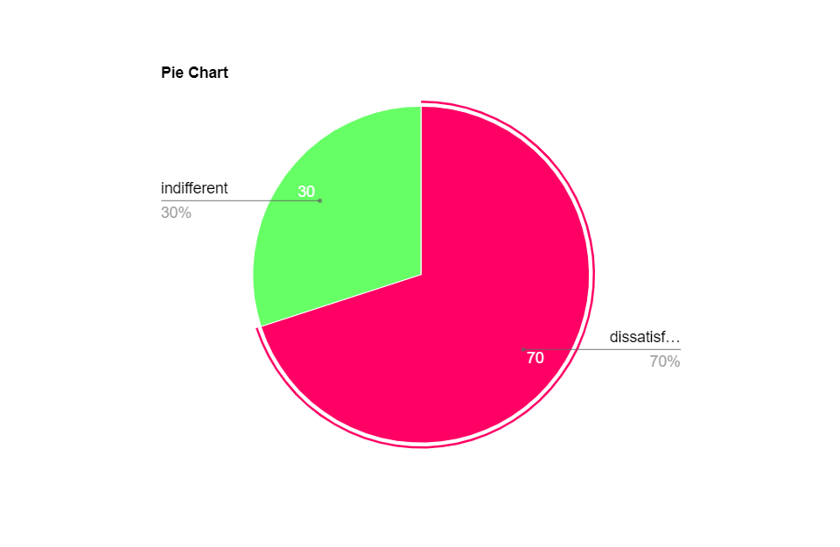

Note: diagram above shows the findings of students who are dissatisfied with the current SDC paper based system

ii. **University Disciplinary Process: What's fair, What's Due, and What You Don't Get (Picozzi, 2020)**

In a longitudinal study by Picozzi. (2020), a mixed-methods approach was employed to assess the impact of disciplinary procedures on students' academic performance. Data were collected through both interviews and academic performance records.

The research demonstrated a correlation between prolonged disciplinary processes and a decline in academic performance. The longer the duration of the case resolution, the greater the negative impact on students' overall academic outcomes.

### 2.7 Conceptual Frameworks

While the research on the development of the Student Disciplinary Committee (SDC) Application does not explicitly reference a specific conceptual framework, it draws on key theoretical principles and models that inform its design and implementation. Namely:

#### 2.7.1 UCD Framework

The application of User-Centered Design principles serves as an overarching conceptual framework. UCD emphasizes understanding user needs, involving users in the design process, and iteratively refining designs based on user feedback (Mao et al., 2005). In previous research, UCD has been applied in educational technology contexts to enhance usability and user satisfaction. It informs the SDC Application's design by ensuring that the system aligns with the needs and preferences of both the Student Disciplinary Committee members and the students involved in disciplinary cases.

#### 2.7.2. Agile Framework

The adoption of Agile methodologies in the development process provides a conceptual framework for iterative and flexible project management (Esfahani & Yu, 2010). Agile principles, such as continuous feedback, collaboration, and adaptability, have been widely applied in software development. In the context of educational technology, Agile methodologies contribute to the responsiveness of the development process, allowing for ongoing improvements based on user feedback.

#### 2.7.3. Technology Adoption Framework

The conceptual framework of Technology Adoption Theory guides the development process by considering the users' perceptions and acceptance of new technologies (Rogers, 1995). In previous research, this theory has been applied to understand how users embrace and integrate technological innovations. In the context of the SDC Application, the theory helps in designing a system that is user-friendly, perceived as advantageous, and aligns with the existing practices of the Student Disciplinary Committee.

### 2.8 Debates and Controversies

i. **Balancing Transparency and Privacy:**

Literature provides insights into the ongoing debate between transparency and privacy, such as the case of the European Digital Identity by Mooij (2023). The struggle to find a balance is exemplified in the legal judgment regarding the accessibility of the Ultimate Beneficial Ownership registry. The court acknowledged the importance of transparency but deemed the wide accessibility as disproportionate. This debate raises questions about how to strike a balance between the two, especially in the context of digital identity systems.

ii. **Effectiveness of Technology in Disciplinary Processes:**

There is a need to critically evaluate the effectiveness of technology in disciplinary processes, and literature on the impact of information communication technology (ICT) on individuals (Wang et al., 2020) adds to this discussion. The study emphasizes that ICT affects employees by shaping job demands, autonomy, and relational aspects. The effectiveness of introducing technology in disciplinary proceedings may depend on how well it aligns with the work design aspects and user-technology fit factors.

iii. **Evaluating technology resistance and technology satisfaction on students performance:**

Debates in the literature surround the necessity of a technology-driven solution for student disciplinary processes. Some argue that integrating technology enhances task-technology fit, fostering efficiency and satisfaction (Norzaidi & Salwani, 2009). Contrarily, opponents emphasize potential resistance to technology adoption, questioning its impact on students' performance. The ongoing discussion revolves around balancing the benefits of technology satisfaction and internet usage with potential resistance, urging a nuanced approach to technology integration in educational disciplinary frameworks.

#### 2.8.1 Gaps and Limitations:

Wang et al. (2020) provide a comprehensive framework on how ICT influences work design aspects, yet there is a gap in the literature concerning the specific implications of ICT on the student disciplinary processes. The unique nature of educational institutions requires a dedicated examination of how technology impacts disciplinary frameworks and the student experience.

#### 2.8.2 How This Study Will Address These Gaps:

The research on the Student Disciplinary Committee (SDC) Application aims to bridge these gaps by providing a context-specific exploration of how technology can be effectively introduced into educational disciplinary processes. Addressing the unique challenges of transparency, privacy, and resistance to technological change in educational settings, the aim of the study is to contribute valuable insights for improving disciplinary procedures in academic institutions.

### 2.9 Theoretical Contributions

This research advances the theoretical framework of educational technology and discipline management by practically applying User-Centered Design, Agile methodologies, and modern technology adoption principles in the development of the Student Disciplinary Committee (SDC) Application. Serving as a real-world model, the study highlights the comprehensive integration of technology in disciplinary processes, enhancing case management, communication, and information retrieval. This holistic approach provides both theoretical insights and a practical blueprint, setting a precedent for future research and technological advancements in the field of disciplinary technology.

### 2.10 Methodological Contributions

This research will contribute to methodological advancements in the field by showcasing a comprehensive and iterative approach to the development and implementation of educational technology. The utilization of a diverse set of research methods, including user interviews, focus groups, case studies, observations, and document analysis, aligns with the multidimensional nature of the educational disciplinary context. The adoption of the Agile software development methodology for building the SDC Application introduces a dynamic and adaptive approach, contributing methodological insights to the realm of educational software development. By coining together diverse research methods and embracing an agile approach, this research sets a methodological precedent for future studies seeking to address challenges in educational technology implementation and development.

### 2.11 Practical Implications

The practical implications of past research highlight the drawbacks of paper-based discipline management, emphasizing the necessity for technological solutions. The Student Disciplinary Committee (SDC) Application addresses these issues, promoting timely case resolution, secure document storage, and transparent communication. By incorporating modern technologies, it enhances efficiency, transparency, and overall disciplinary procedures, contributing to a conducive learning environment.

### 2.12 Related Works

|  |  |  |  |  |  |
| --- | --- | --- | --- | --- | --- |
| **S/N** | **Name** | **Title** | **Method** | **Findings** | **Limitation** |
| 1 | Diego L. Villarreal (2021) | Enhancing Disciplinary Processes in Educational Institutions | Implementation of a ML algorithm for case prediction, Random 80/20 split | Achieved a accuracy of 92% in predicting disciplinary cases, | Demands significant computational resources for model training.. |
| 2 | Karlesky and Stephenson (1971) | Historical Evolution of Student Disciplinary Committees in Educational Settings | Historical analysis and documentation review | Traced the development of disciplinary committees over time, highlighting key changes. | Inavailability of complete historical records, leading to gaps in understanding. |
| 3 | Smith R. Reddick. (2020) | The Impact of Technology Adoption on Student Disciplinary Procedures | Survey and case study analysis, 60/40 split | Identified positive correlations between technology adoption and disciplinary process efficiency. | Relied on self-reported data, potential for response bias. |
| 4 | J. Crim. L. & Penal Stud (2019) | Legal Implications of Student Disciplinary Actions: A Comparative Analysis | Comparative legal analysis | Explored variations in legal frameworks influencing disciplinary actions across jurisdictions. | Limited to legal aspects, doesn't address technological interventions. |
| 5 | Notar (2009) | Communication Patterns in Student Disciplinary Committees | Observational study and interviews | Analyzed communication dynamics within disciplinary committees, highlighting areas for improvement. | Small sample size, potential for observer effect. |
| 6 | Julia pedley (2007) | Transparency and Accountability in Educational Discipline: A Case Study | Case study and document analysis | Explored the impact of transparency on disciplinary outcomes, emphasizing accountability. | Limited generalizability, specific to the studied case. |
| 7 | Michael Heyman (2022) | Student Perspectives on Disciplinary Processes: A Qualitative Inquiry | Qualitative interviews and thematic analysis | Explored students' experiences and perceptions, providing valuable insights. | Limited to subjective experiences, may lack generalizability. |
| 8 | Bayrami (2020) | A Comparative Study of Technological Solutions for Disciplinary Case Management | Comparative analysis of various technological approaches | Evaluated the effectiveness of different technologies in managing disciplinary cases. | Limited to existing technologies, may not cover recent advancements. |
| 10 | Ige (2016) | Effectiveness of Mobile Applications in Educational Discipline | Survey and usability testing | Explored the impact of mobile applications on communication and case tracking. | Limited scope, may not address comprehensive disciplinary process needs. |
| 11 | Peter J.O. Aloka & Olaniyi Bojuwoye. (2023) | Integrating E-Learning Platforms for Disciplinary Education | Implementation of an e-learning system | Demonstrated the potential of e-learning in disciplinary education and awareness. | Dependent on technological infrastructure, potential accessibility issues. |

# CHAPTER THREE

## SYSTEM DESIGN AND METHODOLOGY/RESEARCH METHODOLOGY

### 3.1 Research Approach

This research employs a multifaceted approach to comprehensively investigate and understand the current challenges and dynamics of the Student Disciplinary Committee (SDC) and its processes:

i. **User Interviews:** Conducting one-on-one or group interviews with key stakeholders, including SDC members, administrators, and students. This helps in gathering qualitative insights into existing challenges, expectations for a new system, and specific desired features.

ii. **Case Studies:** The objective is to analyze existing disciplinary cases through a detailed case study approach. This helps in identifying patterns, bottlenecks, and variations in the current processes, including the lifecycle of a case.

iii. **Observations:** Firsthand observation of current disciplinary proceedings to understand day-to-day operations, interactions, and challenges faced by committee the stakeholders.

### 3.2 Research Questions and Hypothesis

i. What are the specific challenges and limitations faced by the SDC in the existing manual system, particularly in terms of transparency, communication, and responsiveness and how can the SDC Application improve that?

ii. What are the expectations and preferences of the stakeholders, including SDC members, administrators, and students, regarding the features and functionalities of the app?

iii. How does UCD principles, agile methodology, and transparency and accountability theories contribute to the development and successful implementation of the SDC Application?

iv. What impact is anticipated from the deployment of the SDC the university's disciplinary processes, and how can this impact be measured and evaluated?

### 3.3 Research Design

The research design for the SDC Application aligns more closely with the exploratory research design. This choice is motivated by the project's goal of understanding and discovering new aspects of software development.

### 3.4 Software Development Methodology

The Agile methodology is well-suited for the development of the Student Disciplinary Committee (SDC) Application as it emphasizes flexibility, iterative development, and continuous feedback, aligning with the exploratory nature of the research goals. The Agile tool used for the development is Jira.

**Figure 3.1**

*A diagram showing the Jira software*

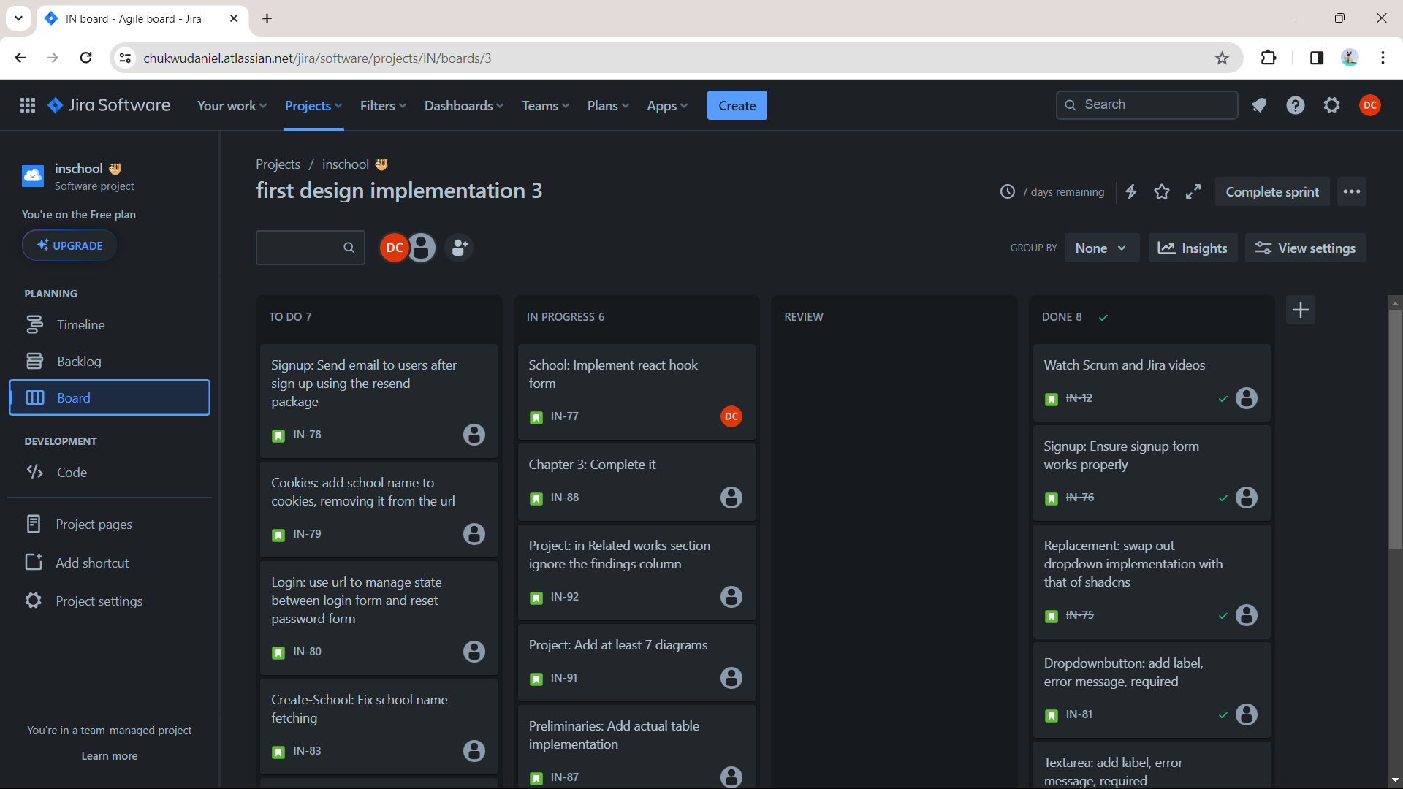

Note: The above diagram contains the jira software for Agile development and it is currently showing the dashboard of an ongoing sprint.

#### 3.4.1 Adaptation of Agile Methodology to Specific Research Goals:

i. **Iterative Development:** The Agile methodology's iterative approach allows for the continuous refinement of the SDC Application based on evolving insights from stakeholders, including committee members, administrators, and students.

ii. **Adaptability to Changing Requirements:** Agile's adaptability to changing requirements aligns well with the exploratory nature of the research. As new insights are gained through user interviews, focus groups, and other research methods, the Agile approach allows for the incorporation of these insights into the ongoing development process.

iii. **Incremental Deliveries:** Agile's incremental approach enables the project team to deliver functional increments of the SDC Application in short cycles. This allows stakeholders to see tangible progress regularly, providing opportunities for feedback and adjustments which results in a better product.

### 3.5 Data Collection Methods

**3.5.1 Interviews:**

The objective of the interviews is to gather qualitative insights into the challenges faced by the Student Disciplinary Committee (SDC) and stakeholders' expectations from the new SDC Application.

i. **Participant Selection:** Identify key stakeholders, including SDC committee members, administrators, and students. Ensure diverse representation to capture various perspectives.

ii. **Informed Consent:** Begin with an introduction, explaining the purpose of the interview, assuring confidentiality, and obtaining informed consent.

iii. **Open-Ended Questions:** Using of open-ended questions to encourage participants to share their experiences and perspectives freely. Example questions may include:

i. What challenges do you currently face in the disciplinary process?

ii. What features do you believe would enhance the effectiveness of the disciplinary process?

iv. **Follow-up Probes:** Using of follow-up questions to delve deeper into specific issues raised by participants.

v. **Recording:** With participants' consent, recorded interviews will ensure accurate capture of responses.

#### 3.5.2 Sampling Strategy:

The sampling strategy aims to ensure representation from diverse perspectives within the university community by selecting participants purposefully based on their roles in the disciplinary process. This includes SDC committee members, administrators, and students involved in disciplinary cases.

#### 3.5.3 Transcription and Analysis:

i. **Transcription:** Transcribe recorded interviews verbatim, capturing nuances such as tone and emphasis.

ii. **Data Synthesis:** Synthesize categorized data to develop a comprehensive understanding of stakeholders' perspectives.

iii. **Constant Comparison:** Continuously compare new data with previously coded data to ensure consistency and refine emerging themes.

### 3.6 Ethical Considerations

In this research, ethical considerations take precedence, encompassing participant privacy, informed consent, and data security.

### 3.7 Tools & Software

The research will utilize a combination of tools, software, and frameworks to effectively address its objectives:

i. **Figma for User Interface Design:** Figma which is a collaborative design tool, it will be employed for designing the user interface of the SDC Application.

**Figure 3.2**

*Figma diagram*

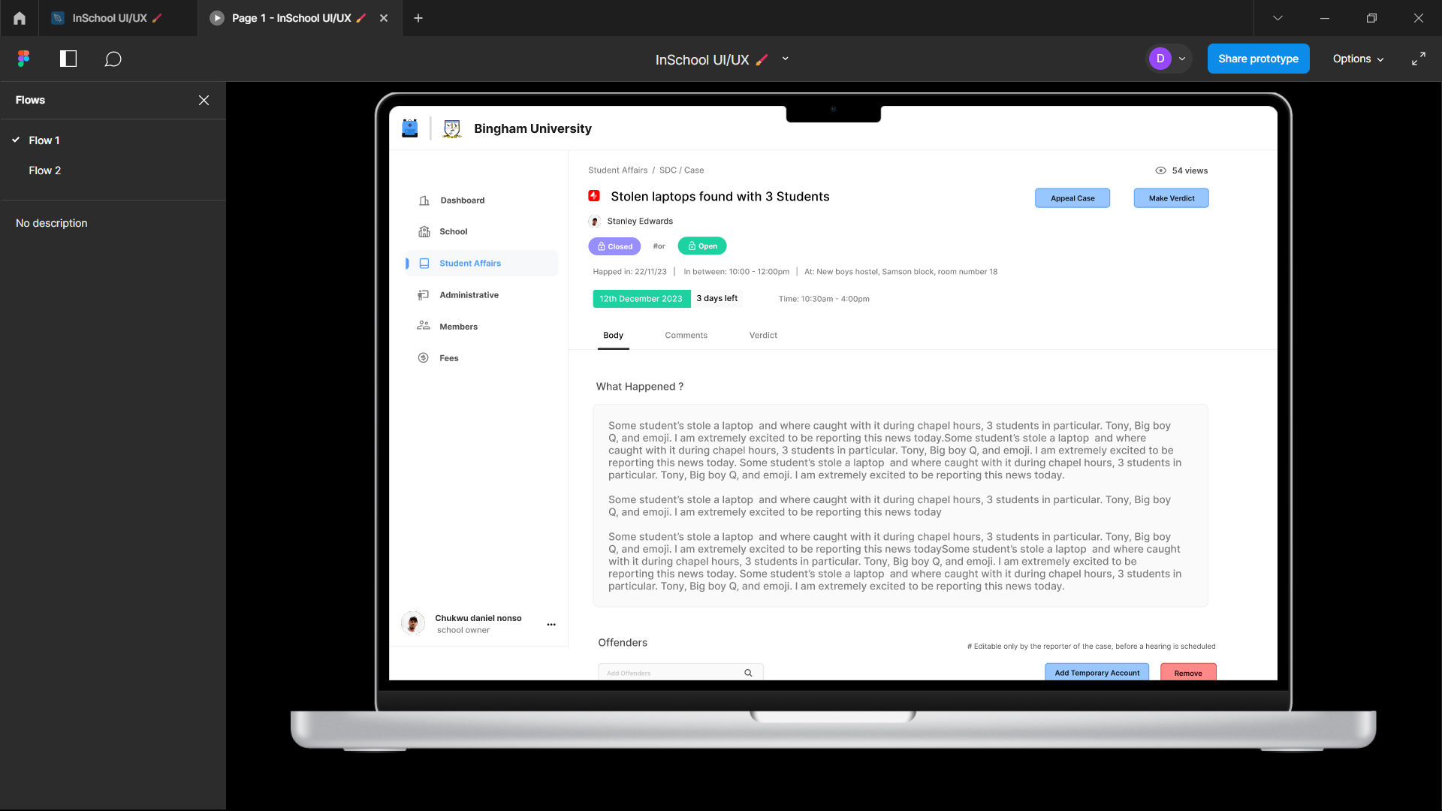

Note: The above diagram displays a screenshot of a figma design prototype (Showing the SDC case page)

ii. **Next.js, Tailwind CSS, and JSX for Frontend Development:** The T3Stack will be used for the front and backend development of the SDC Application, providing a robust, manageable and efficient framework for building responsive and scalable web applications.

iii. **Planetscale Database:** Planetscale will be employed as the database solution for the SDC Application. Its architecture offers scalability and reliability for data storage.

**Figure 3.3**

*A diagram of the Planetscale*

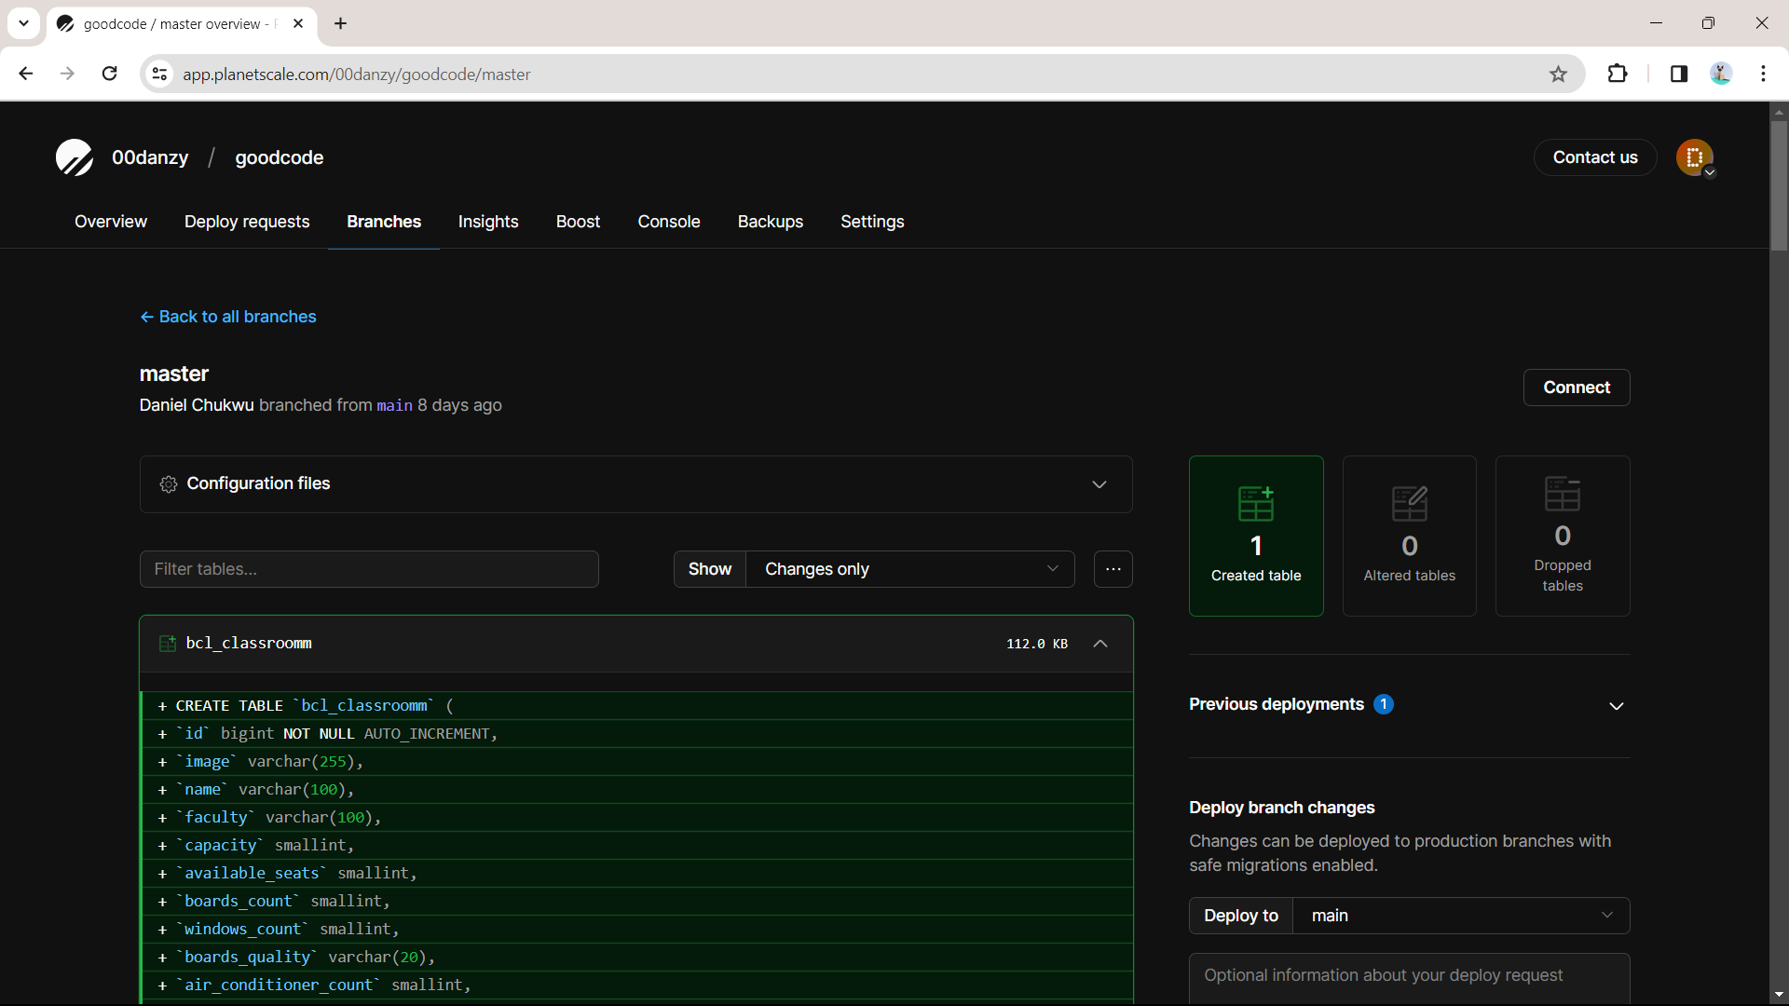

Note: This diagram shows a master database branch in the Planetscale Saas project.

v. **Jest for Testing:** Jest, a JavaScript testing framework, will be used to test the various components and functionalities of the SDC Application. This will ensure the application's reliability, robustness, and adherence to requirements.

vi. **Vercel for Deployment:** Vercel, a serverless deployment platform, will be utilized for deploying the SDC Application. It provides a scalable and efficient hosting solution for web applications, ensuring accessibility and responsiveness.

vii. **Axiom for Production Logging:** Axiom will be integrated for production logging in the SDC Application, enabling efficient monitoring and diagnostics, ensuring a robust and secure user authentication system.

### 3.8 Research Timeline

The research timeline for this study spans from October 28, 2023 – June 28, 2024

**3.8.1 Data Collection:**

i. Start holding interviews, focus groups and conducting surveys.

ii. Collect related documents and relevant data. Refine data collected as things change.

**3.8.2 Design:**

i. Iterate on the SDC Application design based on user feedback.

ii. Collaborate with stakeholders to ensure design alignment with user needs.

**3.8.3 Implementation:**

i. Begin coding the application based on the incremental designs.

ii. Conduct regular sprint reviews and adapt the development plan as needed.

**3.8.4 Testing:**

i. Testing of application features.

ii. Integrating Github Actions to ensure peak product quality deliverables.

**3.8.5 Deploy:**

i. Deploying the SDC Application to vercel on every iteration.

**3.8.6 Reviewing:**

i. Monitoring the applications core web vitals to ensure the application is up to the required CRUX (Chrome User Experience) standard.

ii. Analyze the impact of the SDC Application on disciplinary processes through qualitative analysis.

### 3.9 Data Analysis/Evaluation Plan

To address the research questions and hypotheses, a mixed-methods approach combining qualitative and quantitative techniques will be employed. The data analysis plan is outlined as follows:

#### 3.9.1 Quantitative:

i. Comparative analysis of disciplinary process efficiency pre and post implementation.

ii. Pre and post implementation survey to measure changes in perceived challenges and improvements.

#### 3.9.2 Qualitative:

i. Thorough Analysis of interview and focus group transcripts, identifying common challenges related to transparency, communication, and responsiveness.

ii. Analysis of design documents and stakeholders feedbacks, examining how user-centered design and agile methodology contribute to the application's development.

iii. Content analysis of system usage data and participant feedback.

### 3.10 Validity and Reliability

#### 3.10.1 Quantitative Research (Surveys, Data Analysis):

i. **Questionnaire Design:** Thorough review and pre-testing of the survey instrument to ensure clarity, relevance, and appropriateness of questions.

ii. **Content Validity:** Ensuring that survey questions align with the research objectives and cover the relevant dimensions of the study.

iii. **Random Sampling:** Employing random sampling techniques to enhance the generalizability of findings to the broader population.

#### 3.10.2 Qualitative Research (Interviews, Focus Groups, Thematic Analysis):

i. **Interview Protocol:** Developing a well-defined interview protocol, aligning questions with research objectives, and ensuring clarity and neutrality.

ii. **Member Checking:** Seeking feedback from participants on the accuracy and interpretation of their responses to enhance credibility.

iii. **Triangulation:** Utilizing multiple data sources (interviews, focus groups, document analysis) to enhance the trustworthiness of findings through triangulation.

### 3.11 Data Presentation

i. **Tables:**

Using tables to present summarized quantitative data, key metrics, or comparisons. This should facilitate transparency and allow readers delve into specific aspects of the findings.

ii. **Charts and Graphs:**

Utilizing charts and graphs (e.g., bar charts, line graphs) for visual representation of quantitative trends, patterns and comparisons.

### 3.12 Software Development for the SDC Application

**3.12.1 Review of Methodologies:**

Several methodologies were reviewed, including Waterfall, Scrum, and Kanban. Waterfall, while structured, was deemed too inflexible for the dynamic requirements of the educational environment. Scrum and Kanban were considered but lacked the depth needed for this comprehensive project. However, the chosen approach aligns closely with the iterative and user-focused principles of Agile, ensuring responsiveness to user needs and continuous improvement.

#### 3.12.2 Adopted/Adapted Methodology:

The adopted methodology for the SDC Application is Agile, emphasizing user collaboration, flexibility, and incrementaZl progress. This decision stems from the need for constant stakeholder involvement, given the diverse user groups involved – SDC members, administrators, and students.

#### 3.12.3 System Modelling:

**Figure 3.12.1**

*Use case diagram*

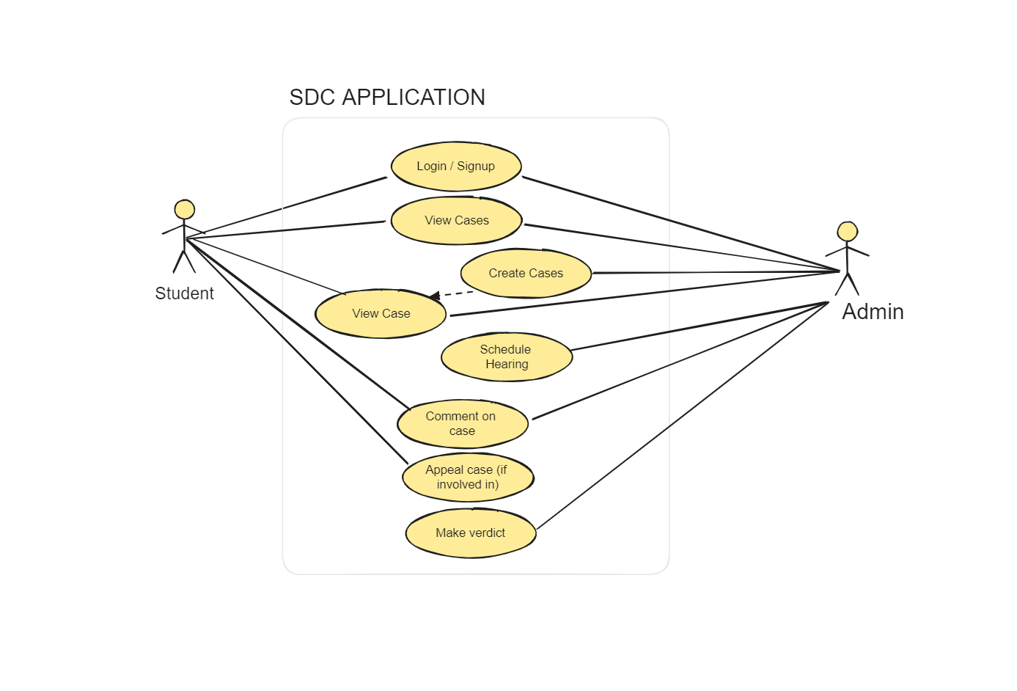

**Figure 3.12.2**

*Activity diagram*

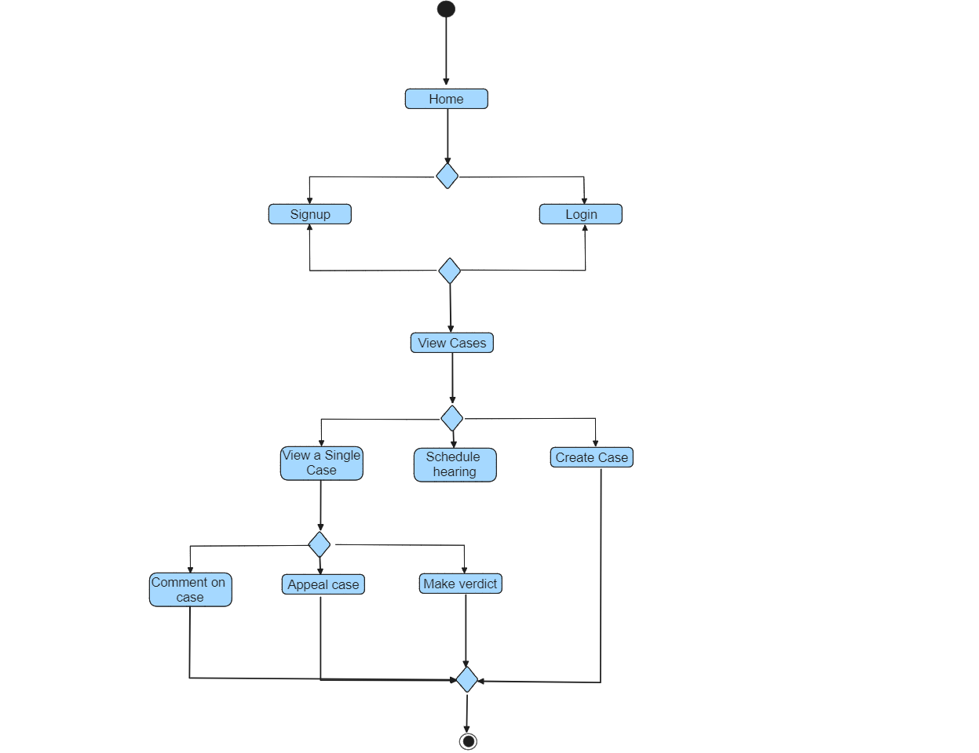

**Figure 3.12.3**

*Class diagram*

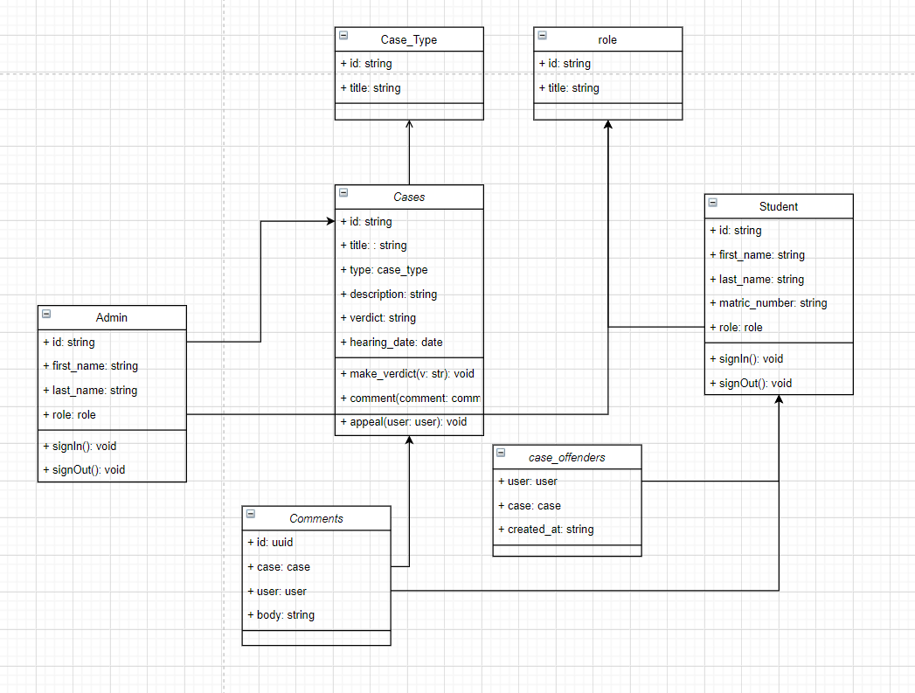

#### 3.12.4 System Requirements:

The system requirements are classified into functional and non-functional categories. Functional requirements encompass features such as case creation, real-time updates, document management, and secure user authentication. Non-functional requirements include data security, system responsiveness, availability, and scalability.

#### 3.12.6 Interface Design:

The interface design of the SDC Application prioritizes a user-friendly experience. Figma is employed for design mock-ups, ensuring a visually appealing and intuitive interface.

#### 3.12.7 Database Schema Design:

The database schema design is crafted using dbdiagram.io, ensuring a structured and efficient data model. It encompasses tables for users, cases, schools, and a lot of other relevant entities.

**Figure 3.12.4**

*Database schema design*

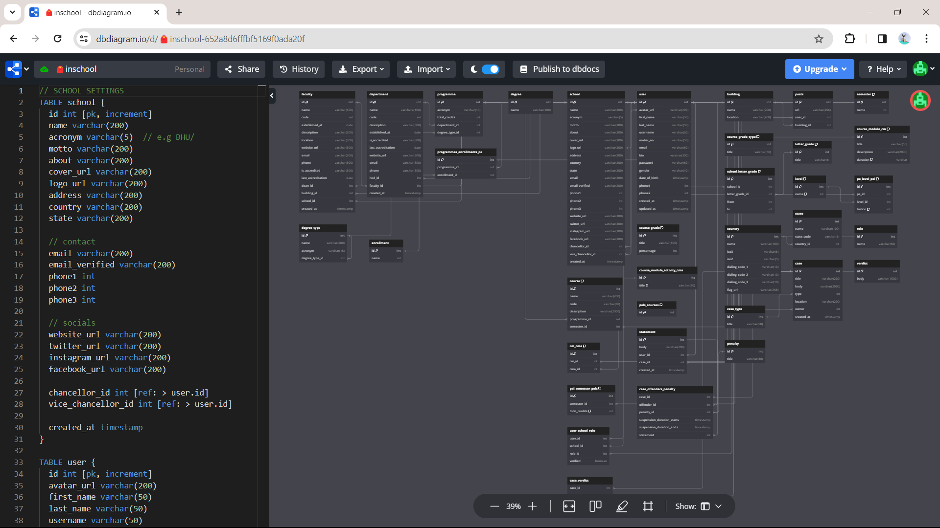

## References

Blandford, S. (1998). Google Books. https://books.google.com.ng/books?hl=en&lr=&id=13oaXCiHbqAC&oi=fnd&pg=PT10&dq=discipline+in+schools&ots=8As7gpBeVD&sig=7DsMbOiKdVSHXb2KOiqoyHJfYpg&redir_esc=y

Mao, J., Vredenburg, K., Smith, P. W., & Carey, T. (2005). The state of user-centered design practice. Communications of the ACM, 48(3), 105–109. https://doi.org/10.1145/1047671.1047677

Hung, L. D. (2023). *Web Development with T3 stack*. Theseus. https://www.theseus.fi/handle/10024/802481

Esfahani, H. C., & Yu, E. (2010). A repository of agile method fragments. In *Springer eBooks* pp. 163–174). https://doi.org/10.1007/978-3-642-14347-2_15

Diego L. Villarreal. (2021, March 8). Students Constitutional Rights and The University Disciplinary Committee. https://heinonline.org/HOL/LandingPage?handle=hein.journals/ncclj3&div=9&id=&page=

Karlesky, J. J., & Stephenson, D. G. (1971). Student disciplinary proceedings: Some preliminary questions. The Journal of Higher Education, 42(8), 648–656. https://doi.org/10.1080/00221546.1971.11774894

Smith R. Reddick. (2020). Due Process Rights in Student Disciplinary Matters. https://heinonline.org/HOL/LandingPage?handle=hein.journals/jcolunly14&div=17&id=&page=

J. Crim. L. & Penal Stud. (2019). The Authority of Disciplinary Committee for Students to Oblige Third Parties to a Specific Behavior. https://heinonline.org/HOL/LandingPage?handle=hein.journals/jlocllwap23&div=34&id=&page=

Notar, C. (2009, September 1). DISCIPLINARY ACTION COMMITTEE (DAC). | Education | EBSCOhost. https://openurl.ebsco.com/EPDB%3Agcd%3A10%3A1154874/detailv2?sid=ebsco%3Aplink%3Ascholar&id=ebsco%3Agcd%3A44016929&crl=c

Julia pedley. (2007). THE DEVELOPMENT OF A STUDENT CONTRACT AND IMPROVEMENT IN STUDENT DISCIPLINARY PROCEDURES AT MASSEY UNIVERSITY. https://heinonline.org/HOL/LandingPage?handle=hein.journals/anzled12&div=8&id=&page=

Ira Michael Heyman. (2022). Some Thoughts on University Disciplinary Proceedings. https://heinonline.org/HOL/LandingPage?handle=hein.journals/calr54&div=13&id=&page=

James M. Picozzi. (2020). University Disciplinary Process: What's fair, What's Due, and What You Don't Get. https://heinonline.org/HOL/LandingPage?handle=hein.journals/ylr96&div=87&id=&page=

Bayrami, M. (2020, April 21). A Comparison of Personality Characteristics and Coping Strategies in Students with Record in Disciplinary Committee of University and Normal Students. https://psychologyj.tabrizu.ac.ir/article_4213.html?lang=en

Ige (2016). Factors influencing disciplinary committee effectiveness: the case of public secondary schools in Ondo State, Nigeria. DigitalCommons@Fayetteville State University. https://digitalcommons.uncfsu.edu/jri/vol4/iss3/3/

Peter J.O. Aloka & Olaniyi Bojuwoye. (2023). Gender differences in decisions on student disciplinary behaviours by disciplinary panels of selected Kenyan secondary schools. https://journals.co.za/doi/abs/10.10520/EJC136364

Edward N. Stoner II & Bradley J. Martineau. (2019). Disciplinary and Academic Decisions Pertaining to Students in Higher Education. https://heinonline.org/HOL/LandingPage?handle=hein.journals/jcolunly27&div=20&id=&page=

Papadakis, M. A., Hodgson, C. S., Teherani, A., & Kohatsu, N. D. (2004). Unprofessional Behavior in Medical School Is Associated with Subsequent Disciplinary Action by a State Medical Board. Journal of Medical Regulation, 90(1), 16–23. https://doi.org/10.30770/2572-1852-90.1.16

Wilson, J. M. (1996). Processes for resolving student disciplinary matters. New Directions for Student Services, 1996(73), 35–52. https://doi.org/10.1002/ss.37119967305

Tamu K. Walton (2019). Protecting Student Privacy: Reporting Campus Crimes as an Alternative to Disclosing Student Disciplinary Records. https://heinonline.org/HOL/LandingPage?handle=hein.journals/indana77&div=10&id=&page=

Daud, N. M., & Mohamed, I. S. (2009). Evaluating technology resistance and technology satisfaction on students’ performance. *Mendeley*, *26*(4), 298–312. https://doi.org/10.1108/10650740910984637