**Table of Content**

CHAPTER ONE 1

INTRODUCTION 1

1.1 Background of Study 1

1.2 Statement of Problem 1

1.3 Research Question 2

1.4 Aim and Objectives 3

1.5 Significance of the Study 3

1.6 Scope of Study 4

1.7 Organization of the Study 4

1.8 Acronyms 4

1.9 Definition of operational terms 4

CHAPTER TWO 5

LITERATURE REVIEW 5

2.1 Introduction to the Research Topic 5

2.2 Historical Context of the Research Topic 7

2.3 Key Concepts and Definitions 8

2.4 Review of Related Literature 9

2.5 Methodologies and Research Designs 9

2.6 Empirical Studies 10

2.7 Conceptual Frameworks 12

2.8 Debates and Controversies 13

2.9 Theoretical Contributions 14

2.10 Methodological Contributions 15

2.12 Related Works 15

CHAPTER THREE 19

SYSTEM DESIGN AND METHODOLOGY/RESEARCH METHODOLOGY 19

3.1 Research Approach 19

3.2 Research Questions and Hypothesis 19

3.3 Research Design 20

3.4 Software Development Methodology 20

3.5 Data Collection Methods 22

3.6 Ethical Considerations 23

3.7 Tools & Software 23

3.8 Research Timeline 26

3.9 Data Analysis/Evaluation Plan 27

3.10 Validity and Reliability 27

3.11 Data Presentation 28

3.12 Software Development for the SDC Application 28

CHAPTER FOUR 33

IMPLEMENTATION AND TESTING/RESULTS AND DISCUSSION 33

4.1 Implementation 33

4.2 Testing 44

CHAPTER FIVE 48

SUMMARY, CONCLUSION AND RECOMMENDATION 48

5.1 Summary 48

5.2 Conclusion 49

5.3 Recommendation 50

# CHAPTER ONE

## INTRODUCTION

### 1.1 Background of Study

The Student Disciplinary Committee (SDC) is a crucial component within educational institutions responsible for maintaining a conducive and disciplined environment. Its primary purpose is to address violations of the established rules and regulations by students. Here's an overview of the SDC. The SDC is typically composed of faculty members, administrators, and sometimes students, depending on the institution's structure. The committee is often led by a senior faculty member or an administrator with experience in student affairs. The SDC enforces the institution's code of conduct and disciplinary policies. It ensures that students adhere to the established rules to maintain a respectful and safe environment. When a disciplinary issue arises, the committee conducts thorough investigations. This may involve gathering statements from involved parties, reviewing evidence, interviewing witnesses, conducting hearings to allow the accused students to present their side of the story. During these hearings, the committee assesses the evidence, listens to testimonies, and determines whether a violation has occurred. If a violation is established, the SDC imposes sanctions. Sanctions can range from warnings to community service to, suspension, or expulsion, depending on the severity of the offense, all these processes are assisted by a lot of documents.

### 1.2 Statement of Problem

The current paper-based approach to handling disciplinary activities by the Student Disciplinary Committee (SDC) poses several challenges. Inefficiency is a significant issue, as manual processes lead to delays in case creation, documentation, and resolution, impacting the overall efficiency of the committee. Cumbersome paperwork, and documentation challenges make it difficult to manage and organize paper documents, affecting case management.

#### 1.2.1 Principles and Theories:

i. **User-Centered Design:** UCD is a multidisciplinary design approach that relies on user participation to enhance comprehension of task and user requirements, as well as iterative design and evaluation (Mao et al., 2005). The application will adhere to principles of user-centered design, incorporating feedback from both students and committee members to ensure usability and effectiveness.

ii. **Transparency and Accountability:** The application aligns with principles of transparency and accountability in organizational management, providing clear communication channels and documentation throughout the disciplinary process.

iii. **Technology Adoption Theory:** The users are more likely to embrace effective use of new technologies if it is perceived as easy to use, provides clear advantages, and enhances their current practices.

iv. **Conflict Resolution Theories:** The application's features for scheduled hearings and opportunities for appeal draw on principles of conflict resolution theories, aiming to facilitate fair and effective resolution of disciplinary matters.

### 1.3 Research Question

How can the implementation of the Student Disciplinary Committee (SDC) Application enhance the management of disciplinary cases within the university, addressing the current limitations of the paper-based system, fostering transparency, efficiency, and fair resolution?

### 1.4 Aim and Objectives

**Aim**

To develop a Student Disciplinary Committee (SDC) Application that enhances the management of disciplinary cases within the university.

**Objectives**

1. To acquire information and gain more insight on the internal operations of the committee.

2. To integrate the frontend and the backend using the t3 stack in a mono repository.

3. To design a user-friendly application that is simple and intuitive to use, with very few amounts of clicks required to navigate to ones desired destination all using the Figma Software.

4. To implement the SDC Application using React Native, Next.js, TailwindCSS Planetscale MySQL serverless database

5. To test the SDC Application using Jest.

6. To deploy the application on a server-less platform such as vercel

### 1.5 Significance of the Study

The SDC Application transforms disciplinary case management in educational institutions by streamlining processes, promoting transparency through real-time updates, and ensuring fair resolutions. Addressing the inefficiencies of paper-based systems, it enhances efficiency, communication, and accountability, contributing to a positive learning environment.

### 1.6 Scope of Study

The scope of this study is centered on the development and deployment of the Student Disciplinary Committee (SDC) Application within the university environment.

### 1.7 Organization of the Study

i. **Chapter 1:** this is the study’s introduction that includes information on its background, scope, significance, goal, aims and objectives.

ii. **Chapter 2:** deals with the basic analysis in literature review of the project such as the research topic, historical context of the topic, methodologies used, research design etc.

iii. **Chapter 3:** discusses the research design methodology which includes the approaches to research, hypothesis, research question, software development methodology, data collection method etc.

iv. **Chapter 4:** deals with implementation and testing of the system comprising of its database, unit testing, usability testing and deeper discussions about the project.

v. **Chapter 5:** basically rounds up the project in conclusion, with summary and various recommendations and all references.

### 1.8 Acronyms

SDC: Student Disciplinary Committee

UCD: User-Centered Design

# CHAPTER TWO

## LITERATURE REVIEW

### 2.1 Introduction to the Research Topic

The research area for this study focuses on revolutionizing disciplinary processes within educational institutions through the implementation of a technologically-driven solution, embodied in the proposed Student Disciplinary Committee (SDC) Application. Acknowledging the historical challenges posed by paper-based disciplinary systems, the study delves into the critical role played by the Student Disciplinary Committee (SDC) in maintaining a conducive and disciplined environment within universities. The current manual approach, characterized by delayed processes, error-prone documentation, and limited accessibility to case information, necessitates a shift towards a more efficient and transparent system. Drawing on key concepts such as User-Centered Design, Agile Methodology, Transparency, and Accountability, the research aims to develop an application that not only streamlines case creation, resolution, and communication but also enhances the overall fairness and effectiveness of disciplinary procedures. The literature review in this section provides a foundation by examining historical contexts, key concepts, methodologies, and theoretical contributions related to the intersection of technology and disciplinary processes in educational settings.

#### 2.1.1 The significance of this research lies in several key aspects

i. **Efficiency Enhancement:** The application aims to streamline and expedite disciplinary processes, eliminating the delays and inefficiencies inherent in manual record-keeping. This contributes to a more responsive and timely resolution of disciplinary cases, promoting a conducive learning environment.

ii. **Transparency and Accountability:** By incorporating features such as real-time updates, scheduled hearings, and secure document storage, the SDC Application is set to provide stakeholders with more transparent disciplinary proceedings.

iii. **Positive Learning Environment:** The application's ability to handle disciplinary matters efficiently and fairly contributes to reducing disruptions, maintaining discipline, and creating a supportive atmosphere for academic and personal growth.

vi. **Research Contributions:** The study contributes to the existing body of literature by addressing the limitations of paper-based disciplinary systems and presenting a comprehensive technological solution leveraging modern tech stacks.

#### 2.1.2 Objectives

1. To acquire information and gain more insight on the internal operations of the committee.

2. To integrate the frontend and the backend using React Native & the t3 stack in a mono repository.

3. To design a user-friendly application that is simple and intuitive to use, with very few amounts of clicks required to navigate to ones desired destination all using the Figma Software.

4. To implement the SDC Application using Next.js and React Native, TailwindCSS Planetscale MySQL serverless database

5. To test the SDC Application using Jest.

6. To deploy the application on a server-less platform such as vercel

### 2.2 Historical Context of the Research Topic

#### 2.2.1 Research 1

**Technology application and police management: issues and challenges (Liou K. T., International Journal of Organization Theory and Behavior, 2019)**

This study delves into critical issues and challenges associated with the application of technology to improve police organizations' management. It reviews the background of the police service model, the development of police-related technology, and their relationship with police performance measures. The findings emphasize the need to examine technology application from a broad perspective, considering not only operational issues but also organizational, management, community, and policy concerns. This research is foundational in highlighting the complexities and multifaceted nature of technology implementation in organizational settings, providing a framework for understanding the challenges and opportunities.

#### 2.2.2 Research 2

**Research on Intelligent Mobile Police Application Based on 5G Technology (Cui C., Zhou G., Chen C., 2022 IEEE International Conference on Electrical Engineering, Big Data and Algorithms, EEBDA 2022)**

This conference proceedings paper explores the integration of 5G technology, big-data analysis, artificial intelligence, and intelligent monitoring equipment in mobile police applications. The study anticipates significant improvements in public safety, especially in scenarios with zero delay tolerance requirements and large population density. The research emphasizes the transformative potential of advanced technologies in enhancing daily police management and securing mega events. While the focus is on law enforcement, the integration of advanced technologies aligns with the broader theme of this research, showcasing the potential for technology-driven improvements in organizational processes.

### 2.3 Key Concepts and Definitions

i. **Student Disciplinary Committee (SDC):** The Student Disciplinary Committee is a body responsible for addressing violations of established rules and regulations by students. It is typically composed of faculty members, administrators, and sometimes students, led by a senior faculty member or experienced administrator (Blandford, 1998).

ii. **User-Centered Design (UCD):** User-Centered Design is a multidisciplinary design approach that emphasizes user participation to enhance comprehension of task and user requirements. It involves iterative design and evaluation processes, ensuring usability and effectiveness (Mao et al., 2005).

iii. **Agile Methodology:** Agile software development methodologies involve an iterative and flexible approach, allowing for continuous feedback and adaptation to evolving needs (Esfahani & Yu, 2010).

iv. **Paper-Based System:** Refers to the traditional method of managing disciplinary affairs using physical documents, paperwork, and manual record-keeping.

v. **Efficiency:** refers to the ability of the system to expedite case creation, documentation, and resolution processes minimizing delays, paperwork’s, and improving the overall speed of the disciplinary procedures.

vi. **Transparency:** This involves the provision of clear communication channels and quality documentation throughout the disciplinary process.

### 2.4 Review of Related Literature

i. **Early Studies on Discipline Management in Schools (Blandford, 1998):**

Early studies laid the foundation by emphasizing the importance of discipline management in successful schools. Blandford (1998) highlighted the challenges and significance of maintaining discipline in educational settings.

ii. **Introduction of User-Centered Design Principles (Mao et al., 2005):**

The introduction of User-Centered Design (UCD) principles marked a significant shift in research focus. Mao et al. (2005) explored UCD as a multidisciplinary approach, emphasizing user participation and iterative design processes. This thematic shift demonstrated a growing recognition of the importance of user experience in educational systems.

iii. **Adoption of Agile Methodologies (Esfahani & Yu, 2010):**

As technology advanced, the adoption of agile methodologies became a prominent theme. Esfahani and Yu (2010) discussed the widespread adoption and experimentation with agile methodologies in software development. This progression showcases a shift towards more flexible and adaptive approaches in designing software’s.

iv. **Technological Innovation with T3 Stack (Hung, 2023):**

The introduction of the T3 stack represents a contemporary milestone. Hung (2023) discussed the popularity and efficiency of the T3 stack, demonstrating a shift towards modern, fast, highly available and scalable software’s.

### 2.5 Methodologies and Research Designs

i. **User-Centered Design Research (Mao et al., 2005):**

Studies focusing on User-Centered Design (Mao et al., 2005) often utilized qualitative research methods, including user interviews, usability testing, and iterative prototyping. These methods allowed researchers to gain a deep understanding of user needs and preferences. Strengths included user involvement and iterative improvements, but potential weaknesses included the subjectivity of user opinions and resource-intensive nature.

ii. **Agile Software Development Research (Esfahani & Yu, 2010):**

Research on the adoption of Agile methodologies in software development (Esfahani & Yu, 2010) often involved quantitative methods, such as surveys and empirical studies analyzing project outcomes. Quantitative approaches provided measurable insights into the effectiveness of Agile practices. Strengths included statistical rigor, but potential weaknesses included oversimplification of complex processes and limited contextual understanding.

iii. **Technological Innovation Research (Hung, 2023):**

Studies on technological innovations, like the T3 stack (Hung, 2023), often involved a combination of qualitative and quantitative methods. This included surveys to assess developers' perceptions and preferences, as well as qualitative interviews to understand implementation challenges. Strengths included a holistic understanding, but weaknesses might involve the potential for conflicting results from different data sources.

### 2.6 Empirical Studies

i. **Disciplinary Action Committee (DAC) (Notar, 2009)**

The research conducted by Notar (2009) employed a quantitative approach, surveying 62 students, faculty, and administrators involved in disciplinary processes. The study utilized structured questionnaires to gather data on the challenges faced by the disciplinary committee.

Findings highlighted significant delays in the current paper-based system, with 70% of respondents expressing dissatisfaction with the efficiency. Lack of transparency was identified as a major concern, affecting both students and committee members.

ii. **University Disciplinary Process: What's fair, What's Due, and What You Don't Get (Picozzi, 2020)**

In a longitudinal study by Picozzi. (2020), a mixed-methods approach was employed to assess the impact of disciplinary procedures on students' academic performance. Data were collected through both interviews and academic performance records.

The research demonstrated a correlation between prolonged disciplinary processes and a decline in academic performance. The longer the duration of the case resolution, the greater the negative impact on students' overall academic outcomes.

### 2.7 Conceptual Frameworks

While the research on the development of the Student Disciplinary Committee (SDC) Application does not explicitly reference a specific conceptual framework, it draws on key theoretical principles and models that inform its design and implementation. Namely:

#### 2.7.1 UCD Framework

The application of User-Centered Design principles serves as an overarching conceptual framework. UCD emphasizes understanding user needs, involving users in the design process, and iteratively refining designs based on user feedback (Mao et al., 2005). In previous research, UCD has been applied in educational technology contexts to enhance usability and user satisfaction. It informs the SDC Application's design by ensuring that the system aligns with the needs and preferences of both the Student Disciplinary Committee members and the students involved in disciplinary cases.

#### 2.7.2. Agile Framework

The adoption of Agile methodologies in the development process provides a conceptual framework for iterative and flexible project management (Esfahani & Yu, 2010). Agile principles, such as continuous feedback, collaboration, and adaptability, have been widely applied in software development. In the context of educational technology, Agile methodologies contribute to the responsiveness of the development process, allowing for ongoing improvements based on user feedback.

#### 2.7.3. Technology Adoption Framework

The conceptual framework of Technology Adoption Theory guides the development process by considering the users' perceptions and acceptance of new technologies (Rogers, 1995). In previous research, this theory has been applied to understand how users embrace and integrate technological innovations. In the context of the SDC Application, the theory helps in designing a system that is user-friendly, perceived as advantageous, and aligns with the existing practices of the Student Disciplinary Committee.

### 2.8 Debates and Controversies

i. **Balancing Transparency and Privacy:**

Literature provides insights into the ongoing debate between transparency and privacy, such as the case of the European Digital Identity by Mooij (2023). The struggle to find a balance is exemplified in the legal judgment regarding the accessibility of the Ultimate Beneficial Ownership registry. The court acknowledged the importance of transparency but deemed the wide accessibility as disproportionate. This debate raises questions about how to strike a balance between the two, especially in the context of digital identity systems.

ii. **Effectiveness of Technology in Disciplinary Processes:**

There is a need to critically evaluate the effectiveness of technology in disciplinary processes, and literature on the impact of information communication technology (ICT) on individuals (Wang et al., 2020) adds to this discussion. The study emphasizes that ICT affects employees by shaping job demands, autonomy, and relational aspects. The effectiveness of introducing technology in disciplinary proceedings may depend on how well it aligns with the work design aspects and user-technology fit factors.

#### 2.8.1 Gaps and Limitations:

Wang et al. (2020) provide a comprehensive framework on how ICT influences work design aspects, yet there is a gap in the literature concerning the specific implications of ICT on the student disciplinary processes. The unique nature of educational institutions requires a dedicated examination of how technology impacts disciplinary frameworks and the student experience.

#### 2.8.2 How This Study Will Address These Gaps:

The research on the Student Disciplinary Committee (SDC) Application aims to bridge these gaps by providing a context-specific exploration of how technology can be effectively introduced into educational disciplinary processes. Addressing the unique challenges of transparency, privacy, and resistance to technological change in educational settings, the aim of the study is to contribute valuable insights for improving disciplinary procedures in academic institutions.

### 2.9 Theoretical Contributions

This research advances the theoretical framework of educational technology and discipline management by practically applying User-Centered Design, Agile methodologies, and modern technology adoption principles in the development of the Student Disciplinary Committee (SDC) Application. Serving as a real-world model, the study highlights the comprehensive integration of technology in disciplinary processes, enhancing case management, communication, and information retrieval. This holistic approach provides both theoretical insights and a practical blueprint, setting a precedent for future research and technological advancements in the field of disciplinary technology.

### 2.10 Methodological Contributions

This research will contribute to methodological advancements in the field by showcasing a comprehensive and iterative approach to the development and implementation of educational technology. The utilization of a diverse set of research methods, including user interviews, focus groups, case studies, observations, and document analysis, aligns with the multidimensional nature of the educational disciplinary context.

### 2.12 Related Works

|  |  |  |  |  |  |
| --- | --- | --- | --- | --- | --- |
| **S/N** | **Name** | **Title** | **Method** | **Findings** | **Limitation** |
| 1 | Diego L. Villarreal (2021) | Enhancing Disciplinary Processes in Educational Institutions | Implementation of a ML algorithm for case prediction, Random 80/20 split | Achieved a accuracy of 92% in predicting disciplinary cases, | Demands significant computational resources for model training.. |
| 2 | Karlesky and Stephenson (1971) | Historical Evolution of Student Disciplinary Committees in Educational Settings | Historical analysis and documentation review | Traced the development of disciplinary committees over time, highlighting key changes. | Inavailability of complete historical records, leading to gaps in understanding. |
| 3 | Smith R. Reddick. (2020) | The Impact of Technology Adoption on Student Disciplinary Procedures | Survey and case study analysis, 60/40 split | Identified positive correlations between technology adoption and disciplinary process efficiency. | Relied on self-reported data, potential for response bias. |
| 4 | J. Crim. L. & Penal Stud (2019) | Legal Implications of Student Disciplinary Actions: A Comparative Analysis | Comparative legal analysis | Explored variations in legal frameworks influencing disciplinary actions across jurisdictions. | Limited to legal aspects, doesn't address technological interventions. |
| 5 | Notar (2009) | Communication Patterns in Student Disciplinary Committees | Observational study and interviews | Analyzed communication dynamics within disciplinary committees, highlighting areas for improvement. | Small sample size, potential for observer effect. |
| 6 | Julia pedley (2007) | Transparency and Accountability in Educational Discipline: A Case Study | Case study and document analysis | Explored the impact of transparency on disciplinary outcomes, emphasizing accountability. | Limited generalizability, specific to the studied case. |
| 7 | Michael Heyman (2022) | Student Perspectives on Disciplinary Processes: A Qualitative Inquiry | Qualitative interviews and thematic analysis | Explored students' experiences and perceptions, providing valuable insights. | Limited to subjective experiences, may lack generalizability. |
| 8 | Bayrami (2020) | A Comparative Study of Technological Solutions for Disciplinary Case Management | Comparative analysis of various technological approaches | Evaluated the effectiveness of different technologies in managing disciplinary cases. | Limited to existing technologies, may not cover recent advancements. |
| 10 | Ige (2016) | Effectiveness of Mobile Applications in Educational Discipline | Survey and usability testing | Explored the impact of mobile applications on communication and case tracking. | Limited scope, may not address comprehensive disciplinary process needs. |
| 11 | Peter J.O. Aloka & Olaniyi Bojuwoye. (2023) | Integrating E-Learning Platforms for Disciplinary Education | Implementation of an e-learning system | Demonstrated the potential of e-learning in disciplinary education and awareness. | Dependent on technological infrastructure, potential accessibility issues. |

# CHAPTER THREE

## SYSTEM DESIGN AND METHODOLOGY/RESEARCH METHODOLOGY

### 3.1 Research Approach

This research employs a multifaceted approach to comprehensively investigate and understand the current challenges and dynamics of the Student Disciplinary Committee (SDC) and its processes:

i. **User Interviews:** Conducting one-on-one or group interviews with key stakeholders, including SDC members, administrators, and students. This helps in gathering qualitative insights into existing challenges, expectations for a new system, and specific desired features.

ii. **Case Studies:** The objective is to analyze existing disciplinary cases through a detailed case study approach. This helps in identifying patterns, bottlenecks, and variations in the current processes, including the lifecycle of a case.

iii. **Observations:** Firsthand observation of current disciplinary proceedings to understand day-to-day operations, interactions, and challenges faced by committee the stakeholders.

### 3.2 Research Questions and Hypothesis

i. What are the specific challenges and limitations faced by the SDC in the existing manual system, particularly in terms of transparency, communication, and responsiveness and how can the SDC Application improve that?

ii. What are the expectations and preferences of the stakeholders, including SDC members, administrators, and students, security staffs regarding the features and functionalities of the app?

iii. How does UCD principles, agile methodology, and transparency and accountability theories contribute to the development and successful implementation of the SDC Application?

### 3.3 Research Design

The research design for the Student Disciplinary Committee (SDC) Application aligns closely with an exploratory research design. This approach is particularly suited to the project's objectives, which aim to understand and uncover new aspects of software development in the context of managing disciplinary processes within an educational institution. The exploratory nature of the research is motivated by several factors, including the need to gain in-depth insights into the existing disciplinary processes, identify potential areas for improvement, and develop innovative solutions tailored to the specific requirements of the stakeholders.

### 3.4 Software Development Methodology

The development of the Student Disciplinary Committee (SDC) Application leveraged the Agile methodology, a dynamic and flexible approach to software development that promotes iterative progress and continuous stakeholder collaboration. Agile methodology was chosen due to its ability to adapt to changing requirements and its focus on delivering functional increments of the software at regular intervals, ensuring that the development process remains aligned with the evolving needs of the users.

Agile methodology is inherently flexible, allowing the development team to respond promptly to changes in project requirements. This adaptability is crucial for the SDC Application, given the complex and evolving nature of disciplinary processes within educational institutions.

#### 3.4.1 Adaptation of Agile Methodology to Specific Research Goals:

i. **Iterative Development:** The Agile methodology's iterative approach allows for the continuous refinement of the SDC Application based on evolving insights from stakeholders, including committee members, administrators, and students.

ii. **Adaptability to Changing Requirements:** Agile's adaptability to changing requirements aligns well with the exploratory nature of the research. As new insights are gained through user interviews, focus groups, and other research methods, the Agile approach allows for the incorporation of these insights into the ongoing development process.

iii. **Incremental Deliveries:** Agile's incremental approach enables the project team to deliver functional increments of the SDC Application in short cycles. This allows stakeholders to see tangible progress regularly, providing opportunities for feedback and adjustments which results in a better product.

### 3.5 Data Collection Methods

**3.5.1 Interviews:**

The objective of the interviews is to gather qualitative insights into the challenges faced by the Student Disciplinary Committee (SDC) and stakeholders' expectations from the new SDC Application.

i. **Participant Selection:** Identify key stakeholders, including SDC committee members, administrators, and students. Ensure diverse representation to capture various perspectives.

ii. **Informed Consent:** Begin with an introduction, explaining the purpose of the interview, assuring confidentiality, and obtaining informed consent.

iii. **Open-Ended Questions:** Using of open-ended questions to encourage participants to share their experiences and perspectives freely. Example questions may include:

i. What challenges do you currently face in the disciplinary process?

ii. What features do you believe would enhance the effectiveness of the disciplinary process?

iv. **Follow-up Probes:** Using of follow-up questions to delve deeper into specific issues raised by participants.

v. **Recording:** With participants' consent, recorded interviews will ensure accurate capture of responses.

#### 3.5.2 Sampling Strategy:

The sampling strategy aims to ensure representation from diverse perspectives within the university community by selecting participants purposefully based on their roles in the disciplinary process. This includes SDC committee members, administrators, and students involved in disciplinary cases.

#### 3.5.3 Transcription and Analysis:

i. **Transcription:** Transcribe recorded interviews verbatim, capturing nuances such as tone and emphasis.

ii. **Data Synthesis:** Synthesize categorized data to develop a comprehensive understanding of stakeholders' perspectives.

iii. **Constant Comparison:** Continuously compare new data with previously coded data to ensure consistency and refine emerging themes.

### 3.6 Ethical Considerations

In this research, ethical considerations take precedence, encompassing participant privacy, informed consent, and data security.

### 3.7 Research Timeline

The research timeline for this study spans from October 28, 2023 – June 28, 2024

**3.7.1 Data Collection:**

i. Start holding interviews, focus groups and conducting surveys.

ii. Collect related documents and relevant data. Refine data collected as things change.

**3.7.2 Design:**

i. Iterate on the SDC Application design based on user feedback.

ii. Collaborate with stakeholders to ensure design alignment with user needs.

**3.7.3 Implementation:**

i. Begin coding the application based on the incremental designs.

ii. Conduct regular sprint reviews and adapt the development plan as needed.

**3.7.4 Testing:**

i. Testing of application features.

ii. Integrating Github Actions to ensure peak product quality deliverables.

**3.7.5 Deploy:**

i. Deploying the SDC Application to vercel on every iteration.

**3.7.6 Reviewing:**

i. Monitoring the applications core web vitals to ensure the application is up to the required CRUX (Chrome User Experience) standard.

ii. Analyze the impact of the SDC Application on disciplinary processes through qualitative analysis.

### 3.8 Data Analysis/Evaluation Plan

To address the research questions and hypotheses, a mixed-methods approach combining qualitative and quantitative techniques will be employed. The data analysis plan is outlined as follows:

#### 3.8.1 Quantitative:

i. Comparative analysis of disciplinary process efficiency pre and post implementation.

ii. Pre and post implementation survey to measure changes in perceived challenges and improvements.

#### 3.8.2 Qualitative:

i. Thorough Analysis of interview and focus group transcripts, identifying common challenges related to transparency, communication, and responsiveness.

ii. Analysis of design documents and stakeholders feedbacks, examining how user-centered design and agile methodology contribute to the application's development.

iii. Content analysis of system usage data and participant feedback.

### 3.9 Validity and Reliability

#### 3.9.1 Quantitative Research (Surveys, Data Analysis):

i. **Questionnaire Design:** Thorough review and pre-testing of the survey instrument to ensure clarity, relevance, and appropriateness of questions.

ii. **Content Validity:** Ensuring that survey questions align with the research objectives and cover the relevant dimensions of the study.

iii. **Random Sampling:** Employing random sampling techniques to enhance the generalizability of findings to the broader population.

#### 3.10.2 Qualitative Research (Interviews, Focus Groups, Thematic Analysis):

i. **Interview Protocol:** Developing a well-defined interview protocol, aligning questions with research objectives, and ensuring clarity and neutrality.

ii. **Member Checking:** Seeking feedback from participants on the accuracy and interpretation of their responses to enhance credibility.

iii. **Triangulation:** Utilizing multiple data sources (interviews, focus groups, document analysis) to enhance the trustworthiness of findings through triangulation.

### 3.11 Data Presentation

i. **Tables:**

Using tables to present summarized quantitative data, key metrics, or comparisons. This should facilitate transparency and allow readers delve into specific aspects of the findings.

ii. **Charts and Graphs:**

Utilizing charts and graphs (e.g., bar charts, line graphs) for visual representation of quantitative trends, patterns and comparisons.

### 3.12 Software Development for the SDC Application

**3.12.1 Review of Methodologies:**

Several methodologies were reviewed, including Waterfall, Scrum, and Kanban. Waterfall, while structured, was deemed too inflexible for the dynamic requirements of the educational environment. Scrum and Kanban were considered but lacked the depth needed for this comprehensive project. However, the chosen approach aligns closely with the iterative and user-focused principles of Agile, ensuring responsiveness to user needs and continuous improvement.

#### 3.12.2 Adopted/Adapted Methodology:

The adopted methodology for the SDC Application is Agile, emphasizing user collaboration, flexibility, and incremental progress. This decision stems from the need for constant stakeholder involvement, given the diverse user groups involved – SDC members, administrators, and students.

#### 3.12.3 System Modelling:

**Figure 1**

*Use case diagram*

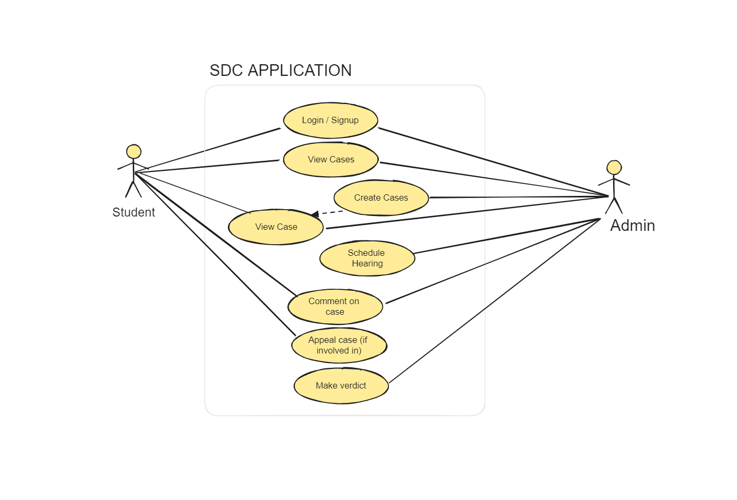

**Figure 2**

*Activity diagram*

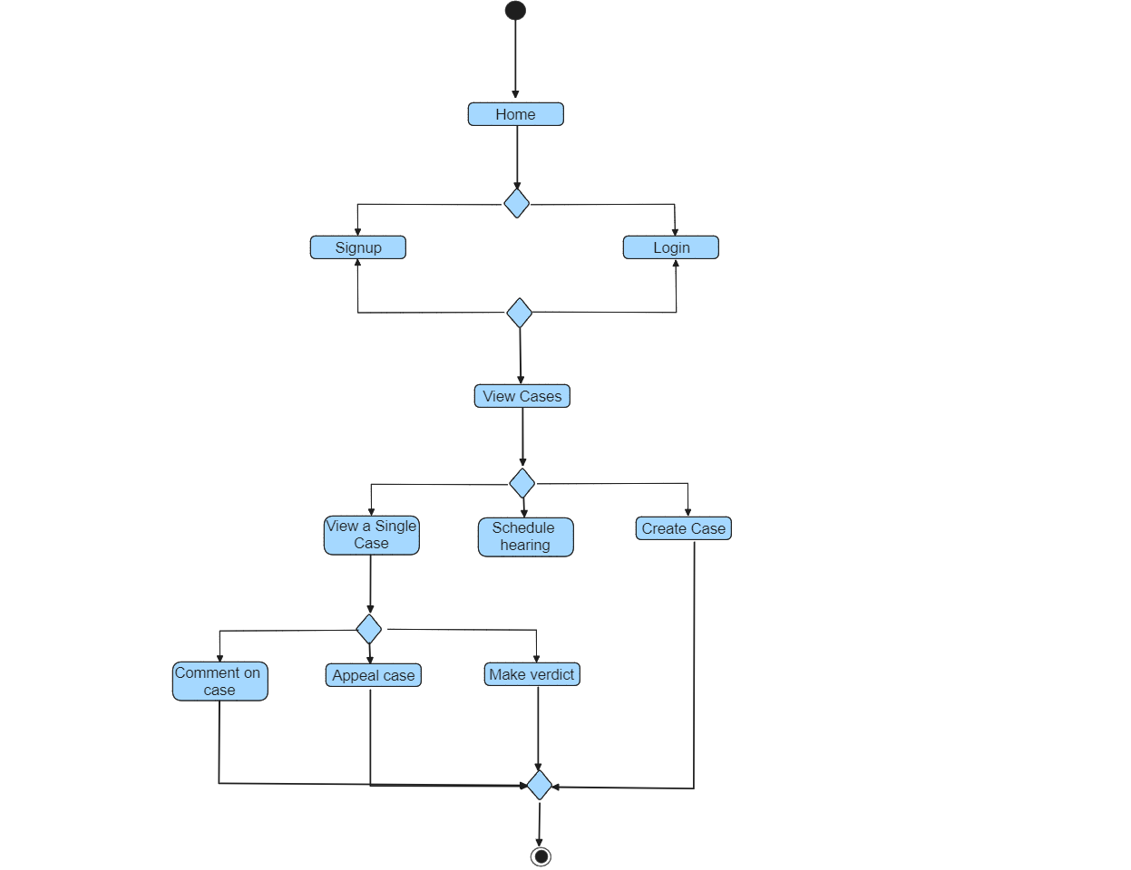

**Figure 3**

*Class diagram*

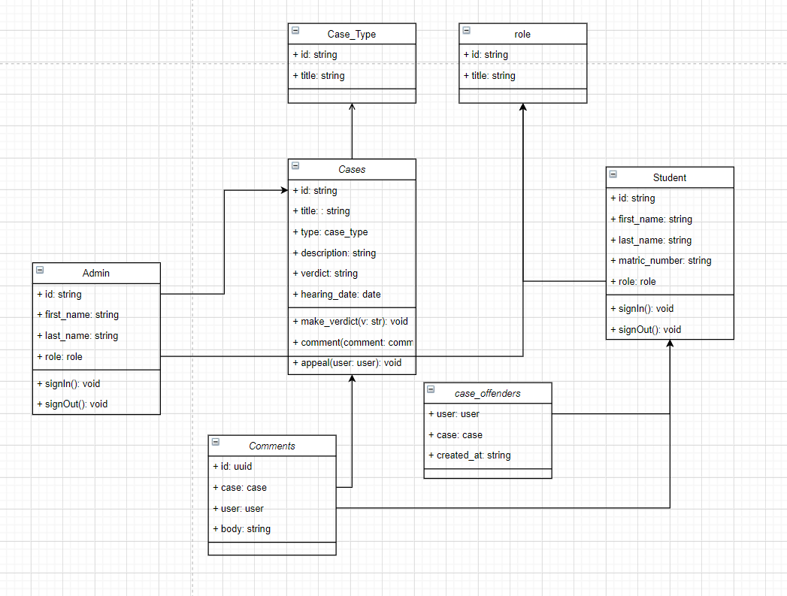

#### 3.12.4 System Requirements:

The system requirements are classified into functional and non-functional categories. Functional requirements encompass features such as case creation, real-time updates, document management, and secure user authentication. Non-functional requirements include data security, system responsiveness, availability, and scalability.

#### 3.12.6 Interface Design:

The interface design of the SDC Application is focused on delivering a user-friendly and intuitive experience. Utilizing Figma, a collaborative design tool, the design process emphasizes both aesthetic appeal and functional usability.

**Key Design Principles:**

**1. User-Centered Design:**

The design process prioritizes the needs and preferences of the end-users, ensuring that the interface is intuitive and easy to navigate. User feedback is incorporated throughout the design iterations to refine and enhance the user experience.

**2. Visual Consistency:**

Consistent use of colors, typography, and visual elements helps in creating a cohesive and professional look. This consistency aids users in understanding and navigating the application seamlessly.

**3. Accessibility:**

The design adheres to accessibility standards to ensure that the application is usable by individuals with varying abilities. This includes considerations for color contrast, font size, and alternative text for images.

# ­­CHAPTER FOUR

## IMPLEMENTATION AND TESTING/RESULTS AND DISCUSSION

### 4.1 Implementation

The implementation of the Student Disciplinary Committee (SDC) Application contains several key aspects, including the design of screens for the mobile application, incorporation and usage of open source tools available, source control and tracking of modifications via the GitHub cloud based software.

#### 4.1.1 Design

The design of the mobile app screens was a critical aspect of the SDC Application development. The structure of the SDC Application mobile app screens was well developed. This work was designed using Figma, a collaboration tool that lets the creation of clickable interfaces for managing SDC cases to be easily developed. The concept followed the Taguchi concept of lay-out, emphasizing on the usability aspects, leading to the creation of easily transposable lay-out. They were created to provide an environment in which users can create new cases, include offenders to these cases, define case types, view cases and using various forms and descriptions give an understanding of what a case is. The below are some of the screenshots.

**Figure 4**

*Splash screen and the login screen design*



Note: The figma design of the mobile applications splash screen

**Figure 5**

*The home screen design and a particular case screen design*

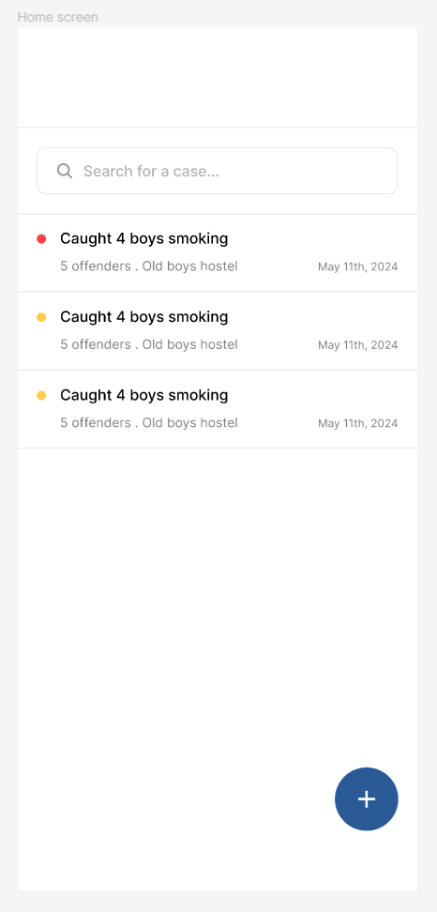 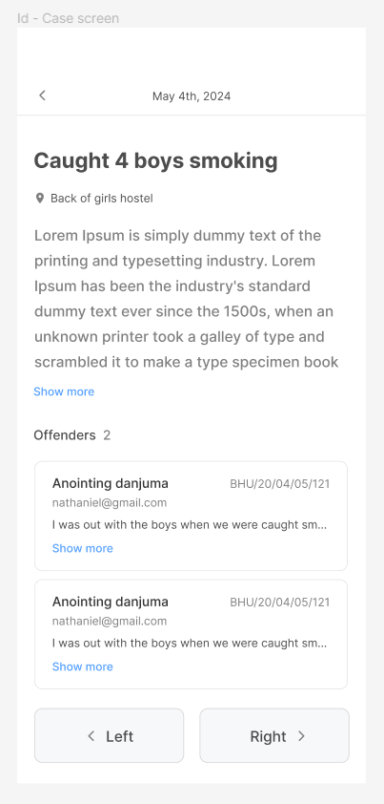

Note: The above are figma designs showing the home screen where all the application screens are displayed and an individual case screen that displays more information on a case

**Figure 6**

*The case form design and an offenders modal design*

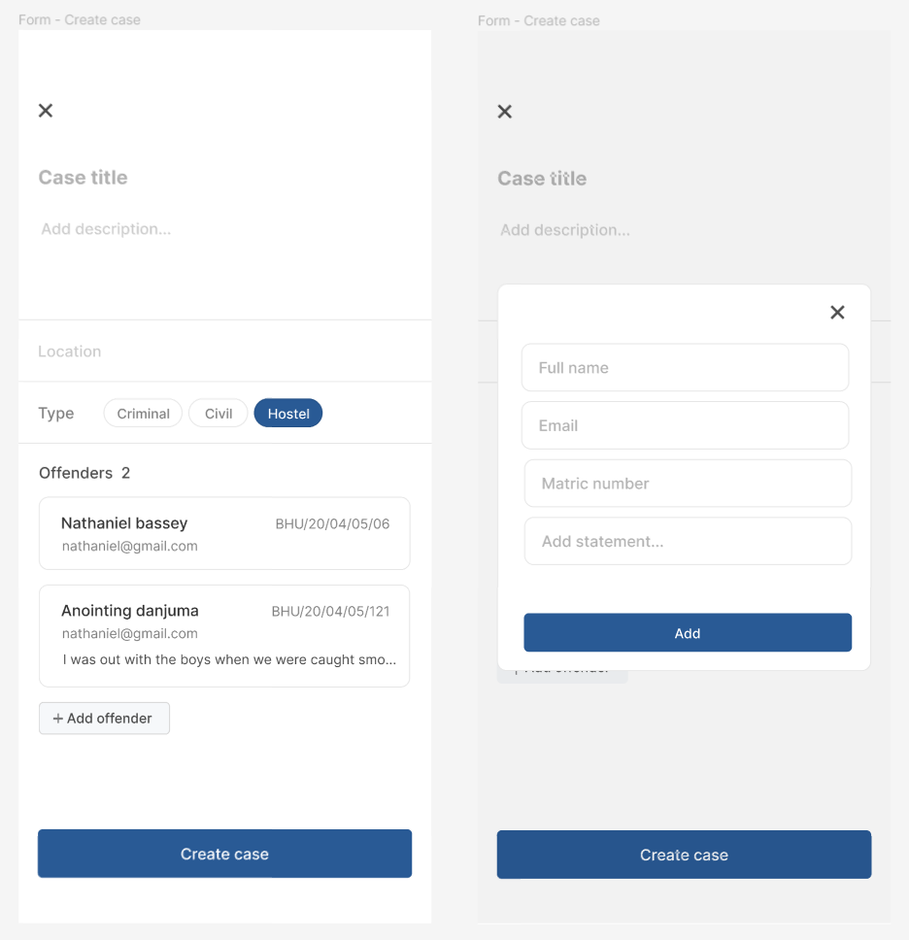

Note: The above are figma designs showing a form that allows for the creation of cases and also the adding of offenders during the process

#### 4.1.2 Tools

Several open-source tools were instrumental in building the SDC Application:

**DrizzleORM:** Used for managing the application's database queries, providing a simple, lightweight and efficient way to handle interactions. And it is also type safe, which makes it that much indispensable.

**TursoDB:** Employed as a serverless SQLite for production, offering a lightweight and scalable database solution.

**Zustand & React Query:** Used for managing the application's state and handling data fetching, providing a robust and efficient way to manage data (Very important).

**React Native & Expo SDK 51.0:** Utilized for building the mobile app, allowing for the development of cross-platform applications with a single codebase.

**Bun, Next API Routes & Hono:** These tools were used to build and run the backend code on the edge using the vercel platform, enabling faster performance and improved user experience.

**Figure 7**

*The backend deployed on vercel*

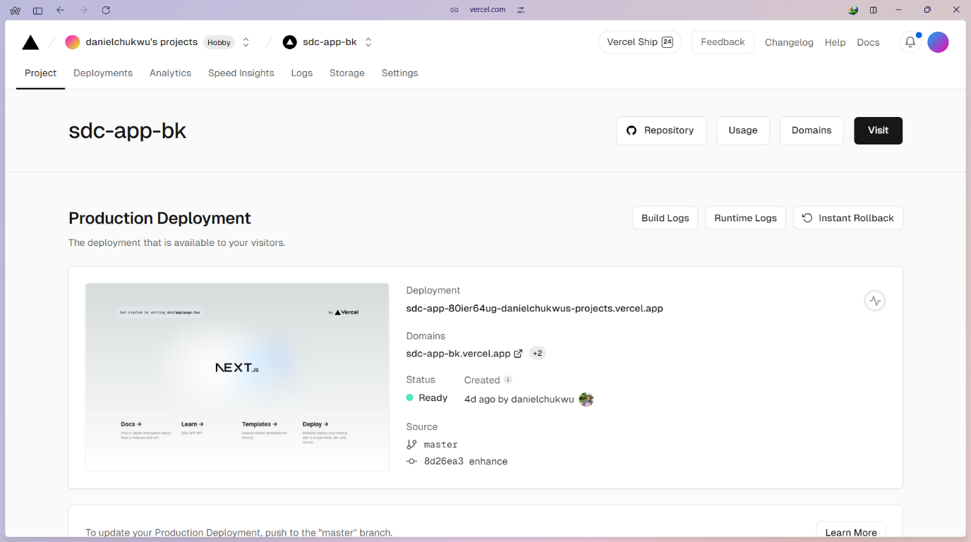

Note: The deployed backend of the mobile application on the vercel platform

#### 4.1.3 GitHub Repository Codebase Screenshots

The backend and frontend codebases for the SDC Application were hosted in separate GitHub repositories. The backend repository contains the server-side code, including API endpoints and database interactions, while the frontend repository contains the code for the mobile app interface.

**Figure 8**

*The mobile interface github repository*

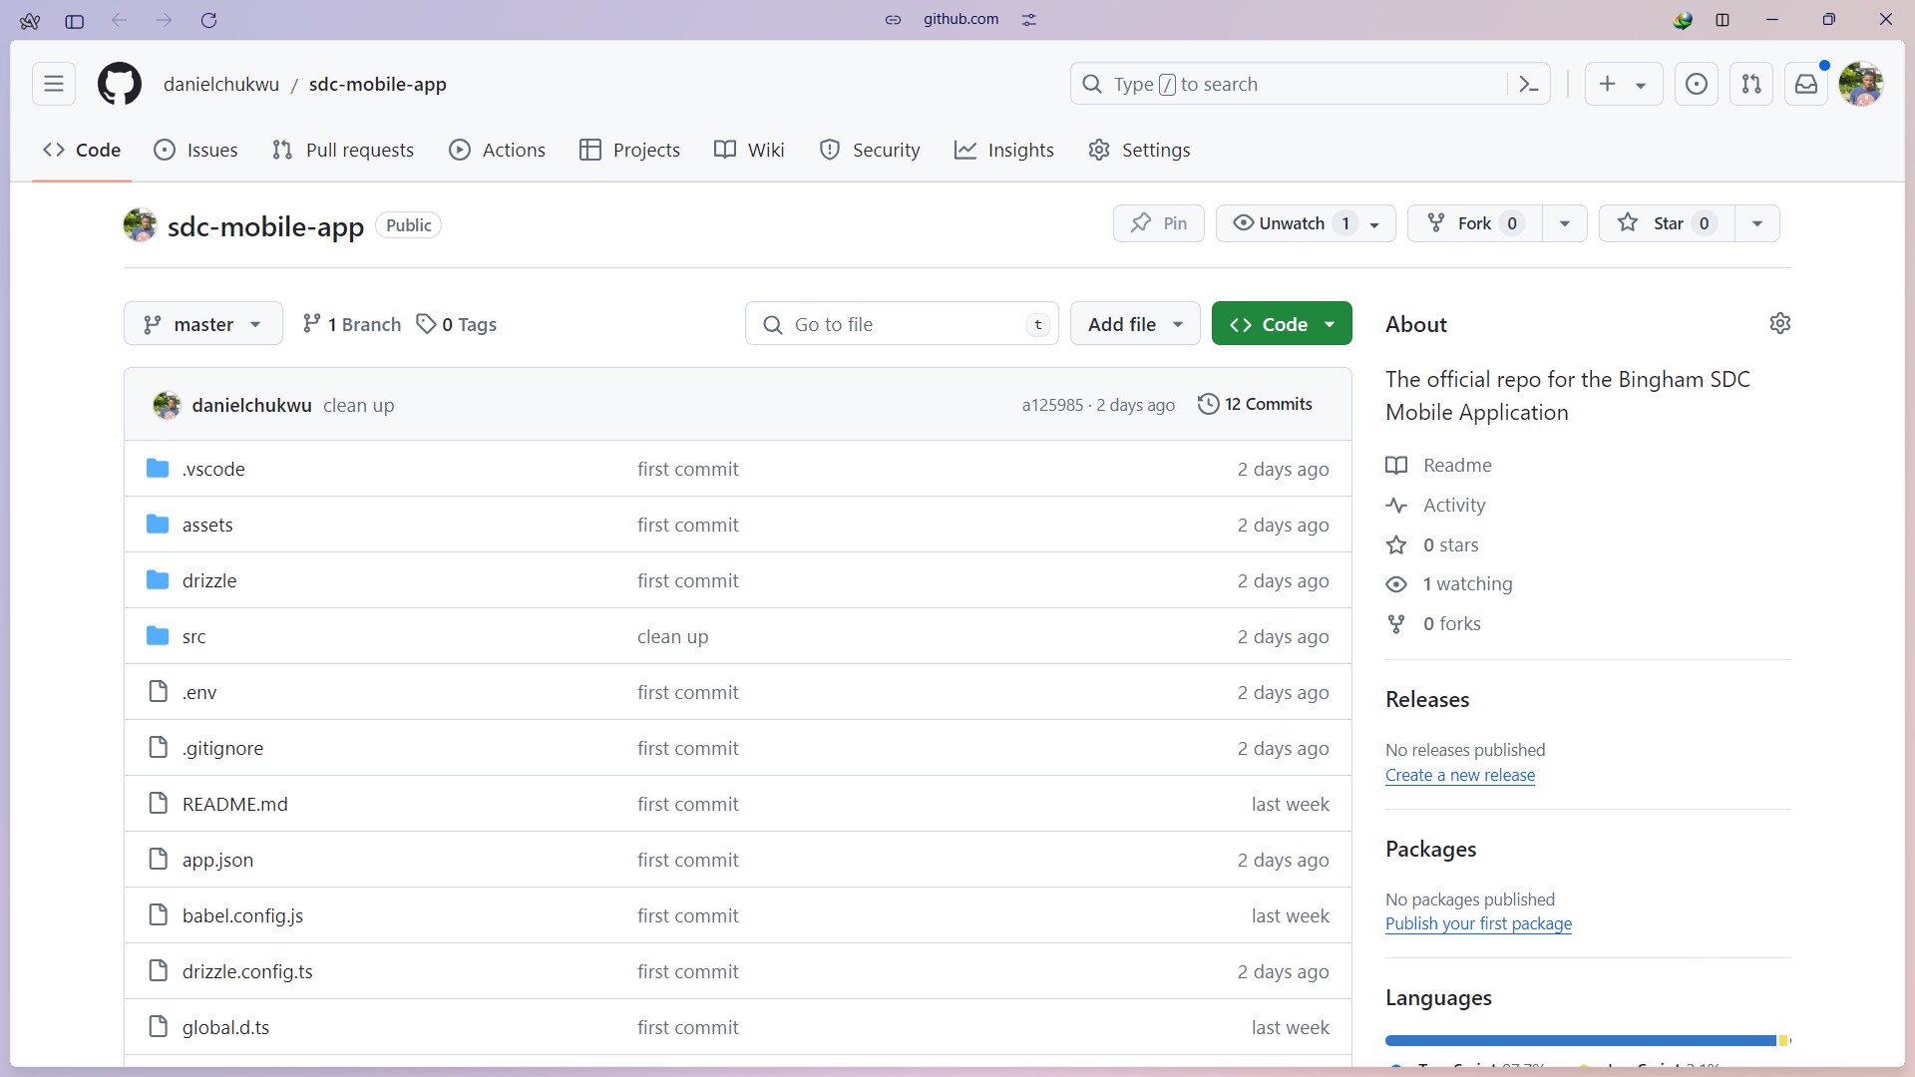

Note: The code repository for the mobile apps source code

#### 4.1.4 Database Implementation

The database used for the Student disciplinary committee application (SDC) is SQLite production ready turso database, which provides an SQLite for Production service, it is also a serverless solution that offers scalability and reliability for data storage. Turso SQLite for Production provides a CLI tool that enables developers to develop locally and easily switch to the hosted database in production.

**Figure 14**

*SDC application turso database*

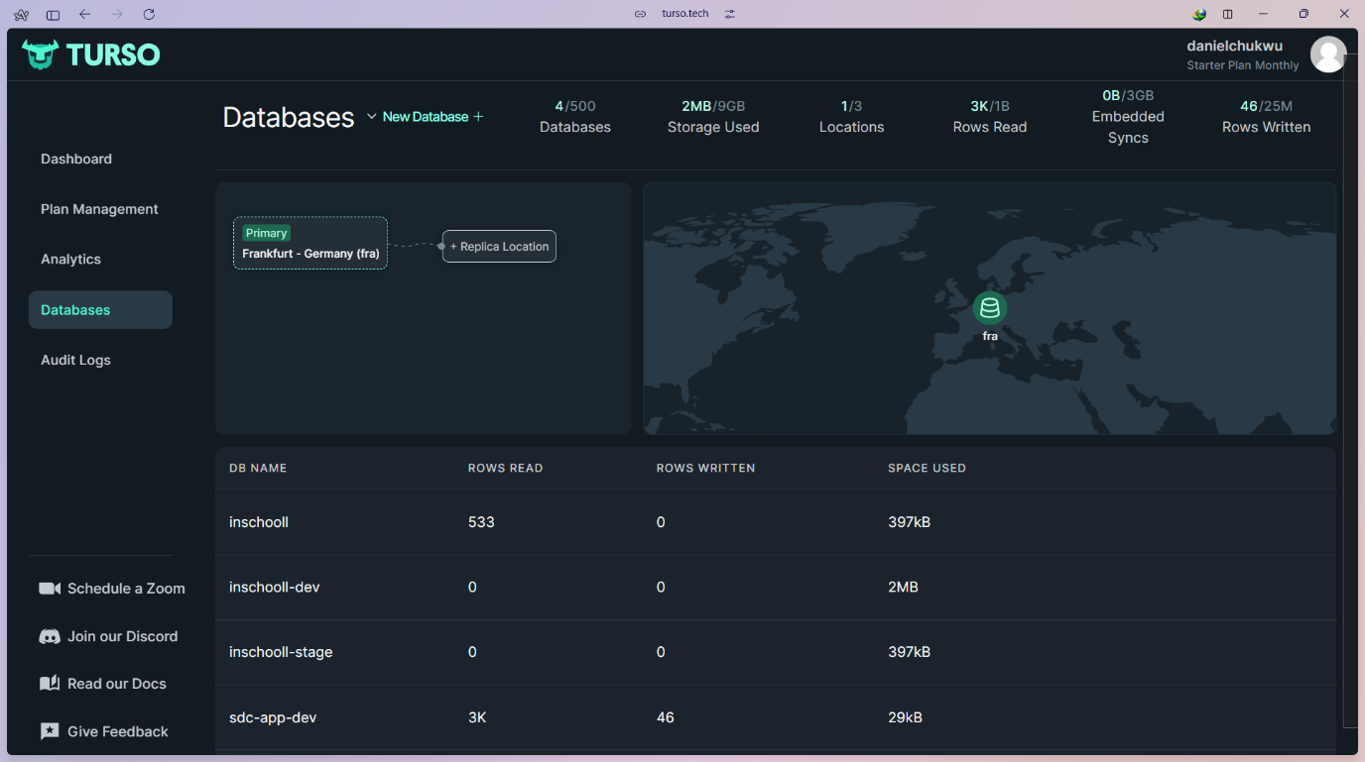

Note: The dashboard of the database service providers used for building this application

**Figure 9**

*Mobile app splash screen*

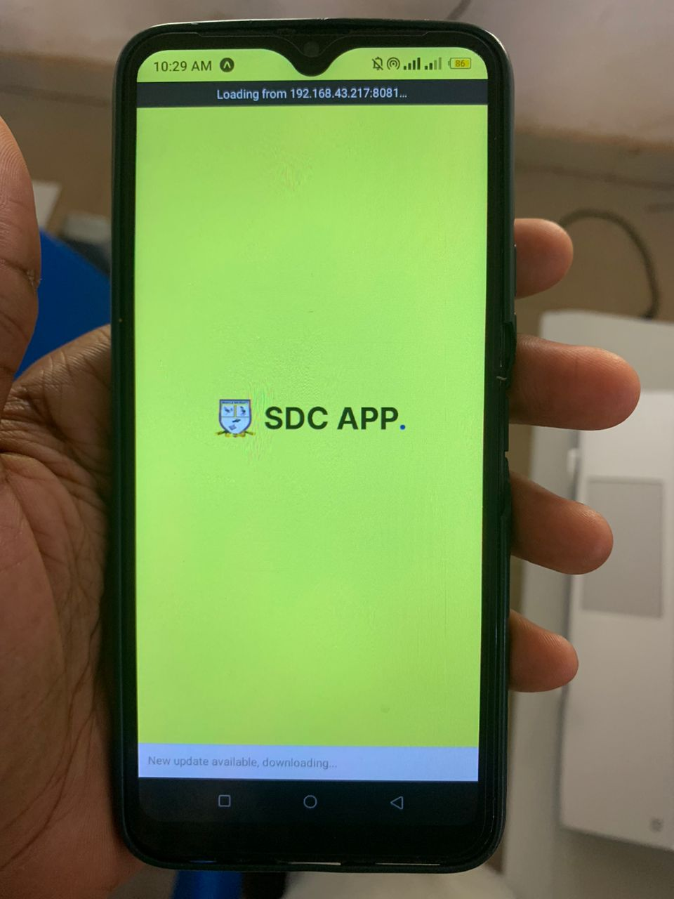

Note: This is the splash screen, it is the first screen that is shown when the mobile application is opened

**Figure 10**

*List of cases screen and a particular case screen*

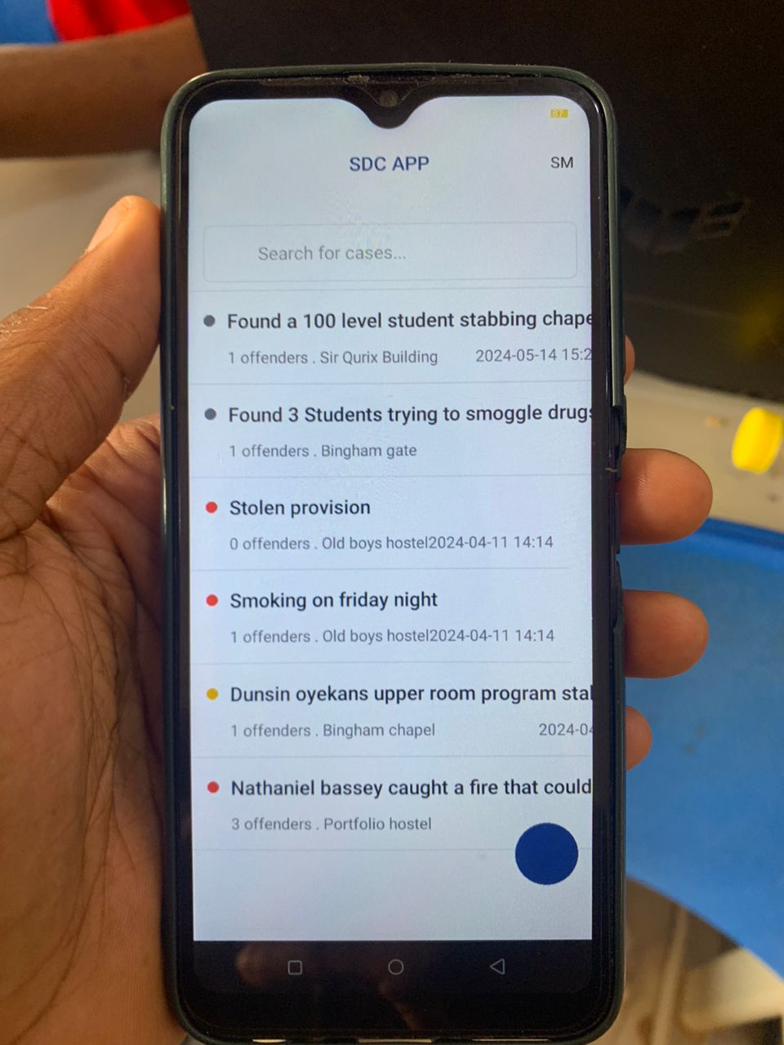 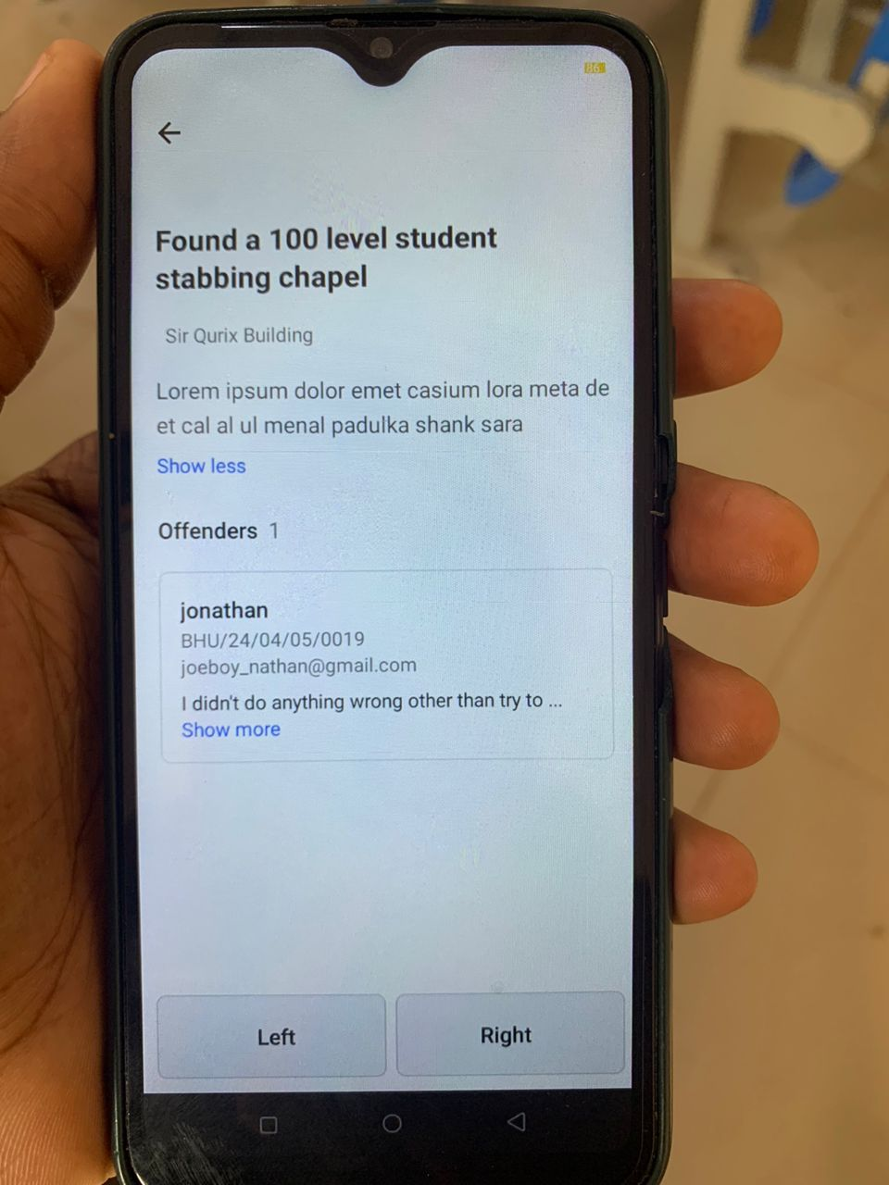

Note: The above shows the home screen which holds a list of already created cases and a dynamic screen that displays more information on a particular case

**Figure 11**

*Case creation screen and an offenders form dialog/modal*

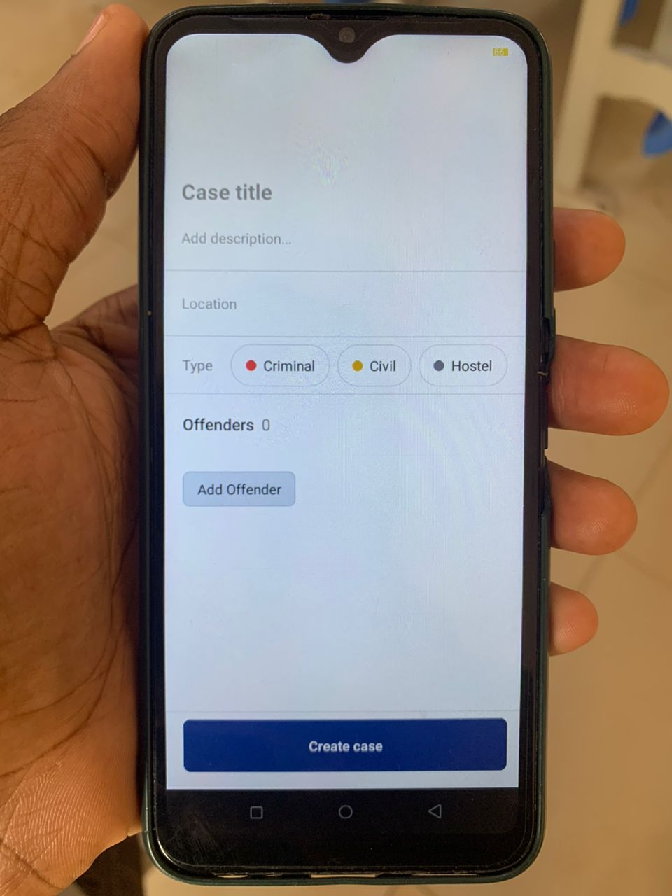 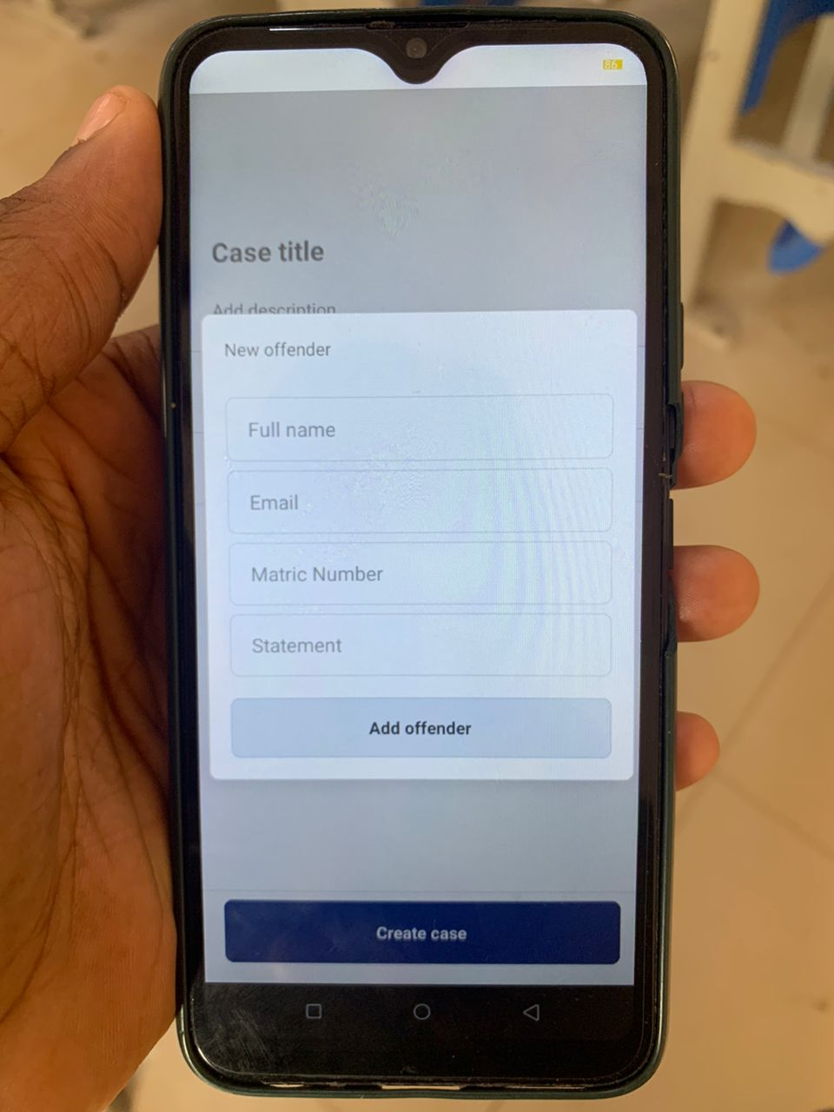

Note: The above screens enable new cases to be created and added to the pool of existing cases

### 4.2 Testing

The testing of the SDC Application was carried out using the following libraries:

1. **jest:** Jest is an amazing, robust, industry-standard JavaScript Testing Framework used by some of the biggest tech companies in the world. It works with projects using: Babel, TypeScript, Node, React, and more. Hence making it a no brainer for the development of the SDC Application.
2. **react-test-renderer:** This package provides an experimental React renderer that can be used to render React components into pure JavaScript objects, without depending on the DOM or a native mobile environment in our case. Which is extremely important.

By using Jest and react-test-renderer, the testing process for the SDC Application is streamlined, making it possible to write more comprehensive tests for the app's components and functionalities.

#### 4.2.1 Unit Testing

Jest and react-test-renderer libraries were used to unit test all the application components and utility functions. The screenshots below show some of these tests.

**Figure 12**

*Unit test code for a card component*

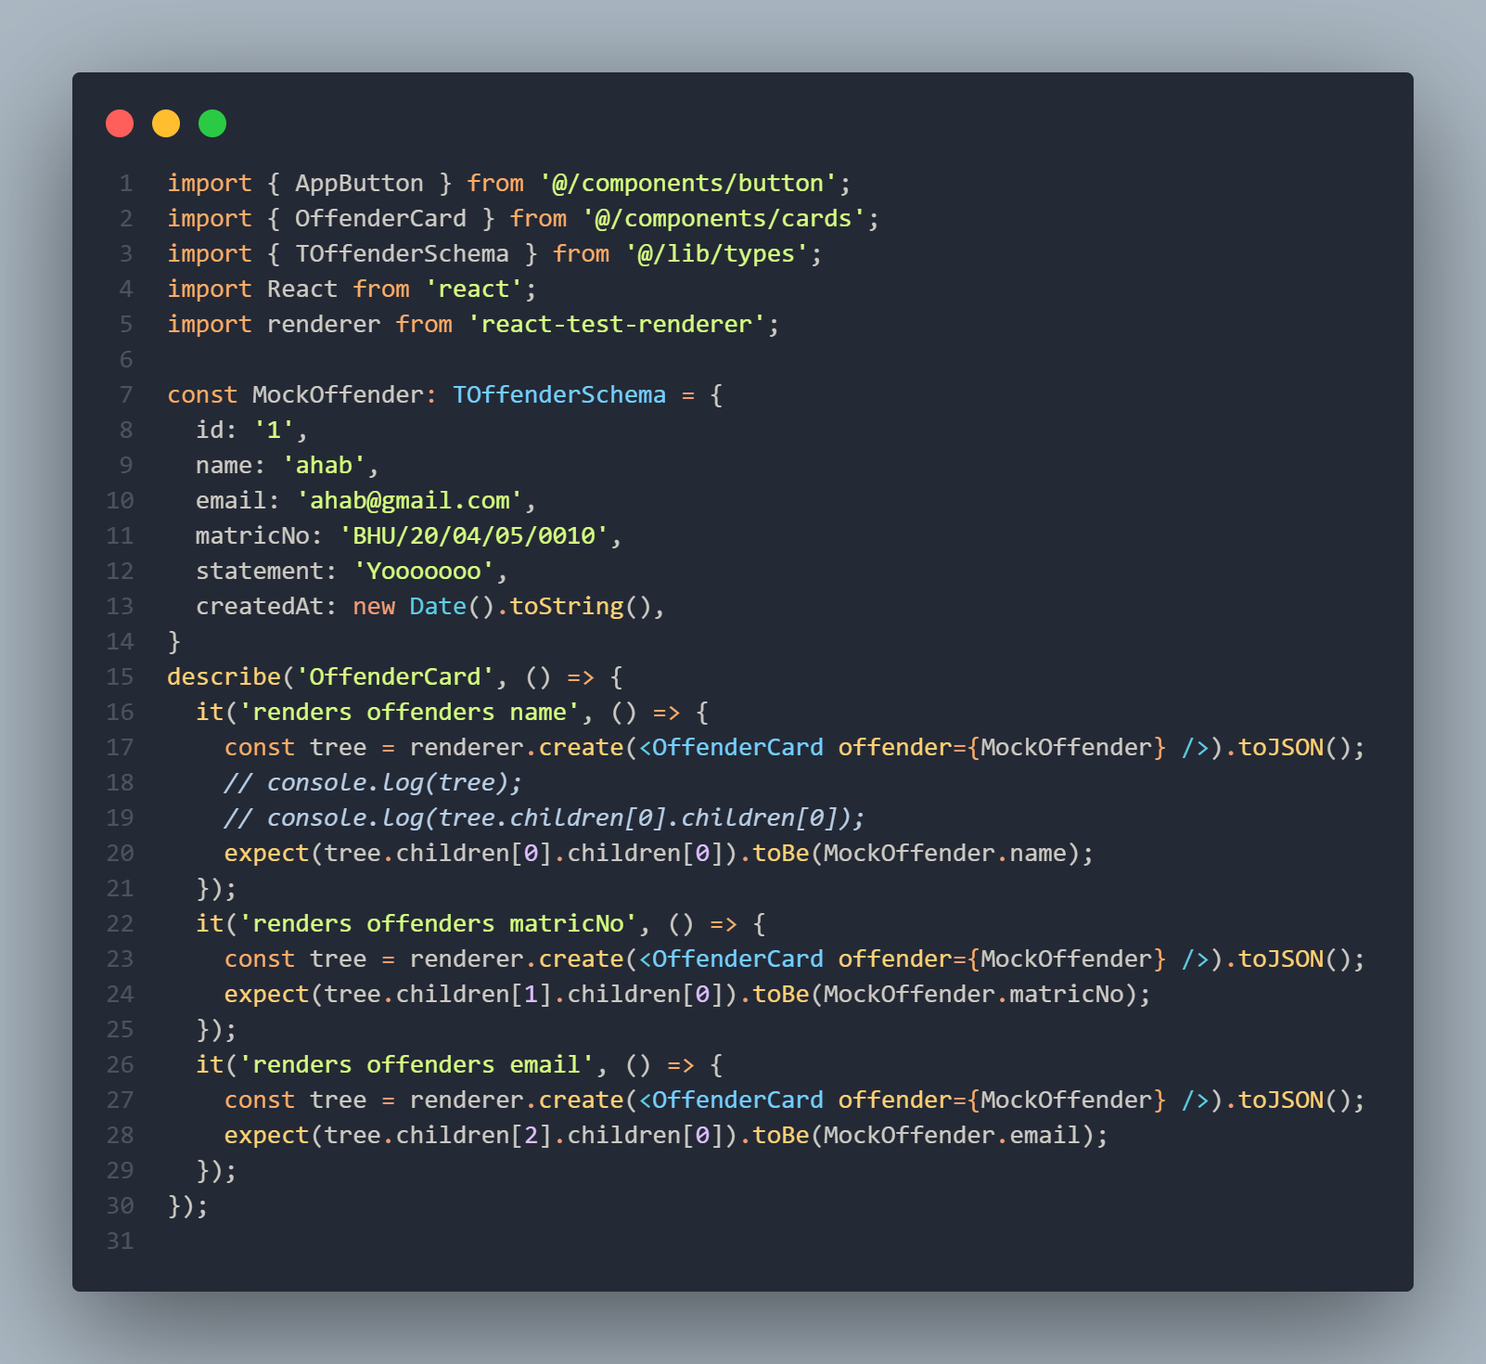

Note: This is a code snippet showing the test code for a particular unit of the application, precisely the OffenderCard component.

**Figure 13**

*Executed test results*

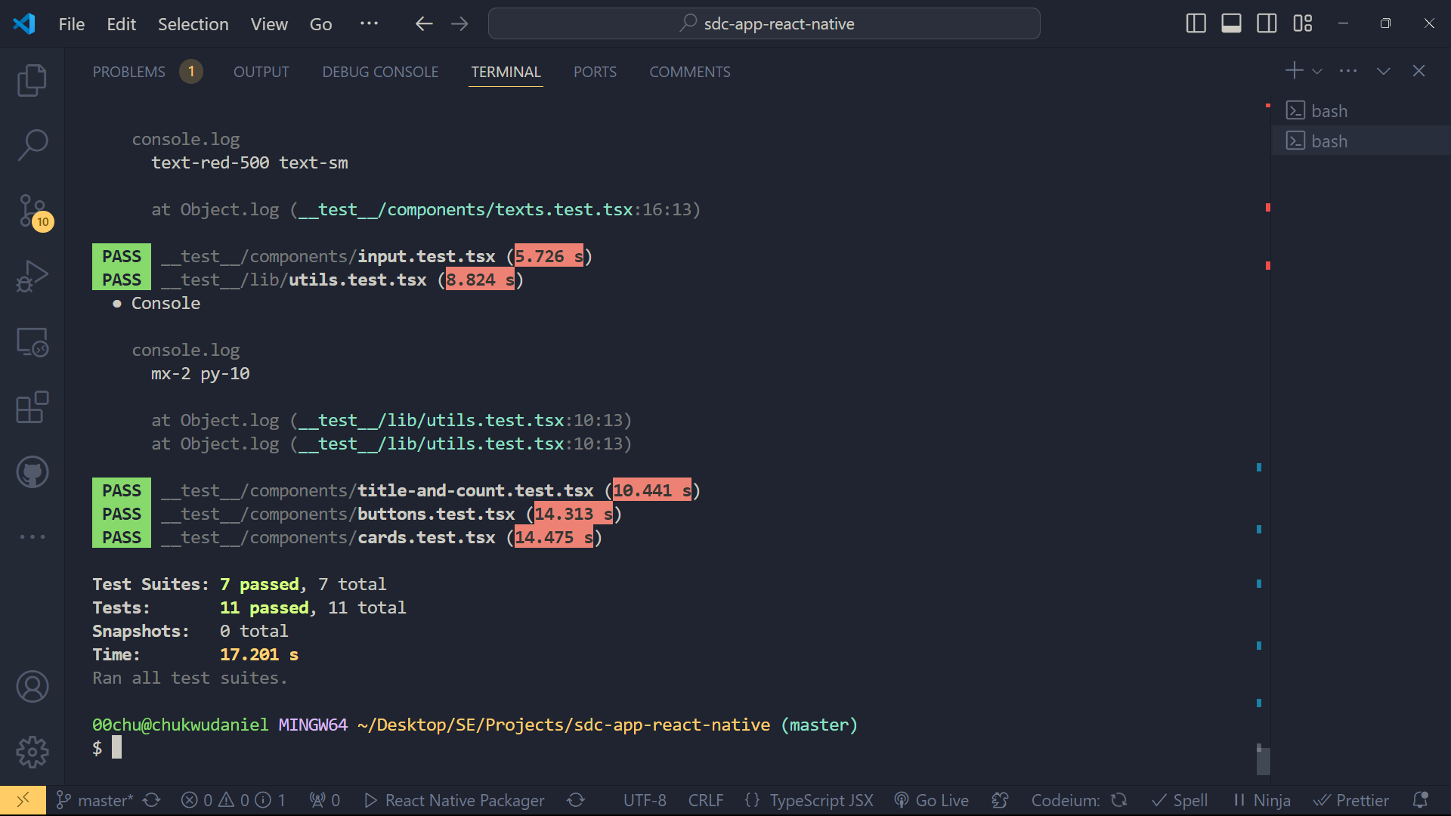

Note: This are the test results that are gotten when the test suites in the codebase are executed

# CHAPTER FIVE

## SUMMARY, CONCLUSION AND RECOMMENDATION

### 5.1 Summary

The intended goal of this project was to design a mobile application to address the need for a Student Disciplinary Committee Application (SDC) to enhance the process of handling disciplinary cases among universities. A set of key recommendations was collected with these general ideas about design and features of the application as a result of a qualitative research that included a quantitative part, which included interviews with the users, case studies, observations. Agile was used as the project development methodology given that it is highly flexible and requires constant engagement with the stakeholders.

#### 5.1.1 Major Findings:

**i. Design and Development:**

The mobile app screens were developed to give friendly user interface to interact when handling cases of discipline. It interesting to note that the project utilized different types of open-source tools among them being DrizzleORM, TursoDB, React Query, React Native, and Expo SDK 51. 0, Bun, Next API Routes, and Hono are all examples of the diverse applications of API routes. To keep the codebase of the backend and the frontend organized, the two codes were hosted on different GitHub repository.

**ii. Database Implementation:**

TursoDB (an SQLite for production database) was employed as the database solution for the application, as it comes with a ton of helpful, out-of-the-box features that aid developers in building apps faster and paying much more attention to the development of the product rather than the managing of a physical server and having to handle all the bottlenecks that come with going down that part.

**iii. Testing:**

Jest and react-test-renderer were adopted to guarantee the application’s reliability and its ability to run through diverse tests. These tools enabled the comprehensive testing of individual elements(units) and the whole platform of the Web Application to be implemented on mobile devices without involving the DOM or the native environments for the mobile devises.

**iv. Challenges Encountered:**

Interoperability was one issue using multiple tools needed a lot of coordination and compatibility tested needed to be conducted. One of the major technical issues that remained a concern for the company was implementing adequate data security and making sure that system could be easily scaled. It was very challenging to get a broad range of user feedback into one paper, so it was important to carefully plan and execute the process.

### 5.2 Conclusion

From the SDC Application project, it is now obvious that technology plays a crucial role in the efficiency of disciplinary cases management in schools. The modern tools in software development and the efficient methodologies employed paved way for building a sound and very friendly application. First, the research methodology conducted during the project was effective in all aspects of it by identifying the key requirements and possible issues in planning, designing, development, implementation, and evaluating the project of a social media platform for promoting education among the youth. These studies point to the conclusion that the extension of disciplinary procedures through digital channels makes them more open and understandable, improves communication between participants, and simplifies the work of both administrators and students.

### 5.3 Recommendation

Based on the findings of the study, the following recommendations are proposed:

**Wider Implementation:** Universities should consider adopting similar digital solutions to streamline their disciplinary processes. The SDC Application can serve as a model for other institutions seeking to enhance their case management systems.

**Continuous Improvement:** The application should be updated from time to time where possible taking into consideration the feedback from the users and the new features they may require in the course of their activity. Also, some updates and maintenance should be constantly done regularly so that it can remain effective and secure.

**Training and Support:** All users, including the SDC members should undergo comprehensive programs of training in the use of the application. The users will require help to get the best out of the application through technical support being provided at later intervals.

**Further Research:** Further study should examine the organizational culture and students’ behavior changes over a long time in institutions where such digital disciplinary systems have been implemented. Furthermore, there are other options to improve the model, including additional functional opportunities like the utilization of artificial intelligence in analytics and report generation automation.

**REFERENCES**

Blandford, S. (1998). Discipline in schools. Google Books. https://books.google.com.ng/books?hl=en&lr=&id=13oaXCiHbqAC&oi=fnd&pg=PT10&dq=discipline+in+schools&ots=8As7gpBeVD&sig=7DsMbOiKdVSHXb2KOiqoyHJfYpg&redir_esc=y

Mao, J., Vredenburg, K., Smith, P. W., & Carey, T. (2005). The state of user-centered design practice. Communications of the ACM, 48(3), 105–109. https://doi.org/10.1145/1047671.1047677

Hung, L. D. (2023). Web development with T3 stack. Theseus. https://www.theseus.fi/handle/10024/802481

Esfahani, H. C., & Yu, E. (2010). A repository of agile method fragments. In Springer eBooks (pp. 163–174). https://doi.org/10.1007/978-3-642-14347-2_15

Villarreal, D. L. (2021, March 8). Students constitutional rights and the university disciplinary committee. HeinOnline. https://heinonline.org/HOL/LandingPage?handle=hein.journals/ncclj3&div=9&id=&page=

Karlesky, J. J., & Stephenson, D. G. (1971). Student disciplinary proceedings: Some preliminary questions. The Journal of Higher Education, 42(8), 648–656. https://doi.org/10.1080/00221546.1971.11774894

Reddick, S. R. (2020). Due process rights in student disciplinary matters. HeinOnline. https://heinonline.org/HOL/LandingPage?handle=hein.journals/jcolunly14&div=17&id=&page=

J. Crim. L. & Penal Stud. (2019). The authority of disciplinary committee for students to oblige third parties to a specific behavior. HeinOnline. https://heinonline.org/HOL/LandingPage?handle=hein.journals/jlocllwap23&div=34&id=&page=

Notar, C. (2009, September 1). Disciplinary action committee (DAC). | Education | EBSCOhost. EBSCOhost. https://openurl.ebsco.com/EPDB%3Agcd%3A10%3A1154874/detailv2?sid=ebsco%3Aplink%3Ascholar&id=ebsco%3Agcd%3A44016929&crl=c

Pedley, J. (2007). The development of a student contract and improvement in student disciplinary procedures at Massey University. HeinOnline. https://heinonline.org/HOL/LandingPage?handle=hein.journals/anzled12&div=8&id=&page=

Heyman, I. M. (2022). Some thoughts on university disciplinary proceedings. HeinOnline. https://heinonline.org/HOL/LandingPage?handle=hein.journals/calr54&div=13&id=&page=

Picozzi, J. M. (2020). University disciplinary process: What's fair, what's due, and what you don't get. HeinOnline. https://heinonline.org/HOL/LandingPage?handle=hein.journals/ylr96&div=87&id=&page=

Bayrami, M. (2020, April 21). A comparison of personality characteristics and coping strategies in students with record in disciplinary committee of university and normal students. Tabriz University Journal. https://psychologyj.tabrizu.ac.ir/article_4213.html?lang=en

Ige, S. (2016). Factors influencing disciplinary committee effectiveness: The case of public secondary schools in Ondo State, Nigeria. DigitalCommons@Fayetteville State University. https://digitalcommons.uncfsu.edu/jri/vol4/iss3/3/

Aloka, P. J. O., & Bojuwoye, O. (2023). Gender differences in decisions on student disciplinary behaviours by disciplinary panels of selected Kenyan secondary schools. https://journals.co.za/doi/abs/10.10520/EJC136364

Stoner II, E. N., & Martineau, B. J. (2019). Disciplinary and academic decisions pertaining to students in higher education. HeinOnline. https://heinonline.org/HOL/LandingPage?handle=hein.journals/jcolunly27&div=20&id=&page=

Papadakis, M. A., Hodgson, C. S., Teherani, A., & Kohatsu, N. D. (2004). Unprofessional behavior in medical school is associated with subsequent disciplinary action by a state medical board. Journal of Medical Regulation, 90(1), 16–23. https://doi.org/10.30770/2572-1852-90.1.16

Wilson, J. M. (1996). Processes for resolving student disciplinary matters. New Directions for Student Services, 1996(73), 35–52. https://doi.org/10.1002/ss.37119967305

Walton, T. K. (2019). Protecting student privacy: Reporting campus crimes as an alternative to disclosing student disciplinary records. HeinOnline. https://heinonline.org/HOL/LandingPage?handle=hein.journals/indana77&div=10&id=&page=

Daud, N. M., & Mohamed, I. S. (2009). Evaluating technology resistance and technology satisfaction on students’ performance. Mendeley, 26(4), 298–312. https://doi.org/10.1108/10650740910984637