EXECUTIVE SUMMARY

Analytical report for INFORMA PLC: Introduction, Fundamental Analysis, and Conclusion. Collect financial statements, visualize trends, and compare findings with previous analysis to investigate potential impacts on share prices.

Table of Contents

1. Introduction
2. Stock Market Analysis
3. Descriptive Analysis

- Informa PLC

- Eventbrite

b) Training Set and Moving Average

c) Applying Exponential Smoothing Techniques

d) Investigating Relationships among Stock Prices of Informa PLC and Competitors/Benchmarks

1. Fundamental Analysis

a) Visualizing Financial Statements

b) Comparing Findings with Stock Market Analysis

1. Conclusion

Introduction

Informa PLC is a leading events, intelligence and research group with £10.11bn market cap. The purpose of me conducting stock & fundamental analysis is to provide investment advice, identify trends, estimate returns & investigate financial position's impact on share prices.

Stock Market Analysis

We created Training and Test sets for our company Informa PLC and its competing company Eventbrite. We will be analyzing the data for both of these companies.

Training and Test Sets setup

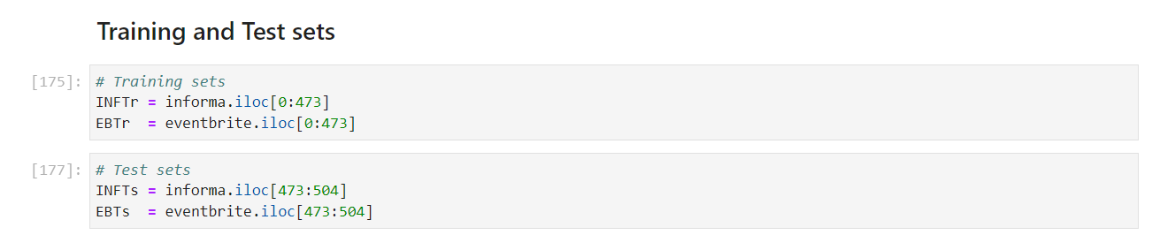

Descriptive Analysis

Informa PLC

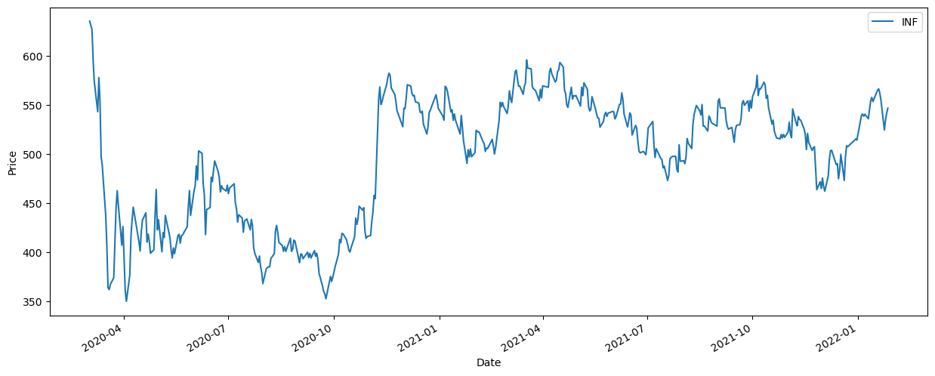

As you can see, Informa PLC's stock price was quite noisy in the year 2020. The stock price ranged from £354.40 to £659.60 per share. However, the price surged more towards the end of 2020.

Informa Plc yearly returns

* Year Return
* 2022 2.78%
* 2021 1.69%
* 2020 -0.40%

Eventbrite

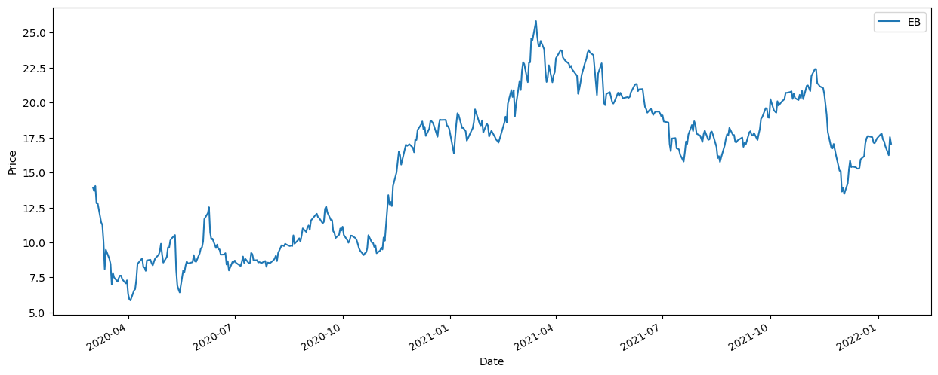

As you can see, Eventbrite's stock price were low and quite unstable for the most of 2020. The price ranged from $5.86 to $25.81 per share. It surged late 2020, but still remained unstable

Eventbrite yearly returns

* Year Return
* 2022 -8.74%
* 2021 -13.87%
* 2020 -40.46%

Training Set and Moving Average

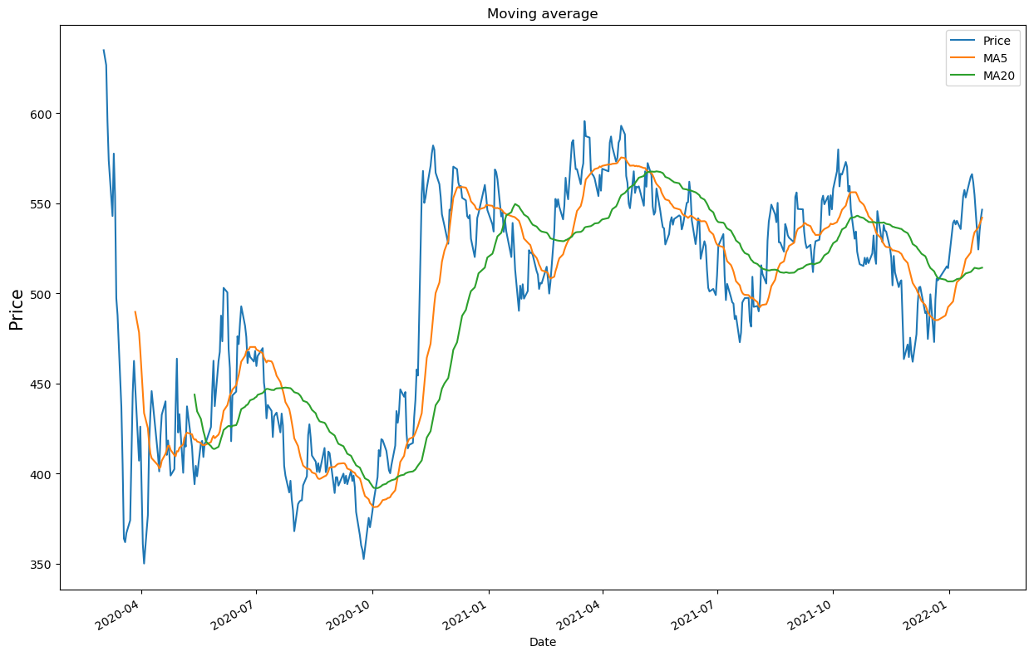

We implemented a moving average crossover trading strategy on the stock prices of both companies, Informa PLC and Eventbrite, using a 20-day and 50-day moving average.

For Informa, PLC the strategy showed a return of 10.26%, while for Eventbrite the return was 6.42%.

Single Exponential Smoothing

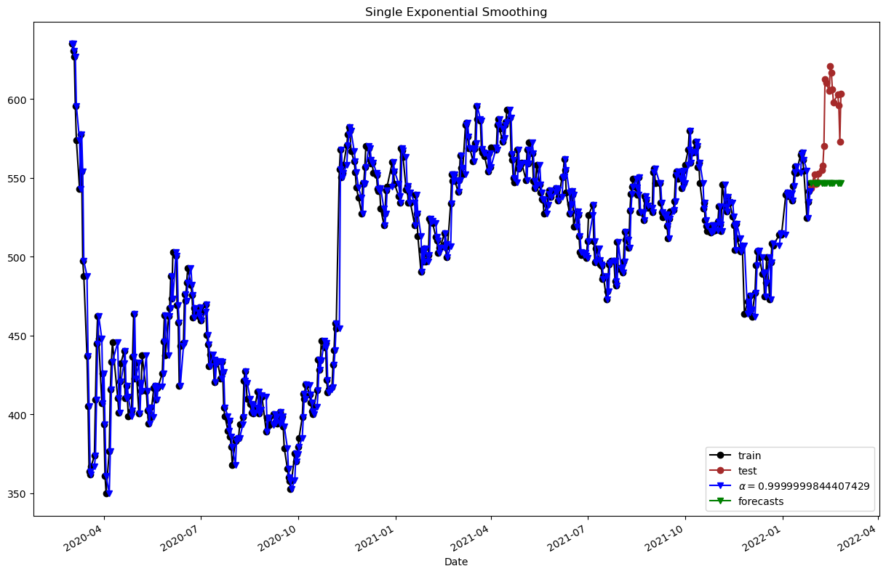

Single smoothing is used to forecast future values in a time series with no trend or seasonality.

Double Exponential Smoothing

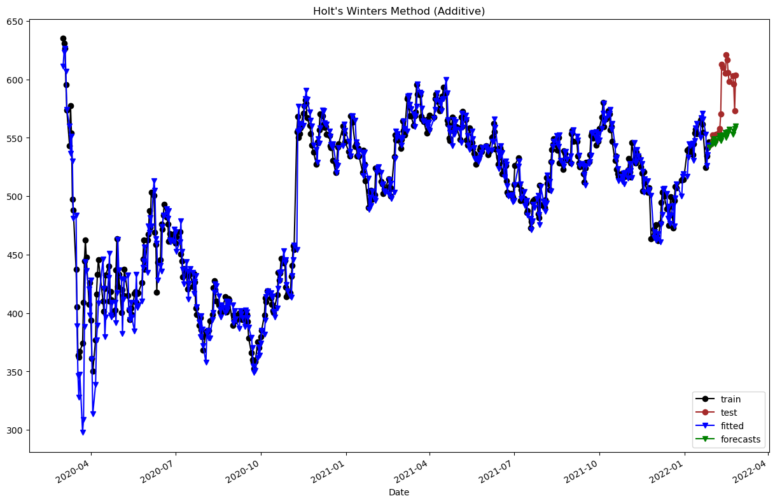

Double smoothing is used to forecast values in a time series with a linear trend.

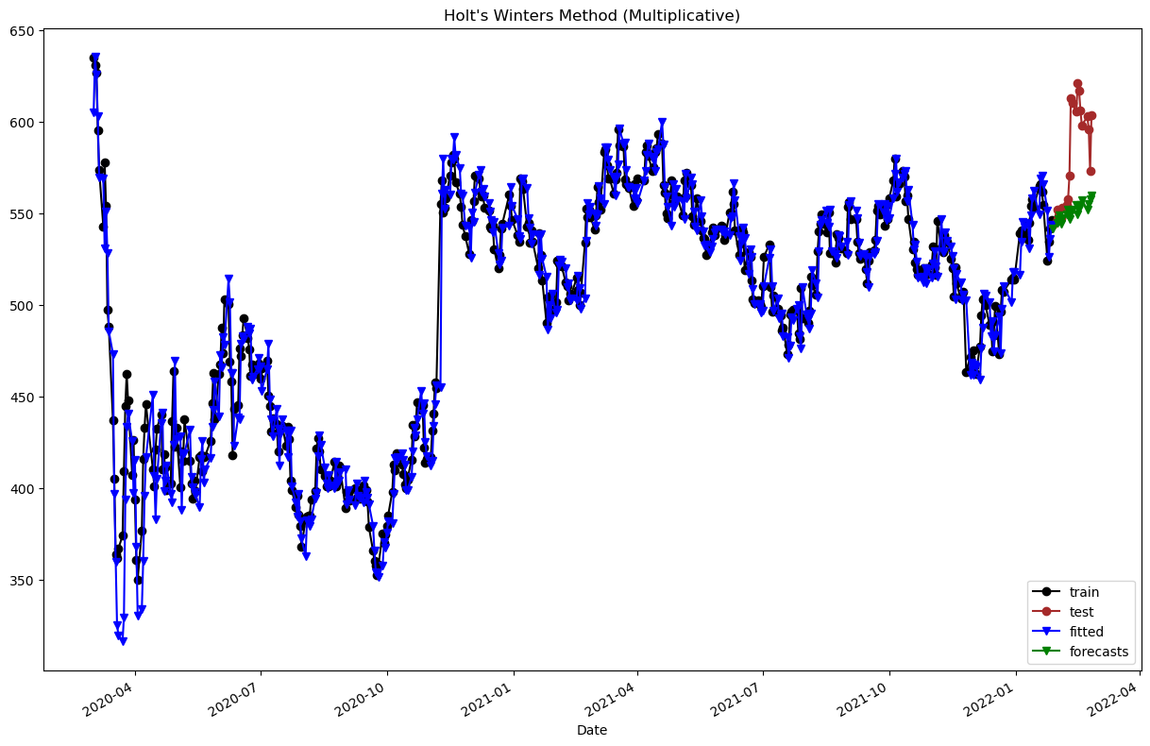

Holt's Winters (Additive)

Holt Winter's smoothing, also known as triple smoothing, is used for time series data with both a trend and seasonality.

Relationships among the stock prices of Informa PLC and Eventbrite

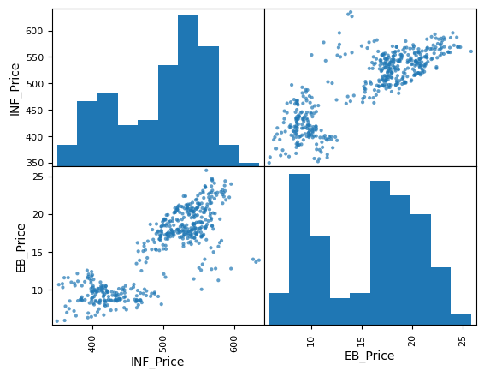

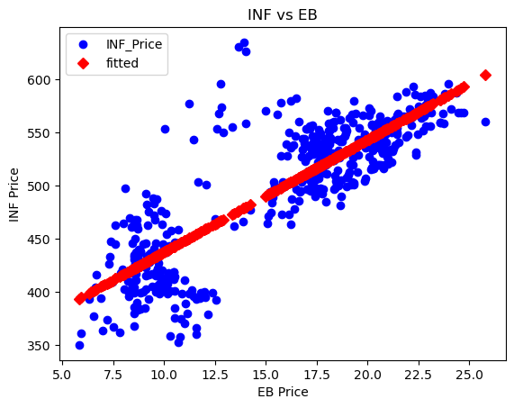

Over here we have a linear positive correlation between the prices of Informa PLC and Eventbrite

Fundamental analysis

The share prices of Informa PLC have been fluctuating over the three years in question.

Balance Sheet

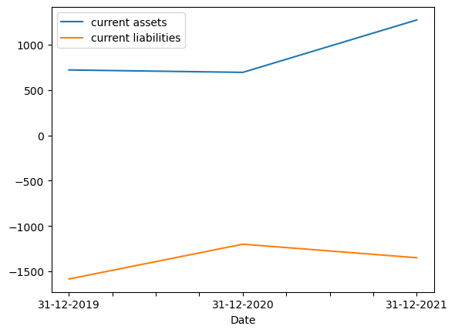

We see that current assets increased significantly from 2020 to 2021, while current liabilities remained relatively stable. This could signal strong financial health, which may have contributed to the increase in share price in 2021 from 5.2 to 17.9.

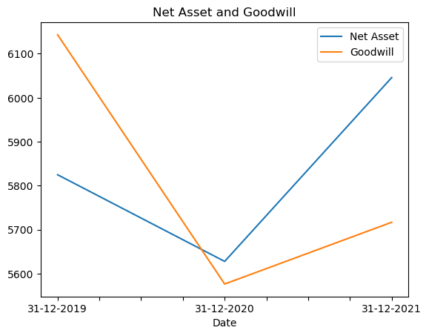

The net cash flow increased from 2019 to 2021, which could be seen as a positive sign for investors. However, the share price decreased in 2020 from 5.3 to -73.4, despite the positive cash flow trend.

Income Statement

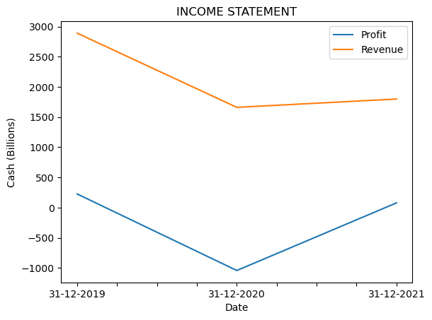

Regardless of the company’s revenue having fallen from 2019, we see that the revenue increased in 2021 compared to 2020, and the company returned to profitability. This could also be seen as positive signs for investors, which may have contributed to the increase in share price from 5.2 to 17.9.

Cash Flow

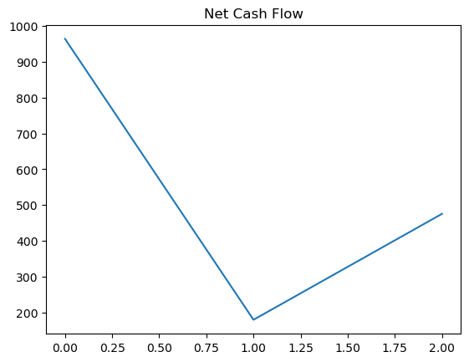

The net cash flow for the company increased from 2019 to 2021. In 2019, the net cash flow was 964.1, which increased to 475.2 in 2021. This indicates that the company generated more cash in the later year, which could be due to increased sales or more efficient management of working capital.

Conclusion

Overall, there are many factors that can impact share prices beyond just financial statements, such as market trends, competition, and macroeconomic conditions. While financial statements are important in analyzing the financial health of a company, they may not always have a direct impact on share prices. Thank you.