# Homework 10

Due date: Apr 16, 2020, 9:30am

Instructions

Exercise 1 & 2 require writing a proof. A proof is a sequence of valid arguments that can be traced by the reader. Think of your proof as a story: Have a storyline in your proof instead of having various disconnected parts. Write in full sentences explaining what you are showing. Do not place any formulas in your proof without any explanation.

1. (15 points)

Let S be a set defined as follows:

Base case: 4 is an element of S

Recursive case: If x is in S, then x2 is in S.

Use structural induction to prove that all element in S are even, where an even number is defined as a number that can be written in the form 2∙k for an integer k.

**Base case: The base case of the definition of S explicitly states that 4 is an element of S. Since 4 is (2 *2) it is an integer of k and is thus even.**

**Inductive case: In the recursive step of the definition of S a new element is constructed by adding two elements that are in S. Assume x is in S and is an integer of k. Since x is an integer of k, x = 2*k. We can write it as x^2 = (2*x)^2. Therefore x^2 is a element of S.**

1. (15 points)

We define a perfect ternary tree as follows:

Base case: A single node is a perfect ternary tree.

Recursive case: If T1, T2, and T3 are perfect ternary trees with roots r1, r2, and r3 respectively, and T1, T2, and T3 have distinct nodes and T1, T2, and T3 have the same height, then the structure with root r and with an edge from r to root r1, an edge from r to r2, and an edge from r to r3 is a perfect ternary tree.

Use structural induction to prove that a perfect ternary tree has (3h + 1 - 1) / 2 nodes where h is the height of the tree.

**Basis case: A perfect ternary tree T of height 0 consists of a single node. Therefore, the number of nodes is 1 = (30 + 1 - 1) / 2 = (3h + 1 - 1) / 2.**

**Inductive case: Induction hypothesis: Assume that the number of nodes of all perfect binary trees with height h is (3h + 1 - 1) / 2 for a height h ≥ 0.**

**Inductive step: Let T be a perfect ternary tree with height h + 1. We need to show that the number of nodes of T is (3h + 1 - 1) / 2. Since the height h + 1 of T is at least 1 (since h ≥ 0), T has more than one node. In particular, the root of T has a nonempty left, right, and middle subtree. Each of the two subtrees is a perfect ternary tree since T is a perfect ternary tree. In addition, we know that each subtree has height h. By induction hypothesis the three subtrees have exactly (3h + 1 - 1) / 2 ­nodes. In summary, we have shown that a perfect ternary tree with height h + 1 has (3h + 1 - 1) / 2 nodes.**

1. (12 points)

Draw a binary search tree with the nodes cat, cow, dog, duck, goat, goose, hen, horse, mouse, pig, rooster, sheep, turkey and that meets the requirement below. Node values are compared lexicographically:

1. The tree is complete.
2. The tree has the greatest possible height.
3. The tree is height-balanced and has the greatest possible height among the height-balanced trees with the given nodes.

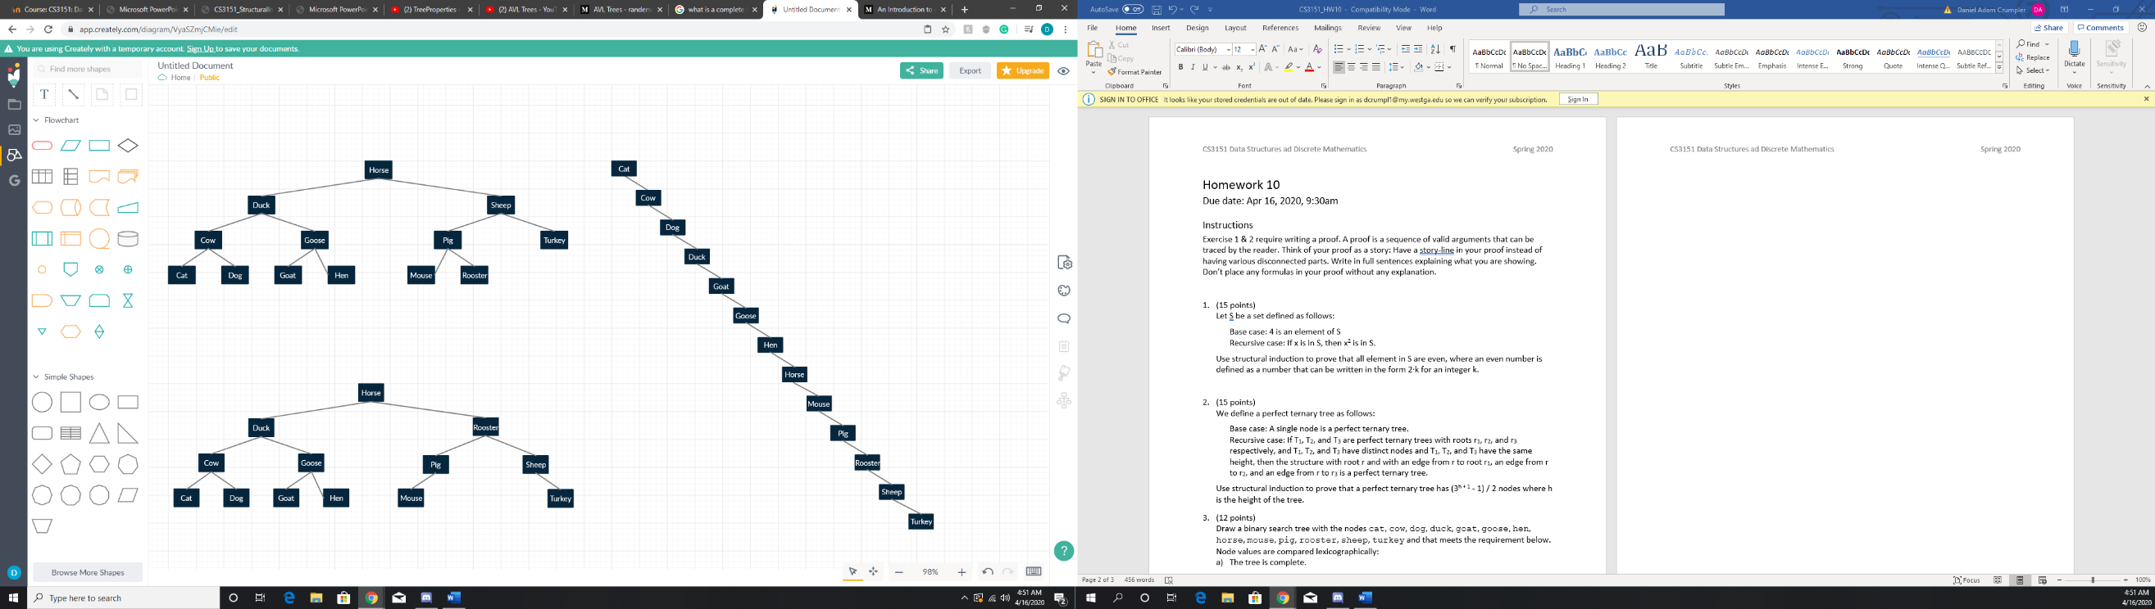

b)

a)

c)

1. (8 points)

Determine the balance factor of the specified nodes and decide whether the tree is an AVL tree. The numbers represent the comparable node values.

-1

|  |  |
| --- | --- |
| 1. Balance factor of 20: **-1**   Balance factor of 15: **2**  Balance factor of 17: **-1**  Is the tree an AVL tree? **NO** | A close up of a map  Description automatically generated  -1  0  2  -1  0  0 |
| 1. Balance factor of 20: **0**   Balance factor of 15: **0**  Balance factor of 16: **0**  Is the tree an AVL tree? **YES** | A close up of a map  Description automatically generated  -1  0  0  0  0 |

Submission

Submit a single PDF file (preferred) or a single MS Word document with your solutions. No other file formats are accepted. If you prefer to write (or draw) your solution by hand and you do not have a scanner, take pictures of your hand-written solutions and imbed the pictures in a Word document.