Handyman Tools

Overview of Handyman Tools

A national chain of tool rental stores, Handyman Tools, has decided to try out a new online tools rental service for its customers. They’ve already done an informal survey of their regular rental customers and determined that the majority of them would be interested in online inventory and reservation services. At the same time, Handyman Tools has decided to upgrade their entire paper record based tools rental service to improve efficiency in tracking a larger inventory. Your job is to develop the information management system that supports some of the services involved in the tools rental service. Handyman Tools has decided that each store will have its own isolated instance of the online application.

Customers

The Handyman Tools rental service will have 2 types of users, the rental customers and clerks on duty. A customer is any user interested in renting a tool. The clerk on duty represents the employee responsible for handling the inventory.

In the rest of this document, we first describe the interface for each user type, then present aspects of the system as a whole. We will assume throughout the document that all users will access the system through the same entry point (Figure [1]).

The customer logs in by entering a username and password, selecting the “Customer” radio button, and clicking on enter. If no customer exists in the system with that username, then a new interface (see Figure [2]) will pop up prompting the user to create a new profile for accessing the system. If a valid customer exists with that login name, and they have entered the correct password, then a different interface (Figure [3]) will be loaded. The customer login name is always their email address.
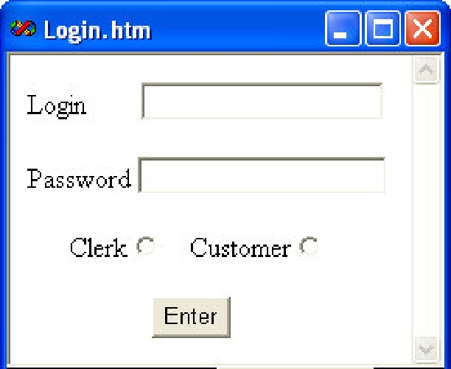

Figure 1. Login screen for all users.
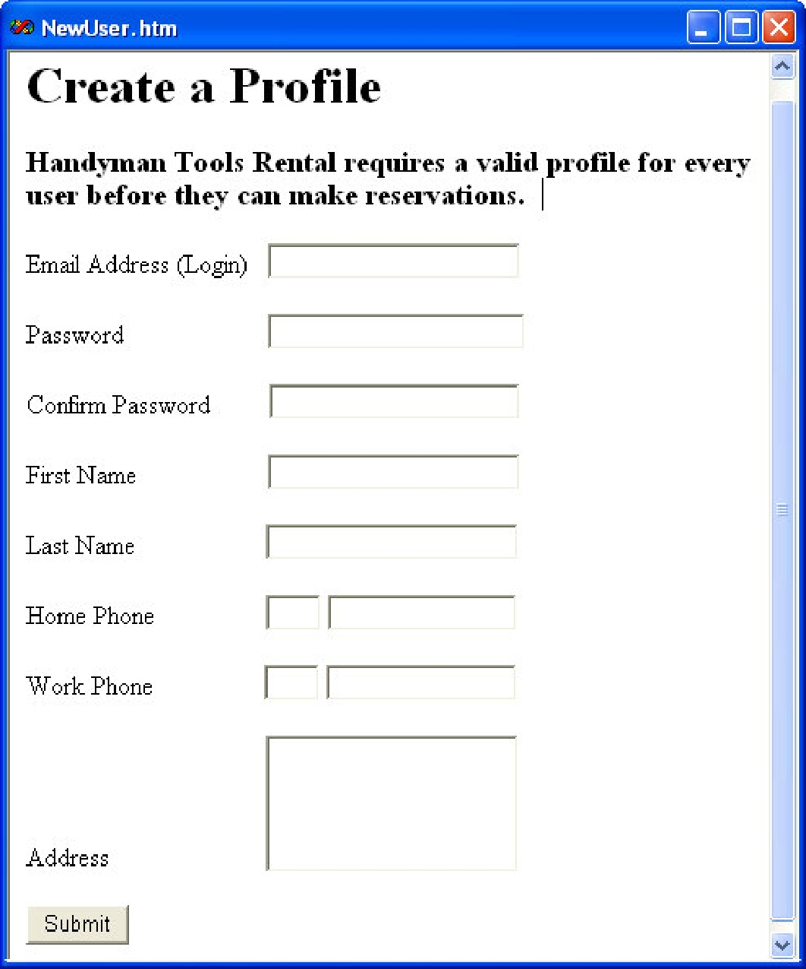

Figure 2. Creating a New User.
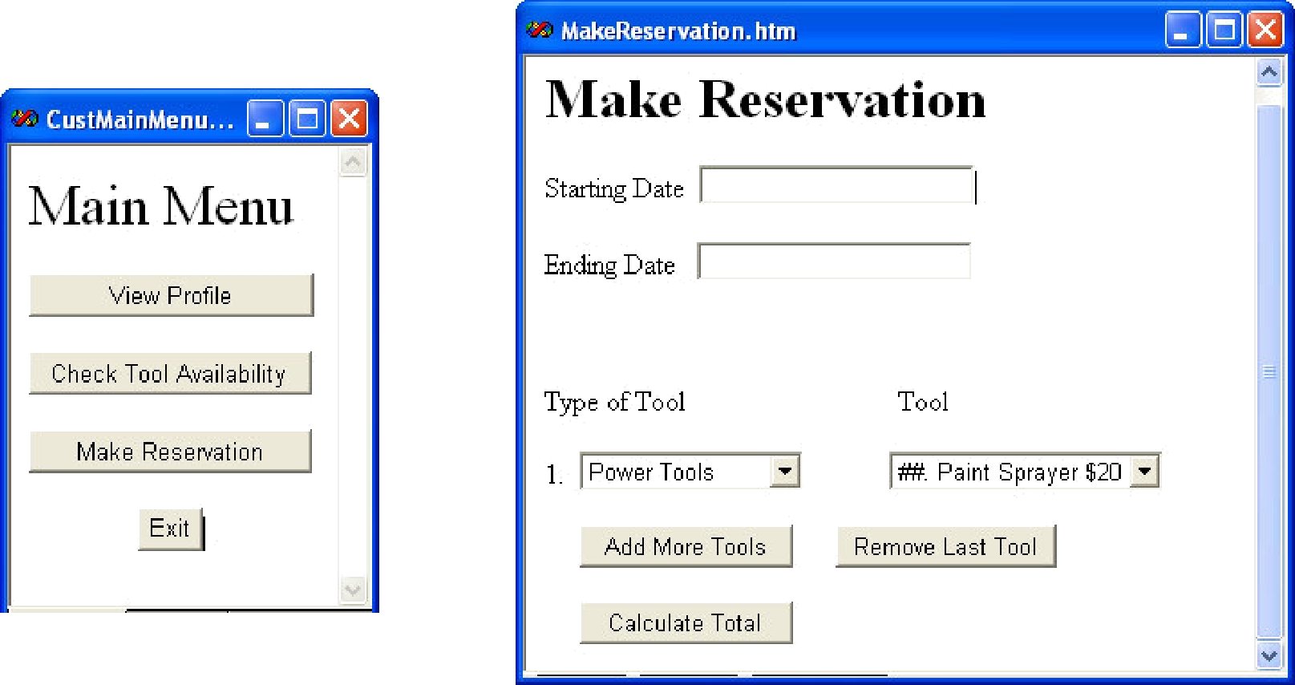

Figure 3. Customer Main Menu

Figure 4. Make Reservation Screen.
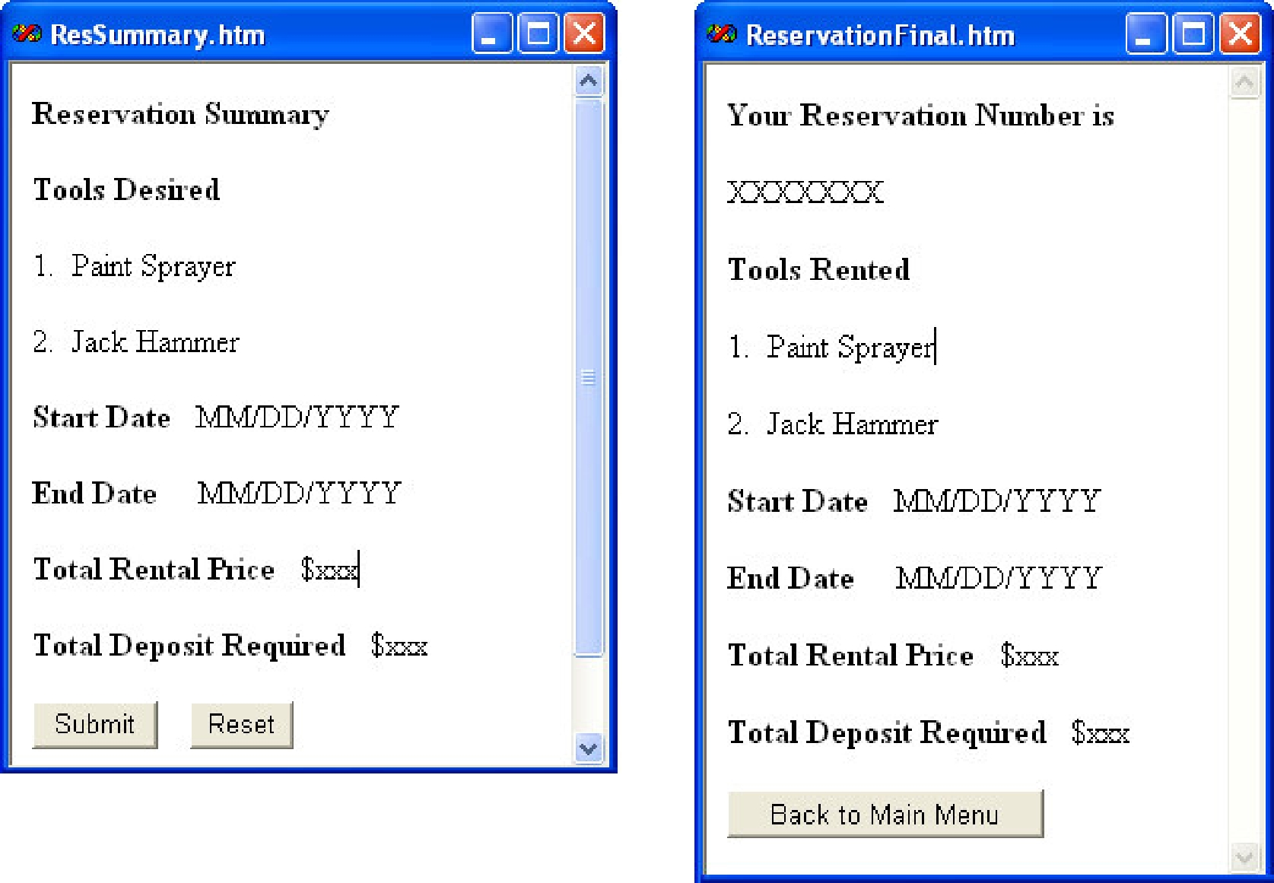

Figure 5. Reservation Summary

Figure 6. Reservation Summary and Number.
Make Reservation

When the “Make Reservation” button is selected from the main menu, a new interface is loaded into the browser (Figure [4]). The customer enters a start and end date for the reservation, and selects a tool type. The possible types of tools correspond to the categories of tools available for rental: hand tools, construction, and power tools. The contents of the tool drop down menu will depend on the tool type selected by the user, and the inventory available for rent. For each tool option, the system presents the tool number, an abbreviated description, and one day’s rental price. A user is allowed to rent up to 50 tools per reservation.

When the “Calculate Total” button is pressed, a summary of the reservation (Figure [5]) is displayed before being entered into the system. The total rental price and the total deposit price, which will be refunded upon returning the tools, is displayed for all tools. The rental price is calculated as the sum of the rental prices for all tools rented, multiplied by the number of days over which they are rented. The total deposit price is the sum of the deposits required for each individual tool.

When the “Submit” button on Figure [5] is pressed, a final reservation screen (Figure [6]) should pop up if the reservation is successful, displaying the reservation number in addition to the reservation summary. No reservation should be successful if any of the tools being reserved are already reserved over the same time period.
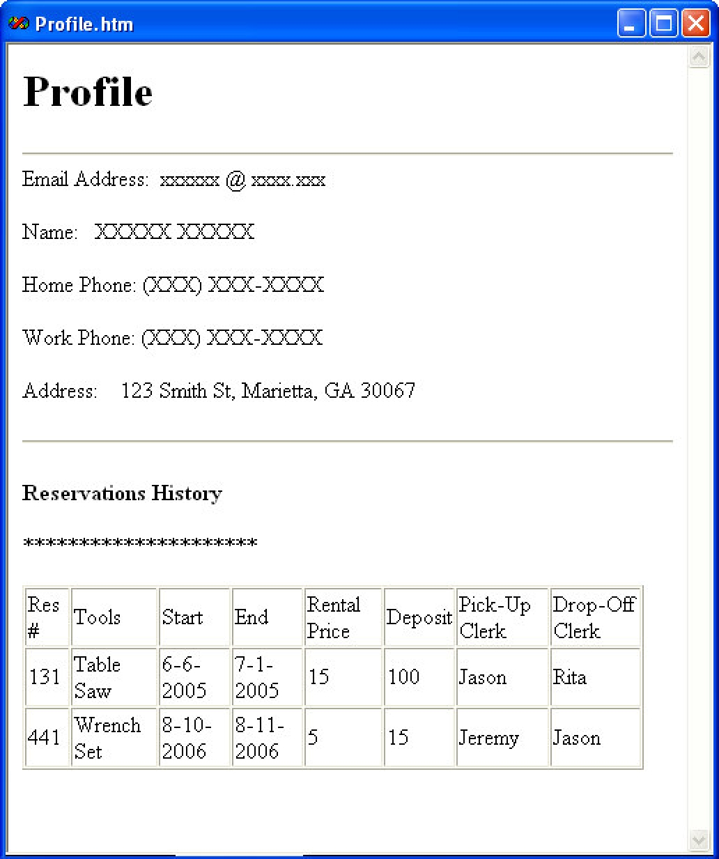

Figure 7. Viewing the rental customer profile.

View Profile

When a rental customer selects the “View Profile” option from the main menu, the view profile page (Figure [7]) is loaded into the browser. The profile lists all of the known information about the user, including profile information, and rental history. The rental history lists the summaries for all reservations made by the user, ordered from most recent to oldest, and includes the names of any clerks who have handled the reservation.

Check Available Tools

The final option available to the rental customer is to check the inventory of the store available over a specific time period. When the “Check Tool Availability” option is selected from the main menu, a page is loaded (Figure [8]) where the user can select the type of tool they are interested in checking on, and set the dates of their query.

After pressing the submit button, the rental customer is presented with the entire inventory available during their specified time frame (Figure [9]), displaying tool ID number, an abbreviated description, the deposit required, and the rental price/day. Available inventory includes all tools that will be available for rent on every day from start date to end date. Any tool with an existing reservation for one of those days is not listed.

To get further information about the tool, the rental customer may enter a tool ID number, and select “View Details”, to get a full description of a tool. The full description includes all information known about the tool, excepting reservations and service orders.
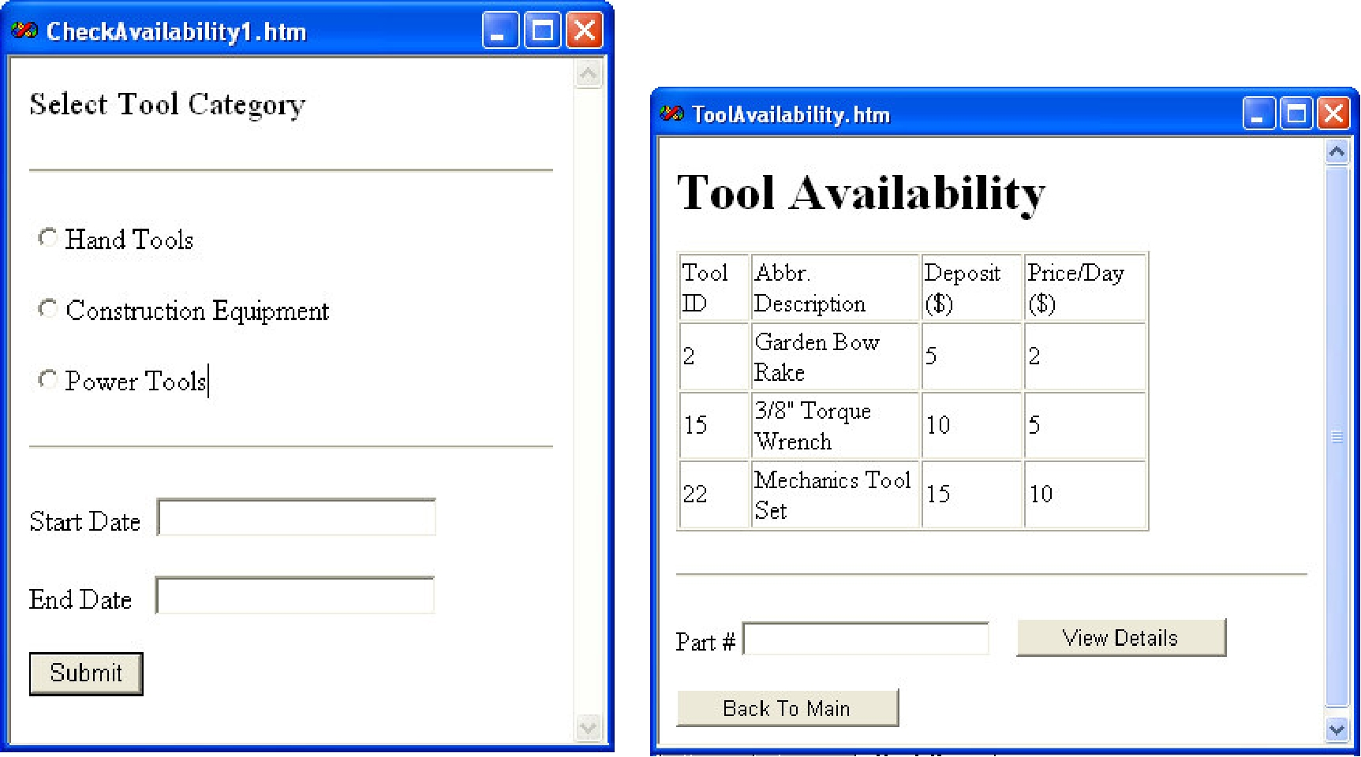

Figure 8. | Check Availability - First Screen. | Figure 9. | Check Availability - Results.

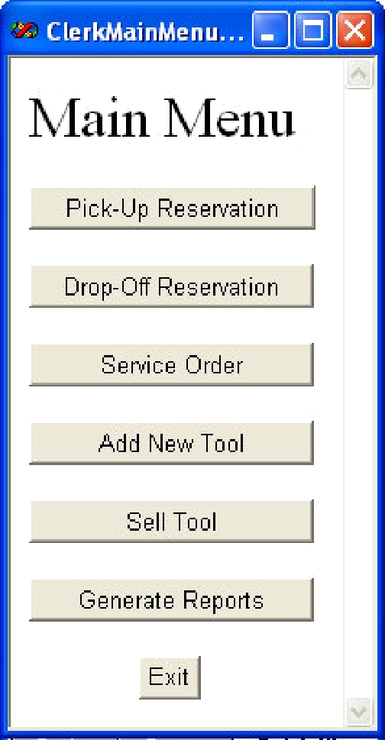

Figure 10. Clerk Main

Menu.
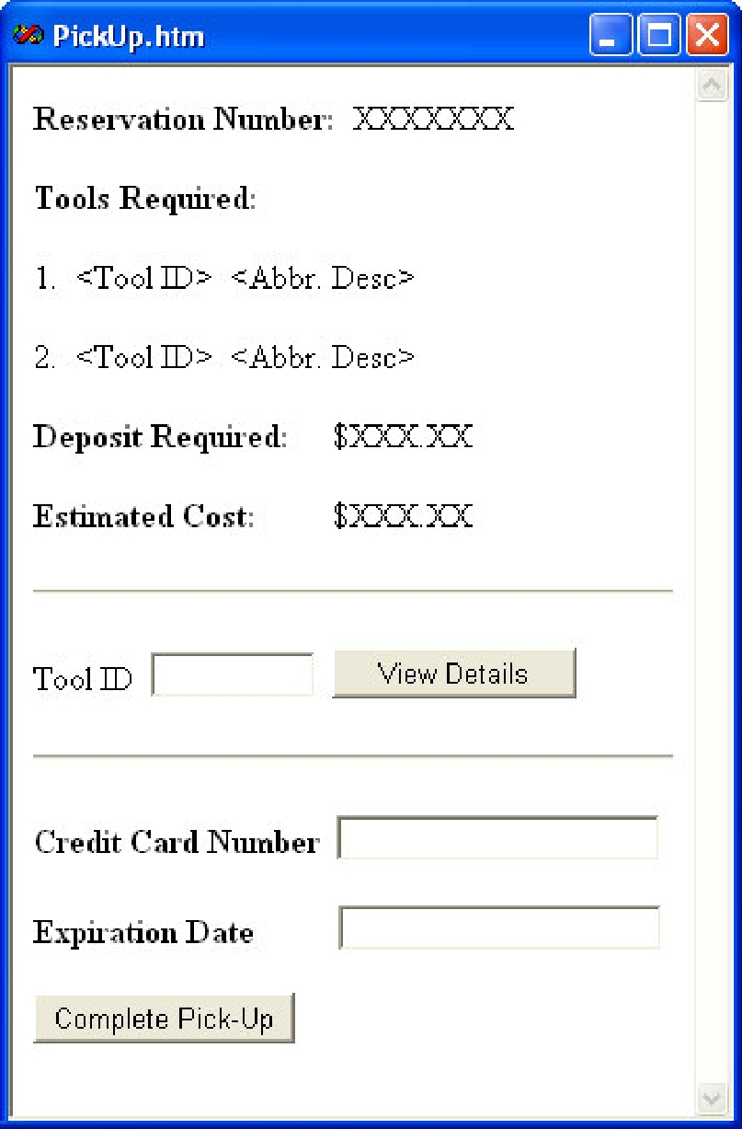
Clerks
The clerk on duty at Handyman Tools logs in to the system through the same interface as the customer (Figure [1]), selecting the clerk option instead of customer. The clerk’s login is a string of up to16 alphanumeric characters, which was assigned when the clerk was entered into the system. When a successful login is completed, the clerk is presented with a main menu interface (Figure [10]).

Pick-Up

The clerk’s primary task is to handle the pick-up and drop-off of tools that customers have reserved. When the “Pick-Up” button is selected, the clerk is first prompted to enter the reservation number being picked up and then presented with a summary of the reservation (Figure [11]). To assist the clerk in finding the correct item in inventory, they are given the option of viewing more details about the tools. This option is the same as the one for the customer under the check availability interface.

Once the clerk has collected all of the tools, he/she enters the customer credit card details into the form, and selects the “Complete Pick-Up” button. This loads the rental contract (Figure [12]) for the customer to sign.

Drop-Off

The drop-off task is essentially the same as pick-up, without requiring a credit card number and expiration date to be re-entered. At the end of the task, the final receipt (Figure [13]) is loaded into the browser for printing. The credit card charged should be the same credit card the deposit was charged too.

Figure 11. Pick-Up Interface.

Add New Tool

The clerks are also responsible for adding new tools to the inventory. Every tool inserted should have an abbreviated description, an original purchase price, a daily rental price, a deposit amount, and a

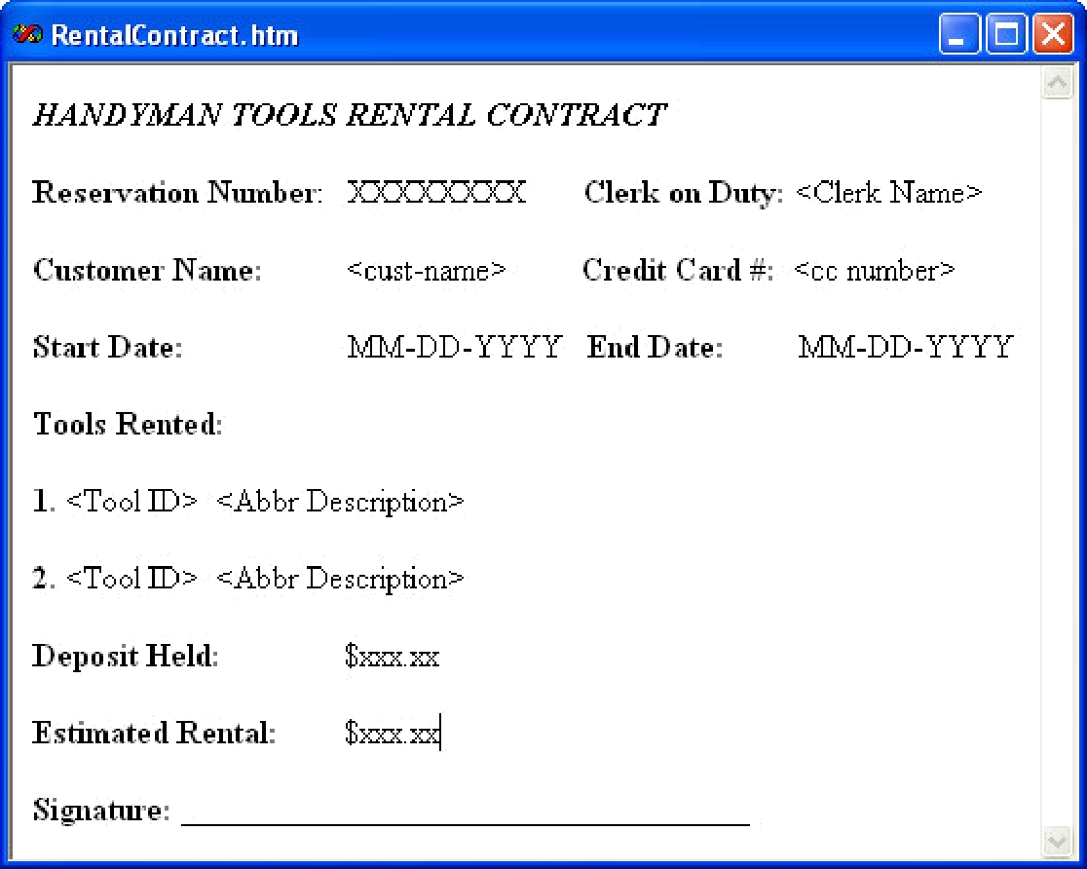

Figure 12. Rental Contract on Pick-Up.
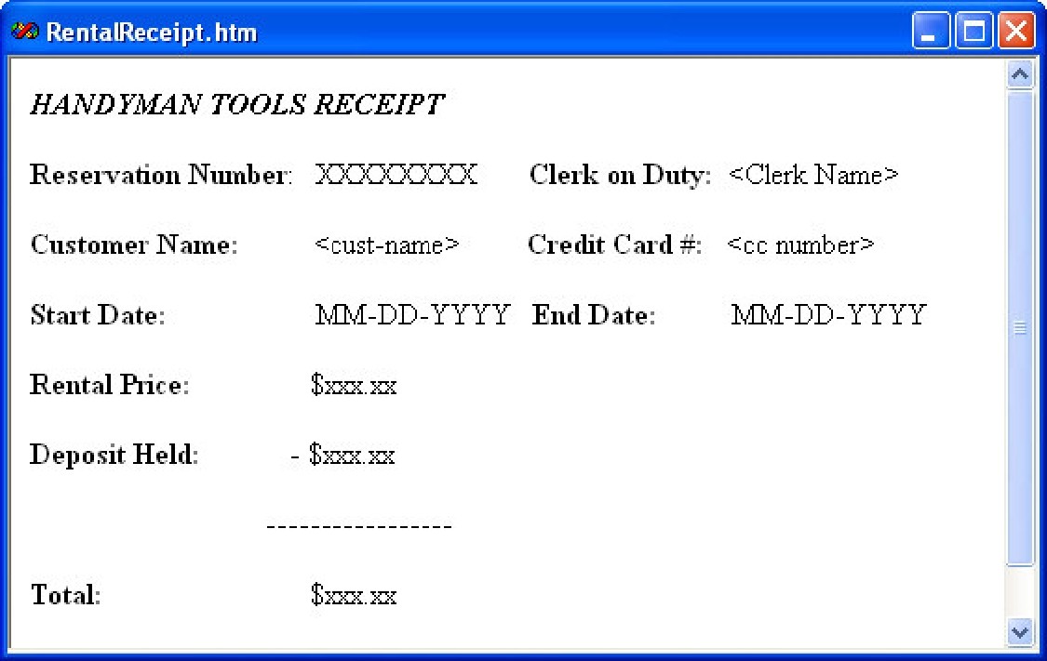

Figure 13. Receipt on Drop-Off.

detailed description of the tool. In addition, it has been requested that accessories be separately listed for power tools, because power tools often include small and easily displaced parts that are expensive to replace. This will assist clerks in making sure the tools are complete when they are returned to the store. Figure [14] shows an example interface.

Sell Tool

As new tools are added to the inventory, old tools need to be taken out of circulation. These tools are then made available for sale in the store at half of the original purchase price. To sell a tool, the clerk enters the tool number into a “Sell Tool” interface to and is returned a sale price by the system.

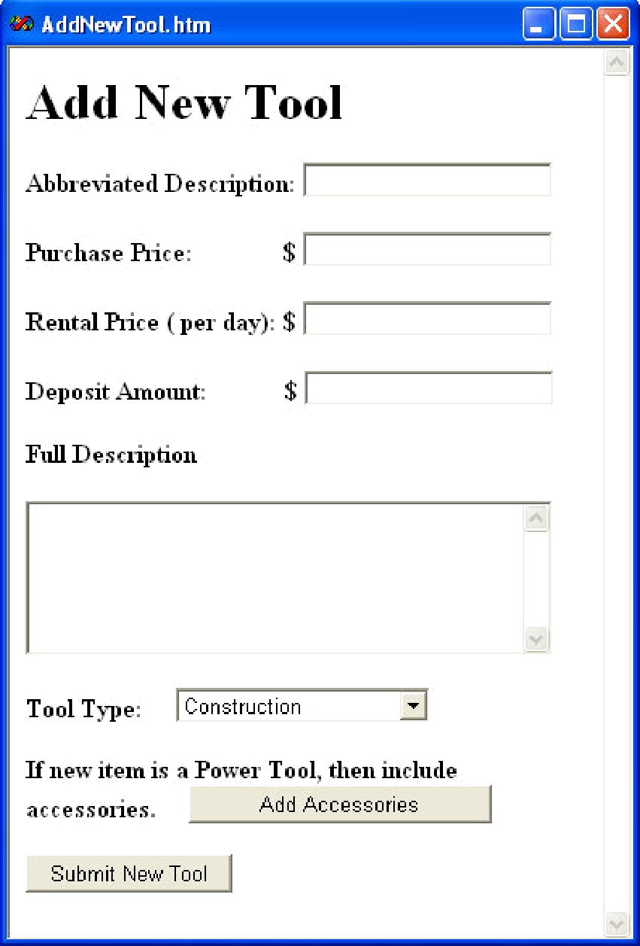

Figure 14. Add New Tool.
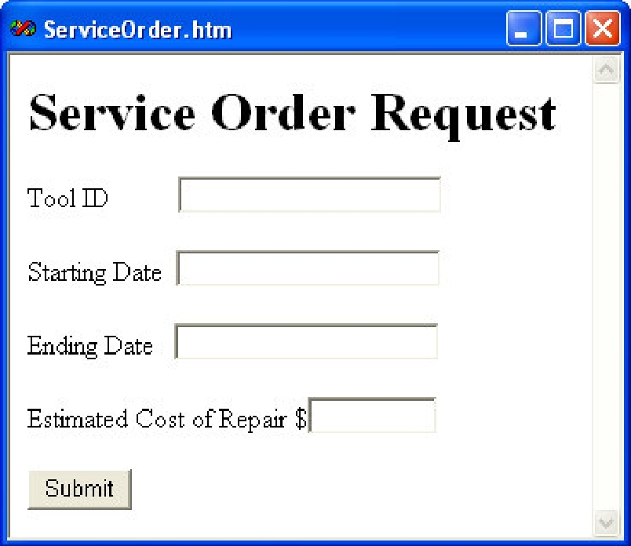

Figure 15. Service Order Request

Interface.

Hold Tool for Repair

Some tools are too expensive to replace when they develop mechanical problems, and need to be sent off for repair. The clerk is responsible for filling out a service order request (Figure [15]). While the tool is being repaired, it is not available for rent.

Generate Reports

Three reports are generated monthly by the system to summarize the rental systems success. The first report is a listing of every item in inventory, listing tool ID, abbreviated description, rental profit, cost of tool, and total profit. The rental profit is the rental price multiplied by the number of days that the tool has been rented. The cost of the tool is the original price of the tool, plus the cost of any service orders made on the tool. The total profit is the rental profit minus the cost of the tool. The list is ordered by the total profit made on each item.

The second report is a list of all rental customers who rented a tool over the last month. Their names, email addresses, and number of rentals are printed, and the list is ordered first by number of tools rented, and then last name.

The final report is for clerks to track their own progress in achieving this month’s clerk-of-the-month. The report lists the clerks name, the number of pick-ups handled this month, the number of drop-offs handled this month, and the sum of the two. It is ordered by the total number of pick-ups and drop-offs.

General Comments

- Assume that all rentals are picked up and returned on time. There are no cancellations for any reason.

- A service order cannot be placed over an existing reservation.

- Items “sold” within the last month should not appear in the first report.

Statistics

  - In each store, it is expected that the new online service will handle about 200 reservations per day.

  - On average, 3 tools are rented out for each reservation.
  - It is expected that the new online service will expand the customer base for each store to about 100,000 registered customers.
  - 2/3 of the reservations will be made by returning customers.

  - The tool inventory available for rent currently consists of 6000 separate tools in each store.

  - New tools are added to the inventory 10 times / week.

  - Old tools are put up for sale 10 times / week.

