**JQuery Vertical Timeline**

**Description: WEB**

This is a simple timeline that uses css for animations, has an understandable HTML structure and has a responsive design. Its appearance and interface is easy to edit with Css and only uses a JQuery function.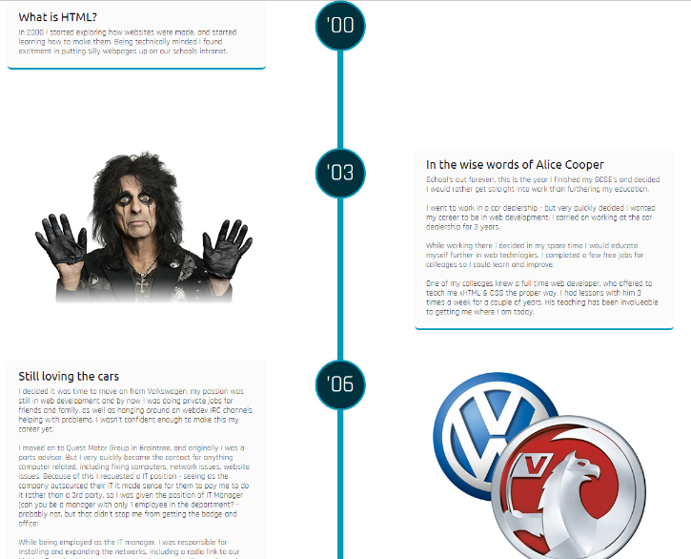

***By: Daniel David Alvaez Rivero***

***and***

***First Line Team***

***2018***

**Browser Support:**

IE10+ Firefox 4+ Chrome 4+ Safari 3.1+ Opera 10.5+

Handheld Safari 3.2+ Android Browser 2.1+ Opera 10+ Blackberry 7+ Firefox Android 32+ IE 10+

**GitHub: MOVIL**

**https://github.com/ChubbyNinja/jquery-vertical-timeline**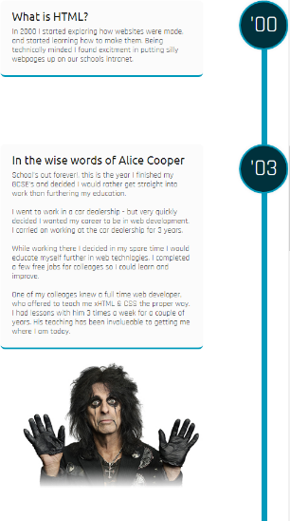

**DEMO:**

[**http://danny.hearnah.com/#timeline**](http://danny.hearnah.com/#timeline)

**Eeyellow Timeline**

eeyellow.Timeline is a lightweight and simple-to-use jQuery plugin used to generate a responsive, vertical timeline from plain html markup.

**Key features**

* Responsive layout based on Bootstrap grid system.
* Allow to expand / collapse event descriptions by clicking on the headers.
* Allows to display multiple events as a carousel based on Bootstrap's carousel component.

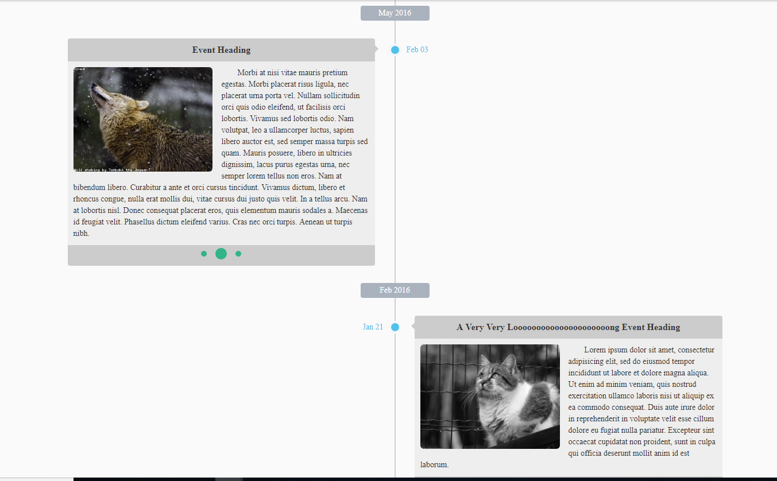

**Demo:** <https://www.jqueryscript.net/demo/Responsive-Timeline-Plugin-With-jQuery-Bootstrap-eeyellow-Timeline/>