**DSM 760 ASSIGNMENT 1**

**Student Name: Daniel Chiatuiro**

**Student Number: 170483226**

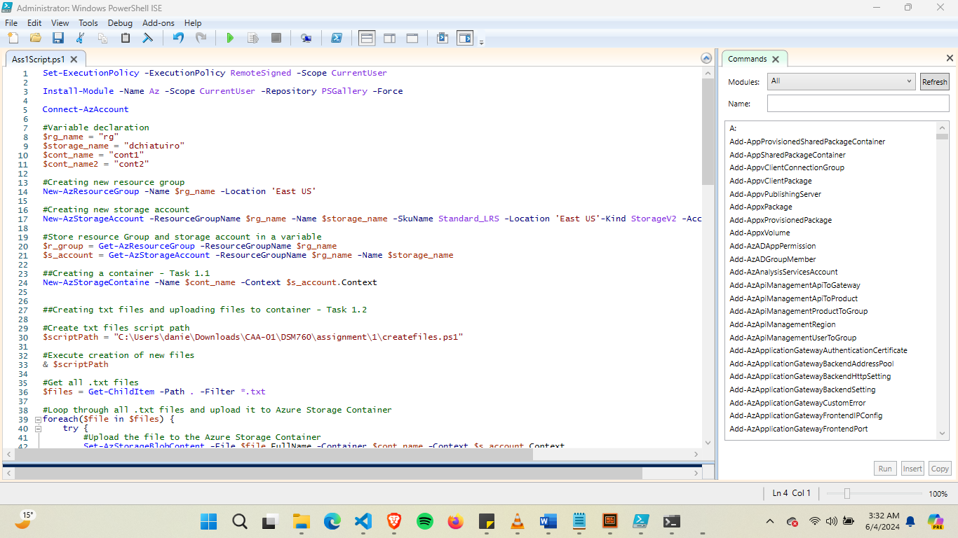

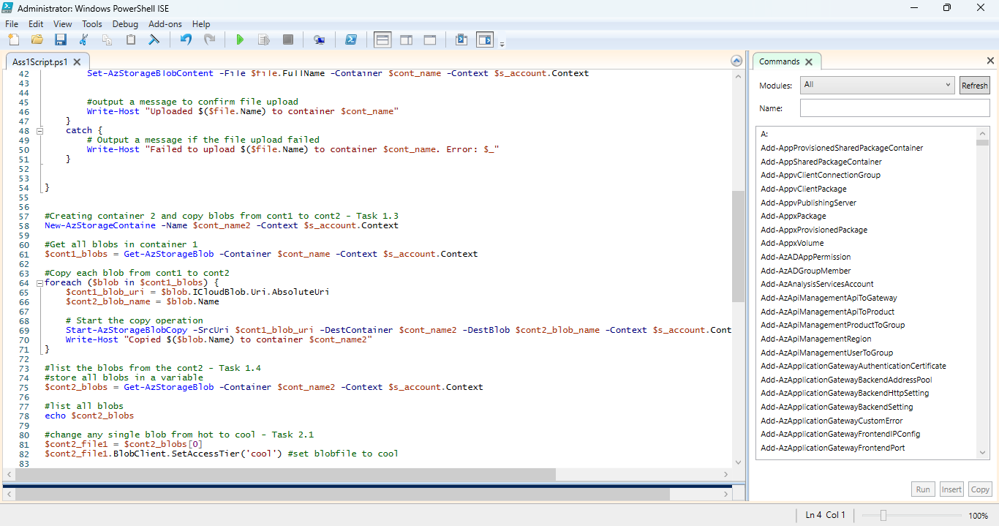

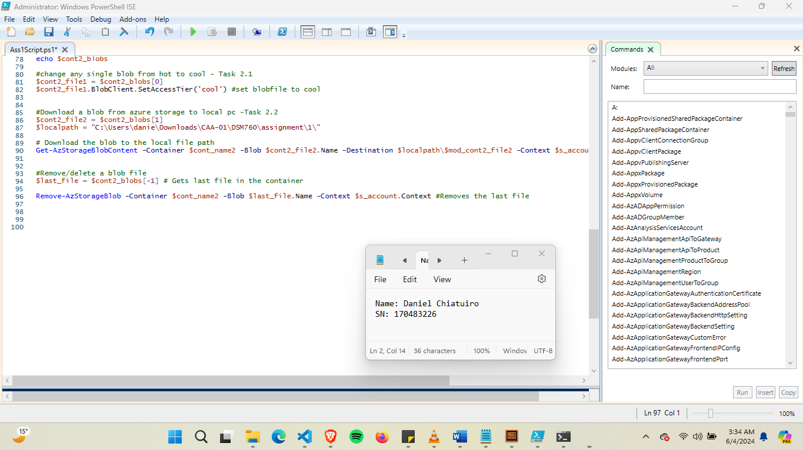

**Task 1: Create containers and upload files to Azure Blob storage using PowerShell:**

* 1. Create the container using PowerShell name it “Cont1”

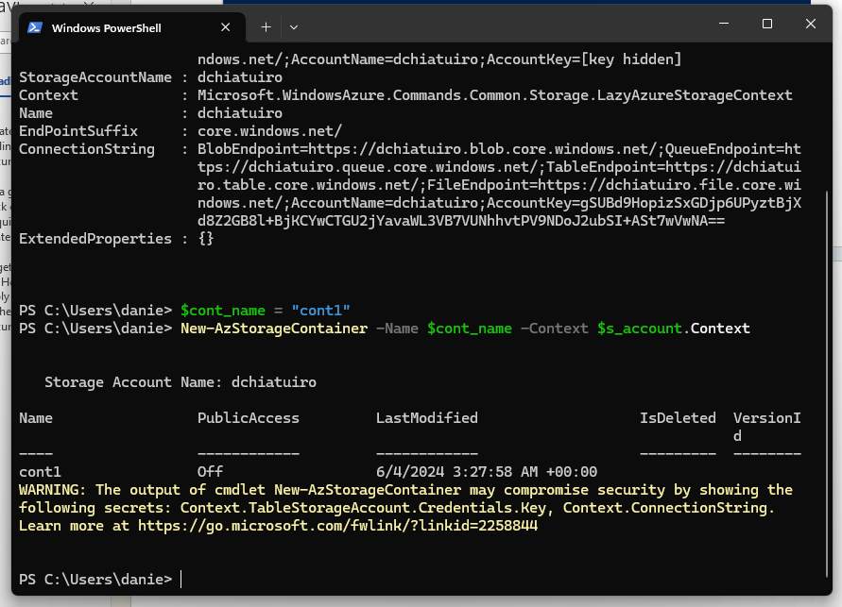

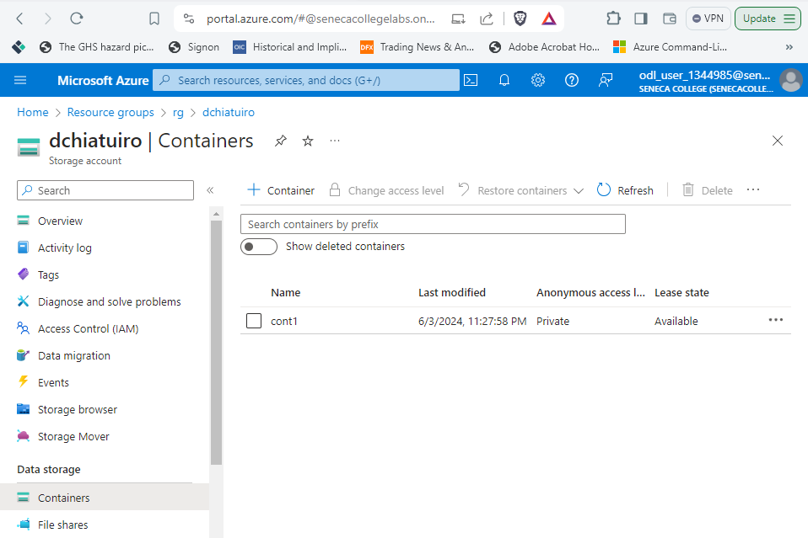

* 1. Create text files and upload it from your computer to your container ‘cont1’

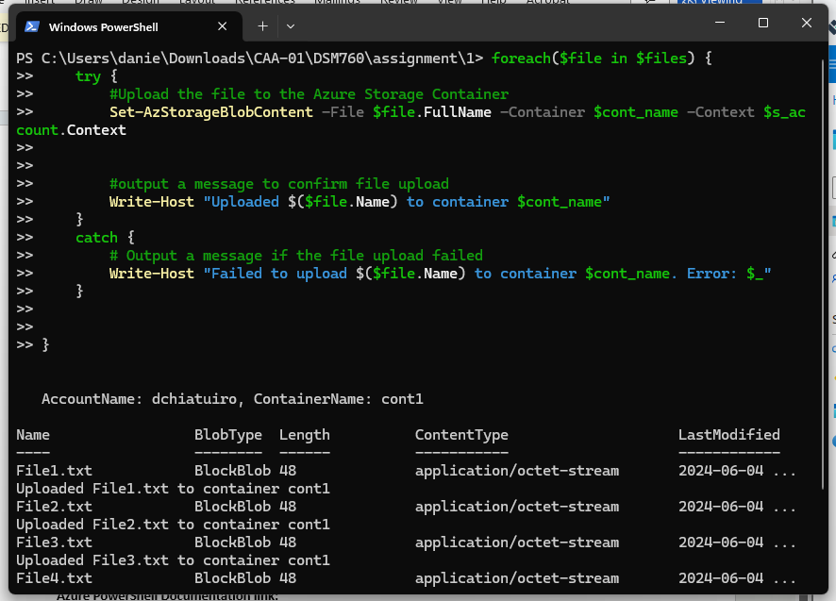

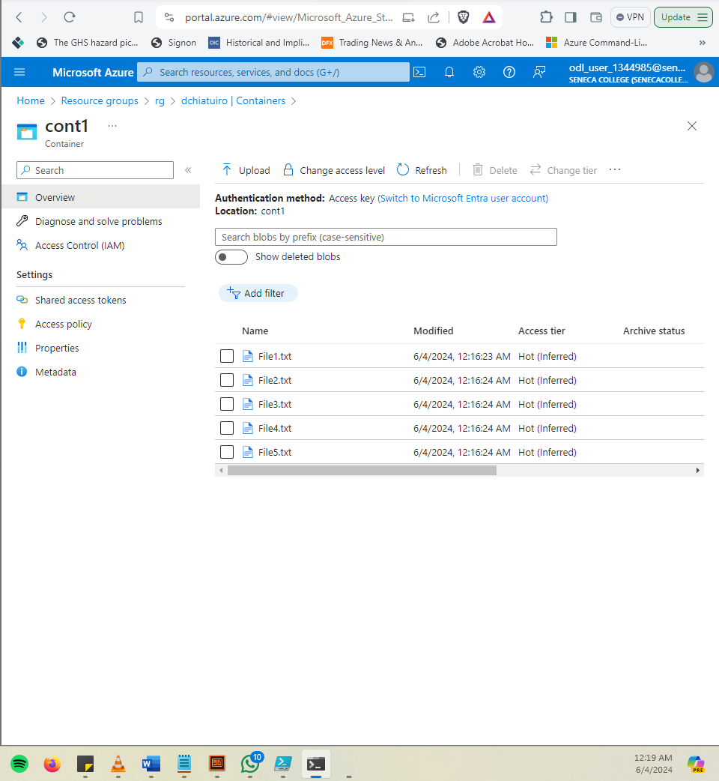

* 1. create a new container named ‘cont2’ in your Azure storage account and copy all files from ‘cont1’ to ‘cont2’.

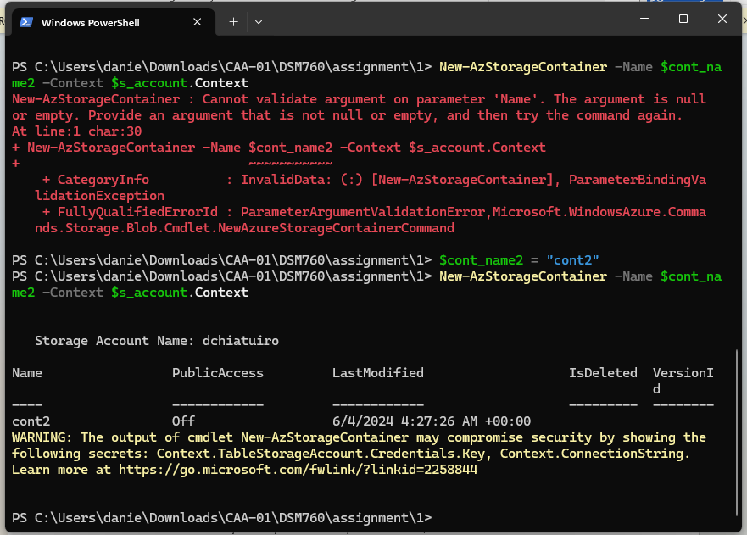

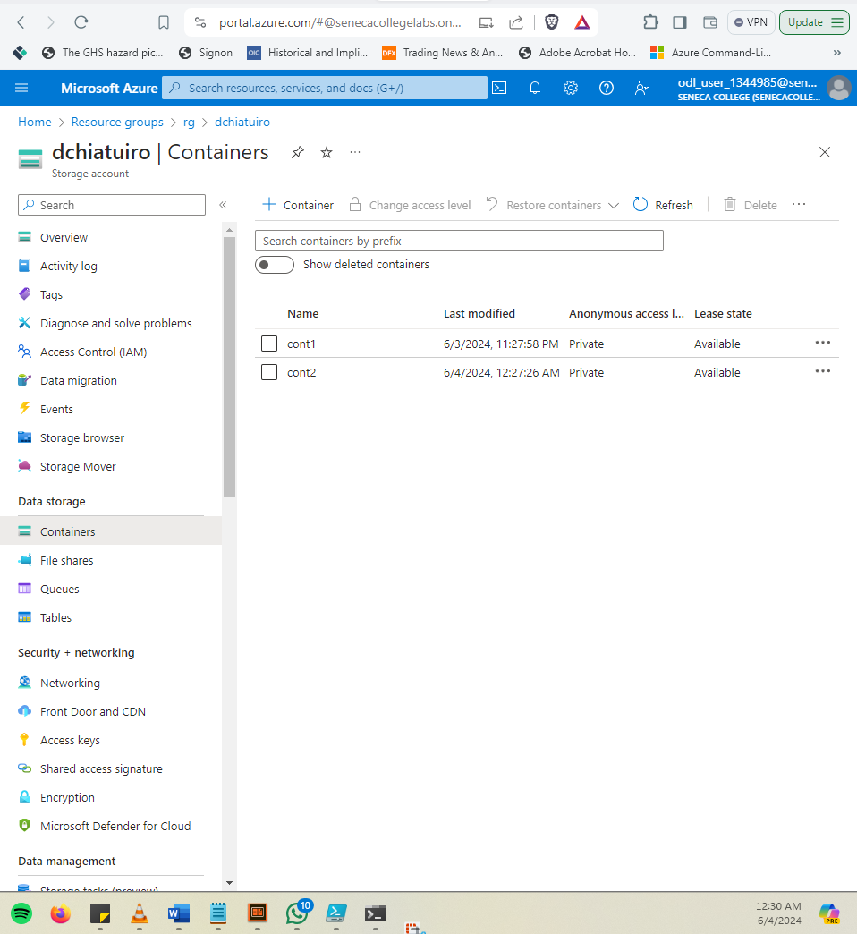

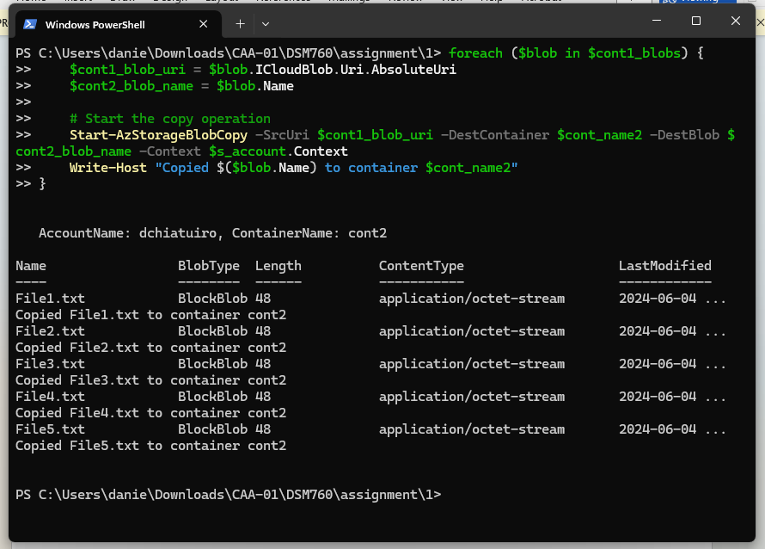

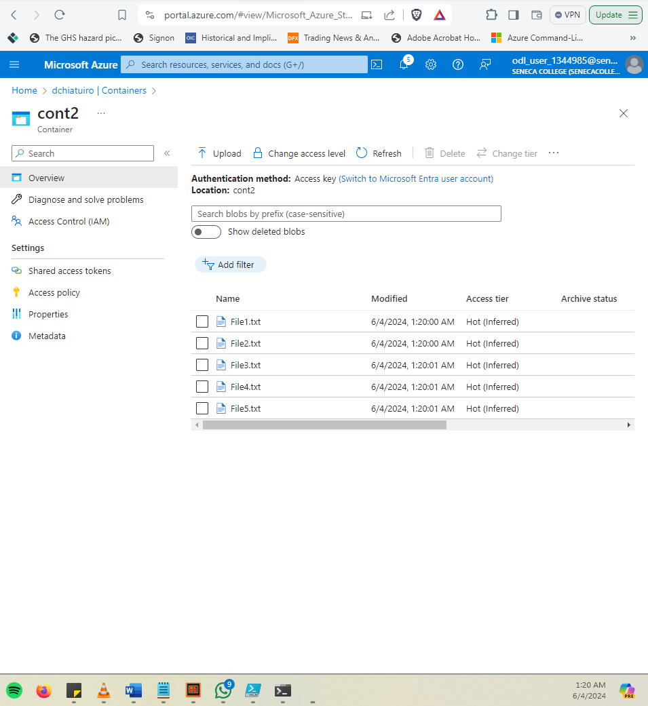

* 1. list the blobs from the container ‘cont2’ using PowerShell script.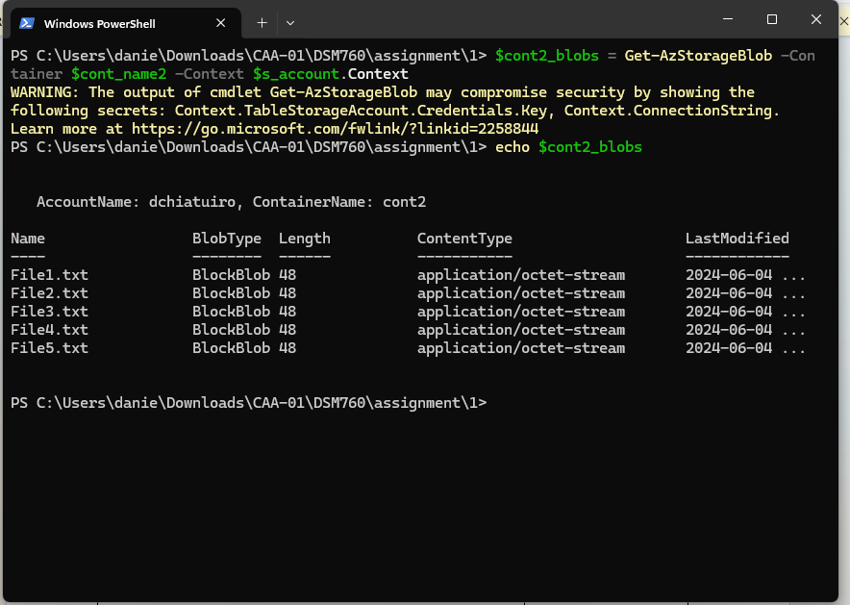

**Task 2: Modifying a blob access tier**

* 1. Write PowerShell script to change the access tier of one of your blob files to ‘cool’

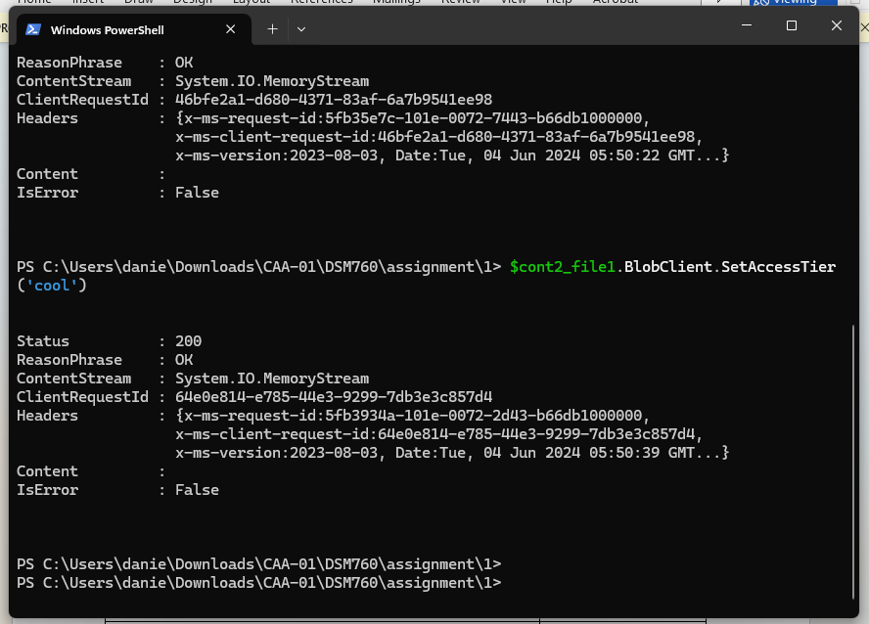

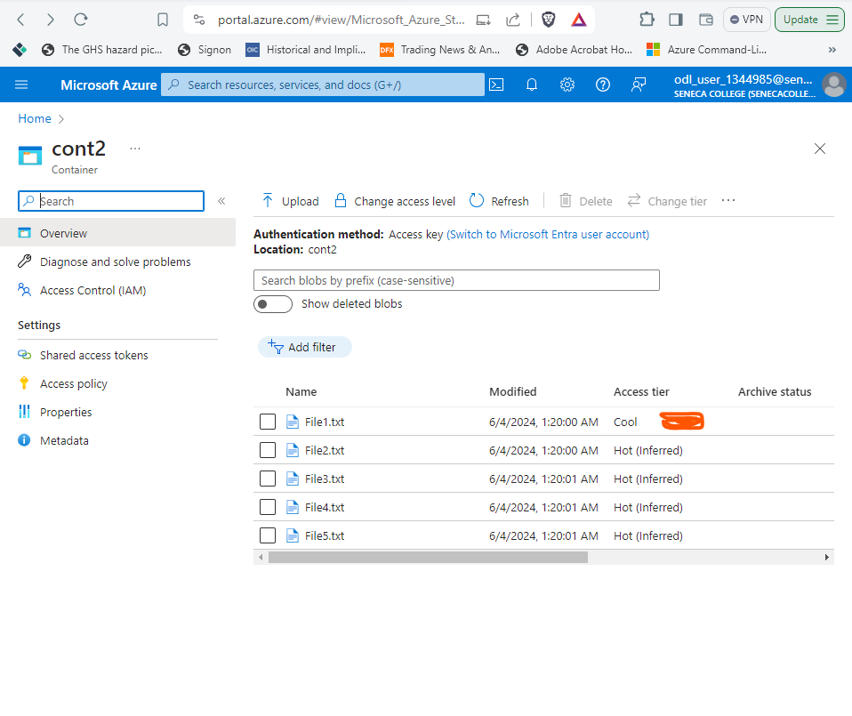

* 1. Write PowerShell script to download a blob from Azure Storage to your local computer.

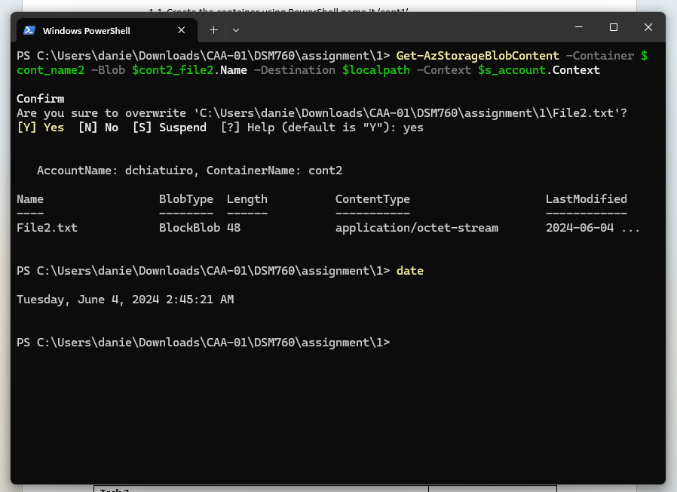

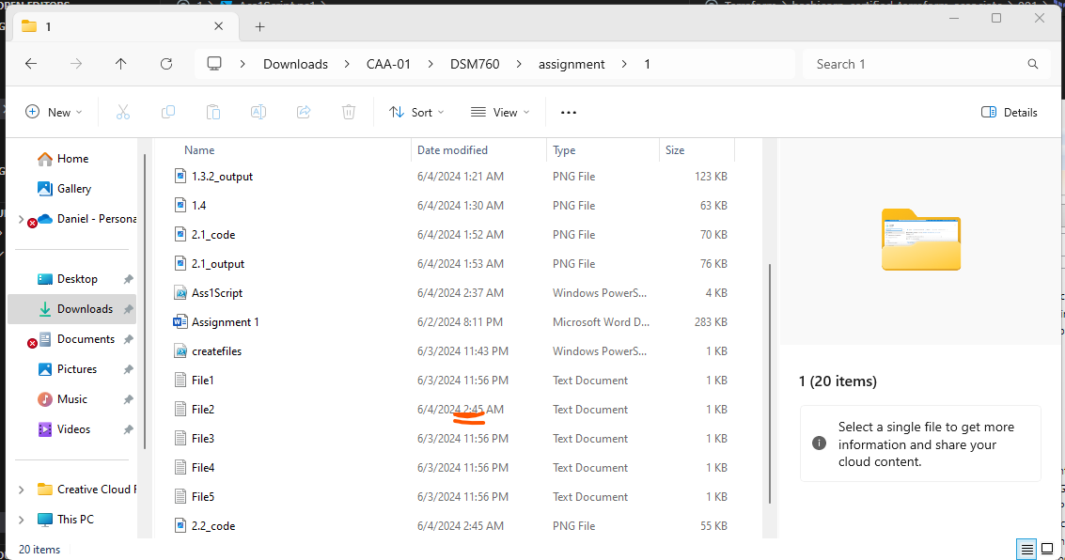

2.3 Write PowerShell script to remove/delete a blob file.

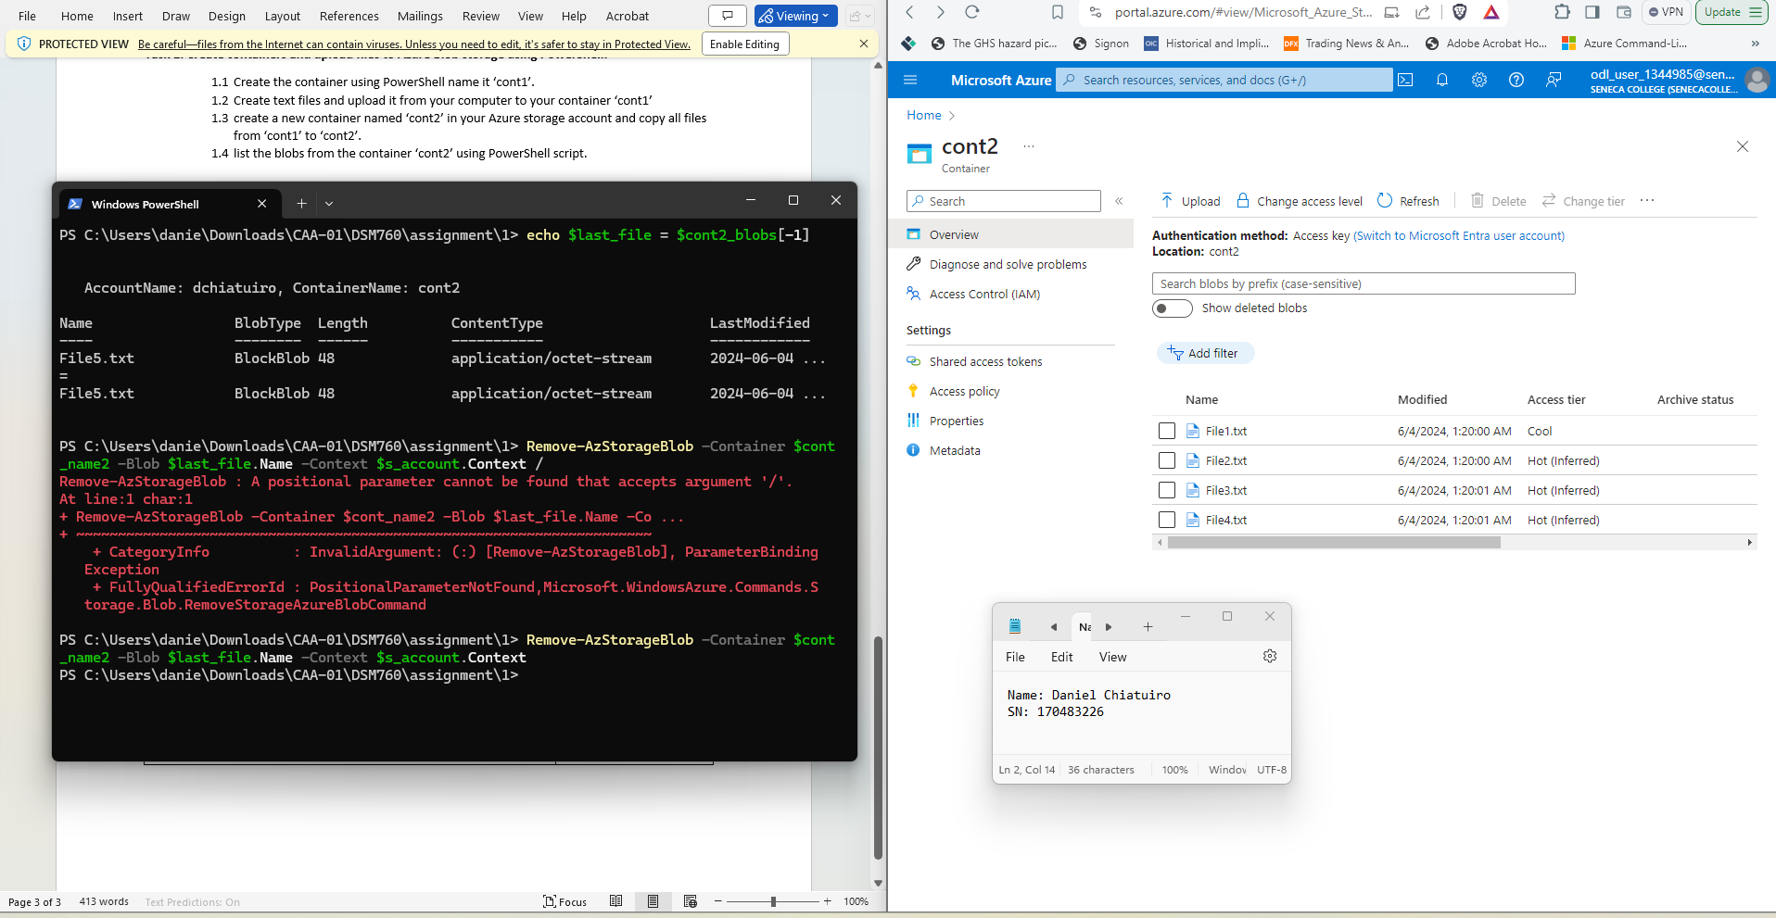

Task 1 and Task2 completed successfully.