

Frontend Coding Test

**Goal**: Build this single page using React JS. *(No other pages required)*

We have set up a skeleton application that gets you started. Follow the instructions in the readme to get your environment up and running.  
  
The task is to build the interface you see in the “requirements” folder, named “design.png”   
  
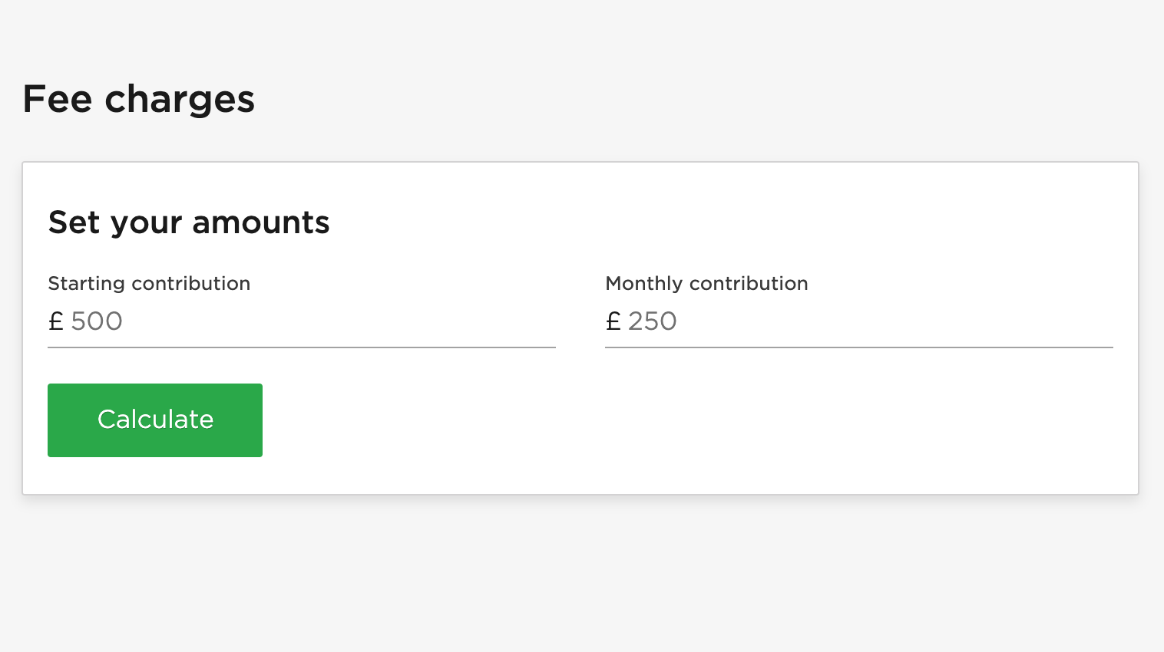  
  
When a user fills in the starting contribution and the monthly contribution then hits ‘Calculate’ we want the function **calculateTotalFees** to be executed and calculate the **totalFees** based on the input values (Calculation rules to follow).   
  
Please then show these values in the UI using the design “with-calculation.png” as a reference.  
  
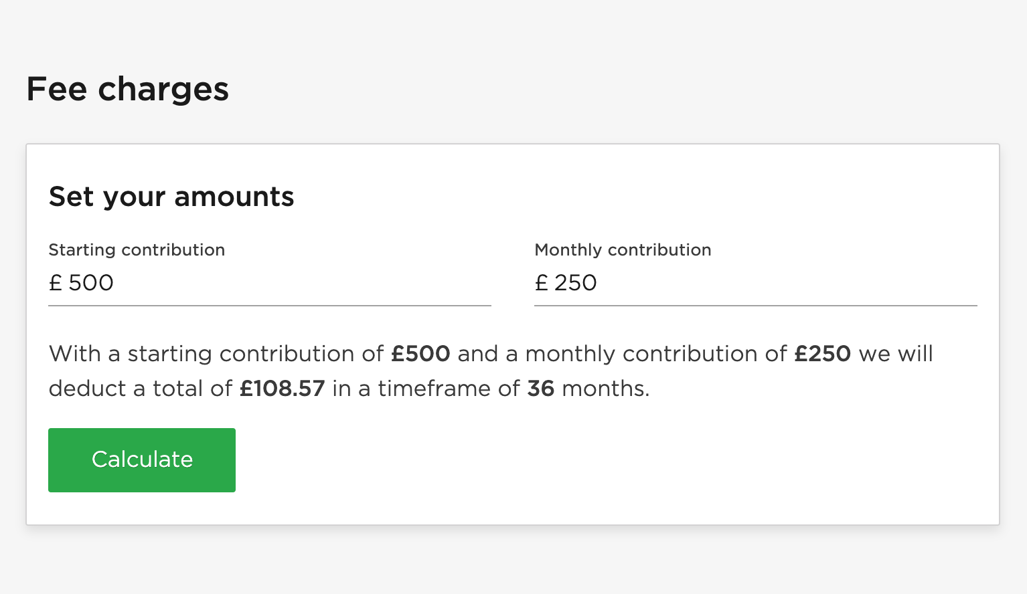  
  
How to Calculate Total Fees

The **calculateTotalFees** function will return the total accrued fees over a 36 month period.

Rules for calculation:

You are a brand new customer of Nutmeg and you open up a new Investment Pot. When you open up the pot, you contribute a starting amount of £500 for the first month. You have set up a monthly contribution of £250 for month 2 and onwards.  
  
Every month you contribute £250, and for each month you contribute (minus the first month) we will apply a fee charge of 0.0625% on the total value of the pot. This charge happens 'after' the monthly contribution is made.  
  
Calculate the total fees over 36 months and display the result as seen in the design provided under requirements/Design.png

There is an example test case in the repo.

We’d like you to spend as little or as long as you would like on building the rest of the design. As long as you can demonstrate things in the following areas:

1. Code structure
2. Semantic markup
3. Styling (Styled/Sass/CSS)
4. Testing
5. Code quality
6. Accessibility standards
7. Pixel perfection
8. Level of Effort
9. Level of documentation

We will also be identifying any: code smells, unorganised markup, overengineering, inconsistent code formatting and bad naming conventions so please be mindful of this.

**As a visual reference, you can find our style guide here:** <https://www.nutmeg.com/guidelines>. We’ve also included our primary font, Gotham, for your use in the application so you don’t need to spend time importing it.

**Please bear in mind the following:**

* The **index.css** should be ignored as it’s just compiled CSS taken from our Design system.

## When you’re done:

* Send us your code via CVS, Bitbucket [private repo], Github or zip, so that we can review your work. Once reviewed, **please delete the repository (if applicable) so others cannot copy it.**
* Make a note for yourself of your reasoning behind how you approached the problem — we’ll discuss and walk through it all with you in your final interview

Good luck! – Nutmeg team