Daniel Diamont

EE 445L

Lab 7 Report

1. Objectives – Requirements Document

Daniel Diamont

dd28977

Requirements Document: Lab 7

**1. Overview**

**1.1. Objectives:** Why are we doing this project? What is the purpose?

The objectives of this project are to design, build, and test a useful embedded system. Educationally, students are learning about designing Printed Circuit Boards, interfacing hardware and software for a functional embedded system, and mechanical enclosures for an embedded system. My goal is to create an autonomous vehicle that uses computer vision and a discrete PID control algorithm to guide itself through an obstacle course.

**1.2. Roles and Responsibilities:** Who will do what? Who are the clients?

EE445L students are the engineers and the TA, Professor Valvano, and the competition judges are the clients. All tasks will be performed by Daniel Diamont.

* Tasks:
  + Requirements Document
  + PCB Schematic
  + Bill of Materials
  + PCB Design
  + Drivers for hardware interfacing
  + PID controller software
  + Computer-Vision software
  + Enclosure Design
  + Fully functional embedded system

**1.4. Interactions with Existing Systems:** Include this if you are connecting to another board

The system will use a Raspberry Pi 2 Model B board to perform the video-processing, PID control, and DC motor control. The camera will be connected directly to the Pi’s Camera Interface module. Additionally, the system will use a printed circuit board – designed by the student – to interface the Raspberry Pi with DC motors, and an accelerometer + gyro. The system will by powered by a +9.0V battery, and a Linear Dropout Regulator will be used to step down the voltage to +5V for the Pi and the peripherals.

**2. Function Description**

**2.1. Functionality:** What will the system do precisely?

The robot car will interface over Wi-Fi to a Python application on a PC, which will either send a command enabling full autonomy, or manually override directional control of the DC motors for demonstration purposes. Fully-autonomous mode will allow the robot car to capture video of its immediate forward area, process the video to recognize markings to follow and obstacles to navigate, and plot and execute a path through the course using a software PID controller.

The robot car’s software will use multithreading, parallel programming, and interrupt-driven concurrent programming techniques to handle Wi-Fi communication, video-processing, PID control, motor control, and sensor data acquisition at the same time.

**2.4. Performance:** Define the measures and describe how they will be determined.

The system will be judged qualitatively by 9 measures. First, the software modules must be easy to understand and well-organized. Second, the system must satisfy the two input/two output requirements and the multiple ISR requirement. Third, the turnover rate between frame capture and motor control output must be real-time. Fourth, the system must be able to reliably communicate from the controller PC with minimal TCP packet loss. Fifth, the time to run one execution of all threads except for the main thread must be minimized to reduce overhead in the real-time system. Sixth, the design will be judged on whether the robot-car and embedded system enclosure are well-thought out and functional. Seventh, the PCB design must be simple and elegant. Eight, there must be a thorough Bill of Materials to calculate the final cost of the project. Ninth, the system must have mechanisms in place to make it simple to debug the hardware and software in a modular fashion.

**2.5. Usability:** Describe the interfaces. Be quantitative if possible.

I will use a Raspberry Pi 2 Model B. The Pi will be interfaced with an 5 megapixel ArduCAM OV5647 camera module for the video-capture, an 802.11(b/g/n) Wi-Fi USB adapter for communication, the Raspbian Operating System, Python 2.7 for drivers, OpenCV2 libraries for computer vision, PID, and motor control, L293 IC for the motor driver, and MPU 6050 for the gyro + accelerometer.

**3. Deliverables**

**3.1. Reports:** Reports for Labs 7 and 11 will be written

**3.2. Outcomes:**

**Lab 7 grading (different from labintro.pdf)**

Lab 7 is the first of three parts to your own project. The grading rubric for this lab will be different from the one mentioned in the labintro.pdf document."

********************************************************************************************

**Pre-preparation (10)** - Requirements Document

You will be judged on the clarity of thought you have about your project. At a very abstract level you should be able to explain your TA what you intend to do and how you intend to do it. You can go through your Requirements document while you explain it to the TA. This will be like a MRD (Marketing Requirements Document) presentation to your TA.

**Preparation (10)** - Schematic

By the prep-day you should have a very clear idea about your project. So you should be able to describe the lower level interface of your system. You can go through your schematic and BOM while you explain it to the TA. While you do this you would also like to point out your hardware and software design boundaries. This will be like a PRD (Product Requirements Document) presentation to your TA.

**Check out (30)** - PCB layout

Complexity (10) - You should be able to convince your TA that you have taken up a challenging project. Indicate the cool features of your project and the effort you will have to put in to make it work. Be as specific as possible.

Planning (10) - For every big project it is important to plan things out ahead of time. Break up your work into smaller steps and assign a deadline to each one. Remember to adhere to them.

Prototyping - Although as part of this lab you need to prototype your system before you finalize your PCB layout, your grade on this will be reflected in Lab 8 where you design the software for the system and do a much more precise prototyping.

PCB Layout (10) - Due with Checkout

**Oral Questions (10)**

**Timely submission (10)** - The PCB order process has to be done in bulk (for the discount) and on time (so that we get back the PCB on time). So it is very important you adhere to the deadline.

**Report (30)**

Requirements Document (10) - Due with Pre-Prep

Schematic (10) - A significant amount of this grade will be on how you plan to debug your board

Test points

Proper use of the logic analyzer

Measurement data (10) - Due with Lab submission along with a copy of the above

**Lab 11 grading (different from labintro.pdf)**

Lab 11 is the third of three parts to your own project. The grading rubric for this lab will be different from the one mentioned in the labintro.pdf document.

*************************************************************************************************

**Preparation (20)** shown to TA before lab starts

High level application for the system, graded on completeness rather than style (10)

Complete BOM and having all parts (5)

2-page requirements document (5)

There are prizes to be won! Consider submitting your Lab 11 project to the **TI design competition**. For details ask your professor.

TM4C123, LM4041, LM78M05, LP2950, INA122, LM2937, OPA2350, TLC5616, and TPA731 are all TI devices any three of which satisfy entry rules.

**Checkout (30)**

Project demonstration, quality of design (30)

Description of how the system was tested (5)

**Software Quality (30)**

Modularity and organization (10)

Readability (10)

Functionality (10)

**Report (20)**

Testing procedure and testing data (10)

YouTube video (10)

1. Hardware Design
   1. SCH file

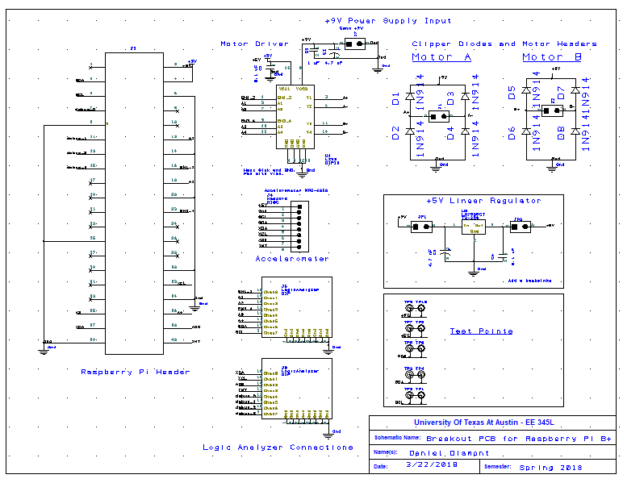

* 1. PCB Layout

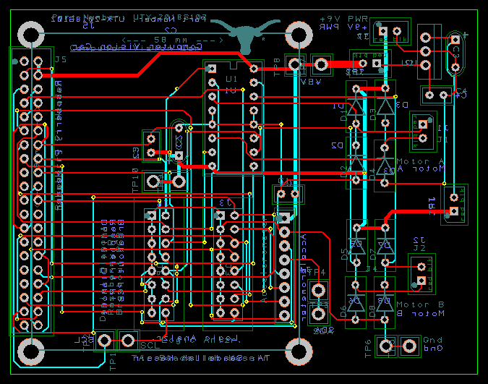

* 1. Mechanical Considerations:

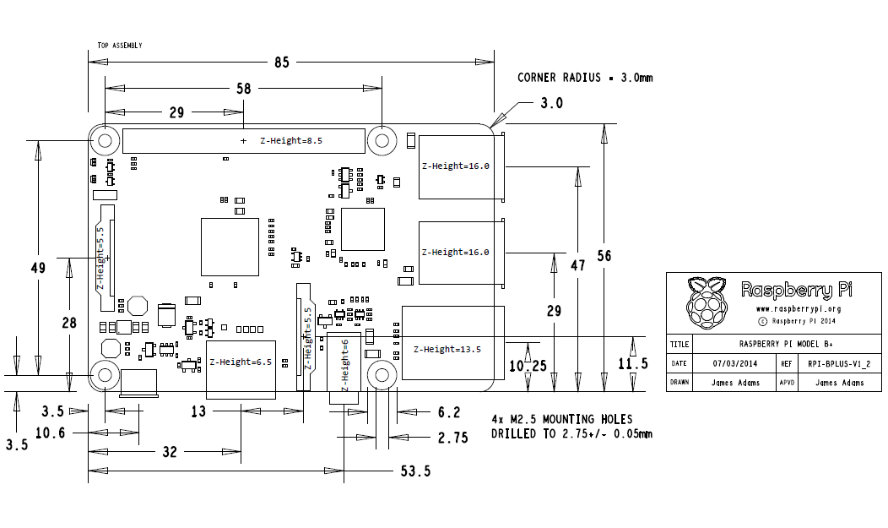

* 1. Printouts
     1. Top

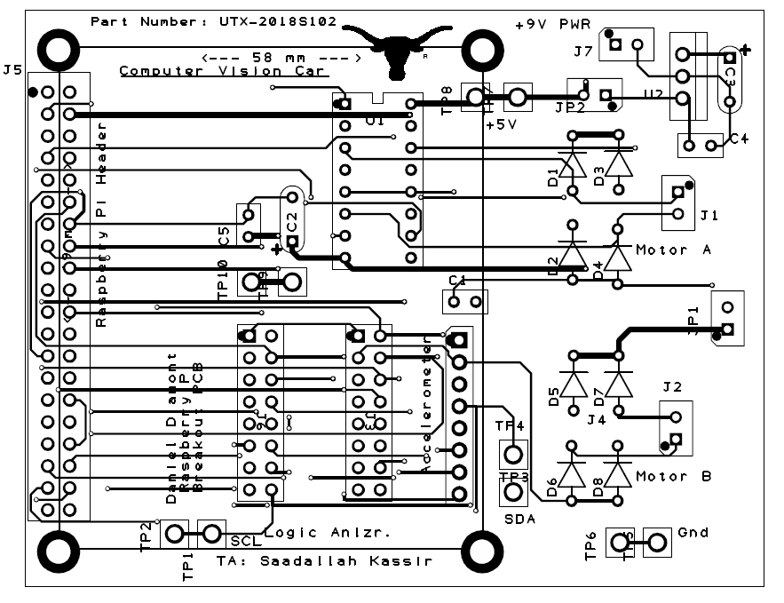

* + 1. Bottom

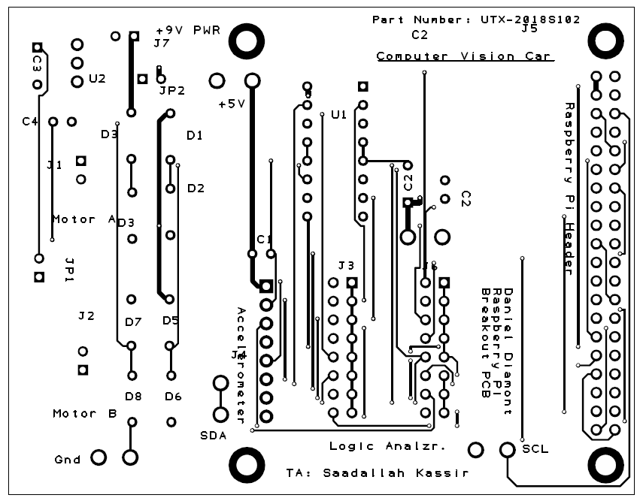

1. Software Design
   1. Python 2.7
      1. Motor Controller w/ PWM
      2. Computer Vision module w/ openCV2
      3. Accelerometer and Gyro Data Acquisition
      4. PID Controller
2. Measurement Data
   1. Estimated Current:
      1. Gyro – 3.6 mA
      2. Accelerometer – 500 uA
      3. Raspberry Pi – 600 mA
      4. L293 – 60 mA
      5. Camera – 250 mA

Total: 0.9141 Amps

* 1. Estimated Cost - $133.84 (see attached BOM)

1. Analysis and Discussion
   1. Copy of reviewed SCH/PCB signed by professor

