Assignment 04: Ant Build

PROFESSOR HEMDAL – RSEG 127 RELEASE CONTROL AND CONTINOOUS INTEGRATION/CONTINUOUS DEPLOYMENT

Daniel Diaz

2017

Contents

Screenshots or terminal output showing the running of all three build targets (ant commands). 1

Screenshots or terminal output showing the program working correctly. 2

1. User enters 50 3

2. User Enters 65 4

Screenshot of your build.xml file in the Ant Editor in Eclipse 6

# 

# Screenshots or terminal output showing the running of all three build targets (ant commands).

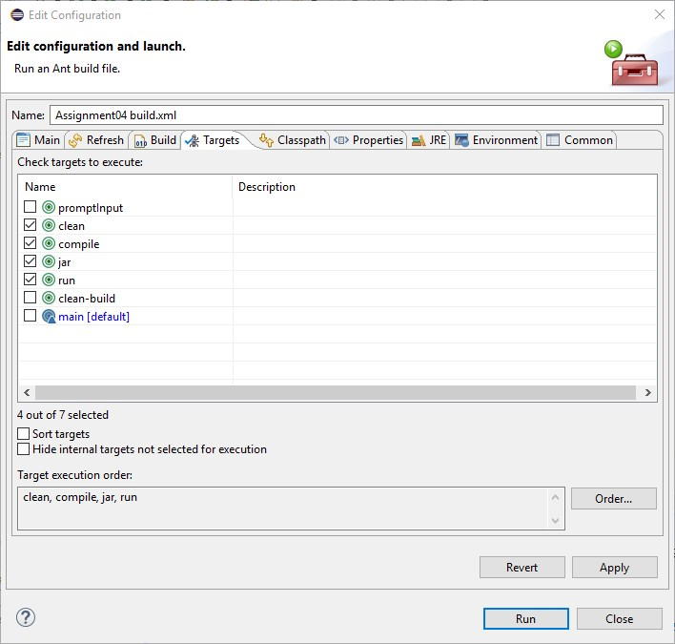

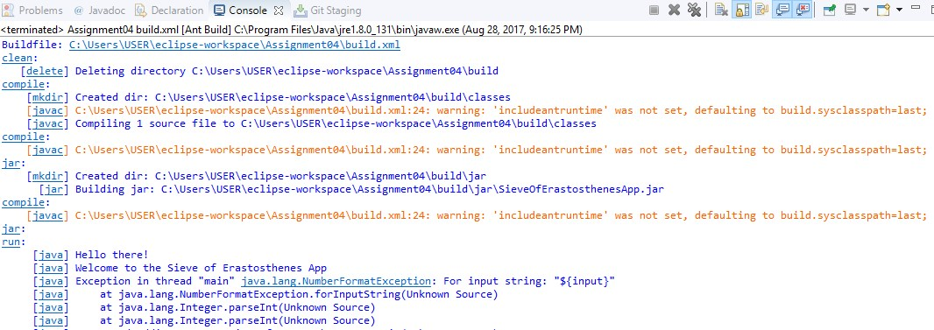

# Screenshots or terminal output showing the program working correctly.

## User enters 50

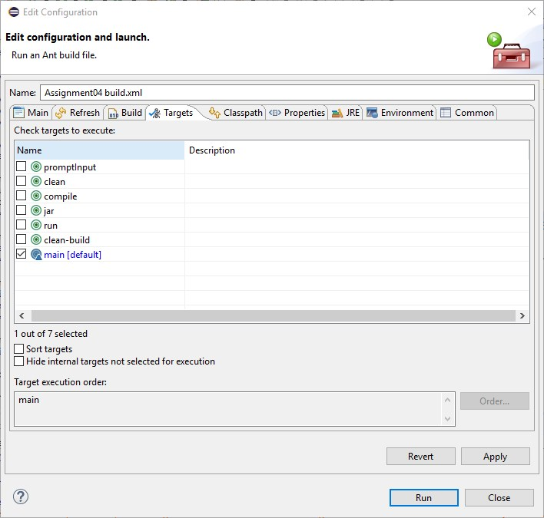

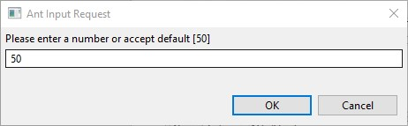

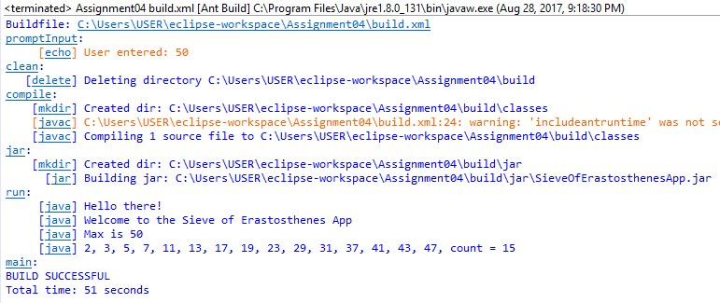

## User Enters 65

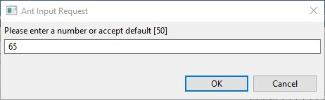

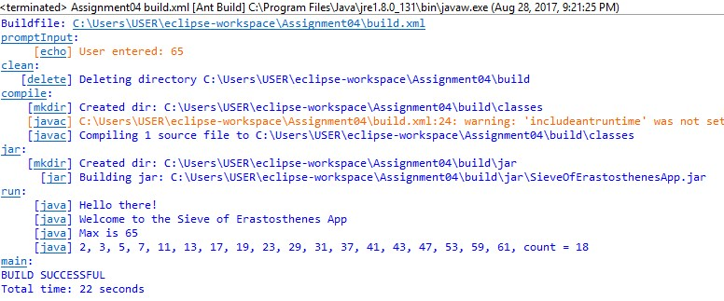

Screenshot of your build.xml file in the Ant Editor in Eclipse