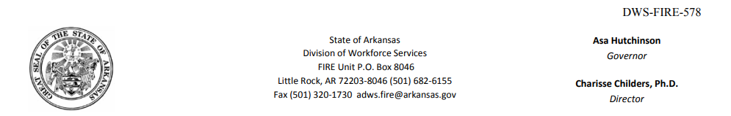

<<[data.getClaimantName()]>> **NOTICE OF AGENCY**

<<[data.getClaimantAddress()]>> **DETERMINATION**

Mailing Date of Notice: <<[data.getMailingDate()]>>

Social Security No: <<[data.getSocialSecurityNo()]>>

Benefit-Year: <<[data.getBenefitYear()]>>

Initial Claim: <<[data.getInitialClaimDate()]>>

Local Office No: <<[data.getLocalOfficeNumber()]>>

Findings of Fact:

When you claimed benefits for weeks ending <<[data.getBenefitWeekEndDate()]>>, you did not correctly report your work or earnings for <<[data.getEmployerName()]>>. However, the evidence does not show it was done with a willful intent to receive increased benefits. This determination covers the following benefit year(s): <<[data.getBenefitYear()]>>.

Decision:

Not Disqualified. Although your earnings amounts are not correct, fraud has not been assessed and there is no disqualification under the fraud provisions of the law. However, because the earnings amounts are not correct you may have been overpaid benefits in which case a Notice of Non Fraud Overpayment Determination will be issued. If you disagree that the earnings amounts are incorrect you should file an appeal of this decision.

\*\*\****Importante***: Este documento(s) contiene información importante acerca de su derecho de compensación por desempleo, responsabilidades y/o beneficios. Es muy importante que usted entienda la información contenida en este documento. Si necesita ayuda en la traducción y comprensión de esta información, por favor repórtese a su oficina local de inmediato. **Si usted no está de acuerdo con esta determinación o decisión, debe presentar una apelación antes del plazo límite especificado en la determinación o decisión.**

Law:

**Had FRAUD been assessed**, ACA § 11-10-519(a)(2) (A) and (B) would apply. This code section provides in part, that an individual will be disqualified for any continued claim week he willfully makes a false statement of a material fact or willfully fails to disclose a material fact when obtaining or attempting to obtain any benefits and for an additional 13 weeks of unemployment as defined in § 11-10-512, and which shall commence with the Sunday of the first week with respect to which a claim is filed commencing with the week of the mailing of the determination of disqualification, and an additional 3-week disqualification for each week of falsification. Any remaining weekly and maximum benefits payable subsequent to the mailing date of this determination shall be terminate.

Appeal Rights:

Arkansas. Code Ann. § 11-10-524(a) provides that a party entitled to this notice ( Employer or Claimant ) may file an appeal within 20 calendar days after the mailing of the notice to his last known address. An appeal may be filed by either completing a written appeal form (which may be obtained from any Arkansas Division of Workforce Services Office) or by writing to the Arkansas Appeal Tribunal, P.O. Box 8013, Little Rock, AR 72203. If an appeal is filed, please attach a copy of this form to the appeal letter and continue to file weekly claims to protect your benefit rights. All correspondence relating to an appeal should include the claimant’s social security number. For more information, refer to your UI handbook or contact your local Arkansas Division of Workforce Services Office.

**Arkansas Division of Workforce Services**

**FIRE Unit**

