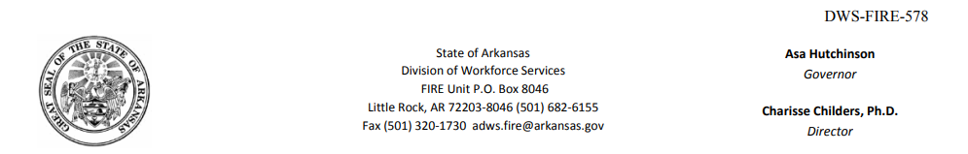

<<[data.getEmployerName()]>> **NOTICE OF AGENCY**

<<[data.getEmployerAddress()]>> **DETERMINATION**

Mailing Date of Notice: <<[data.getMailingDate()]>>

Social Security No: <<[data.getSocialSecurityNo()]>>

Benefit-Year: <<[data.getBenefitYear()]>>

Initial Claim: <<[data.getInitialClaimDate()]>>

Local Office No: <<[data.getLocalOfficeNumber()]>>

RE : <<[data.getClaimantName()]>>

Findings of Fact:

When you claimed benefits for weeks ending <<[data.getBenefitWeekEndDate()]>>, you did not correctly report your work or earnings for <<[data.getEmployerName()]>>. Wage Information from your employer indicates you worked each week and had earnings. Your failure to correctly report your work and earnings resulted in your receiving benefits to which you were not entitled. This determination covers the following benefit year(s): <<[data.getBenefitYear()]>>.

Decision:

Disqualified for the week(s) listed in the 'Findings of Facts' plus a penalty period beginning with the week in which a claim is filed after <<[data.getDisqualificationStartDate()]>> and until you have claimed and/or worked 25 week(s) as provided for in the Period of Disqualification.

***Importante: Este documento(s) contiene información importante acerca de su derecho de compensación por desempleo, responsabilidades y/o beneficios. Es muy importante que usted entienda la información contenida en este documento. Si necesita ayuda en la traducción y comprensión de esta información, por favor repórtese a su oficina local de inmediato. **Si usted no está de acuerdo con esta determinación o decisión, debe presentar una apelación antes del plazo límite especificado en la determinación o decisión.**

Period of Disqualification:

ACA §11-10-519(a)(2) (A) and (B) and ACA §11-10-512 provide the disqualification shall continue until: 1) you have claimed the weeks of unemployment as stated above in which you would be eligible for benefits except for this disqualification, or 2) you have had the weeks of employment as stated above after claiming a week of unemployment and earned an amount equal to your weekly benefit amount each week, or a combination of 1 and 2.

Law: ACA §11-10-519(a)(2) (A) and (B) provide in part, that an individual will be disualified for any continued claim week he willfully makes a false statement of a material fact or willfully fails to disclose a material fact when obtaining or attempting to obtain any benefits and for an additional 13 weeks of unemployment as defined in §11-10-512, and which shall commence with the Sunday of the first week with respect to which a claim is filed commencing with the week of the mailing of the determination of disqualification, and an additional 3-week disqualification for each week of falsification. Any remaining weekly and maximum benefits payable subsequent to the mailing date of this determination shall be terminated.

**ACA §11-10-519(a)(3)(B) provides in part that an individual who is issued a fraud determination and on or after October 1, 2019 was determined to have been overpaid benefits shall not be eligible to receive any future benefits until the entire fraud overpayment balance is repaid in full, including the benefit amount, penalties, interest and costs.**

**Arkansas Division of Workforce Services FIRE Unit**

Appeal Rights:

Arkansas. Code Ann. §11-10-524(a) provides that a party entitled to this notice ( **Employer or Claimant** ) may file an appeal within 20 calendar days after the mailing of the notice to his last known address. An appeal may be filed by either completing a written appeal form (which may be obtained from any Arkansas Division of Workforce Services Office) or by writing to the Arkansas Appeal Tribunal, P.O. Box 8013, Little Rock, AR 72203. If an appeal is filed, please attach a copy of this form to the appeal letter and continue to file weekly claims to protect your benefit rights. All correspondence relating to an appeal should include the claimant’s social security number. For more information, refer to your UI handbook or contact your local Arkansas Division of Workforce Services Office.

