Databases Project – Spring 2019
Team No: 32
Names: Sophie Ammann, Samuel Chassot, Daniel Filipe Nunes Silva

Contents

Contents 1
Deliverable 1 2
Assumptions 2
Entity Relationship Schema 3
Schema 5
Relational Schema 6
DDL 7
General Comments 8

Deliverable 1

Assumptions
We use MySQL syntax for this project.
The weak entities (House_properties, Economic_properties, Administrative_properties and Review_scores) are linked to Listing and exist if and only if the listing exists: they have to be created/deleted when a Listing is created/deleted (ON DELETE CASCADE). The attributes of Review_scores can be null if the Listing is new and was not yet evaluated. Storing information of the listings grouped by theme in different table should provide us some efficiency advantage for further queries.
Both Listing and Neighbourhood are linked to a city, therefore we have decided to relate a Listing to a Neighbourhood, that is itself linked to a City. We assumed it would avoid having the same information twice (is in a City - relation).
The Review is written by exactly one Reviewer and for exactly one Listing. If a Reviewer unsubscribes of the Airbnb platform, we have decided that the Review shall still exist. Also, if a Listing disappears, we suppose that the Review still exists.
We suppose that City in this database has a unique name inside their country. Hence we can use city_name and country_code as primary key.

Entity Relationship Schema

Entities | Description
Listing | Represents a listing in an AirBnb service.
Host | Person that hosts a listing.
Neighbourhood | Part of a city.
City | City.
House_properties | Properties of the accommodation.
Economic_ properties | Costs related to the rent of the accommodation.
Administrative_ properties | Rules related to the rent of the accommodation.
Review | Review in the Airbnb system of a listing.
Reviewer | Person who writes a review about a listing.
Review_scores | Scores related to a listing of a review in different domains.
Calender | Availabilites of a listing.
Location | Location on a map of a listing.

Entity | Relation | Entity | Constraints
a Listing | has | House_properties | one-to-one relationship (Listing‘s weak entity)
a Listing | has | Economic_properties | one-to-one relationship (Listing‘s weak entity)
a Listing | has | Administrative_properties | one-to-one relationship (Listing‘s weak entity)
a Listing | has | Review_scores | one-to-one relationship (Listing‘s weak entity)
a Host | owns | a Listing | each listing has exatcly one host
a Listing | occupies | a Calender | a listing has availabilities in time. Each date has the corresponding listing's availability
a Review | reviews | a Listing | a review reviews exaxtly one listing
a Reviewer | writes | a Review | a review has exactly one reviewer
a Listing | is in | a Neighbourdhood | a listing is in exactly one neigbourhood
a Listing | is in | a City | a listing is in exactly one city
a Neigbourhood | is in | a City | a neigborhood is in exactly one city

Schema
<Add the figure of the ER schema> //TODO

Relational Schema
Table | Referes to | Relates with
Listing | Listing (entity) | Host_id (owns)
Host | Host (entity)
Neigbourhood | Neigbourhood (entity) | City (is in)
House_ properties | House_properties (entity) | Listing (has)
Economic_ properties | Economic_properties (entity) | Listing (has)
Administrative_ properties | Administrative_ properties (entity) | Listing (has)
Review_scores | Review_scores (entity) | Listing (has)
Review | Review (entity) | Reviewer (writes), Listing (reviews)
Reviewer | Reviewer (entity)
Calender | Calender (entity) | Listing (occupies)
City | City (entity)
Location | (relation) | Listing, Neighbourhood, City (is in)

DDL
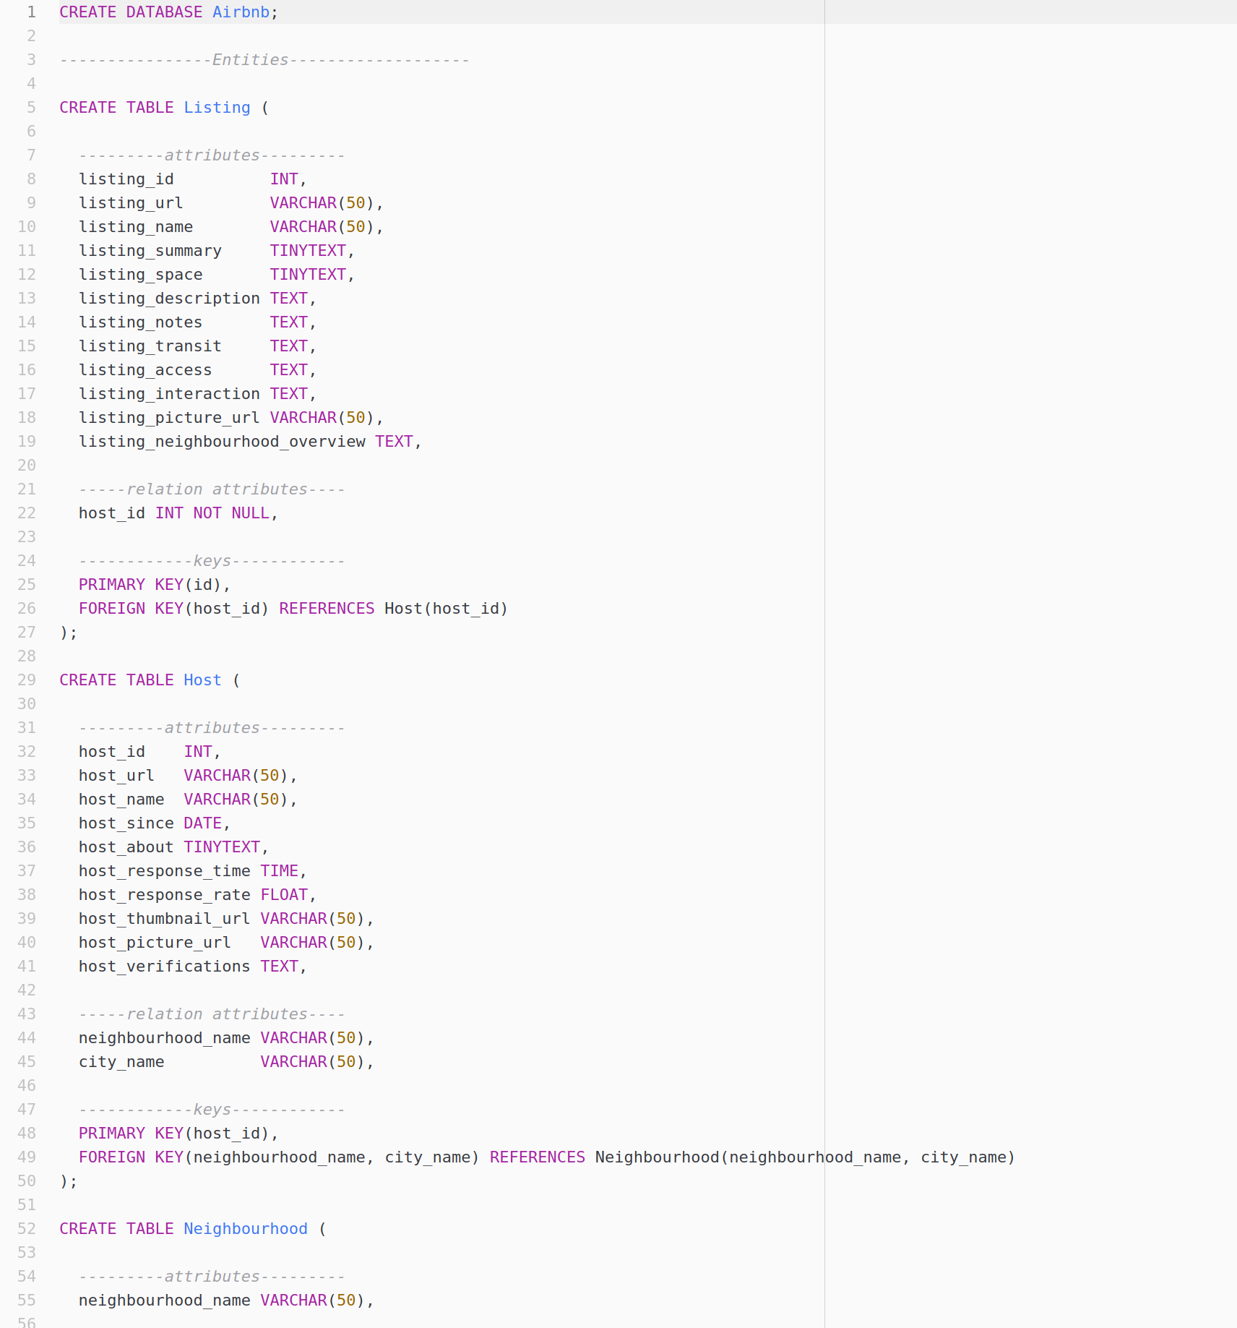
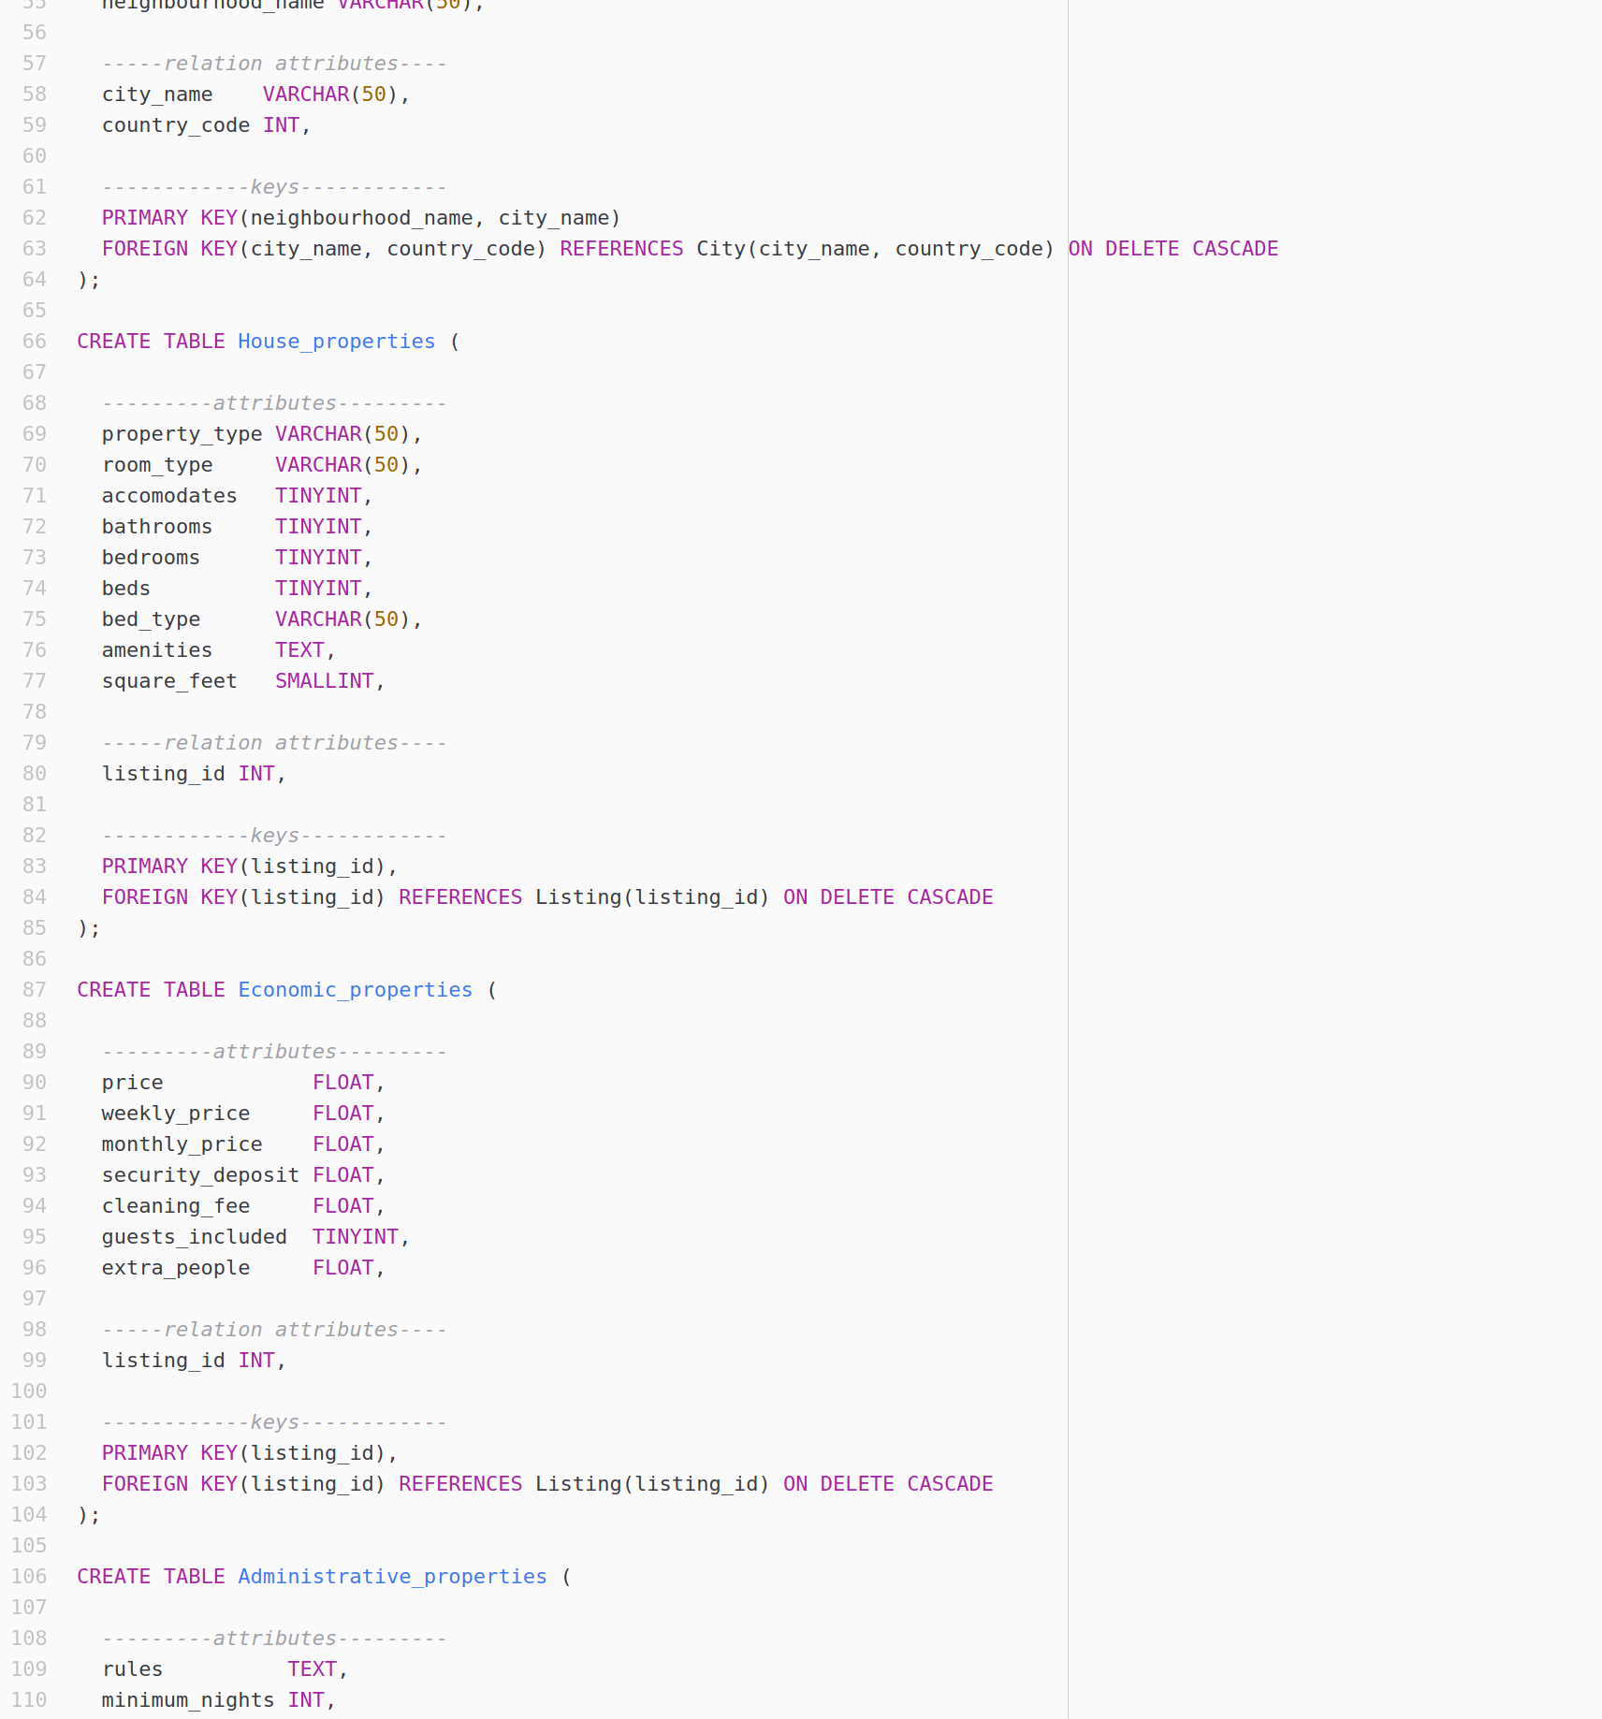
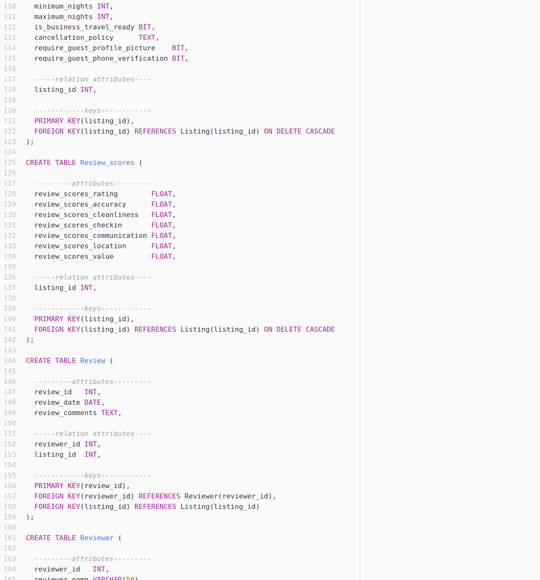
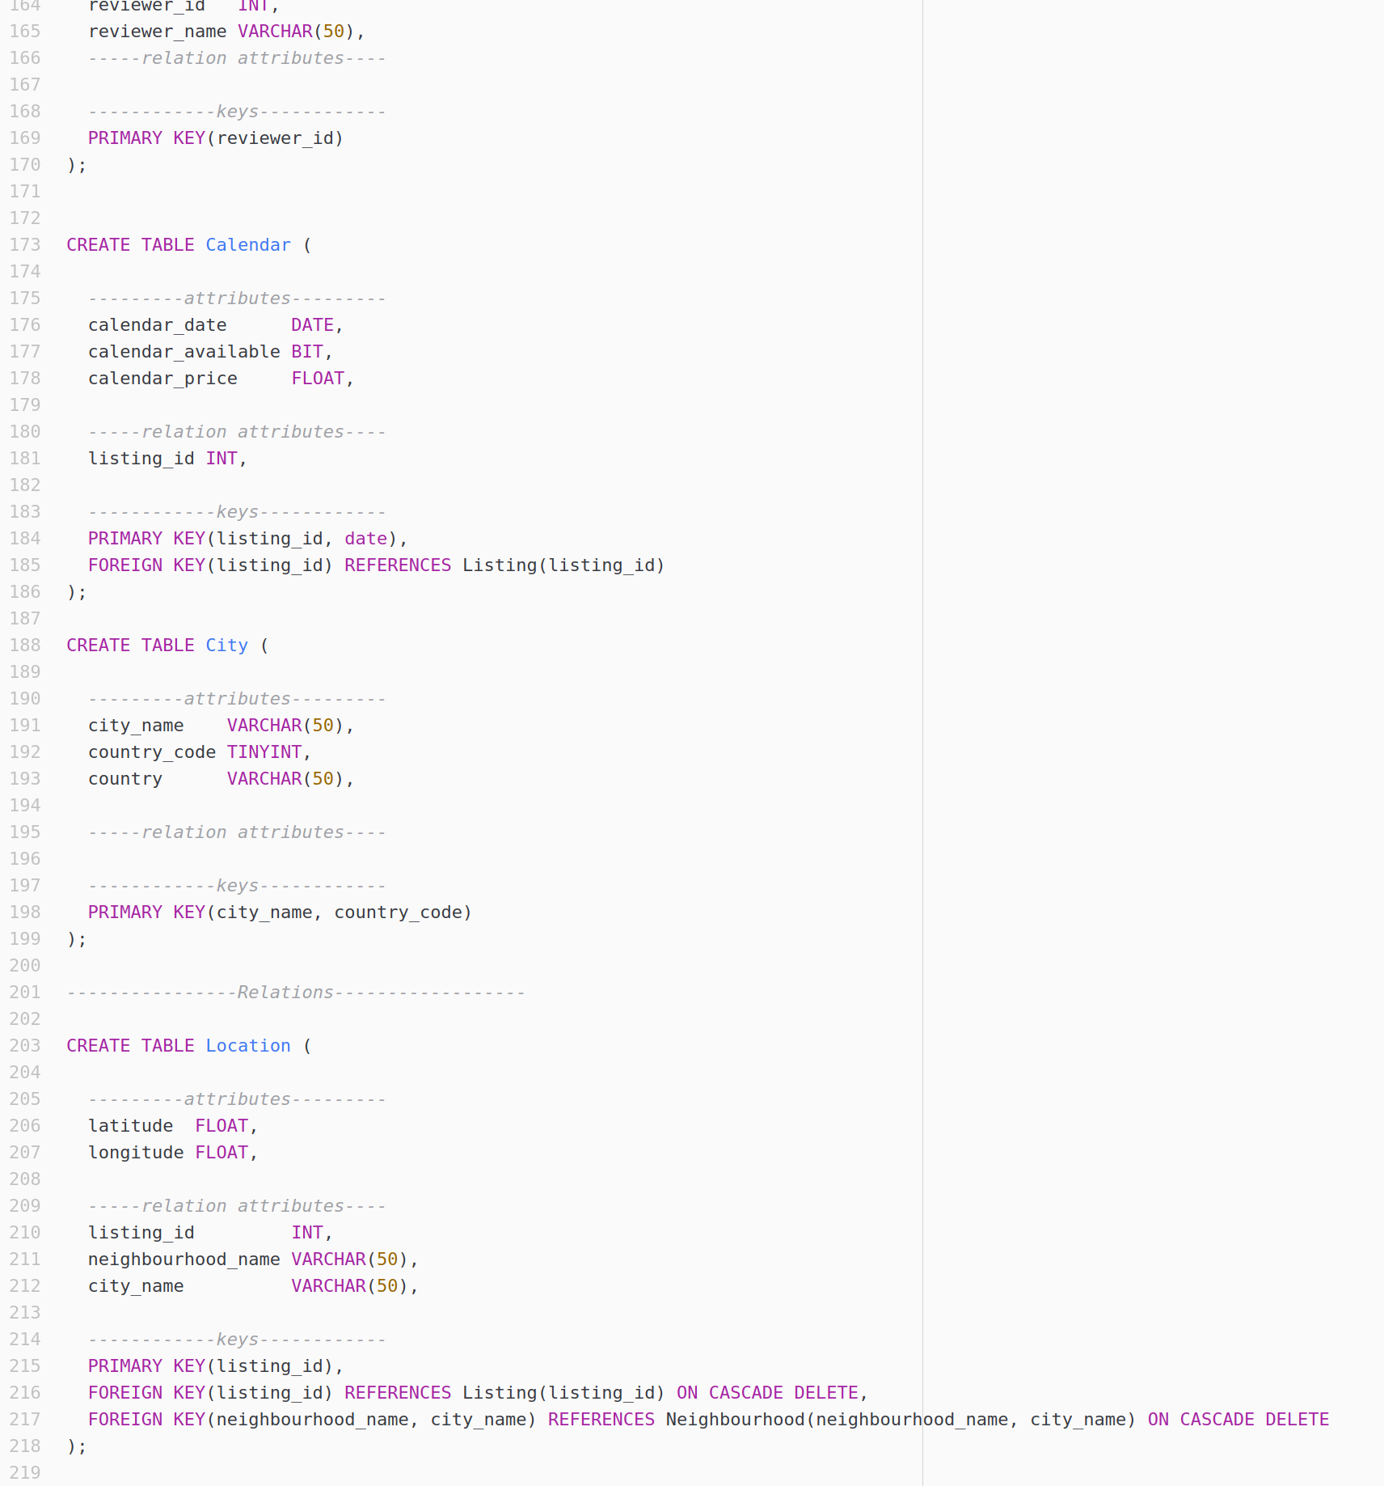

General Comments
For this first work, we thought it was important to work the three together to understand the database correctly. We designed the basis of the ER model, and modified it until the three of us were satisfied. Then we split the work (SQL commands, report, creation of ER model).

