**REPORT**

**Homework 1: Linear Algebra and Floating Point Arithmetic**

**Daniele Napolitano**

***Direct Methods for the solution of Linear Systems.***

* RANDOM MATRIX

Given n=100, we get the following graphs: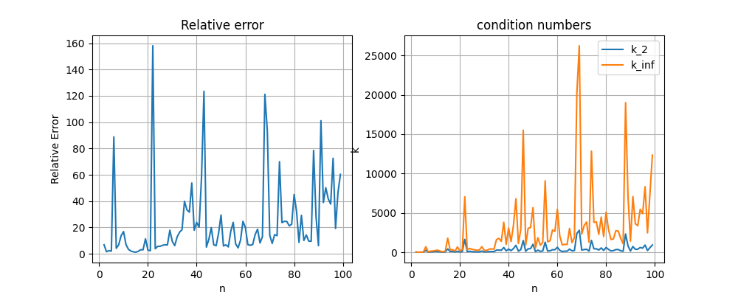

* VANDERMONDE MATRIX

Given n=15:

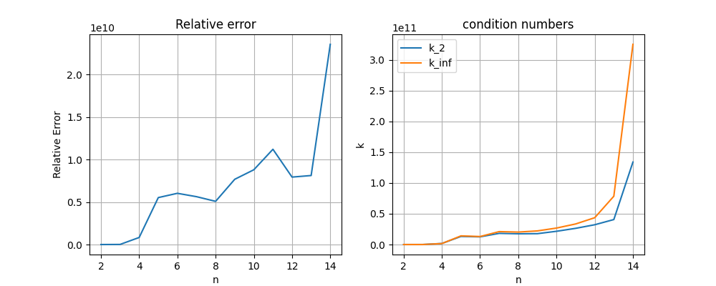

For n>=20, we get a singular matrix, which cannot be solved using Numpy’s function *solve()*

* HILBERT MATRIX

Given n=12:

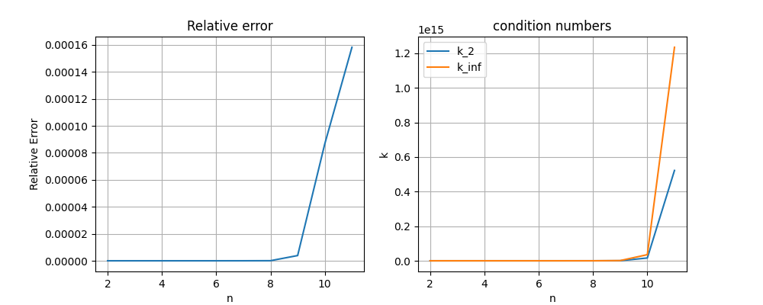

The condition number (both k2 and kinf) starts to rise at n=10

***Floating point operations***

* NEPERO’S NUMBER

