MSOFT, potential type1:

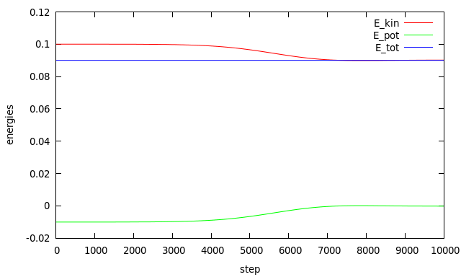
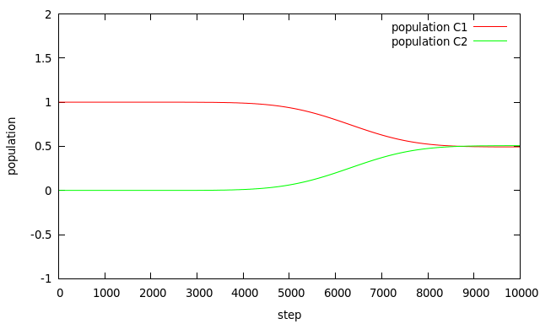

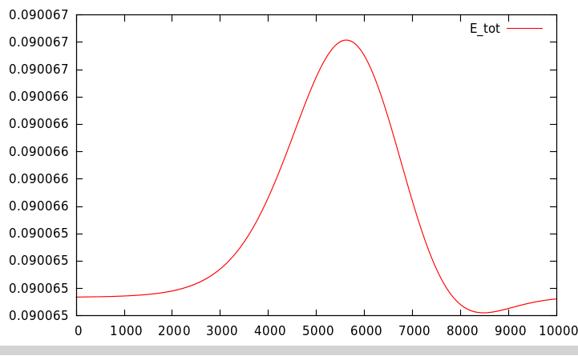
Before the modification:

After moving calc_ekin, to be computed at the same time of calc_epot (same simulation):

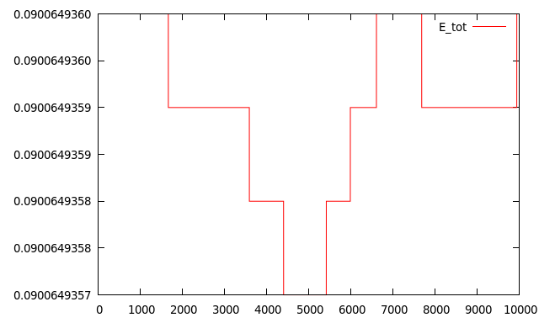
(notice that this time is an error of 1E-9, three order of magnitude less than previously and probably due to machine errors)

