# Short URL app

User guide:

After you follow the instructions read on Docker-HUB ( ) in your terminal appear this:

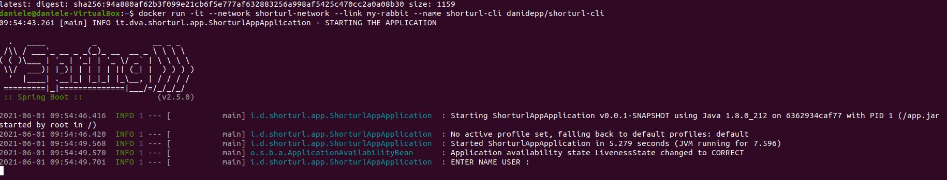

At this point insert your email

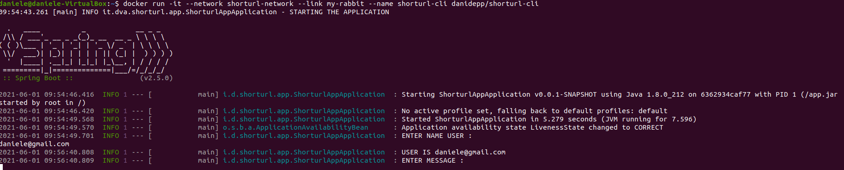

Now you try lunch query for packaging and unpackaging the URL

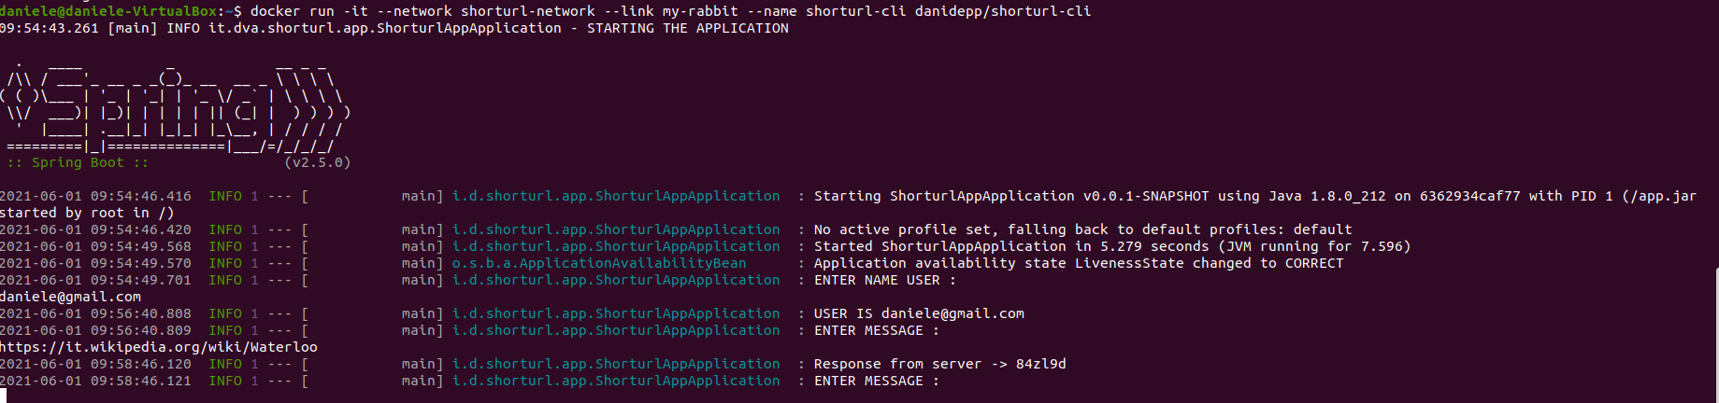

Your response is possible to read on console from server.

Obviously the application provide a undecode the URL insert the key:

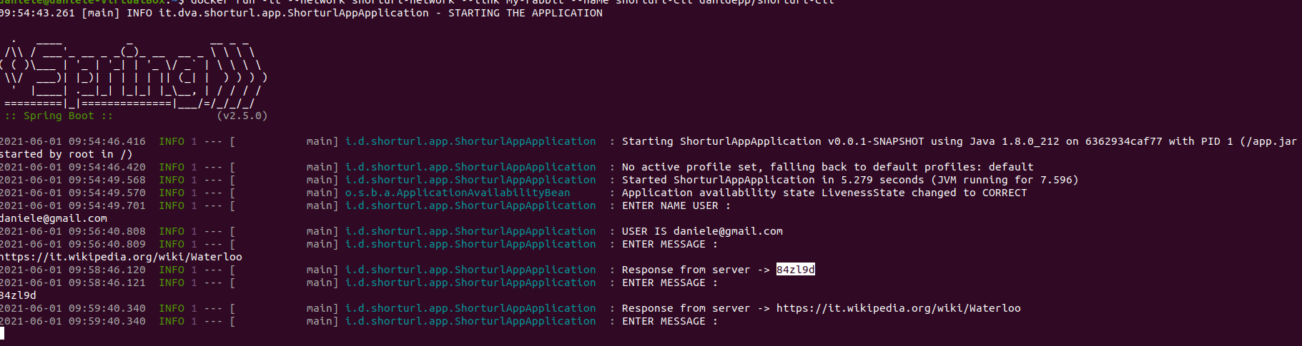

Read the statistics by a command : stat follow the key

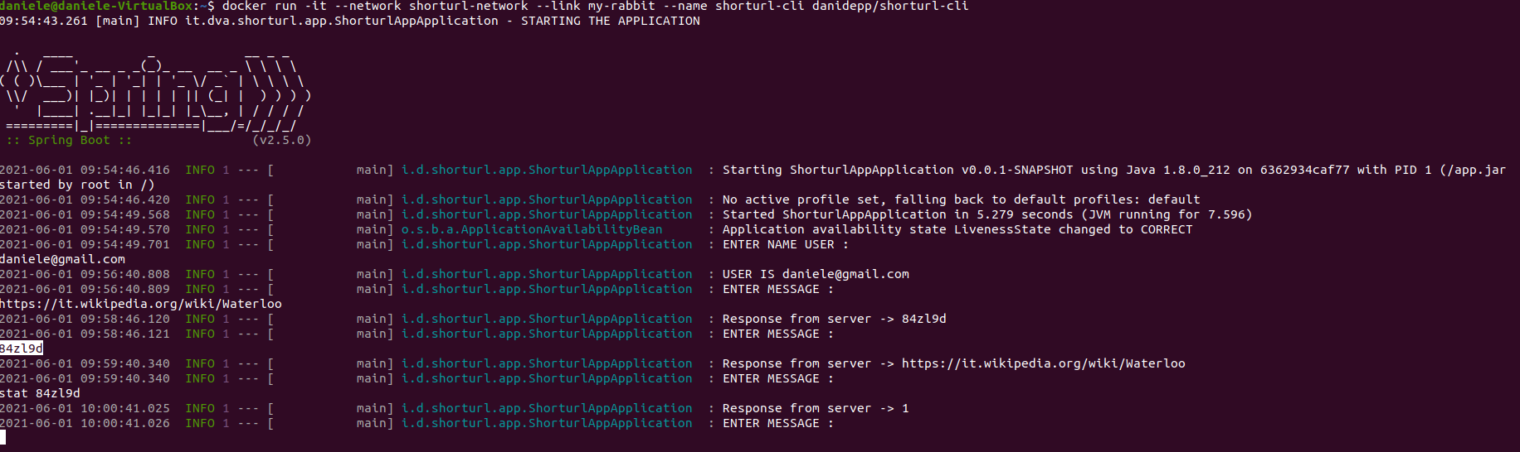

The response will number times you retrieve the long URL by key .