Random Forest Report - Total Rent

SCENARIO: N6 - NO IMPUTATION - DEBUG

Model Target
Target variable: obj_totalRent
Description: Total Rent
Unit: EUR/month
The target variable represents total monthly rent. Living space is included as an explanatory variable.

PLZ Observation Scenario
Scenario name: N6 - NO IMPUTATION - DEBUG
Model target: obj_totalRent
Minimum number of observations per PLZ: 6
Number of model features before preprocessing: 23
Model features:
- obj_heatingType
- obj_ExclusiveExpose
- obj_regio1
- obj_balcony
- obj_cellar
- obj_hasKitchen
- obj_picturecount
- obj_lift
- obj_petsAllowed
- obj_condition
- obj_livingSpace
- obj_typeOfFlat
- obj_garden
- obj_barrierFree
- obj_energyType_cat
- obj_hasNumberOfFloorsInfo
- obj_numberOfFloors_num
- obj_hasParkingInfo
- obj_noParkSpaces_num
- obj_hasLastRefurbishInfo
- obj_yearsSinceLastRefurbish
- obj_buildingAge
- obj_yearsBetweenConstructionAndRefurbish

Global Outlier Clipping
Enabled: True
Mode: remove_rows
Tail percentage per side: 0.25%
Target clipping enabled: True
Excluded features: []
Variables monitored: 8
Variables that triggered outliers: 8
Rows removed by outlier rule: 1449
Detailed outlier listings are hidden to keep the report concise. Use this summary to compare scenarios.

PLZ Group Filtering
Rows before PLZ filtering: 61166
PLZ groups before filtering: 5496
Rows after PLZ filtering: 54369
PLZ groups after filtering: 2385
Removed PLZ groups: 3111
Examples of removed PLZ groups:
71384: n=5
74078: n=5
64404: n=5
83024: n=5
26639: n=5
22297: n=5
53859: n=5
55283: n=5
47839: n=5
22159: n=5
71116: n=5
86956: n=5
13589: n=5
13583: n=5
67550: n=5
24106: n=5
86551: n=5
37688: n=5
15711: n=5
70439: n=5

Rows Used
Initial rows: 83273
Rows after dropping missing model target/group: 71368
Rows after missing value handling: 61166
Rows used after PLZ filtering: 54369
Use imputation: False

Variable Type Summary
Number of binary variables: 10
- obj_ExclusiveExpose
- obj_balcony
- obj_cellar
- obj_hasKitchen
- obj_lift
- obj_garden
- obj_barrierFree
- obj_hasNumberOfFloorsInfo
- obj_hasParkingInfo
- obj_hasLastRefurbishInfo
Number of numeric non-binary variables: 7
- obj_picturecount
- obj_livingSpace
- obj_numberOfFloors_num
- obj_noParkSpaces_num
- obj_yearsSinceLastRefurbish
- obj_buildingAge
- obj_yearsBetweenConstructionAndRefurbish
Number of categorical variables: 6
- obj_heatingType
- obj_regio1
- obj_petsAllowed
- obj_condition
- obj_typeOfFlat
- obj_energyType_cat

PEARSON CORRELATION - N6 - NO IMPUTATION - DEBUG
Pearson correlation was computed using available data. Pandas uses pairwise valid observations.
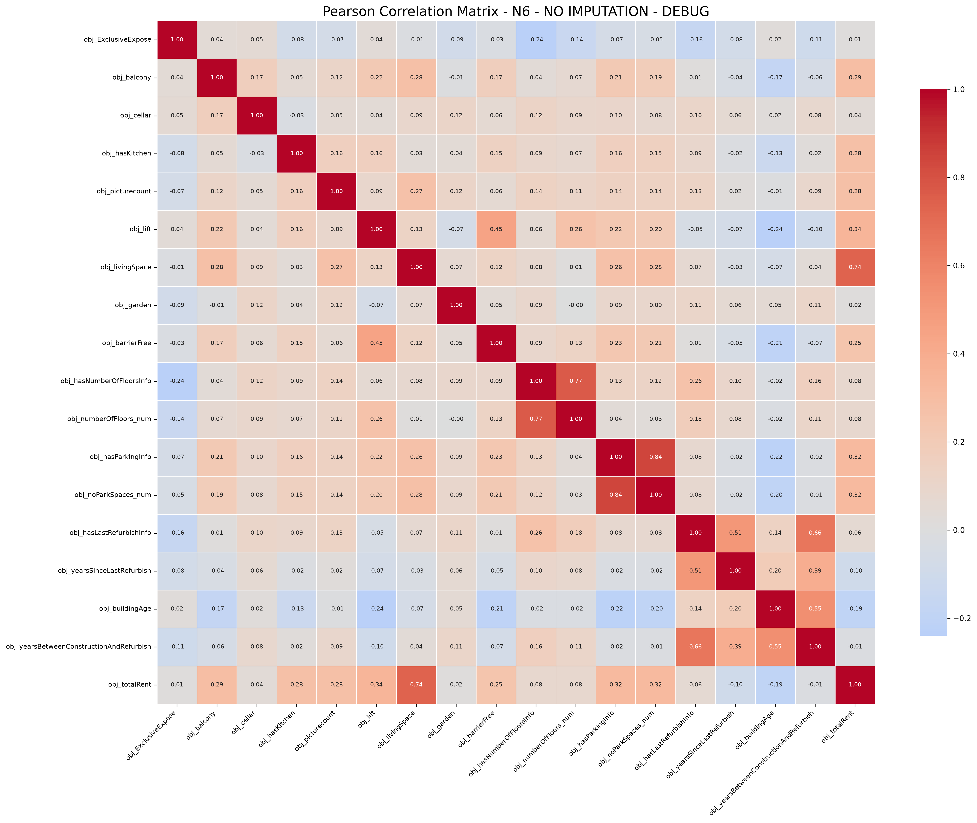

Pearson Correlation with obj_totalRent
Top Pearson correlations with the target:
obj_livingSpace: 0.7379
obj_lift: 0.3419
obj_noParkSpaces_num: 0.3182
obj_hasParkingInfo: 0.3169
obj_balcony: 0.2918
obj_hasKitchen: 0.2798
obj_picturecount: 0.2783
obj_barrierFree: 0.2469
obj_buildingAge: -0.1923
obj_yearsSinceLastRefurbish: -0.0972
obj_hasNumberOfFloorsInfo: 0.0824
obj_numberOfFloors_num: 0.0803
obj_hasLastRefurbishInfo: 0.0565
obj_cellar: 0.0405
obj_garden: 0.0152
obj_ExclusiveExpose: 0.0148
obj_yearsBetweenConstructionAndRefurbish: -0.0127
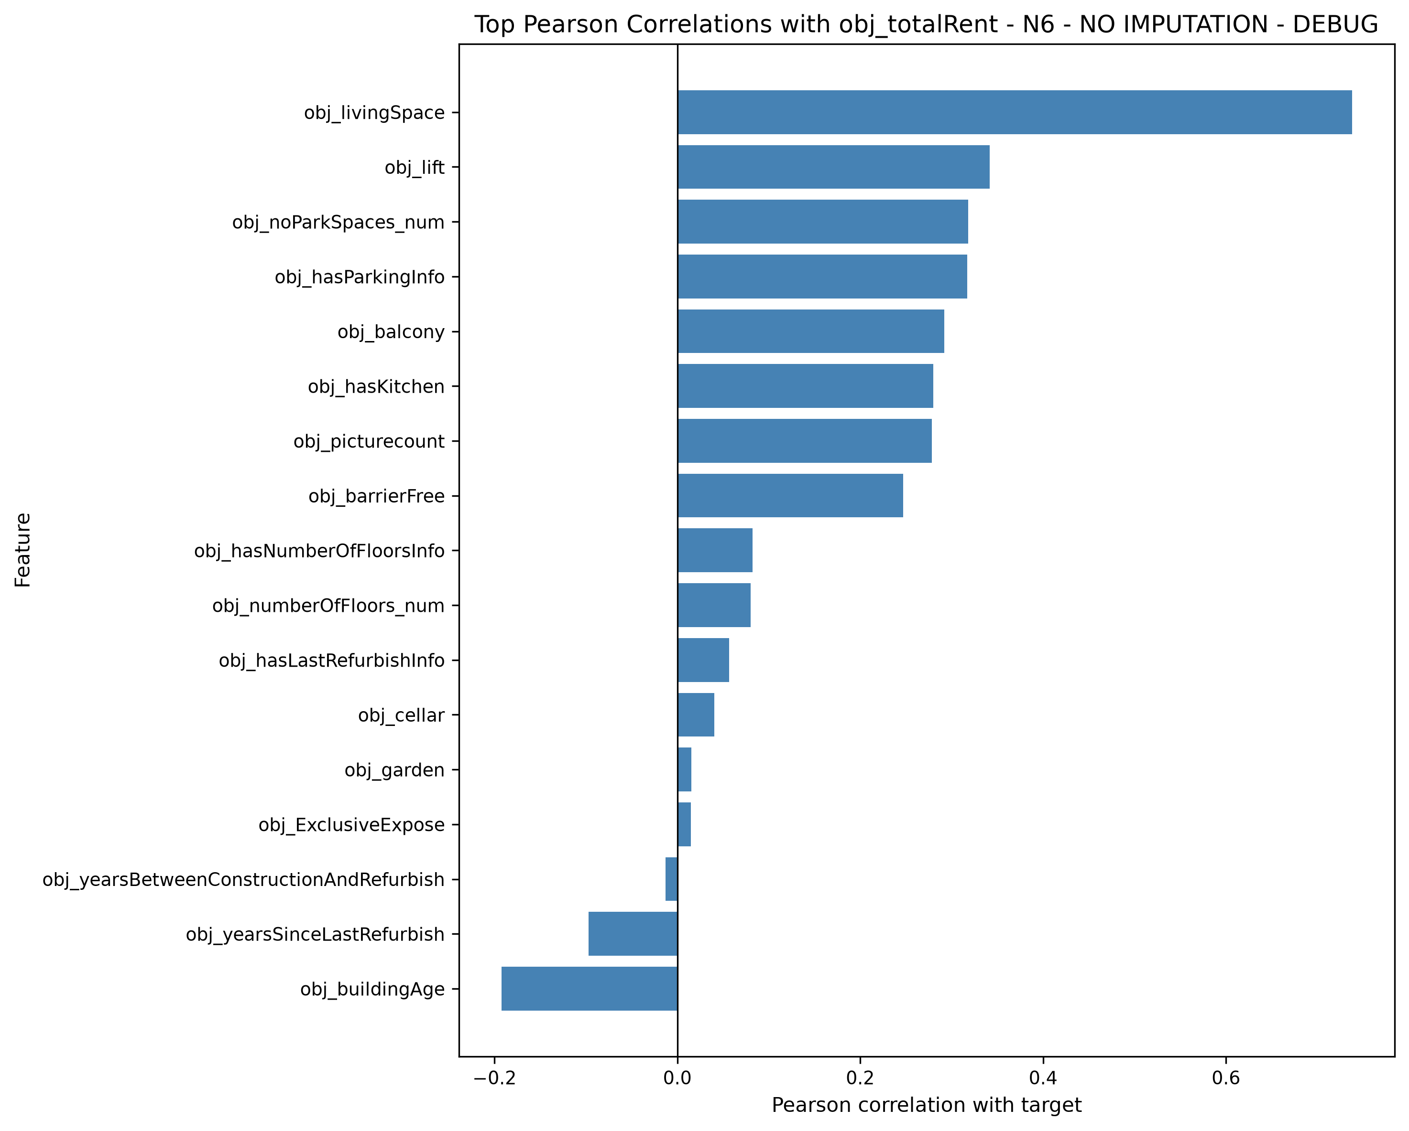
Note: Pearson correlation measures linear relationships among numeric variables. Pure categorical variables were excluded before one-hot encoding.

Grouped Train/Test Split
Grouping variable: obj_zipCode
Test size: 0.25
Training observations: 39368
Test observations: 15001
Training groups: 1788
Test groups: 597
Overlapping groups: 0
OK: no group appears simultaneously in training and testing.

Random Forest Training - N6 - NO IMPUTATION - DEBUG
Model: Random Forest Regressor
Validation: GroupKFold
Group column: obj_zipCode
CV folds: 5
RandomizedSearchCV iterations: 15
Scoring metric: negative root mean squared error
Training completed.
Best grouped CV RMSE: 233.3629
Best parameters:
model__n_estimators: 300
model__min_samples_split: 10
model__min_samples_leaf: 2
model__max_features: 0.5
model__max_depth: 30

Random Forest Metrics - N6 - NO IMPUTATION - DEBUG

Train Performance
RMSE: 144.7900
MAE: 87.3130
R2: 0.9144

Grouped Test Performance
RMSE: 203.2644
MAE: 129.5607
R2: 0.8136

Cross-Validation Performance
Best grouped CV RMSE: 233.3629

Out-of-Bag Performance
OOB R2: 0.8008

Overfitting Indicators
RMSE gap Test - Train: 58.4745
R2 gap Train - Test: 0.1008

Comparison of Train, Grouped Test and OOB R2
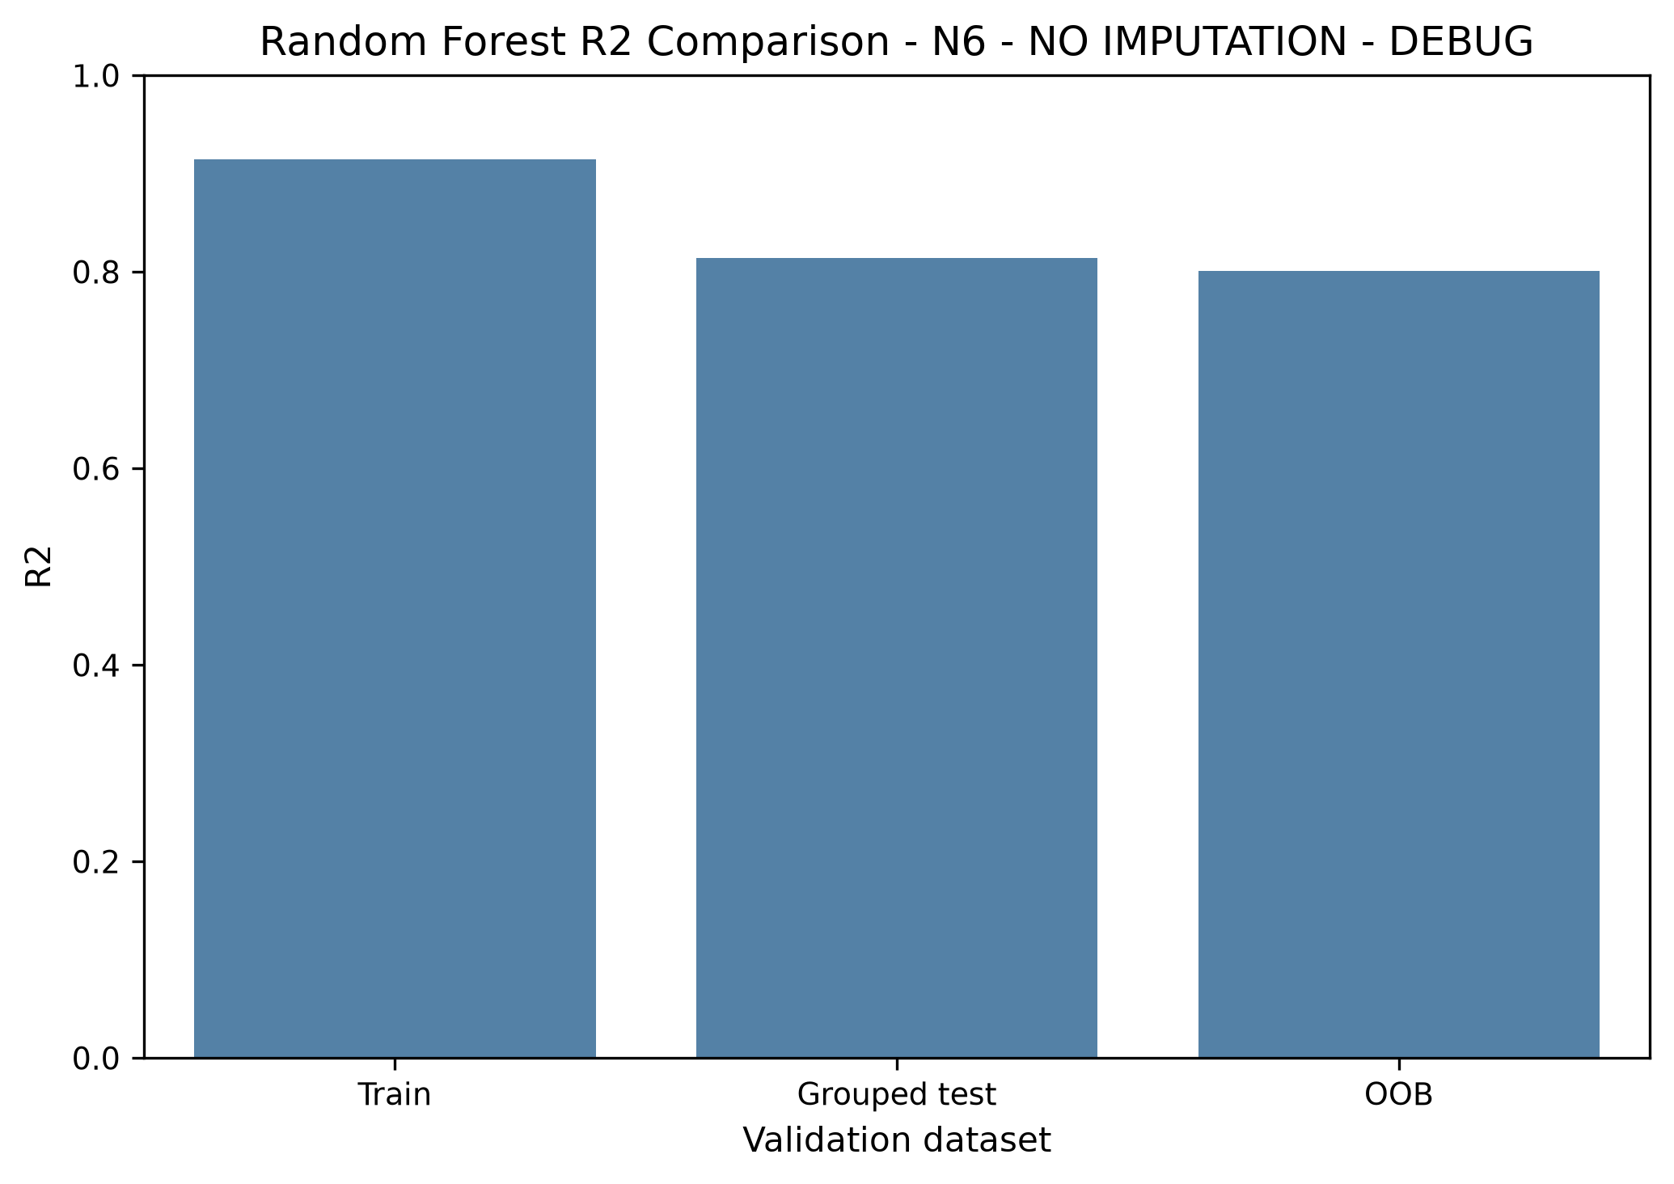

WORKED RF EXAMPLES - N6 - NO IMPUTATION - DEBUG
The examples below compare actual and predicted rent values for selected observations.

Example 1
Row index: 559
Region: Berlin
Actual rent: 695.5600
Predicted rent: 783.9322
Residual (actual - predicted): -88.3722

Example 2
Row index: 36
Region: Hamburg
Actual rent: 1040.0000
Predicted rent: 899.3951
Residual (actual - predicted): 140.6049

Example 3
Row index: 1
Region: Nordrhein_Westfalen
Actual rent: 690.0000
Predicted rent: 919.8357
Residual (actual - predicted): -229.8357

Example 4
Row index: 5
Region: Hessen
Actual rent: 1655.0000
Predicted rent: 1609.8067
Residual (actual - predicted): 45.1933

Example 5
Row index: 13
Region: Baden_Württemberg
Actual rent: 700.0000
Predicted rent: 649.1473
Residual (actual - predicted): 50.8527

Example Decision Tree (text excerpt)
This is one tree from the forest (depth limited for readability).
|--- obj_livingSpace <= 85.67
| |--- obj_livingSpace <= 64.99
| | |--- obj_hasKitchen <= 0.50
| | | |--- obj_regio1_Sachsen <= 0.50
| | | | |--- truncated branch of depth 27
| | | |--- obj_regio1_Sachsen > 0.50
| | | | |--- truncated branch of depth 23
| | |--- obj_hasKitchen > 0.50
| | | |--- obj_livingSpace <= 49.97
| | | | |--- truncated branch of depth 25
| | | |--- obj_livingSpace > 49.97
| | | | |--- truncated branch of depth 25
| |--- obj_livingSpace > 64.99
| | |--- obj_hasKitchen <= 0.50
| | | |--- obj_lift <= 0.50
| | | | |--- truncated branch of depth 27
| | | |--- obj_lift > 0.50
| | | | |--- truncated branch of depth 20
| | |--- obj_hasKitchen > 0.50
| | | |--- obj_lift <= 0.50
| | | | |--- truncated branch of depth 26
| | | |--- obj_lift > 0.50
| | | | |--- truncated branch of depth 20
|--- obj_livingSpace > 85.67
| |--- obj_livingSpace <= 121.77
| | |--- obj_livingSpace <= 100.03
| | | |--- obj_heatingType_floor_heating <= 0.50
| | | | |--- truncated branch of depth 25
| | | |--- obj_heatingType_floor_heating > 0.50
| | | | |--- truncated branch of depth 21
| | |--- obj_livingSpace > 100.03
| | | |--- obj_lift <= 0.50
| | | | |--- truncated branch of depth 21
| | | |--- obj_lift > 0.50
| | | | |--- truncated branch of depth 22
| |--- obj_livingSpace > 121.77
| | |--- obj_livingSpace <= 149.29
| | | |--- obj_numberOfFloors_num <= 4.50
| | | | |--- truncated branch of depth 23
| | | |--- obj_numberOfFloors_num > 4.50
| | | | |--- truncated branch of depth 10
| | |--- obj_livingSpace > 149.29
| | | |--- obj_numberOfFloors_num <= 4.50
| | | | |--- truncated branch of depth 20
| | | |--- obj_numberOfFloors_num > 4.50
| | | | |--- truncated branch of depth 10

Internal RF Feature Importance - N6 - NO IMPUTATION - DEBUG
Top 30 features by internal Random Forest feature importance:
obj_livingSpace: 0.582172
obj_lift: 0.075410
obj_hasKitchen: 0.038654
obj_buildingAge: 0.031942
obj_regio1_Bayern: 0.024573
obj_picturecount: 0.023024
obj_noParkSpaces_num: 0.022499
obj_numberOfFloors_num: 0.019236
obj_regio1_Sachsen: 0.018767
obj_regio1_Berlin: 0.015972
obj_regio1_Hessen: 0.014945
obj_balcony: 0.012517
obj_heatingType_floor_heating: 0.011459
obj_hasParkingInfo: 0.006998
obj_yearsBetweenConstructionAndRefurbish: 0.006992
obj_regio1_Sachsen_Anhalt: 0.006719
obj_regio1_Hamburg: 0.006641
obj_yearsSinceLastRefurbish: 0.005479
obj_petsAllowed_no: 0.004301
obj_condition_well_kept: 0.004019
obj_energyType_cat_energy_required: 0.003991
obj_energyType_cat_energy_consumption: 0.003872
obj_petsAllowed_no_information: 0.003439
obj_cellar: 0.003308
obj_regio1_Nordrhein_Westfalen: 0.002986
obj_condition_mint_condition: 0.002906
obj_condition_first_time_use_after_refurbishment: 0.002619
obj_regio1_Niedersachsen: 0.002222
obj_garden: 0.002208
obj_condition_no_information: 0.002197
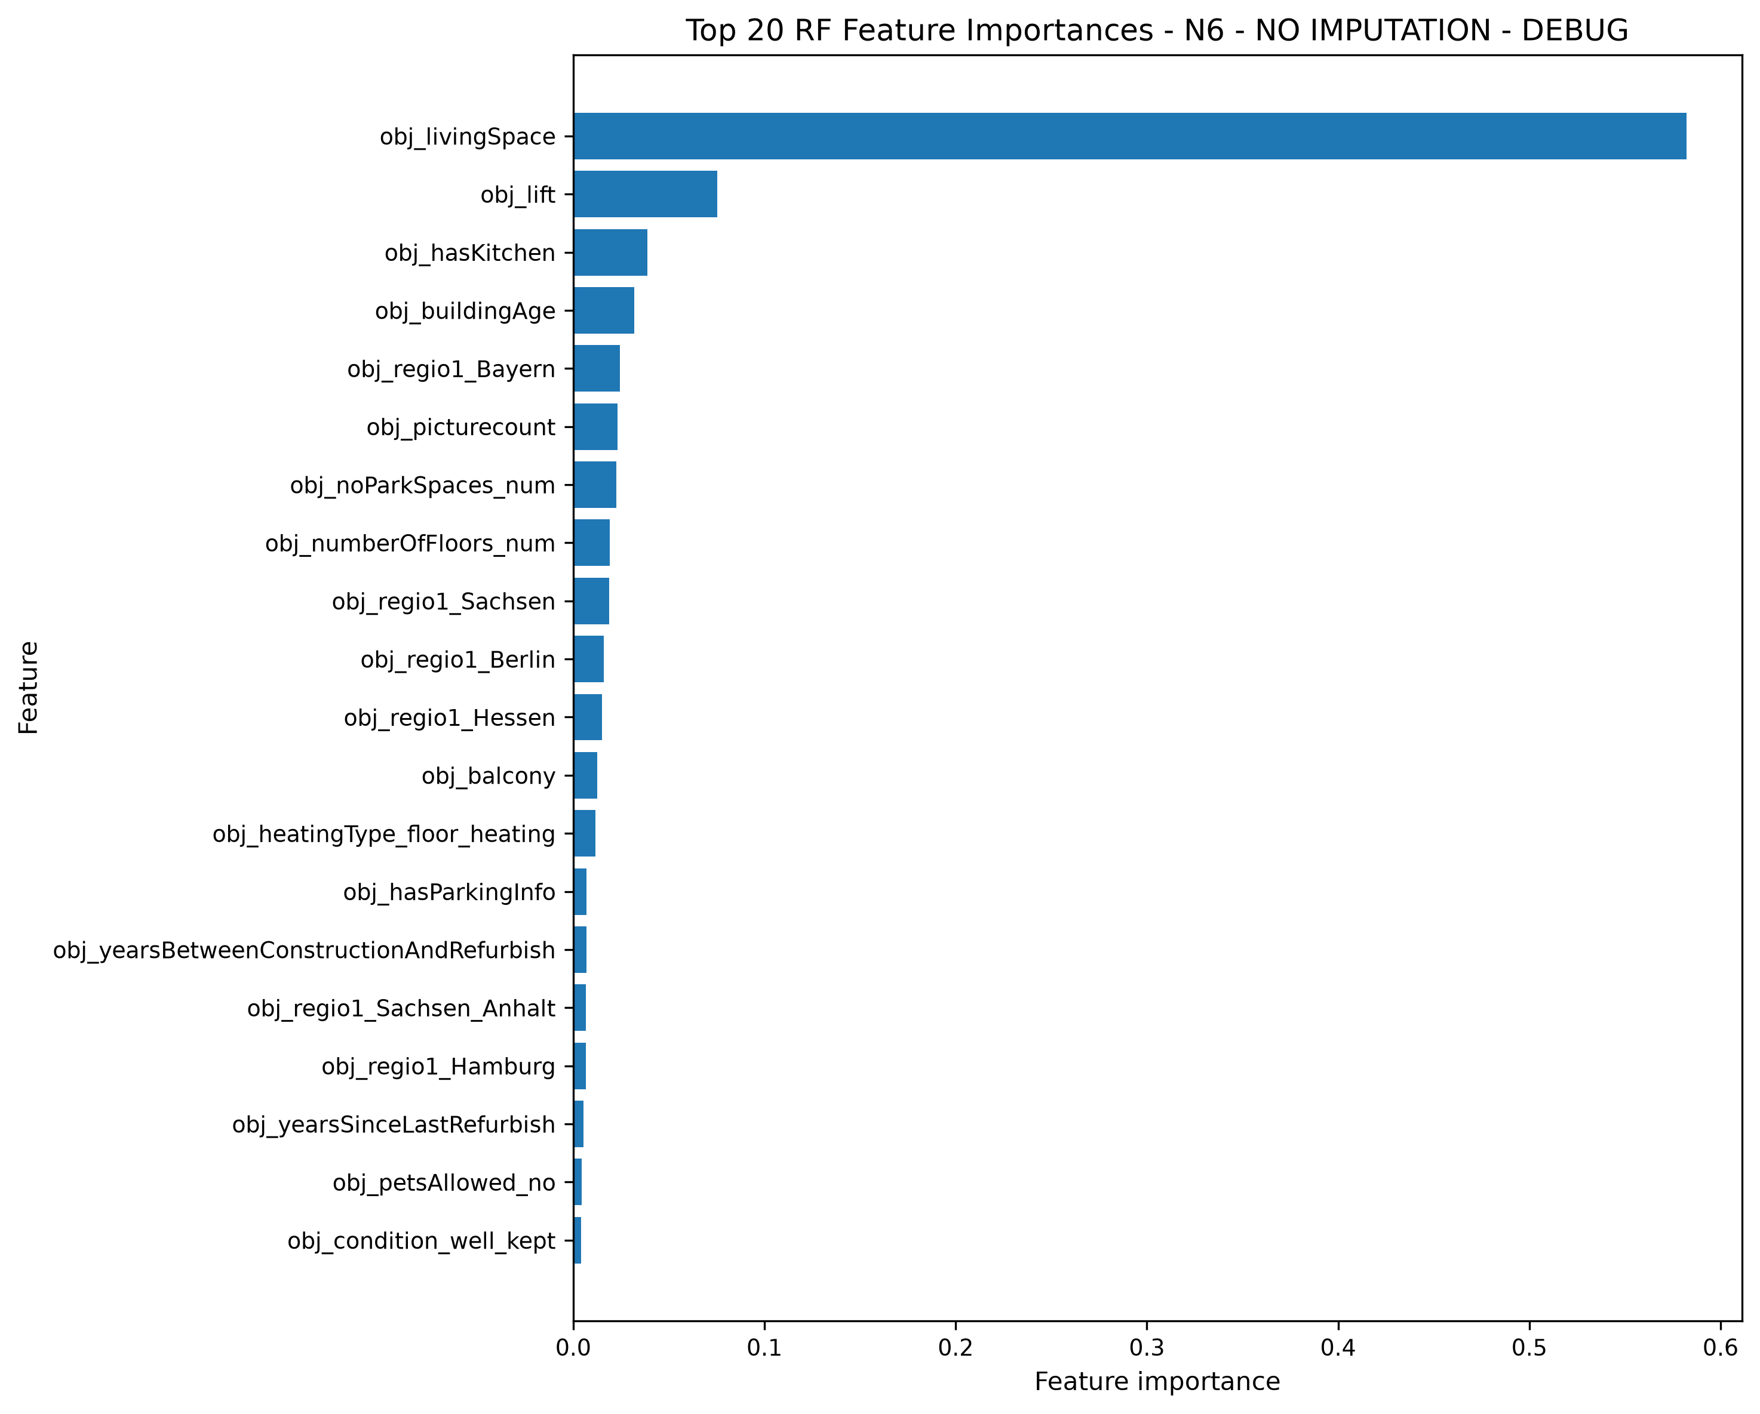

Permutation Importance - N6 - NO IMPUTATION - DEBUG
Permutation importance sample size: 5000
N repeats: 5
Permutation importance by original feature:
obj_livingSpace: mean=274.649092, std=3.597907
obj_regio1: mean=71.228579, std=1.363823
obj_lift: mean=24.564773, std=2.650548
obj_hasKitchen: mean=14.210777, std=1.146578
obj_buildingAge: mean=6.092335, std=0.655570
obj_numberOfFloors_num: mean=5.319404, std=0.887484
obj_balcony: mean=3.287976, std=0.375339
obj_picturecount: mean=2.873030, std=0.546699
obj_heatingType: mean=2.559590, std=0.353983
obj_condition: mean=2.524538, std=0.413500
obj_petsAllowed: mean=2.034291, std=0.102202
obj_energyType_cat: mean=1.584665, std=0.218280
obj_yearsSinceLastRefurbish: mean=0.615778, std=0.105523
obj_ExclusiveExpose: mean=0.601167, std=0.078600
obj_cellar: mean=0.453098, std=0.171119
obj_noParkSpaces_num: mean=0.449597, std=0.181185
obj_typeOfFlat: mean=0.298371, std=0.273219
obj_barrierFree: mean=0.265893, std=0.068634
obj_yearsBetweenConstructionAndRefurbish: mean=0.148032, std=0.134301
obj_hasNumberOfFloorsInfo: mean=0.012308, std=0.177534
obj_hasLastRefurbishInfo: mean=-0.009800, std=0.065325
obj_hasParkingInfo: mean=-0.035877, std=0.105974
obj_garden: mean=-0.044290, std=0.060383
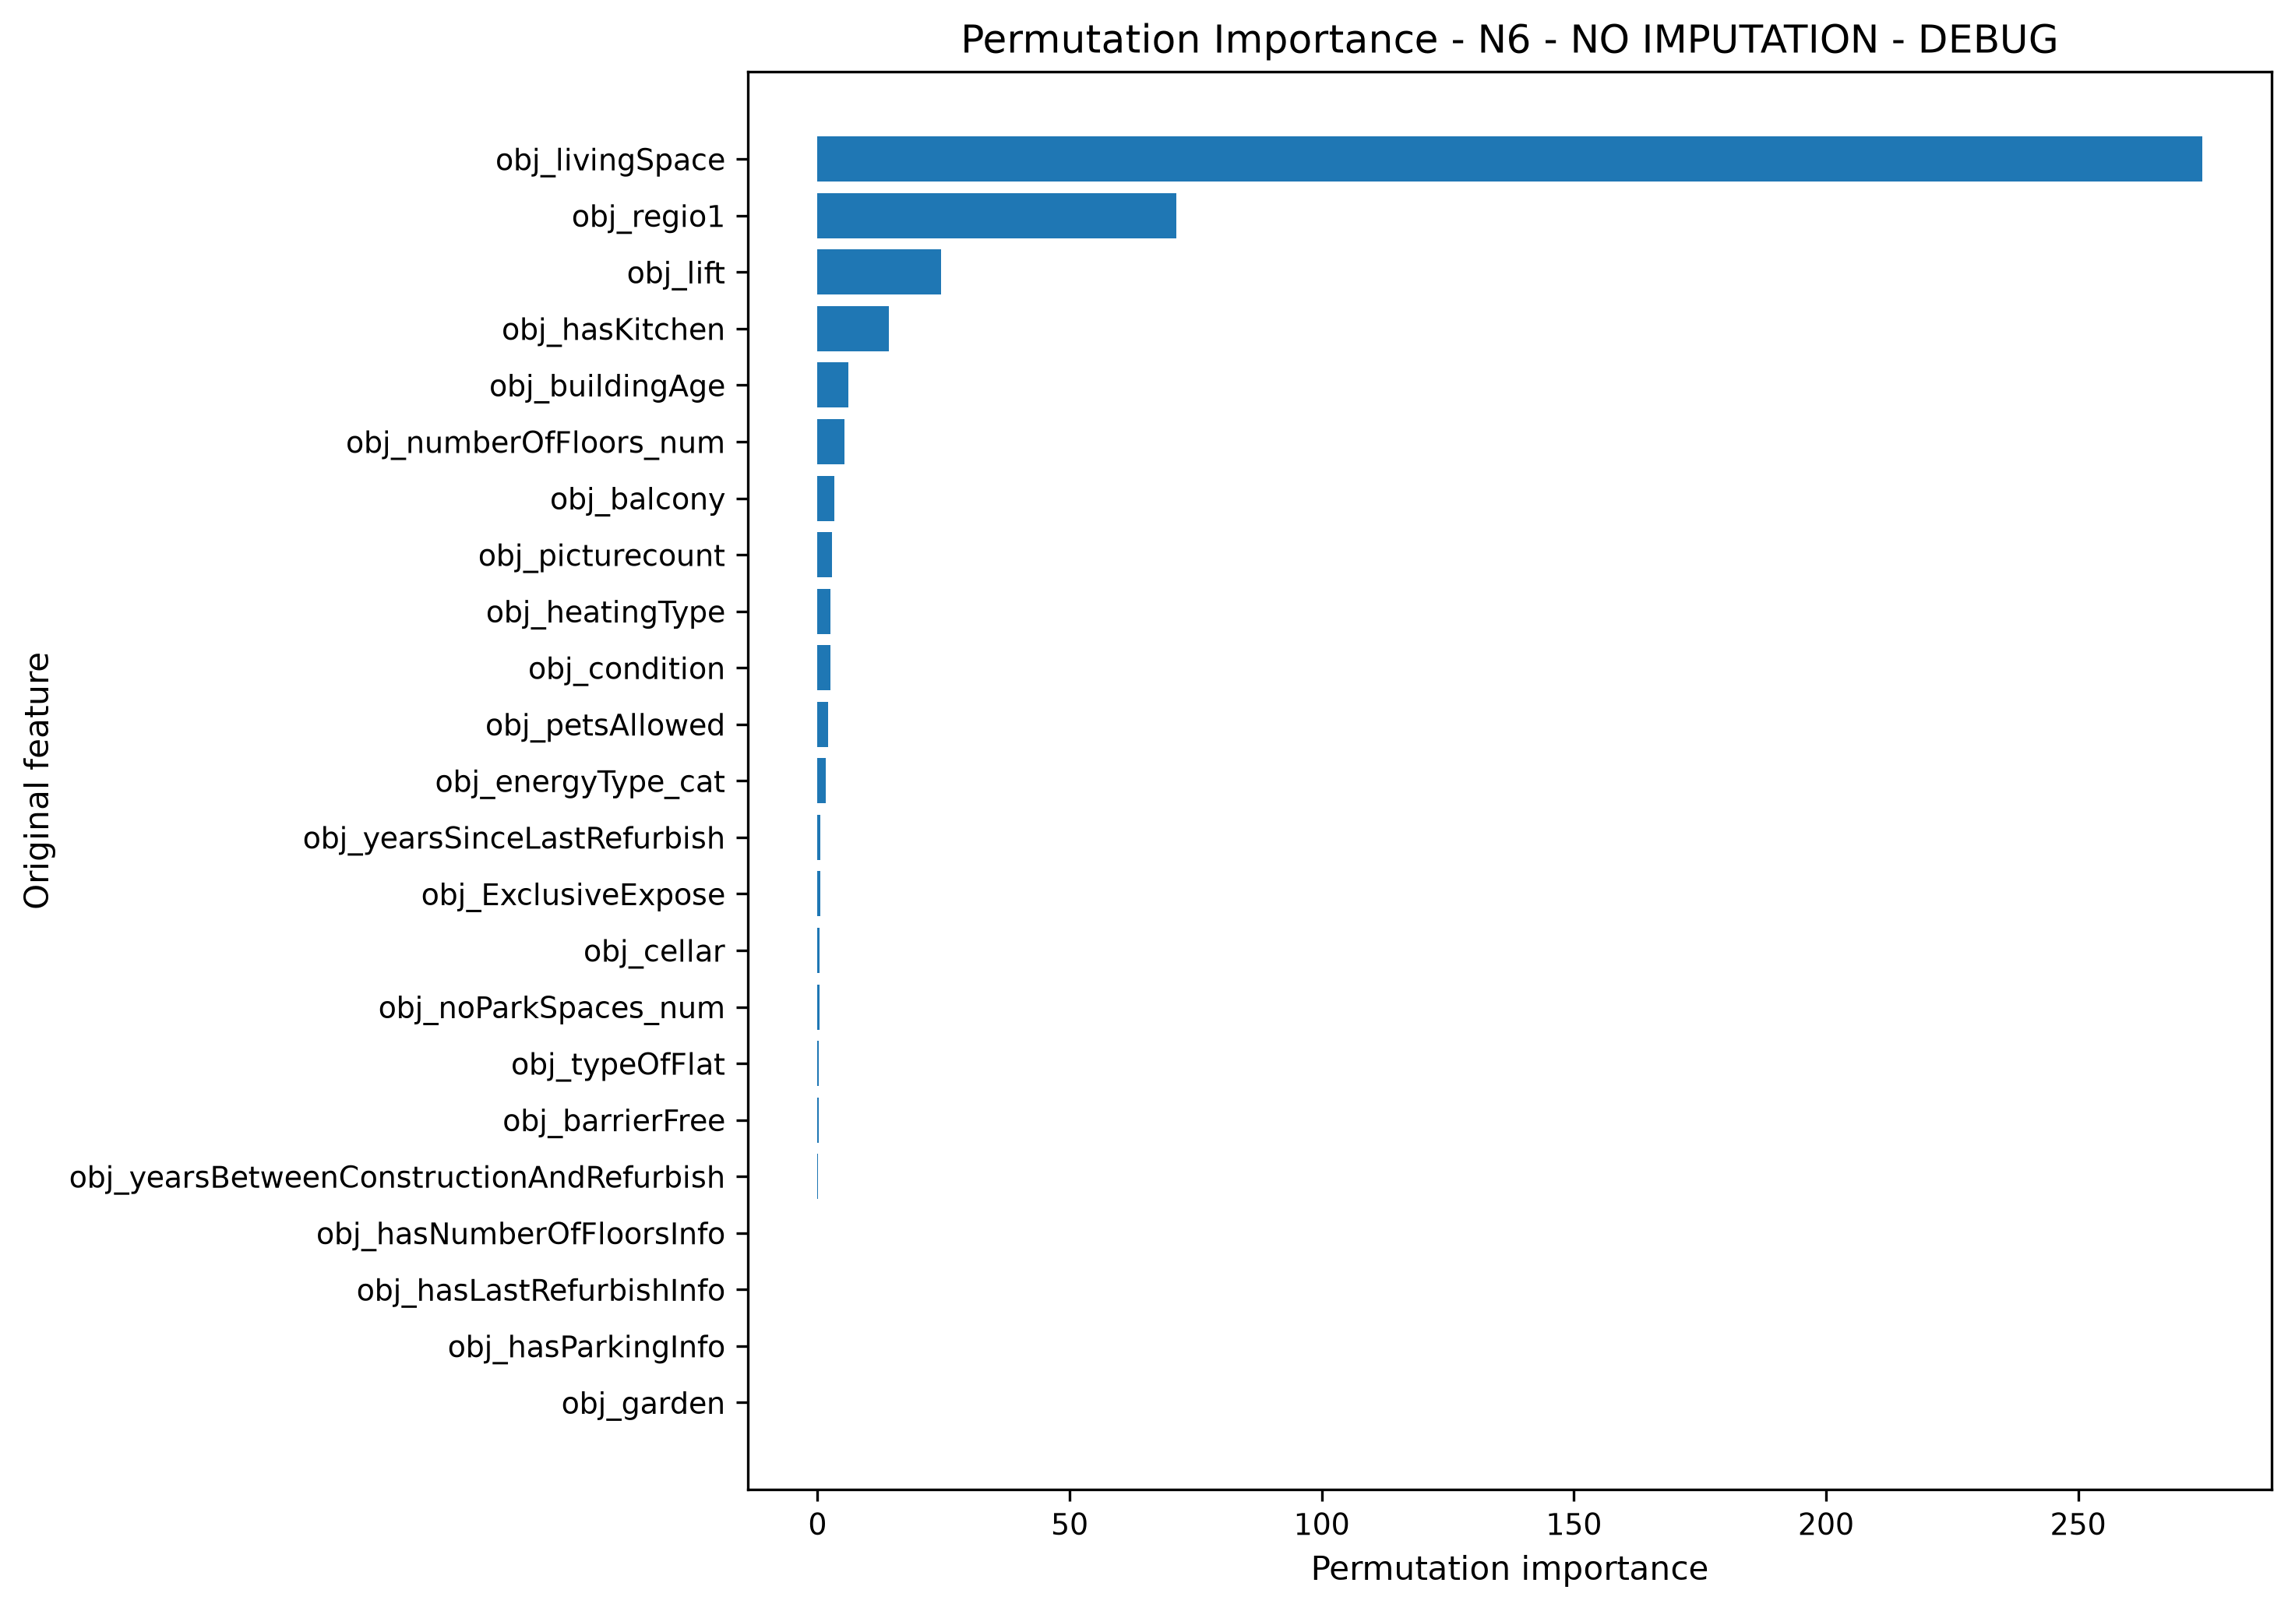

Partial Dependence Plots - N6 - NO IMPUTATION - DEBUG

PDP: obj_livingSpace
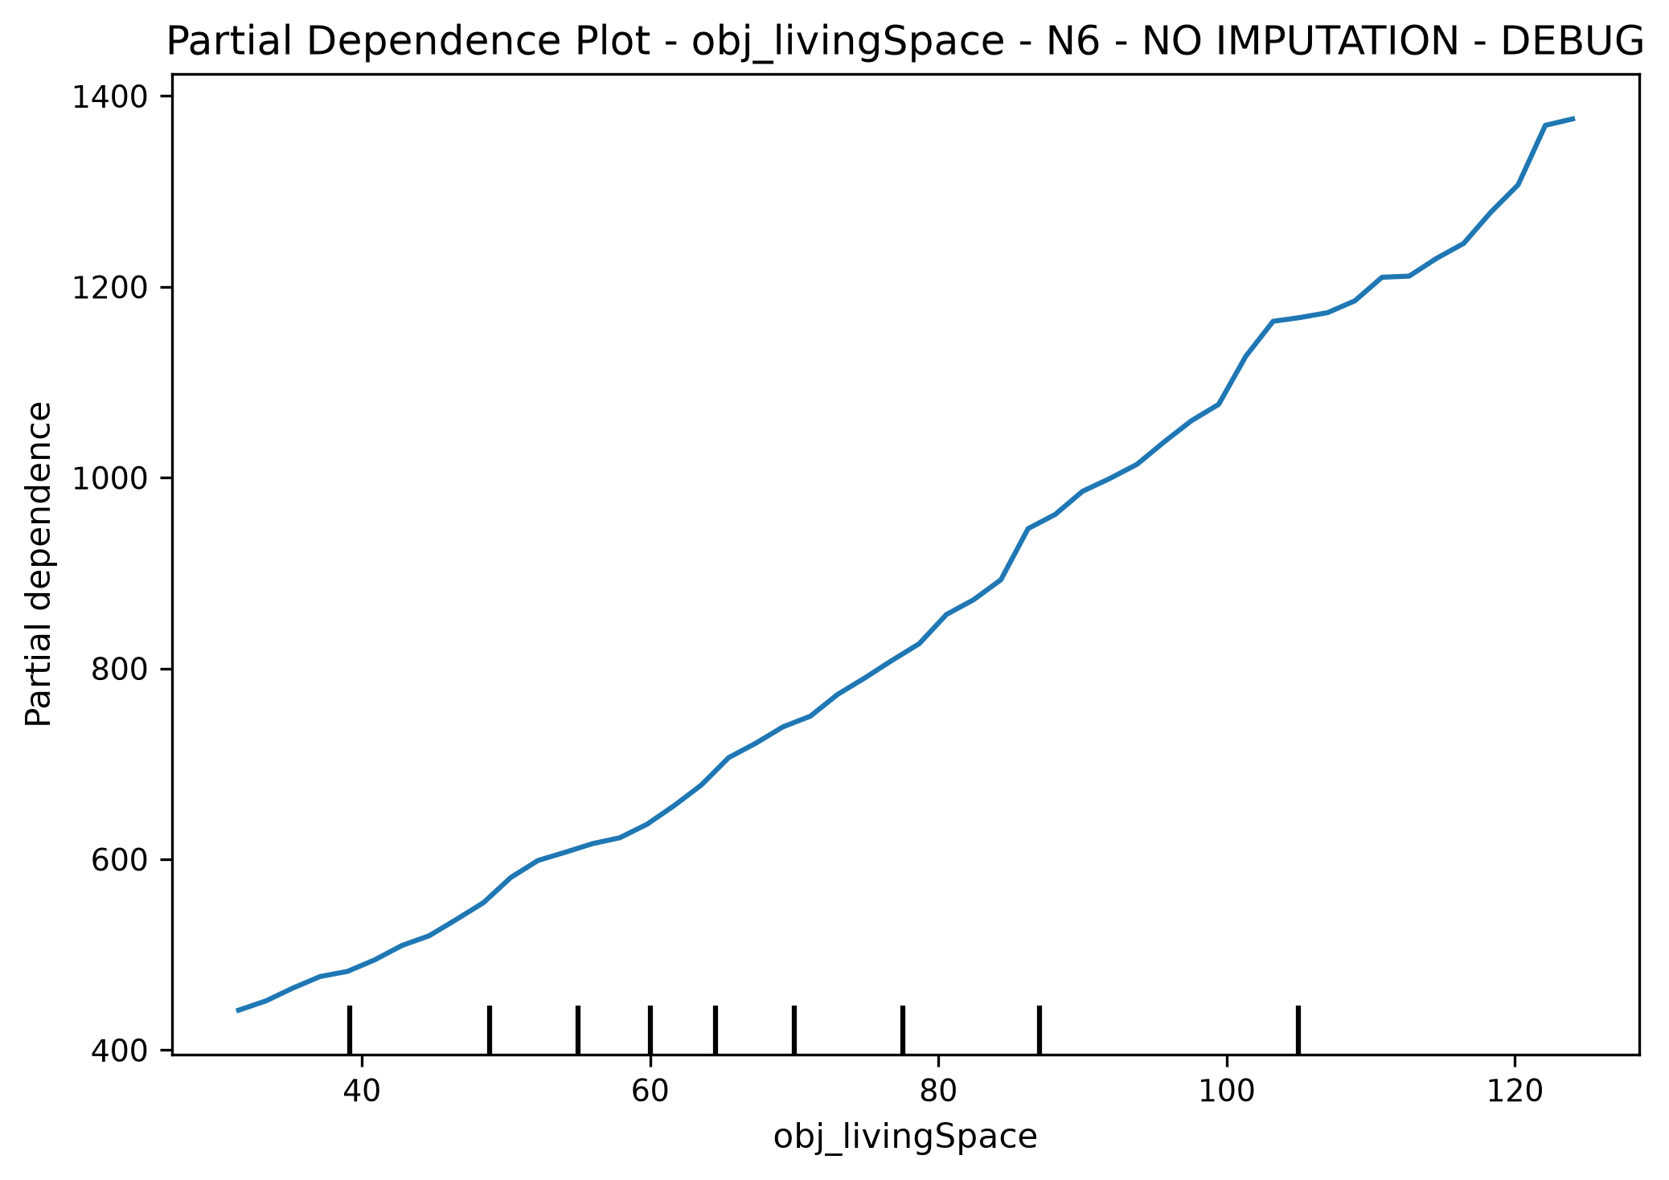

PDP: obj_picturecount
PDP for obj_picturecount could not be generated: The column 6 contains integer data. Partial dependence plots are not supported for integer data: this can lead to implicit rounding with NumPy arrays or even errors with newer pandas versions. Please convert numerical features to floating point dtypes ahead of time to avoid problems.

PDP: obj_lift
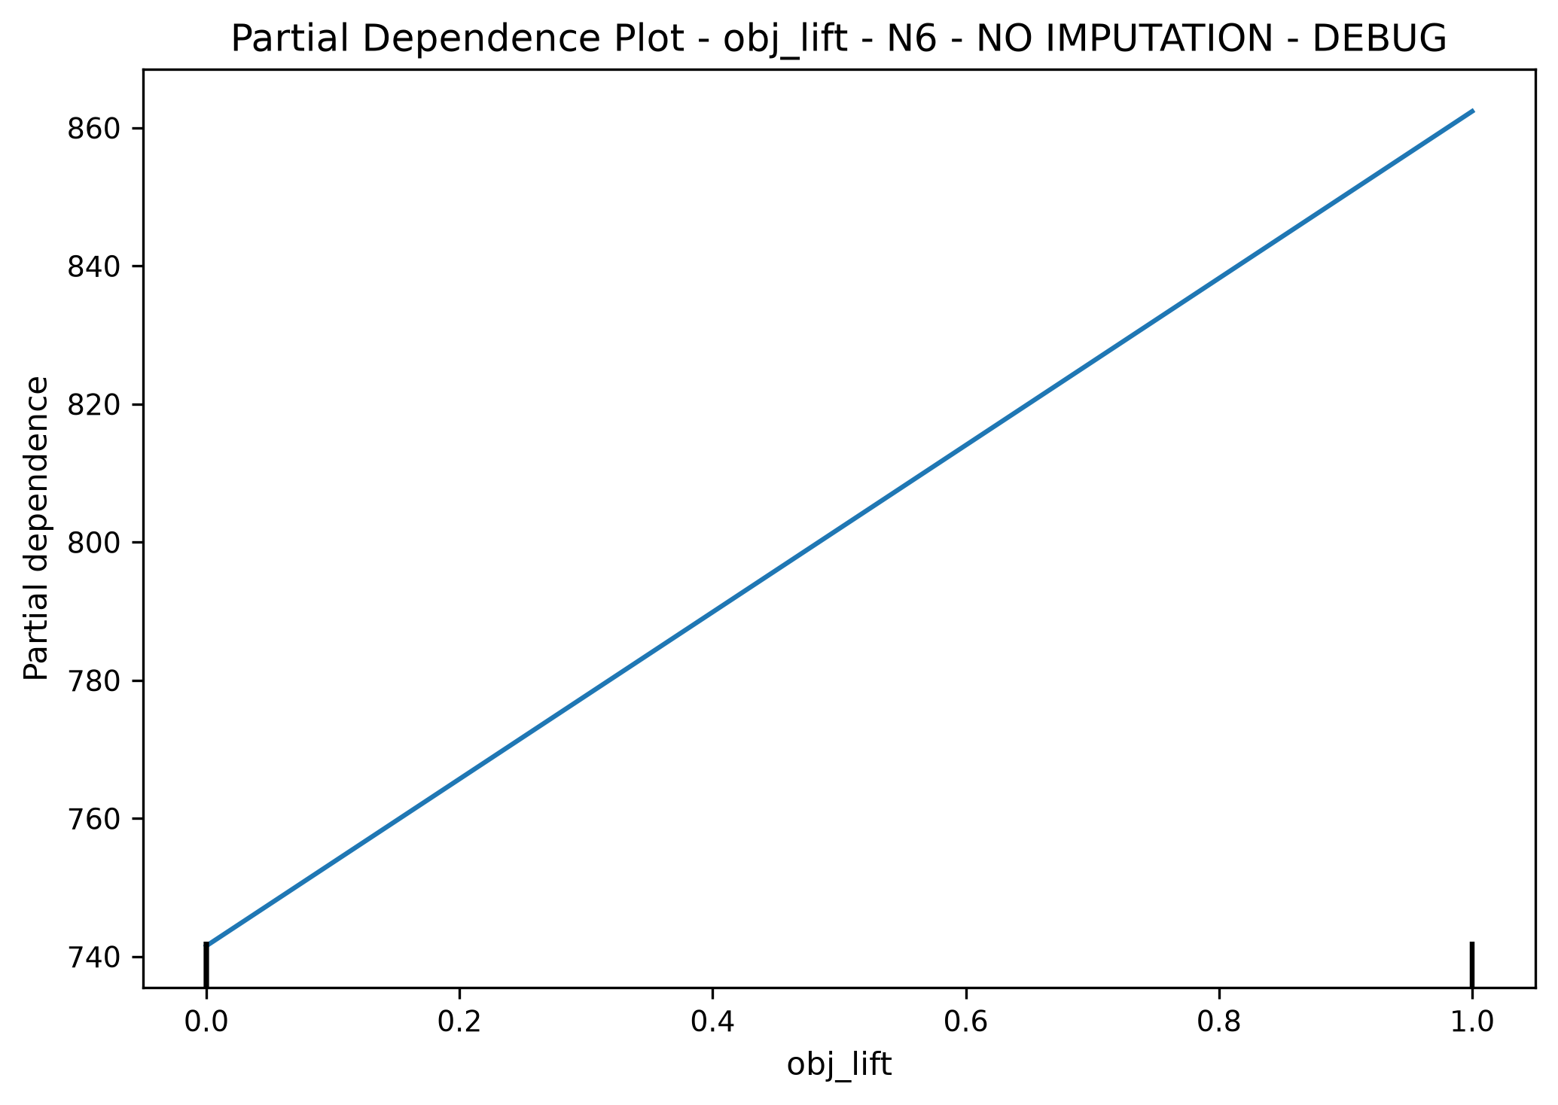

PDP: obj_balcony
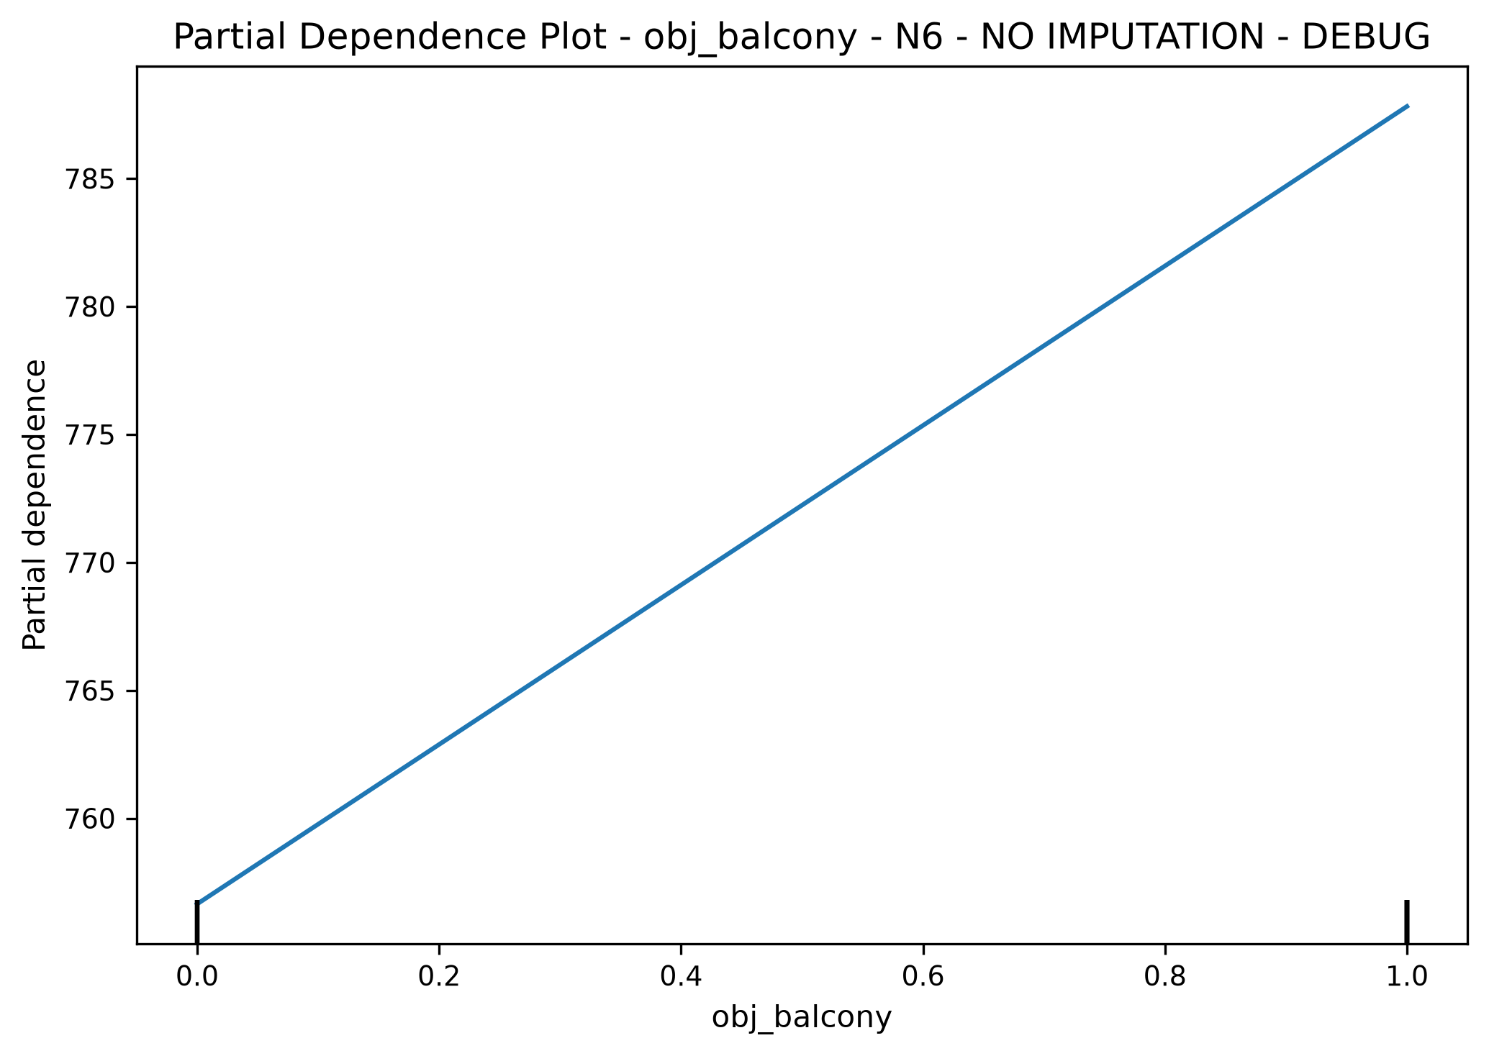

PDP: obj_hasKitchen
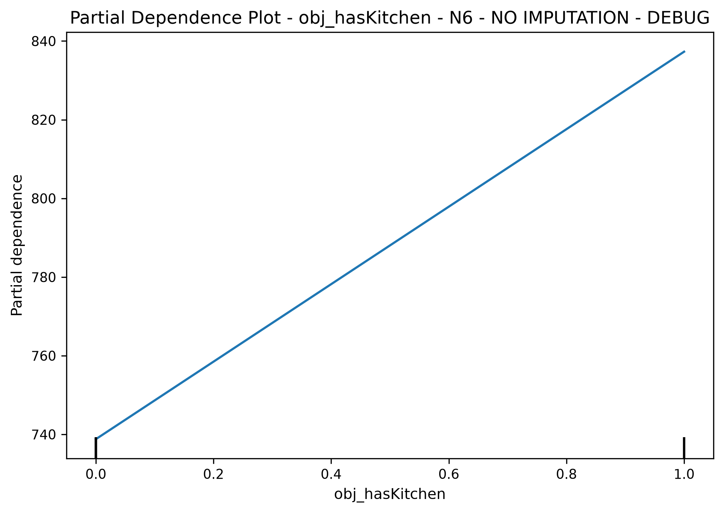

2D PDP: obj_livingSpace x obj_picturecount
2D PDP could not be generated: The column 6 contains integer data. Partial dependence plots are not supported for integer data: this can lead to implicit rounding with NumPy arrays or even errors with newer pandas versions. Please convert numerical features to floating point dtypes ahead of time to avoid problems.

Diagnostic Plots - N6 - NO IMPUTATION - DEBUG
Status labels (OK/CHECK/NOT OK) in RF diagnostics are heuristic indicators for readability and are not formal statistical tests.

Actual vs Predicted
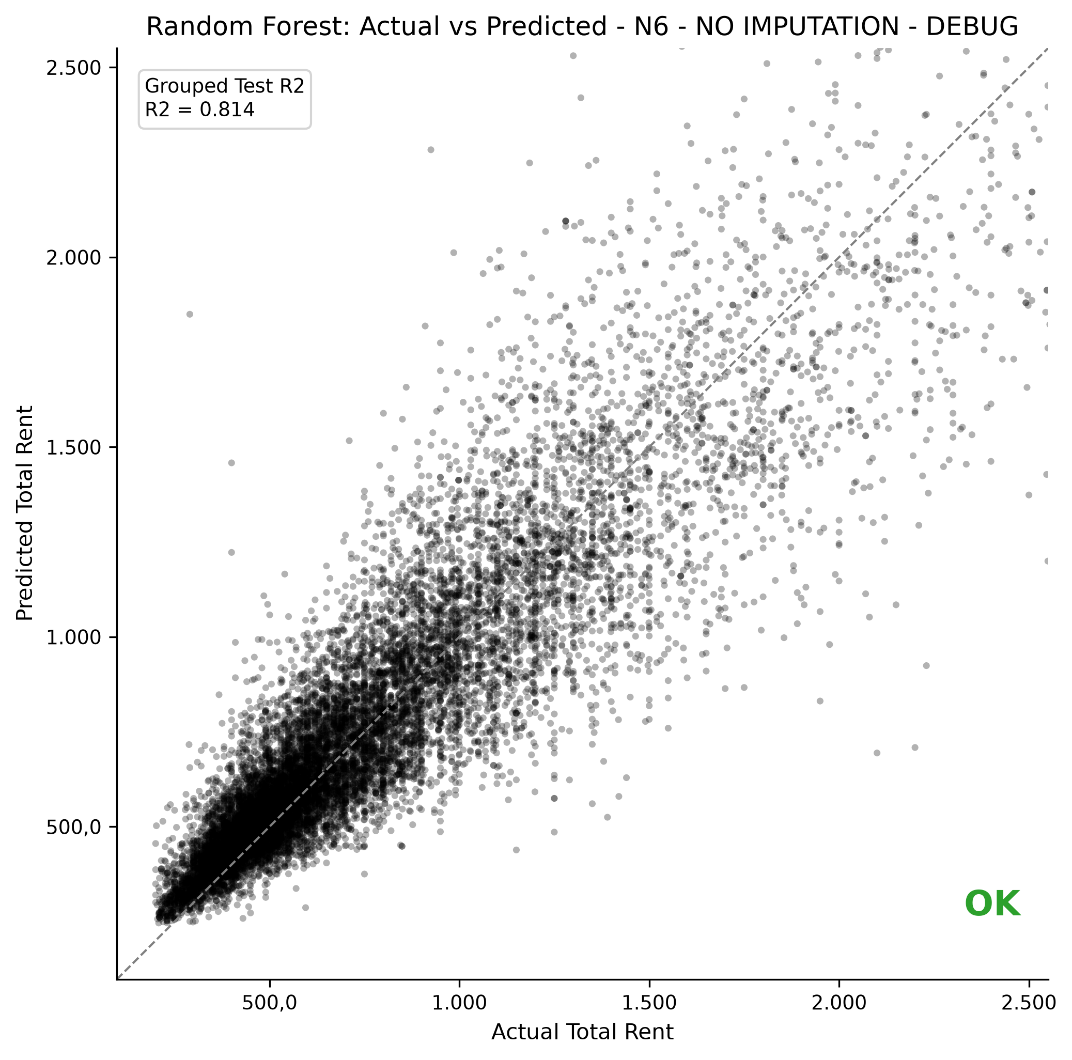

Residuals vs Predicted
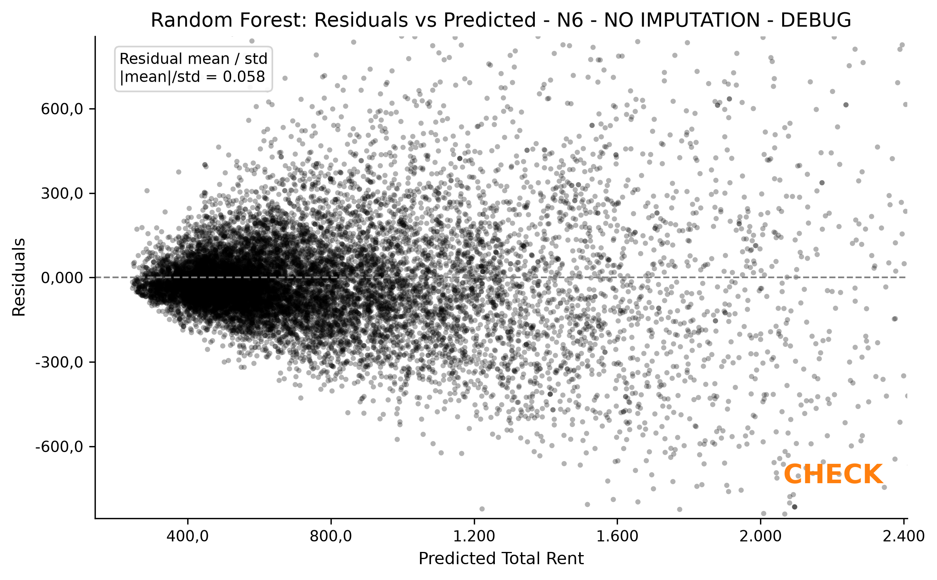

Residual Distribution
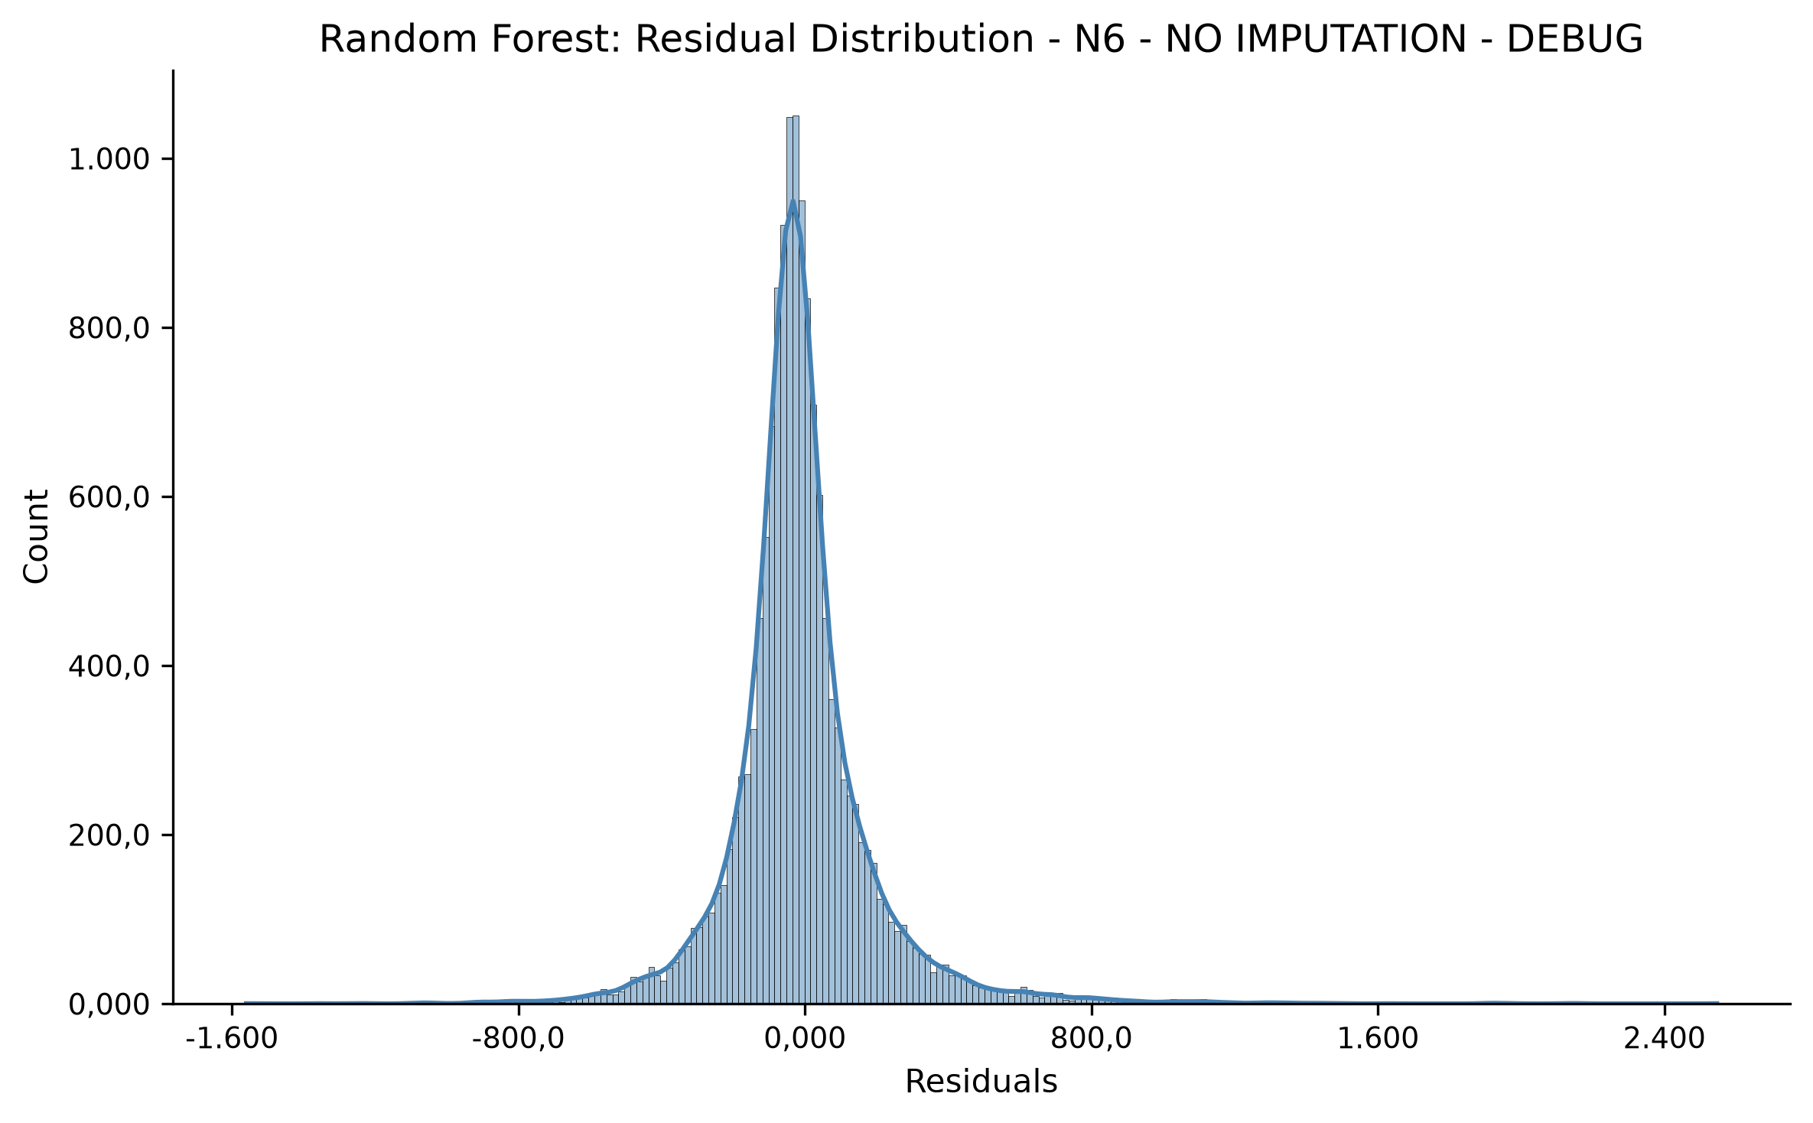

Absolute Error Distribution
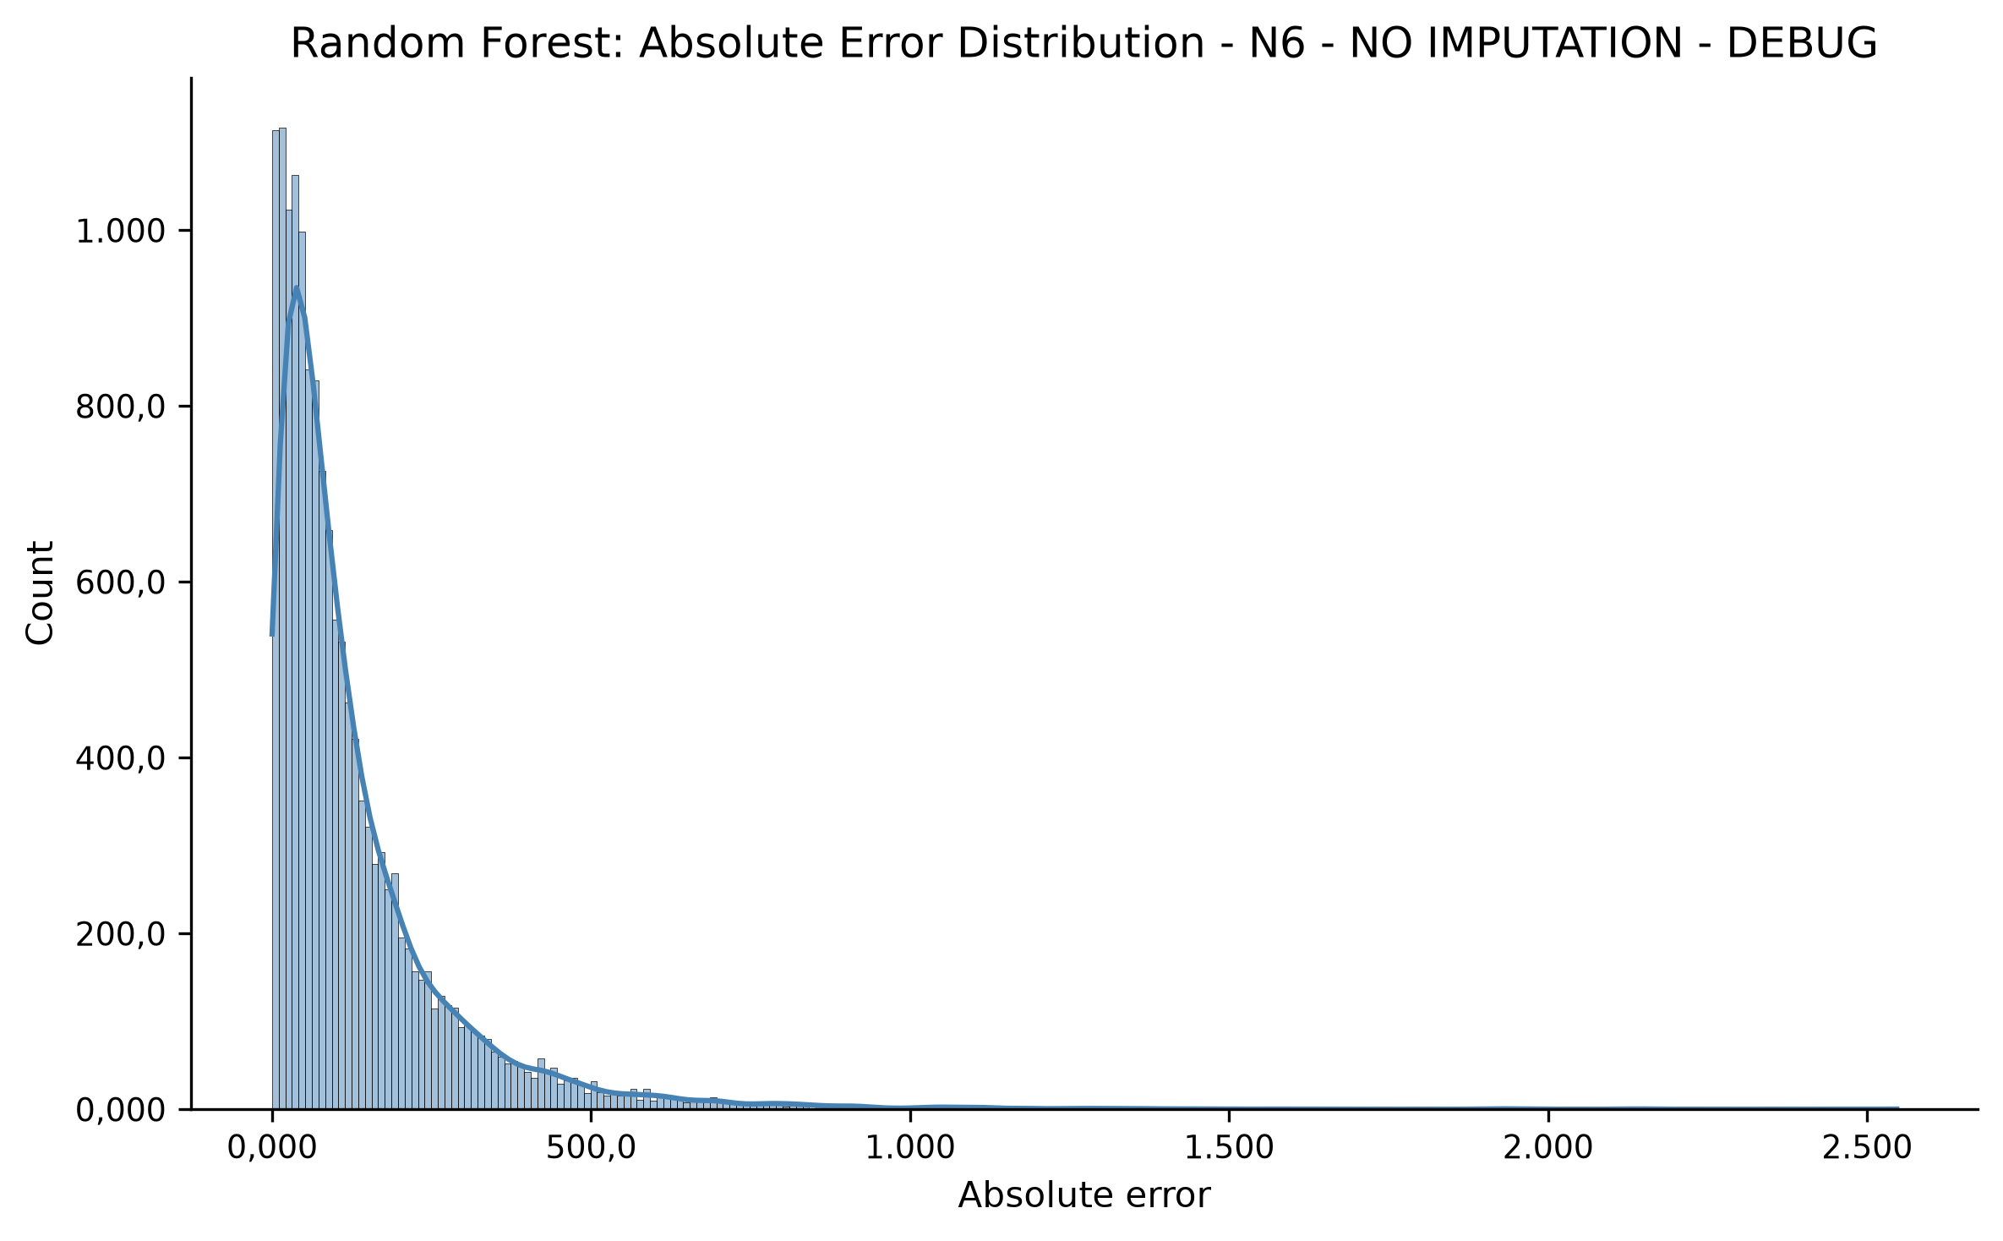

Absolute Percentage Error Distribution
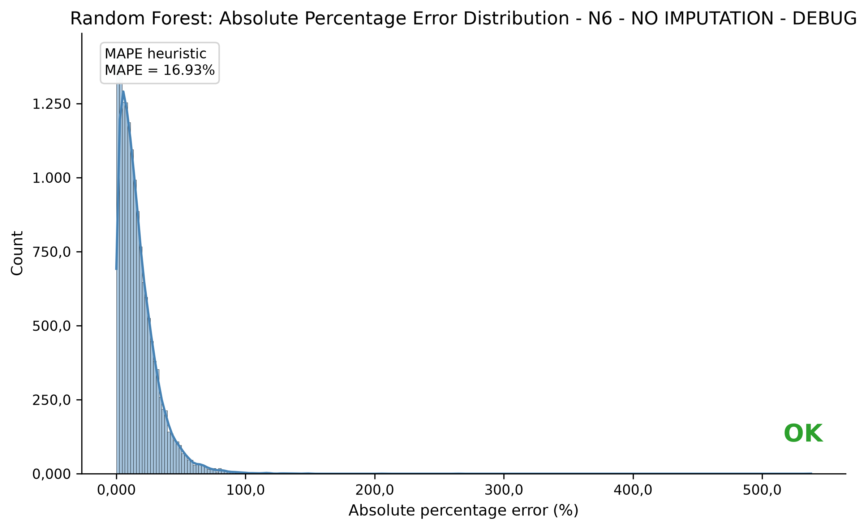

Error Summary - N6 - NO IMPUTATION - DEBUG
Absolute error summary:
count: 15001.0000
mean: 129.5607
std: 156.6272
min: 0.0074
25%: 35.8947
50%: 79.8494
75%: 164.5146
90%: 300.2361
95%: 421.5481
99%: 764.4035
max: 2546.3716
MAPE (%): 16.9340
MdAPE (%): 12.9987
sMAPE (%): 15.9165

Group-Level Error Summary - N6 - NO IMPUTATION - DEBUG
Top 20 obj_zipCode groups with highest mean absolute error - all groups:
81679.0 | n=6.0 | MAE=1314.3825 | mean residual=1314.3825 | MAPE=42.76%
80805.0 | n=11.0 | MAE=949.3736 | mean residual=949.3736 | MAPE=34.43%
20457.0 | n=29.0 | MAE=690.7737 | mean residual=690.7737 | MAPE=29.71%
70597.0 | n=20.0 | MAE=685.3844 | mean residual=678.2439 | MAPE=38.68%
81247.0 | n=15.0 | MAE=662.5185 | mean residual=662.5185 | MAPE=31.59%
81545.0 | n=11.0 | MAE=660.5792 | mean residual=660.5792 | MAPE=28.75%
70173.0 | n=22.0 | MAE=562.0859 | mean residual=562.0859 | MAPE=30.53%
50672.0 | n=10.0 | MAE=530.5191 | mean residual=530.5191 | MAPE=38.99%
20148.0 | n=10.0 | MAE=530.1770 | mean residual=488.0045 | MAPE=32.58%
60596.0 | n=13.0 | MAE=501.3664 | mean residual=501.3664 | MAPE=23.66%
81739.0 | n=8.0 | MAE=500.0923 | mean residual=366.2669 | MAPE=23.57%
78464.0 | n=6.0 | MAE=492.3070 | mean residual=492.3070 | MAPE=24.12%
80636.0 | n=9.0 | MAE=482.4724 | mean residual=482.4724 | MAPE=25.34%
50674.0 | n=21.0 | MAE=477.0517 | mean residual=474.1421 | MAPE=28.51%
22605.0 | n=10.0 | MAE=471.5470 | mean residual=471.5470 | MAPE=20.70%
81477.0 | n=10.0 | MAE=469.9836 | mean residual=469.9836 | MAPE=24.47%
80797.0 | n=26.0 | MAE=455.5199 | mean residual=455.5199 | MAPE=29.11%
97688.0 | n=22.0 | MAE=449.2008 | mean residual=-449.2008 | MAPE=62.71%
85716.0 | n=10.0 | MAE=437.3496 | mean residual=437.3496 | MAPE=26.81%
10707.0 | n=20.0 | MAE=424.8815 | mean residual=383.6560 | MAPE=23.07%

Group-Level Error Summary - n_obs >= 3
Top 20 obj_zipCode groups with highest mean absolute error considering only groups with n_obs >= 3:
81679.0 | n=6.0 | MAE=1314.3825 | mean residual=1314.3825 | MAPE=42.76%
80805.0 | n=11.0 | MAE=949.3736 | mean residual=949.3736 | MAPE=34.43%
20457.0 | n=29.0 | MAE=690.7737 | mean residual=690.7737 | MAPE=29.71%
70597.0 | n=20.0 | MAE=685.3844 | mean residual=678.2439 | MAPE=38.68%
81247.0 | n=15.0 | MAE=662.5185 | mean residual=662.5185 | MAPE=31.59%
81545.0 | n=11.0 | MAE=660.5792 | mean residual=660.5792 | MAPE=28.75%
70173.0 | n=22.0 | MAE=562.0859 | mean residual=562.0859 | MAPE=30.53%
50672.0 | n=10.0 | MAE=530.5191 | mean residual=530.5191 | MAPE=38.99%
20148.0 | n=10.0 | MAE=530.1770 | mean residual=488.0045 | MAPE=32.58%
60596.0 | n=13.0 | MAE=501.3664 | mean residual=501.3664 | MAPE=23.66%
81739.0 | n=8.0 | MAE=500.0923 | mean residual=366.2669 | MAPE=23.57%
78464.0 | n=6.0 | MAE=492.3070 | mean residual=492.3070 | MAPE=24.12%
80636.0 | n=9.0 | MAE=482.4724 | mean residual=482.4724 | MAPE=25.34%
50674.0 | n=21.0 | MAE=477.0517 | mean residual=474.1421 | MAPE=28.51%
22605.0 | n=10.0 | MAE=471.5470 | mean residual=471.5470 | MAPE=20.70%
81477.0 | n=10.0 | MAE=469.9836 | mean residual=469.9836 | MAPE=24.47%
80797.0 | n=26.0 | MAE=455.5199 | mean residual=455.5199 | MAPE=29.11%
97688.0 | n=22.0 | MAE=449.2008 | mean residual=-449.2008 | MAPE=62.71%
85716.0 | n=10.0 | MAE=437.3496 | mean residual=437.3496 | MAPE=26.81%
10707.0 | n=20.0 | MAE=424.8815 | mean residual=383.6560 | MAPE=23.07%

FINAL COMPARISON - RANDOM FOREST - Total Rent
Debug mode was enabled. Only one scenario was executed.
Comparison table across Random Forest scenarios:
scenario model_target model_target_label model_target_unit min_plz_obs use_imputation n_obs n_train n_test n_total_groups n_train_groups n_test_groups n_overlap_groups n_selected_features_original rows_initial rows_after_model_target_group_drop rows_after_missing_handling rows_before_plz_filter rows_after_plz_filter groups_before_plz_filter groups_after_plz_filter removed_plz_groups RF_Train_RMSE RF_Test_RMSE RF_RMSE_Gap RF_Train_MAE RF_Test_MAE RF_Test_MAPE_pct RF_Test_MdAPE_pct RF_Test_sMAPE_pct RF_Train_R2 RF_Test_R2 RF_R2_Gap RF_Best_Grouped_CV_RMSE RF_OOB_R2 RF_Best_Params
N6 - NO IMPUTATION - DEBUG obj_totalRent Total Rent EUR/month 6 False 54369 39368 15001 2385 1788 597 0 23 83273 71368 61166 61166 54369 5496 2385 3111 144.78996 203.264416 58.474457 87.312961 129.560687 16.933993 12.998693 15.916486 0.914417 0.813636 0.100781 233.362942 0.800839 {'model__n_estimators': 300, 'model__min_samples_split': 10, 'model__min_samples_leaf': 2, 'model__max_features': 0.5, 'model__max_depth': 30}

Comparison Plot - RMSE and MAE
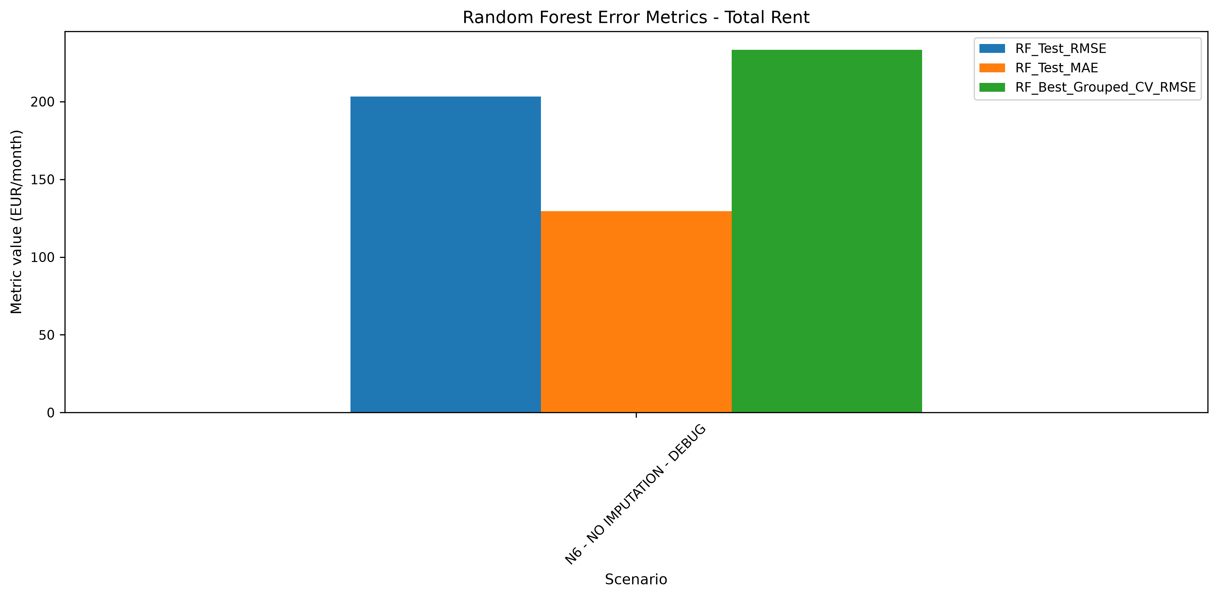

Comparison Plot - R2
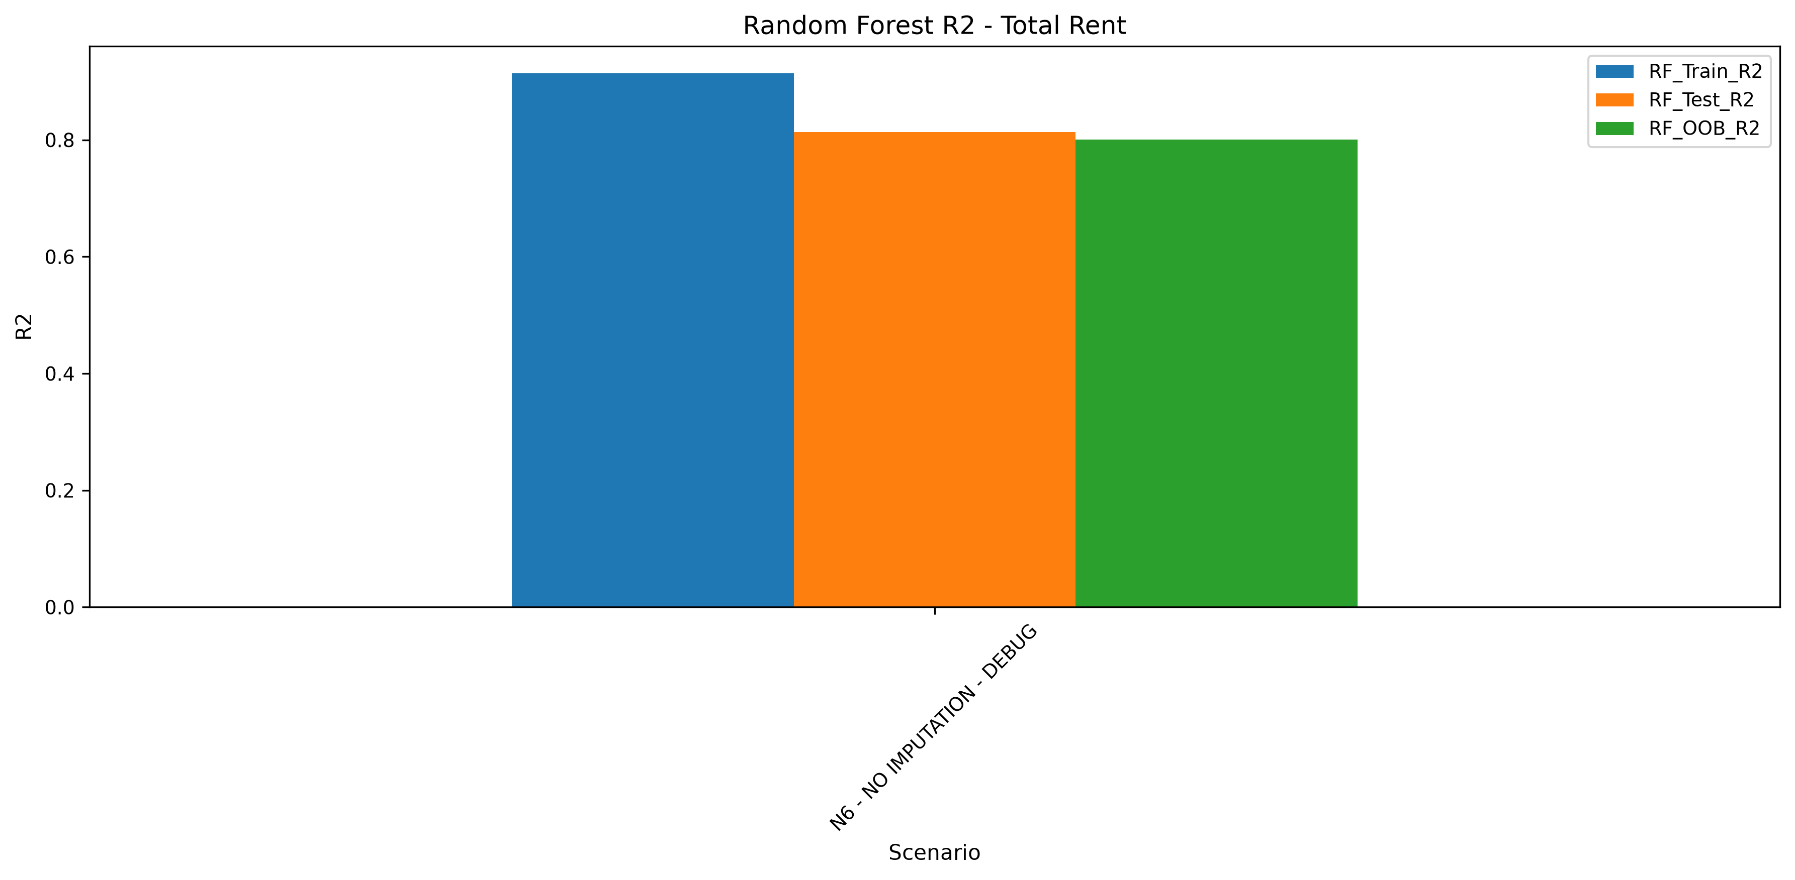

Comparison Plot - Overfitting Gaps
