**Assignment Front Cover Sheet**

**TITLE PAGE**

**Programme of Study: Foundation Degree in Applied Computing**

**ASSIGNMENT**

**NAME OF STUDENT: Daniel Fears YEAR OF STUDY 2**

**College Email Address: fea05095797@student.citybathcoll.ac.uk**

**Unit code: LP20552A1 Unit Title Mobile Technologies**

**Unit Tutor Danielle Vass** [vassd@citybathcoll.ac.uk](mailto:vassd@citybathcoll.ac.uk)

**ASSIGNMENT TITLE:**

**LP20539A1: App Development**

**WORD COUNT 1063 DATE SUBMITTED 12/05/2015**

**(May not exceed +/- 10% of limit) (Late submissions may be penalised)**

**CHEATING AND PLAGIARISM DECLARATION**

**I confirm the following**

*I have read and understood the following sources that explain cheating and plagiarism;*

*the University of Bath website at* [*http://www.bath.ac.uk/library/help/infoguides/plagiarism.html*](http://www.bath.ac.uk/library/help/infoguides/plagiarism.html)

*and my programme handbook, To the best of my knowledge, my work does not contain plagiarised material.*

**SIGNATURE: Daniel Fears**

Ensure that you have completed your work as specified by the deadline date and time (**Thursdays 4pm**)

You must submit one electronic copy of your work to the relevant location as detailed in the assignment brief and/or the Regulations for Submitting Assignments document.

You must keep a copy (electronic and paper) of this assignment for your own records.

|  |  |  |  |  |  |  |
| --- | --- | --- | --- | --- | --- | --- |
| bath college MONO copy | | Assessment feedback form Students must attach this form and the assessment brief to work submitted for assessment | | | | UoB_logo-blu-xs |
| Hand out date: | | *(as per assessment plan)* | Hand in date: | | | *(as per assessment plan)* |
| Assessor: | | Danielle Vass | Date received: | | |  |
| Assessor’s comments | | | | | | |
| Percentage mark awarded |  | | | **Contribution to Unit Marks** | | **60%** |
| Unit Outcomes | * Analyse and recommend an appropriate mobile solution for the workplace. * Demonstrate an understanding of a variety of mobile technologies (e.g. Mobile-device based languages, operating systems, internet browsers and environments). * Produce a mobile application for a given specification. * Research current developments in emerging mobile device techniques. | | | | | |
| Assessor’s signature |  | | | | Date |  |
| Moderator’s signature |  | | | | Date |  |

# Aims

This assignment aims to provide evidence for the learning outcomes of the unit. (See above).

It will demonstrate your ability to do the following:

* Use GUI design and visual programming skills in a given language.
* Show good problem solving skills, Time management and Planning and prioritisation of tasks.
* Prepare high quality reports and documentation to support applications.
* Present information appropriately.
* Perform user demonstrations and prepare questionnaires to aid critical evaluation of products.

# Scenario

You are tasked with creating an Android app for a travel agency to demonstrate their travel destinations.

A requirement of the app will be to display photographs of travel destinations using a popular web API Flickr (different web API you must email a request to the lecturer to get agreement).

You must also come up with at least one additional feature e.g. allowing users to favourite photographs, or displaying other additional information on locations such as the current weather.

Finally, you must demonstrate a good HCI and incorporate some Material Design aspects into your app.

Your app is required to run on Android 5.0 (SDK 21) and above. It is not necessary to have a real Android device yourself, as Android Studio will provide an emulator to use.

# Tasks

1. Working Android App

- Marked in a student viva - students demonstrate and defend their work one-on-one

2. App Report

a. A mock app store listing

b. What you learned

c. What your proud of

d. What you could improve (programming wise)

e. Features you’d like to add to your app if you had more time

f. Differences you see between building desktop and mobile apps

3. Presentation on the past / present / future of mobile technologies

# SubMISSION

You should submit a folder containing:

1. Android app project folder (all source code)
2. Presentation exported as a folder of images (PNG preferable)
3. Report as a word document

# Grading Criteria

|  |  |  |  |
| --- | --- | --- | --- |
| Element | Wt. | Criteria | Marks |
| Task 1: Android App | 70% | Splash Screen | 0 – 10 |
| List of Destinations Screen | 0 – 10 |
| Specific Destination Screen | 0 – 10 |
| Pictures from API | 0 – 10 |
| Bonus Feature(s) | 0 – 10 |
| HCI (Material Design) | 0 – 10 |
| Quality of the viva defence | 0 – 10 |
| Task 2: Presentation (Past, Present, Future of mobile) | 20% | Standard of English | 0 – 5 |
| Multiple Operating Systems mentioned (Android, iOS, Blackberry, Windows Mobile) | 0 – 8 |
| Future tech | 0 – 7 |
| Task 3: Report | 10% | App Store Listing | 0 – 2 |
| What you Learned | 0 – 1 |
| What your Proud of | 0 – 1 |
| Improvements | 0 – 1 |
| Additional Features | 0 – 2 |
| Differences between Mobile and Desktop | 0 - 3 |

**Daniel Fears**

**Mobile Application Development**

City of Bath College

Avon St

Bath

BA1 1UP

Contents

[**Daniel Fears** 1](#_Toc418204332)

[**Development Project** 1](#_Toc418204333)

[City of Bath College 1](#_Toc418204334)

[Avon St 1](#_Toc418204335)

[Bath 1](#_Toc418204336)

[BA1 1UP 1](#_Toc418204337)

[Abstract 3](#_Toc418204338)

[Introduction 4](#_Toc418204339)

# Abstract

This report outlines my development during mobile application lecturers. It contains information relating to skills I’ve learned, and a critical evaluation of the application that was developed and concludes that the travel application required for the unit was developed successfully.

# Introduction

The following report will outline information relating to the development of a travel themed Android mobile application. It will cover an in-depth evaluation of what was learned during the course, potential improvements of features to include to the finished product, as well as a mock application store listing.

# Mock Application Listing

Store page search results Store listing part 1

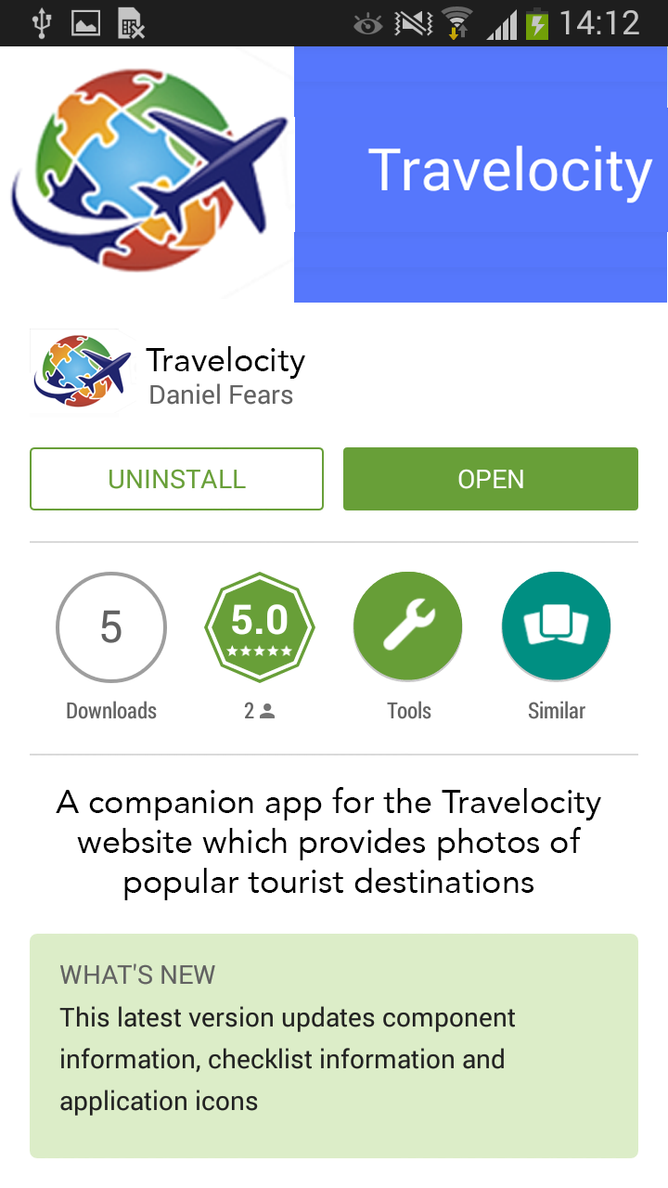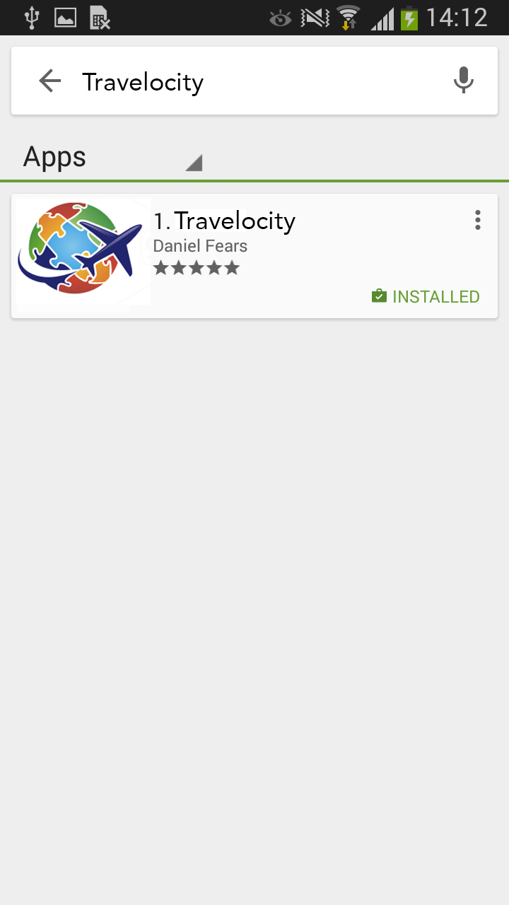

Store listing part 2 Store listing part 3

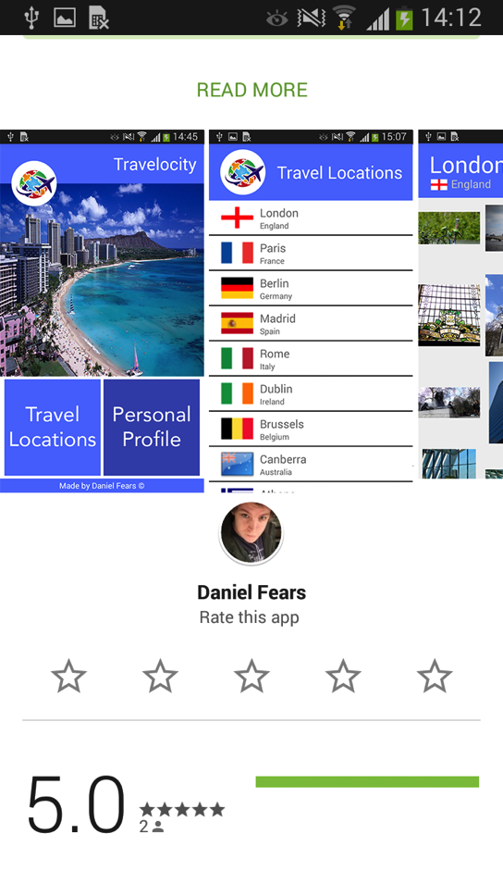 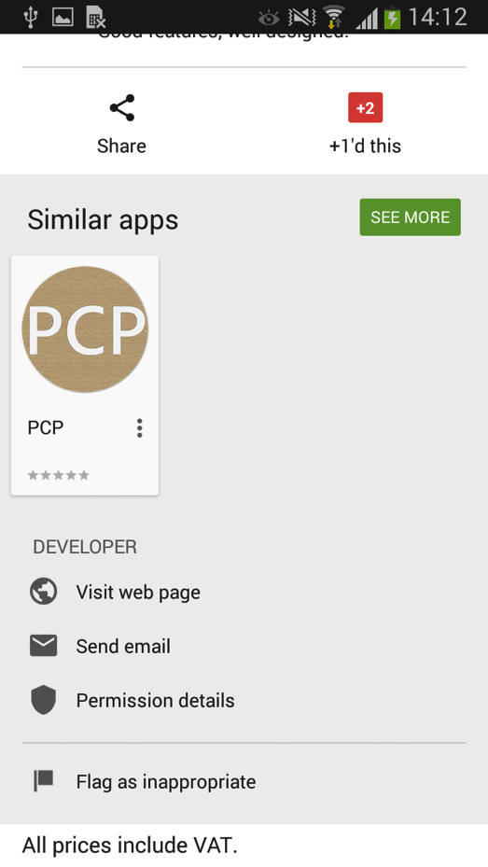

Developer console mock up

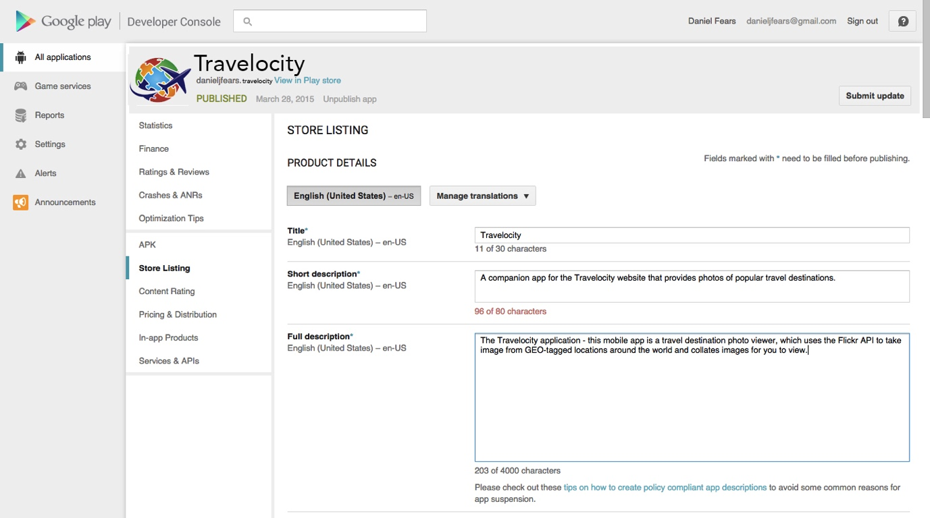

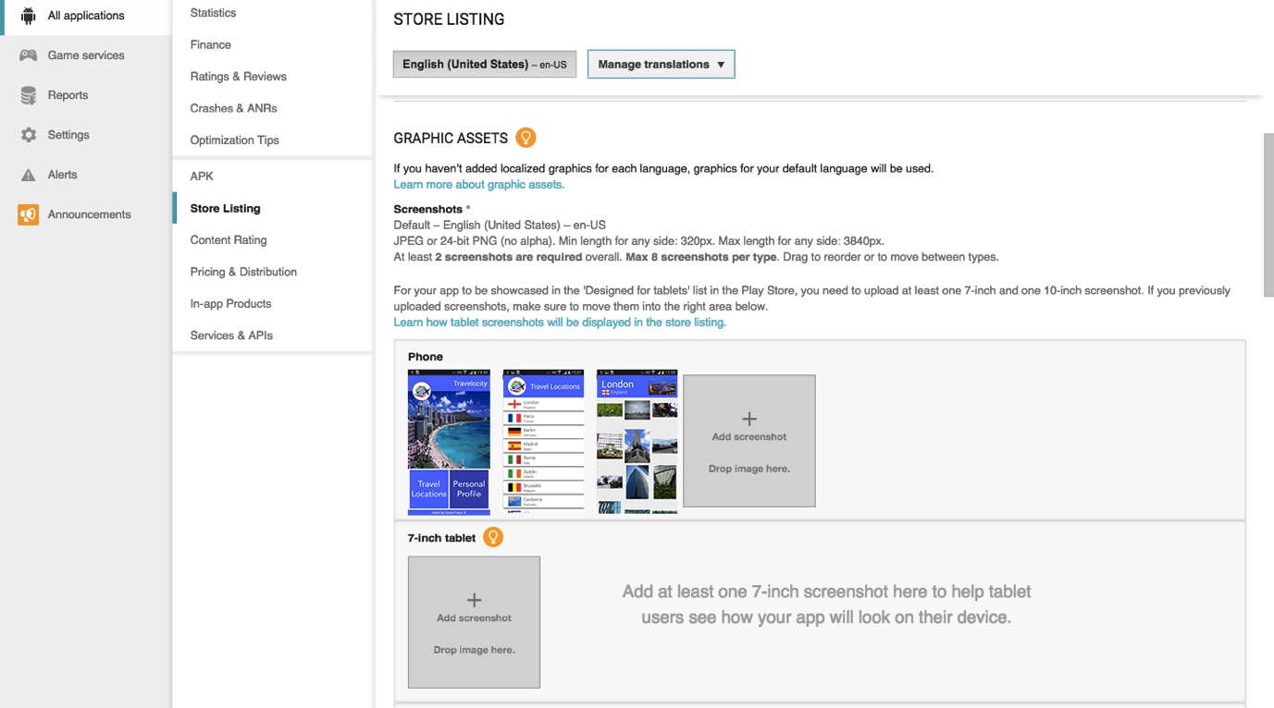

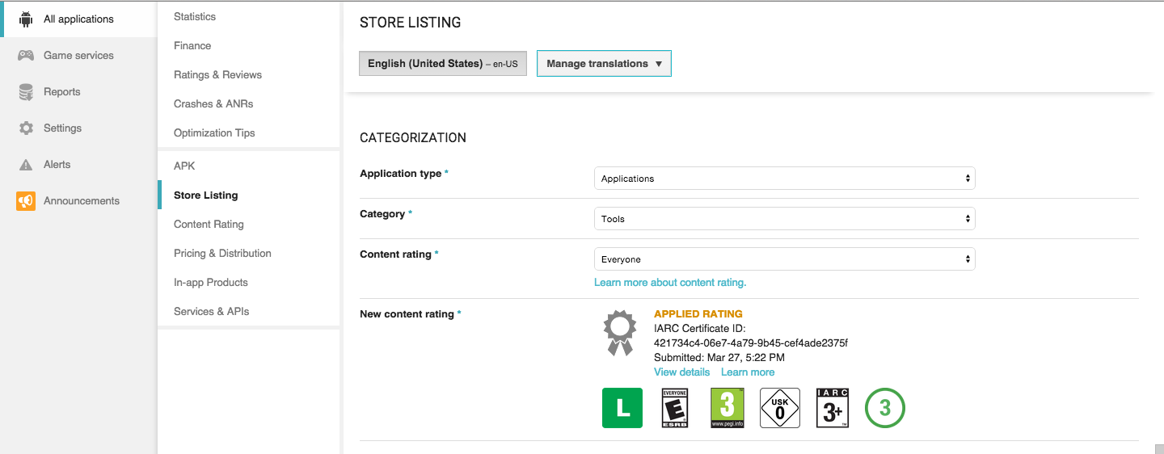

# What I learned

My time during the mobile development unit has been spent learning about the theory and practice of Android programming. I have learned about the core principles of Android development, including the various layout options available, and how the individual elements of activities such as .xml and Java files, interact with one another. Once the fundamentals of activities were established, I learned how intents could be used to move between activities, giving applications more depth and a wider variety of functionality. During lecturers I learned to create list views, using a single .xml file and passing information to it depending on which list view entry was selected – this allowed the creation of multiple pages programmatically, without the need to manually create each layout.

As I enjoyed Android development so much, I decided to do it for other units on my course. Through this, I had to learn more skills to satisfy criteria for clients I was working alongside – For my main project, I learned how to utilise and populate check boxes, which acted as a guide for users where they could check their progress off. For my multimedia project, I learned how to embed a video view, and through it I could stream video files over the internet, hosted from my own web provider, with a media player to control the playback of video. I also learned how to incorporate animated GIF files, where two java class files would take a GIF file apart, count the number frames it was made of, and display them on screen sequentially to emulate animation.

This unit also introduced me to the concept of version control software, where we used GitHub to save and update our projects, with a history of what updates have been made. Using GitHub allowed me to work seamlessly between my MacBook and home PC and played a part in how much easier it was to develop applications.

# What I’m proud of

As this was my first time developing mobile applications for Android (or any other platform for that matter), it has given me great joy in being able to visualise a concept, and bring it to life on a mobile device. The learning curve has been difficult for Android Studio, so I’m proud of myself for having grasped the basics and develop something worthwhile with it. I was enjoying developing apps so much that I bought into the Google developer program and have since released an application to the app store. Having an application out there for other people to use makes me feel good about myself, as well as having the code I worked hard on stored safely on GitHub for potential employers to discover.

# Potential improvements / Additional features

I feel in its current state, my application is reasonably well tailored and works as intended. I think if I could make any improvements to my app, it would be to make better use of the screen space on the countries list view. Features I would add to my application, should I have the time, would be to include information relating to weather on each of the countries pages, as they will give a better indicator to users as to the type of climate that country typically has. I would also introduce a feature to click on photos and have them open in a larger preview window for users to better see what they are, with the option for users to save their favourite ones. I feel my application would also benefit from having more options on the home screen, perhaps allowing users to see more intricate details on each country, instead of a direct list view leading to a photo gallery.

# Desktop vs. Mobile applications

There are two main differences between the design choices behind desktop and mobile applications which sets them apart. The first of which is the portability factor; mobile applications can make better use of global positioning information, as a mobile device can be used to track co-ordinates for a number of reasons. Some examples of this would include Runkeeper, which monitors your location when you go running, and tracks your distance, speed and time. Another GPS related application could be a navigation of mapping software, such as Google Maps or TomTom, that allows the user to use their mobile device to track their location, and provide directions to a specific location. Desktop applications would lack any form of actual application using GPS related technologies and as such, they are reserved for mobile apps.

The second main difference between mobile and desktop applications is the way in which they are interacted with by users. The screen economy and number of ways a user can interact with a mobile device is limited (touching the screen or using the few included buttons) and due to the smaller size of screen, and lack of proper input methods, mobile applications are designed for minimal functionality. Desktop applications can take full advantage of the fact users have much larger screens, and a variety of input methods, and can adapt their functionality around these additional components.

# Conclusion

This unit has taught me valuable programming skills and for the first time has shown me something I am passionate about. Mobile development has been the first unit of the two years I’ve done this course where I could see myself doing it at a much higher level for a living. I have learned valuable skills during my time in mobile development lecturers, and has allowed me to further my experience exercising programming logic. My travel application was fully developed in line with the unit criteria, and although the bonus feature isn’t ground breaking, I am happy with the end result.