faraway-glm.Rmd

Robesyn

25 February 2017

Code Faraway GLM

## Warning: package 'tidyverse' was built under R version 3.3.2

## Loading tidyverse: ggplot2  
## Loading tidyverse: tibble  
## Loading tidyverse: tidyr  
## Loading tidyverse: readr  
## Loading tidyverse: purrr  
## Loading tidyverse: dplyr

## Warning: package 'tibble' was built under R version 3.3.1

## Warning: package 'tidyr' was built under R version 3.3.1

## Warning: package 'purrr' was built under R version 3.3.1

## Conflicts with tidy packages ----------------------------------------------

## filter(): dplyr, stats  
## lag(): dplyr, stats

## Warning: package 'faraway' was built under R version 3.3.2

head(gavote)

## equip econ perAA rural atlanta gore bush other votes ballots  
## APPLING LEVER poor 0.182 rural notAtlanta 2093 3940 66 6099 6617  
## ATKINSON LEVER poor 0.230 rural notAtlanta 821 1228 22 2071 2149  
## BACON LEVER poor 0.131 rural notAtlanta 956 2010 29 2995 3347  
## BAKER OS-CC poor 0.476 rural notAtlanta 893 615 11 1519 1607  
## BALDWIN LEVER middle 0.359 rural notAtlanta 5893 6041 192 12126 12785  
## BANKS LEVER middle 0.024 rural notAtlanta 1220 3202 111 4533 4773

glimpse(gavote)

## Observations: 159  
## Variables: 10  
## $ equip (fctr) LEVER, LEVER, LEVER, OS-CC, LEVER, LEVER, OS-CC, OS-P...  
## $ econ (fctr) poor, poor, poor, poor, middle, middle, middle, middl...  
## $ perAA (dbl) 0.182, 0.230, 0.131, 0.476, 0.359, 0.024, 0.079, 0.079...  
## $ rural (fctr) rural, rural, rural, rural, rural, rural, urban, urba...  
## $ atlanta (fctr) notAtlanta, notAtlanta, notAtlanta, notAtlanta, notAt...  
## $ gore (int) 2093, 821, 956, 893, 5893, 1220, 3657, 7508, 2234, 164...  
## $ bush (int) 3940, 1228, 2010, 615, 6041, 3202, 7925, 14720, 2381, ...  
## $ other (int) 66, 22, 29, 11, 192, 111, 520, 552, 46, 52, 709, 40, 7...  
## $ votes (int) 6099, 2071, 2995, 1519, 12126, 4533, 12102, 22780, 466...  
## $ ballots (int) 6617, 2149, 3347, 1607, 12785, 4773, 12522, 23735, 574...

summary(gavote)

## equip econ perAA rural atlanta   
## LEVER:74 middle:69 Min. :0.0000 rural:117 Atlanta : 15   
## OS-CC:44 poor :72 1st Qu.:0.1115 urban: 42 notAtlanta:144   
## OS-PC:22 rich :18 Median :0.2330   
## PAPER: 2 Mean :0.2430   
## PUNCH:17 3rd Qu.:0.3480   
## Max. :0.7650   
## gore bush other votes   
## Min. : 249 Min. : 271 Min. : 5.0 Min. : 832   
## 1st Qu.: 1386 1st Qu.: 1804 1st Qu.: 30.0 1st Qu.: 3506   
## Median : 2326 Median : 3597 Median : 86.0 Median : 6299   
## Mean : 7020 Mean : 8929 Mean : 381.7 Mean : 16331   
## 3rd Qu.: 4430 3rd Qu.: 7468 3rd Qu.: 210.0 3rd Qu.: 11846   
## Max. :154509 Max. :140494 Max. :7920.0 Max. :263211   
## ballots   
## Min. : 881   
## 1st Qu.: 3694   
## Median : 6712   
## Mean : 16927   
## 3rd Qu.: 12251   
## Max. :280975

Per county (rows)

gavote$undercount <- (gavote$ballots - gavote$votes)/gavote$ballots  
summary(gavote$undercount)

## Min. 1st Qu. Median Mean 3rd Qu. Max.   
## 0.00000 0.02779 0.03983 0.04379 0.05647 0.18810

percounty<- gavote %>% mutate(diff = ballots-votes, undercount = diff/ballots)  
summary(percounty$undercount)

## Min. 1st Qu. Median Mean 3rd Qu. Max.   
## 0.00000 0.02779 0.03983 0.04379 0.05647 0.18810

Note this is different than overall, for all counties together

with(gavote, sum(ballots-votes)/sum(ballots))

## [1] 0.03518021

overall<-gavote %>% summarize(sumdiff = sum(ballots-votes), sum = sum(ballots), proportionUndervotes = round(sumdiff/sum,3) )  
overall$proportionUndervotes

## [1] 0.035

hist(gavote$undercount, main="Undercount", xlab="Percent Undercount")

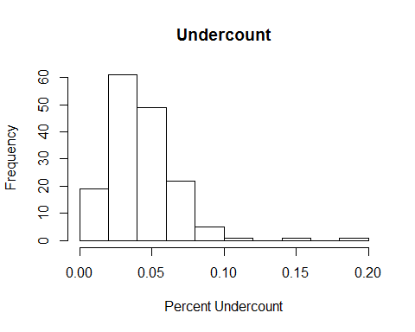

gavote %>% ggplot(aes(undercount)) +   
 geom_histogram(binwidth = 0.01)

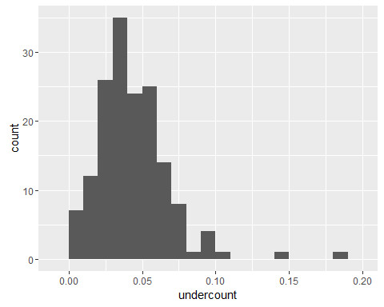

plot(density(gavote$undercount), main="Undercount")  
rug(gavote$undercount)

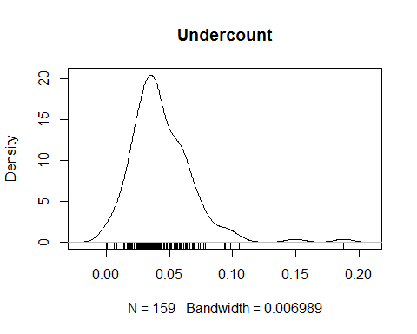

gavote %>% ggplot(aes(undercount)) +   
 geom_density() +  
 geom_rug() +   
 theme_minimal()

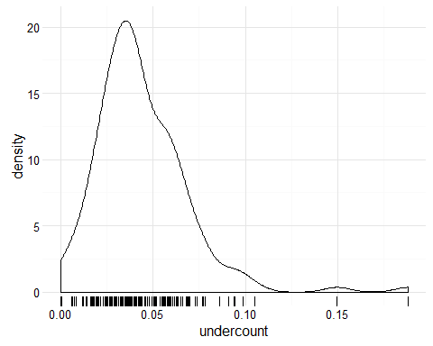

pie(table(gavote$equip), col=gray(0:4/4))

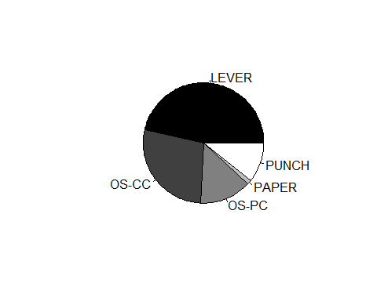

gavote %>% ggplot(aes(equip, fill=econ)) +  
 geom_bar()

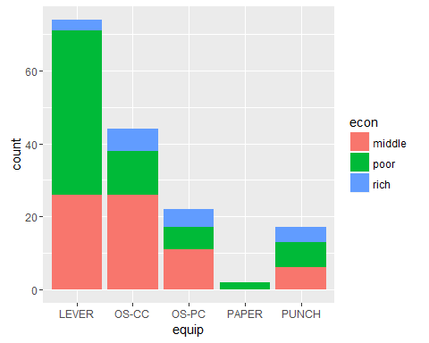

gavote %>% ggplot(aes(equip, fill=econ)) +  
 geom_bar(position="fill")

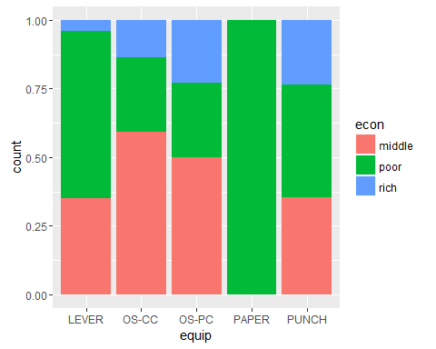

gavote$pergore <- gavote$gore/gavote$votes   
plot(pergore ~ perAA, gavote, xlab="Proportion African American", ylab = "Proportion for Gore", pch=20, col="blue")

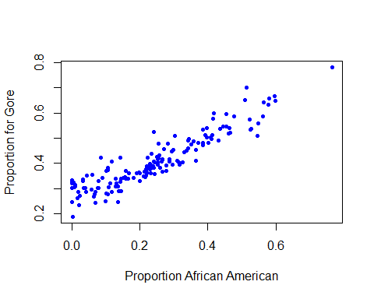

gavote %>% ggplot(aes(equip, undercount)) +   
 geom_boxplot()

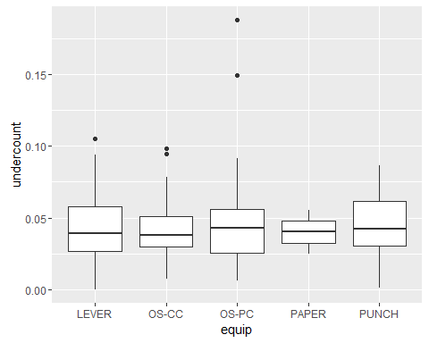

xtabs(~atlanta + rural, gavote)

## rural  
## atlanta rural urban  
## Atlanta 1 14  
## notAtlanta 116 28

names(gavote)

## [1] "equip" "econ" "perAA" "rural" "atlanta"   
## [6] "gore" "bush" "other" "votes" "ballots"   
## [11] "undercount" "pergore"

gavote <- gavote %>% rename(usage = rural)  
names(gavote)

## [1] "equip" "econ" "perAA" "usage" "atlanta"   
## [6] "gore" "bush" "other" "votes" "ballots"   
## [11] "undercount" "pergore"

nix <- gavote %>% select(perAA, ballots, undercount, pergore)  
nix

## perAA ballots undercount pergore  
## APPLING 0.182 6617 0.0782832099 0.3431710  
## ATKINSON 0.230 2149 0.0362959516 0.3964268  
## BACON 0.131 3347 0.1051688079 0.3191987  
## BAKER 0.476 1607 0.0547604231 0.5878868  
## BALDWIN 0.359 12785 0.0515447790 0.4859805  
## BANKS 0.024 4773 0.0502828410 0.2691374  
## BARROW 0.079 12522 0.0335409679 0.3021815  
## BARTOW 0.079 23735 0.0402359385 0.3295874  
## BEN.HILL 0.282 5741 0.1881205365 0.4792963  
## BERRIEN 0.107 4475 0.0145251397 0.3718821  
## BIBB 0.396 52075 0.0441478637 0.5021697  
## BLECKLEY 0.166 3867 0.0305146108 0.3395572  
## BRANTLEY 0.036 4910 0.0700610998 0.3004818  
## BROOKS 0.341 4754 0.0427008835 0.4605581  
## BRYAN 0.130 7059 0.0000000000 0.3076923  
## BULLOCH 0.218 15371 0.0383189122 0.3762008  
## BURKE 0.465 7431 0.0398331315 0.5213735  
## BUTTS 0.252 5907 0.0460470628 0.4047915  
## CALHOUN 0.562 2065 0.0861985472 0.5866455  
## CAMDEN 0.192 10204 0.0083300666 0.3593240  
## CANDLER 0.239 2846 0.0435699227 0.3868479  
## CARROLL 0.128 26740 0.0373597607 0.3400023  
## CATOOSA 0.009 18114 0.0216959258 0.3086733  
## CHARLTON 0.231 2963 0.0496118799 0.3604403  
## CHATHAM 0.341 78381 0.0243298759 0.4915396  
## CHATTAHOOCHEE 0.344 1227 0.0162999185 0.4971002  
## CHATTOOGA 0.085 6823 0.0507108310 0.4213370  
## CHEROKEE 0.021 53458 0.0207639642 0.2348705  
## CLARKE 0.242 29519 0.0208340391 0.5247371  
## CLAY 0.563 1334 0.0427286357 0.6429131  
## CLAYTON 0.509 63309 0.0301852817 0.6521711  
## CLINCH 0.252 1996 0.0335671343 0.4230171  
## COBB 0.160 236525 0.0063375964 0.3687932  
## COFFEE 0.259 9687 0.0265304016 0.3810180  
## COLQUITT 0.200 10355 0.0369869628 0.3306258  
## COLUMBIA 0.099 37606 0.0424932192 0.2490835  
## COOK 0.252 4280 0.0785046729 0.4155680  
## COWETA 0.144 32104 0.0273797658 0.2900240  
## CRAWFORD 0.251 3632 0.0178964758 0.4241660  
## CRISP 0.326 5973 0.0609409007 0.4043502  
## DADE 0.005 5290 0.0455576560 0.3224401  
## DAWSON 0.001 6003 0.0174912544 0.2472024  
## DECATUR 0.331 7898 0.0316535832 0.4442992  
## DEKALB 0.514 228352 0.0366626962 0.7023775  
## DODGE 0.231 6044 0.0276307081 0.3957802  
## DOOLY 0.463 3755 0.0625832224 0.5400568  
## DOUGHERTY 0.523 30752 0.0548907388 0.5728737  
## DOUGLAS 0.169 31943 0.0306796481 0.3604948  
## EARLY 0.365 3798 0.0560821485 0.4524407  
## ECHOLS 0.077 954 0.0587002096 0.3028953  
## EFFINGHAM 0.109 11436 0.0687303253 0.3034742  
## ELBERT 0.257 5960 0.0179530201 0.4317444  
## EMANUEL 0.298 6262 0.0000000000 0.4527308  
## EVANS 0.296 3203 0.0384014986 0.3951299  
## FANNIN 0.001 8691 0.0346335289 0.3261025  
## FAYETTE 0.101 42766 0.0074124304 0.2806191  
## FLOYD 0.107 27820 0.0357656362 0.3832992  
## FORSYTH 0.003 37078 0.0356815362 0.1872186  
## FRANKLIN 0.061 6183 0.0680899240 0.3540437  
## FULTON 0.416 280975 0.0632227066 0.5776316  
## GILMER 0.000 7616 0.0323004202 0.3025780  
## GLASCOCK 0.070 1100 0.0727272727 0.2441176  
## GLYNN 0.212 23151 0.0331303183 0.3474803  
## GORDON 0.033 12899 0.0538026204 0.3303564  
## GRADY 0.242 7195 0.0683808200 0.4059376  
## GREENE 0.366 5550 0.0636036036 0.4111988  
## GWINNETT 0.114 192303 0.0062037514 0.3214588  
## HABERSHAM 0.018 10377 0.0661077383 0.2610670  
## HALL 0.065 39247 0.0279511810 0.2689122  
## HANCOCK 0.765 3255 0.0519201229 0.7822424  
## HARALSON 0.045 8609 0.0513416192 0.3512918  
## HARRIS 0.159 8738 0.0201419089 0.3401075  
## HART 0.142 7731 0.0252231277 0.4235669  
## HEARD 0.101 3369 0.0507569012 0.3683552  
## HENRY 0.136 39851 0.0246919776 0.3079991  
## HOUSTON 0.199 38139 0.0301790818 0.3596031  
## IRWIN 0.220 2887 0.0121233114 0.3874474  
## JACKSON 0.059 11980 0.0287979967 0.2939407  
## JASPER 0.252 4186 0.0580506450 0.3951306  
## JEFF.DAVIS 0.143 4574 0.0771753389 0.3266998  
## JEFFERSON 0.526 5810 0.0419965577 0.5341358  
## JENKINS 0.371 2704 0.0410502959 0.4820671  
## JOHNSON 0.279 2961 0.0263424519 0.3694069  
## JONES 0.229 8430 0.0429418743 0.3844819  
## LAMAR 0.255 5452 0.0407190022 0.4195029  
## LANIER 0.234 2023 0.0588235294 0.4369748  
## LAURENS 0.288 14565 0.0363199451 0.4078085  
## LEE 0.135 8130 0.0302583026 0.2455606  
## LIBERTY 0.435 10320 0.0337209302 0.5362014  
## LINCOLN 0.310 3300 0.0596969697 0.4108927  
## LONG 0.224 2402 0.0366361366 0.4213483  
## LOWNDES 0.288 25911 0.0184863571 0.4174269  
## LUMPKIN 0.011 6886 0.0197502178 0.3142222  
## MACON 0.578 4603 0.0538779057 0.6330654  
## MADISON 0.070 8254 0.0316210322 0.2858751  
## MARION 0.337 2186 0.0009149131 0.4496337  
## MCDUFFIE 0.317 6832 0.0412763466 0.3938931  
## MCINTOSH 0.386 4144 0.0740830116 0.5334897  
## MERIWETHER 0.392 7178 0.0653385344 0.5128931  
## MILLER 0.220 2215 0.0293453725 0.3641860  
## MITCHELL 0.414 6292 0.0783534647 0.5123297  
## MONROE 0.230 7837 0.0377695547 0.3764753  
## MONTGOMERY 0.243 2573 0.0248736883 0.4037465  
## MORGAN 0.231 6199 0.0479109534 0.3791935  
## MURRAY 0.003 8742 0.0423244109 0.3205925  
## MUSCOGEE 0.396 54471 0.0423711700 0.5404789  
## NEWTON 0.197 19157 0.0408205878 0.3647891  
## OCONEE 0.042 11361 0.0169879412 0.2851003  
## OGLETHORPE 0.156 4602 0.0471534116 0.3464082  
## PAULDING 0.067 24947 0.0275383814 0.2779472  
## PEACH 0.411 7296 0.0217927632 0.4960067  
## PICKENS 0.007 8303 0.0122847164 0.3034996  
## PIERCE 0.107 4897 0.0441086379 0.2777184  
## PIKE 0.138 5055 0.0336300692 0.2892528  
## POLK 0.117 10520 0.0384030418 0.4064848  
## PULASKI 0.267 3547 0.0566676064 0.4154214  
## PUTNAM 0.267 6712 0.0615315852 0.4146690  
## QUITMAN 0.418 931 0.0290010741 0.5995575  
## RABUN 0.002 5536 0.0352239884 0.3325220  
## RANDOLPH 0.527 3021 0.1496193313 0.5375633  
## RICHMOND 0.454 60904 0.0552673059 0.5459522  
## ROCKDALE 0.145 25229 0.0292916881 0.3387097  
## SCHLEY 0.277 1199 0.0191826522 0.3911565  
## SCREVEN 0.385 4832 0.0233857616 0.4731935  
## SEMINOLE 0.271 3058 0.0591890124 0.4563782  
## SPALDING 0.233 15798 0.0257627548 0.3788578  
## STEPHENS 0.090 8706 0.0379048932 0.3425263  
## STEWART 0.599 2077 0.0592200289 0.6484135  
## SUMTER 0.431 10315 0.0599127484 0.4896360  
## TALBOT 0.581 2601 0.0269127259 0.6566574  
## TALIAFERRO 0.596 881 0.0556186152 0.6682692  
## TATTNALL 0.218 6025 0.0688796680 0.3499109  
## TAYLOR 0.402 3084 0.0985732815 0.4820144  
## TELFAIR 0.302 3855 0.0939040208 0.5087317  
## TERRELL 0.546 3279 0.0506251906 0.5088339  
## THOMAS 0.314 12777 0.0562729905 0.4032178  
## TIFT 0.216 10803 0.0439692678 0.3434353  
## TOOMBS 0.214 7667 0.0596061041 0.3665742  
## TOWNS 0.000 4621 0.0268340186 0.3324439  
## TREUTLEN 0.293 2168 0.0945571956 0.4477840  
## TROUP 0.244 18479 0.0365279506 0.3582903  
## TURNER 0.352 2661 0.0770387073 0.4759772  
## TWIGGS 0.446 3884 0.0692584964 0.5468880  
## UNION 0.000 7221 0.0366985182 0.3205865  
## UPSON 0.241 8791 0.0579001251 0.3813089  
## WALKER 0.034 19654 0.0386180930 0.3355914  
## WALTON 0.118 19785 0.0354814253 0.2873762  
## WARE 0.221 10283 0.0636973646 0.3614458  
## WARREN 0.549 2226 0.0363881402 0.5575758  
## WASHINGTON 0.462 6927 0.0340695828 0.5195038  
## WAYNE 0.152 8342 0.0405178614 0.3418291  
## WEBSTER 0.454 950 0.0431578947 0.5951595  
## WHEELER 0.254 1733 0.0911713791 0.4774603  
## WHITE 0.019 7338 0.0402016898 0.2859577  
## WHITFIELD 0.040 23854 0.0231407730 0.3018625  
## WILCOX 0.265 2430 0.0267489712 0.4067653  
## WILKES 0.386 4136 0.0265957447 0.4818679  
## WILKINSON 0.408 3792 0.0137130802 0.5037433  
## WORTH 0.266 6458 0.0614741406 0.3652863

cor(nix)

## perAA ballots undercount pergore  
## perAA 1.0000000 0.02773230 0.2296874 0.92165247  
## ballots 0.0277323 1.00000000 -0.1551724 0.09561688  
## undercount 0.2296874 -0.15517245 1.0000000 0.21876519  
## pergore 0.9216525 0.09561688 0.2187652 1.00000000

lmod <- lm(undercount ~ pergore + perAA, gavote)  
lmod

##   
## Call:  
## lm(formula = undercount ~ pergore + perAA, data = gavote)  
##   
## Coefficients:  
## (Intercept) pergore perAA   
## 0.03238 0.01098 0.02853

coef(lmod)

## (Intercept) pergore perAA   
## 0.03237600 0.01097872 0.02853314

predict(lmod)

## APPLING ATKINSON BACON BAKER BALDWIN   
## 0.04133661 0.04329088 0.03961823 0.05241202 0.04795484   
## BANKS BARROW BARTOW BEN.HILL BERRIEN   
## 0.03601558 0.03794768 0.03824856 0.04568440 0.03951183   
## BIBB BLECKLEY BRANTLEY BROOKS BRYAN   
## 0.04918830 0.04084040 0.03670210 0.04716214 0.03946337   
## BULLOCH BURKE BUTTS CALHOUN CAMDEN   
## 0.04272642 0.05136792 0.04401044 0.05485224 0.04179928   
## CANDLER CARROLL CATOOSA CHARLTON CHATHAM   
## 0.04344251 0.03976103 0.03602163 0.04292433 0.04750227   
## CHATTAHOOCHEE CHATTOOGA CHEROKEE CLARKE CLAY   
## 0.04764892 0.03942706 0.03555377 0.04504196 0.05549852   
## CLAYTON CLINCH COBB COFFEE COLQUITT   
## 0.05405937 0.04421053 0.04099018 0.04394917 0.04171247   
## COLUMBIA COOK COWETA CRAWFORD CRISP   
## 0.03793540 0.04412875 0.03966886 0.04419461 0.04611705   
## DADE DAWSON DECATUR DEKALB DODGE   
## 0.03605864 0.03511850 0.04669830 0.05475324 0.04331231   
## DOOLY DOUGHERTY DOUGLAS EARLY ECHOLS   
## 0.05151597 0.05358825 0.04115587 0.04775781 0.03789845   
## EFFINGHAM ELBERT EMANUEL EVANS FANNIN   
## 0.03881787 0.04444902 0.04584928 0.04515983 0.03598472   
## FAYETTE FLOYD FORSYTH FRANKLIN FULTON   
## 0.03833868 0.03963718 0.03451702 0.03800347 0.05058744   
## GILMER GLASCOCK GLYNN GORDON GRADY   
## 0.03569792 0.03705342 0.04223991 0.03694448 0.04373769   
## GREENE GWINNETT HABERSHAM HALL HANCOCK   
## 0.04733356 0.03915798 0.03575577 0.03718296 0.06279187   
## HARALSON HARRIS HART HEARD HENRY   
## 0.03751672 0.04064671 0.04107793 0.03930191 0.03963794   
## HOUSTON IRWIN JACKSON JASPER JEFF.DAVIS   
## 0.04200207 0.04290696 0.03728655 0.04390438 0.04004298   
## JEFFERSON JENKINS JOHNSON JONES LAMAR   
## 0.05324856 0.04825427 0.04439236 0.04313121 0.04425755   
## LANIER LAURENS LEE LIBERTY LINCOLN   
## 0.04385018 0.04507076 0.03892391 0.05067472 0.04573235   
## LONG LOWNDES LUMPKIN MACON MADISON   
## 0.04339329 0.04517635 0.03613962 0.05581840 0.03751186   
## MARION MCDUFFIE MCINTOSH MERIWETHER MILLER   
## 0.04692807 0.04574544 0.04924682 0.04919190 0.04265158   
## MITCHELL MONROE MONTGOMERY MORGAN MURRAY   
## 0.04981344 0.04307184 0.04374217 0.04313021 0.03598129   
## MUSCOGEE NEWTON OCONEE OGLETHORPE PAULDING   
## 0.04960889 0.04200194 0.03670443 0.04063029 0.03733922   
## PEACH PICKENS PIERCE PIKE POLK   
## 0.04954864 0.03590777 0.03847804 0.03948920 0.04017706   
## PULASKI PUTNAM QUITMAN RABUN RANDOLPH   
## 0.04455514 0.04454688 0.05088522 0.03608373 0.05331472   
## RICHMOND ROCKDALE SCHLEY SCREVEN SEMINOLE   
## 0.05132390 0.04023190 0.04457407 0.04855631 0.04511893   
## SPALDING STEPHENS STEWART SUMTER TALBOT   
## 0.04318359 0.03870448 0.05658610 0.05004936 0.05616301   
## TALIAFERRO TATTNALL TAYLOR TELFAIR TERRELL   
## 0.05671849 0.04243780 0.04913822 0.04657823 0.05354144   
## THOMAS TIFT TOOMBS TOWNS TREUTLEN   
## 0.04576222 0.04230964 0.04250660 0.03602581 0.04565230   
## TROUP TURNER TWIGGS UNION UPSON   
## 0.04327165 0.04764528 0.05110591 0.03589563 0.04343877   
## WALKER WALTON WARE WARREN WASHINGTON   
## 0.03703049 0.03889793 0.04265003 0.05416216 0.05126179   
## WAYNE WEBSTER WHEELER WHITE WHITFIELD   
## 0.04046588 0.05186413 0.04486532 0.03605758 0.03683139   
## WILCOX WILKES WILKINSON WORTH   
## 0.04440304 0.04868008 0.04954797 0.04397619

residuals(lmod)

## APPLING ATKINSON BACON BAKER BALDWIN   
## 3.694660e-02 -6.994927e-03 6.555058e-02 2.348407e-03 3.589940e-03   
## BANKS BARROW BARTOW BEN.HILL BERRIEN   
## 1.426726e-02 -4.406713e-03 1.987376e-03 1.424361e-01 -2.498669e-02   
## BIBB BLECKLEY BRANTLEY BROOKS BRYAN   
## -5.040438e-03 -1.032579e-02 3.335900e-02 -4.461253e-03 -3.946337e-02   
## BULLOCH BURKE BUTTS CALHOUN CAMDEN   
## -4.407512e-03 -1.153479e-02 2.036622e-03 3.134631e-02 -3.346921e-02   
## CANDLER CARROLL CATOOSA CHARLTON CHATHAM   
## 1.274103e-04 -2.401269e-03 -1.432571e-02 6.687554e-03 -2.317240e-02   
## CHATTAHOOCHEE CHATTOOGA CHEROKEE CLARKE CLAY   
## -3.134900e-02 1.128378e-02 -1.478981e-02 -2.420792e-02 -1.276988e-02   
## CLAYTON CLINCH COBB COFFEE COLQUITT   
## -2.387409e-02 -1.064340e-02 -3.465258e-02 -1.741877e-02 -4.725510e-03   
## COLUMBIA COOK COWETA CRAWFORD CRISP   
## 4.557823e-03 3.437592e-02 -1.228910e-02 -2.629814e-02 1.482385e-02   
## DADE DAWSON DECATUR DEKALB DODGE   
## 9.499013e-03 -1.762724e-02 -1.504472e-02 -1.809054e-02 -1.568160e-02   
## DOOLY DOUGHERTY DOUGLAS EARLY ECHOLS   
## 1.106725e-02 1.302490e-03 -1.047622e-02 8.324335e-03 2.080176e-02   
## EFFINGHAM ELBERT EMANUEL EVANS FANNIN   
## 2.991246e-02 -2.649599e-02 -4.584928e-02 -6.758328e-03 -1.351190e-03   
## FAYETTE FLOYD FORSYTH FRANKLIN FULTON   
## -3.092625e-02 -3.871541e-03 1.164519e-03 3.008646e-02 1.263527e-02   
## GILMER GLASCOCK GLYNN GORDON GRADY   
## -3.397497e-03 3.567386e-02 -9.109594e-03 1.685814e-02 2.464313e-02   
## GREENE GWINNETT HABERSHAM HALL HANCOCK   
## 1.627004e-02 -3.295423e-02 3.035196e-02 -9.231782e-03 -1.087175e-02   
## HARALSON HARRIS HART HEARD HENRY   
## 1.382490e-02 -2.050480e-02 -1.585480e-02 1.145499e-02 -1.494596e-02   
## HOUSTON IRWIN JACKSON JASPER JEFF.DAVIS   
## -1.182299e-02 -3.078365e-02 -8.488548e-03 1.414627e-02 3.713236e-02   
## JEFFERSON JENKINS JOHNSON JONES LAMAR   
## -1.125200e-02 -7.203976e-03 -1.804991e-02 -1.893311e-04 -3.538550e-03   
## LANIER LAURENS LEE LIBERTY LINCOLN   
## 1.497335e-02 -8.750812e-03 -8.665610e-03 -1.695379e-02 1.396462e-02   
## LONG LOWNDES LUMPKIN MACON MADISON   
## -6.757149e-03 -2.669000e-02 -1.638940e-02 -1.940494e-03 -5.890828e-03   
## MARION MCDUFFIE MCINTOSH MERIWETHER MILLER   
## -4.601315e-02 -4.469098e-03 2.483619e-02 1.614664e-02 -1.330621e-02   
## MITCHELL MONROE MONTGOMERY MORGAN MURRAY   
## 2.854002e-02 -5.302281e-03 -1.886848e-02 4.780742e-03 6.343119e-03   
## MUSCOGEE NEWTON OCONEE OGLETHORPE PAULDING   
## -7.237717e-03 -1.181356e-03 -1.971648e-02 6.523126e-03 -9.800841e-03   
## PEACH PICKENS PIERCE PIKE POLK   
## -2.775587e-02 -2.362305e-02 5.630602e-03 -5.859127e-03 -1.774015e-03   
## PULASKI PUTNAM QUITMAN RABUN RANDOLPH   
## 1.211247e-02 1.698470e-02 -2.188415e-02 -8.597412e-04 9.630461e-02   
## RICHMOND ROCKDALE SCHLEY SCREVEN SEMINOLE   
## 3.943407e-03 -1.094021e-02 -2.539142e-02 -2.517055e-02 1.407009e-02   
## SPALDING STEPHENS STEWART SUMTER TALBOT   
## -1.742084e-02 -7.995867e-04 2.633931e-03 9.863392e-03 -2.925028e-02   
## TALIAFERRO TATTNALL TAYLOR TELFAIR TERRELL   
## -1.099874e-03 2.644187e-02 4.943506e-02 4.732579e-02 -2.916246e-03   
## THOMAS TIFT TOOMBS TOWNS TREUTLEN   
## 1.051077e-02 1.659632e-03 1.709950e-02 -9.191787e-03 4.890489e-02   
## TROUP TURNER TWIGGS UNION UPSON   
## -6.743701e-03 2.939342e-02 1.815259e-02 8.028909e-04 1.446136e-02   
## WALKER WALTON WARE WARREN WASHINGTON   
## 1.587605e-03 -3.416505e-03 2.104733e-02 -1.777402e-02 -1.719221e-02   
## WAYNE WEBSTER WHEELER WHITE WHITFIELD   
## 5.198114e-05 -8.706238e-03 4.630606e-02 4.144113e-03 -1.369061e-02   
## WILCOX WILKES WILKINSON WORTH   
## -1.765407e-02 -2.208434e-02 -3.583489e-02 1.749795e-02

deviance(lmod)

## [1] 0.09324918

df.residual(lmod)

## [1] 156

nrow(gavote) - length(coef(lmod))

## [1] 156

sqrt(deviance(lmod)/df.residual(lmod)) # residual standard error

## [1] 0.02444895

lmodsum <- summary(lmod)  
lmodsum

##   
## Call:  
## lm(formula = undercount ~ pergore + perAA, data = gavote)  
##   
## Residuals:  
## Min 1Q Median 3Q Max   
## -0.046013 -0.014995 -0.003539 0.011784 0.142436   
##   
## Coefficients:  
## Estimate Std. Error t value Pr(>|t|)   
## (Intercept) 0.03238 0.01276 2.537 0.0122 *  
## pergore 0.01098 0.04692 0.234 0.8153   
## perAA 0.02853 0.03074 0.928 0.3547   
## ---  
## Signif. codes: 0 '***' 0.001 '**' 0.01 '*' 0.05 '.' 0.1 ' ' 1  
##   
## Residual standard error: 0.02445 on 156 degrees of freedom  
## Multiple R-squared: 0.05309, Adjusted R-squared: 0.04095   
## F-statistic: 4.373 on 2 and 156 DF, p-value: 0.01419

lmodsum$sigma # also residual standard error (see above)

## [1] 0.02444895

lmodsum$r.squared

## [1] 0.05308861

lmodsum$r.squared

## [1] 0.05308861

cor(predict(lmod),gavote$undercount)^2

## [1] 0.05308861

lmodsum$adj.r.squared

## [1] 0.04094872

lmod

##   
## Call:  
## lm(formula = undercount ~ pergore + perAA, data = gavote)  
##   
## Coefficients:  
## (Intercept) pergore perAA   
## 0.03238 0.01098 0.02853

coef(lmod)

## (Intercept) pergore perAA   
## 0.03237600 0.01097872 0.02853314

summary(lmod)

##   
## Call:  
## lm(formula = undercount ~ pergore + perAA, data = gavote)  
##   
## Residuals:  
## Min 1Q Median 3Q Max   
## -0.046013 -0.014995 -0.003539 0.011784 0.142436   
##   
## Coefficients:  
## Estimate Std. Error t value Pr(>|t|)   
## (Intercept) 0.03238 0.01276 2.537 0.0122 *  
## pergore 0.01098 0.04692 0.234 0.8153   
## perAA 0.02853 0.03074 0.928 0.3547   
## ---  
## Signif. codes: 0 '***' 0.001 '**' 0.01 '*' 0.05 '.' 0.1 ' ' 1  
##   
## Residual standard error: 0.02445 on 156 degrees of freedom  
## Multiple R-squared: 0.05309, Adjusted R-squared: 0.04095   
## F-statistic: 4.373 on 2 and 156 DF, p-value: 0.01419

sumary(lmod) # library(faraway)

## Estimate Std. Error t value Pr(>|t|)  
## (Intercept) 0.032376 0.012761 2.5370 0.01216  
## pergore 0.010979 0.046922 0.2340 0.81531  
## perAA 0.028533 0.030738 0.9283 0.35470  
##   
## n = 159, p = 3, Residual SE = 0.02445, R-Squared = 0.05

gavote$cpergore <- gavote$pergore - mean(gavote$pergore)  
gavote$cperAA <- gavote$perAA - mean(gavote$perAA)  
lmodi <- lm(undercount ~ cperAA + cpergore * usage + equip, gavote)  
sumary(lmodi)

## Estimate Std. Error t value Pr(>|t|)  
## (Intercept) 0.0432973 0.0028386 15.2529 < 2.2e-16  
## cperAA 0.0282641 0.0310921 0.9090 0.364786  
## cpergore 0.0082368 0.0511562 0.1610 0.872299  
## usageurban -0.0186366 0.0046482 -4.0095 9.564e-05  
## equipOS-CC 0.0064825 0.0046799 1.3852 0.168060  
## equipOS-PC 0.0156396 0.0058274 2.6838 0.008097  
## equipPAPER -0.0090920 0.0169263 -0.5372 0.591957  
## equipPUNCH 0.0141496 0.0067827 2.0861 0.038658  
## cpergore:usageurban -0.0087995 0.0387162 -0.2273 0.820515  
##   
## n = 159, p = 9, Residual SE = 0.02335, R-Squared = 0.17

anova(lmod, lmodi)

## Analysis of Variance Table  
##   
## Model 1: undercount ~ pergore + perAA  
## Model 2: undercount ~ cperAA + cpergore * usage + equip  
## Res.Df RSS Df Sum of Sq F Pr(>F)   
## 1 156 0.093249   
## 2 150 0.081775 6 0.011474 3.5077 0.002823 **  
## ---  
## Signif. codes: 0 '***' 0.001 '**' 0.01 '*' 0.05 '.' 0.1 ' ' 1

drop1(lmodi, test="F")

## Single term deletions  
##   
## Model:  
## undercount ~ cperAA + cpergore * usage + equip  
## Df Sum of Sq RSS AIC F value Pr(>F)   
## <none> 0.081775 -1186.1   
## cperAA 1 0.0004505 0.082226 -1187.2 0.8264 0.36479   
## equip 4 0.0054438 0.087219 -1183.8 2.4964 0.04521 *  
## cpergore:usage 1 0.0000282 0.081804 -1188.0 0.0517 0.82051   
## ---  
## Signif. codes: 0 '***' 0.001 '**' 0.01 '*' 0.05 '.' 0.1 ' ' 1

confint(lmodi)

## 2.5 % 97.5 %  
## (Intercept) 0.0376884415 0.048906189  
## cperAA -0.0331710614 0.089699222  
## cpergore -0.0928429315 0.109316616  
## usageurban -0.0278208965 -0.009452268  
## equipOS-CC -0.0027646444 0.015729555  
## equipOS-PC 0.0041252334 0.027153973  
## equipPAPER -0.0425368415 0.024352767  
## equipPUNCH 0.0007477196 0.027551488  
## cpergore:usageurban -0.0852990903 0.067700182

plot(lmodi)

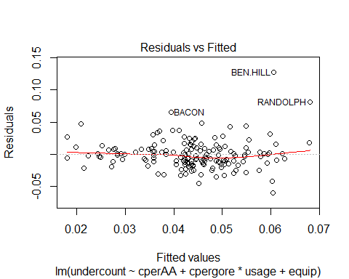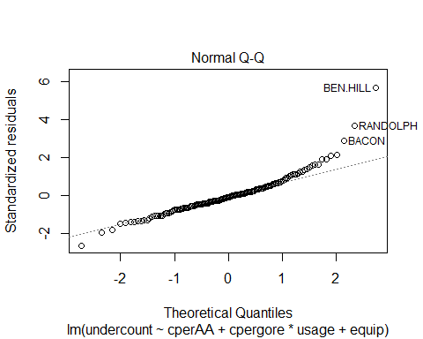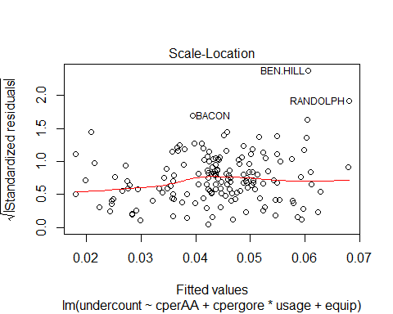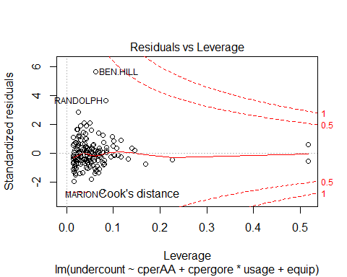

gavote[cooks.distance(lmodi) > 0.1,]

## equip econ perAA usage atlanta gore bush other votes ballots  
## BEN.HILL OS-PC poor 0.282 rural notAtlanta 2234 2381 46 4661 5741  
## RANDOLPH OS-PC poor 0.527 rural notAtlanta 1381 1174 14 2569 3021  
## undercount pergore cpergore cperAA  
## BEN.HILL 0.1881205 0.4792963 0.07097452 0.03901887  
## RANDOLPH 0.1496193 0.5375633 0.12924148 0.28401887

halfnorm(hatvalues(lmodi))

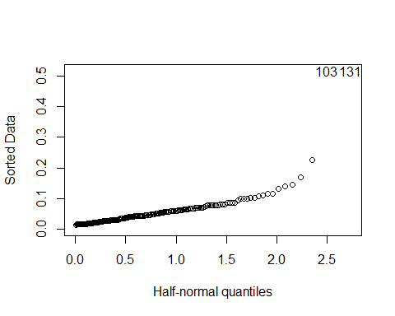

gavote[hatvalues(lmodi) > 0.3,]

## equip econ perAA usage atlanta gore bush other votes ballots  
## MONTGOMERY PAPER poor 0.243 rural notAtlanta 1013 1465 31 2509 2573  
## TALIAFERRO PAPER poor 0.596 rural notAtlanta 556 271 5 832 881  
## undercount pergore cpergore cperAA  
## MONTGOMERY 0.02487369 0.4037465 -0.004575261 1.886792e-05  
## TALIAFERRO 0.05561862 0.6682692 0.259947458 3.530189e-01

termplot(lmodi, partial = TRUE, terms = 1)

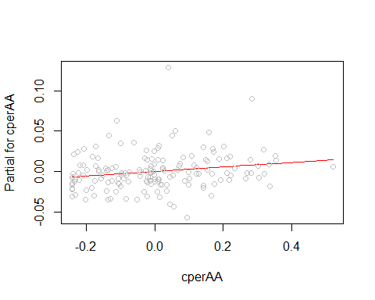

library(MASS)

##   
## Attaching package: 'MASS'

## The following object is masked from 'package:dplyr':  
##   
## select

library(dplyr) # to avoid masking of select by MASS package  
rlmodi <- rlm(undercount ~ cperAA + cpergore * usage + equip, gavote)  
summary(rlmodi)

##   
## Call: rlm(formula = undercount ~ cperAA + cpergore * usage + equip,   
## data = gavote)  
## Residuals:  
## Min 1Q Median 3Q Max   
## -6.026e-02 -1.165e-02 -6.587e-06 1.100e-02 1.379e-01   
##   
## Coefficients:  
## Value Std. Error t value  
## (Intercept) 0.0414 0.0023 17.8662  
## cperAA 0.0327 0.0254 1.2897  
## cpergore -0.0082 0.0418 -0.1972  
## usageurban -0.0167 0.0038 -4.4063  
## equipOS-CC 0.0069 0.0038 1.8019  
## equipOS-PC 0.0081 0.0048 1.6949  
## equipPAPER -0.0059 0.0138 -0.4269  
## equipPUNCH 0.0170 0.0055 3.0720  
## cpergore:usageurban 0.0073 0.0316 0.2298  
##   
## Residual standard error: 0.01722 on 150 degrees of freedom

wlmodi <- lm(undercount ~ cperAA + cpergore * usage + equip, gavote, weights=ballots)  
wlmodi

##   
## Call:  
## lm(formula = undercount ~ cperAA + cpergore * usage + equip,   
## data = gavote, weights = ballots)  
##   
## Coefficients:  
## (Intercept) cperAA cpergore   
## 0.043687 0.068093 -0.046885   
## usageurban equipOS-CC equipOS-PC   
## -0.017916 0.005582 -0.005823   
## equipPAPER equipPUNCH cpergore:usageurban   
## -0.014154 0.015661 0.011998

sqrt(0.035*(1-0.035)/881)

## [1] 0.006191697

plmodi <- lm(undercount ~ poly(cperAA, 4) + cpergore * usage + equip, gavote)  
summary(plmodi)

##   
## Call:  
## lm(formula = undercount ~ poly(cperAA, 4) + cpergore * usage +   
## equip, data = gavote)  
##   
## Residuals:  
## Min 1Q Median 3Q Max   
## -0.058563 -0.012963 -0.001987 0.009230 0.127984   
##   
## Coefficients:  
## Estimate Std. Error t value Pr(>|t|)   
## (Intercept) 0.043460 0.002875 15.115 < 2e-16 ***  
## poly(cperAA, 4)1 0.052258 0.069391 0.753 0.45260   
## poly(cperAA, 4)2 -0.002988 0.026135 -0.114 0.90914   
## poly(cperAA, 4)3 -0.005363 0.024267 -0.221 0.82538   
## poly(cperAA, 4)4 -0.016513 0.024199 -0.682 0.49606   
## cpergore 0.013153 0.056930 0.231 0.81761   
## usageurban -0.019129 0.004741 -4.035 8.76e-05 ***  
## equipOS-CC 0.006440 0.004720 1.364 0.17455   
## equipOS-PC 0.015587 0.005879 2.652 0.00889 **   
## equipPAPER -0.010272 0.017204 -0.597 0.55137   
## equipPUNCH 0.014053 0.006866 2.047 0.04247 *   
## cpergore:usageurban -0.010538 0.041362 -0.255 0.79926   
## ---  
## Signif. codes: 0 '***' 0.001 '**' 0.01 '*' 0.05 '.' 0.1 ' ' 1  
##   
## Residual standard error: 0.02354 on 147 degrees of freedom  
## Multiple R-squared: 0.1726, Adjusted R-squared: 0.1107   
## F-statistic: 2.788 on 11 and 147 DF, p-value: 0.002539

termplot(plmodi, partial = TRUE, terms = 1)

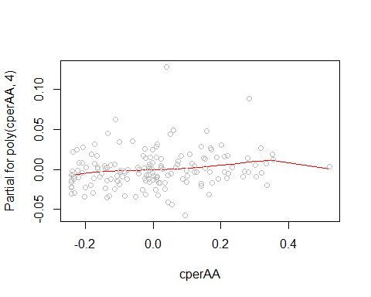

library(splines)  
blmodi <- lm(undercount ~ cperAA + bs(cpergore, 4) + usage + equip, gavote)  
blmodi

##   
## Call:  
## lm(formula = undercount ~ cperAA + bs(cpergore, 4) + usage +   
## equip, data = gavote)  
##   
## Coefficients:  
## (Intercept) cperAA bs(cpergore, 4)1 bs(cpergore, 4)2   
## 0.048166 0.027045 -0.001337 -0.018839   
## bs(cpergore, 4)3 bs(cpergore, 4)4 usageurban equipOS-CC   
## 0.019684 -0.026591 -0.019426 0.006815   
## equipOS-PC equipPAPER equipPUNCH   
## 0.015527 -0.008347 0.012998

biglm <- lm(undercount ~ (equip + econ + usage + atlanta)^2 + (equip + econ + usage + atlanta)*(perAA + pergore), gavote)  
biglm

##   
## Call:  
## lm(formula = undercount ~ (equip + econ + usage + atlanta)^2 +   
## (equip + econ + usage + atlanta) * (perAA + pergore), data = gavote)  
##   
## Coefficients:  
## (Intercept) equipOS-CC   
## 0.1133313 -0.0130587   
## equipOS-PC equipPAPER   
## -0.1239885 -0.0564436   
## equipPUNCH econpoor   
## -0.0629444 0.0219635   
## econrich usageurban   
## -0.0806679 -0.0048248   
## atlantanotAtlanta perAA   
## -0.0819097 -0.1593997   
## pergore equipOS-CC:econpoor   
## 0.0065156 -0.0113257   
## equipOS-PC:econpoor equipPAPER:econpoor   
## 0.0302820 NA   
## equipPUNCH:econpoor equipOS-CC:econrich   
## 0.0139002 0.0152270   
## equipOS-PC:econrich equipPAPER:econrich   
## 0.0239473 NA   
## equipPUNCH:econrich equipOS-CC:usageurban   
## 0.0218965 0.0004060   
## equipOS-PC:usageurban equipPAPER:usageurban   
## -0.0114057 NA   
## equipPUNCH:usageurban equipOS-CC:atlantanotAtlanta   
## 0.0398945 0.0011520   
## equipOS-PC:atlantanotAtlanta equipPAPER:atlantanotAtlanta   
## 0.0094463 NA   
## equipPUNCH:atlantanotAtlanta econpoor:usageurban   
## NA -0.0173178   
## econrich:usageurban econpoor:atlantanotAtlanta   
## -0.0007059 NA   
## econrich:atlantanotAtlanta usageurban:atlantanotAtlanta   
## 0.0432488 0.0261763   
## equipOS-CC:perAA equipOS-PC:perAA   
## 0.1408650 -0.0434235   
## equipPAPER:perAA equipPUNCH:perAA   
## 0.1195016 0.1206340   
## equipOS-CC:pergore equipOS-PC:pergore   
## -0.0162213 0.3350799   
## equipPAPER:pergore equipPUNCH:pergore   
## NA 0.0355427   
## econpoor:perAA econrich:perAA   
## 0.0275978 0.0792574   
## econpoor:pergore econrich:pergore   
## -0.0239484 0.0427712   
## usageurban:perAA usageurban:pergore   
## -0.0060042 -0.0760928   
## atlantanotAtlanta:perAA atlantanotAtlanta:pergore   
## 0.0765157 0.0479664

smallm <- step(biglm, trace=FALSE)  
smallm

##   
## Call:  
## lm(formula = undercount ~ equip + econ + usage + perAA + equip:econ +   
## equip:perAA + usage:perAA, data = gavote)  
##   
## Coefficients:  
## (Intercept) equipOS-CC equipOS-PC   
## 0.0435310 -0.0128784 0.0034922   
## equipPAPER equipPUNCH econpoor   
## -0.0578329 -0.0142618 0.0180113   
## econrich usageurban perAA   
## -0.0157358 -0.0006736 -0.0389879   
## equipOS-CC:econpoor equipOS-PC:econpoor equipPAPER:econpoor   
## -0.0114503 0.0424178 NA   
## equipPUNCH:econpoor equipOS-CC:econrich equipOS-PC:econrich   
## -0.0160832 0.0047127 -0.0111987   
## equipPAPER:econrich equipPUNCH:econrich equipOS-CC:perAA   
## NA 0.0168340 0.1181524   
## equipOS-PC:perAA equipPAPER:perAA equipPUNCH:perAA   
## 0.0321434 0.1260840 0.1243346   
## usageurban:perAA   
## -0.0472147

drop1(smallm, test="F")

## Single term deletions  
##   
## Model:  
## undercount ~ equip + econ + usage + perAA + equip:econ + equip:perAA +   
## usage:perAA  
## Df Sum of Sq RSS AIC F value Pr(>F)   
## <none> 0.053627 -1231.1   
## equip:econ 6 0.0075232 0.061150 -1222.3 3.2500 0.005084 **  
## equip:perAA 4 0.0068439 0.060471 -1220.0 4.4348 0.002101 **  
## usage:perAA 1 0.0010214 0.054649 -1230.1 2.6474 0.105984   
## ---  
## Signif. codes: 0 '***' 0.001 '**' 0.01 '*' 0.05 '.' 0.1 ' ' 1

finalm <- lm(undercount ~ equip + econ + perAA + equip:econ + equip:perAA, gavote)  
finalm

##   
## Call:  
## lm(formula = undercount ~ equip + econ + perAA + equip:econ +   
## equip:perAA, data = gavote)  
##   
## Coefficients:  
## (Intercept) equipOS-CC equipOS-PC   
## 0.041871 -0.011327 0.008575   
## equipPAPER equipPUNCH econpoor   
## -0.058427 -0.015751 0.020266   
## econrich perAA equipOS-CC:econpoor   
## -0.016966 -0.042040 -0.010964   
## equipOS-PC:econpoor equipPAPER:econpoor equipPUNCH:econpoor   
## 0.048385 NA -0.003560   
## equipOS-CC:econrich equipOS-PC:econrich equipPAPER:econrich   
## 0.002278 -0.013318 NA   
## equipPUNCH:econrich equipOS-CC:perAA equipOS-PC:perAA   
## 0.020031 0.107249 -0.005906   
## equipPAPER:perAA equipPUNCH:perAA   
## 0.129136 0.086849

summary(finalm)

##   
## Call:  
## lm(formula = undercount ~ equip + econ + perAA + equip:econ +   
## equip:perAA, data = gavote)  
##   
## Residuals:  
## Min 1Q Median 3Q Max   
## -0.057011 -0.010632 -0.000069 0.009198 0.082545   
##   
## Coefficients: (2 not defined because of singularities)  
## Estimate Std. Error t value Pr(>|t|)   
## (Intercept) 0.041871 0.005028 8.328 6.5e-14 ***  
## equipOS-CC -0.011327 0.007373 -1.536 0.126700   
## equipOS-PC 0.008575 0.011178 0.767 0.444288   
## equipPAPER -0.058427 0.037014 -1.579 0.116687   
## equipPUNCH -0.015751 0.018745 -0.840 0.402175   
## econpoor 0.020266 0.005529 3.665 0.000349 ***  
## econrich -0.016966 0.012392 -1.369 0.173128   
## perAA -0.042040 0.016594 -2.534 0.012385 *   
## equipOS-CC:econpoor -0.010964 0.009885 -1.109 0.269224   
## equipOS-PC:econpoor 0.048385 0.013795 3.507 0.000608 ***  
## equipPAPER:econpoor NA NA NA NA   
## equipPUNCH:econpoor -0.003560 0.012427 -0.286 0.774921   
## equipOS-CC:econrich 0.002278 0.015378 0.148 0.882465   
## equipOS-PC:econrich -0.013318 0.017054 -0.781 0.436149   
## equipPAPER:econrich NA NA NA NA   
## equipPUNCH:econrich 0.020031 0.021997 0.911 0.364045   
## equipOS-CC:perAA 0.107249 0.032855 3.264 0.001377 **   
## equipOS-PC:perAA -0.005906 0.043414 -0.136 0.891981   
## equipPAPER:perAA 0.129136 0.081806 1.579 0.116676   
## equipPUNCH:perAA 0.086849 0.046500 1.868 0.063875 .   
## ---  
## Signif. codes: 0 '***' 0.001 '**' 0.01 '*' 0.05 '.' 0.1 ' ' 1  
##   
## Residual standard error: 0.02 on 141 degrees of freedom  
## Multiple R-squared: 0.4276, Adjusted R-squared: 0.3585   
## F-statistic: 6.195 on 17 and 141 DF, p-value: 1.318e-10

pdf <- data.frame(econ=rep(levels(gavote$econ), 5), equip=rep(levels(gavote$equip), rep(3,5)), perAA=0.233)  
pdf

## econ equip perAA  
## 1 middle LEVER 0.233  
## 2 poor LEVER 0.233  
## 3 rich LEVER 0.233  
## 4 middle OS-CC 0.233  
## 5 poor OS-CC 0.233  
## 6 rich OS-CC 0.233  
## 7 middle OS-PC 0.233  
## 8 poor OS-PC 0.233  
## 9 rich OS-PC 0.233  
## 10 middle PAPER 0.233  
## 11 poor PAPER 0.233  
## 12 rich PAPER 0.233  
## 13 middle PUNCH 0.233  
## 14 poor PUNCH 0.233  
## 15 rich PUNCH 0.233

pp <- predict(finalm, new=pdf)

## Warning in predict.lm(finalm, new = pdf): prediction from a rank-deficient  
## fit may be misleading

pp

## 1 2 3 4 5 6   
## 0.03207552 0.05234143 0.01510907 0.04573784 0.05503927 0.03104909   
## 7 8 9 10 11 12   
## 0.03927441 0.10792510 0.00898981 0.00373682 0.02400273 -0.01322963   
## 13 14 15   
## 0.03656002 0.05326578 0.03962504

xtabs(round(pp, 3) ~ econ + equip, pdf)

## equip  
## econ LEVER OS-CC OS-PC PAPER PUNCH  
## middle 0.032 0.046 0.039 0.004 0.037  
## poor 0.052 0.055 0.108 0.024 0.053  
## rich 0.015 0.031 0.009 -0.013 0.040

pdf <- data.frame(econ = rep("middle", 15), equip=rep(levels(gavote$equip), rep(3,5)), perAA=rep(c(.11, 0.23,0.35), 5))  
pdf

## econ equip perAA  
## 1 middle LEVER 0.11  
## 2 middle LEVER 0.23  
## 3 middle LEVER 0.35  
## 4 middle OS-CC 0.11  
## 5 middle OS-CC 0.23  
## 6 middle OS-CC 0.35  
## 7 middle OS-PC 0.11  
## 8 middle OS-PC 0.23  
## 9 middle OS-PC 0.35  
## 10 middle PAPER 0.11  
## 11 middle PAPER 0.23  
## 12 middle PAPER 0.35  
## 13 middle PUNCH 0.11  
## 14 middle PUNCH 0.23  
## 15 middle PUNCH 0.35

pp <- predict(finalm, new=pdf)

## Warning in predict.lm(finalm, new = pdf): prediction from a rank-deficient  
## fit may be misleading

pp

## 1 2 3 4 5   
## 0.037246475 0.032201640 0.027156806 0.037717125 0.045542214   
## 6 7 8 9 10   
## 0.053367302 0.045171832 0.039418252 0.033664672 -0.006976002   
## 11 12 13 14 15   
## 0.003475532 0.013927065 0.031048546 0.036425589 0.041802632

propAA <- gl(3,1,15, labels=c("low","medium","high"))  
xtabs(round(pp, 3) ~ propAA + equip,pdf)

## equip  
## propAA LEVER OS-CC OS-PC PAPER PUNCH  
## low 0.037 0.038 0.045 -0.007 0.031  
## medium 0.032 0.046 0.039 0.003 0.036  
## high 0.027 0.053 0.034 0.014 0.042