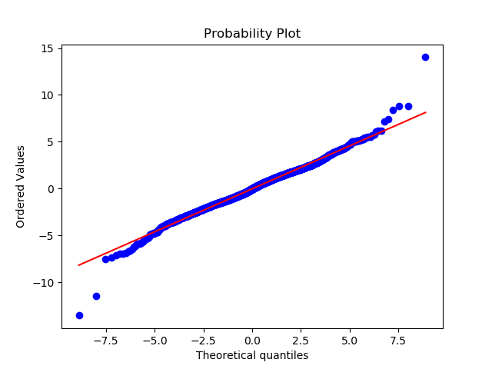
The distA.csv matches the Laplace distribution.
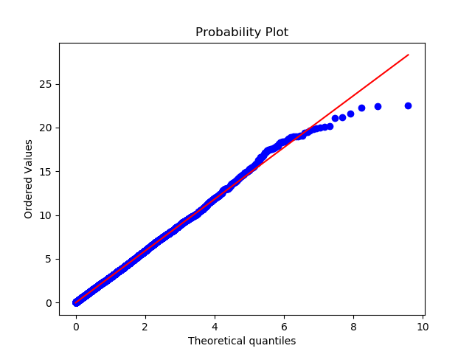
The distB.csv matches the Exponential distribution.
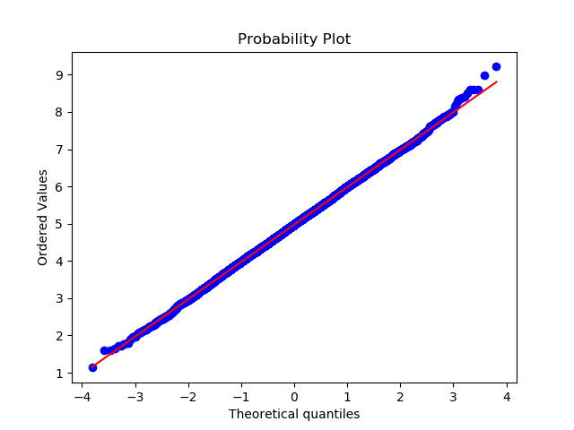
The distC.csv matches the Gaussian distribution.

