The VFT of the Faculty object that the Student* s erroneously points to

**~Faculty() code**

**~Faculty**

putSalary ( ) code

putSalary()

getSalary( ) code

getSalary()

print() code

print()

The red arrow shows what is called by s→getGPA(). Note that putSalary( ) and getGPA() are in the same positions in their respective class’ VFTs.

The VFT of the Student object that the Faculty* f erroneously points to

**~Student() code**

**~Student**

getGPA( ) code

getGPA()

putGPA( ) code

putGPA()

The red arrow shows what is called by s→putSalary(500.0). Note that putSalary(500.0 ) and getGPA() are in the same positions in their respective class’ VFTs.

The VFT of the Student object that the Faculty* f erroneously points to

**~Student() code**

**~Student**

getGPA( ) code

getGPA()

putGPA( ) code

putGPA()

The red arrow shows what is called by s→getSalary(). Note that getSalary() and putGPA() are in the same positions in their respective class’ VFTs.

The last one crashes, so I cannot see the outcome. I think the reason could be that the getGPA() did not have corresponding value in it.

mainStaticCast.cpp

For the mainStaticCast.cpp, the compiler could not pass my code, so I commanded some of the static_cast value. It turn out that it just crash at the first getting code “ s->putGPA(6.6);”

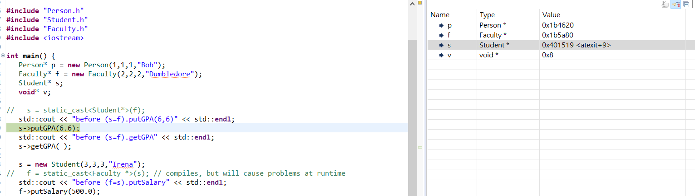

mainDynamicCast.cpp

In the mainDynamicCast.cpp, the compiler do pass all of my code but “s = dynamic_cast<Student*>(v);” this one. The code just crash in “ s->putGPA(6.6);”

This is what I run in debug mode and the value for Student* is “0x0”, which did not have a location to assign it, so it just crash.

